Pictures
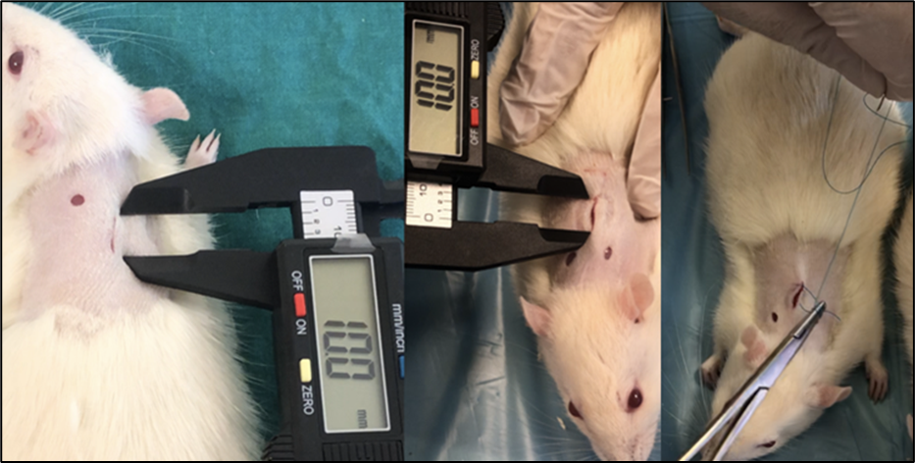
Picture 1. Wound opening and suturing

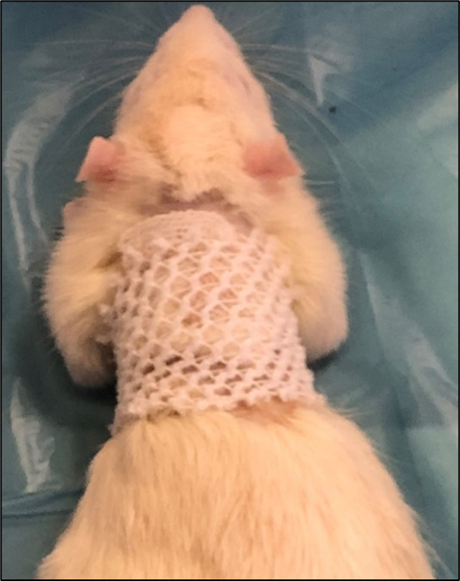
Picture 2. Isotonic wet dressing
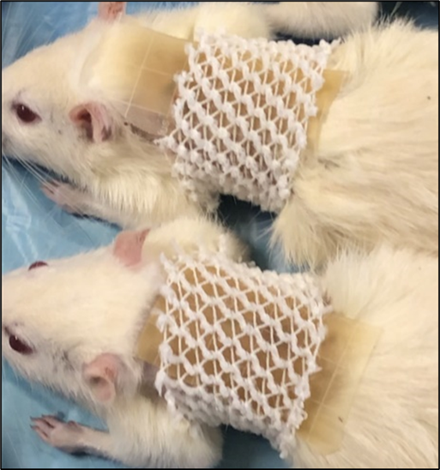
Picture 3. Hydrocolloid dressing

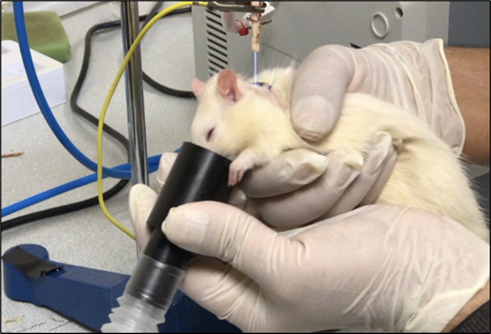
Picture 4. APPJ application

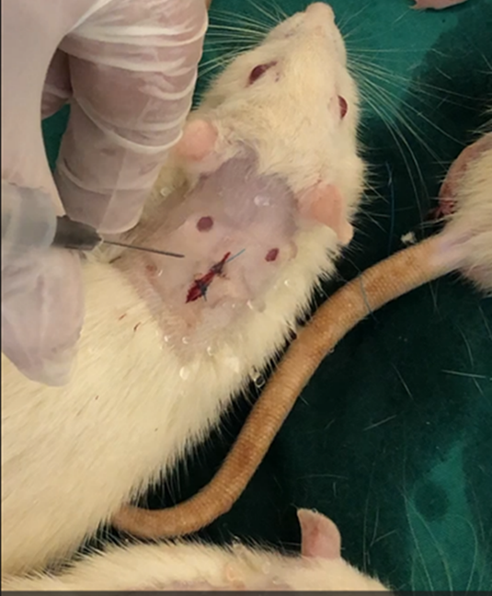
Picture 5. Medium application

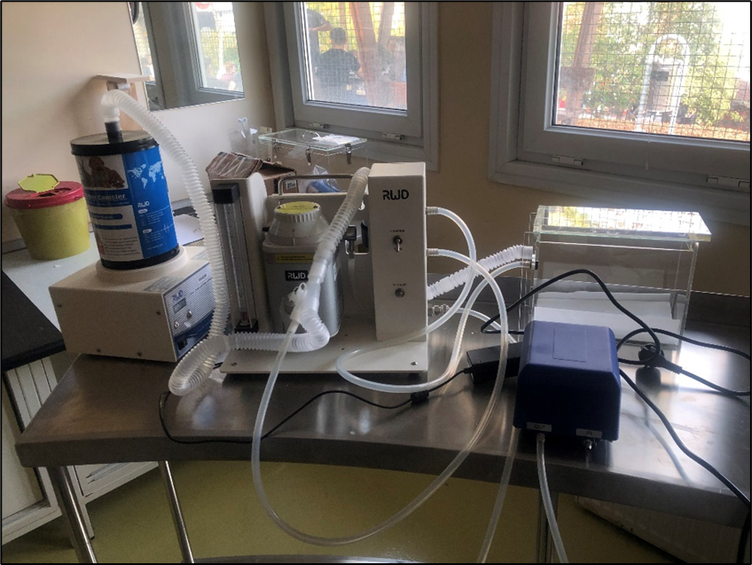
Picture 6. Sedation device
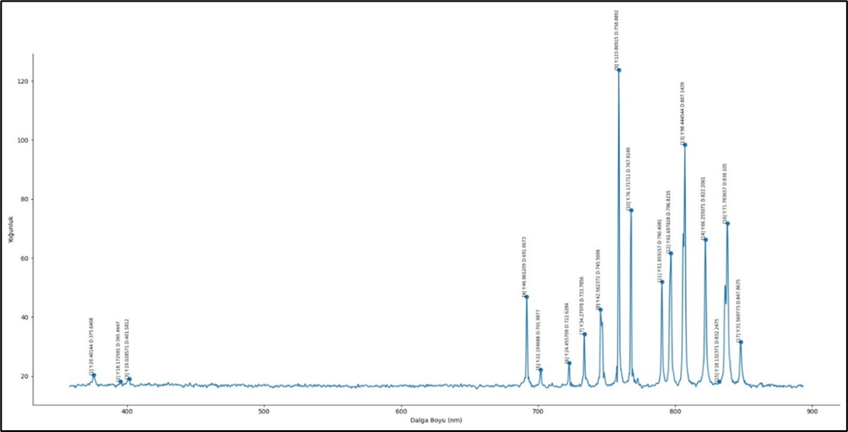
Picture 7. Measuring Plasma with Spectrometer

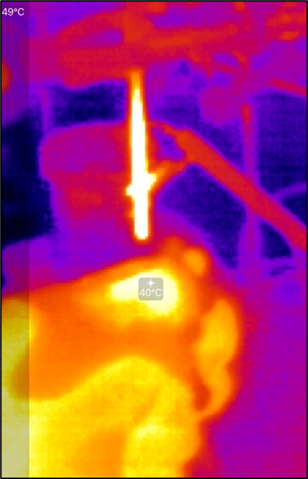
Picture 8. Measuring plasma temperature with a thermal camera
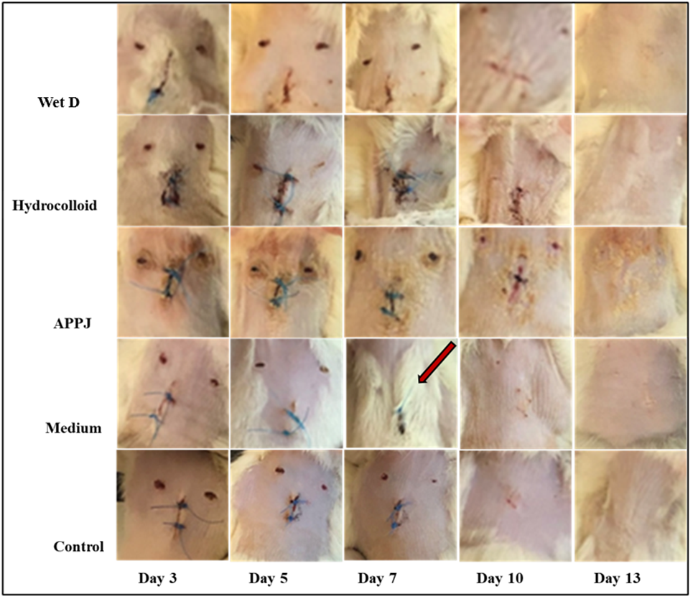
Picture 9. Monitoring of wound healing

