Supplemental Information for the Manuscript “Documenting the Occurrence of Microbial Carbonate Deposits in Puerto Rico”
by
Bryan J. Rodriguez-Colon^{1,*}, Wilson R. Ramirez-Martinez², Aliyah M. Chabrier-Alpi³, Carlos Ríos-Velázquez⁴, Noraida Martínez-Rivera⁵, Gregory S. Baker⁶, Yasawantha Hiripitiyage⁷, Belinda S.M. Sturm⁷, Jennifer A. Roberts¹

¹Department of Geology, University of Kansas, Lawrence, Kansas 66045, USA.
²Department of Geology, University of Puerto Rico–Mayagüez, Mayagüez, Puerto Rico 00681, USA.
³Department of Marine Sciences, University of Puerto Rico–Mayagüez, Mayagüez, Puerto Rico 00681, USA.
⁴Department of Biology, University of Puerto Rico–Mayagüez, Mayagüez, Puerto Rico 00681, USA.
⁵Microscopy and Analytical Imaging Laboratory, University of Kansas, Lawrence, Kansas 66045, USA.
⁶Geoscience Program, Colorado Mesa University, Grand Junction, CO, 81501 USA.
⁷Department of Civil, Environmental & Architectural Engineering, University of Kansas, Lawrence, Kansas 66045, USA.

*bryan.rodriguez@ku.edu

Submitted to Scientific Reports

Supplementary Tables:

Sample | δ¹³C_{carb} VPDB | δ¹⁸O_{carb} VPDB
Microbialite_LP19-Crust | -4.63 | 1.3
Microbialite_LP19-MiddleCrust | -1.68 | 1.08
Microbialite_PL19-BlackLayer1 | -1.62 | 1.25
Microbialite_PL19-BlackLayer2 | -3.16 | 1.34
Microbialite_PL19-BottomLayer1 | -1.63 | 1.36
Microbialite_PL19-Bottomlayer2 | -3.74 | 0.9
PL-13A | -7.5 | -3.77
PL-13B | -6.31 | -3.87
PL-1A | -8.8 | -4.15
PL-1B | -9 | -4.33
PL-Outcrop_1m* | 1.25 | 1.21
PL-Outcrop_6m* | 0.01 | 1.22
PL-Outcrop_10m* | -0.73 | 1.54
PL-Outcrop_12m* | 0.18 | 1.17
PL-Outcrop_23m* | 1.38 | 1.58
PL-Core_1m* | 0.41 | 1.38
PL-Core_8m* | 1.24 | 1.53
PL-Core_6m* | 0.72 | 1.74
PL-Core_13m* | -0.81 | 1.05
PL-BeachSand | -0.08 | -2.49
Table S1. Stable isotope composition of carbonate samples from Laguna Providencia and surrounding units. Carbon (δ¹³C) and oxygen (δ¹⁸O) isotope values for microbialite carbonates from Laguna Providencia, along with comparative values from Ponce Limestone bedrock and modern beach sand samples. Samples marked with an asterisk (*) were previously reported by Padilla-Montalvo^{[1]}.

Lagoon and sample name | Sample Layer | Sample Layer | Observed | Shannon | Simpson | Bacteria Relative Abundance (%) | Archaea Relative Abundance (%)
Vernales  (SV1-E) | C/G | SVE1-CG | 426.5 ± 55.86 | 4.05 ± 0.19 | 0.95 ± 0.01 | 98.47 | 1.53
Vernales  (SV1-E) | G | SVE1-G | 753 ± 12.73 | 4.95 ± 0.27 | 0.97 ± 0.02 | 90.41 | 9.59
Vernales  (SV1-E) | R | SVE1-R | 777 ± 229.1 | 4.79 ± 0.26 | 0.97 | 85.08 | 14.92
Vernales  (SV1-E) | B | SVE1-B | 915.5 ± 57.28 | 5.14 ± 0.07 | 0.98 | 64.69 | 35.31
Salinetas  (SS-NW) | C | SS-C | 245.5 ± 118.09 | 3.97 ± 0.19 | 0.94 ± 0.04 | 69.09 | 30.91
Salinetas  (SS-NW) | G | SS-G | 687 ± 16.97 | 4.88 ± 0.21 | 0.97 | 70.35 | 29.65
Salinetas  (SS-NW) | DP | SS-DP | 58.5 ± 41.72 | 2.56 ± 0.15 | 0.84 ± 0.06 | 98.14 | 1.86
Salinetas  (SS-NW) | B | SS-B | 348.5 ± 313.25 | 2.61 ± 1.34 | 0.76 ± 0.15 | 54.10 | 45.90
Providencia  (LP) | C1 | LP-C1 | 1183 ± 9.9 | 5.53 ± 0.48 | 0.98 ± 0.02 | 84.66 | 15.34
Providencia  (LP) | C2 | LP-C2 | 993.5 ± 210.01 | 5.23 ± 0.34 | 0.98 ± 0.01 | 90.30 | 9.70
Providencia  (LP) | BR | LP-BR | 1279.5 ± 201.53 | 5.5 ± 0.27 | 0.99 | 75.90 | 24.10
Providencia  (LP) | B | LP-B | 1074 ± 148.49 | 5.17 ± 0.17 | 0.96 ± 0.03 | 55.02 | 44.98
Providencia  (LP) | BOTTOM | LP-BOTTOM | 1423.5 ± 54.45 | 5.57 ± 0.05 | 0.99 | 64.31 | 35.31
Table S2. Alpha diversity metrics of microbial communities across samples with domain-level percentages. Values shown include observed ASV richness, Shannon diversity index, and Simpson diversity index, where observed richness represents the number of unique ASVs detected and the Shannon and Simpson indices describe community diversity and evenness. Percentages of reads assigned to Archaea and Bacteria are also reported for each layer. Sample-layer abbreviations: C, crust; G, green layer; R, pink layer; B, black layer; DP, dark pink layer; BR, brown layer; BOTTOM, basal microbialite layer.

Supplementary Figures

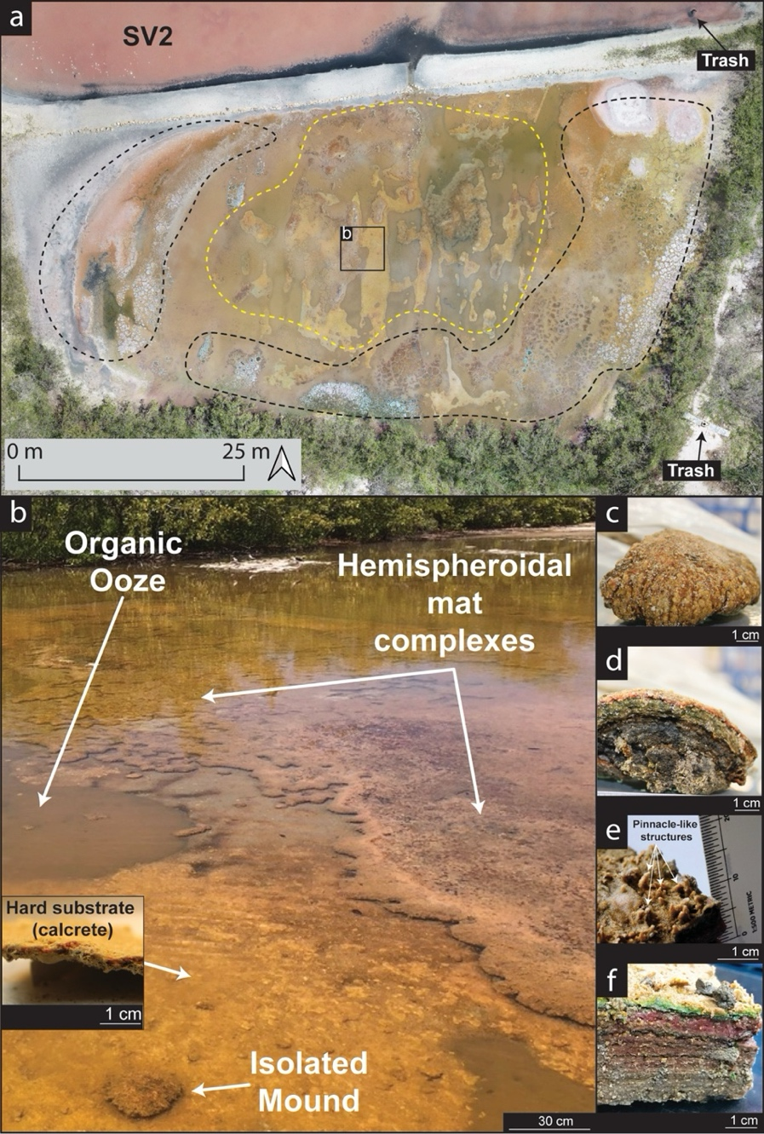
Figure S1. Field overview and sample context of calcifying microbial mats at Salinas Vernales (SV), southwestern Puerto Rico. (a) Drone image of pond SV2 showing distinct surface morphologies. The yellow dashed line outlines areas with hemispheroidal mat complexes, while black dashed lines indicate polygonal microbial mats and evaporitic crusts. (b) Field photograph of SV1 showing hemispheroidal mat complexes and isolated mounds colonizing calcrete substrates. The inset highlights the calcrete hardground overlain by a laminated microbial mat. (c–f) Representative mat morphologies and vertical structures, including (c) Hemispheriodal domes, (d) cross-section showing distinct organic-rich and carbonate laminae across different pigmentations, (e) pinnacle-like surface morphologies across flat microbial mats, and (f) dissected flat mat sample displaying color-banded layering from surface crust to basal sections.
Figure S2. Field overview and sample context of non-lithifying microbial mats at Salinas Salinetas (SS), southwestern Puerto Rico. (a) Drone image from fieldwork 2019 campaign showing the northwest pond (SS-NW) and central pond (SS-C). The pink and white surface coloration corresponds to halite and gypsum crusts associated with desiccation and evaporite formation. (b) Field photograph of the SS-NW pond margin as observed from the northern area showing the extensive salt crust and shallow water conditions during sampling. (c) Representative microbial mat fragment displaying dark organic-rich material overlain by a thin halite crust. (d-e) Close-up in SS-C showing microbial mat chips growing in bioclasts (~1–2 cm diameter) observed in the field.

Figure S3. Field overview of microbialite buildup megastructure at Laguna Providencia (LP), southwestern Puerto Rico. (a) Drone image from 2019 fieldwork campaign showing the spatial extent of the microbialite megastructure across the lagoon’s central sector. White dashed lines outline the main microbialite buildup. (a-i) Bathymetric model illustrating the morphology of the microbialite structure; dashed arrows indicate steep slopes (green area), whereas solid arrows denote gentler gradients (red area). (a-ii) Vectorized image of the microbialite buildup distribution, highlighting the areas where microbialites are most likely concentrated (green color), with areas of either no microbialites present or buried microbialites (dark gray color). (b) Drone image showing clustered microbialite accumulations forming laterally continuous patches. (c) Drone image showing discrete, isolated mound-like microbialite structures. (d) Drone image showing linear to elongate arrangements of microbialite heads, forming meter-scale alignments. (e) Field photograph taken in January 2020 corresponding to the clustered microbialite accumulations shown in (b). (f) Field photograph corresponding to the isolated microbialite structures shown in (c).

Figure S4. Macro- and meso-scale structure of microbialite buildups at Laguna Providencia (LP), southwestern Puerto Rico. (a) Representative microbialite from the western sector of the lagoon showing irregular clotted macrofabrics and an actively growing pustular microbial mat at the surface. (b) Sub-fossilized portions of the microbialite dominated by clotted internal textures. (c–d) Close-up views illustrating the composite structure of LP microbialites, including (c) primary clotted fabrics and (d) secondary irregular laminated textures locally intergrown within the deposit.

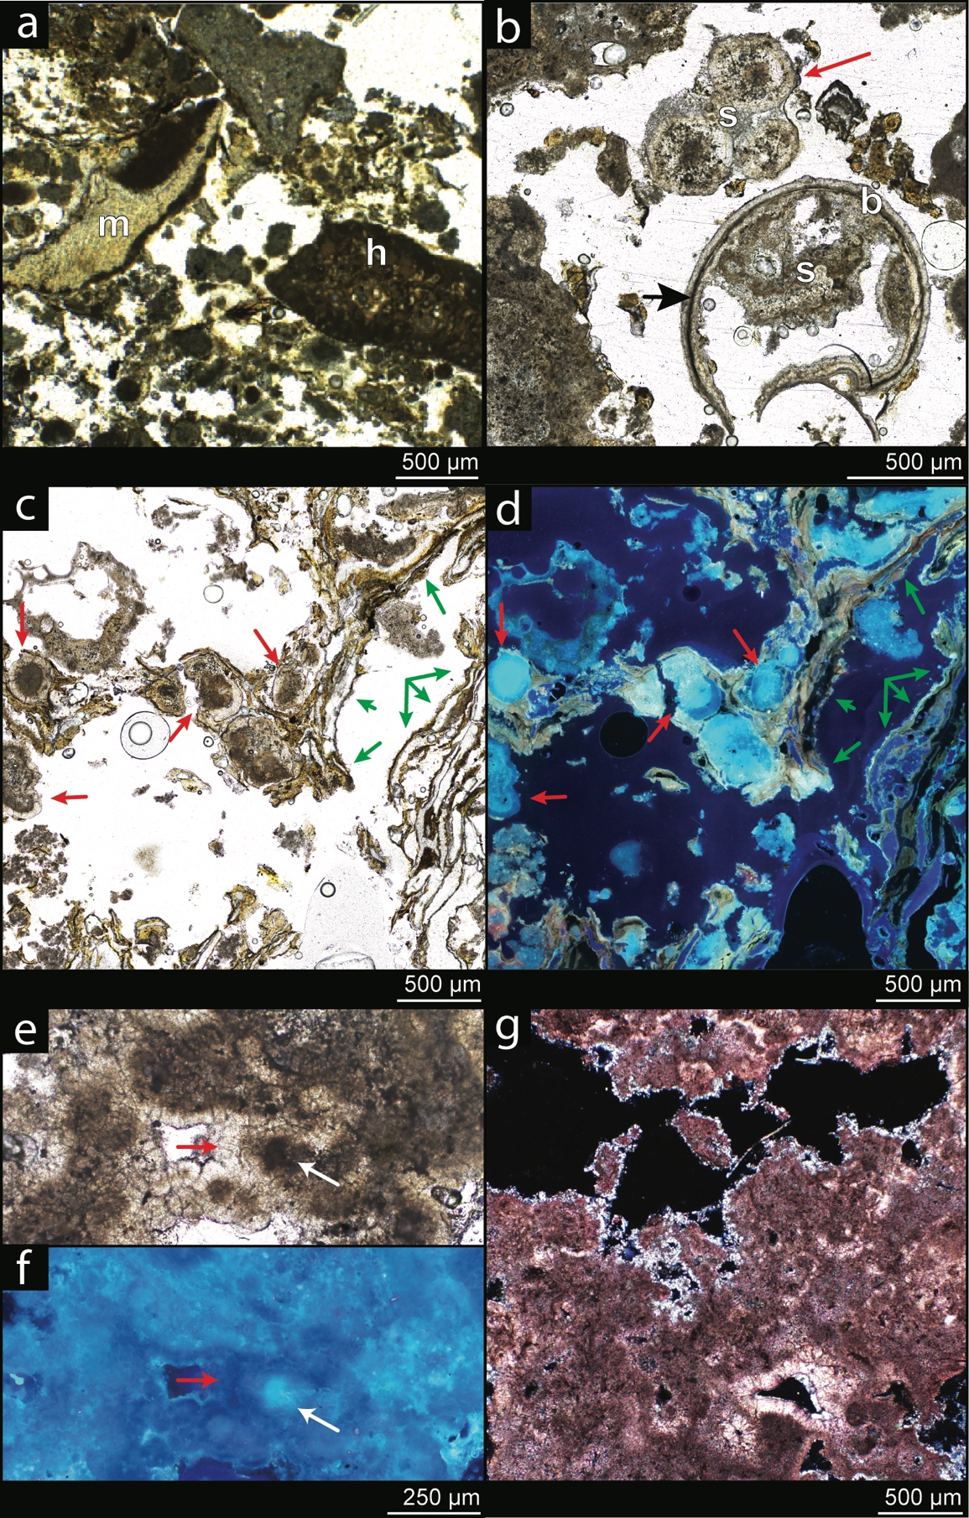
Figure S5. Additional petrographic characteristics of microbialite and microbial mat samples from Salinas Vernales (SV) and Laguna Providencia (LP), southwestern Puerto Rico. (a) Thin section from SV1-E showing bioclastic fragments of mollusks (letter m) and Halimeda sp. (letter h) embedded in micritic matrix, indicating minor detrital input within an otherwise authigenic framework. (b) Microbialite thin section from LP showing composite spherulites (letter s) associated with micritic envelopes and bivalve fragments (letter b). The bivalve fragment hosts internally clustered spherulites, suggesting in-situ precipitation within pore microenvironments. (c–d) Active microbial mats from LP showing biofilm laminae containing spherulitic aggregates. (c) Plane-polarized light reveals microbial laminations (green arrows) and embedded spherulites (red arrows). (d) The corresponding fluorescence image highlights enhanced luminescence within spherulite centers. (e–f) Sub-fossilized thrombolitic section from LP under (e) plane-polarized and fluorescence (f) light. Fluorescence is concentrated at the centers of clustered spherulites (white arrow). (g) Thin section of LP microbialite stained with Alizarin Red S and potassium ferrocyanide, showing widespread Mg-calcite (purple areas) with minor aragonite (light pink areas) infilling voids, indicative of possible early diagenetic recrystallization.

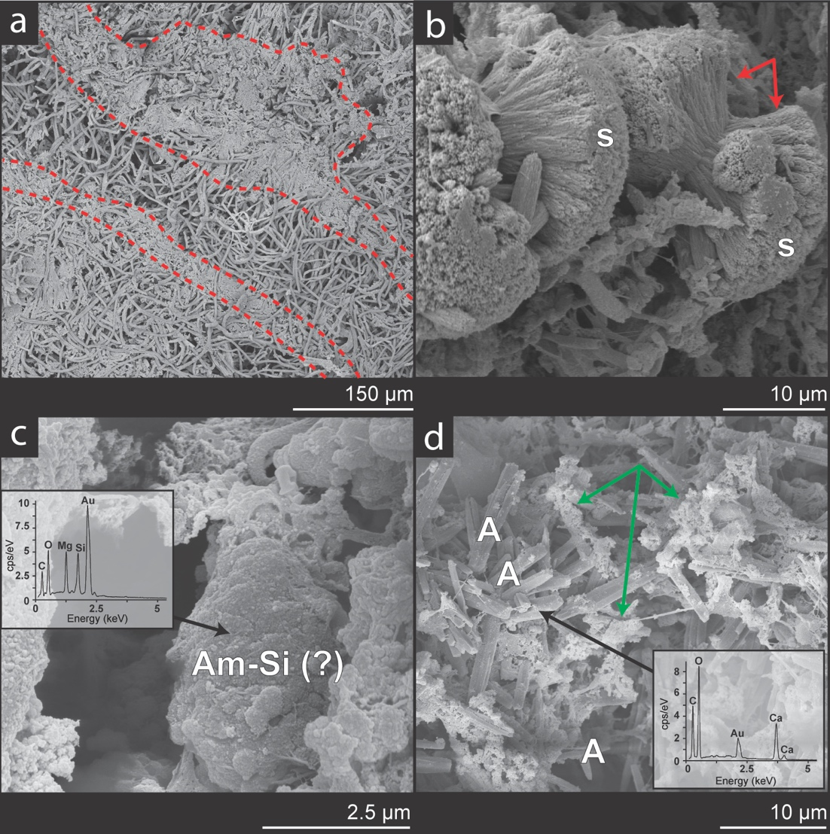
Figure S6. Additional Scanning Electron micrographs of microbial fabrics and mineral phases from Salinas Vernales (SV) and Laguna Providencia (LP), southwestern Puerto Rico. (a) Overview of SV1-E sample showing intertwined microbial filaments and micritic layers (red dashed areas). (b) Detail of SV1-E spherulites (letter s) forming dumbbell-shaped aggregates with fibrous internal textures (blue arrows). (c) SEM image of LP showing a putative amorphous Mg-silicate phase (letters Am-Si), confirmed by corresponding Energy Dispersive X-ray Spectroscopy (EDS) inset highlighting Mg and Si peaks. (d) SEM image from the basal section of LP microbialites showing randomly oriented aragonite needles (letter A, confirmed with EDS with a lack of Mg), surrounded by organic matter (green arrows).

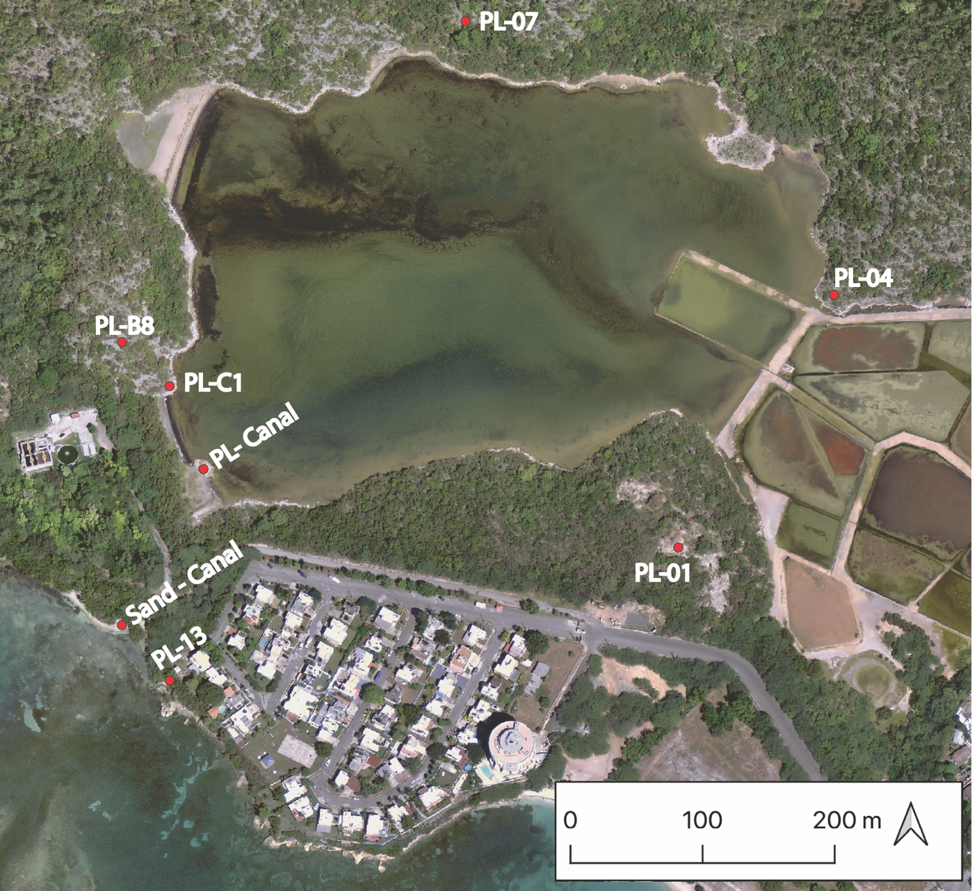
Figure S7. Sampling locations around Laguna Providencia, southwestern Puerto Rico. Map showing the locations where Ponce Limestone bedrock and modern beach sand samples were collected around Laguna Providencia for comparative mineralogical and stable isotope analyses^{[1]}.

Figure S8. Relative abundance of major microbial guilds across microbial mat and microbialite layers. Bar plots show the distribution of key microbial groups discussed, such as Cyanobacteria, Purple Non-Sulfur Bacteria, Sulfate-Reducing Bacteria, and Methanogens. IS means Incertae Sedis.

References
1 Padilla-Montalvo, J. A., Ramirez-Martinez, W. R., Rodriguez-Colon, B. J. & Roberts, J. A. Petrography and Geochemistry of Dolomites in Montalva, Guánica Tools to Assess the Timing and Process of Dolomitization. Geological Society of America Abstracts with Programs 54, 5, Abstract 144-144 (2022). 10.1130/abs/2022AM-383098

