Figure S1: Schematic representation of steps involved in cloning and expression of EG7A_MALCI and CBH7A_MALCI in P. pastoris expression host.

Figure S2: Screening of clones grown on BMMY medium for endoglucanase (EG7A_MALCI) and cellobiohydrolase (CBH7A_MALCI) activity using barley β-glucan and pNPC as respective substrates. Bars represent mean± SE (n=3).

Figure S3: (A) Homology model of EG7A_MALCI, and (B) Superimposed structure of endoglucanase from M. cinnamomea (blue) and Fusarium oxysporum-1ovwA (yellow)

Figure S4: (A) Homology model of CBH7A_MALCI (B) Superimposed structure of CBH from M. cinnamomea (red) and Dictostyleum purpureum-4zzpA (green)
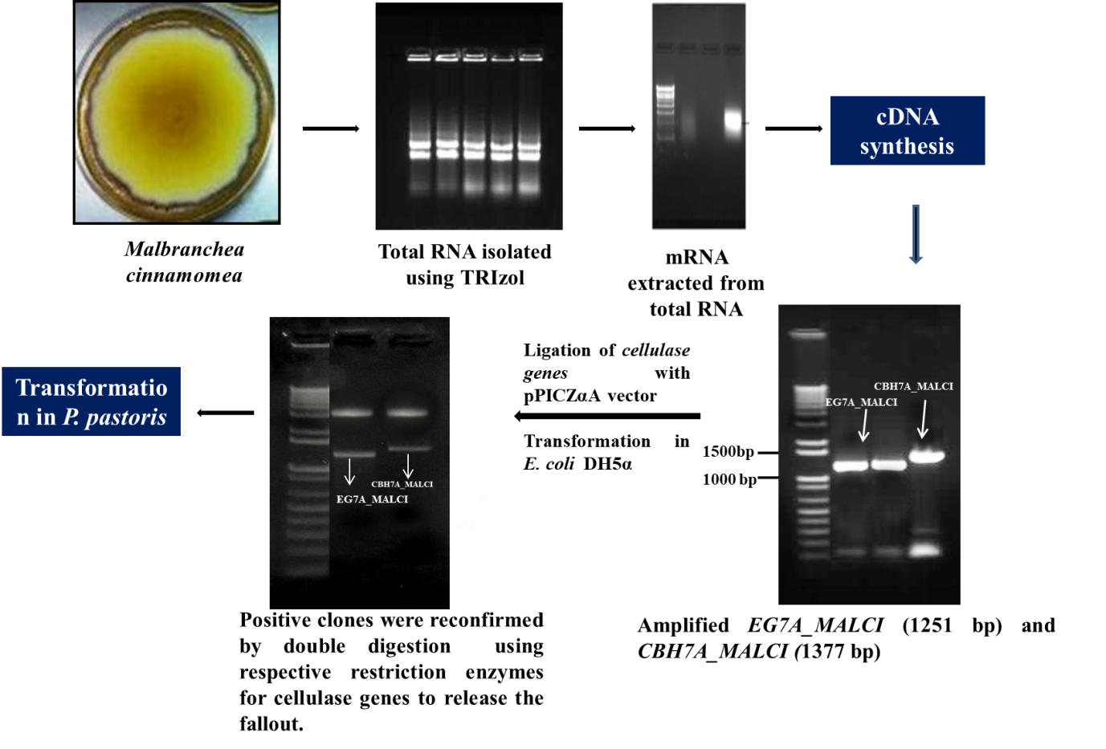

Figure S1: Schematic representation of steps involved in cloning and expression of EG7A_MALCI and CBH7A_MALCI in P. pastoris expression host.

Figure S2: Screening of clones grown on BMMY medium for endoglucanase (EG7A_MALCI) and cellobiohydrolase (CBH7A_MALCI) activity using barley β-glucan and pNPC as respective substrates.

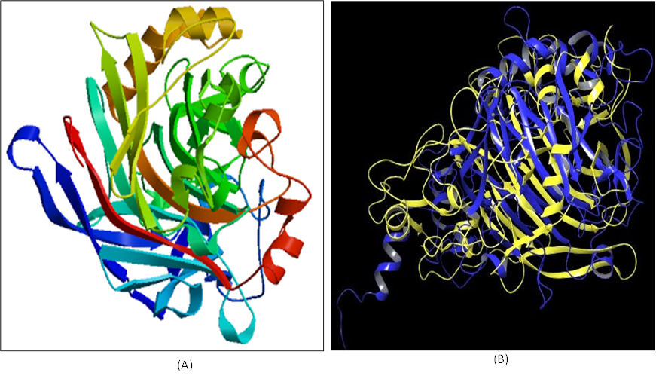
Figure S3: (A) Homology model of EG7A_MALCI, and (B) Superimposed structure of endoglucanase from M. cinnamomea (blue) and Fusarium oxysporum-1ovwA (yellow)

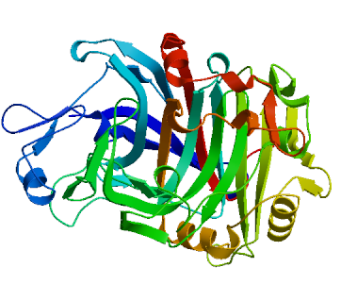
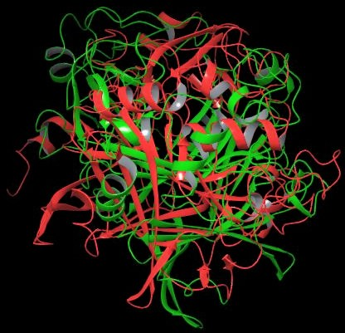
(A)
(B)

Figure S4: (A) Homology model of CBH7A_MALCI (B) Superimposed structure of CBH from M. cinnamomea (red) and Dictostyleum purpureum-4zzpA (green)

