Table 1 statistic of knee pain between Tai Chi practitioner
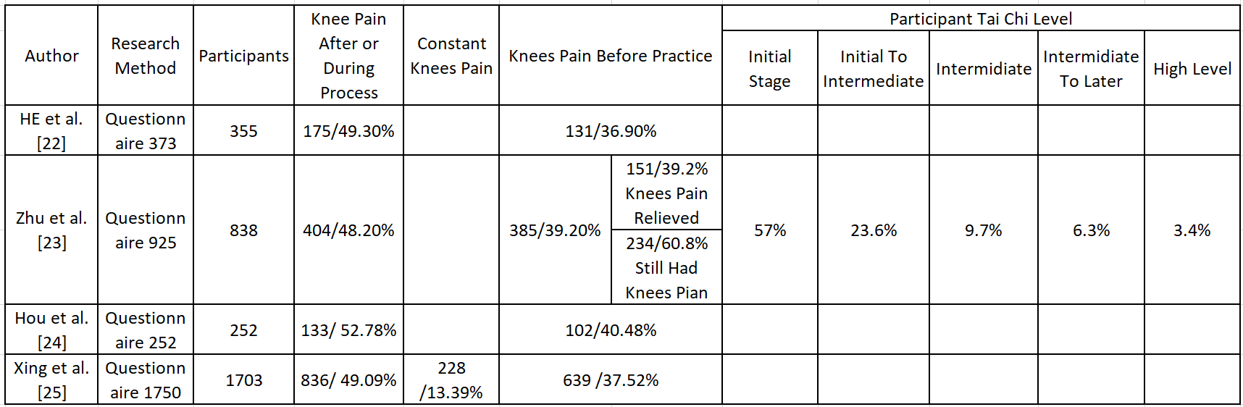
Table 2 Relationship between posture level and knee pain
