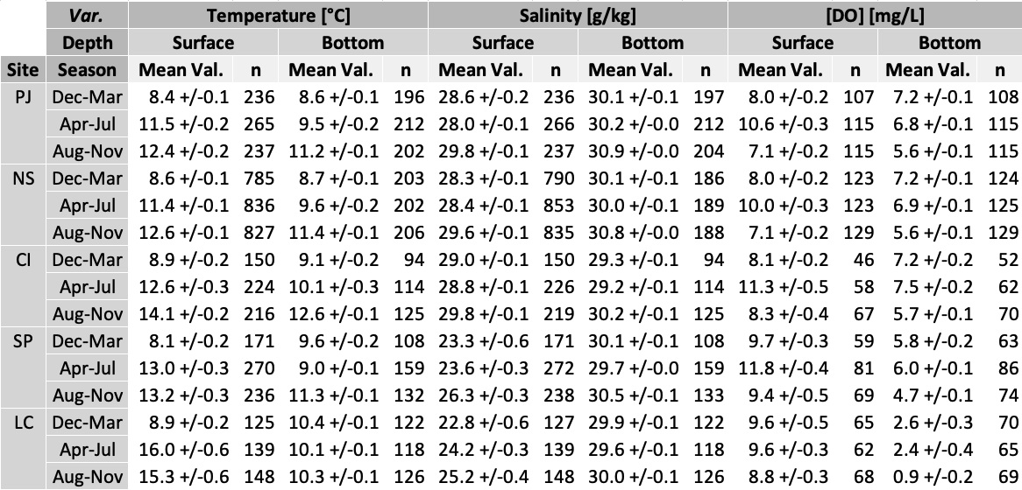
Table 2 Time series average (mean) values with 95% confidence intervals and sample size (n) for each variable, site, season, and depth

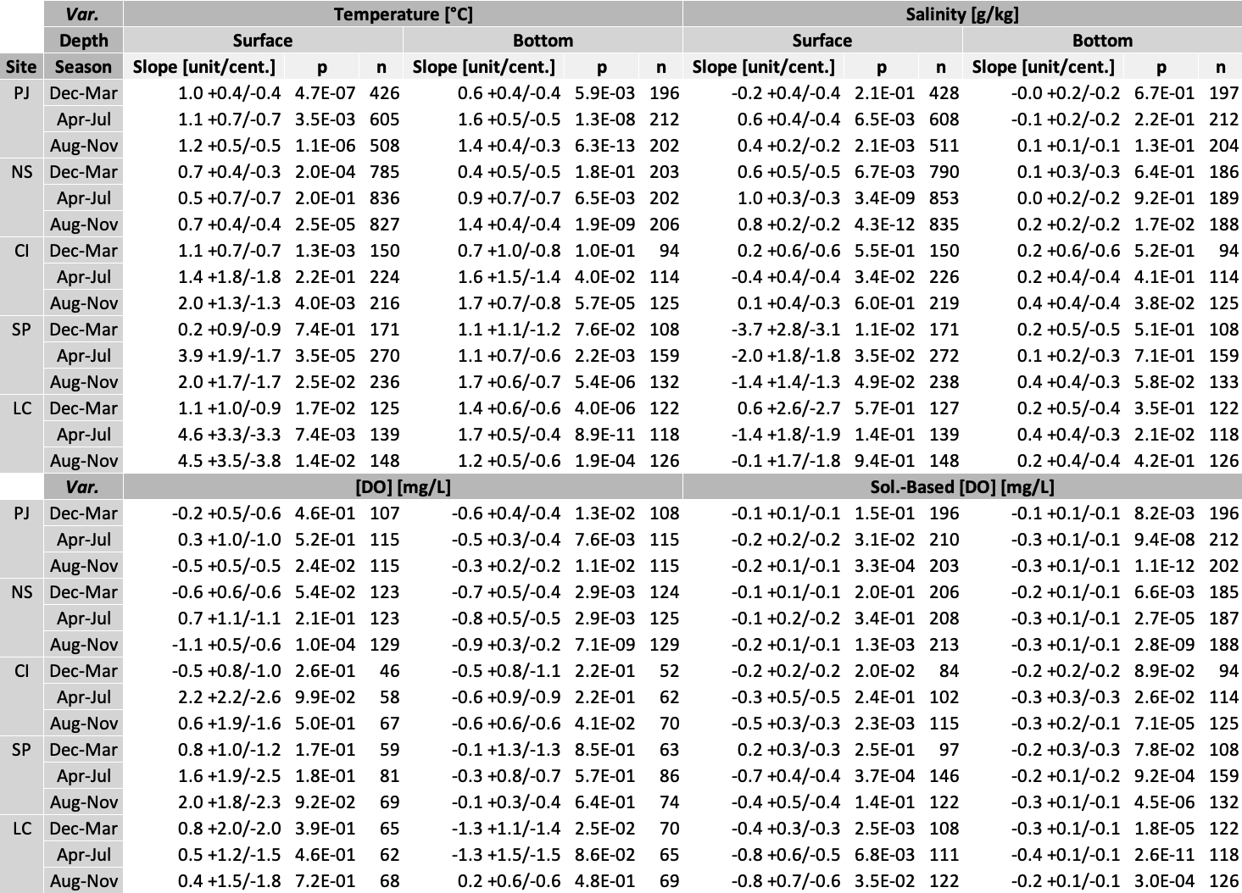
Table 3 All century-scale trends calculated using Theil-Sen slopes with 95% confidence intervals, Mann-Kendall trend p-values (p), and sample sizes (n) for each variable, site, season, and depth. The variables with calculated trends shown here are temperature, salinity, DO, and the solubility-based DO calculated from observed temperature and salinity with the method described in Garcia & Gordon (1992) and Section 2.4

