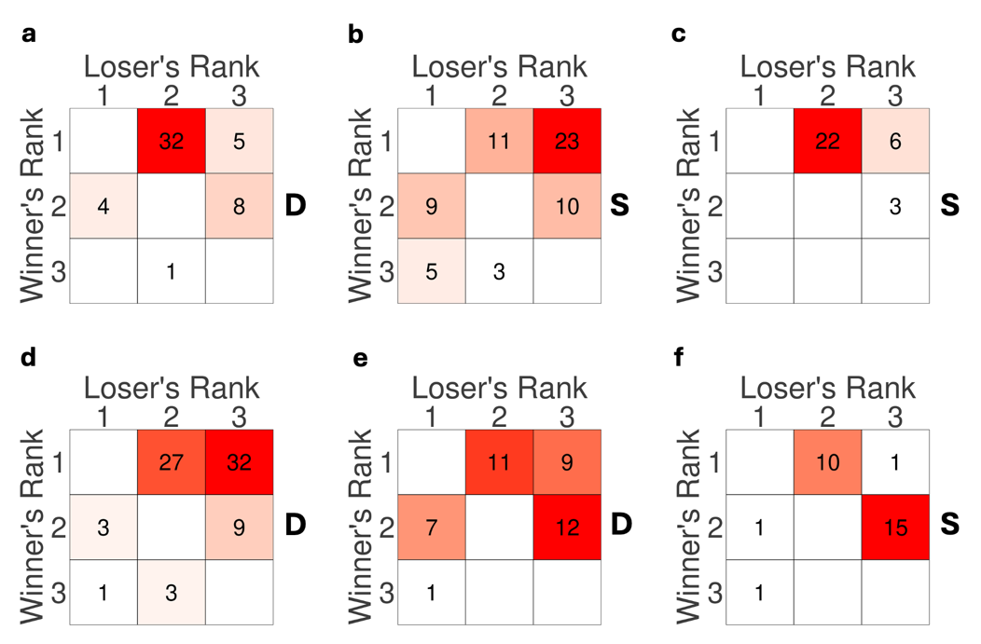
Figure S1. Agonistic Behavior Observations. Sociomatrices show the total frequency of agonistic interactions that occurred between all pairs of individuals across all cohorts (a-f) over the entire observation period. Winners of each contest are listed in rows, and losers are listed in columns. Ranks were calculated using the DS method (see methods). nuclei of each matrix are colored on a gradient from white (lowest value in each matrix) to red (highest value in each matrix). The stimulus presented to each mid-ranked subject is denoted by “D” or “S” for dominant and subordinate urine, respectively.

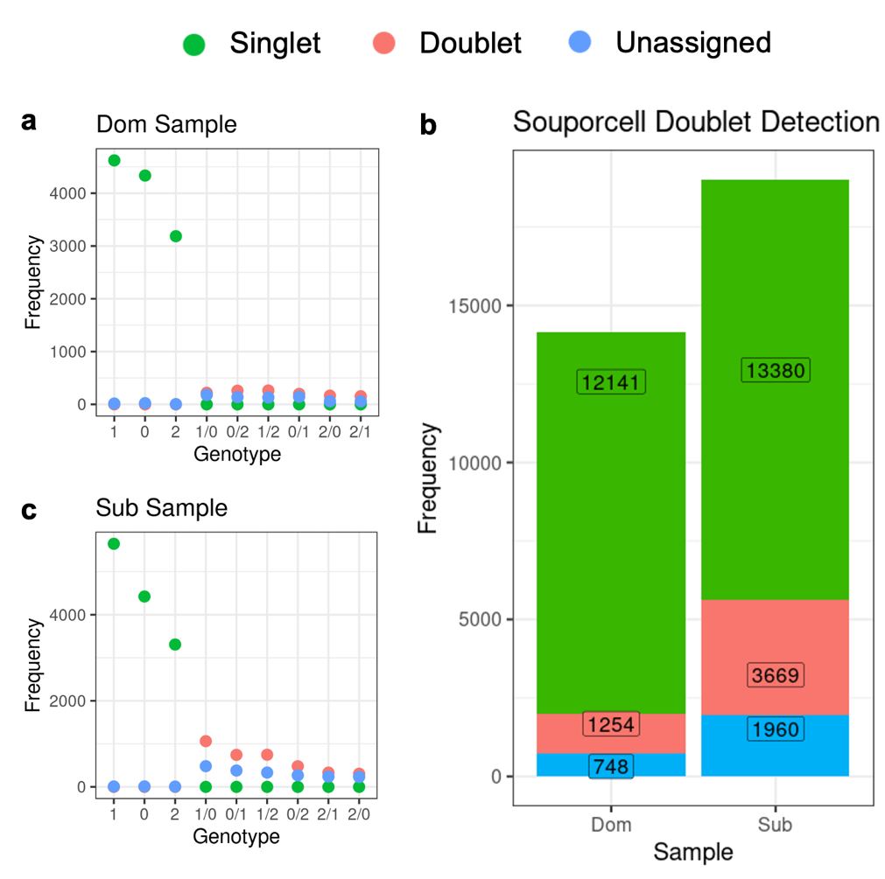
Figure S2. Breakdown of Individual Genotypes per Sample Pool. Results of Souporcell sample demultiplexing. Single nuclei are represented in green. Suspected doublets are in red and nuclei for which the method could not confirm singlet or doublet status are in blue.
HIDDEN TEXT: NOTE: If you have more than one appendix you can use the Heading 2,h2 style and label each appendix separately, e.g., Appendix A, Appendix B, etc. You could also title this section “Appendices” using the Heading 2, h2 style, and use Heading 3,h3 for each separate appendix

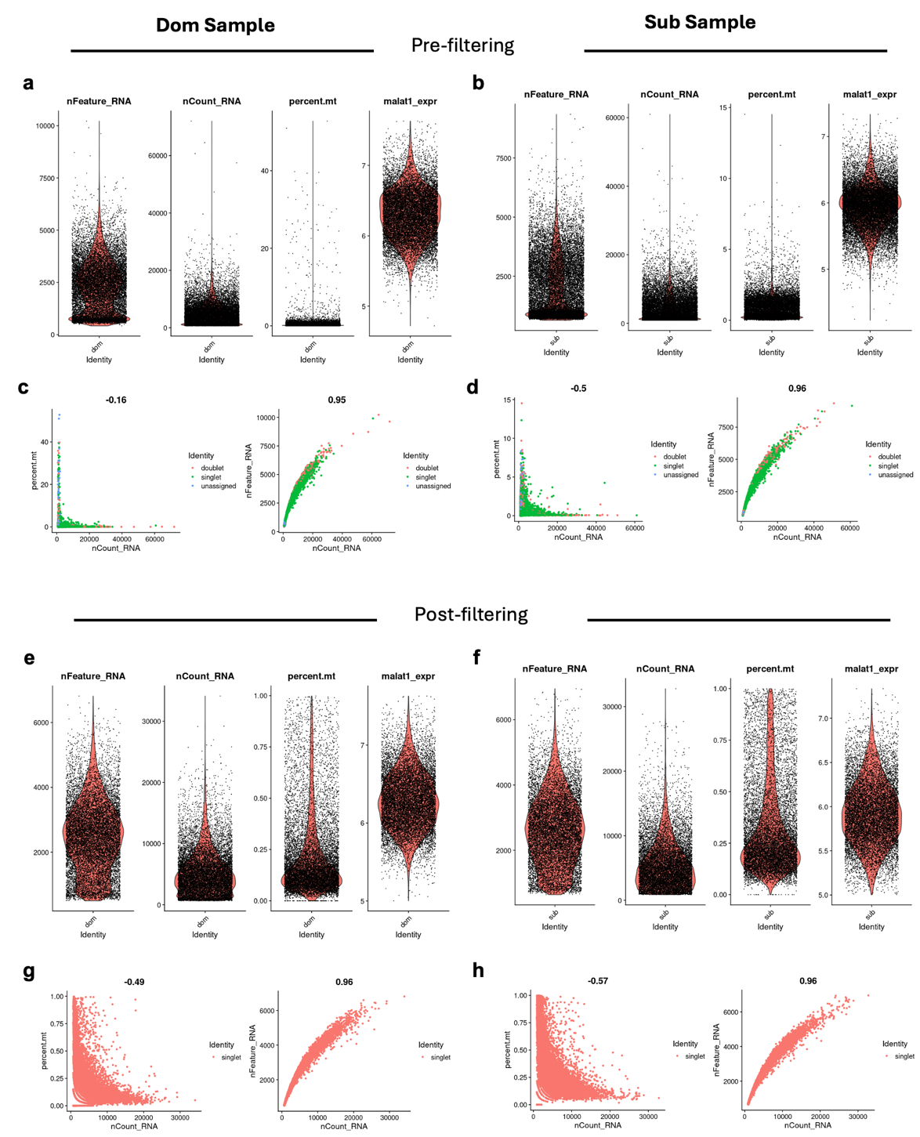
Figure S3. Quality Control Metrics for snRNA-Seq Data Using Seurat. Plots display various quality metrics evaluated for single-cell RNA sequencing data prior to cell filtering (a-d) and after cell filtering (E-H). The left column of plots (a,c,e,g) shows nuclei from the Dom sample, while the right column (b,d,f,h) shows nuclei from the Sub sample. a,b,e,f) Violin plots for quality metrics: nFeature_RNA refers to the number of unique genes detected per cell, aiding in identifying potential doublets; nCount_RNA refers to the total mRNA molecules counted per cell, where extremes may indicate either poor-quality samples or doublets; percent.mt indicates the percentage of mitochondrial RNA content per cell, with higher values typically signifying cell stress or apoptosis; malat1_expr is the expression level of the non-coding RNA MALAT1, useful for assessing cell state or technical variations. Each plot includes a density overlay that highlights the distribution of data points, with individual nuclei represented as black dots. These plots are instrumental in setting thresholds for subsequent data filtering to ensure the inclusion of viable and representative single nuclei in the analysis. c,d,g,h) The left scatter plot shows the relationship between mitochondrial RNA content and total mRNA counts nuclei with low total RNA counts and higher mitochondrial content may be poor quality. The right scatter plot shows the relationship between the number of detected genes and total mRNA counts. Unusually high mRNA counts and a higher number of detected genes may be indicative of doublets. Data points represent nuclei and are color coded by Souporcell assignment as a “singlet”, “doublet”, or “unassigned”. Only singlets were retained for further analysis.

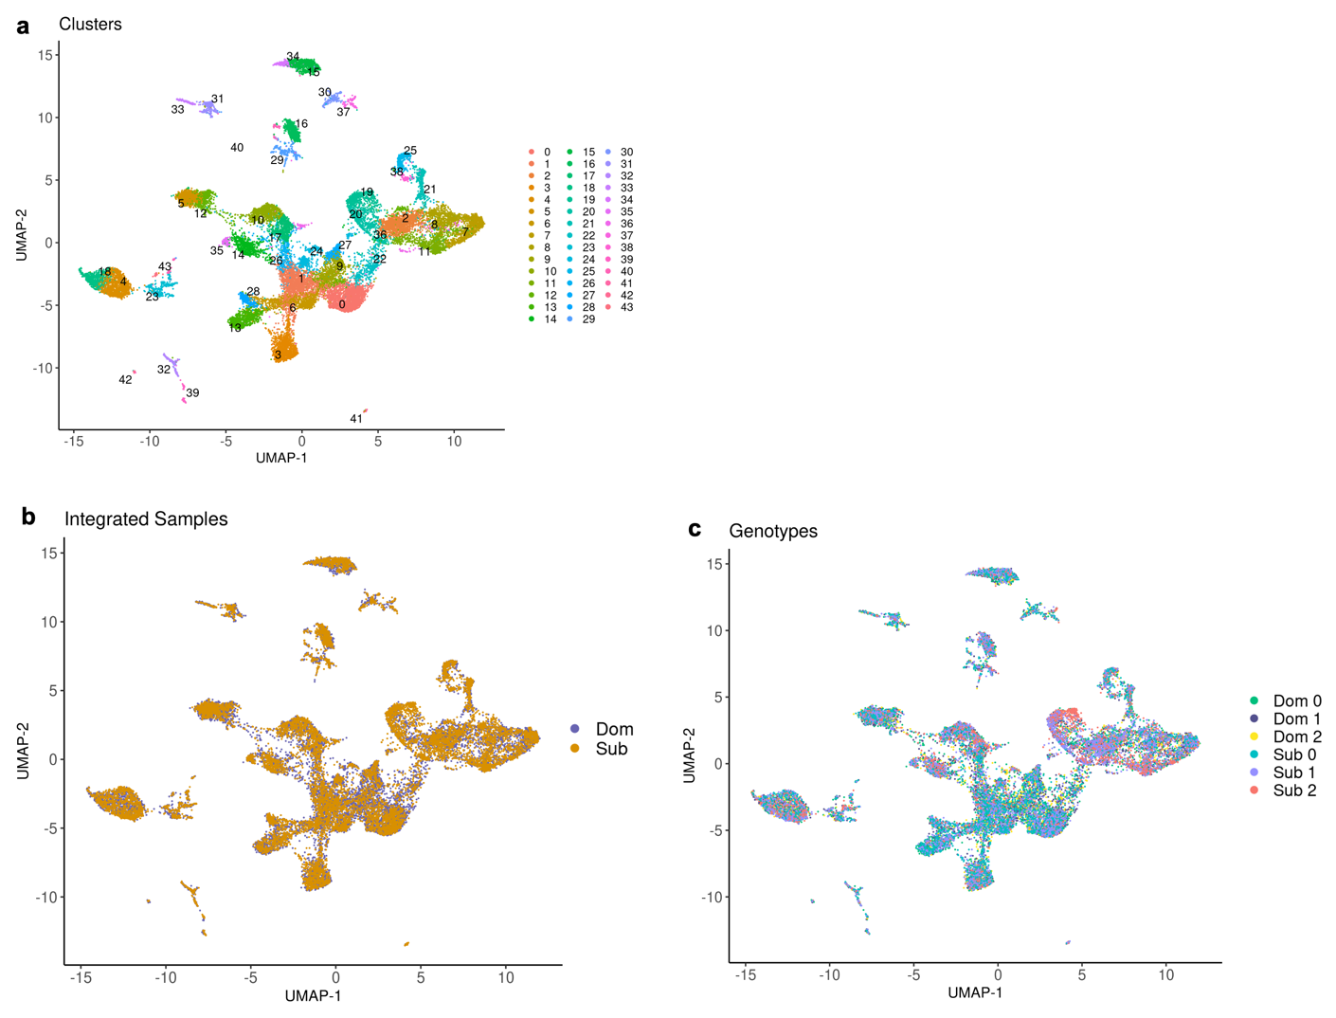

Figure S4. UMAP Visualization of Integrated snRNA-Seq Data from Dominant and Subordinate Samples. a) Uniform Manifold Approximation and Projection (UMAP) plot showing 22,695 nuclei from an integrated dataset combining samples from both dominant (Dom) and subordinate (Sub) groups. The integration process aligns the datasets to minimize batch effects, enabling a unified view of cellular heterogeneity. Each point represents a single cell and is colored by clusters, which consist of transcriptionally similar nuclei in the combined dataset. b) The same UMAP with nuclei color-coded by their sample of origin, visualizing the successful integration of the Dom and Sub datasets. c) The same UMAP with nuclei color-coded according to the individual mouse from which they originated, as determined by Souporcell. Each color represents a distinct genetic profile corresponding to a specific mouse.

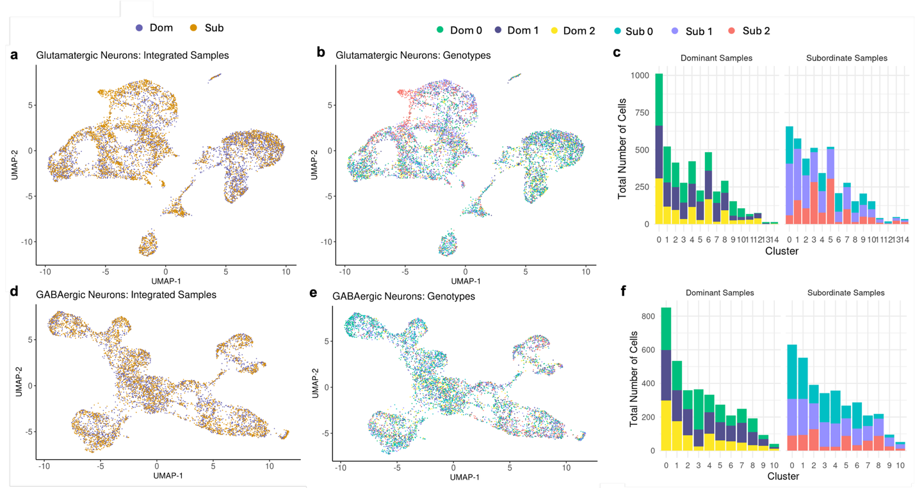
Figure S5. UMAPs and Cluster Distribution of Integrated Glutamatergic and GABAergic Neuron Datasets. a, d) UMAP visualizations of integrated samples for glutamatergic neurons (a) and GABAergic neurons (d), with nuclei colored by their sample origin. b, e) UMAP plots showing the genotypic categorization within the glutamatergic (b) and GABAergic (e) populations. Each color represents a putative individual mouse within dominant (Dom 0, Dom 1, Dom 2) and subordinate (Sub 0, Sub 1,Sub 2) sample pools. c,f) Bar graphs displaying the distribution of nuclei assigned to each genotype across identified clusters within Dom and Sub sample pools for glutamatergic (c) and GABAergic (f) neurons.

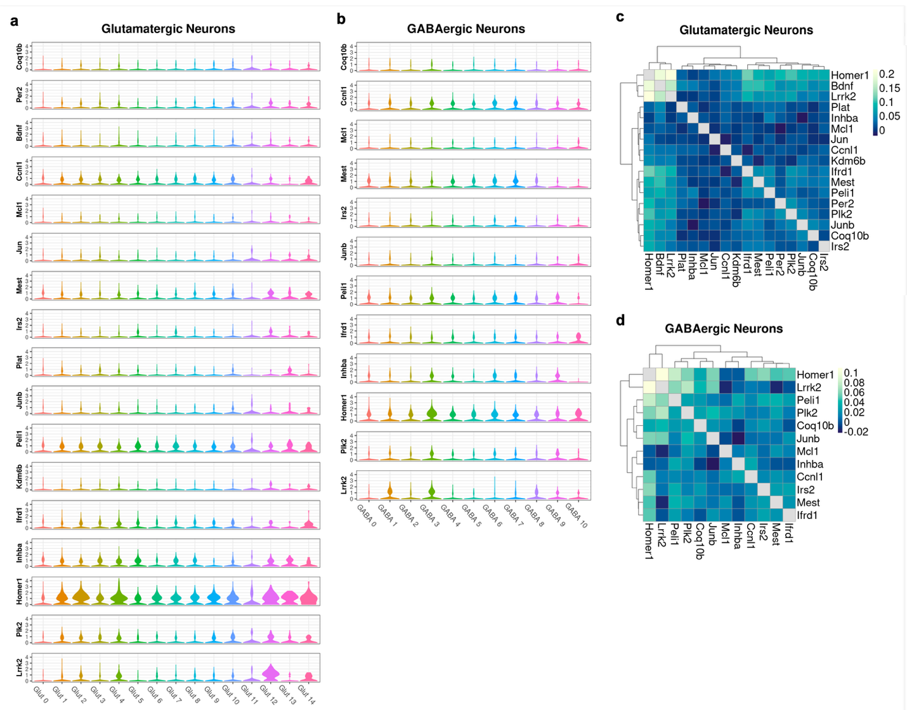
Figure S6. Expression and Correlation Analysis of Immediate Early Genes (IEGs) in Glutamatergic and GABAergic Neurons. a, b) Violin plots showing the log-normalized expression levels of IEGs across glutamatergic (a) and GABAergic (b) neuron clusters. Each plot shows the distribution of expression for a specific gene across different clusters. C, d) Heatmaps depicting the correlation matrices of IEG expression within glutamatergic (c) and GABAergic (d) neurons. Each matrix presents the pairwise Pearson correlation coefficients between the expression levels of IEGs. The color scale, from dark blue to light blue, indicates the strength of the correlation, with lighter shades representing stronger positive correlations.

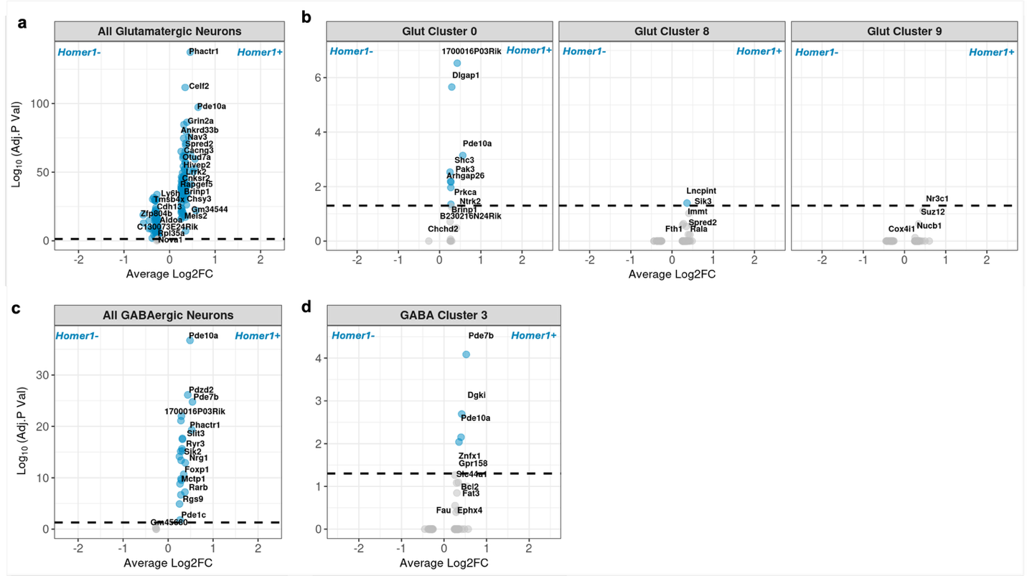
Figure S7. Differentially Expressed Genes between Homer1⁺ and Homer1⁻ Nuclei. Volcano plots display the effect size and significance of differentially expressed genes (DEGs) between neurons that express Homer1 (Homer1⁺) and those that do not (Homer1⁻) among all glutamatergic neurons (a), all GABAergic neurons (c) and clusters that exhibited significant differential proportions of Homer1⁺ neurons between Dom and Sub stimuli. Data points in blue indicate DEGs with Bonferroni-adjusted P-values of 0.05 or higher. Genes with positive Log2 fold changes (Log2Fc) show higher expression in Homer1⁺ nuclei compared to Homer1⁻ nuclei. The gene Homer1 is excluded from these plots because it was used to define the differential expression groups, leading to an infinite value for Log(adjusted P-value).

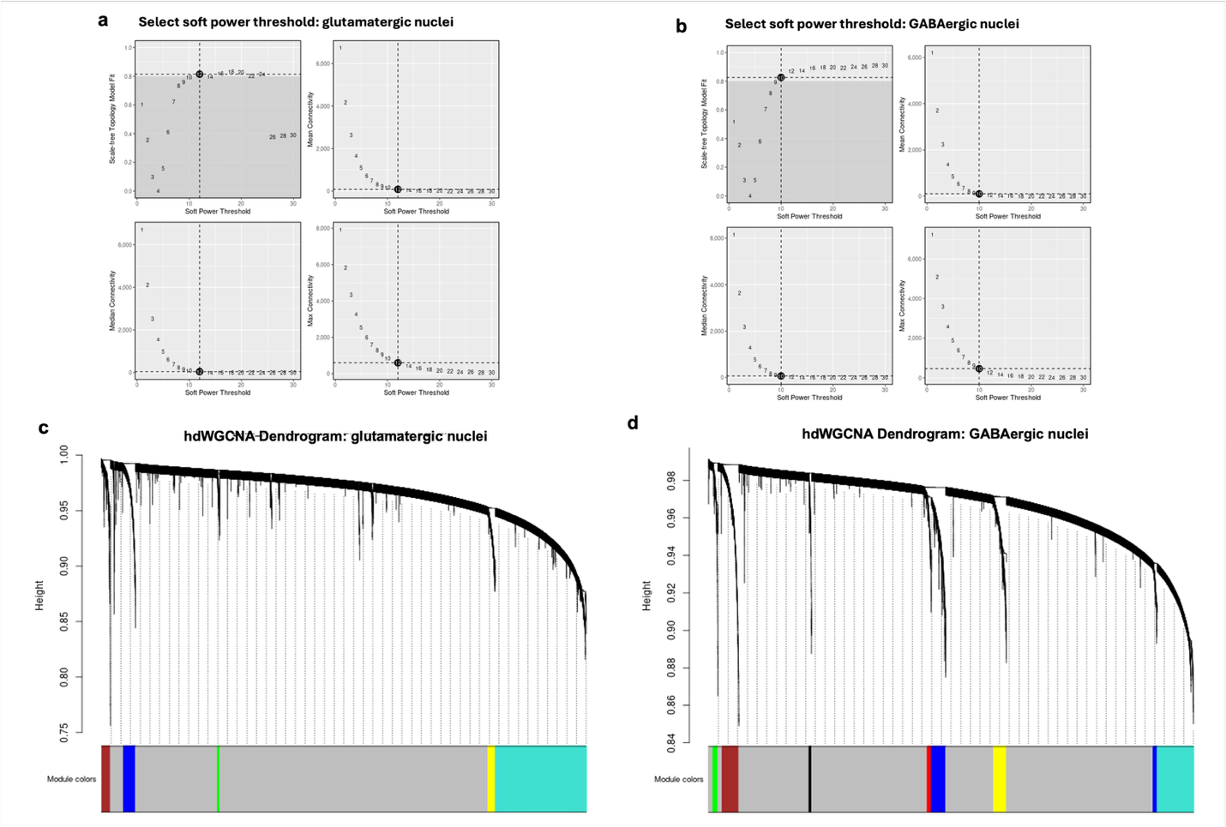

Figure S8. Supplemental hdWGCNA Plots. a,b) Selection of soft power threshold in hdWGCNA for glutamatergic (a) and GABAergic neurons (b). These plots demonstrate the process of selecting a soft power threshold for network construction in hdWGCNA and were used to determine the scale-free fit index and mean connectivity as functions of the soft power threshold (x-axis). Top Left: Scale-free fit index vs. soft power threshold. The dashed line indicates the target fit index of 0.9. Top Right: Mean connectivity vs. soft power threshold, showing a decrease as the power increases. Bottom Left: A detailed view focusing on lower soft power thresholds and their corresponding scale-free fit indices. Bottom Right: Detailed view of mean connectivity against lower soft power thresholds. The chosen power threshold optimizes network topology for subsequent gene co-expression analysis, balancing between adequate connectivity and a high scale-free fit index. c, d) The dendrogram illustrates the hierarchical clustering of genes based on their topological overlap, used to assess shared connectivity in the hdWGCNA package. Each endpoint of the dendrogram corresponds to a single gene, and the height at which branches merge reflects the dissimilarity between gene expression profiles. The y-axis shows the height (dissimilarity) scale, which quantifies the distance between gene pairs. Lower heights indicate greater similarity. The color band at the bottom denotes the module assignment for each gene. Each color represents a different module, indicating a group of highly interconnected genes. The gray color denotes genes that have not been assigned to any module, often due to insufficient correlation or unique expression patterns that do not align well with other clusters.

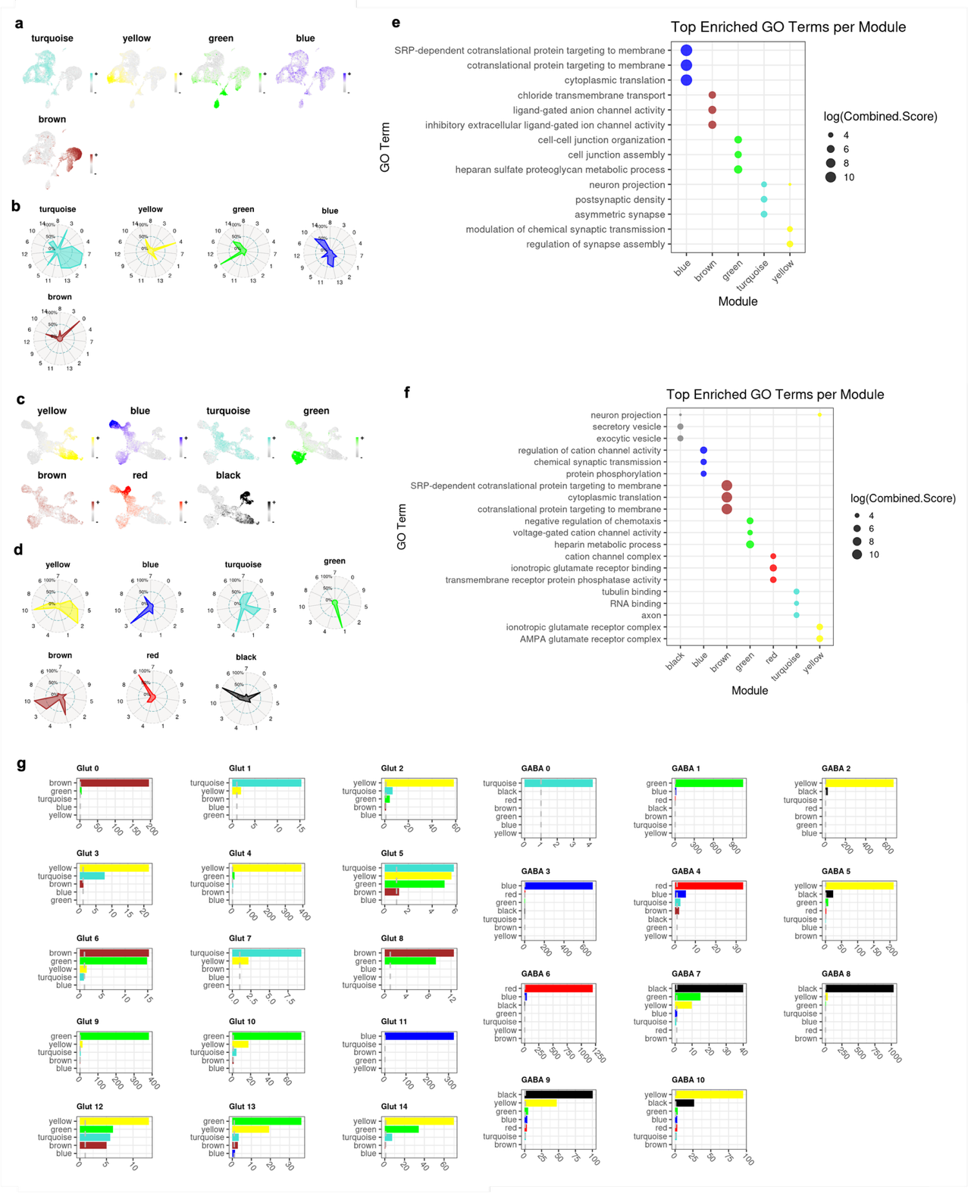

Figure S9. hdWGCNA of Glutamatergic and GABAergic Clusters. a,c) Feature plots showing the expression of module eigengenes (MEs) across UMAP projections of glutamatergic (a) and GABAergic (c) nuclei. The color intensity in each plot corresponds to the expression level of the ME in individual nuclei. B,d) Radar plots depicting the relative expression levels of Mes across the glutamatergic (b) and GABAergic (d) clusters. The radial distance from the center indicates the relative expression level of a given ME within that cluster, with values closer to the outer edge indicating higher expression levels. The center of the circle represents 0% of the maximum expression of the ME, while the outer edge represents 100%. e,f) Dot plots show significant GO terms for each module with the three lowest P values. Dot color corresponds to the module, while size corresponds to the log of the Combined Score for each term. The Combined Score is equal to the log of the P value multiplied by the z-score of enrichment for a given term. g) Bar plots show the number of genes shared between modules and cluster markers. A dashed gray line marks the significance threshold, indicating the minimum level of gene overlap considered statistically significant.

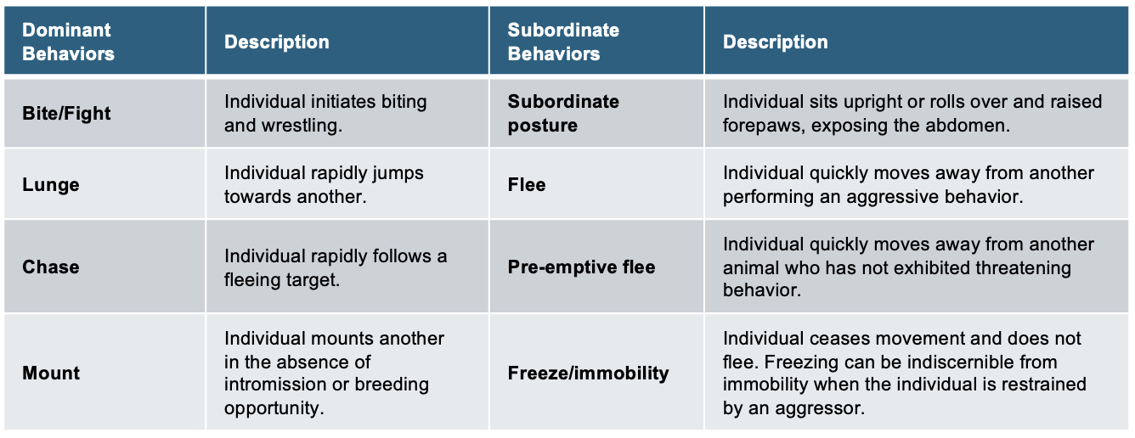
Table S1. Mouse Social Behavior Ethogram. Observers documented instances of agonistic interactions by recording pairs of offensive and defensive behaviors (e.g., "Bite/Flight - Flee"). In cases of a "pre-emptive flee," where the aggressive animal displayed no observable behavior, "NA" was recorded.

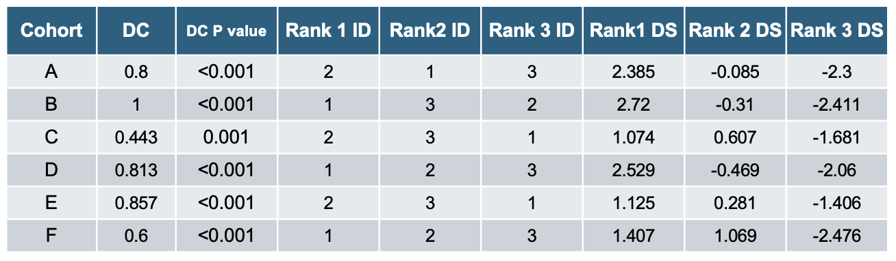
Table S2. Dominance Results. Directional Consistency (DC) of dominance interactions and David’s Scores (DS) were calculated. In brief, DC assesses the degree to which all agonistic interactions in a group occur in the direction of the more dominant individual to the more subordinate individual within each relationship. It is equal to (H- L)/(H+L) where H is the frequency of behaviors occurring in the most frequent direction and L is the frequency of behaviors occurring in the least frequent direction within each relationship. The significance of DC values were evaluated using the randomization test (Leiva, Solanas, and Salafranca 2008). DS provides an individual dominance rating and ranking for each individual in a group, determining the overall success of each individual at winning contests relative to the success of all other individuals. The most dominant and subordinate individuals in each hierarchy had the highest and lowest DS, respectively.

The following large supplemental tables are saved in Supplemental_Data.xlsx

Table S3. Cell Type Markers. Significantly higher expressed genes in each main cell type. Genes were considered significant based on a log fold change (logFc) ≥ 1 and p-value ≤ 0.05.

Table S4. Glutamatergic Neuron Cluster Markers. Significantly higher expressed genes (cluster markers) for each glutamatergic neuron cluster compared to neurons in other glutamatergic clusters. Identified based on logFC ≥ 1 and p-value ≤ 0.05.

Table S5. GABAergic Neuron Cluster Markers. Significantly higher expressed genes (cluster markers) for each GABAergic neuron cluster compared to neurons in other GABAergic clusters. Identified based on logFC ≥ 1 and p-value ≤ 0.05.

Table S6. Expression Summary for Neurotransmitter and Receptor Genes of Interest Across Neuronal Clusters. Summary of the expression of genes encoding social neuropeptides, neuromodulators, and their receptors across neuronal clusters. Mean nuclear expression levels and standard deviations are provided for each gene of interest.

Table S7. Subclass Assignment for Neuronal Clusters. Subclasses were assigned to cells within each neuronal cluster using the Map My Cells tool from the Allen Institute. Columns include the cell count (number of cells assigned to each subclass), the fraction of cells assigned to the subclass within the respective neuronal type (glutamatergic or GABAergic), and the fraction of cells within each subclass relative to all cells in the corresponding neuronal cluster.

Table S8. Binomial GLMM Results. Results of binomial generalized linear mixed models (GLMMs) comparing the proportions of Homer1⁺ nuclei in response to dominant (Dom) and subordinate (Sub) stimuli across neuronal clusters.

Table S9. DEGs Between Homer1⁺ and Homer1⁻ Neurons.
Significantly differentially expressed genes (DEGs) between Homer1⁺ and Homer1⁻ neurons. Genes with positive log2 fold-change are elevated in Homer1⁺ neurons, while genes with negative log2 fold-change are elevated in Homer1⁻ neurons.

Table S10. GO Enrichment Results for DEGs Between Homer1⁺ and Homer1⁻ Neurons.
Gene Ontology (GO) enrichment analysis results for DEGs between Homer1⁺ and Homer1⁻ neurons.

Table S11. Glutamatergic Neuron Module Gene Assignments. Module assignments for genes in glutamatergic neurons based on high dimensional weighted gene co-expression network analysis (hdWGCNa). The module membership scores (kMe) are shown for each module (turquoise, yellow, green, blue, and brown). The gray module represents genes that were not assigned to any specific co-expression module and are considered unclustered.

Table S12. GABAergic Neuron Module Gene Assignments. Module assignments for genes in GABAergic neurons based on high dimensional weighted gene co-expression network analysis (hdWGCNa). The module membership scores (kMe) are shown for each module (turquoise, yellow, green, blue, and brown). The gray module represents genes that were not assigned to any specific co-expression module and are considered unclustered.

Table S13. GO Enrichment Results for hdWGCNA modules. Gene Ontology (GO) enrichment analysis results for genes in hdWGCNA modules.

