Supporting Information

Chemo- and Regioselective Hydroformylation of Alkenes with CO₂/H₂ over a Bifunctional Catalyst

Kaimin Hua, Xiaofang Liu,* Baiyin Wei, Zilong Shao, Yuchao Deng, Jianming Zhang, Lin Xia, Liangshu Zhong, Hui Wang,* Yuhan Sun*

Table of Contents

1 Material and Methods 3
2 Typical procedure for hydroformylation of alkenes with CO₂/H₂ 5
3 Gas chromatographic Data 18
4 NMR, ESI-MS and Mass Spectra 147

1 Material and Methods
General. All reactions and operations involving air- or moisture-sensitive compounds were performed in Ar-filled glove box. Unless otherwise noted, all commercially available reagents were used without further purification. Among these, extra-dry solvents with water≤50 ppm (by K.F.) were bought from Energy Chemical. And all reactions were carried out in a Teflon-lined stainless steel reactor of 50 mL capacity equipped with a magnetic stirrer.

Instrumentation. GC analysis was performed on Shimadzu-2014 with a FID detector and a Stabilwax®-DA column (60 m, 0.53 mm, 0.5 μm). The gaseous mixture was collected and analyzed by gas chromatography equipped with thermal conductivity detector (Shimadzu GC-2014C) with Argon as the carrier gas. ESI-MS analysis was performed on WATERS 2695+ZQ2000. Detected masses are given in m/z and correlated to calculated masses of the respective species. High resolution MS (omni star gas analysis system) analyses were performed to detect ¹³CO after ¹³CO₂ Isotope experiment. Detected masses are given in m/z and correlated to calculated masses of the respective species. ¹H- and ¹³C- NMR spectra were recorded on Bruker Avance III 400 MHz spectrometers. Chemical shifts (δ values) were reported in ppm relative to internal TMS.

Calculation of the CO amount in the gaseous product. We quantified the gas from the reactor by the internal standard method (nitrogen as the internal standard). The relative correction factor (f) and correlation coefficients of each component are shown in the following table:
component | H₂ | CO | CH₄ | CO₂
Correction factor(f) | 0.111738704 | 1.099931423 | 0.37969925 | 1.223846589
Correl | 0.999999858 | 0.99933951 | 0.999991074 | 0.999999152

GC analysis of the gas sample clearly indicates the presence of CO, residual H₂ and CO₂ in the gas phase of the reaction system (Figure S1).
Figure S1 GC spectra of the gas phase after the reaction
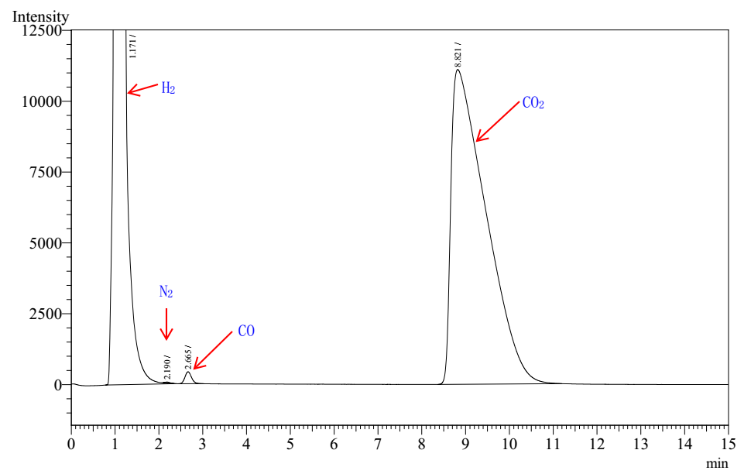

2 Typical procedure for hydroformylation of alkenes with CO₂/H₂
General procedure: All reactions were carried out in a Teflon-lined stainless steel reactor of 50 mL capacity equipped with a magnetic stirrer. Typically, in a glovebox, 1-decene (1.0 mmol), Rh(acac)(CO)₂ (0.02 mmol), ligand (0.12 mmol), Ac₂O (2.0 mmol) and NMP (4 mL) were loaded into the reactor. The autoclave was sealed and purged three times with CO₂ gas, subsequently charged with CO₂ (20 bar), then H₂ (5 bar) to total pressure of 5 bar. The autoclave was then heated at 80 °C for 12 h. After the reaction, the autoclave was cooled in ice water and then the gas was carefully vented into the airbag. The resulting clear solution was diluted with N-methyl-2-pyrrolidinone (10 mL) and added benzyl alcohol (0.5 mmol) or isooctane (0.3 mmol) as internal standard. The sample was filtered through a short cotton plug, and the filtrate was firstly analyzed by GC-MS to determine the structures of the aldehyde products, then immediately analyzed by GC to determine the conversion of alkenes, yields of the aldehydes, and the regioselectivity (n/iso ratio) as well as percentage of isomerization and hydrogenation products. Yields were found to be reproducible within Y = ±5% in three independent runs for selected experiments.

Table S1. The effect of monodentate phosphine ligands^{[a]}

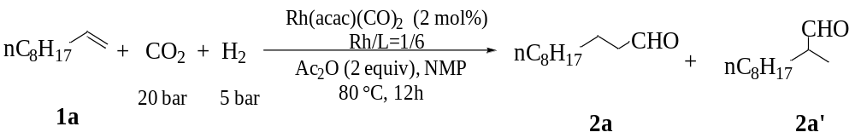
Ligand | 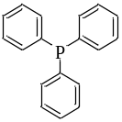 | 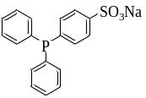 | 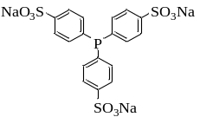 | 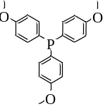 | 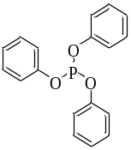
 | L1 | L2 | L3 | L4 | L5
Y/l/b^{[b]} | 15%/3.3 | 16%/2.8 | 14%/9.0 | 26%/3.1 | 0/-
Ligand | 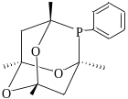 | 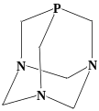 | 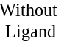
 | L6 (CgPPh) | L7 | -
Y/l/b^{[b]} | 18%/3.2 | 90%/8.1 | 3%/5.7
[a] Reaction conditions: 1-decene (1 mmol), Rh(acac)(CO)₂ (0.02 mmol), ligand (0.12 mmol), Ac₂O (2.0 mmol), H₂/CO₂ = 5/20 bar, 80 °C, 12 h, NMP (4 mL). [b] Determined by GC with benzyl alcohol or isooctane as the internal standard. GC at page 18-25.

Table S2 The effect of bidentate phosphine ligands^{[a]}

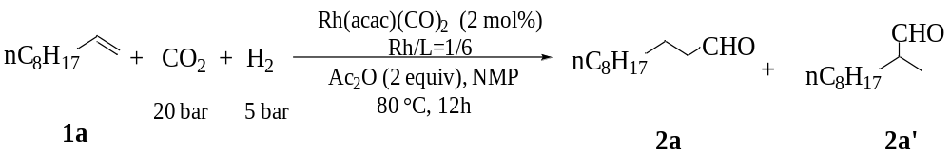
Ligand | 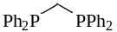 | 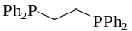 | 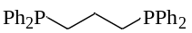 | 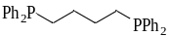 | 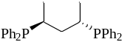
 | L1 | L2 | L3 | L4 | L5
Y/l/b^{[b]} | 6%/2.0 | 0/- | 57%/1.1 | 87%/4.0 | 11%/3.0
Ligand | 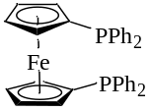 | 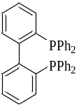 | 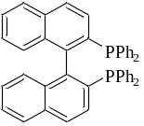 | 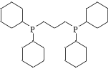 | 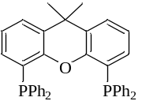
 | L6 | L7 | L8 | L9 | L10
Y/l/b^{[b]} | 6%/13.0 | 20%/12.0 | 15%/6.0 | 15%/4.7 | 5%/1.2
Ligand | 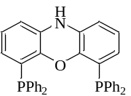 | 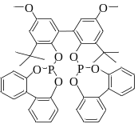
 | L11 | L12
Y/l/b^{[b]} | 6%/1.4 | 0/-
[a] Reaction conditions: 1-decene (1 mmol), Rh(acac)(CO)₂ (0.02 mmol), ligand (0.12 mmol), Ac₂O (2.0 mmol), H₂/CO₂ = 5/20 bar, 80 °C, 12 h, NMP (4 mL). [b] Determined by GC with benzyl alcohol or isooctane as the internal standard. GC at page 26-37.

Table S3 The effect of Rh precursor^{[a]}

Entry | Rh source | PTA/Rh | 2a+2a’^{[b]}/% | l/b^{[b]} | 1a+Iso^{[b]}/% | H^{[b]}/% | GC at page
1 | (PPh₃)₃(CO)Rh-H | - | 17 | 65/35 | 47 | 36 | 38
2 | Rh(OAc)₃ | 6 | 80 | 90/10 | 11 | 9 | 39
3 | RhCl(CO)₂ | 6 | 17 | 93/7 | 77 | 6 | 40
4 | Rh(NO₃)₃ | 6 | 0 | - | 98 | 2 | 41
5 | Rh(acac)(CO)₂ | 6 | 90 | 89/11 | 7 | 3 | 42
[a] Reaction conditions: 1-decene (1 mmol), Rh precursor (0.02 mmol), PTA (0 or 0.12 mmol), Ac₂O (2.0 mmol), H₂/CO₂ = 5/20 bar, 80 °C, 12 h, NMP (4 mL). [b] Determined by GC with benzyl alcohol or isooctane as the internal standard.

Table S4 The effect of PTA/Rh^{[a]}

Entry | PTA/Rh | 2a+2a’^{[b]}/% | l/b^{[b]} | 1a+Iso^{[b]}/% | H^{[b]}/% | GC at page
1 | 0 | 3 | 85/15 | 83 | 14 | 43
2 | 3 | 25 | 68/32 | 22 | 42 | 44
3 | 6 | 90 | 89/11 | 7 | 3 | 45
4 | 9 | 68 | 90/10 | 28 | 5 | 46
[a] Reaction conditions: 1-decene (1 mmol), Rh(acac)(CO)₂ (0.02 mmol), PTA (0 - 0.18 mmol), Ac₂O (2.0 mmol), H₂/CO₂ = 5/20 bar, 80 °C, 12 h, NMP (4 mL). [b] Determined by GC with benzyl alcohol or isooctane as the internal standard.

Table S5 The effect of the solvent^{[a]}

Entry | Solvent | 2a+2a’^{[b]}/% | l/b^{[b]} | 1a+Iso^{[b]}/% | H^{[b]}/% | GC at page
1 | NMP | 90 | 89/11 | 7 | 3 | 47
2 | DMI | 83 | 91/9 | 8 | 9 | 48
3 | DMSO | 73 | 89/11 | 26 | 1 | 49
4 | DMF | 68 | 86/14 | 26 | 6 | 50
5 | THF | 34 | 97/3 | 14 | 52 | 51
6 | toluene | 27 | 95/5 | 59 | 14 | 52
7 | CH₃CN | 26 | 90/10 | 49 | 25 | 53
8 | 1,4-Dioxane | 16 | 92/8 | 17 | 68 | 54
[a] Reaction conditions: 1-decene (1 mmol), Rh(acac)(CO)₂ (0.02 mmol), PTA (0.12 mmol), Ac₂O (2.0 mmol), H₂/CO₂ = 5/20 bar, 80 °C, 12 h, solvent (4 mL). [b] Determined by GC with benzyl alcohol or isooctane as the internal standard.

Table S6 The effect of the temperature^{[a]}

Entry | T/ºC | 2a+2a’^{[b]}/% | l/b^{[b]} | 1a+Iso^{[b]}/% | H^{[b]}/% | GC at page
1 | 60 | 65 | 93/7 | 19 | 16 | 55
2 | 70 | 84 | 87/13 | 9 | 7 | 56
3 | 80 | 90 | 89/11 | 7 | 3 | 57
4 | 90 | 85 | 89/11 | 10 | 5 | 58
5 | 100 | 75 | 90/10 | 11 | 14 | 59
6 | 120 | 78 | 84/16 | 12 | 10 | 60
[a] Reaction conditions: 1-decene (1 mmol), Rh(acac)(CO)₂ (0.02 mmol), PTA (0.12 mmol), Ac₂O (2.0 mmol), H₂/CO₂ = 5/20 bar, 12 h, NMP (4 mL). [b] Determined by GC with benzyl alcohol or isooctane as the internal standard.

Table S7 The effect of the P_{CO2}/P_{H2}^{[a]}.

Entry | P_{CO2}/P_{H2}  bar/bar | 2a+2a’^{[b]}/% | l/b^{[b]} | 1a+Iso^{[b]}/% | H^{[b]}/% | GC at page
1 | 40/10 | 88 | 87/13 | 7 | 5 | 61
2 | 20/5 | 90 | 89/11 | 7 | 3 | 62
3 | 22/3 | 83 | 92/8 | 11 | 6 | 63
4 | 10/3 | 87 | 91/9 | 9 | 4 | 64
5 | 7/3 | 74 | 94/6 | 13 | 13 | 65
6 | 12/12 | 42 | 87/13 | 19 | 39 | 66
[a] Reaction conditions: 1-decene (1 mmol), Rh(acac)(CO)₂ (0.02 mmol), PTA (0.12 mmol), Ac₂O (2.0 mmol), H₂/CO₂, 80 °C, 12 h, NMP (4 mL). [b] Determined by GC with benzyl alcohol or isooctane as the internal standard.

Table S8: Substrate scope.^{[a]}

Entry | Alkene | Conv./%^{[b]} | Yield ^{[b]}/% | l/b | Iso^{[b]}/% | H^{[b]}/% | GC at page
1 |  | 99 | 92 | 90/10 | 3 | 3 | 67
2 | 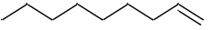 | 99 | 96 | 90/10 | 1 | 1 | 68
3 |  | 99 | 96 | 88/12 | 2 | 1 | 69
4 |  | 99 | 95 | 86/14 | 2 | 1 | 70
5 | 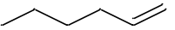 | 100 | 97 | 85/15 | 2 | <1 | 71
6 |  | 99 | 95 | 86/14 | 2 | 2 | 72
7^{[c]} |  | - | 77 | 93/7 | - | - | 73
8^{[c]} |  | - | 73 | 85/15 | - | - | 74
9^{[c]} |  | - | 72 | - | - | - | 75
10 | 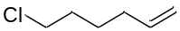 | 98 | 87 | 87/13 | 2 | 8 | 76
11 |  | 99 | 92 | 73/27 | 1 | 6 | 77
12 | 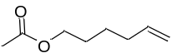 | 98 | 90 | 85/15 | 3 | 4 | 78
13^{[d]} | 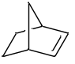 | 76 | 75 | - | 0 | 1 | 79
14^{[e]} | 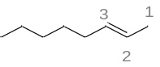 | 90 | 64 | 16/84 | 25 | 1 | 80
15 | 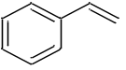 | 99 | 90 | 10/90 | 0 | 1 | 81
16 | 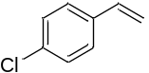 | 98 | 47 | 17/83 | 0 | 4 | 82
17 | 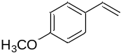 | 94 | 91 | 16/84 | 0 | <1 | 83
[a] Alkene (1 mmol), Rh(acac)(CO)₂ (0.022 mmol), PTA (0.132 mmol), Ac₂O (2.0 mmol), NMP (4 mL), H₂/CO₂=5/20 bar, 80 ºC, 12 h,. [b] Determined by GC analysis with benzyl alcohol or isooctane as the internal standard. [c] alkene (3 mmol), Ac₂O (4.5 mmol). [d] T = 90 ºC. [e] T=100 ºC, 24 h. 1-CHO: 2-CHO: 3-CHO=16:60:24.
Table S9 Control experiments with different ligands.^{[a]}

- PPh₃
Entry | t/h | 2a+2a’^{[b]}/% | l/b^{[b]} | CO/mmol | GC at page
1 | 0.5 | 8 | 82/18 | 0.10 | 84
2 | 1 | 10 | 90/10 | 0.12 | 86
3 | 2 | 13 | 76/24 | 0.08 | 88
4 | 6 | 13 | 80/20 | 0.08 | 90
5 | 12 | 15 | 74/26 | trace | 92

- Xantphos
Entry | t/h | 2a+2a’^{[b]}/% | l/b^{[b]} | CO/mmol | GC at page
1 | 0.5 | 0 | 0 | 0 | 94
2 | 1 | 3 | 60/40 | trace | 96
3 | 2 | 3 | 62/38 | 0.01 | 98
4 | 6 | 4 | 59/41 | 0.03 | 100
5 | 12 | 5 | 50/50 | 0.05 | 102

- dppb
Entry | t/h | 2a+2a’^{[b]}/% | l/b^{[b]} | CO/mmol | GC at page
1 | 0.5 | 58 | 79/21 | 0.25 | 104
2 | 1 | 61 | 82/18 | 0.39 | 106
3 | 2 | 73 | 80/20 | 0.66 | 108
4 | 6 | 87 | 80/20 | 0.61 | 110
5 | 12 | 92 | 78/22 | 0.51 | 112
[a] Reaction conditions: 1-decene (1 mmol), Rh(acac)(CO)₂ (0.02 mmol), ligand (0.12 mmol), Ac₂O (2.0 mmol), H₂/CO₂ = 5/20 bar, 80 °C, 12 h, NMP (4 mL). [b] Determined by GC with benzyl alcohol or isooctane as the internal standard. The data of PTA please see Table S12.
Table S10 Control experiments with different acids additives.^{[a]}

Entry | additive | 2a+2a’^{[b]}/% | l/b^{[b]} | 1a+Iso^{[b]}/% | H^{[b]}/% | GC at page
1 | - | 90 | 89/11 | 7 | 3 | 114
2 | PTSA | 0 | - | 97 | 1 | 115
3 | CH₃SO₃H | trace | - | 84 | 15 | 116
4^{[c]} | - | 92 | 78/22 | 7 | trace | 117
5^{[c,d]} | HCOOH | 94 | 77/23 | 5 | 1 | 118
6^{[c,e]} | HCOOH | 94 | 74/26 | 5 | trace | 119
7^{[c,e]} | Ac₂O | 98 | 80/20 | 1 | trace | 120
8^{[c,f]} | HCOOH+Ac₂O | 91 | 84/16 | 9 | trace | 121
[a] Reaction conditions: 1-decene (1 mmol), Rh(acac)(CO)₂ (0.02 mmol), ligand (0.12 mmol), additive (0.1 mmol), Ac₂O (2.0 mmol), H₂/CO₂ = 5/20 bar, 80 °C, 12 h, NMP (4 mL). [b] Determined by GC with benzyl alcohol or isooctane as the internal standard. [c] Reaction conditions: 1-decene (1 mmol), Rh(acac)(CO)₂ (0.02 mmol), ligand (0.12 mmol), H₂/CO = 5/5 bar, 80 °C, 12 h, NMP (4 mL). [d] additive (0.3 mmol). [e] additive (2.0 mmol). [f] HCOOH (0.3 mmol) and Ac₂O (2.0 mmol).

Table S11: Isotope-Labeling Experiments and Control Experiment

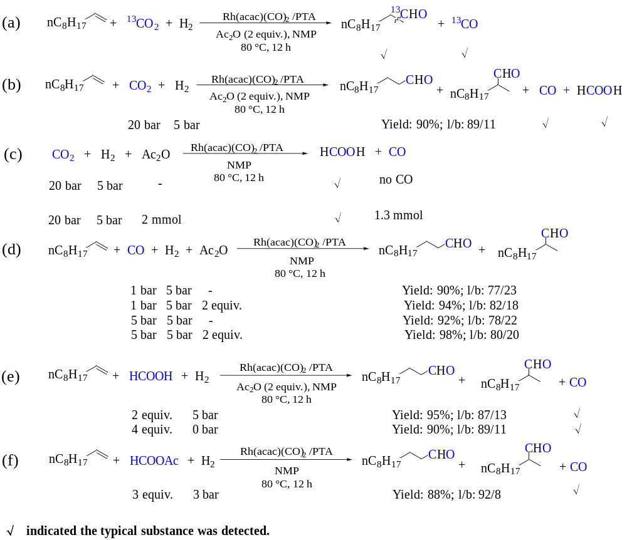
GC at page 122-130. NMR and Mass Spectra at page 147-153.

Table S12 Reaction profiles for the hydroformylation of 1a with CO₂/H₂ catalyzed by Rh/PTA^{[a]}.

Entry | t/h | 2a+2a’^{[b]}/% | l/b^{[b]} | 1a+Iso^{[b]}/% | H^{[b]}/% | CO/mmol | GC at page
1 | 1/6 | 14 | 96/4 | 83 | 3 | 0.46 | 131
2 | 0.5 | 20 | >96/4 | 75 | 5 | 0.91 | 133
3 | 1 | 57 | <96/4 | 35 | 7 | 0.71 | 135
4 | 2 | 73 | 93/7 | 20 | 7 | 0.40 | 137
5 | 4 | 82 | 91/9 | 12 | 6 | 0.39 | 139
6 | 6 | 85 | 89/11 | 8 | 7 | 0.37 | 141
7 | 8 | 85 | 89/11 | 9 | 6 | 0.44 | 143
8 | 12 | 89 | 89/11 | 8 | 4 | 0.41 | 145
[a] Reaction conditions: 1-decene (1 mmol), Rh(acac)(CO)₂ (0.02 mmol), PTA (0.12 mmol), Ac₂O (2.0 mmol), H₂/CO₂ = 5/20 bar, 80 °C, NMP (4 mL). [b] Determined by GC with benzyl alcohol or isooctane as the internal standard.

3 Gas chromatographic Data
In the following GC chromatograms, H represented the hydrogenation product of the corresponding alkene, and Iso represented the isomerization product of the alkene.

3.1 Gas chromatograms to Table S1
L1

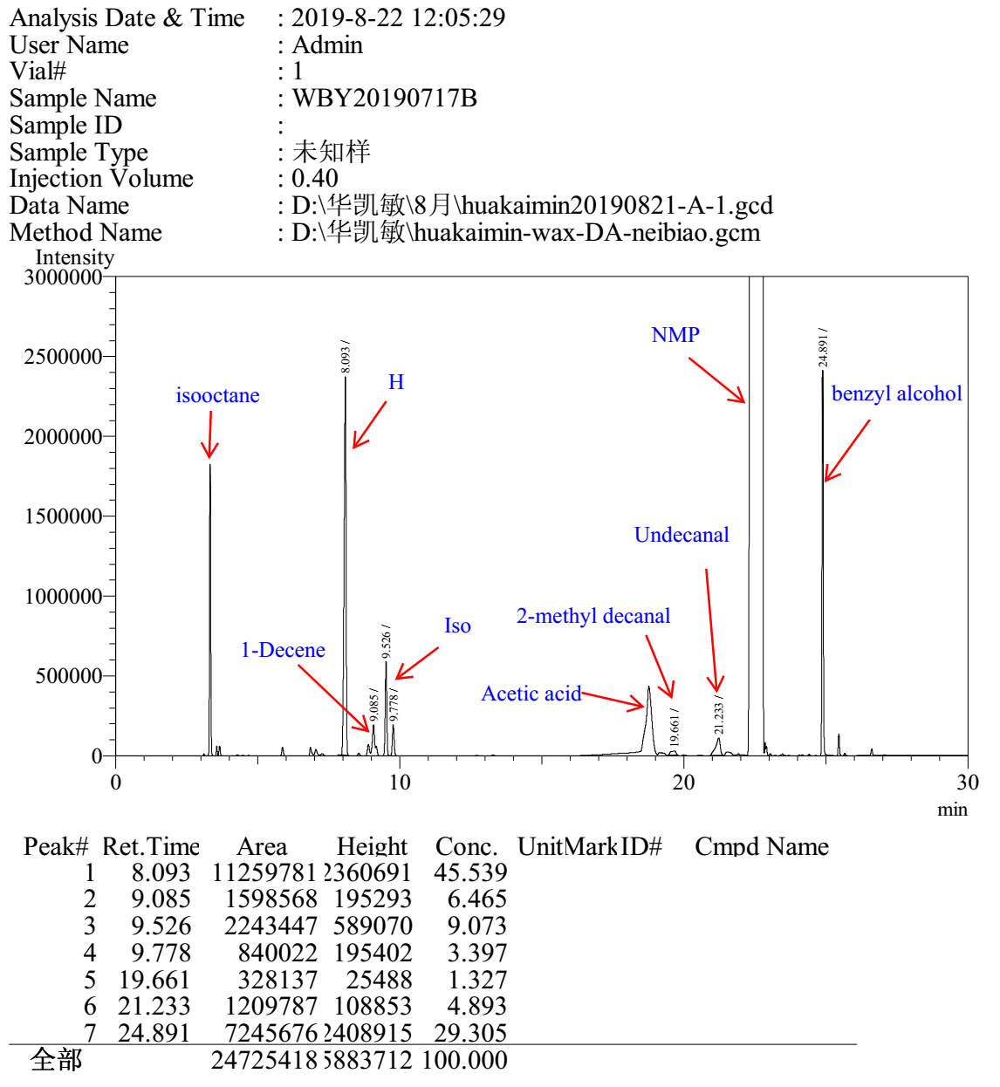

L2

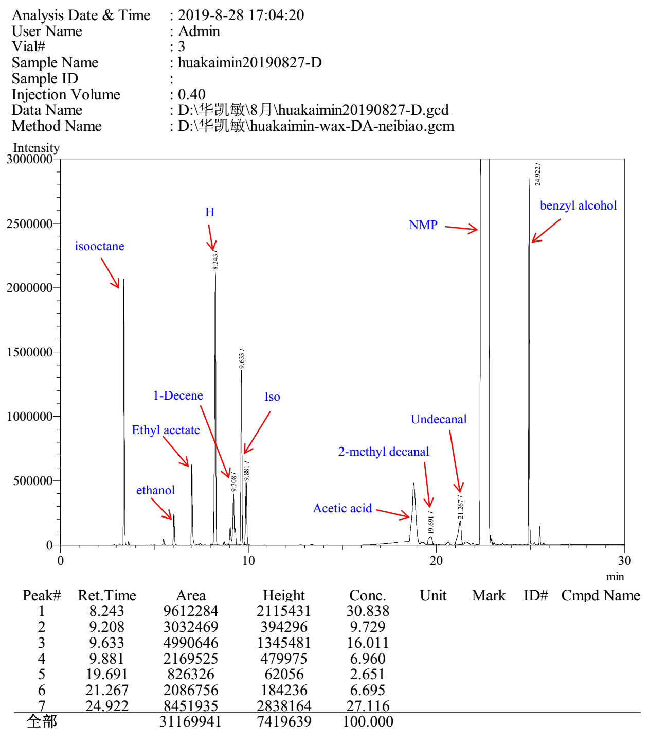

L3

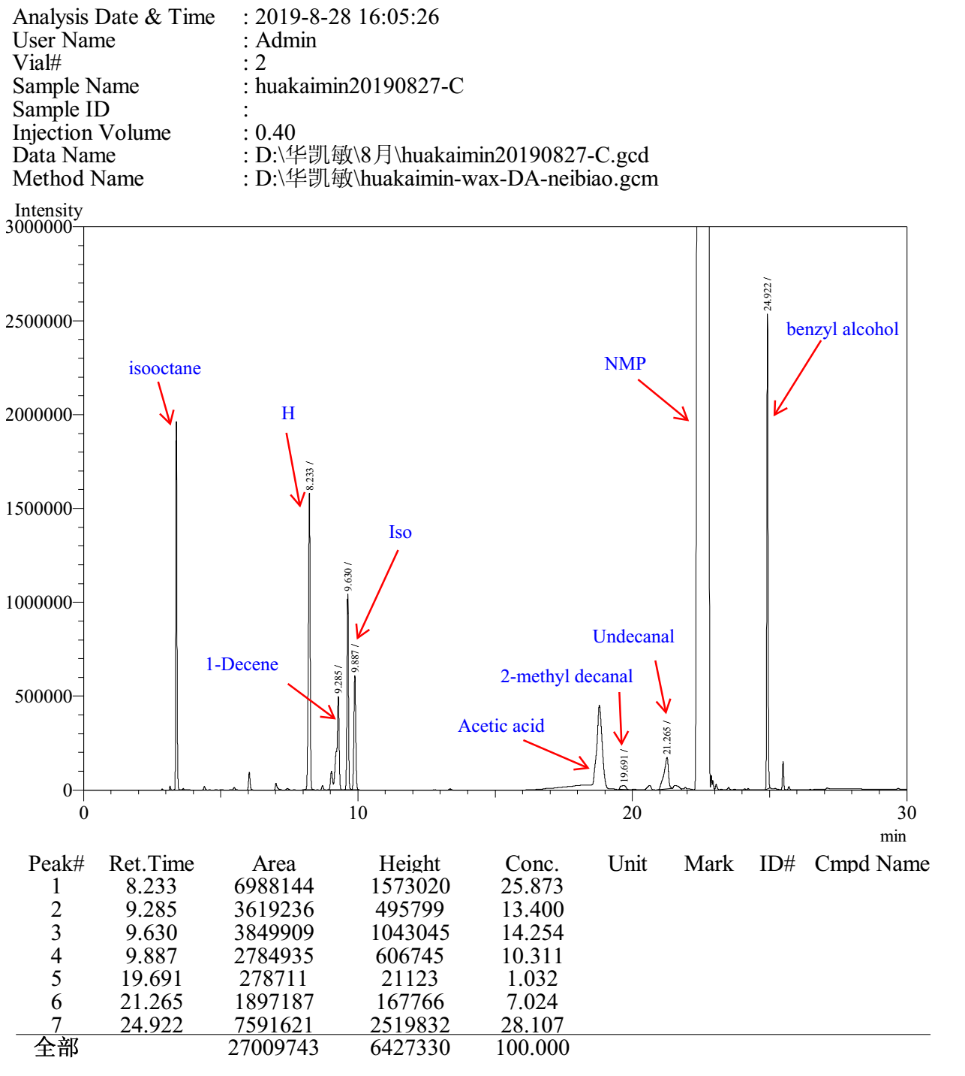

L4

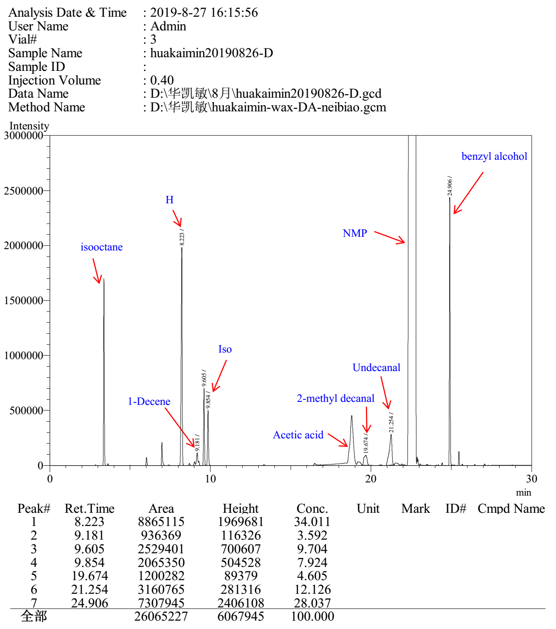

L5

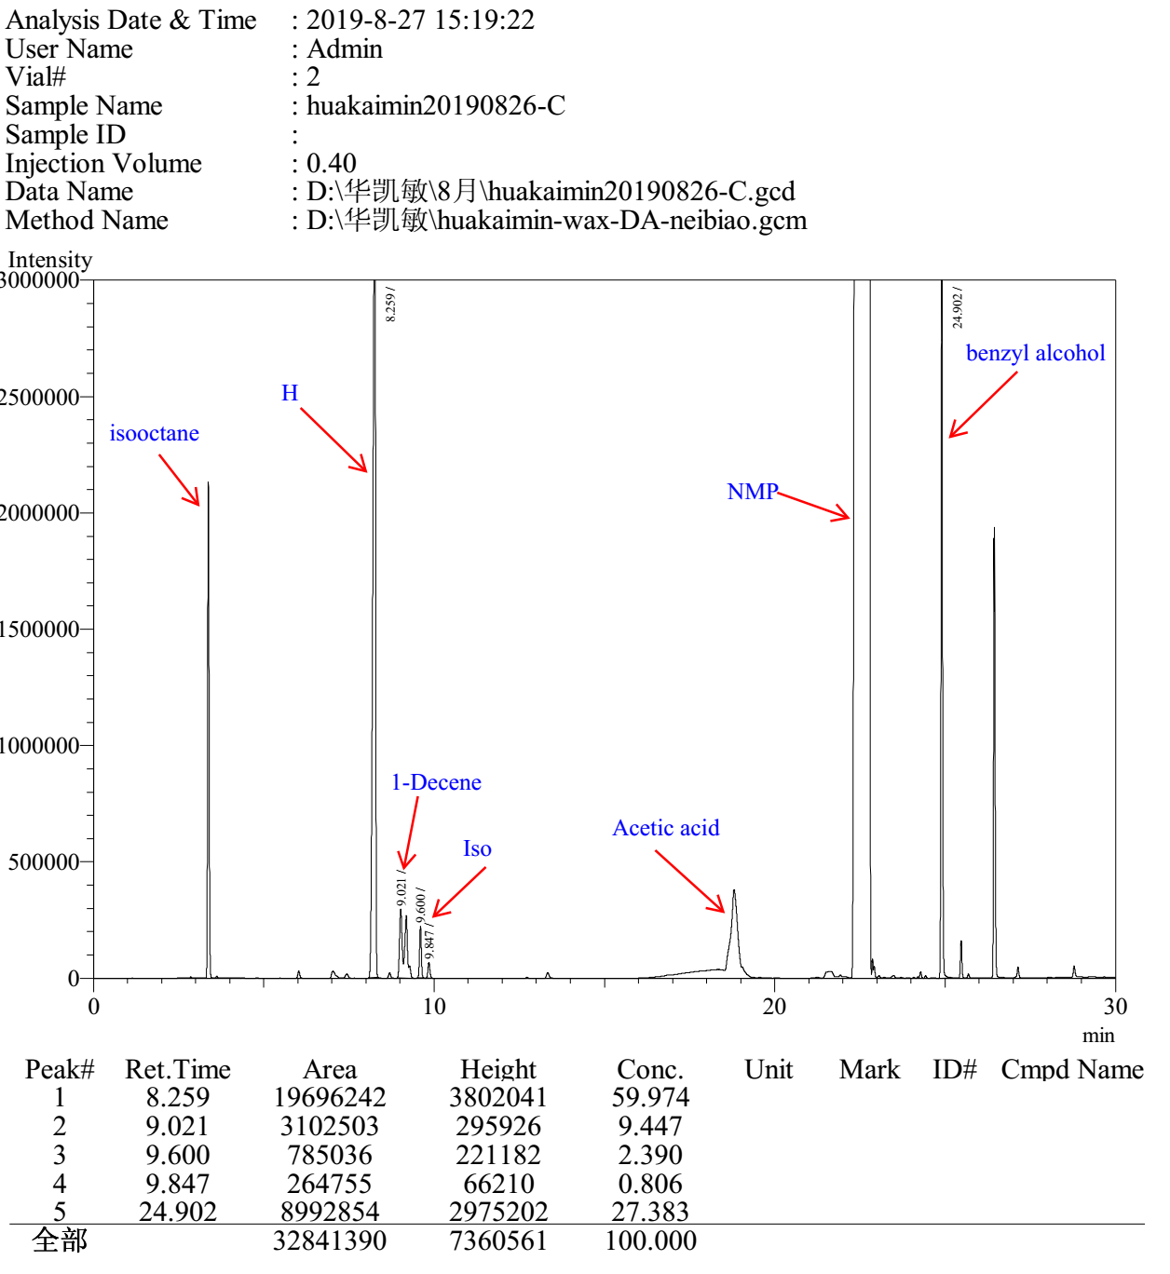

L6

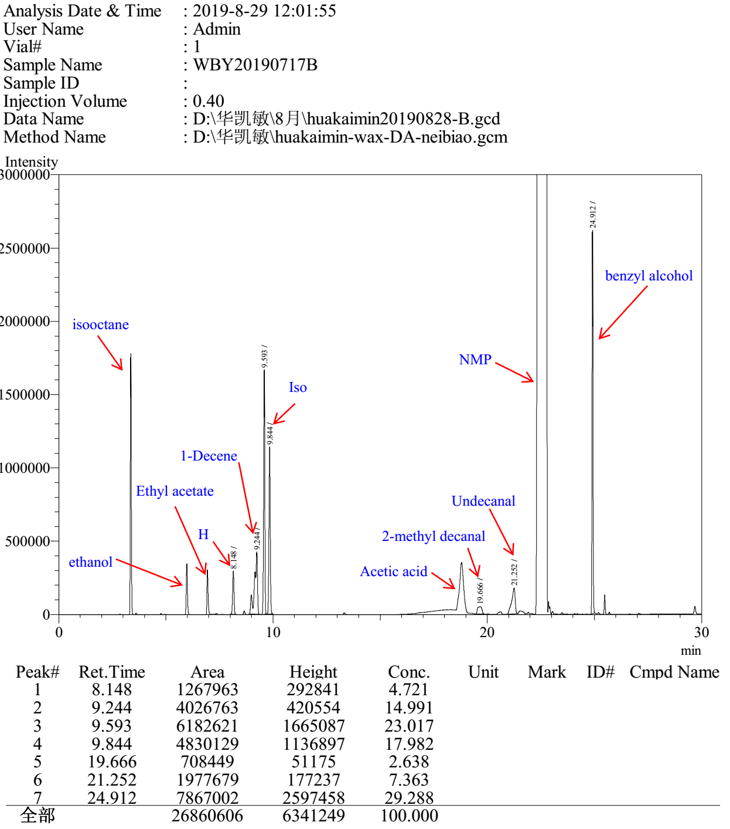

L7 (PTA)

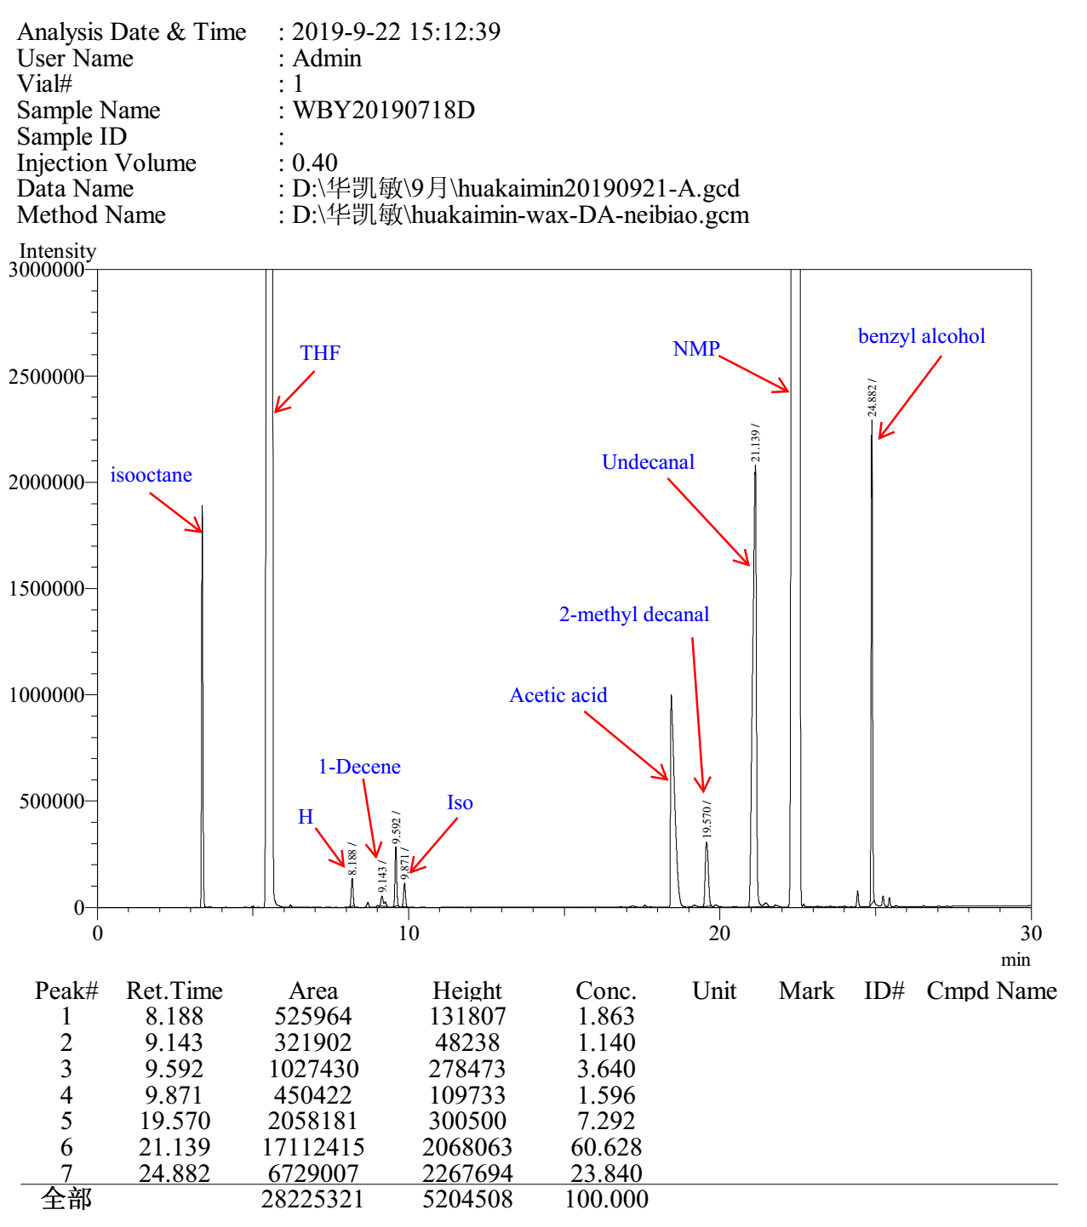

without Ligand

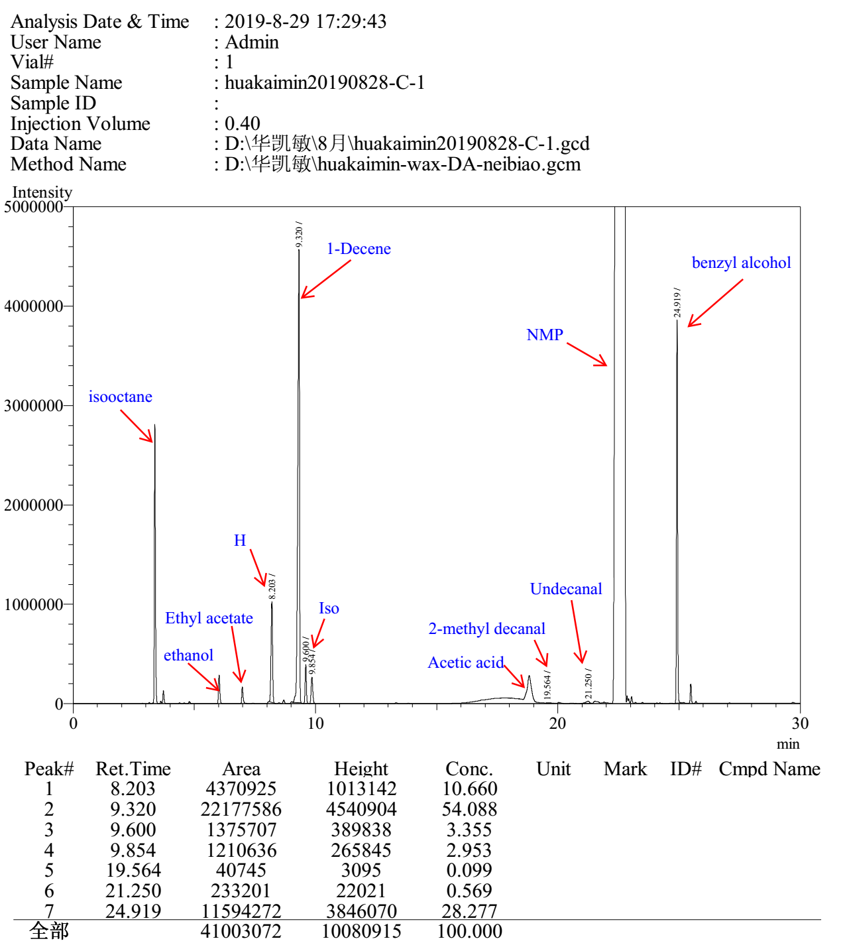

3.2 Gas chromatograms to Table S2

L1

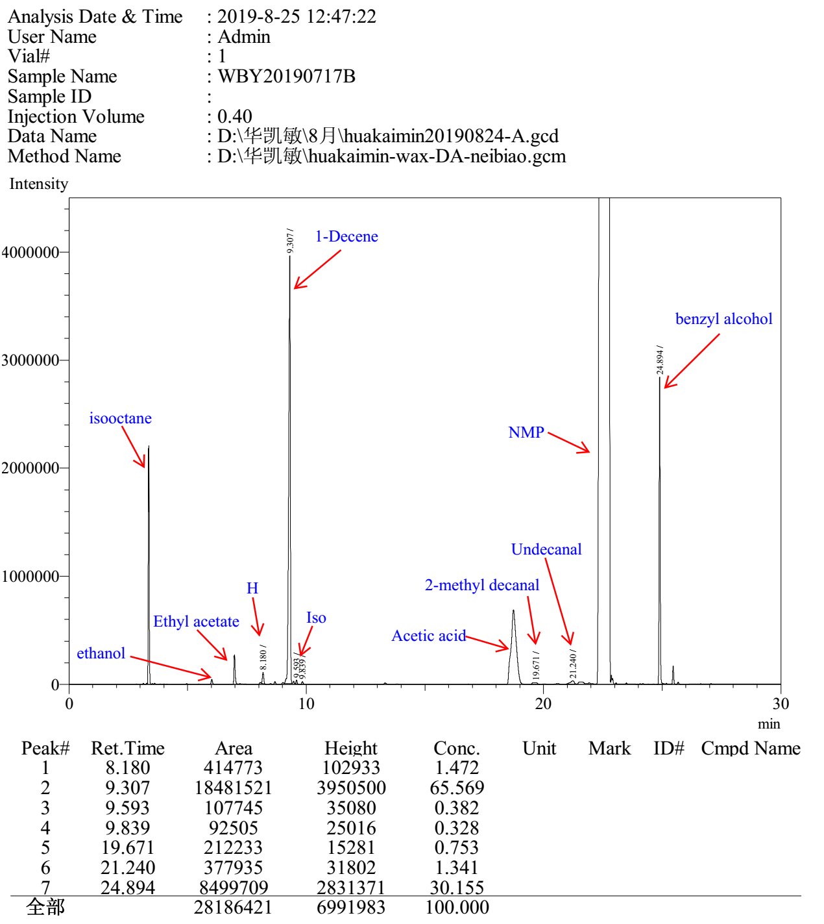

L2

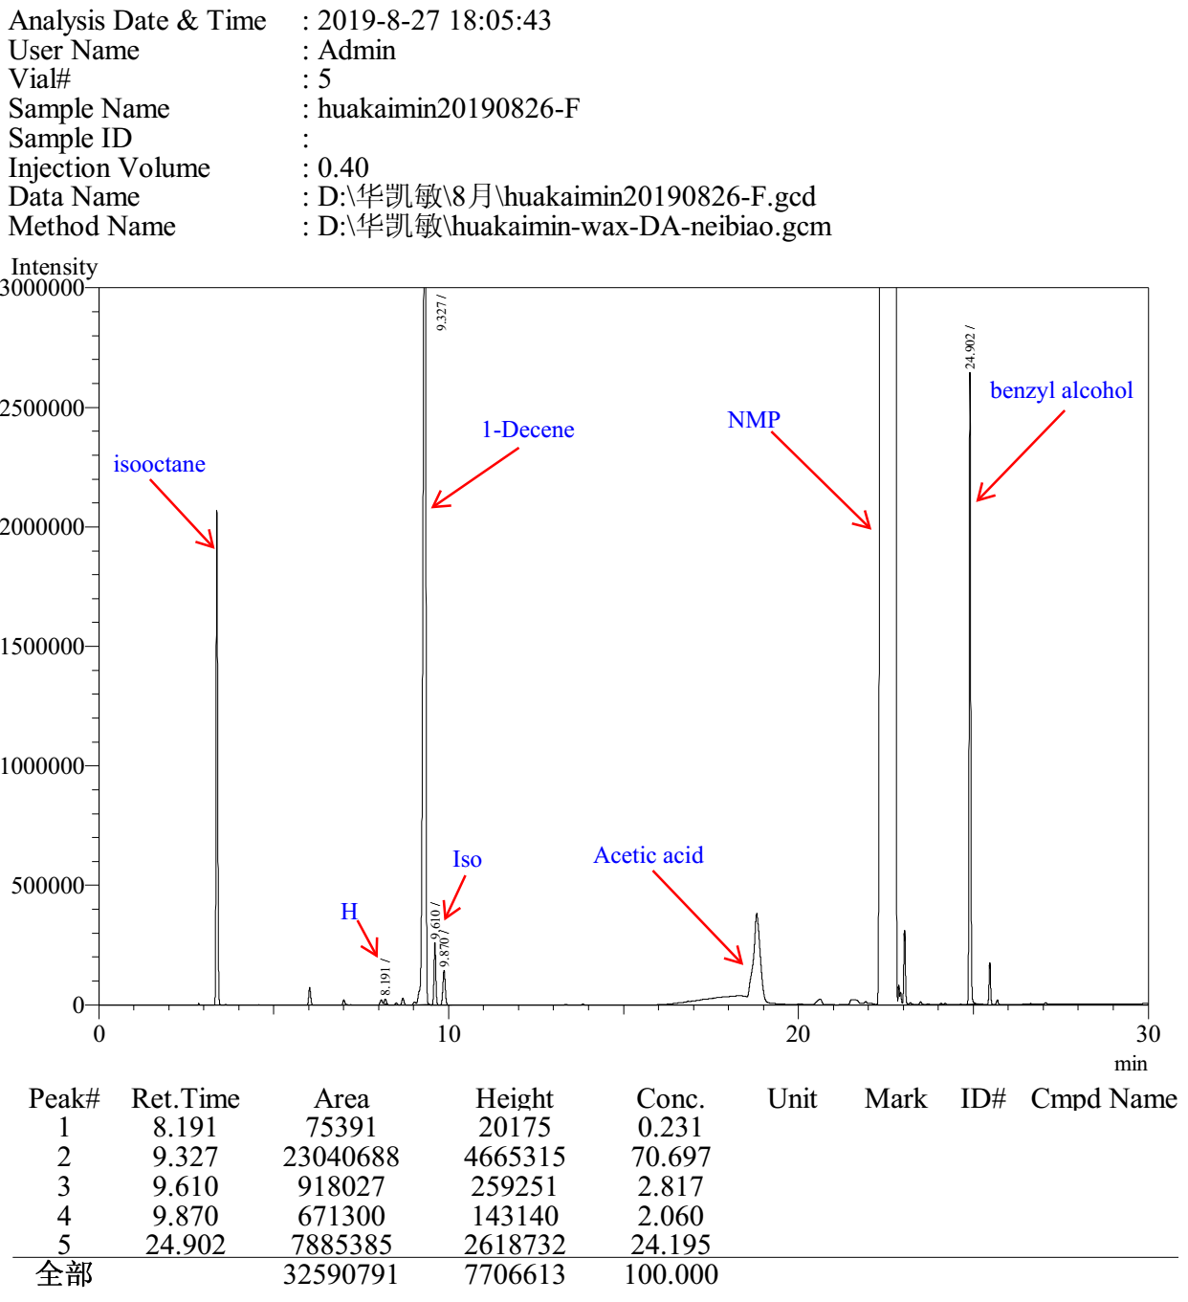
L3

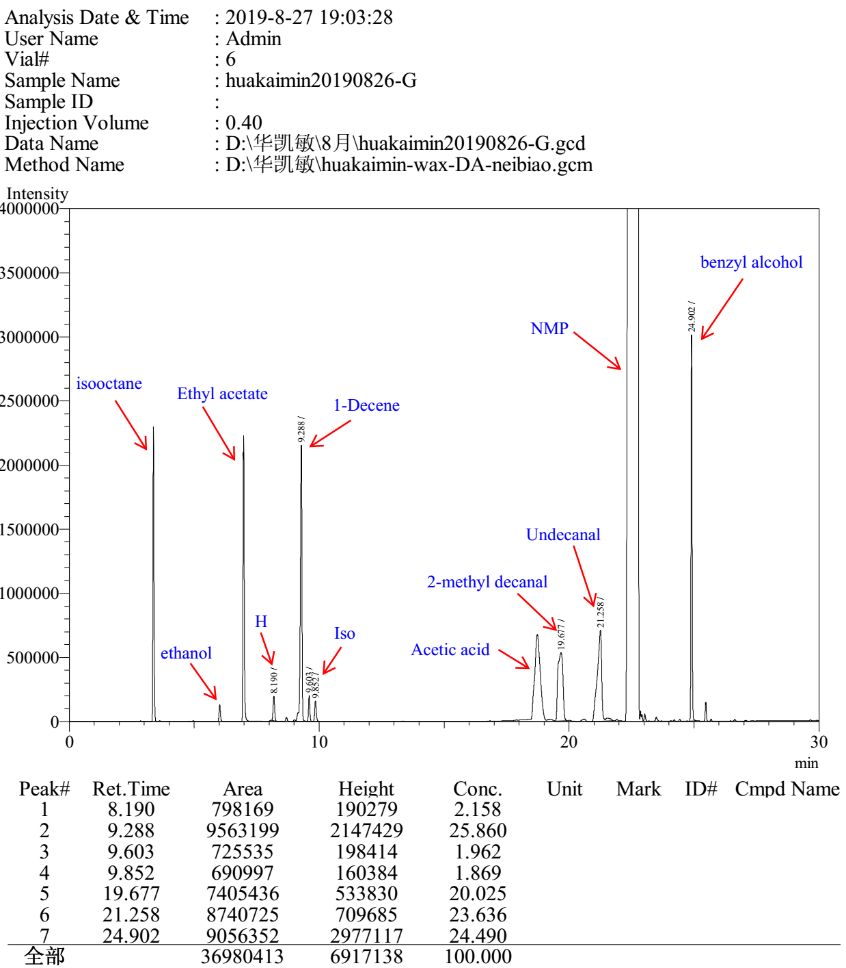

L4

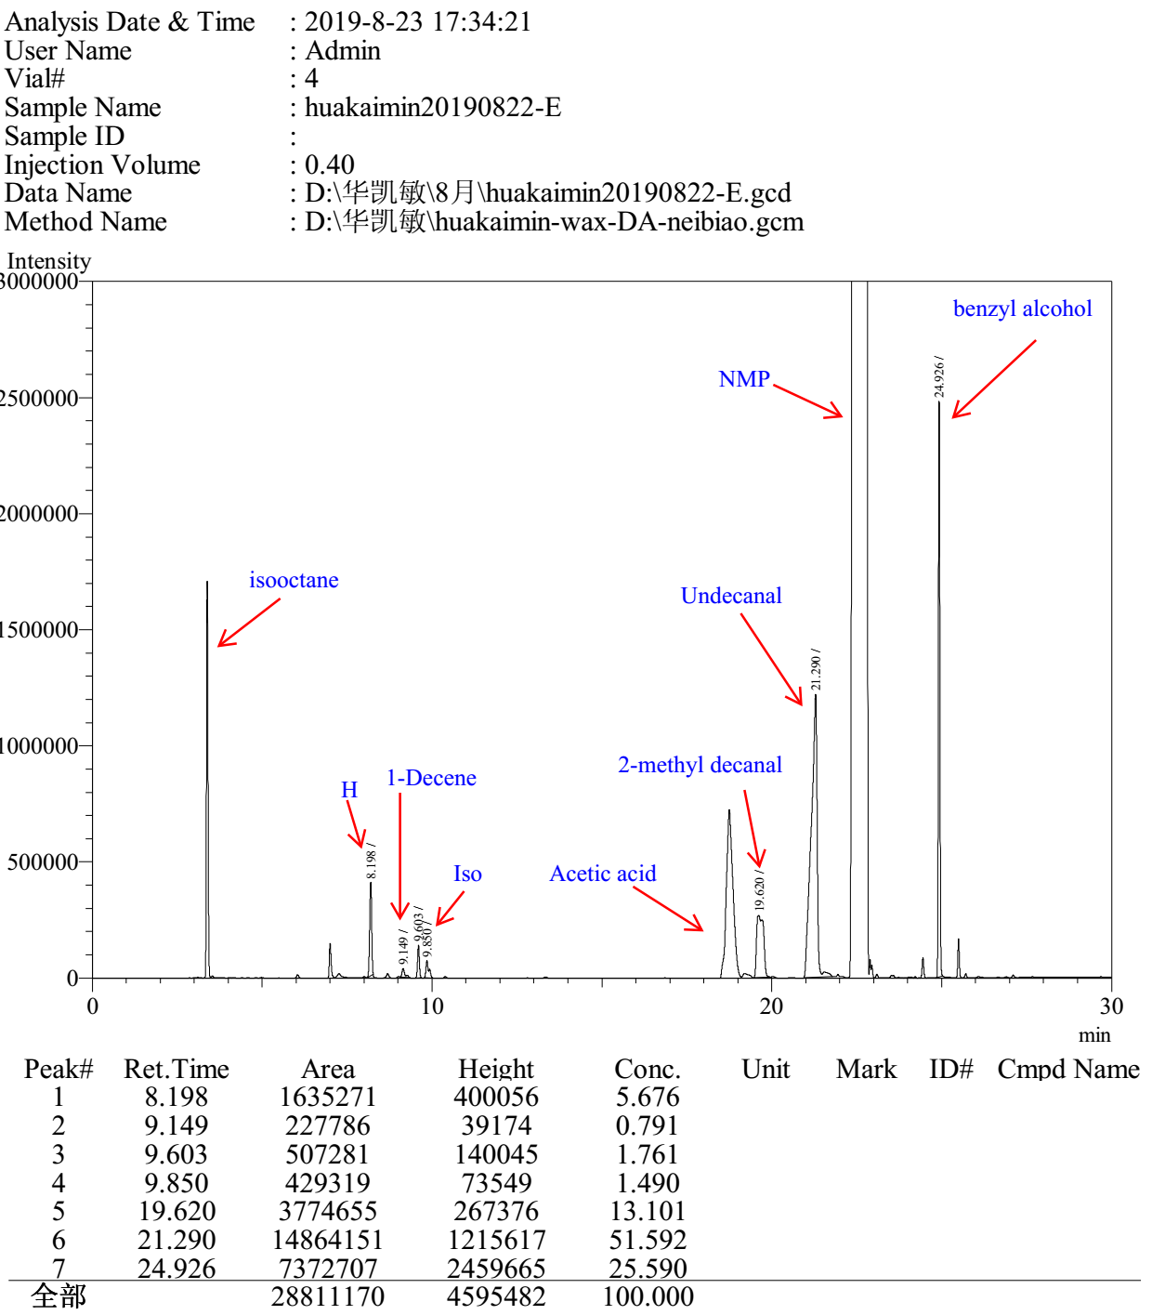

L5

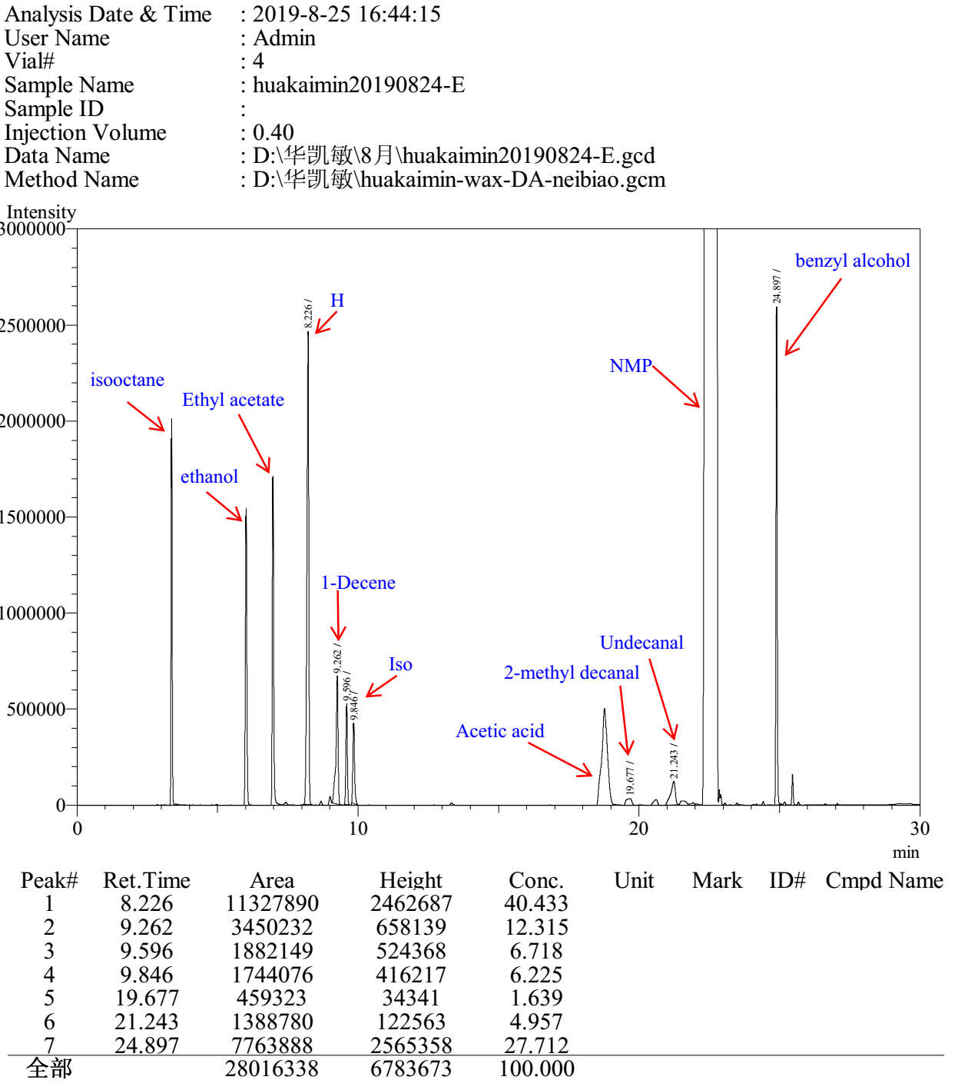

L6

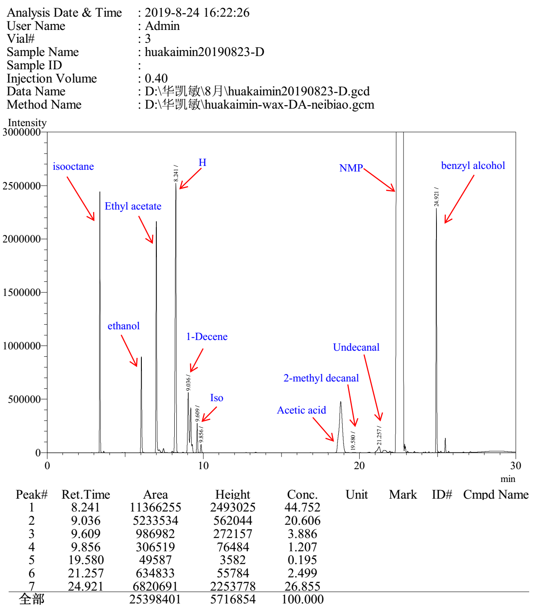

L7

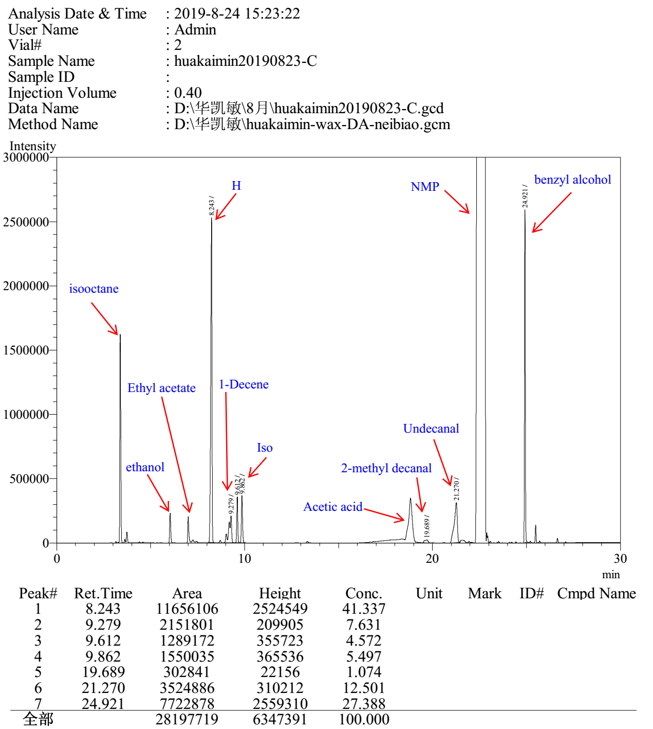

L8

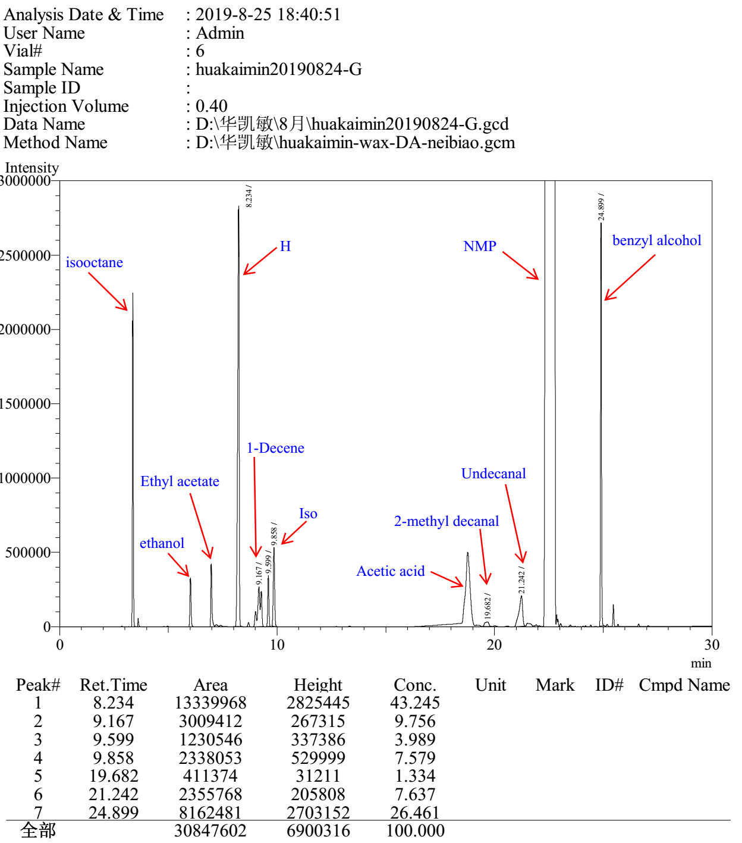

L9

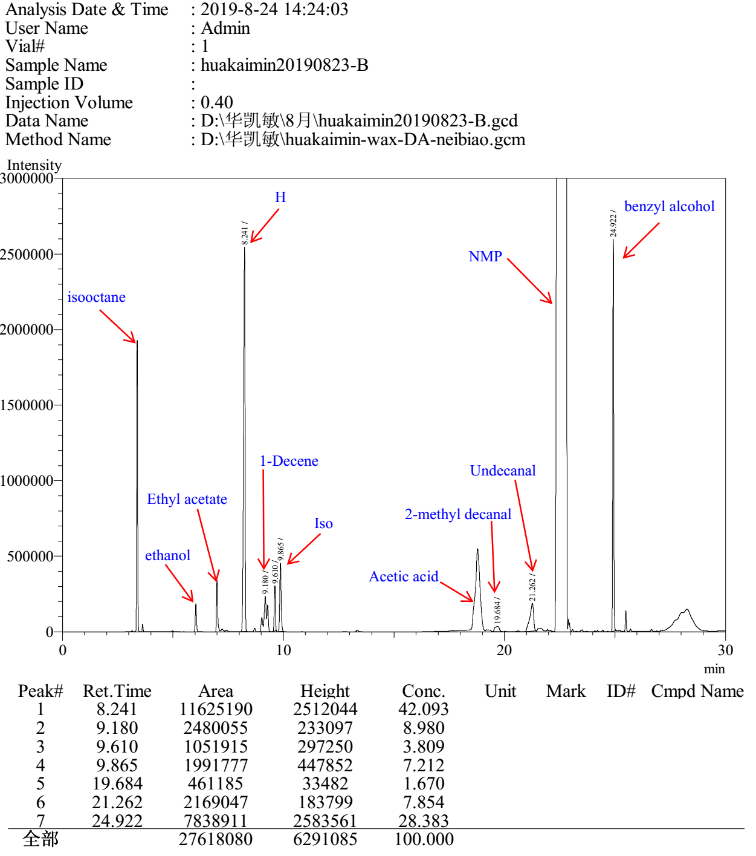

L10

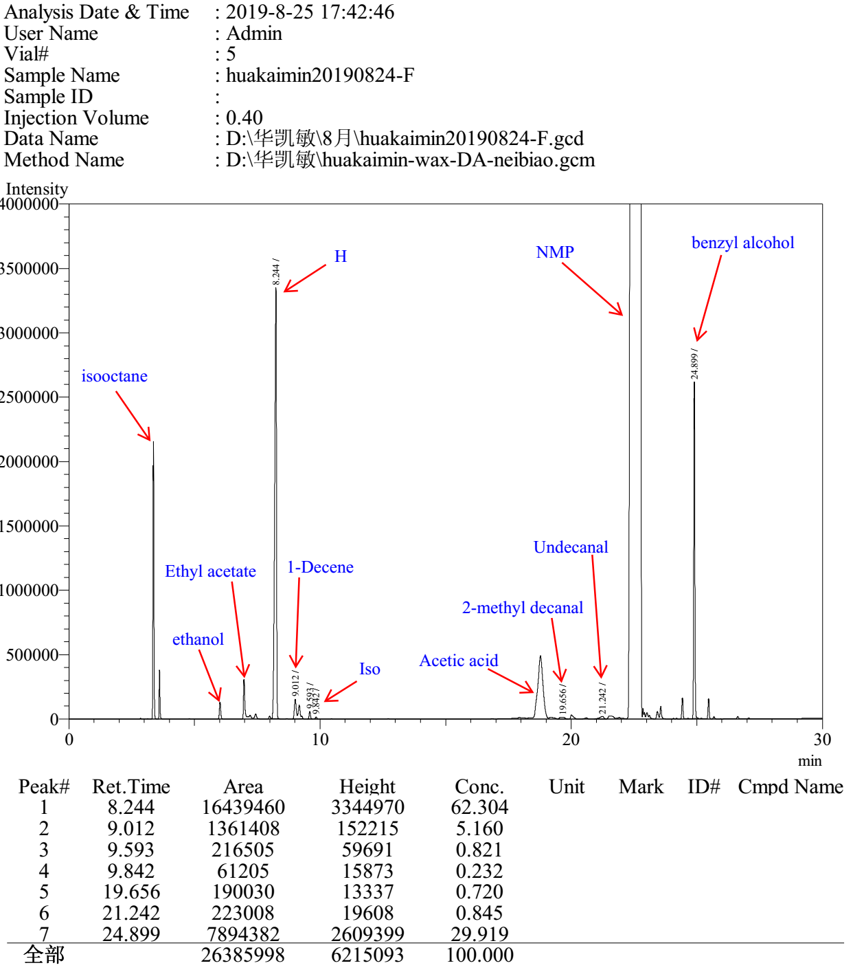

L11

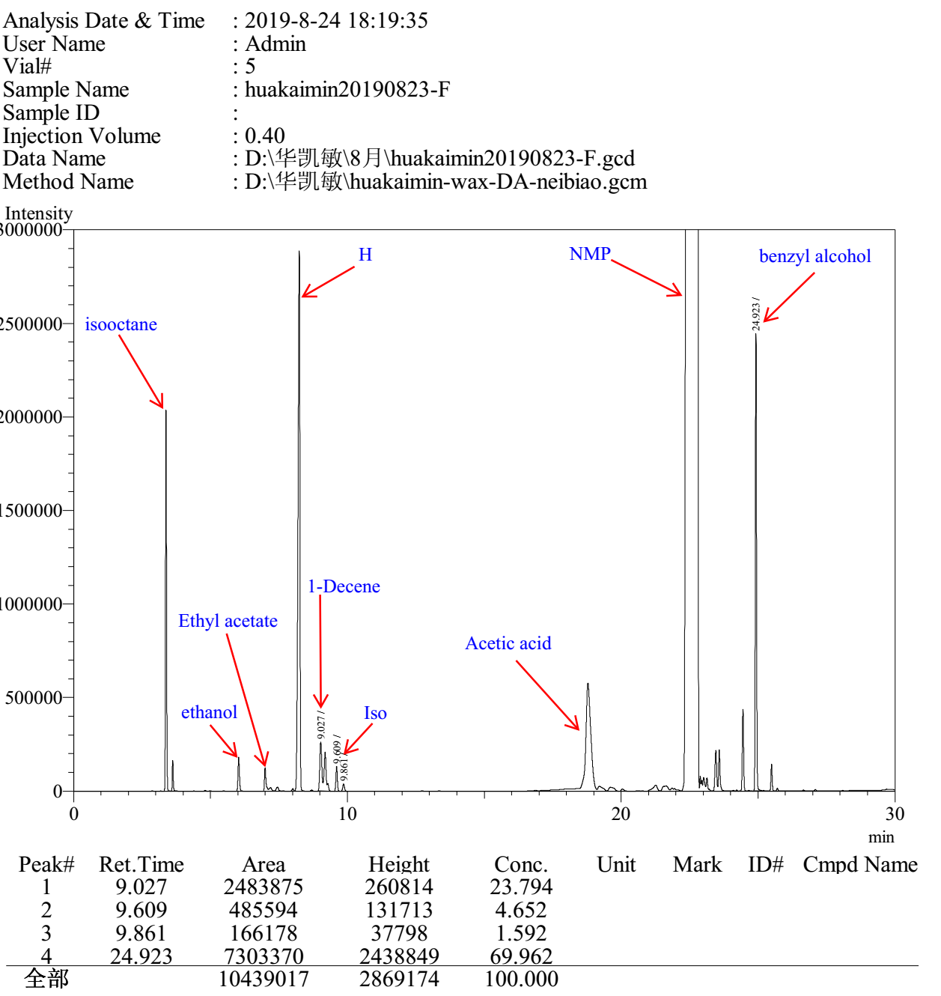

L12

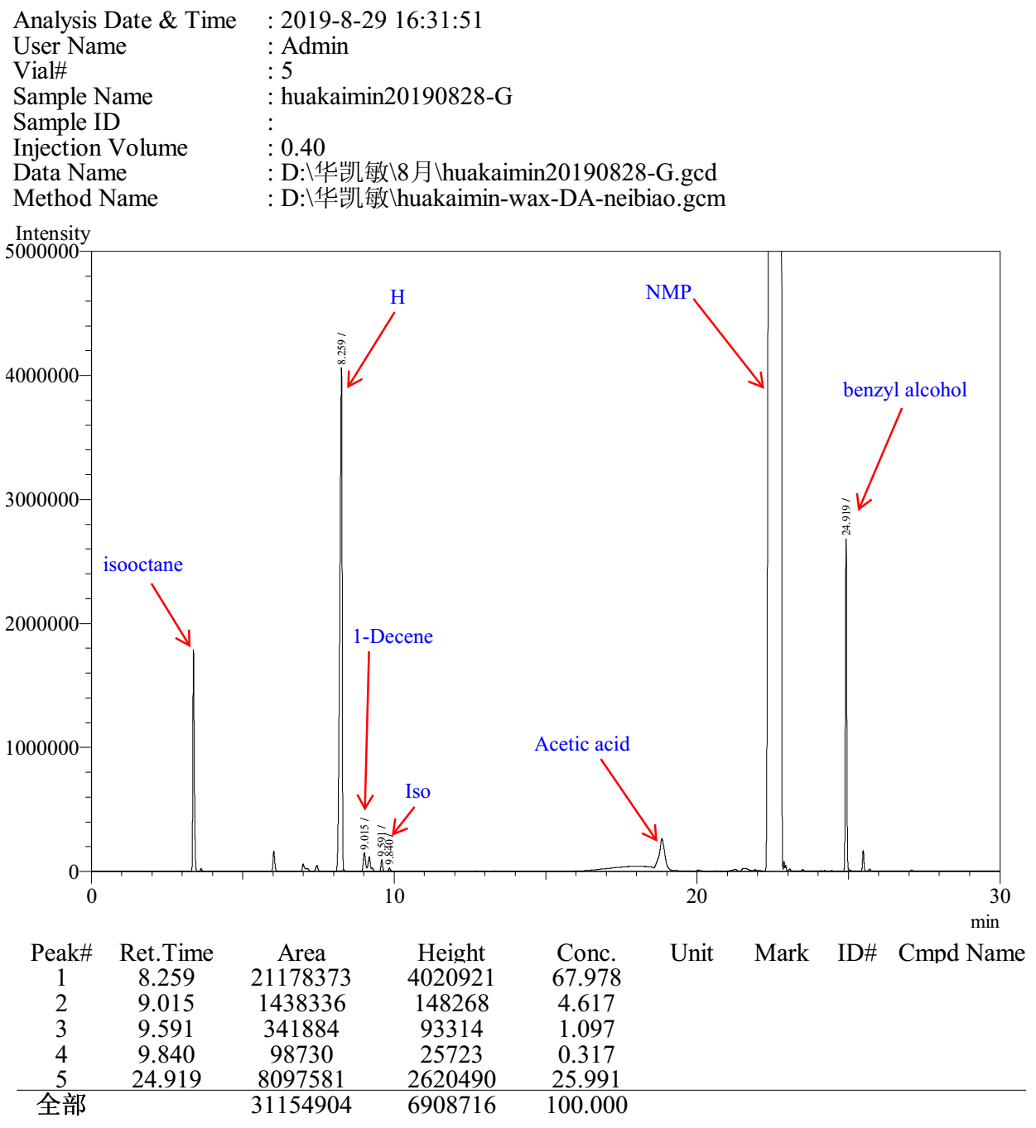

3.3 Gas chromatograms to Table S3

Entry 1

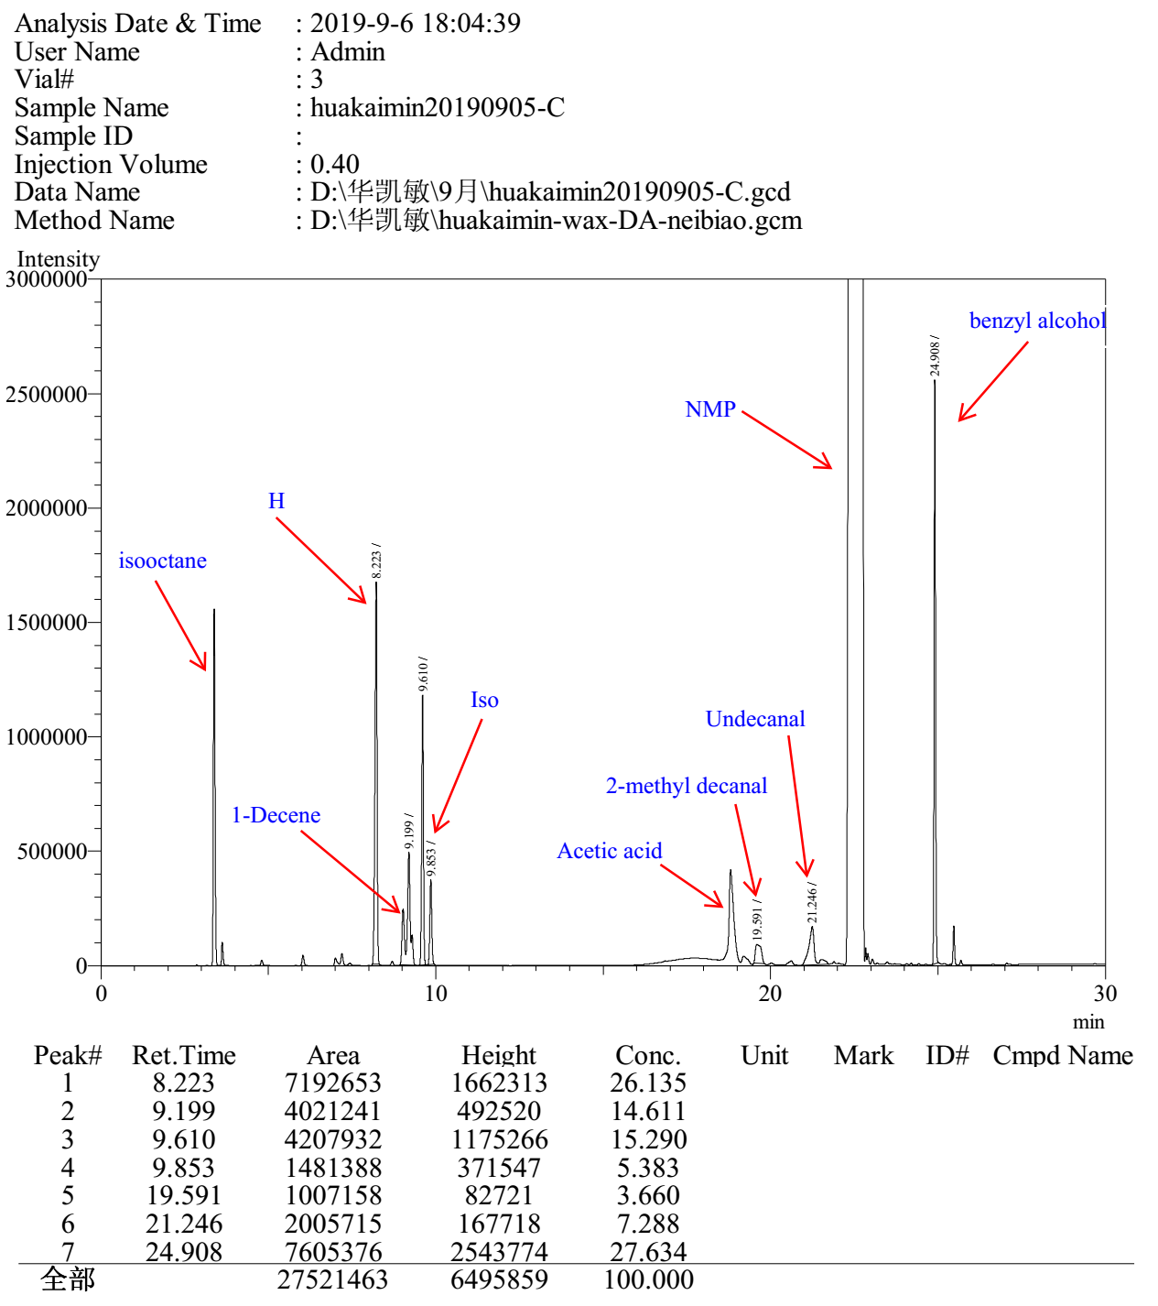

Entry 2

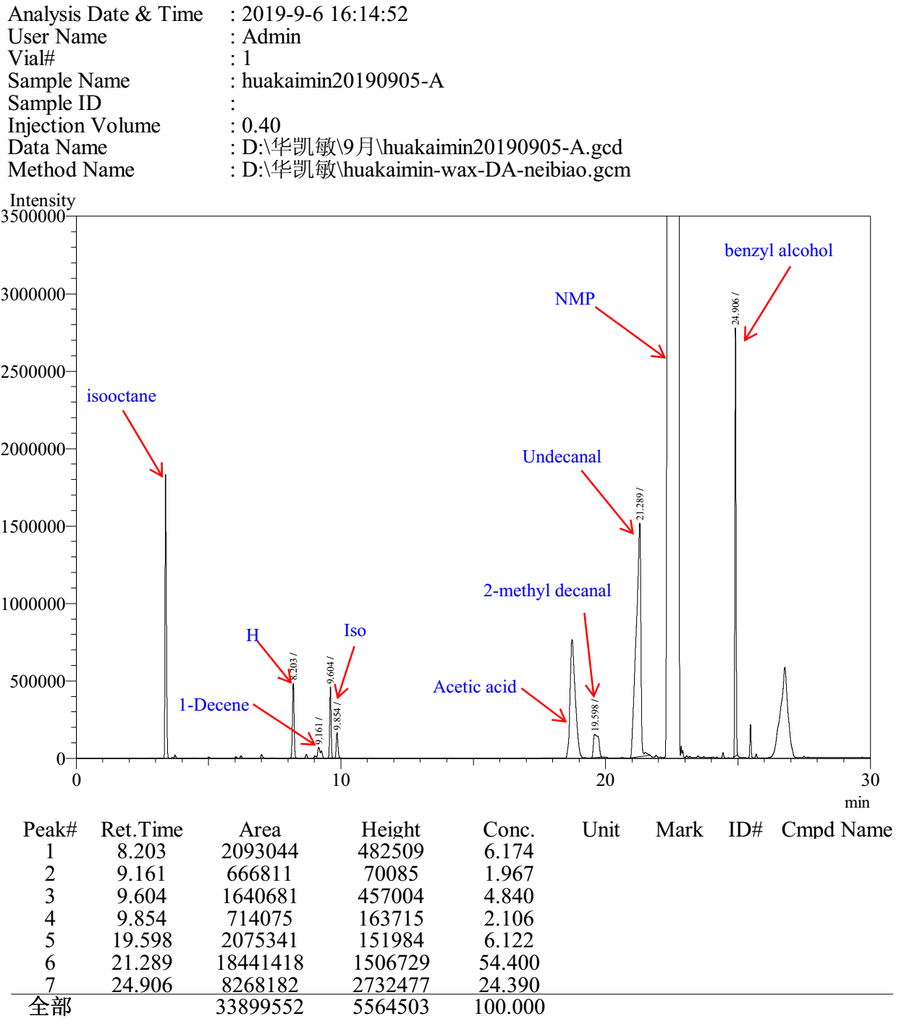

Entry 3

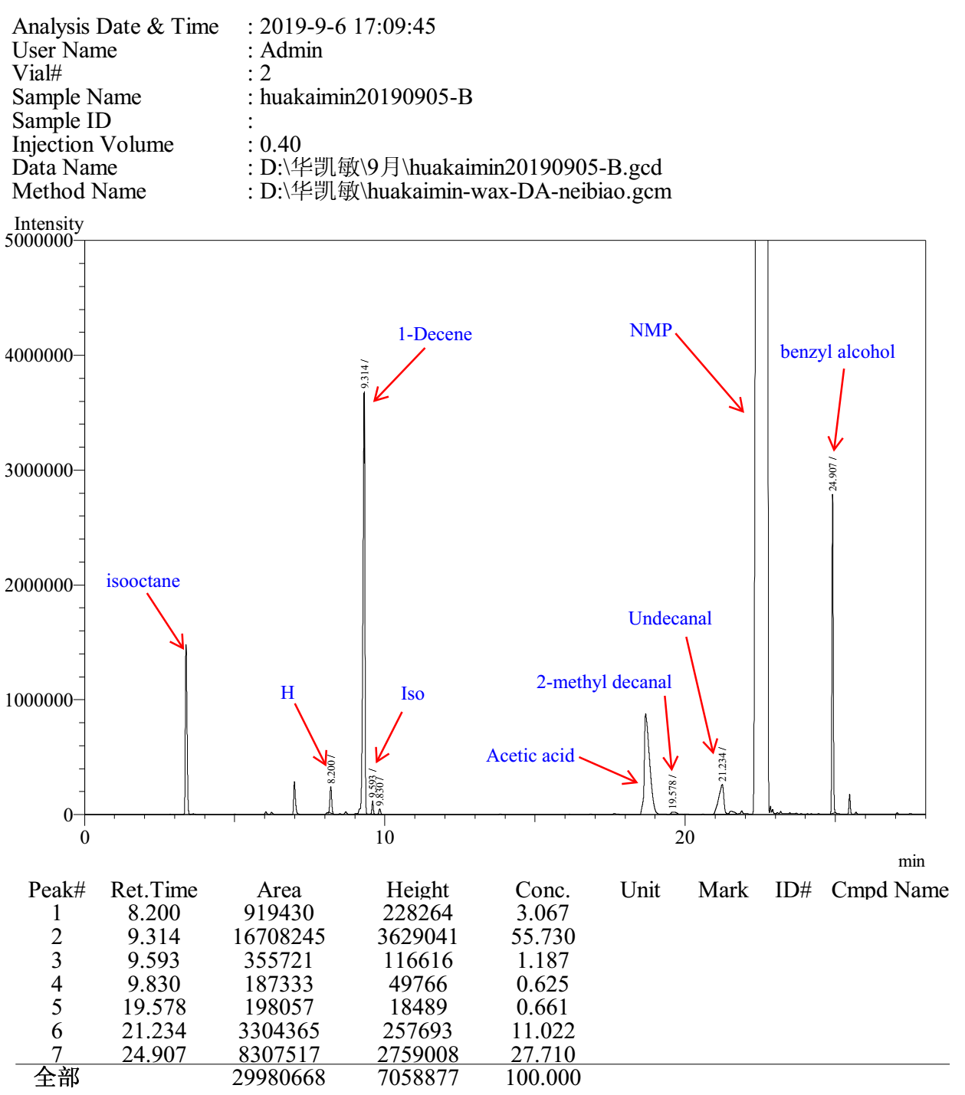

Entry 4

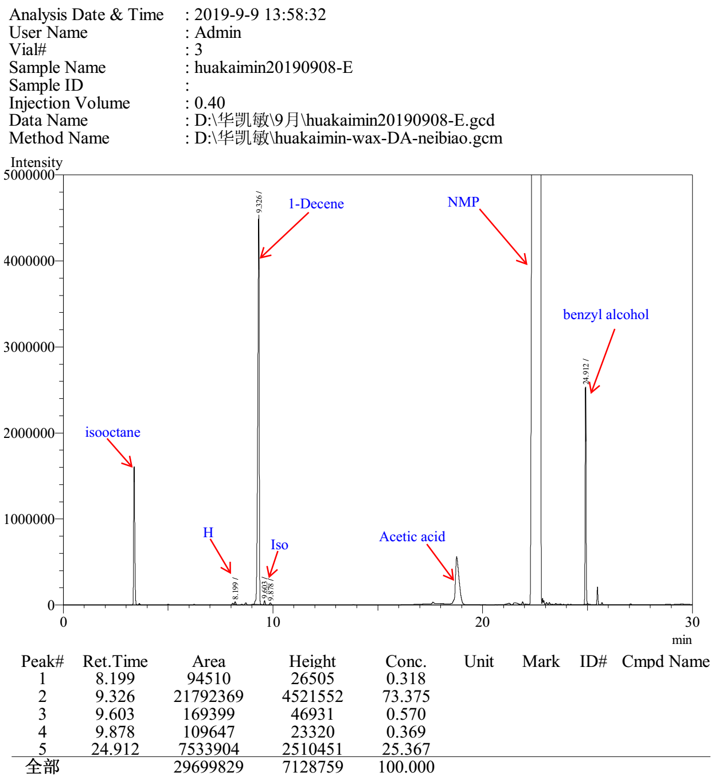

Entry 5

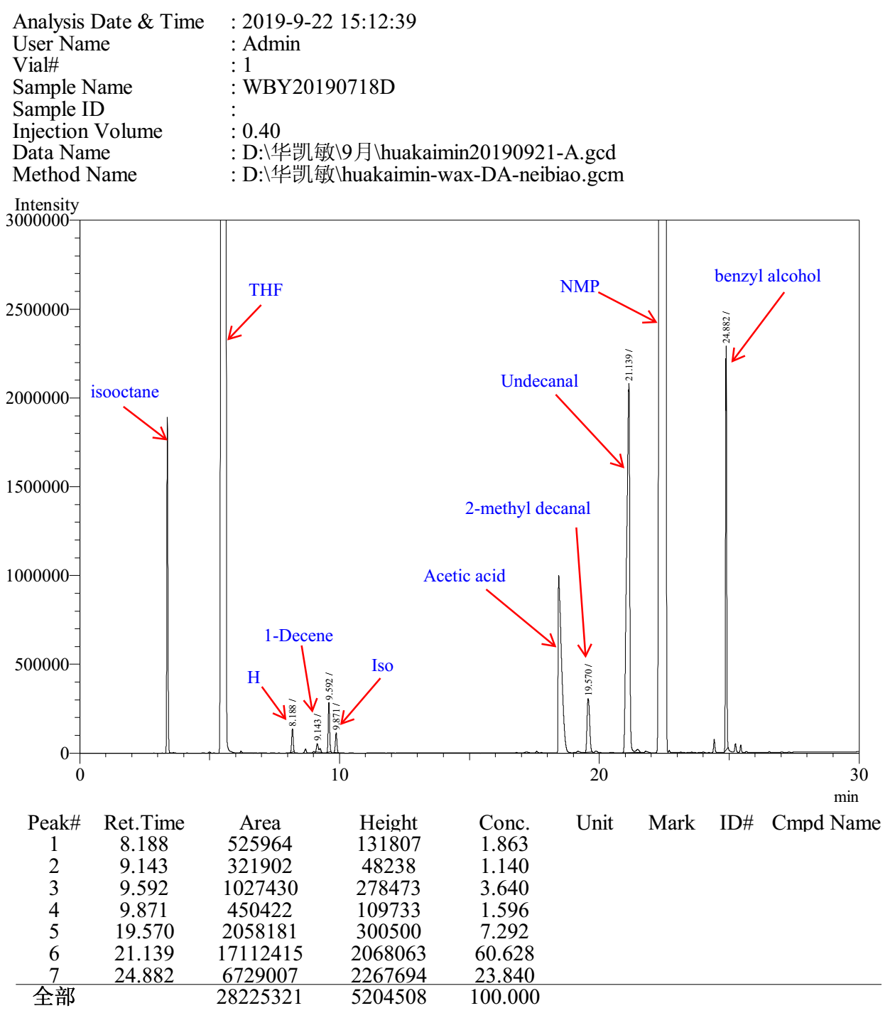

3.4 Gas chromatograms to Table S4

Entry 1

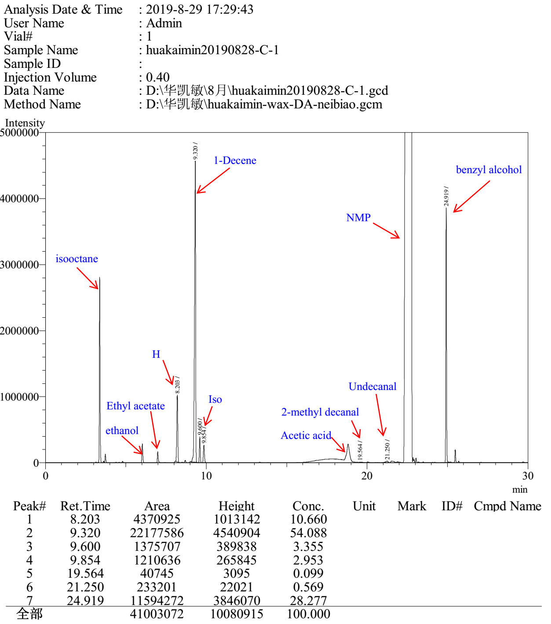

Entry 2

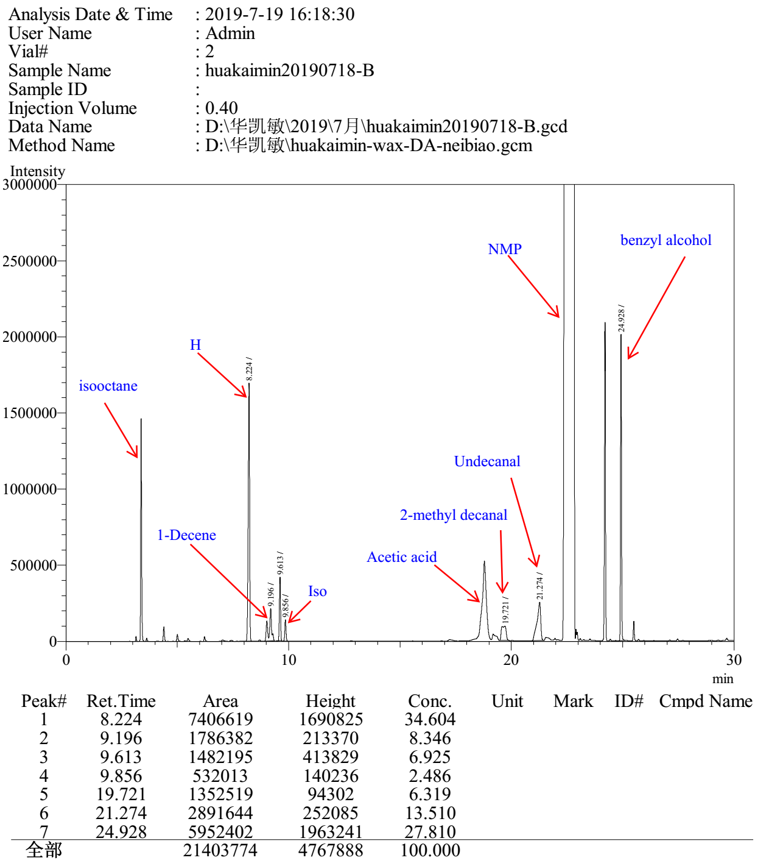

Entry 3

Entry 4

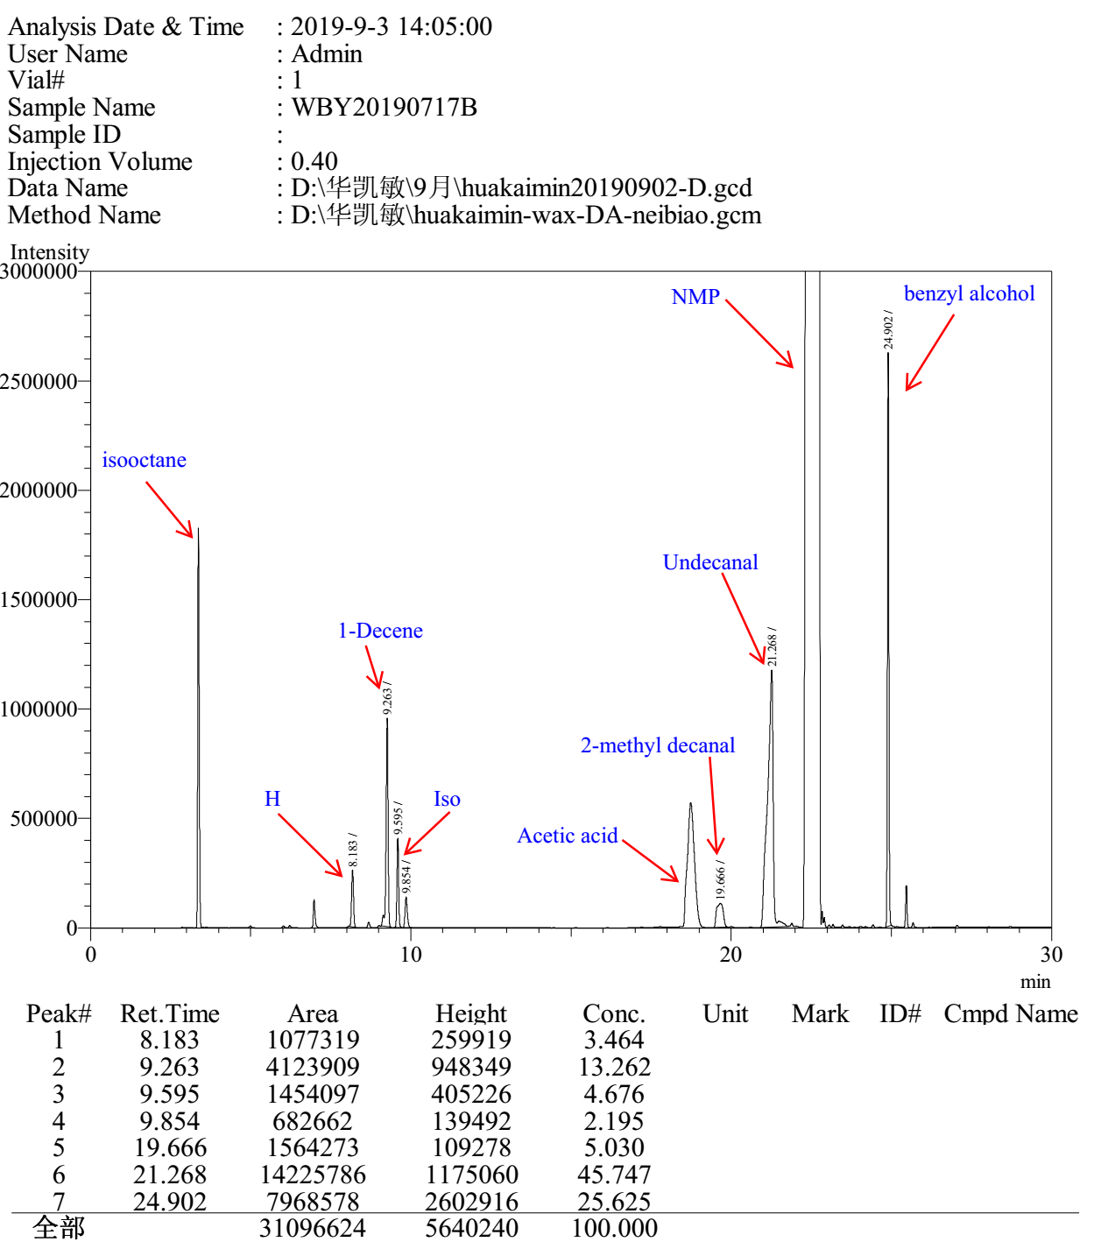

3.5 Gas chromatograms to Table S5

Entry 1

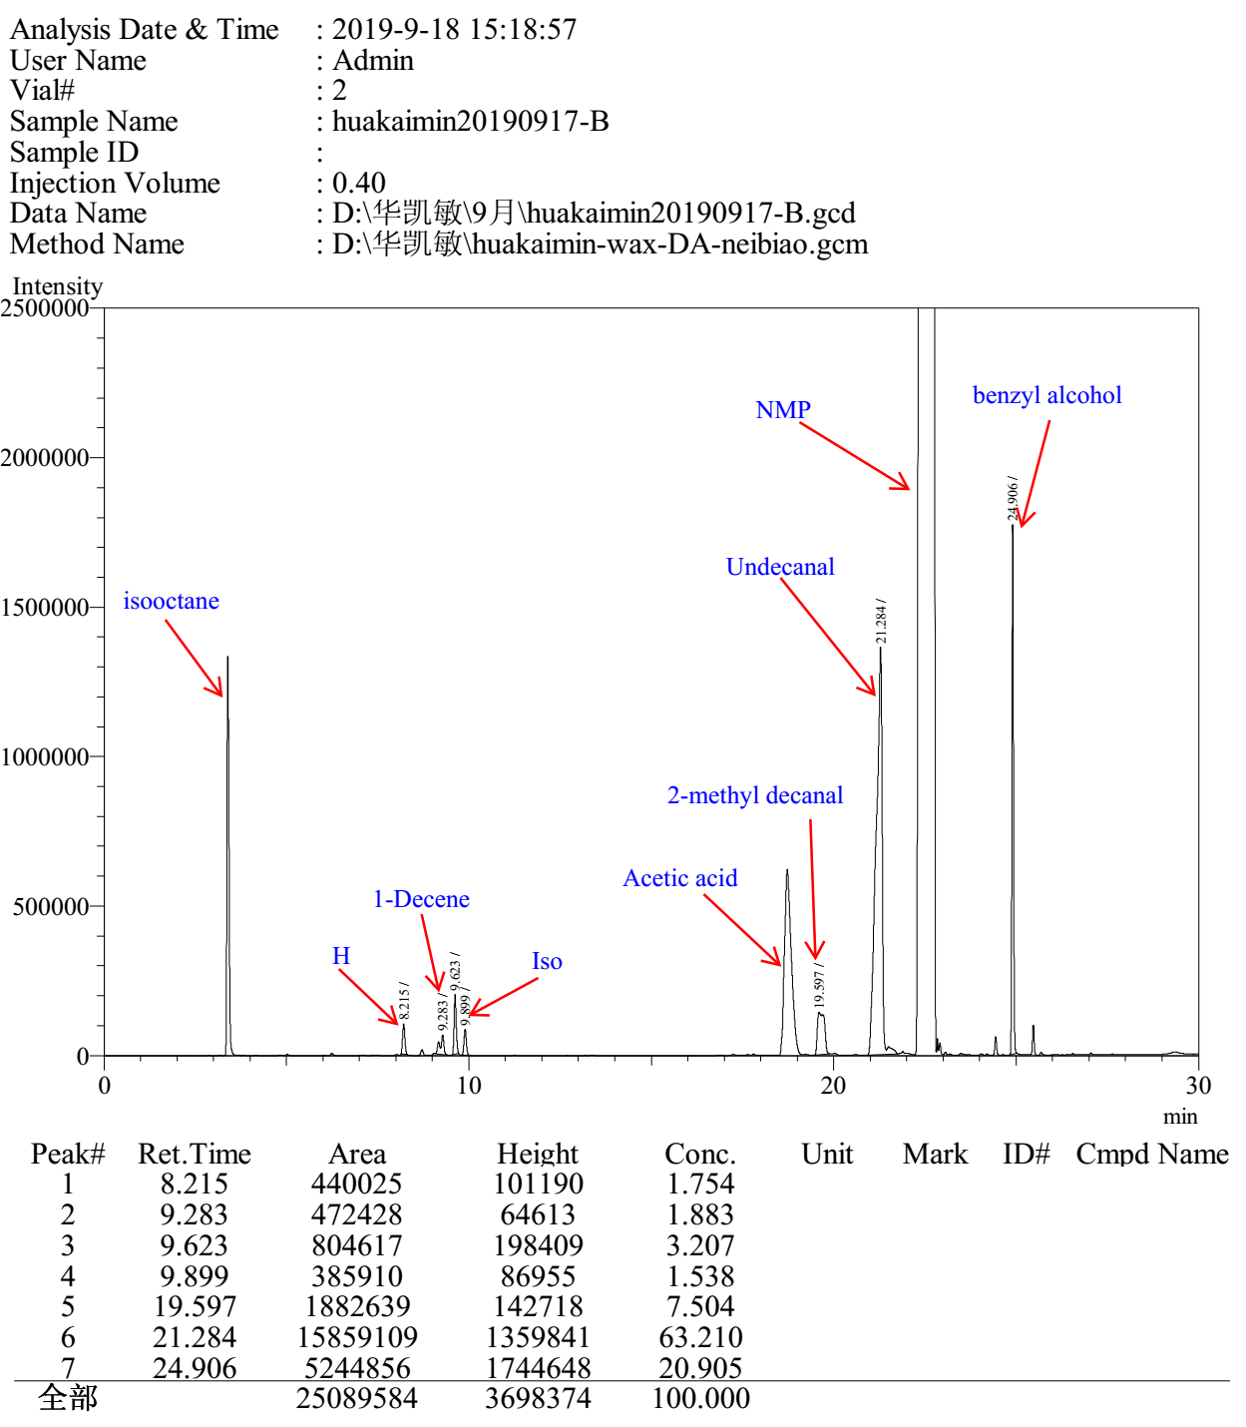

Entry 2

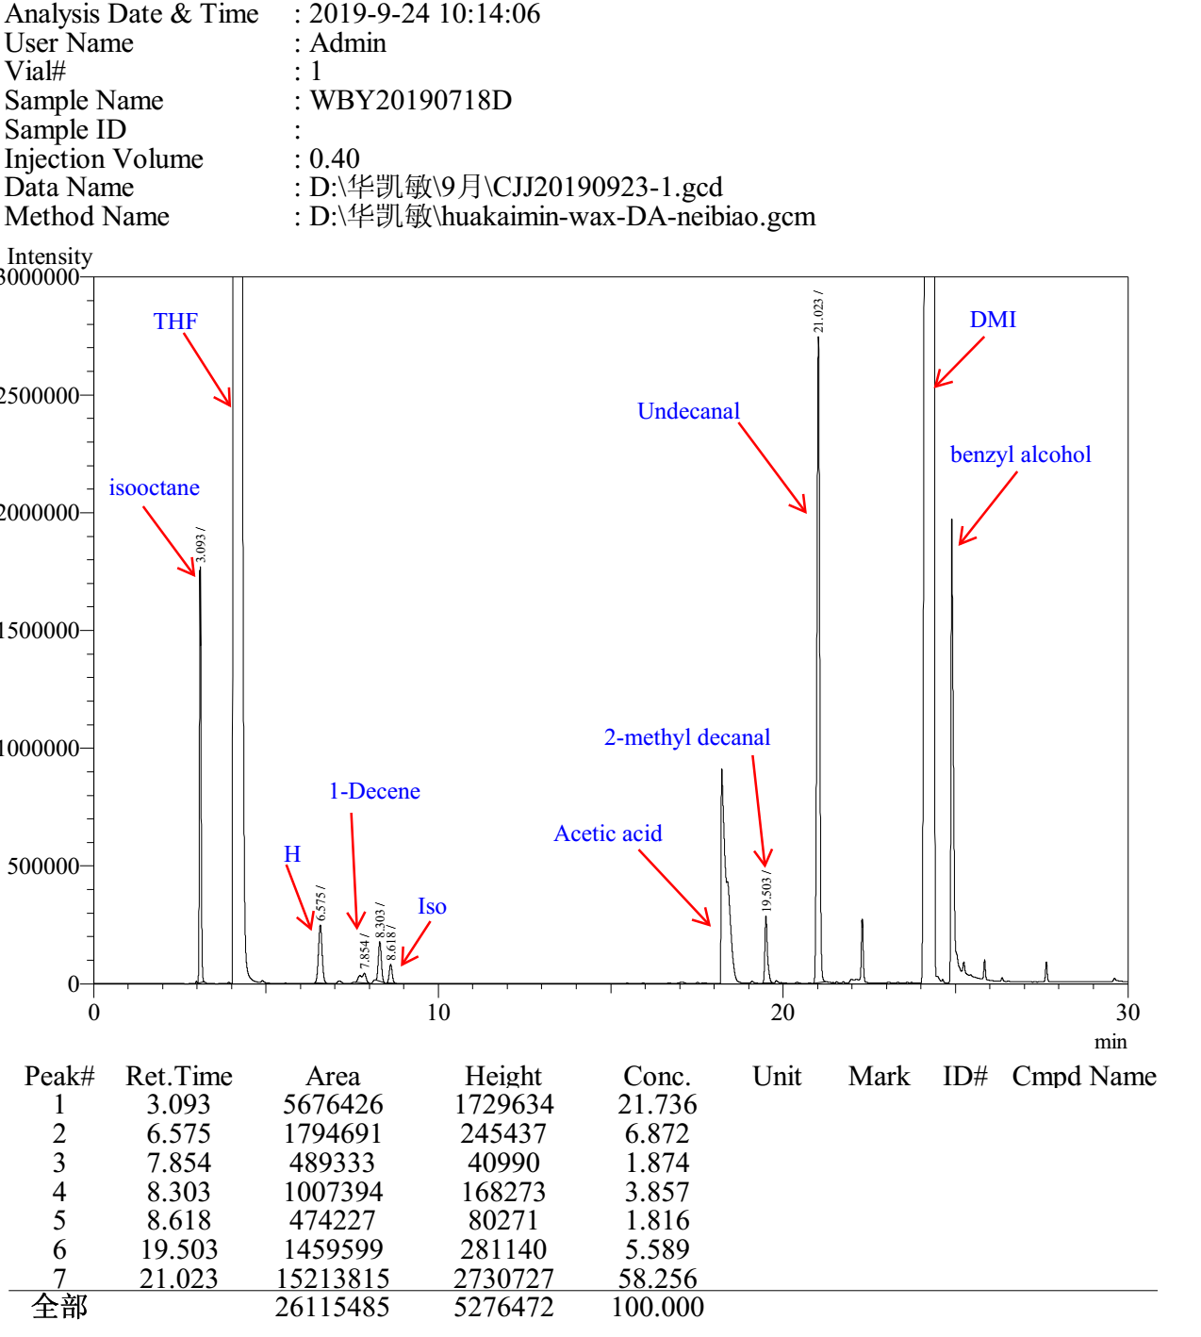

Entry 3

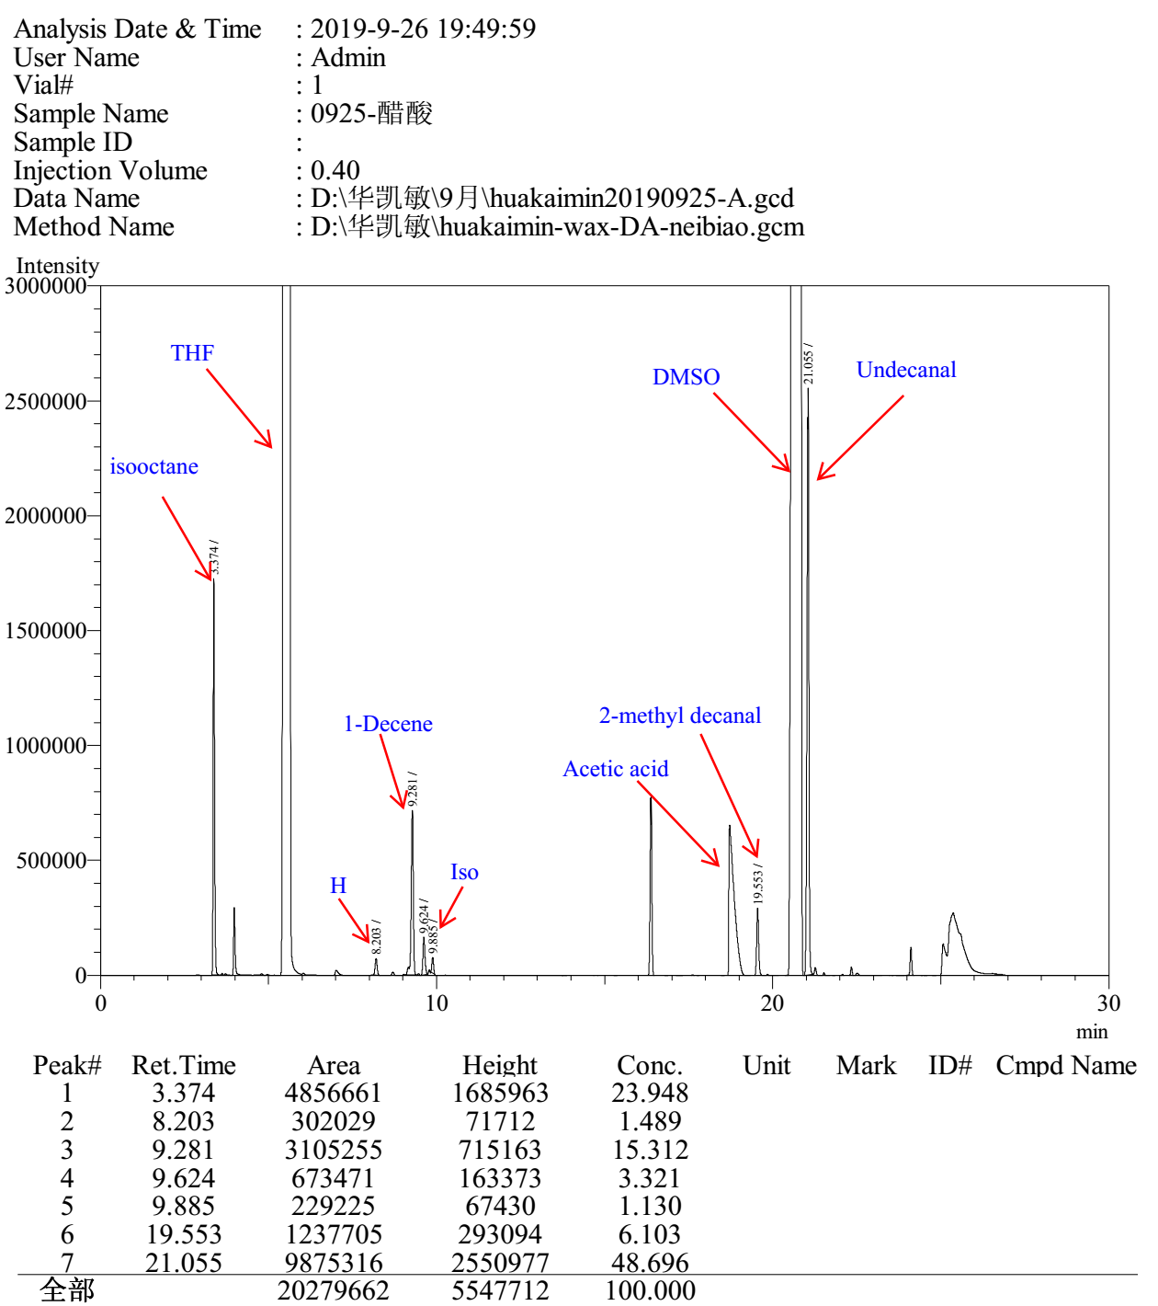

Entry 4

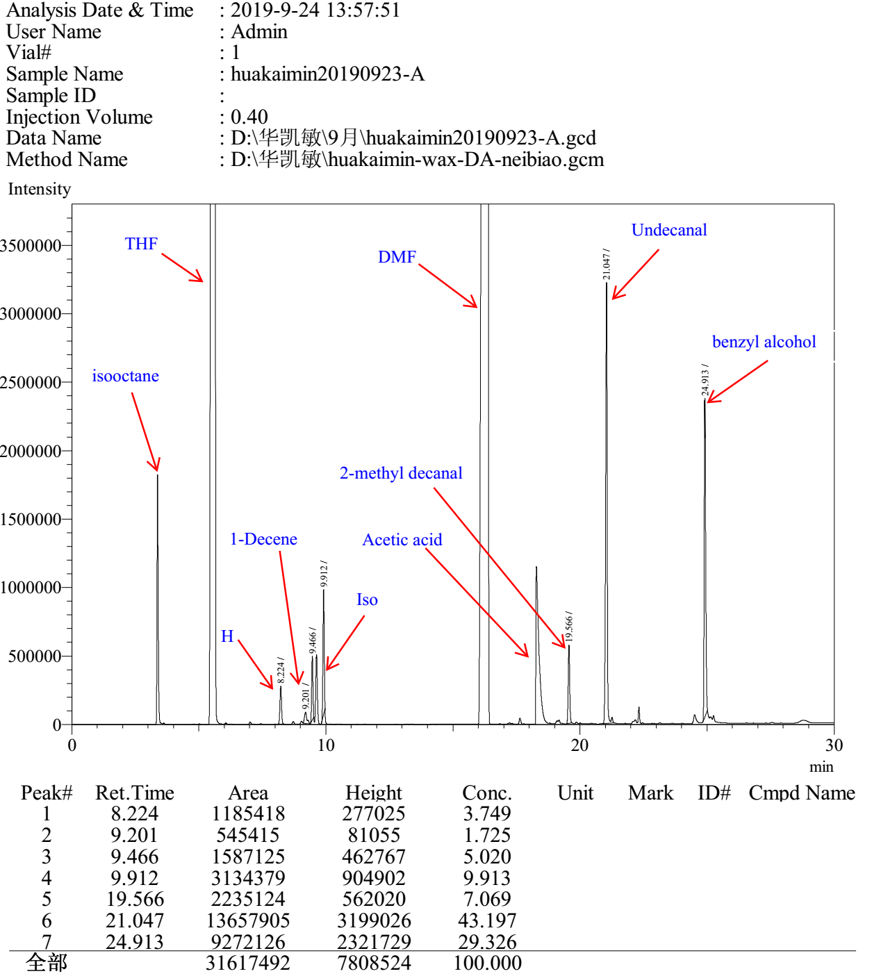

Entry 5

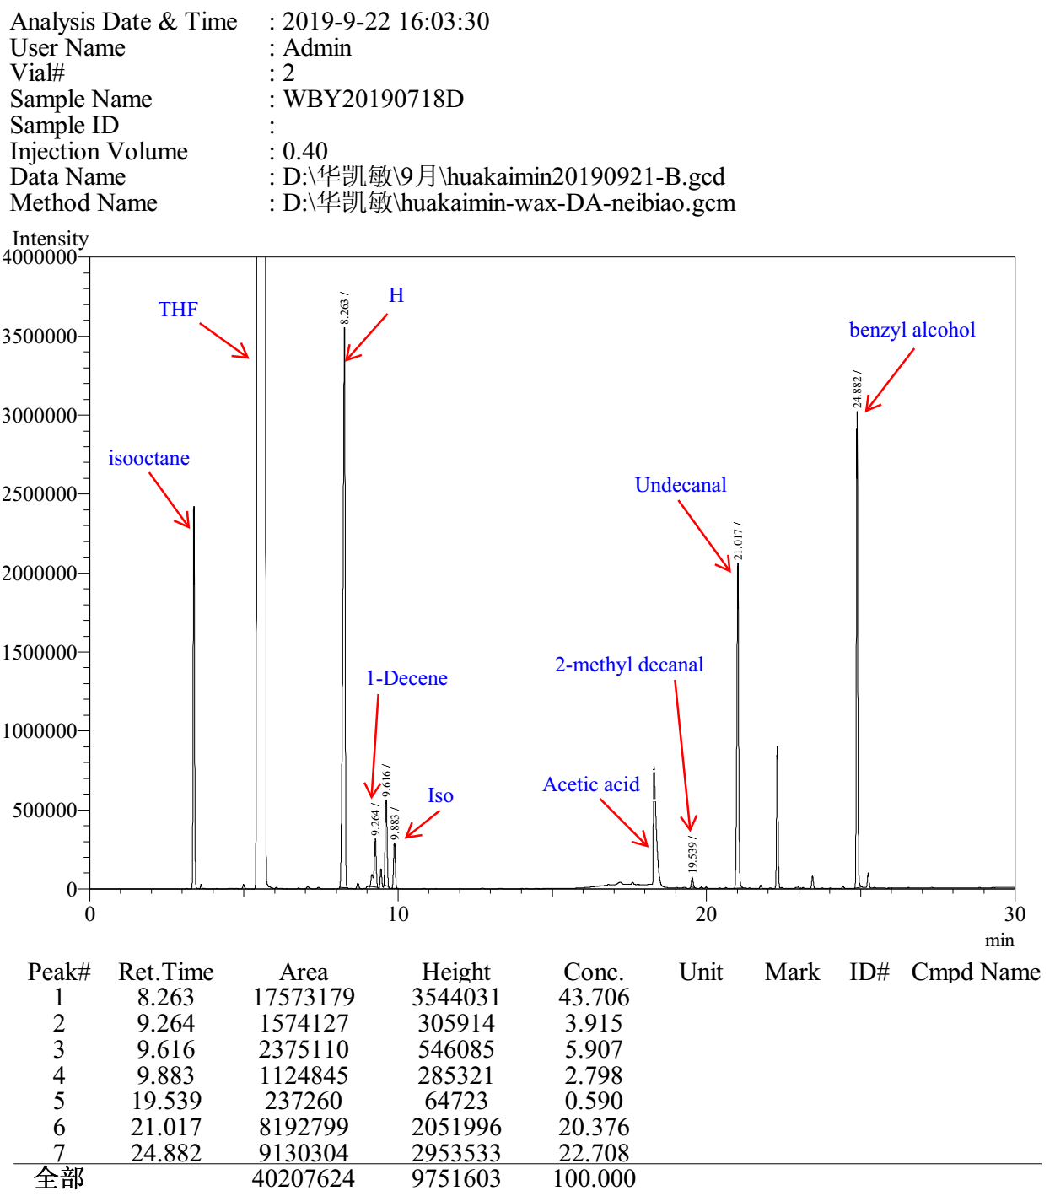

Entry 6

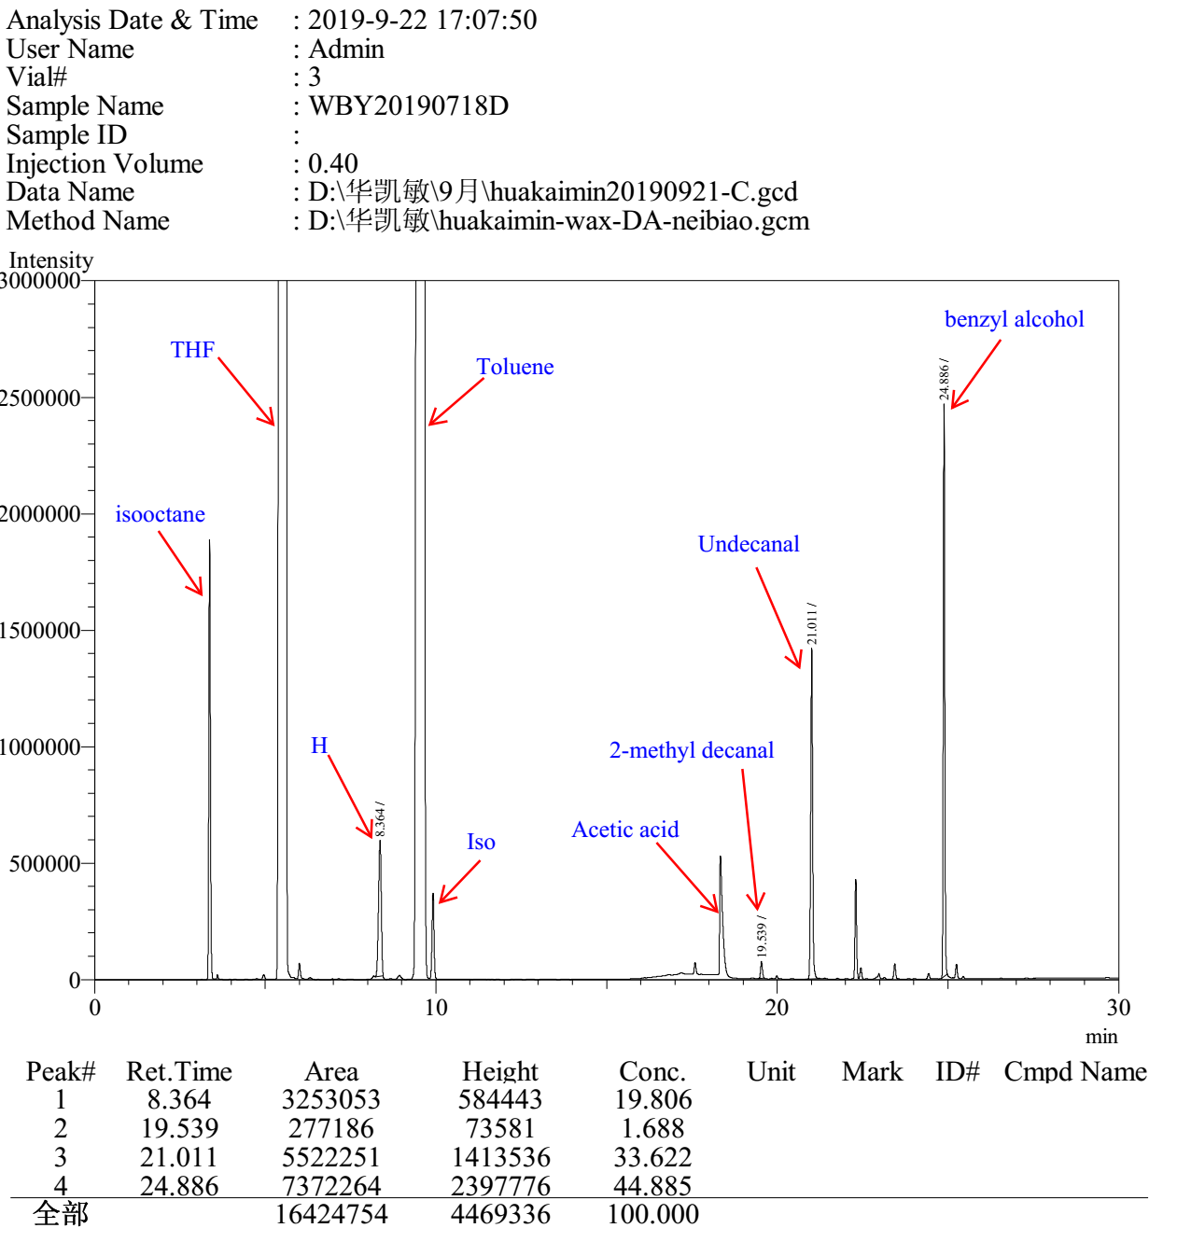

Entry 7

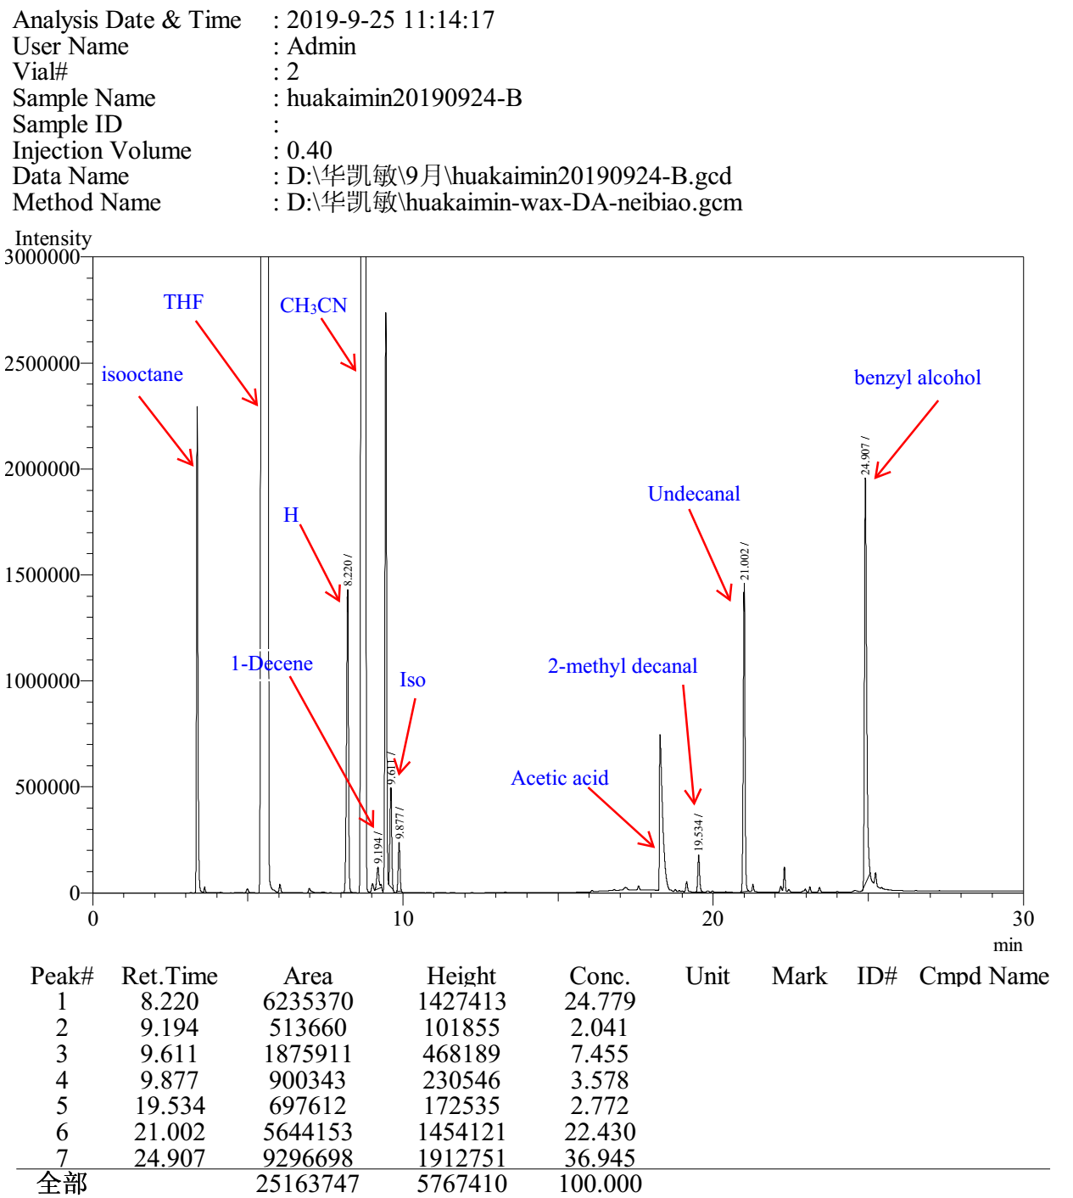

Entry 8

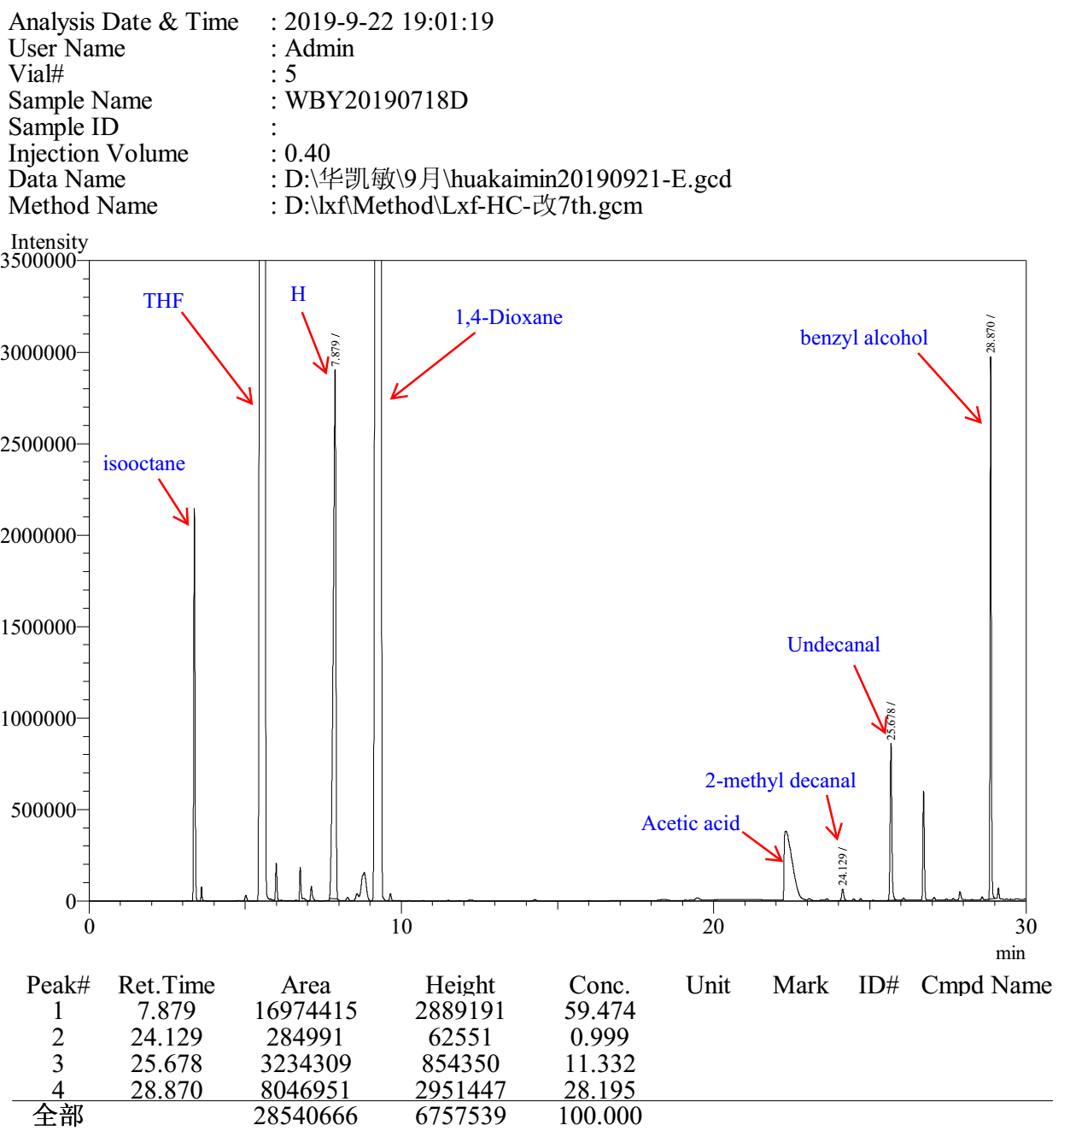

3.6 Gas chromatograms to Table S6

Entry 1

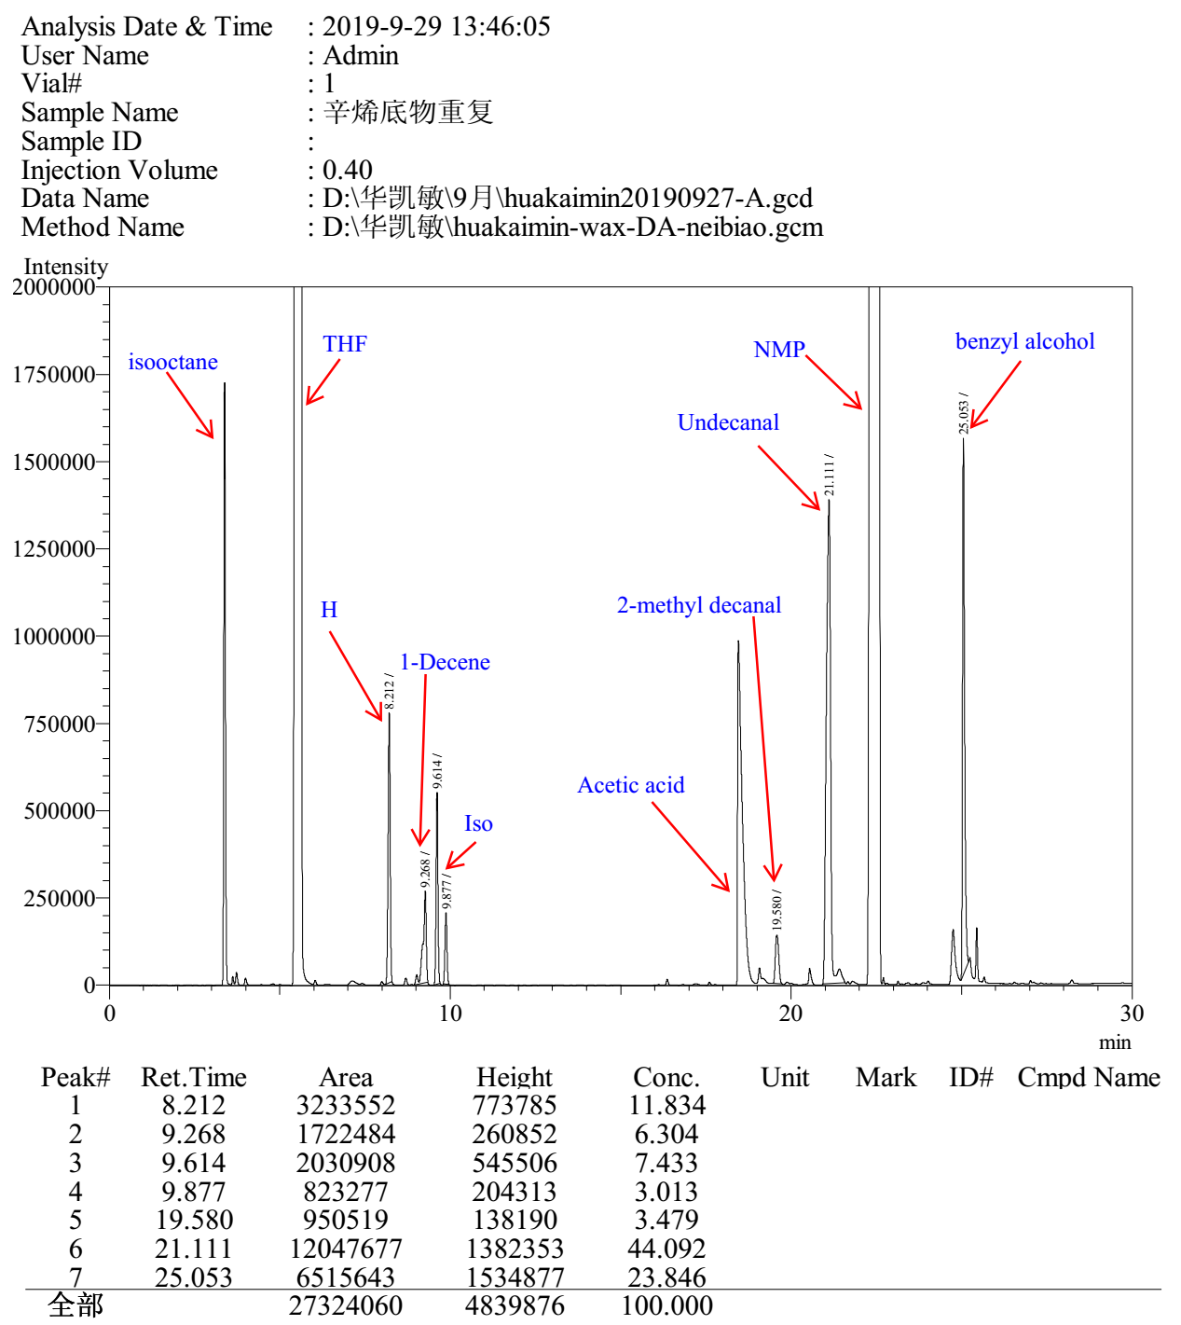

Entry 2

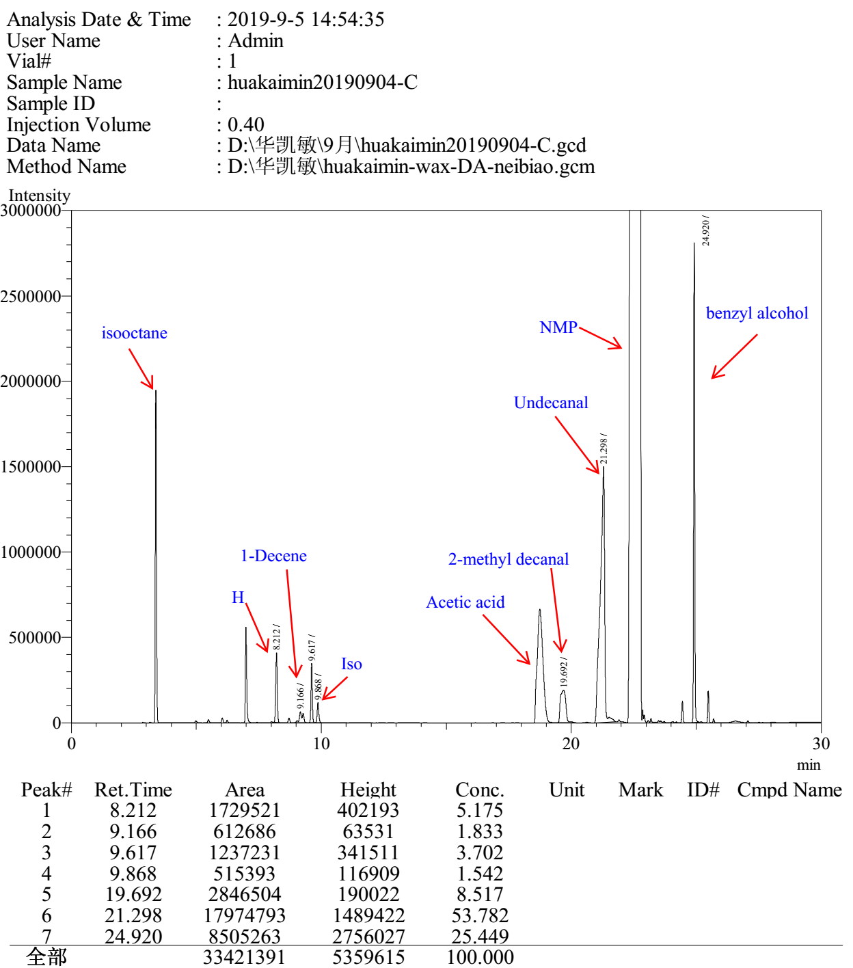

Entry 3

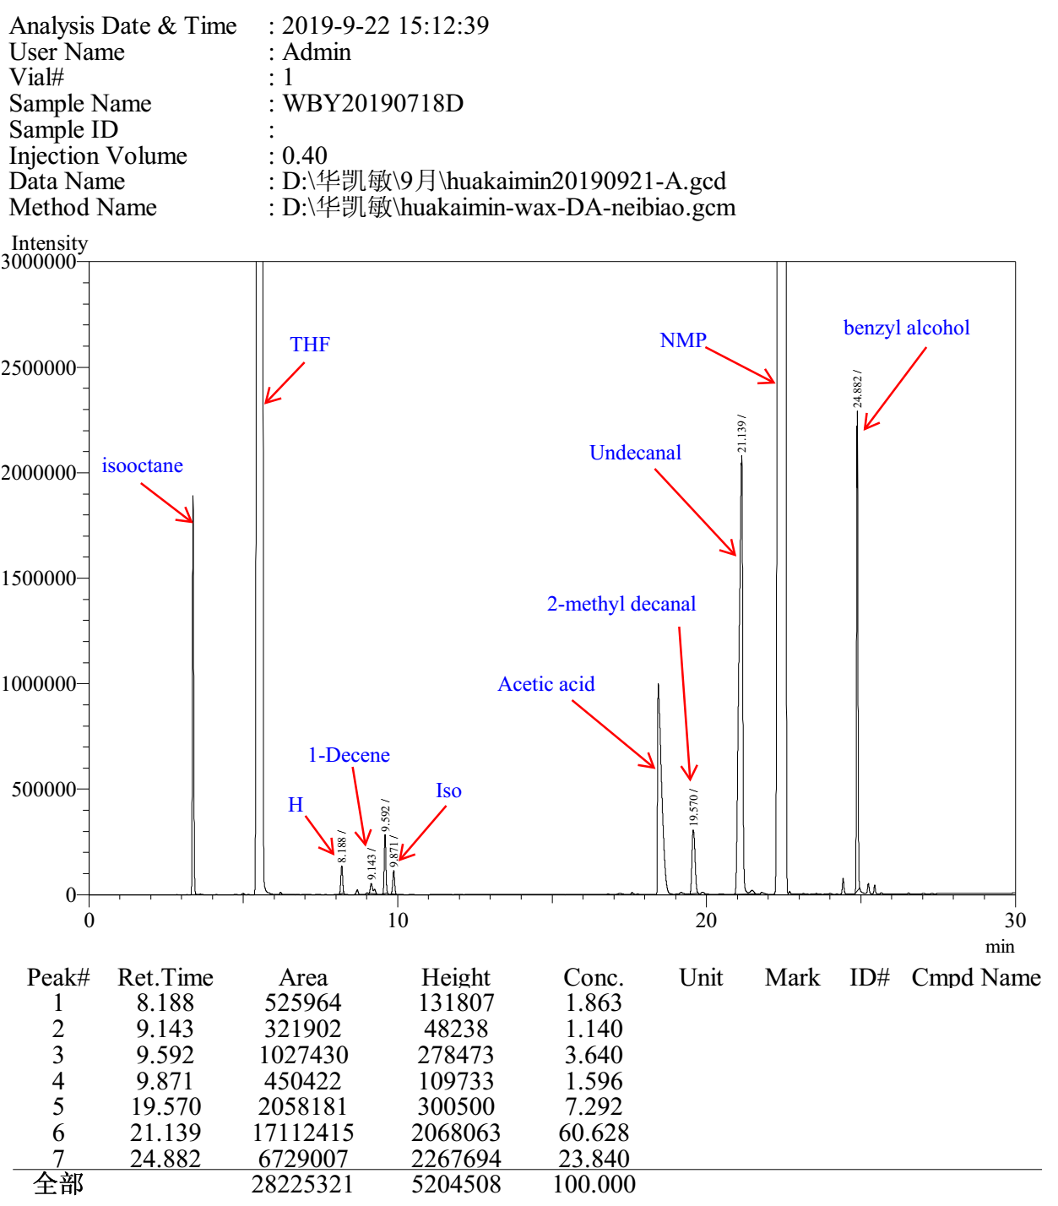

Entry 4

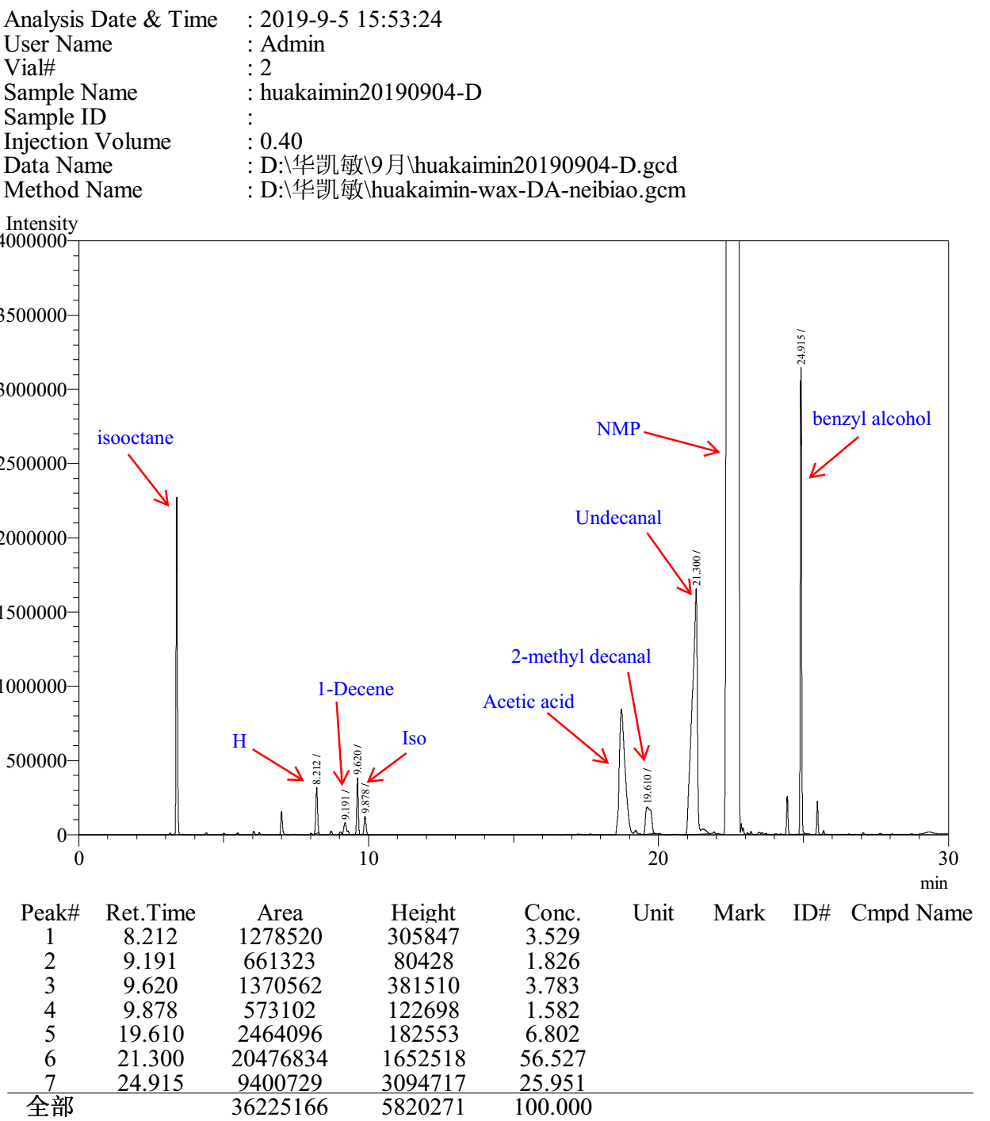

Entry 5

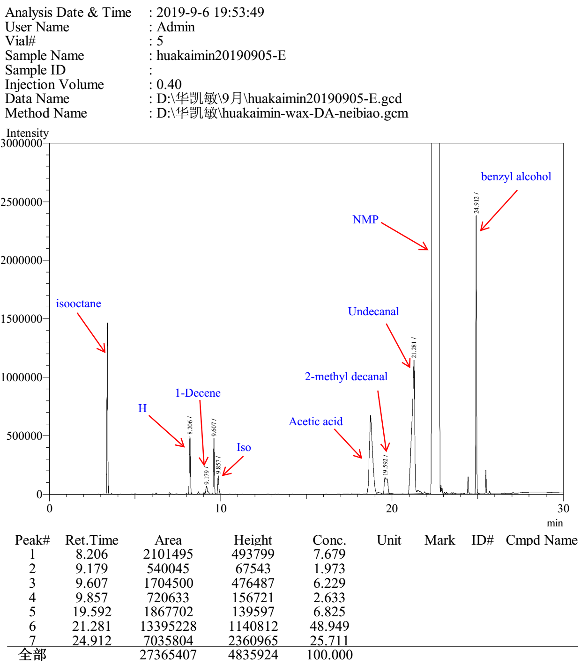

Entry 6

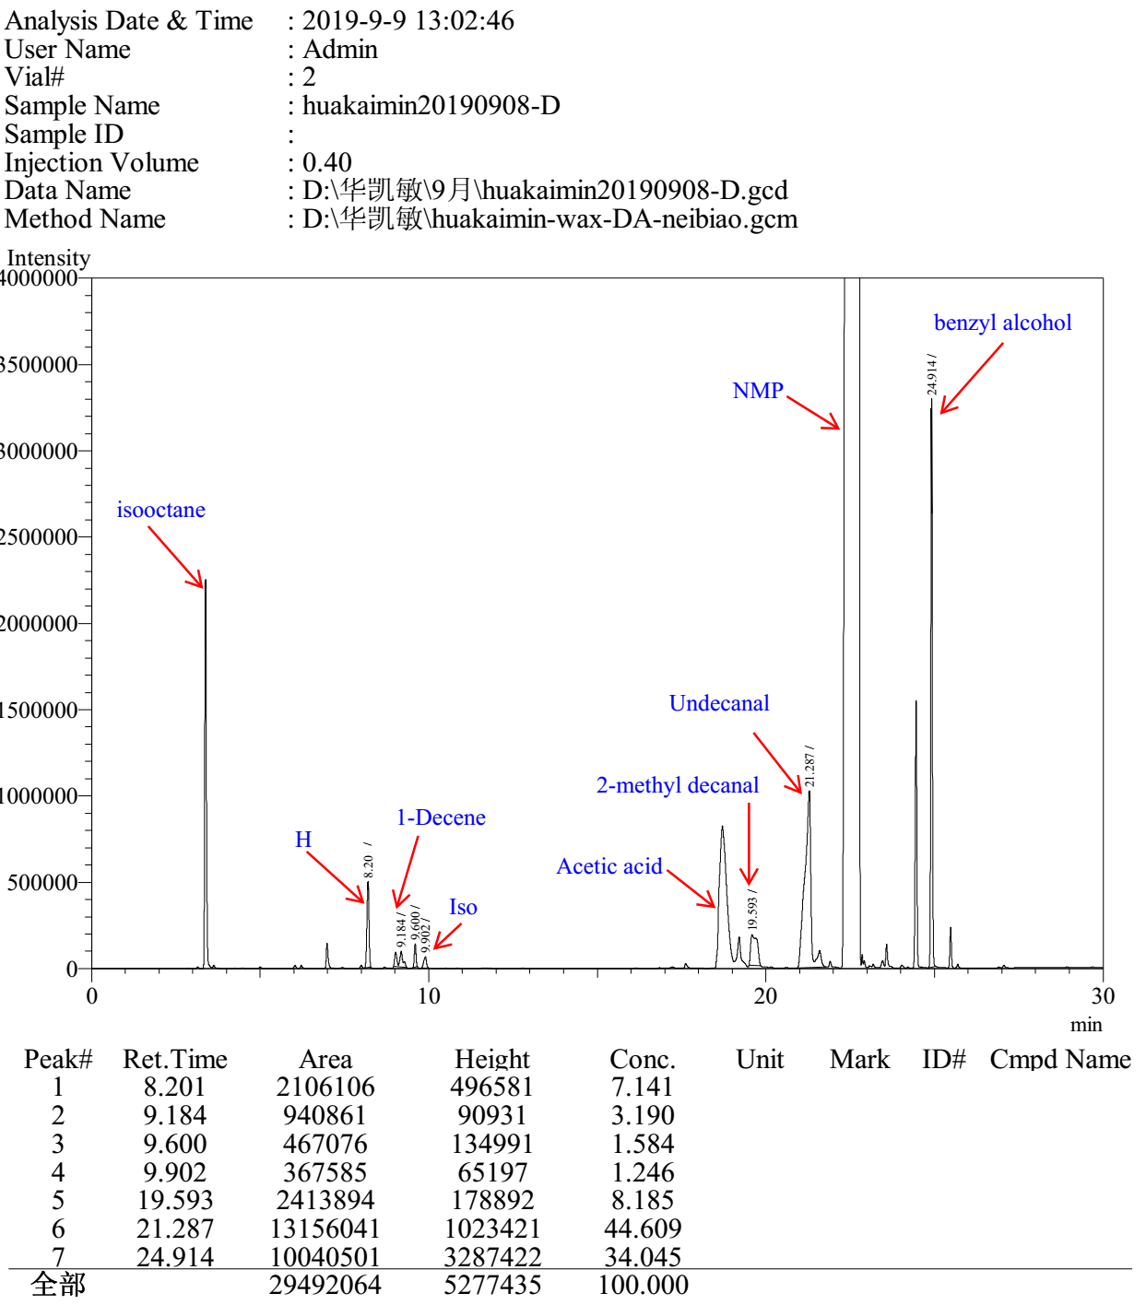

3.7 Gas chromatograms to Table S7

Entry 1

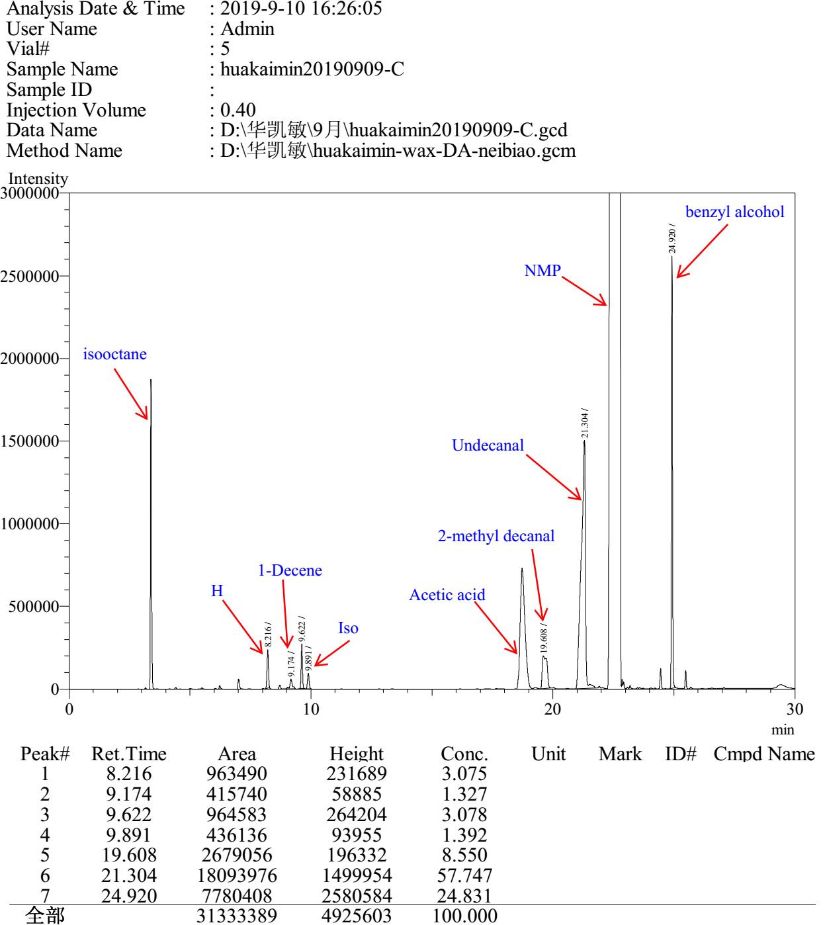

Entry 2

Entry 3

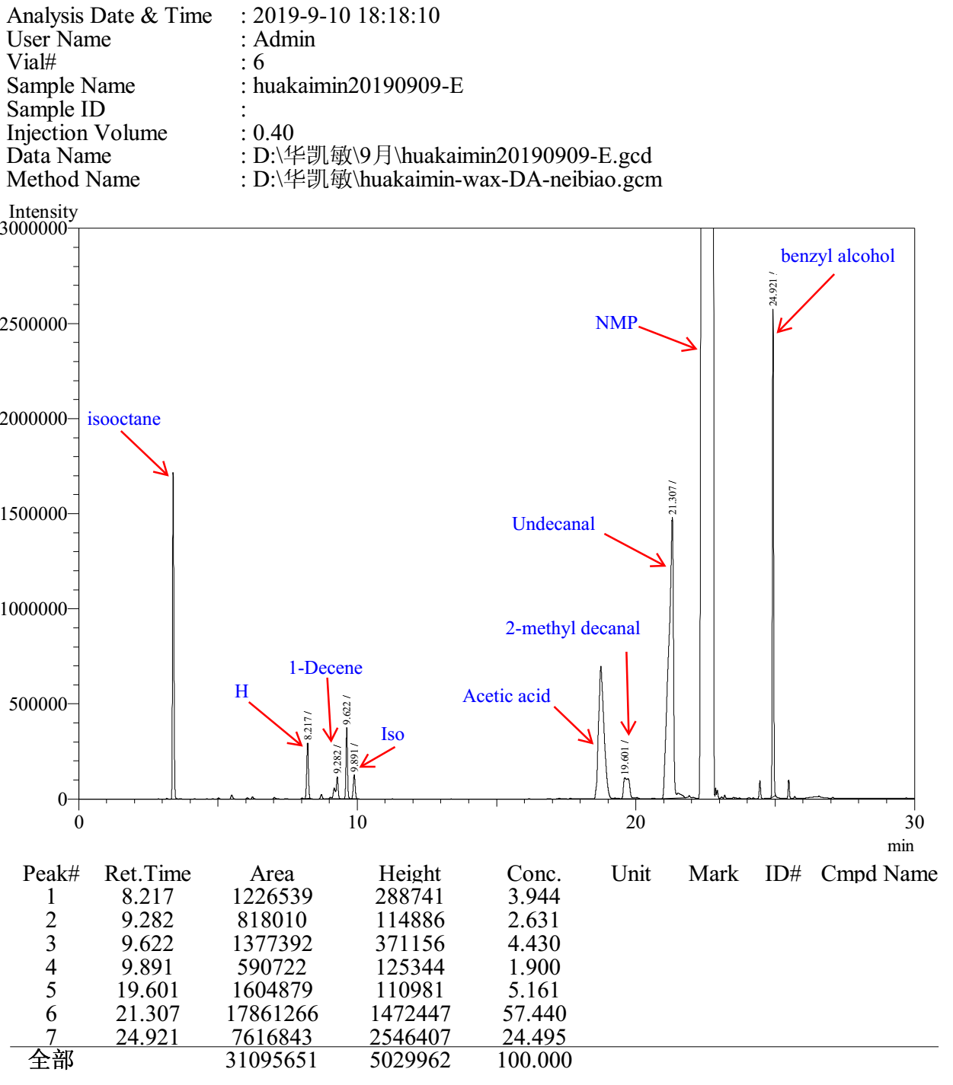

Entry 4

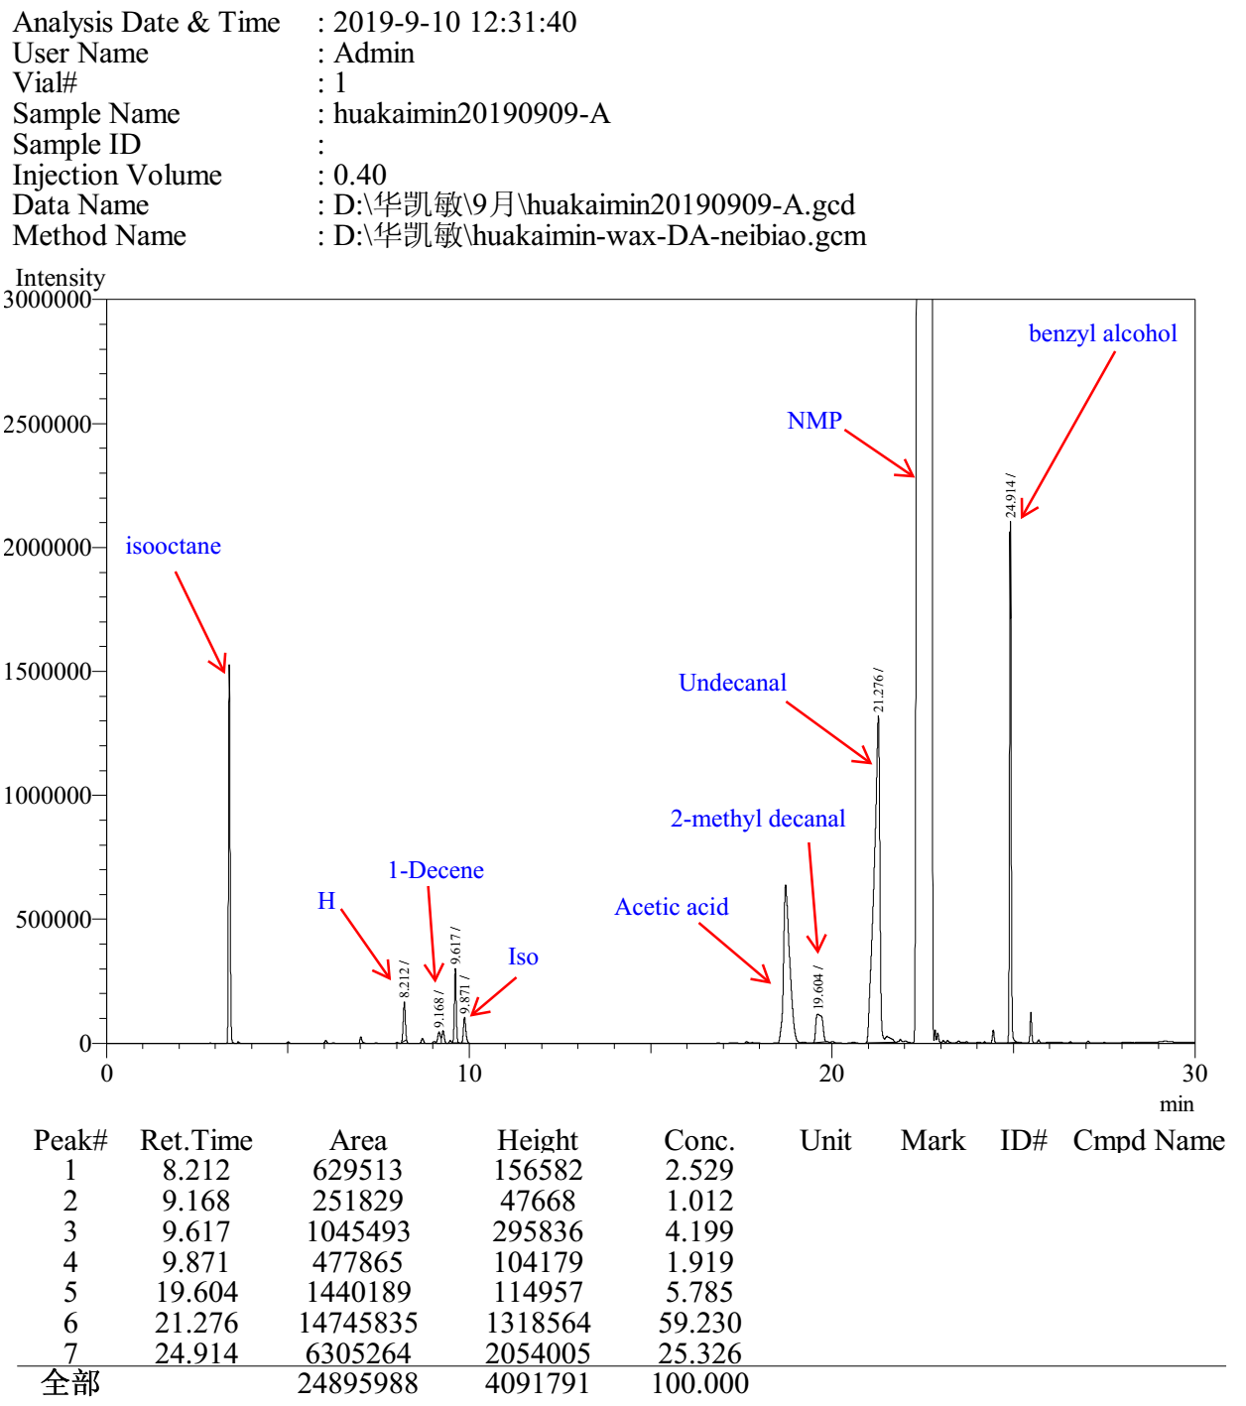

Entry 5

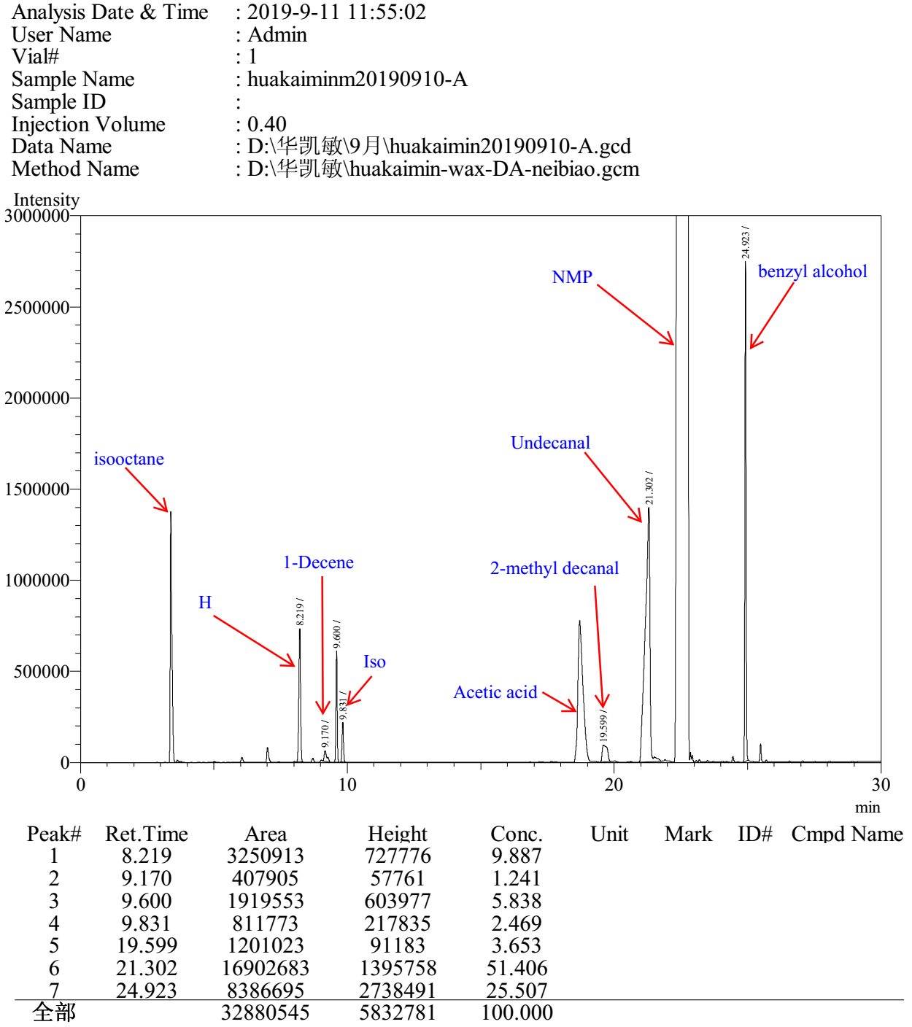

Entry 6

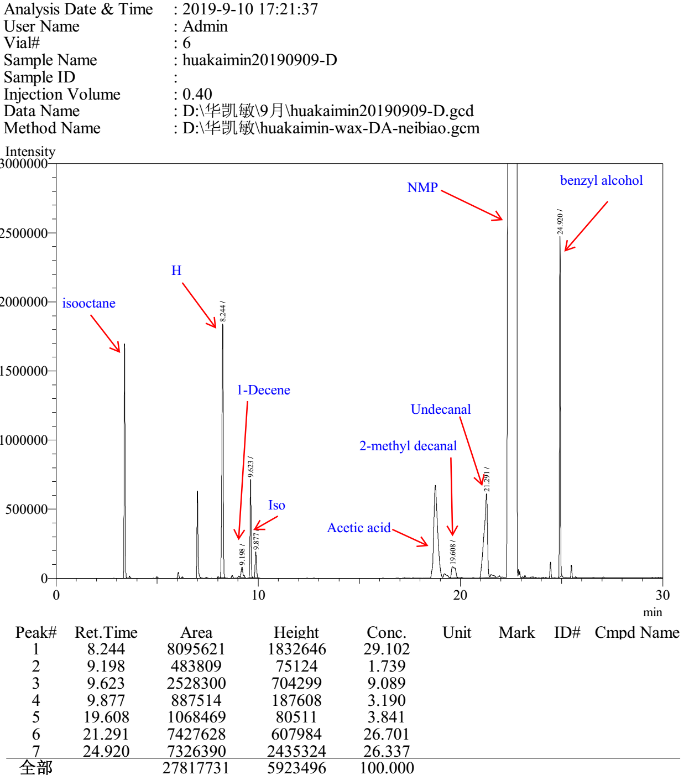

3.8 Gas chromatograms to Table S8

Entry 1

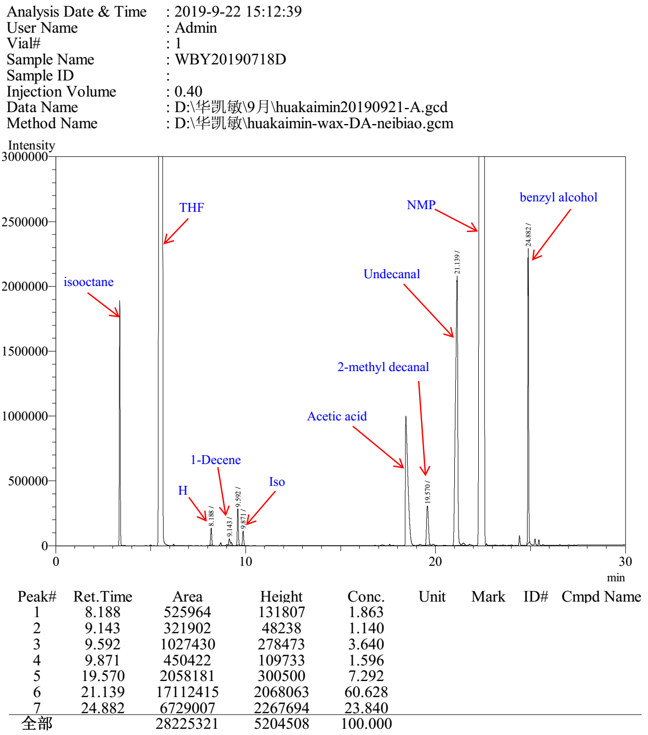

Entry 2

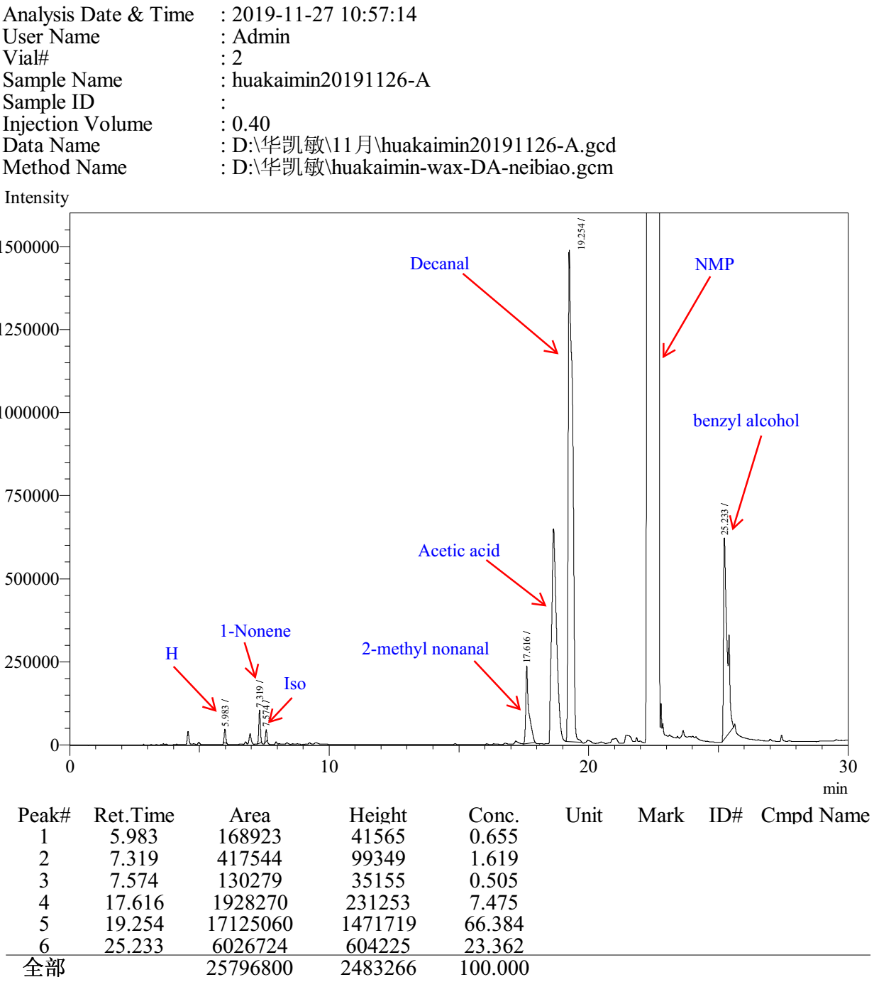

Entry 3

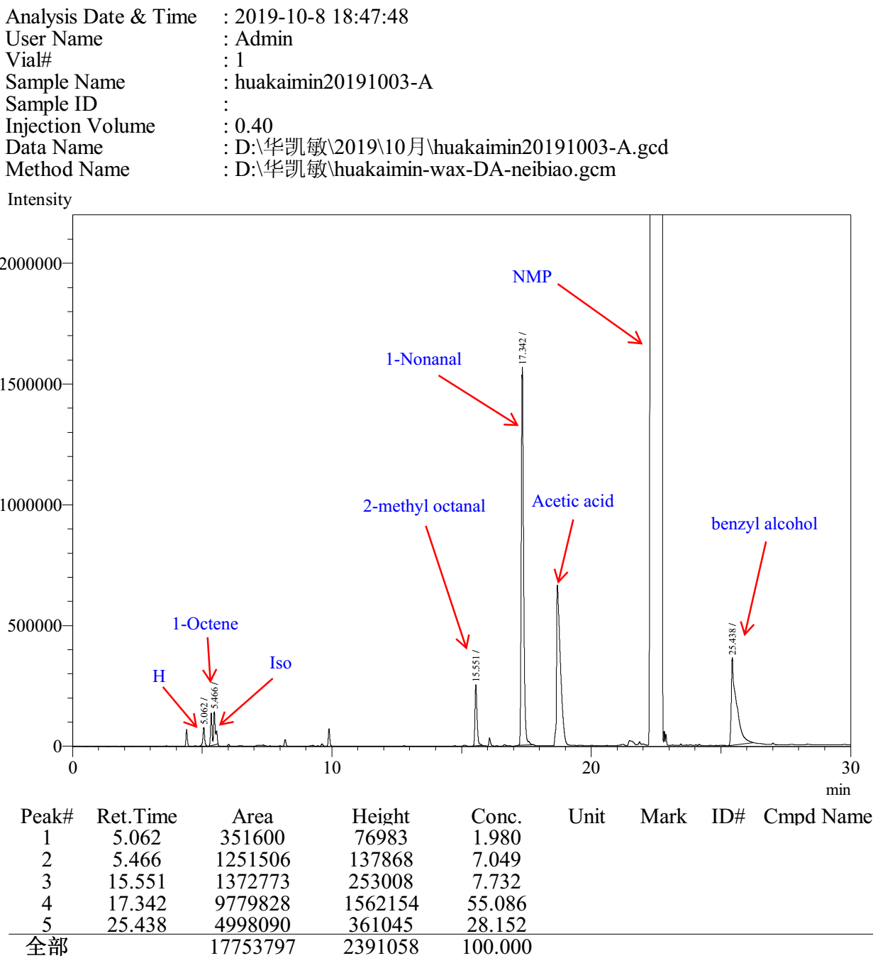

Entry 4

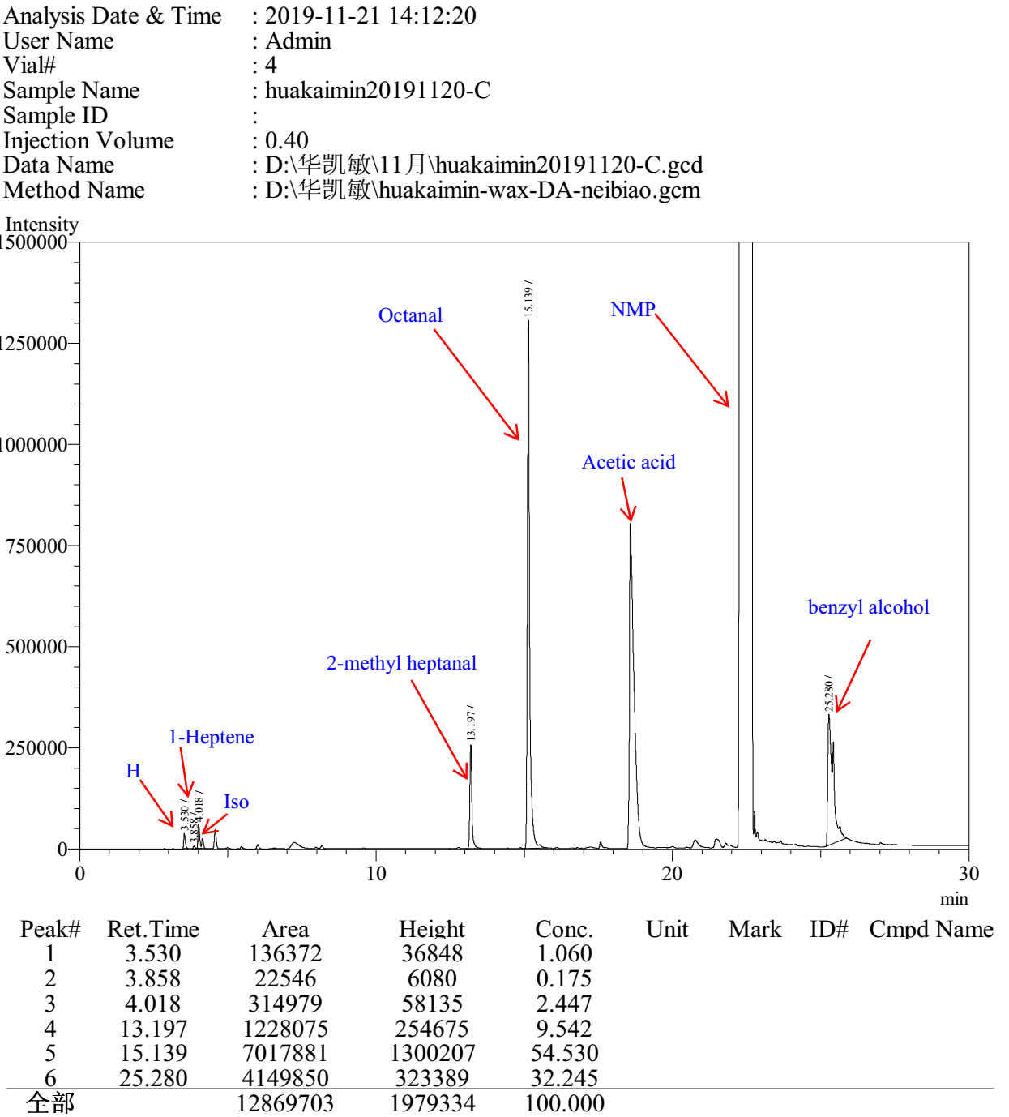

Entry 5

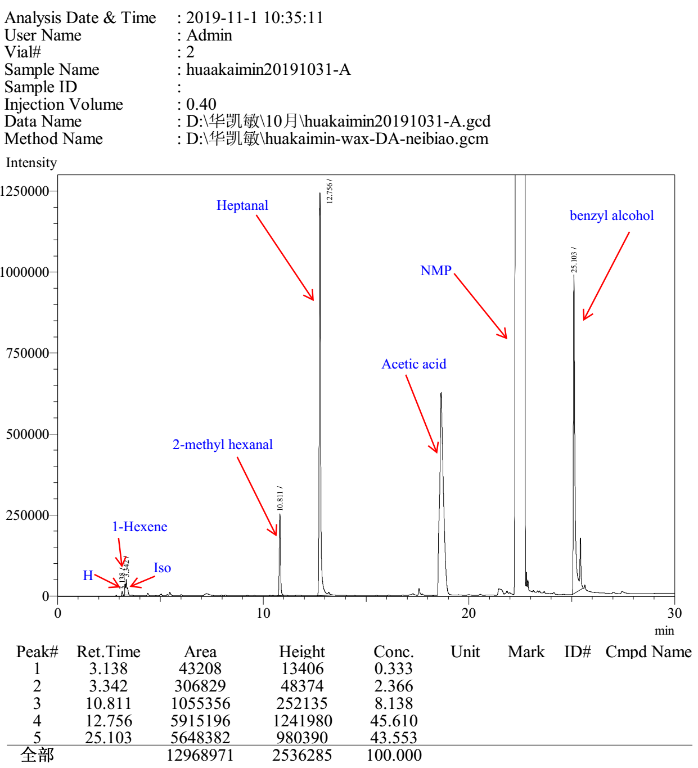

Entry 6

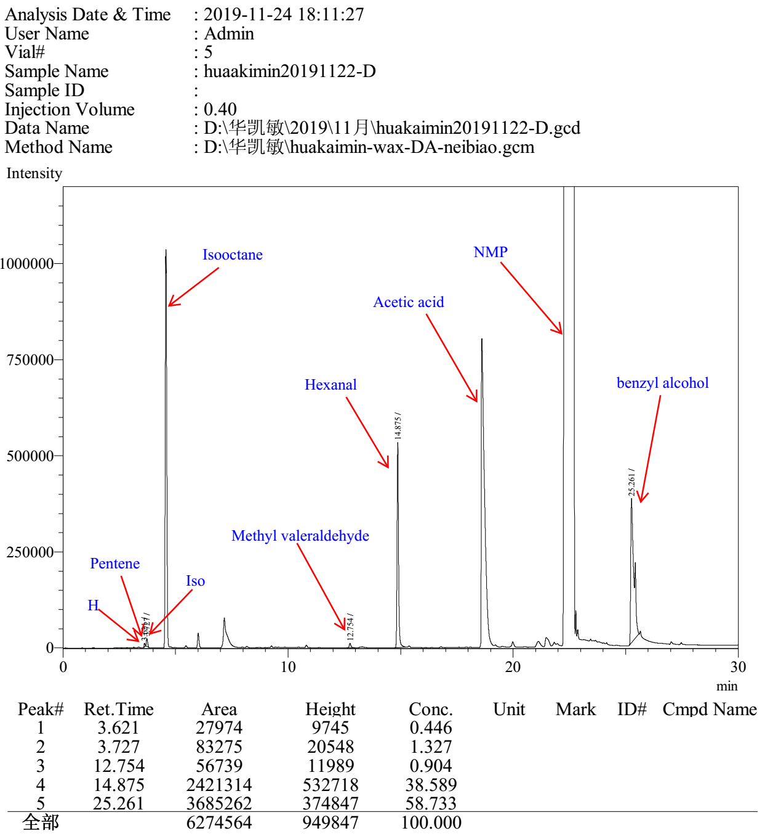

Entry 7

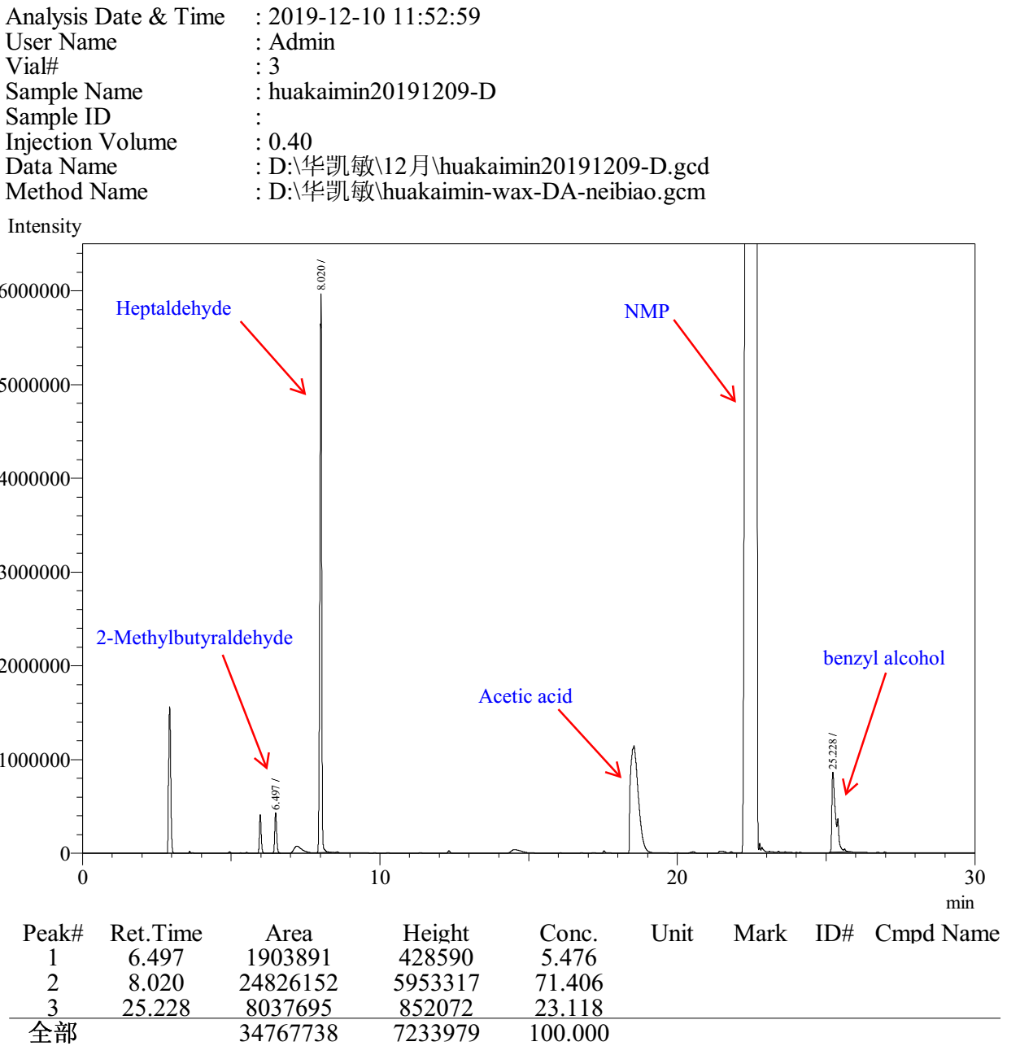

Entry 8

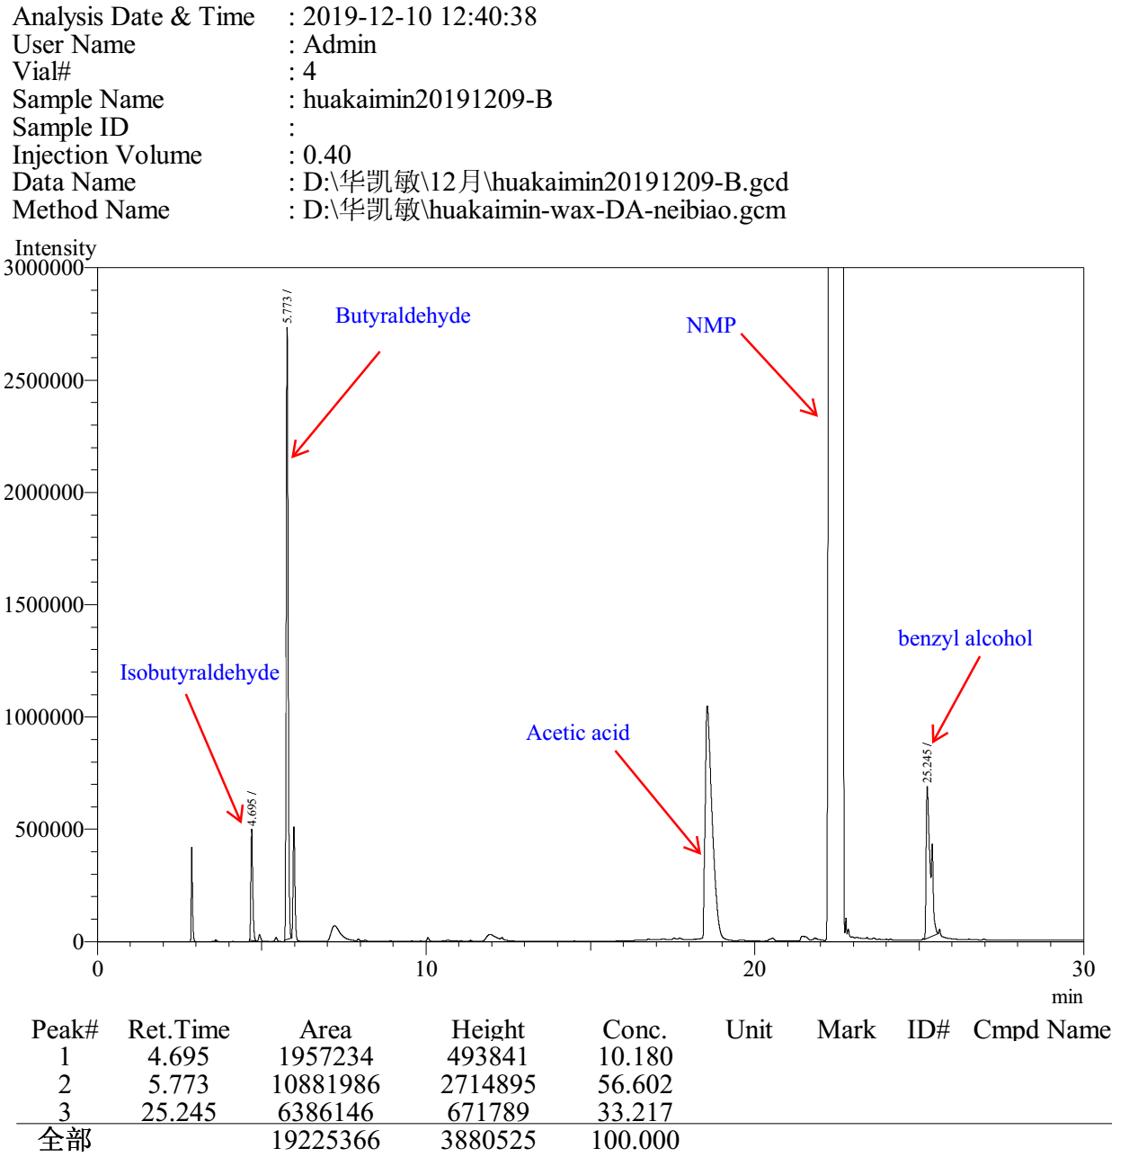

Entry 9

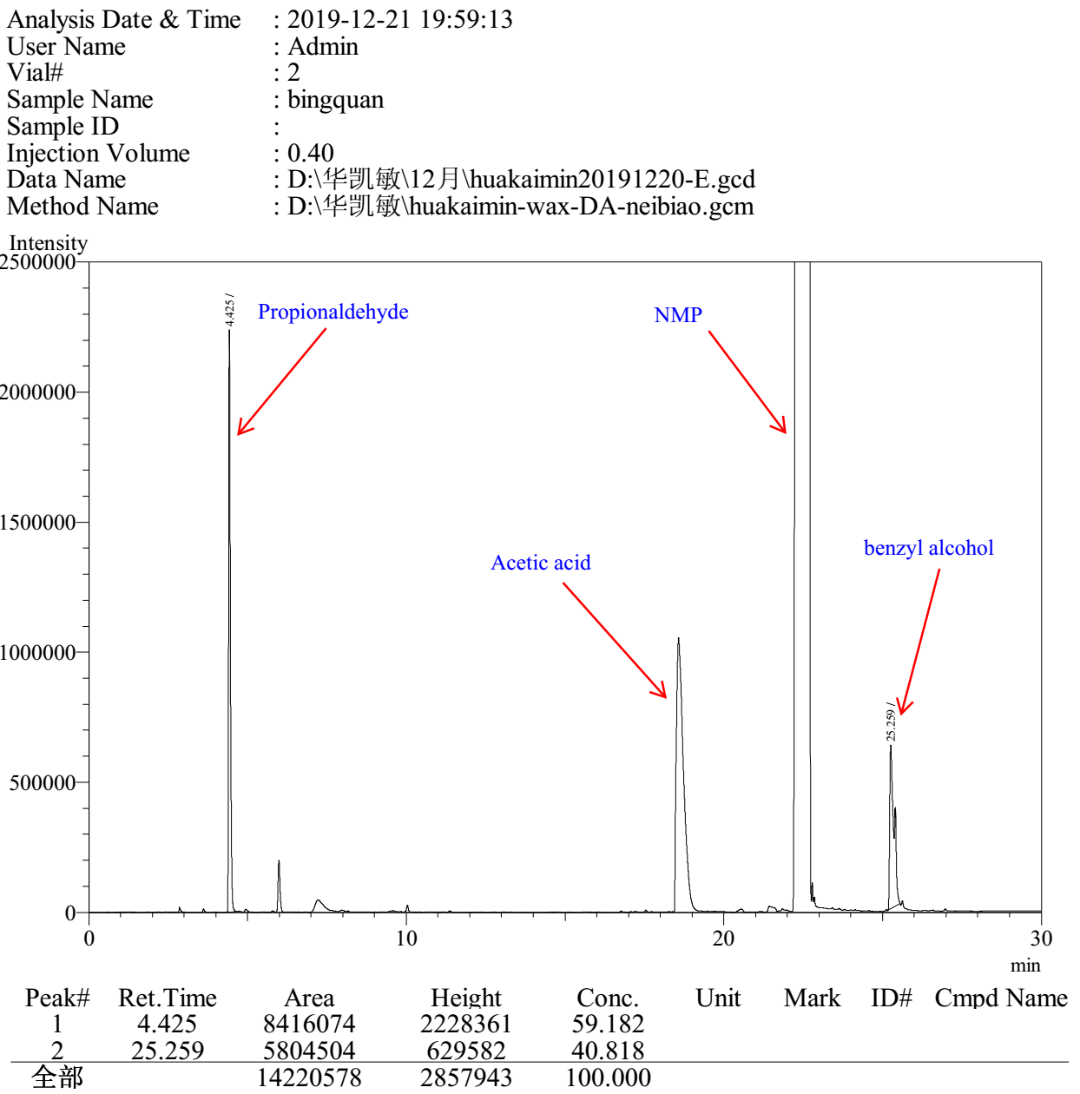

Entry 10

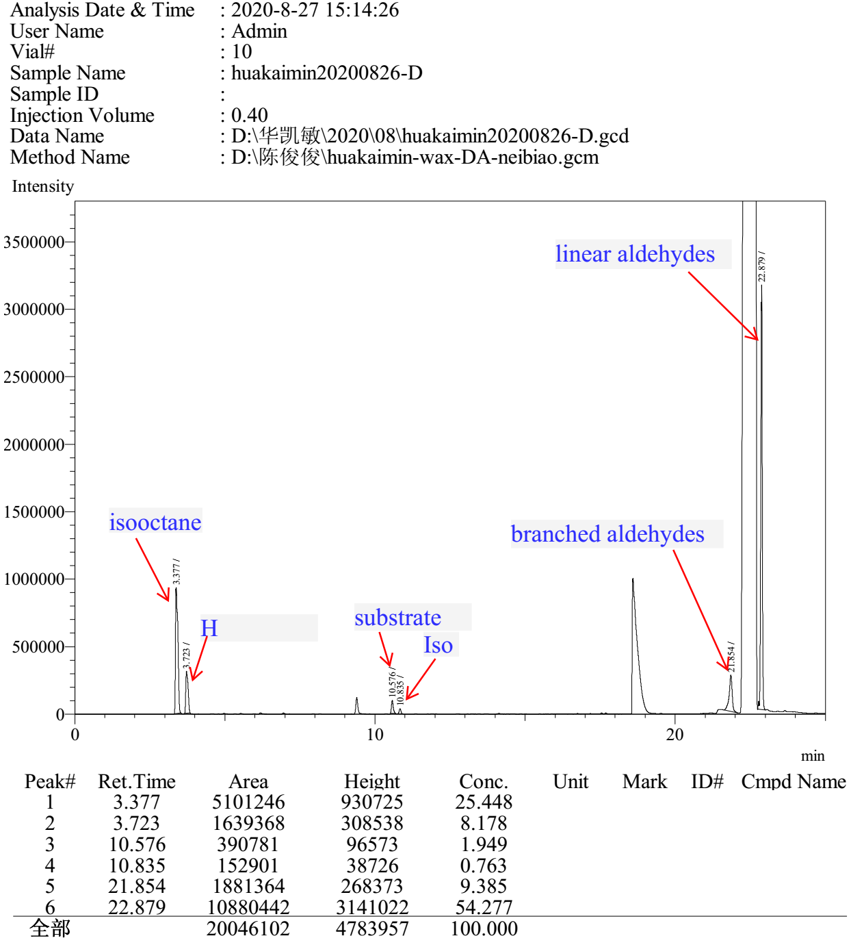

Entry 11

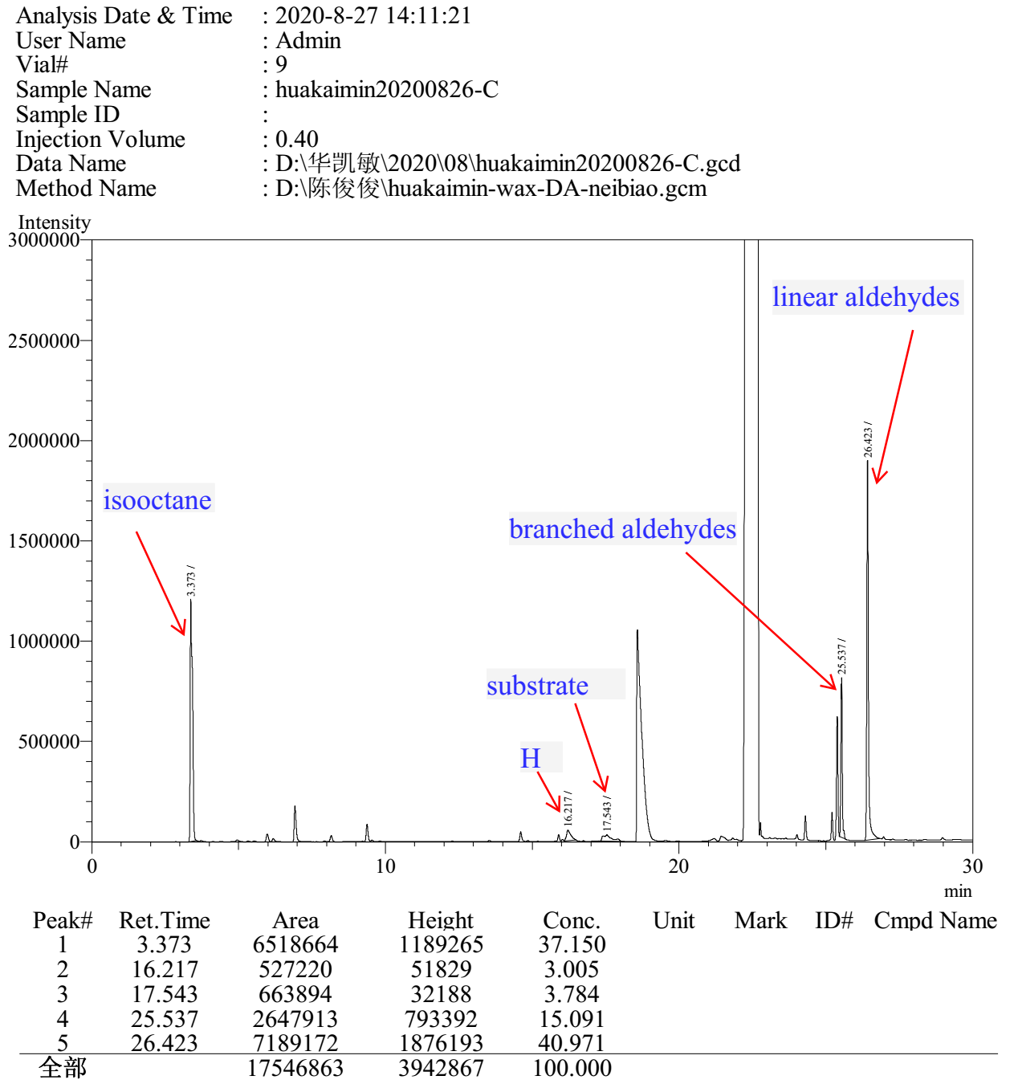

Entry 12

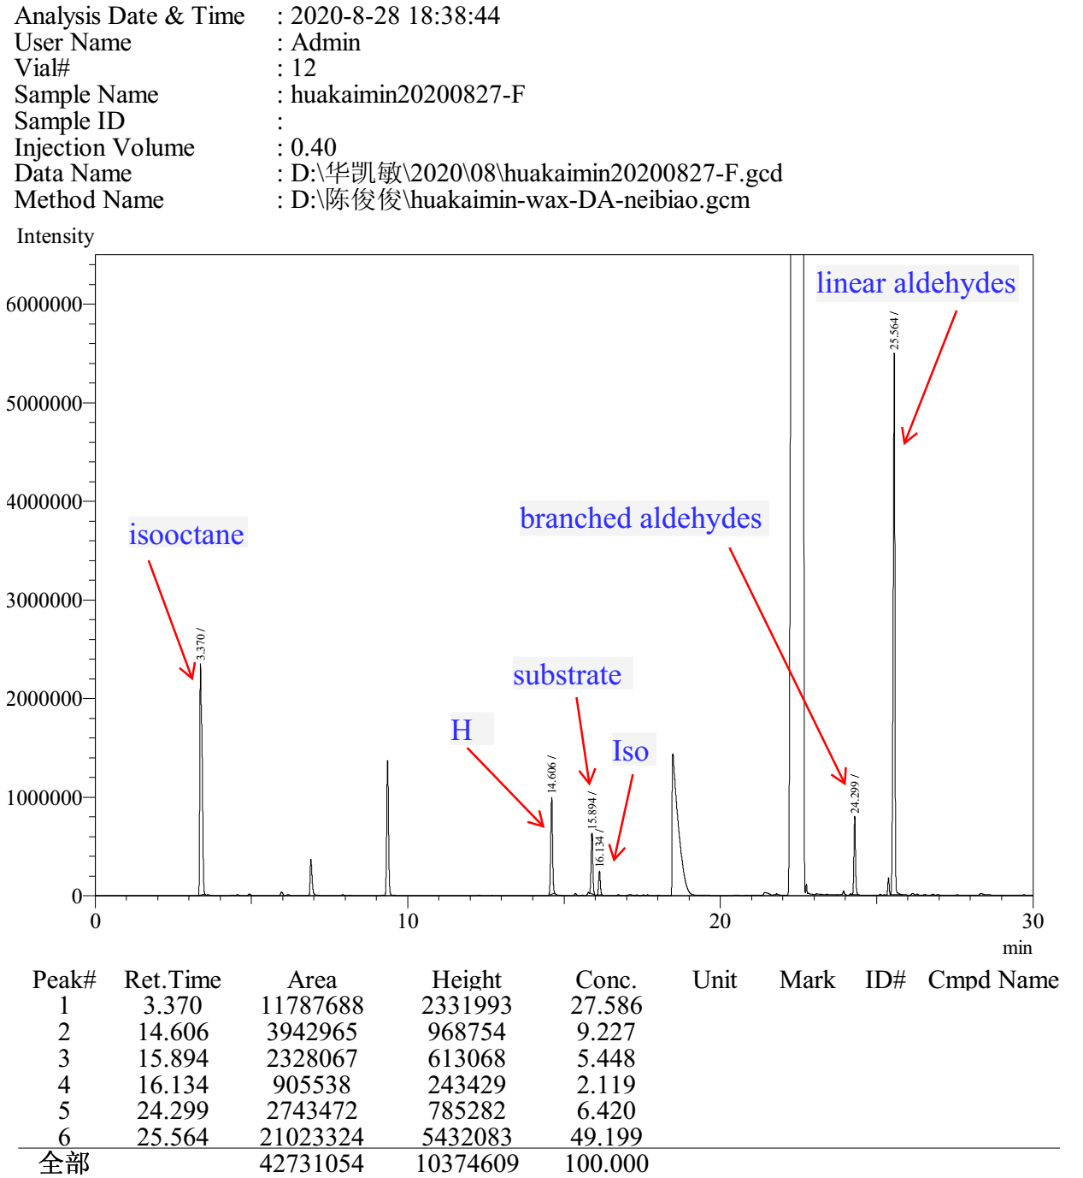
Entry 13

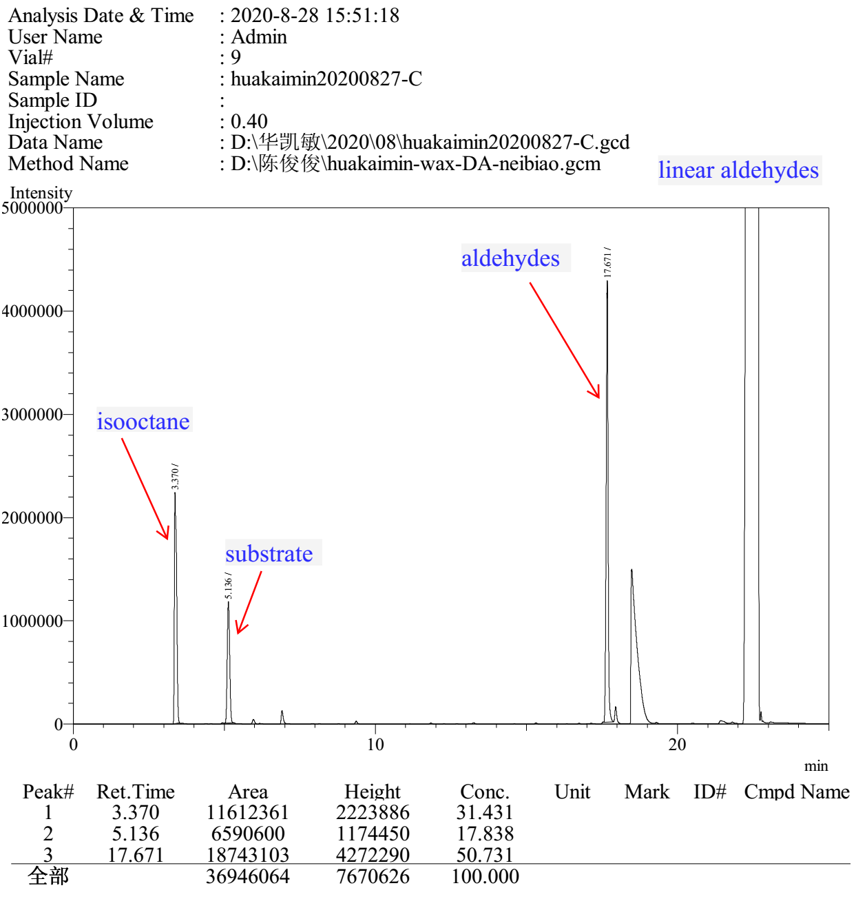

Entry 14

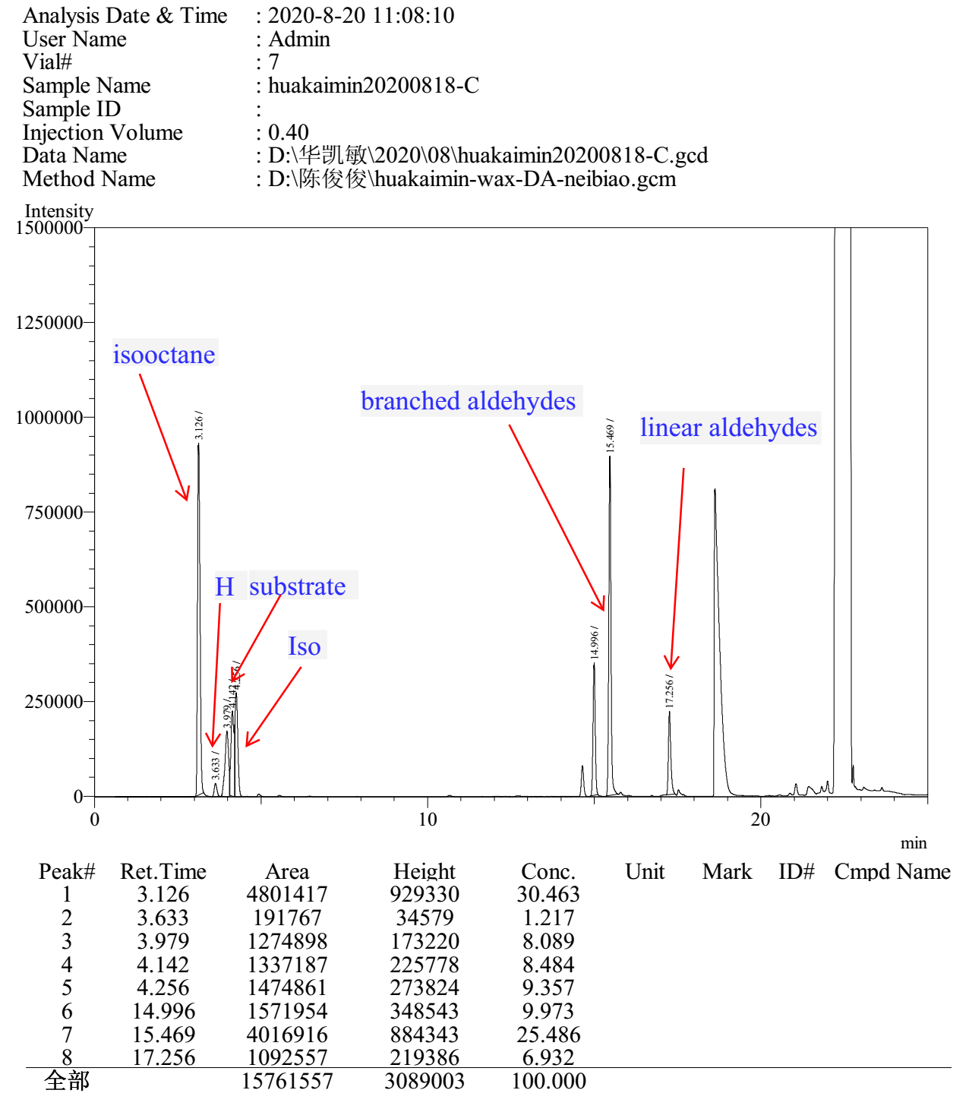

Entry 15

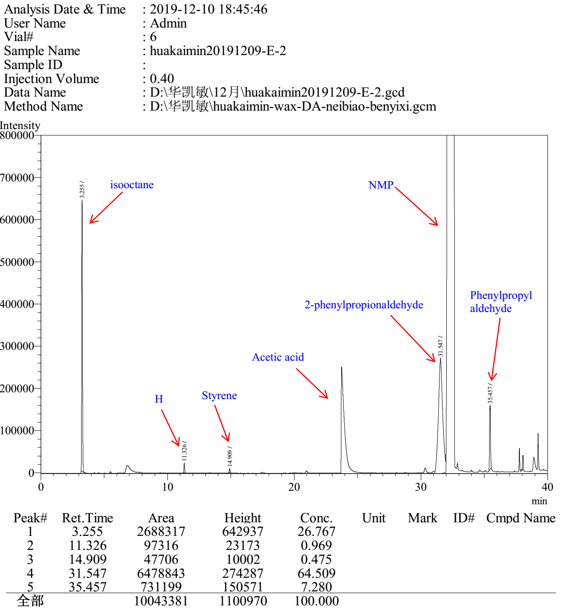

Entry 16

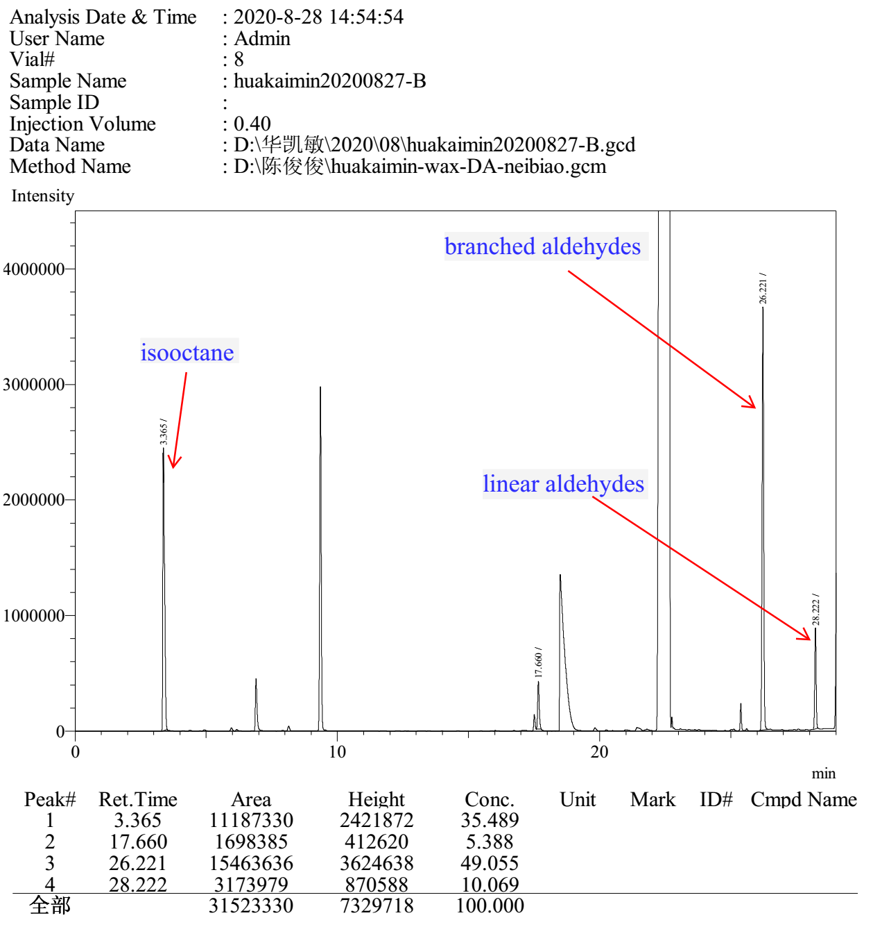

Entry 17

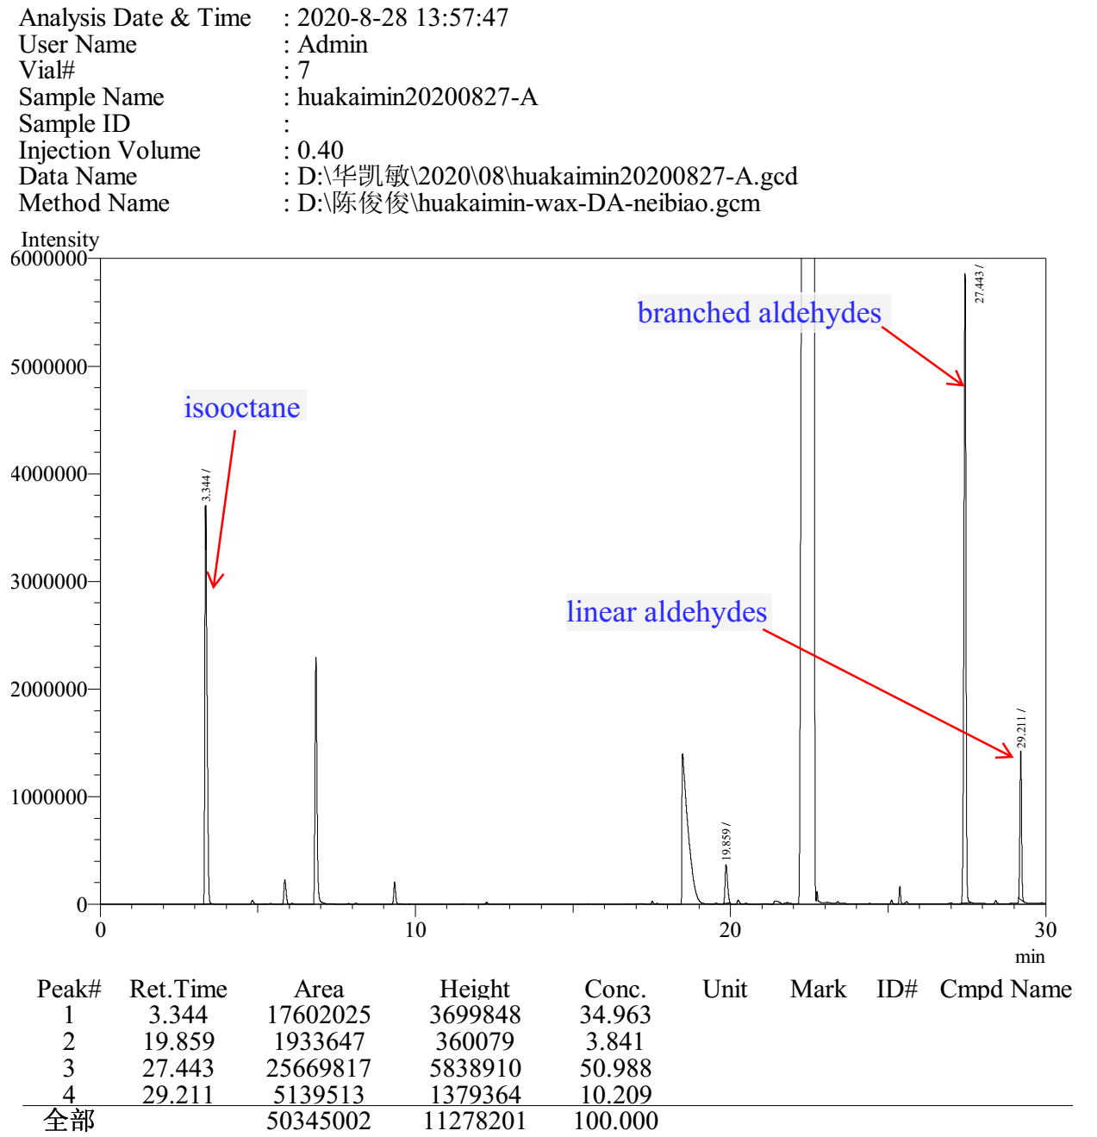

3.9 Gas chromatograms to Table S9

PPh₃ Entry 1

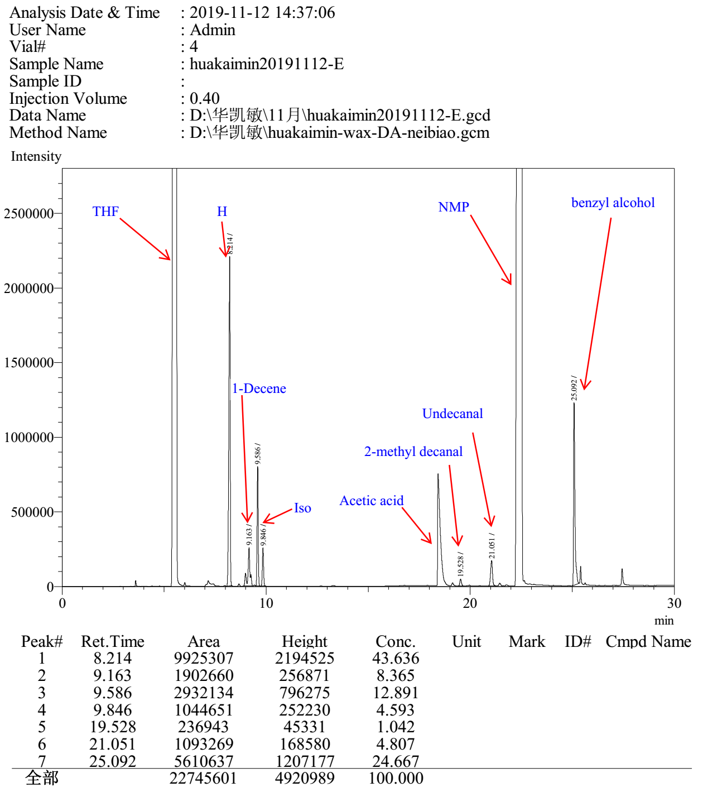

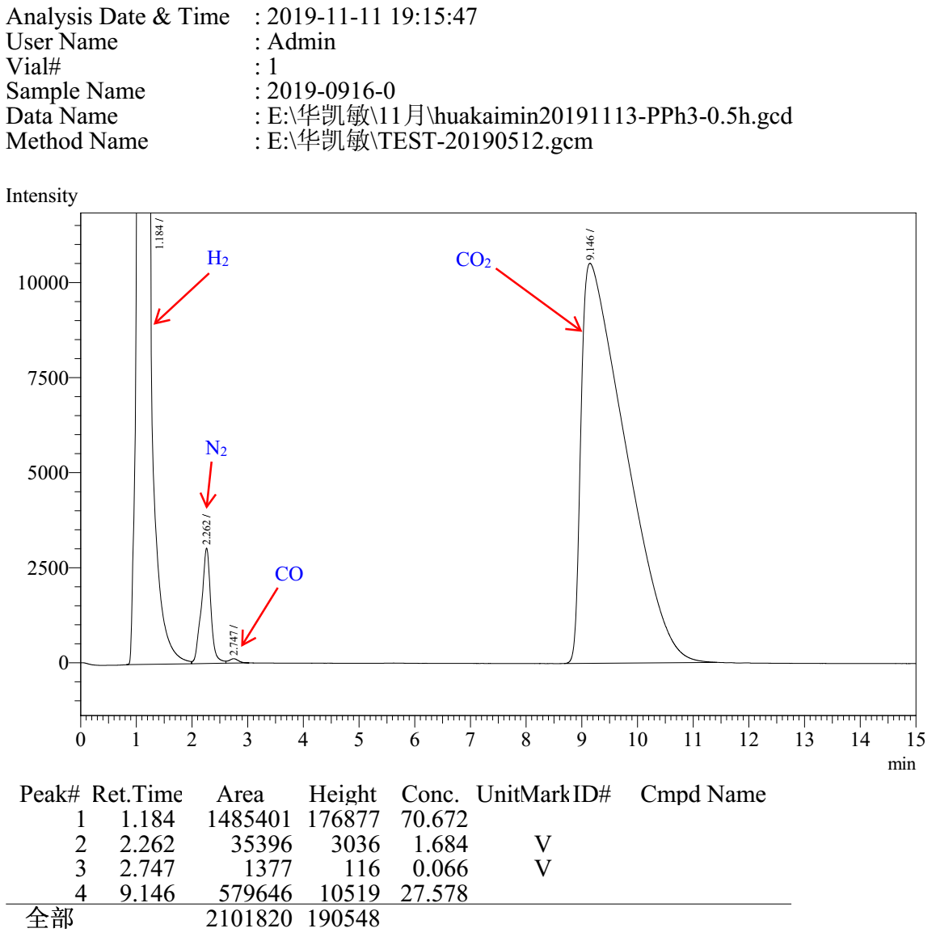

PPh₃ Entry 2

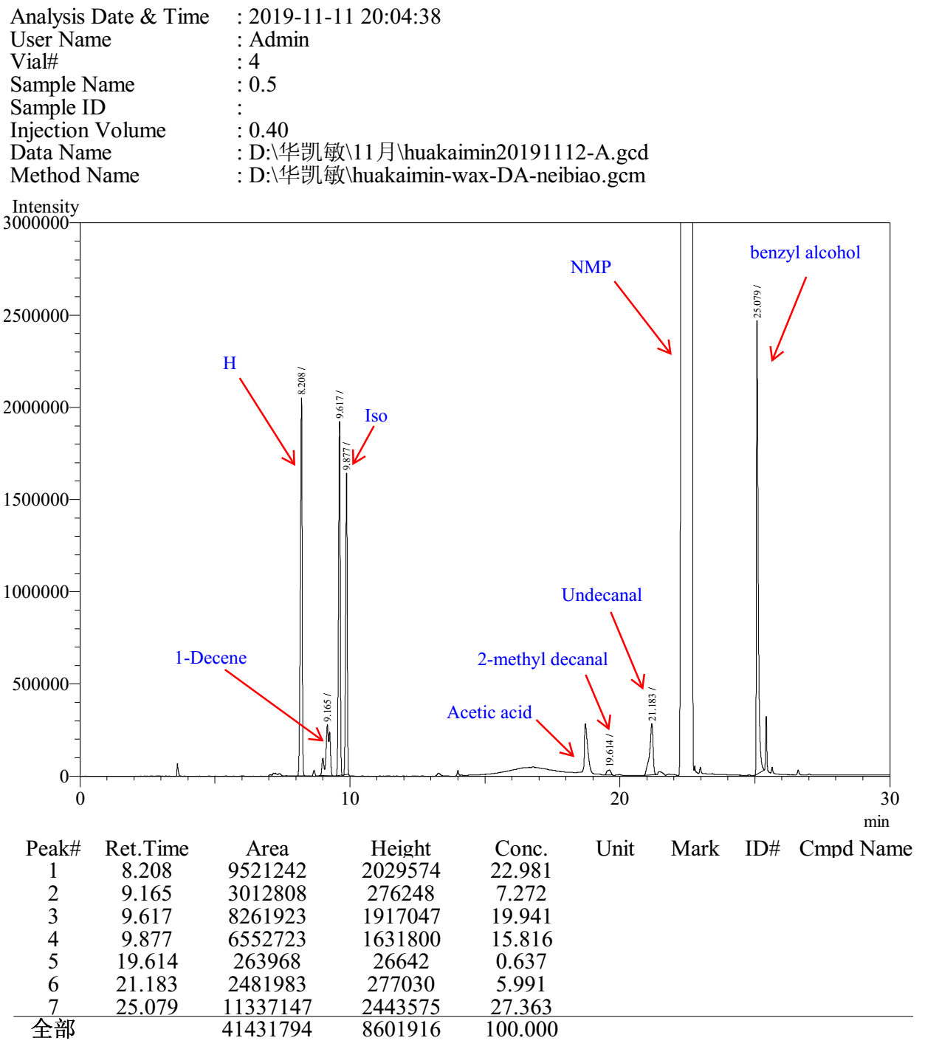

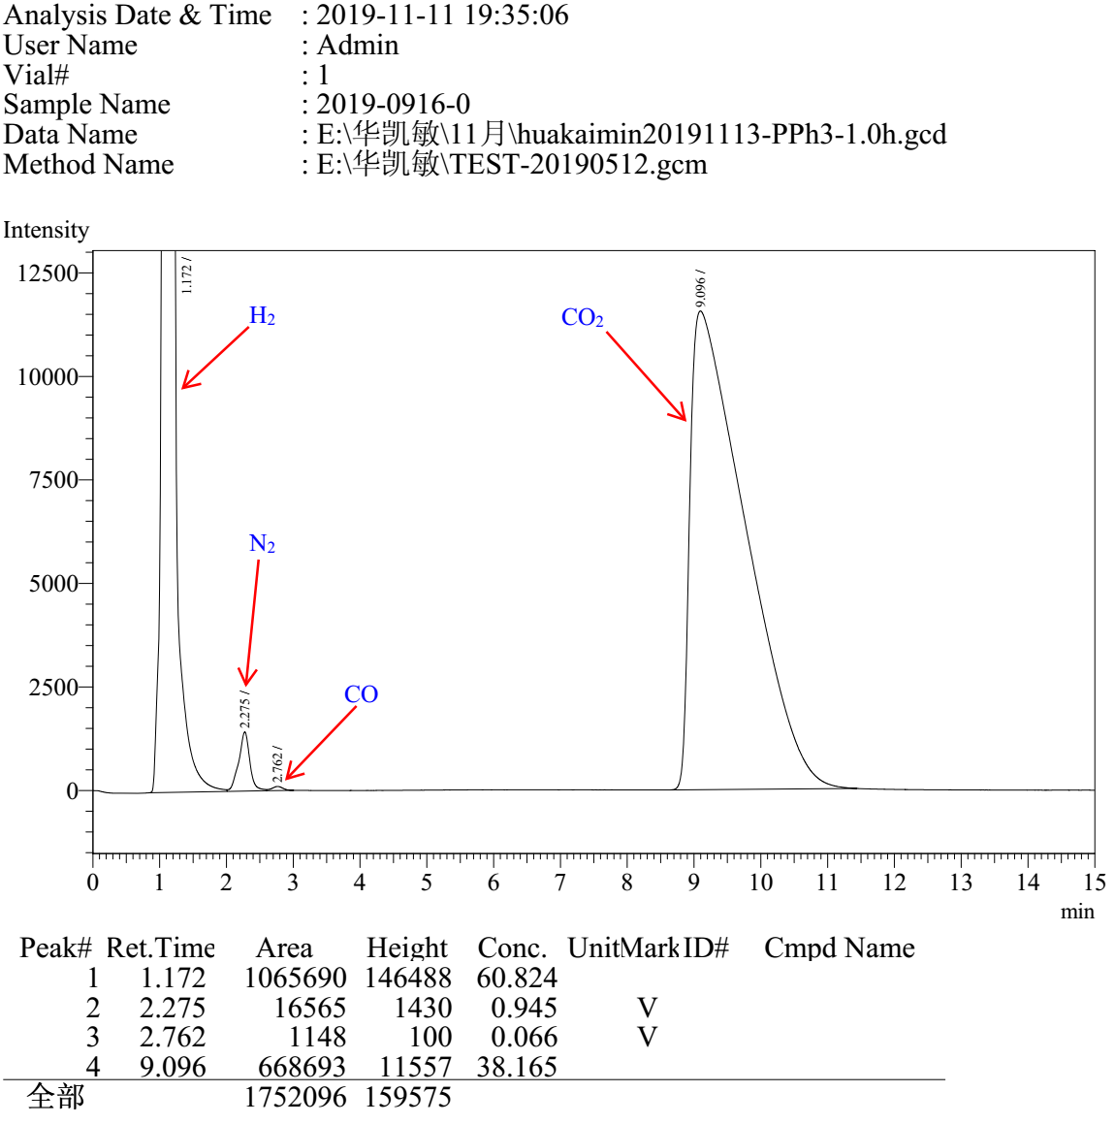

PPh₃ Entry 3

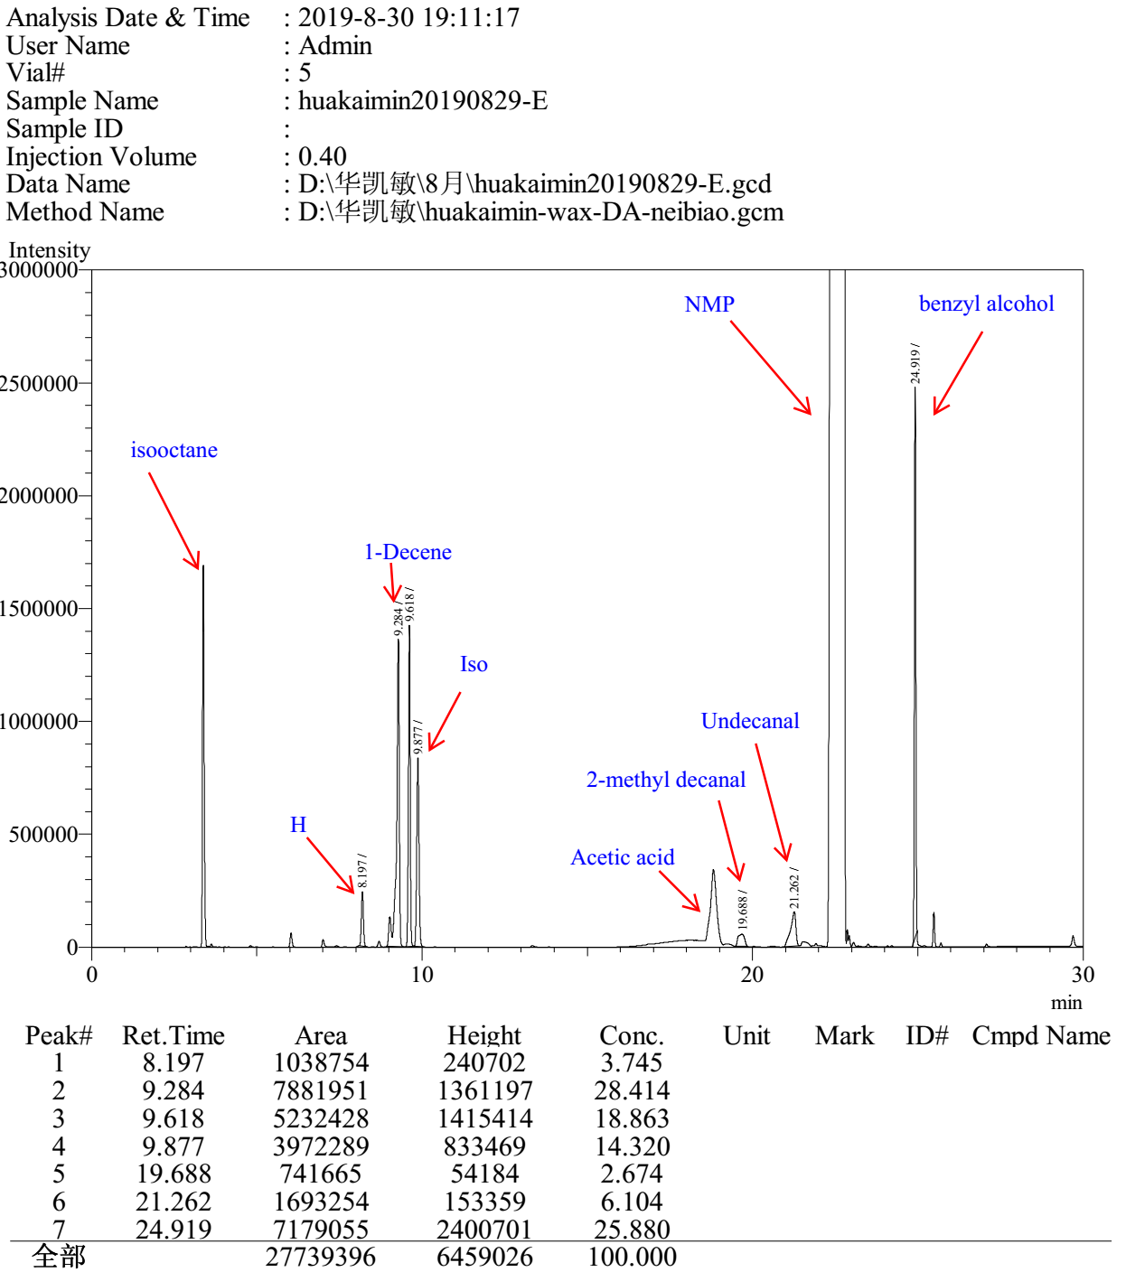

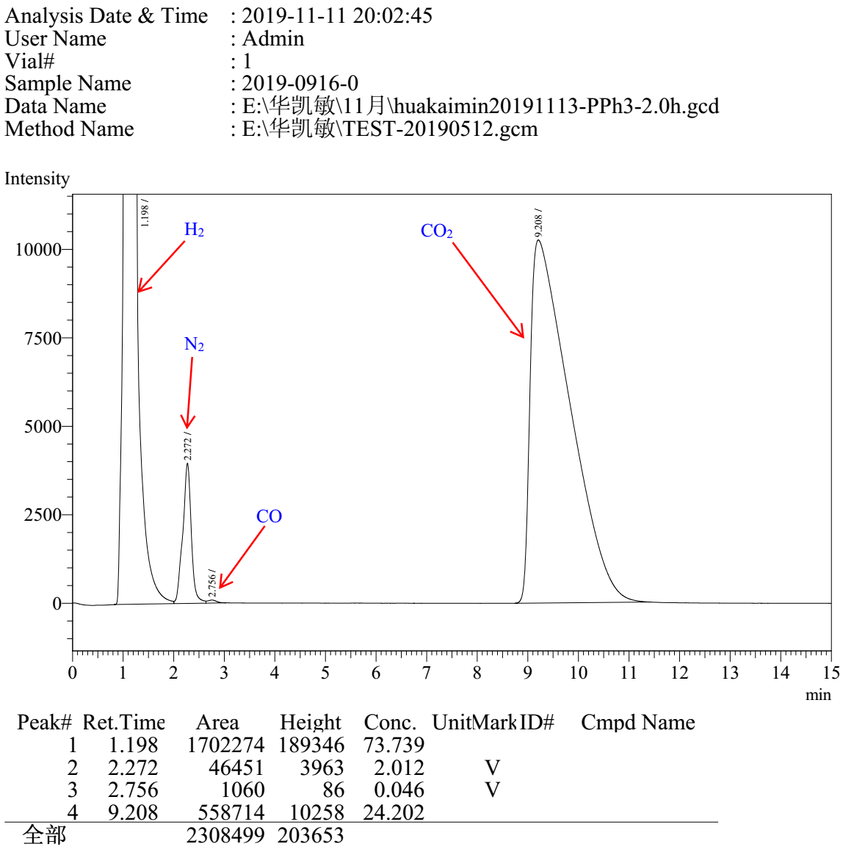

PPh₃ Entry 4

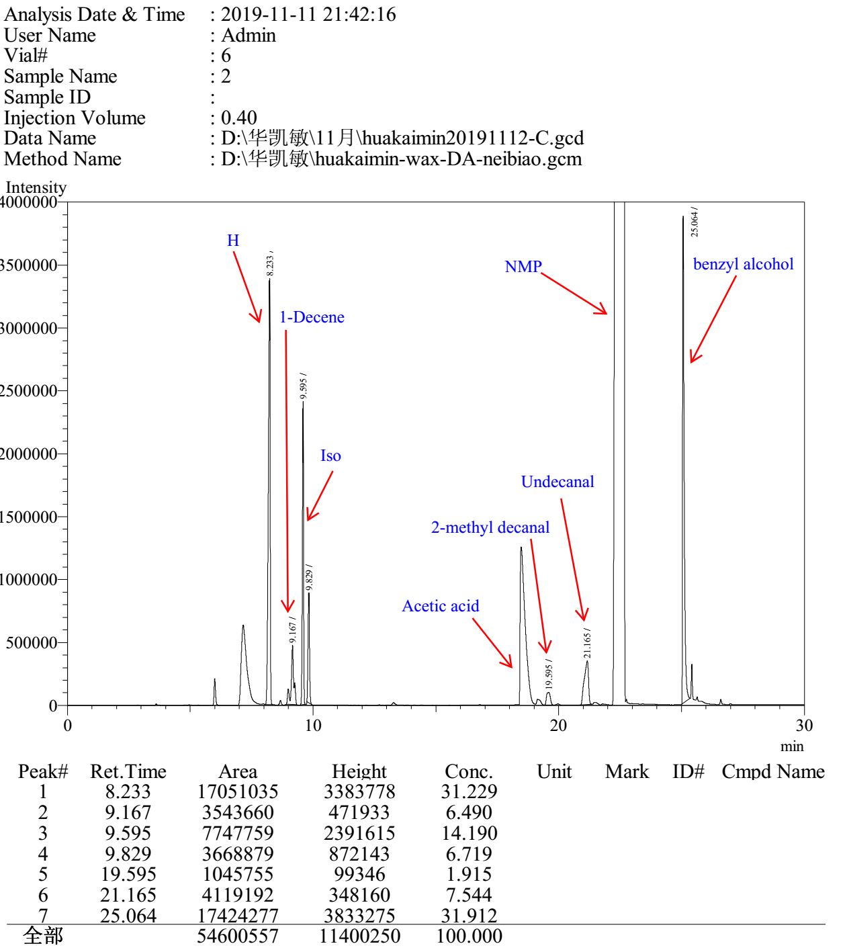

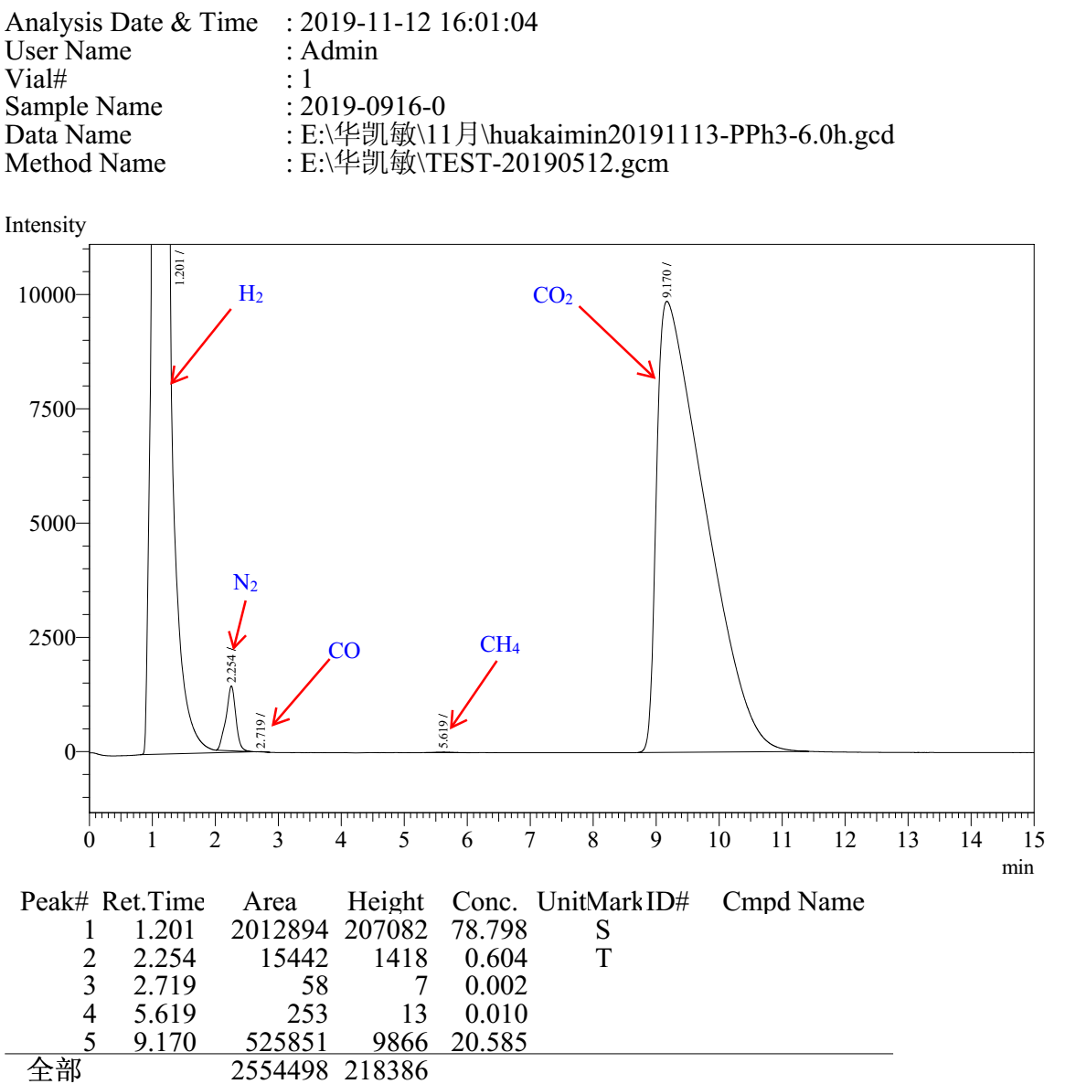

PPh₃ Entry 5

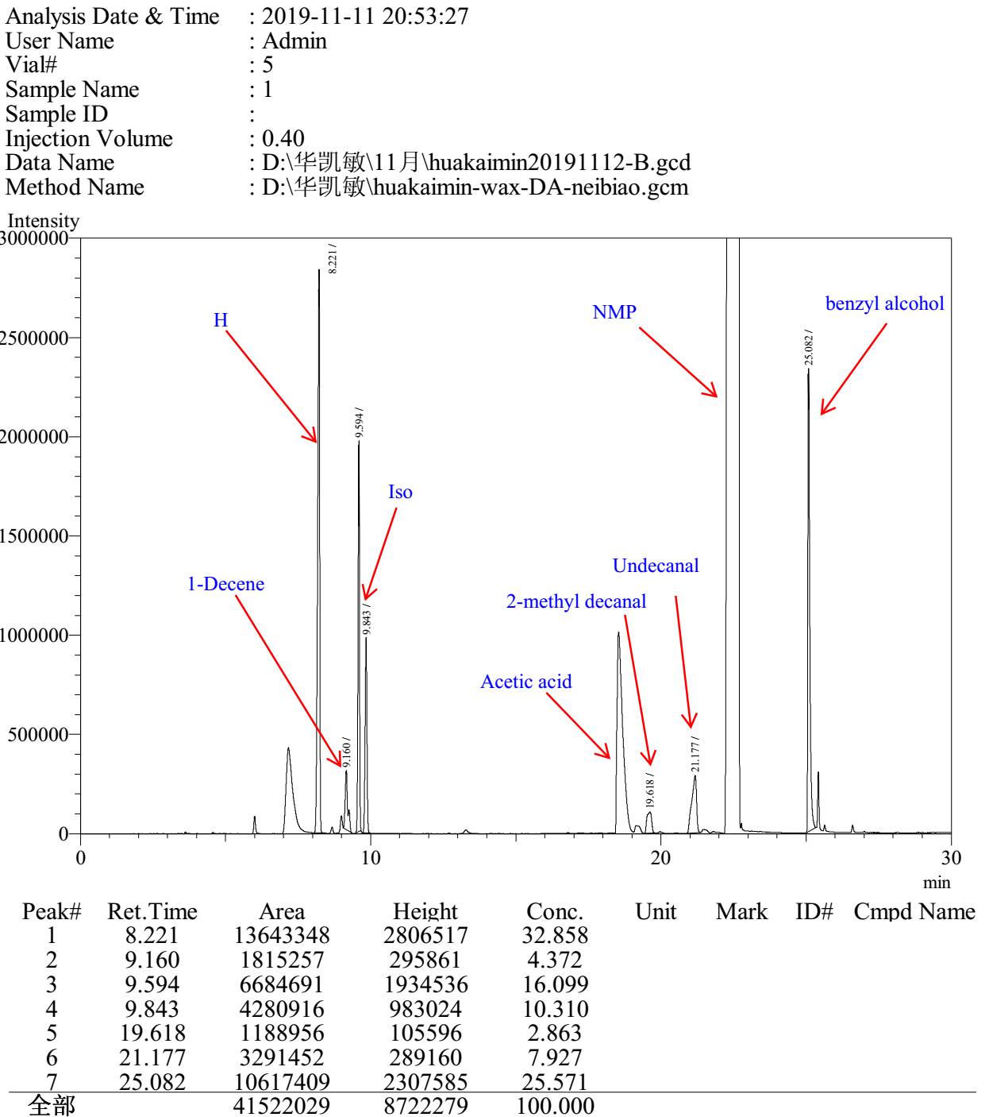

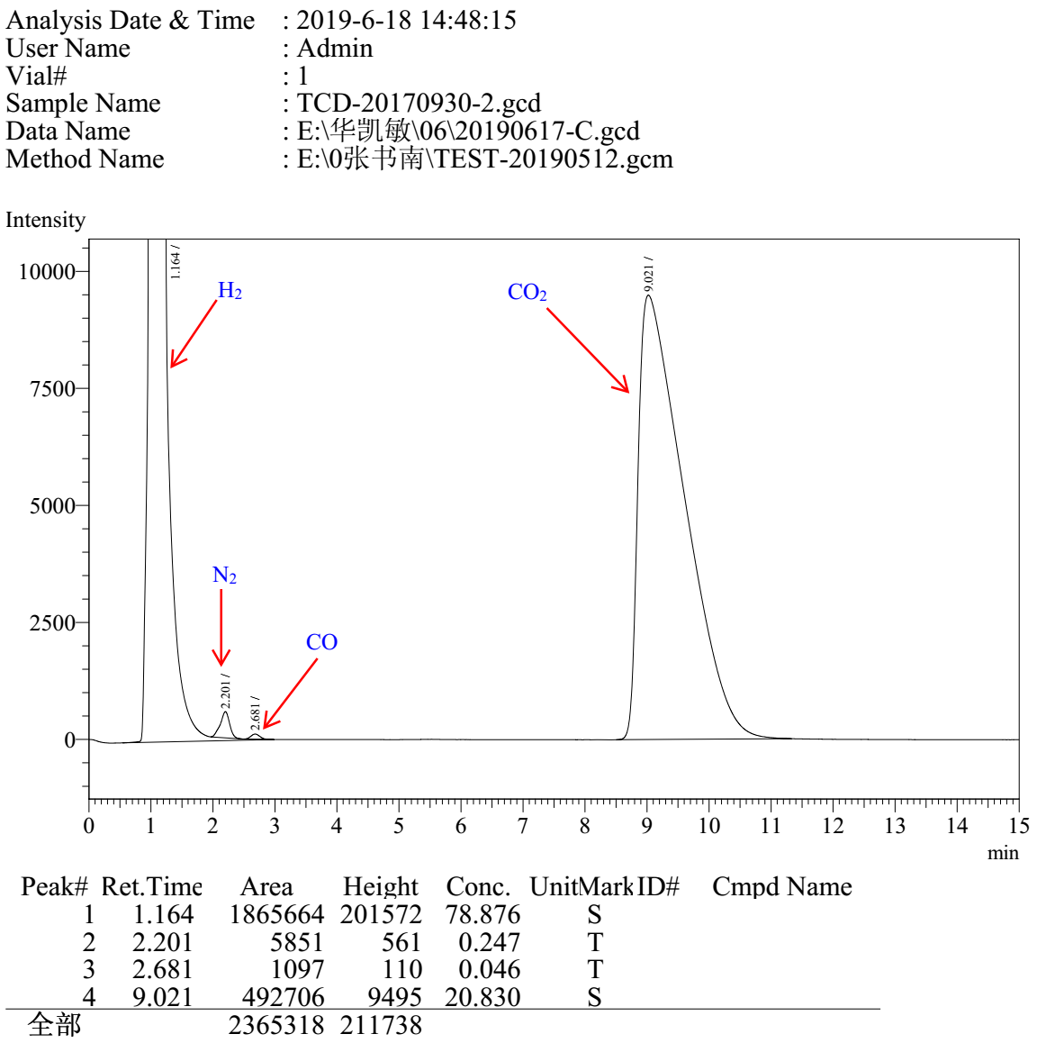

Xantphos Entry 1

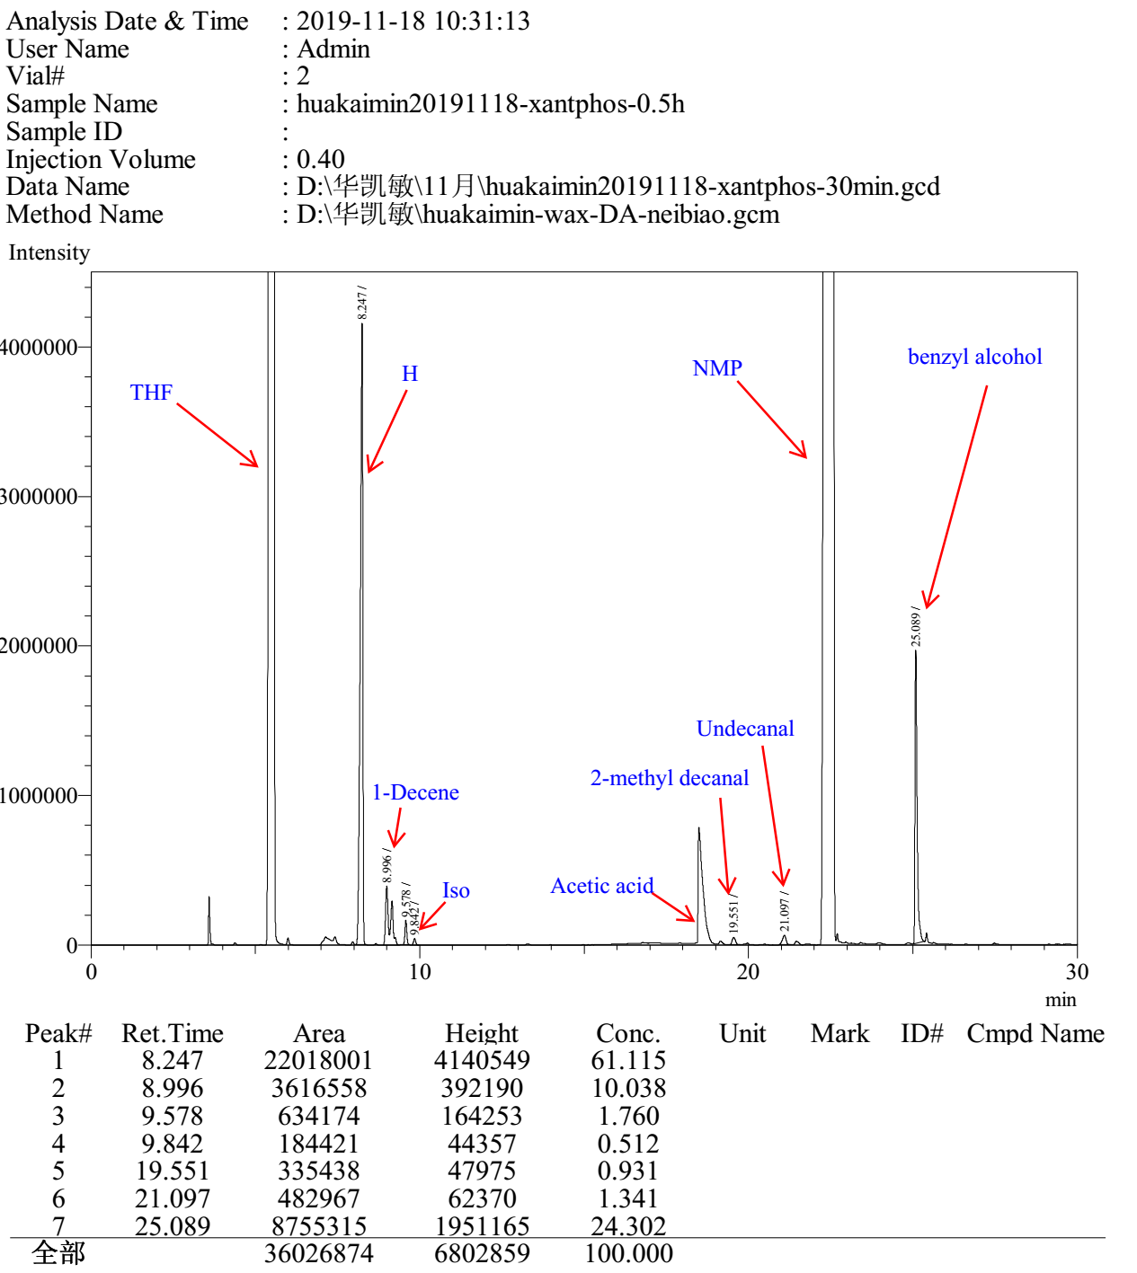

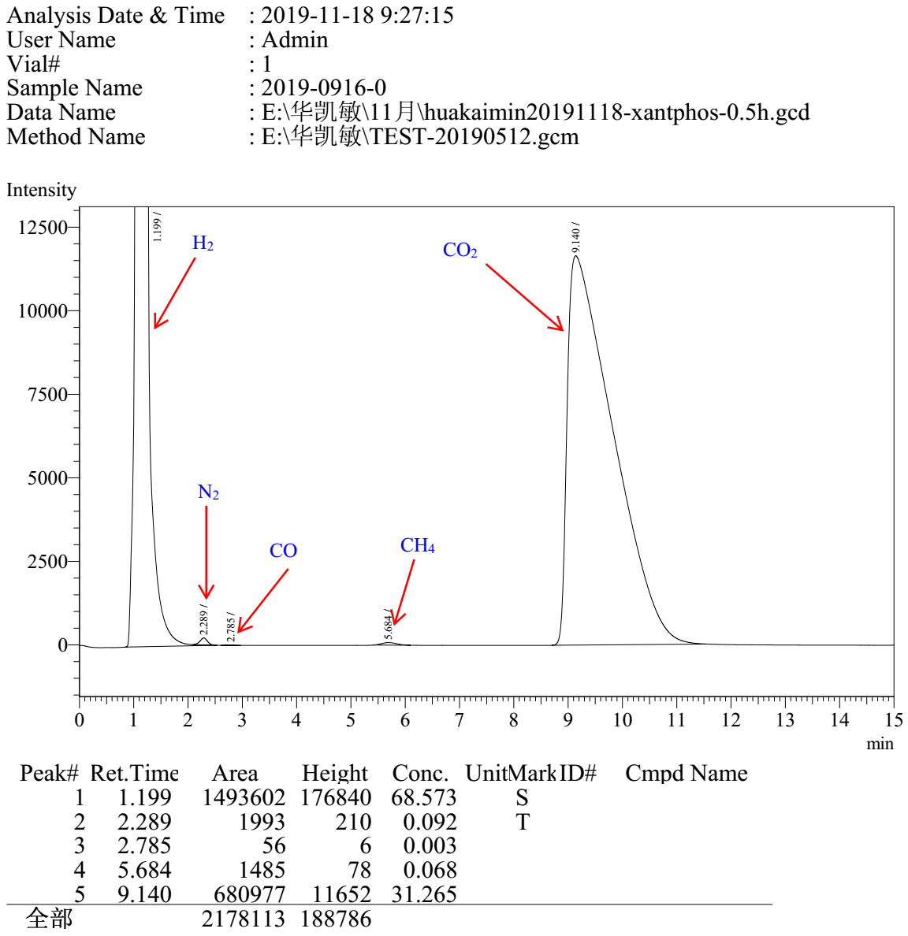

Xantphos Entry 2

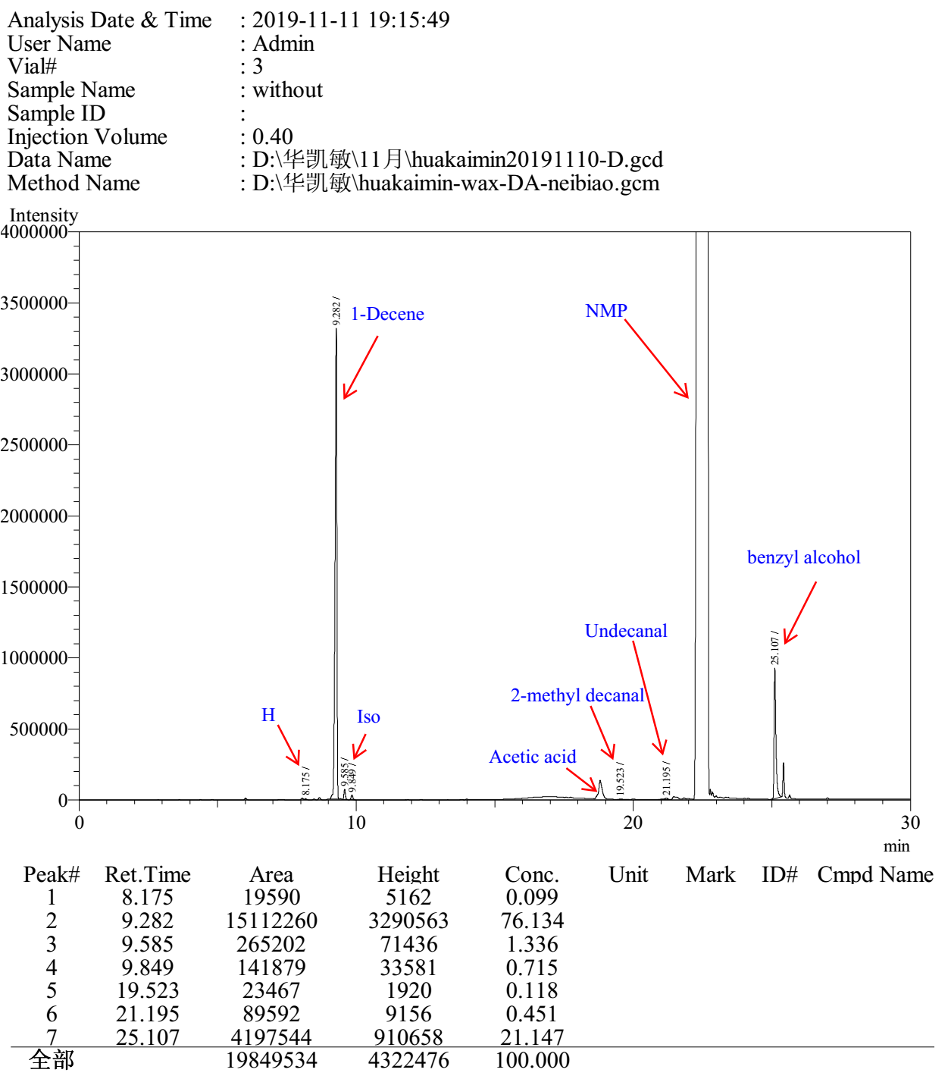

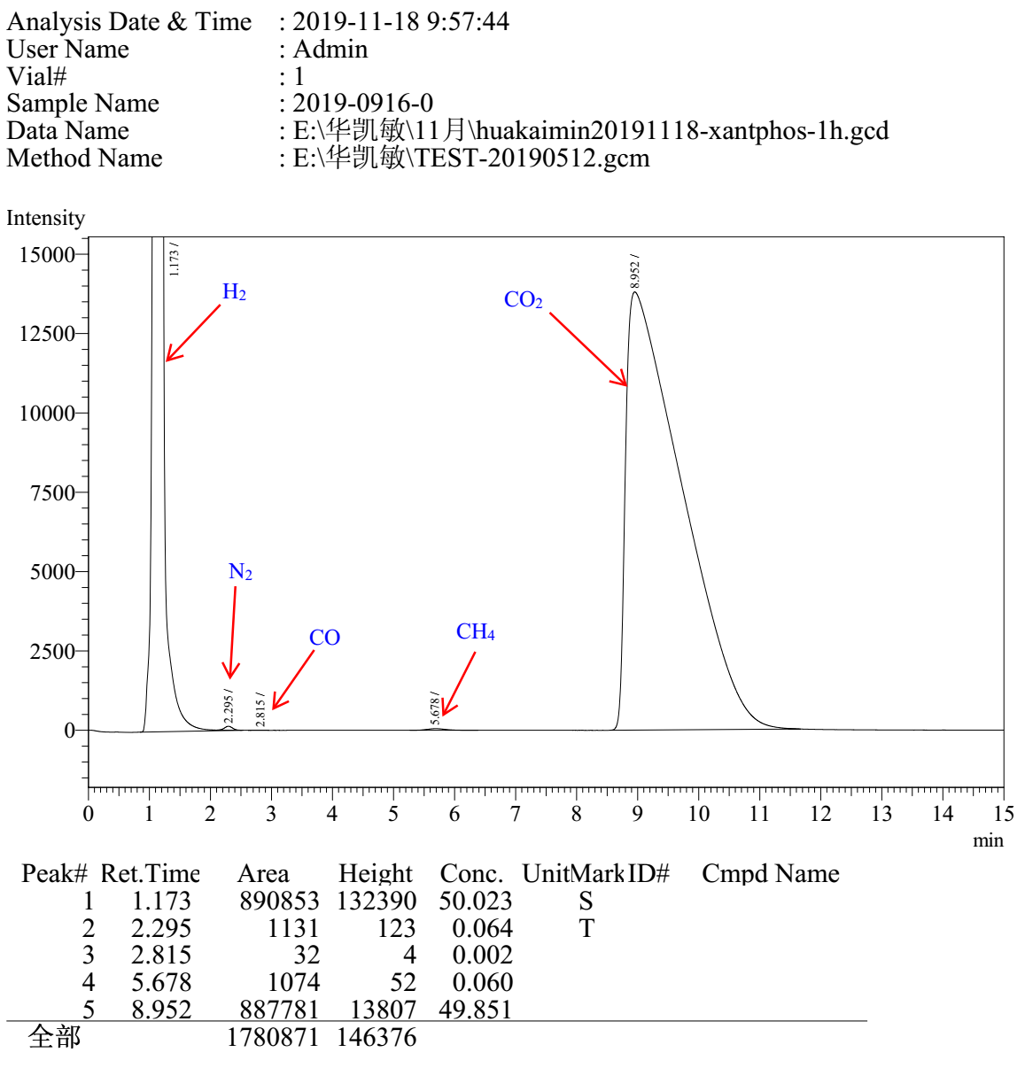

Xantphos Entry 3

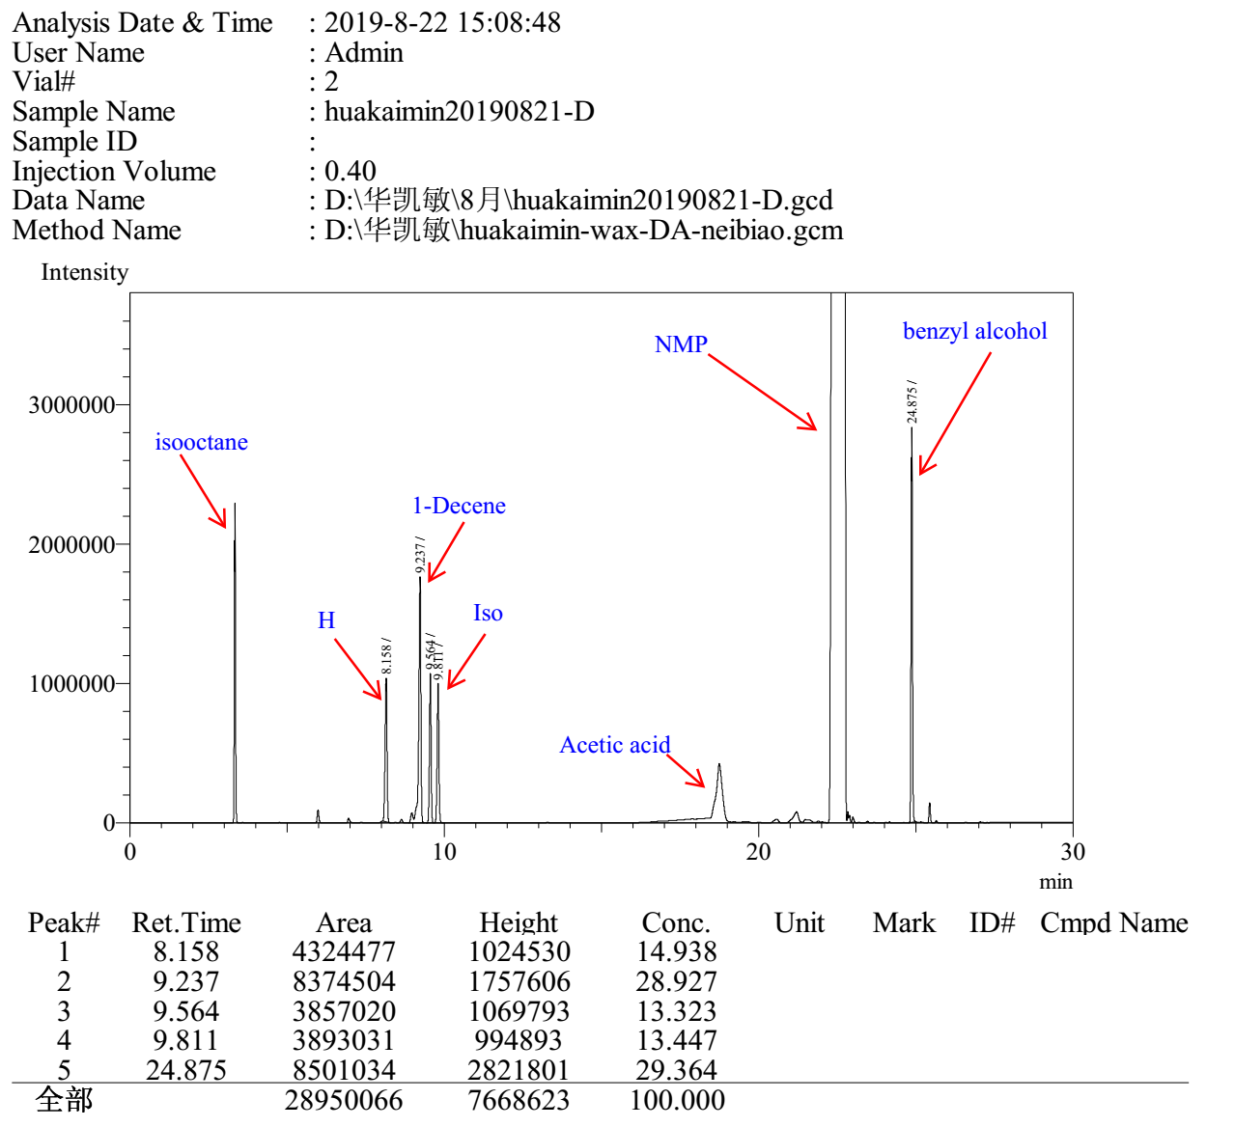

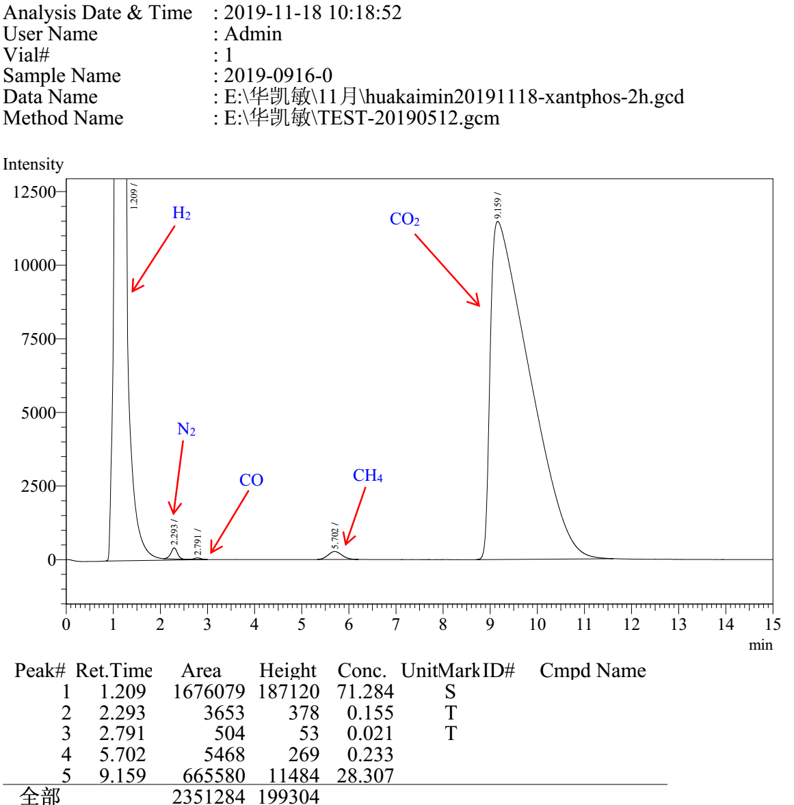

Xantphos Entry 4

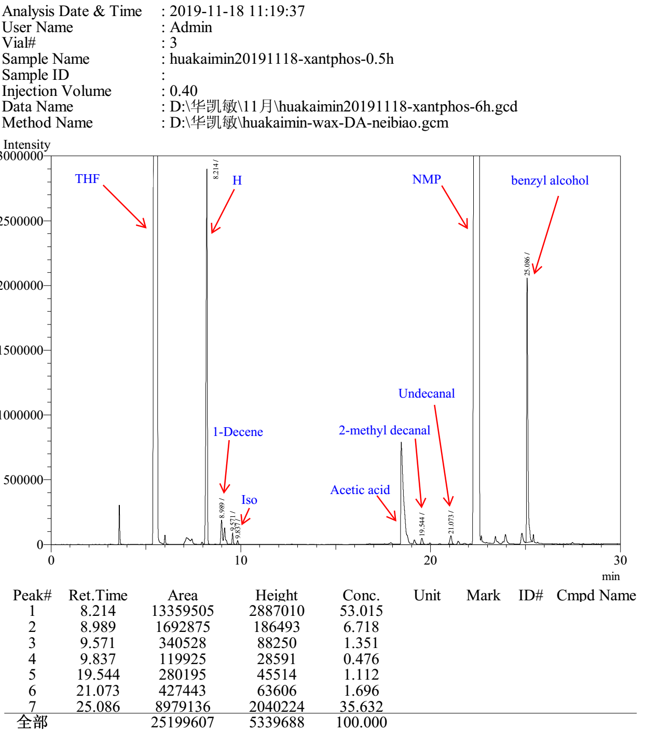

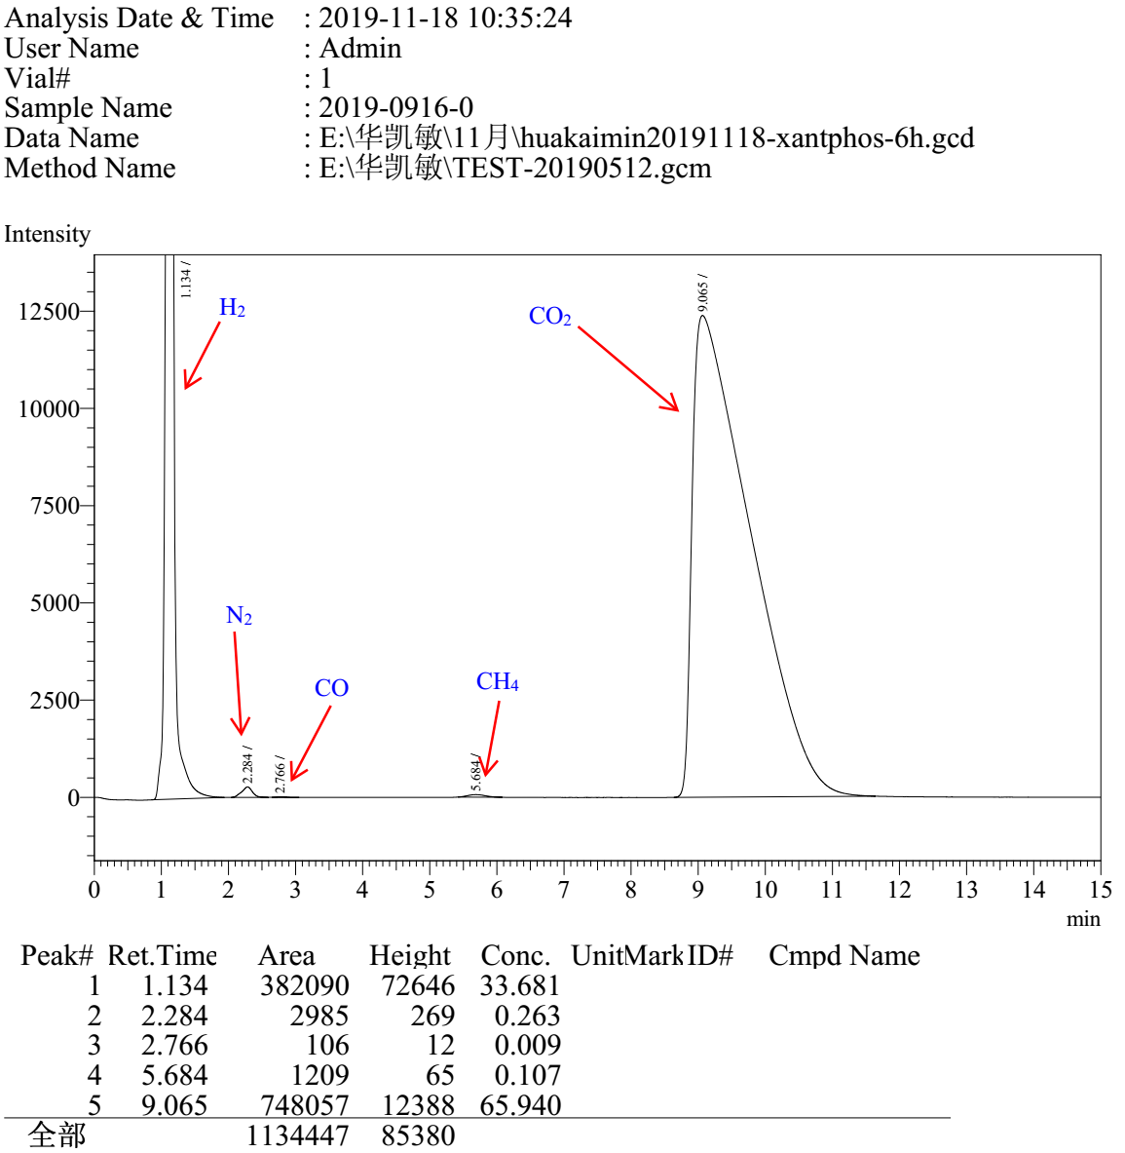

Xantphos Entry 5

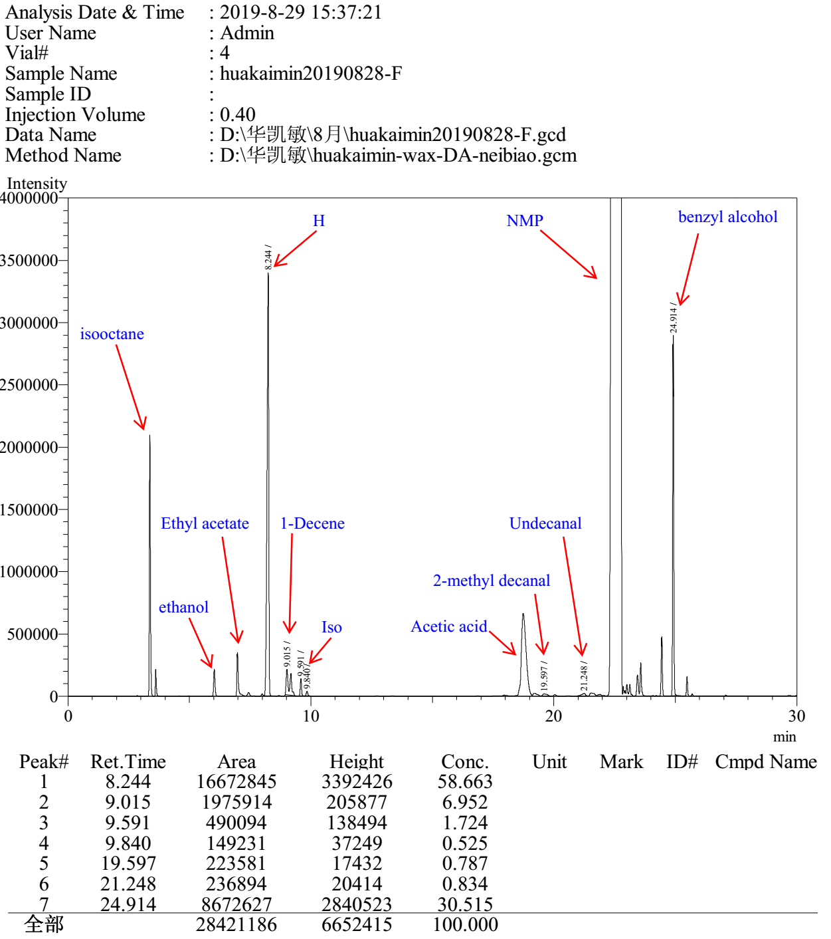

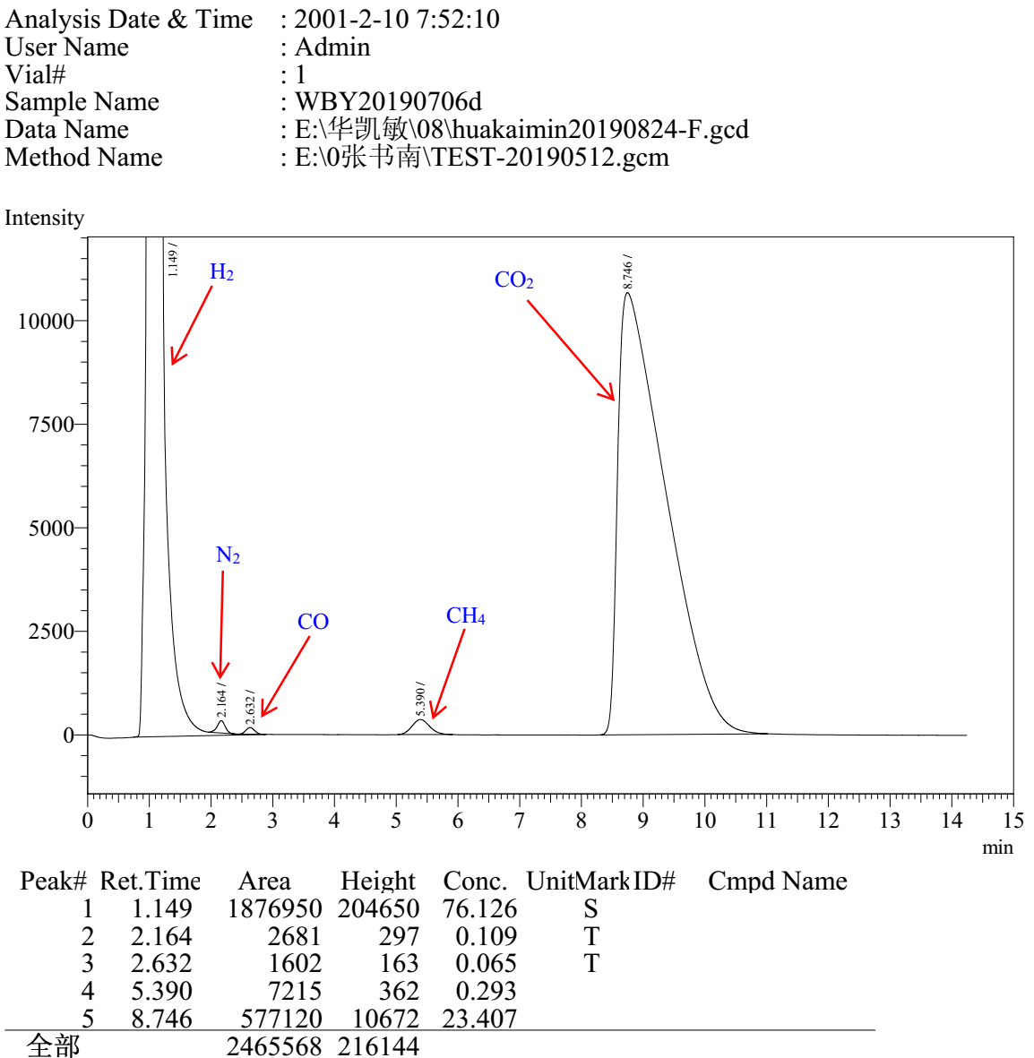

dppb Entry 1

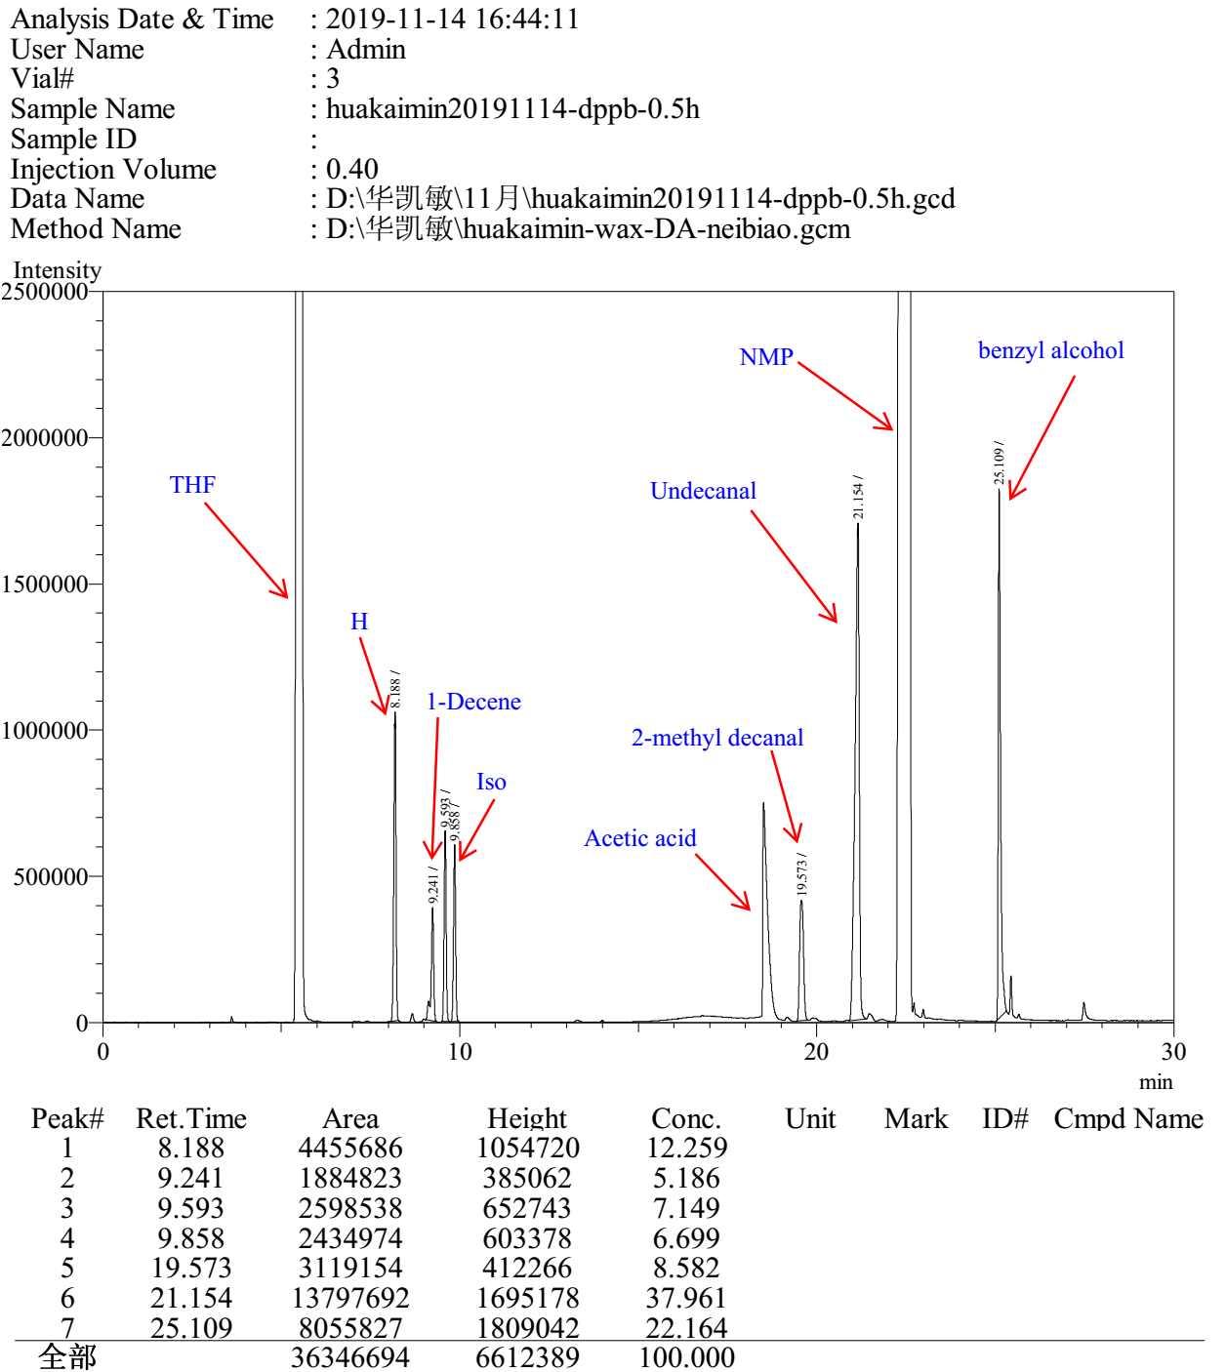

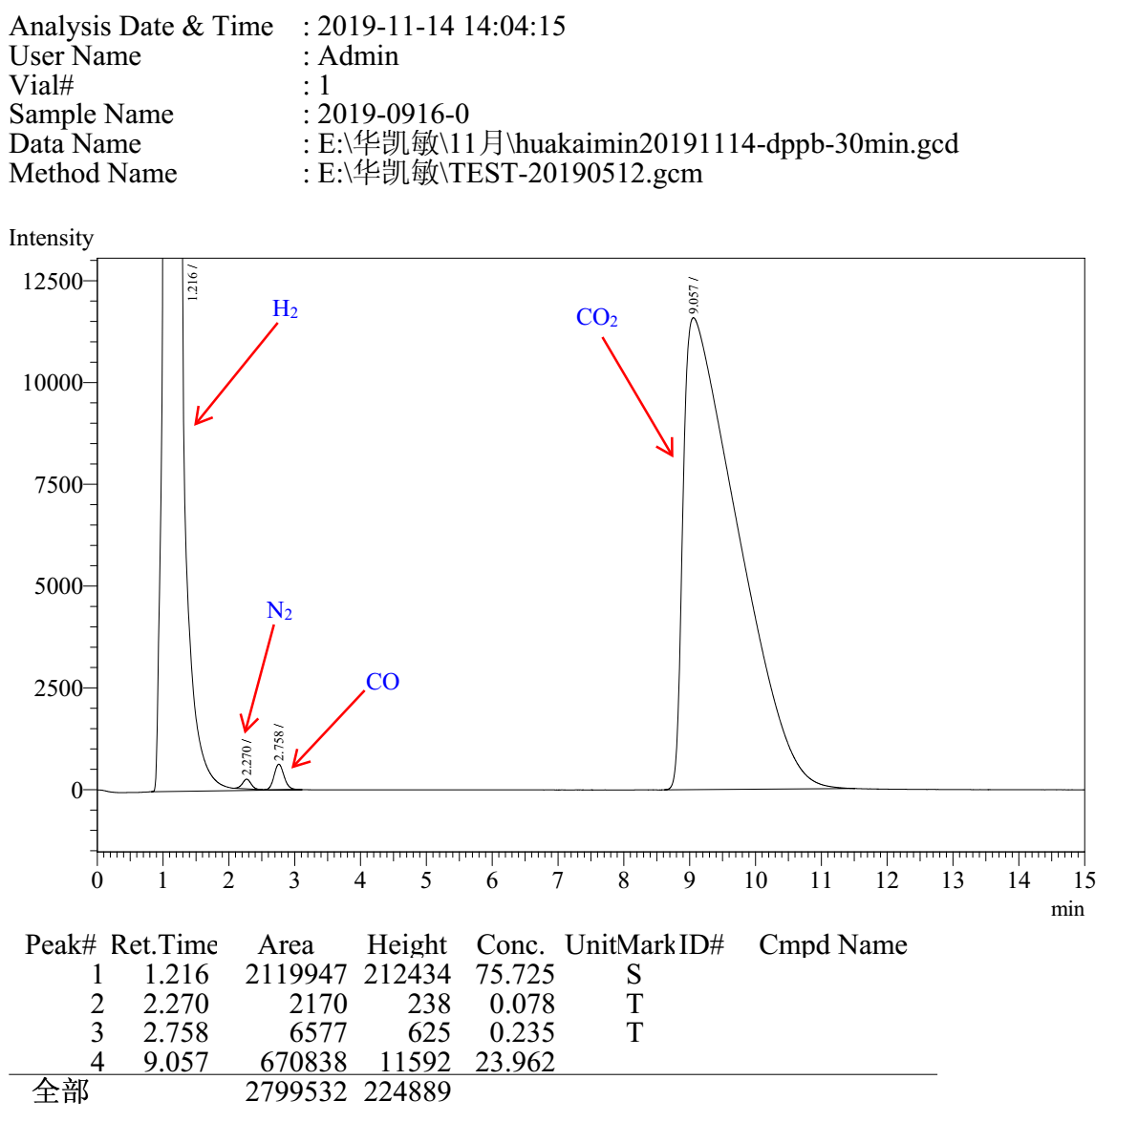

dppb Entry 2

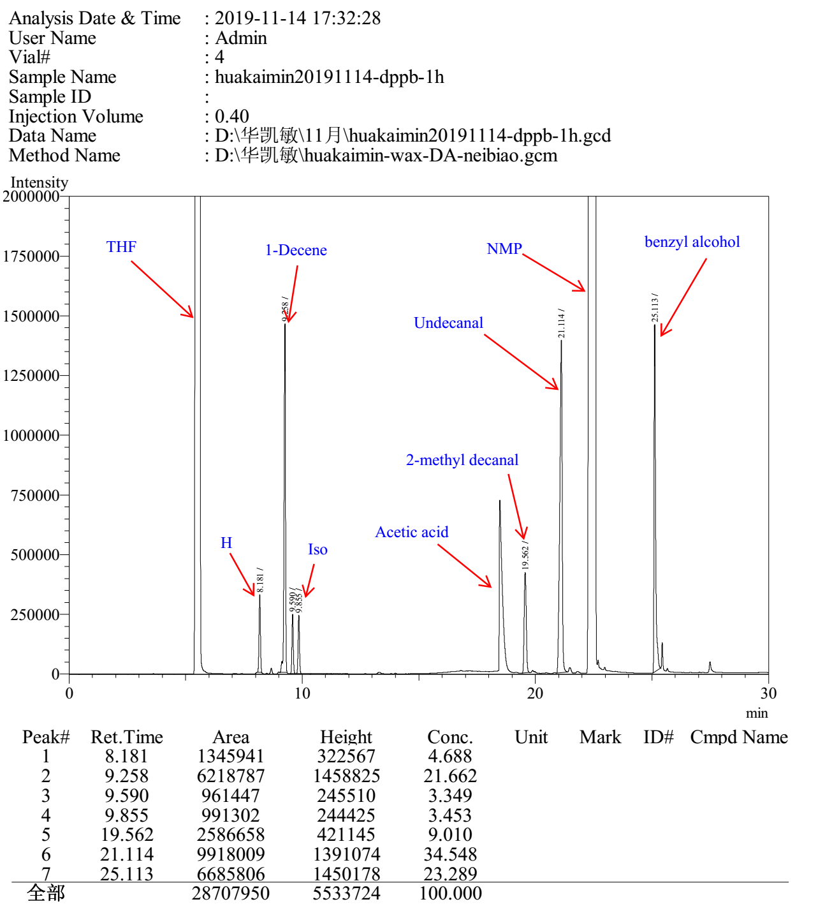

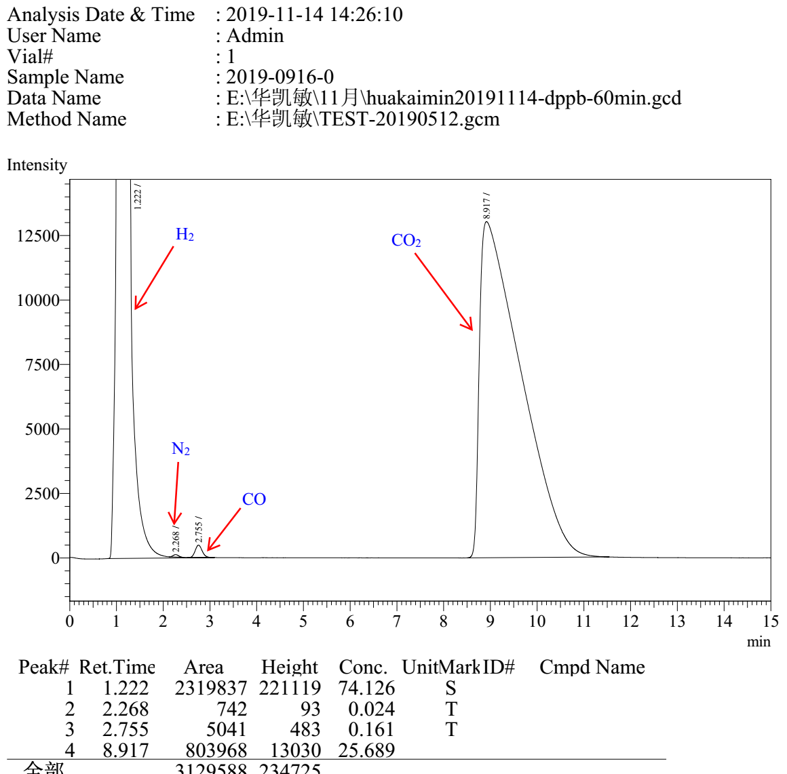

dppb Entry 3

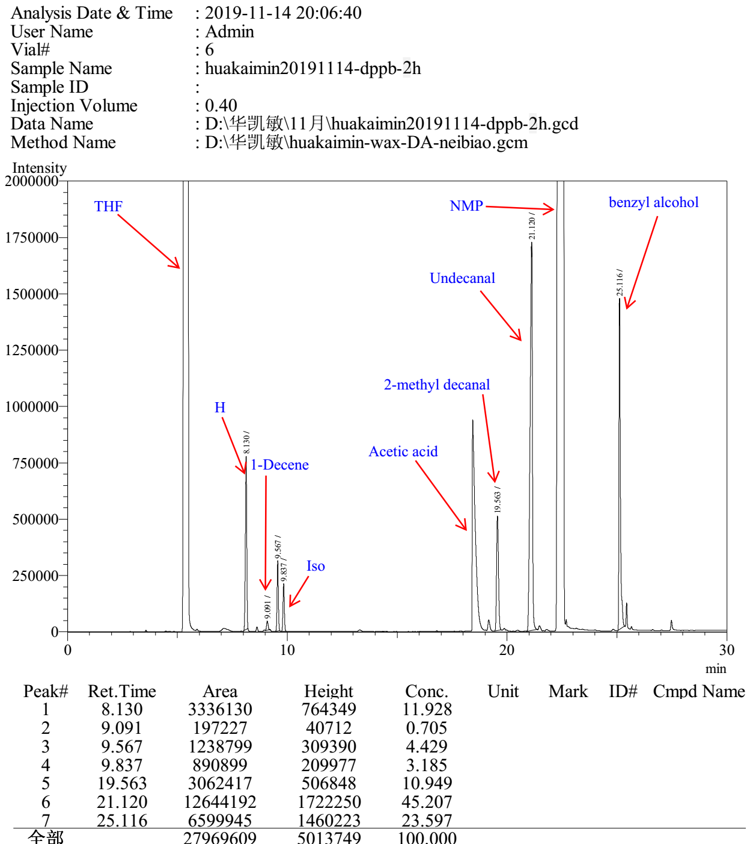

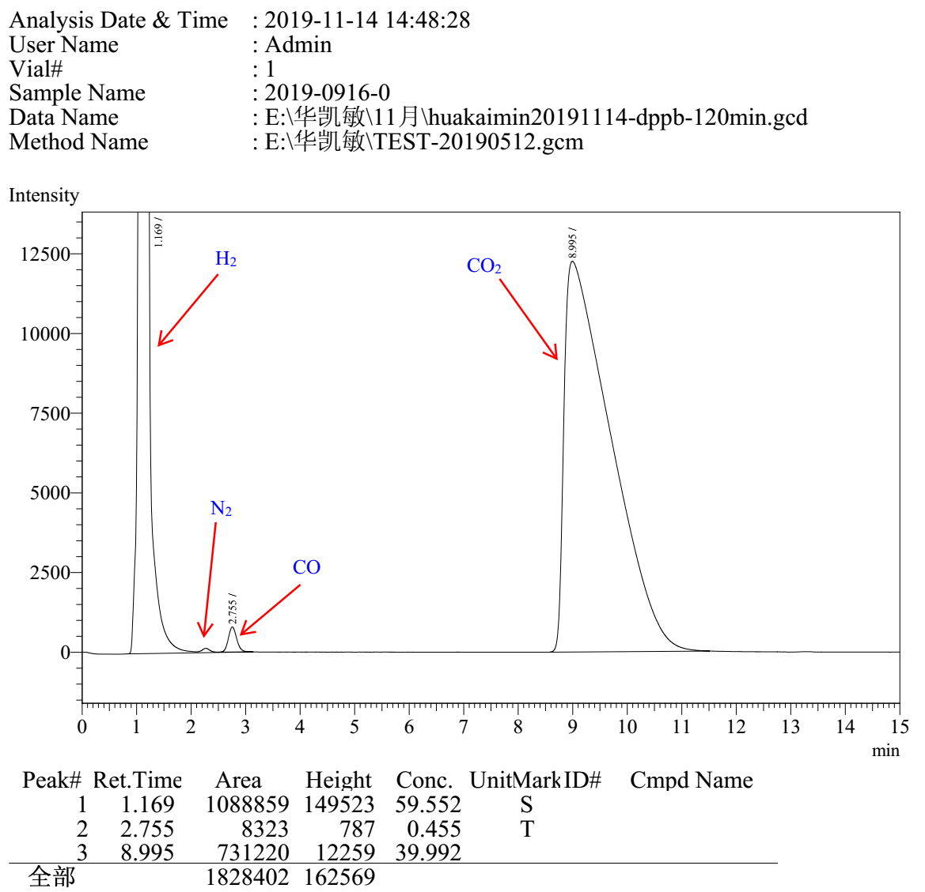

dppb Entry 4

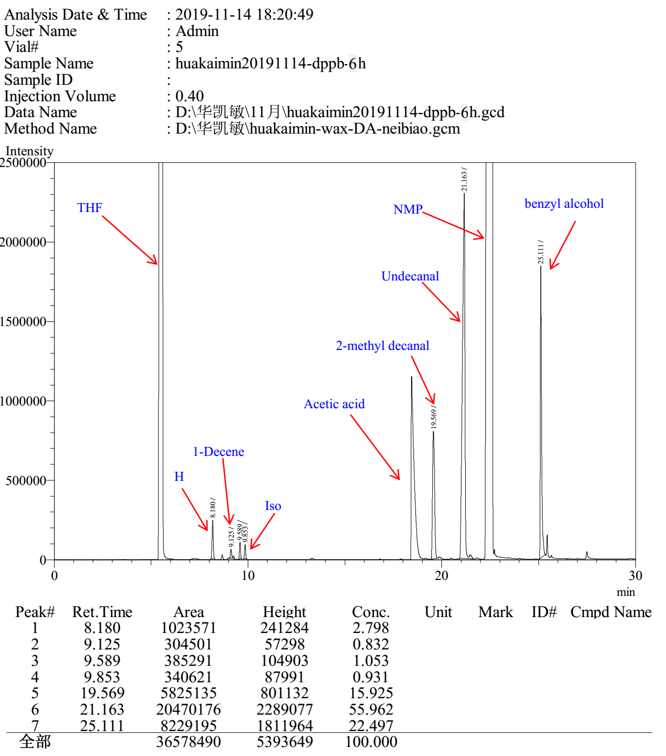
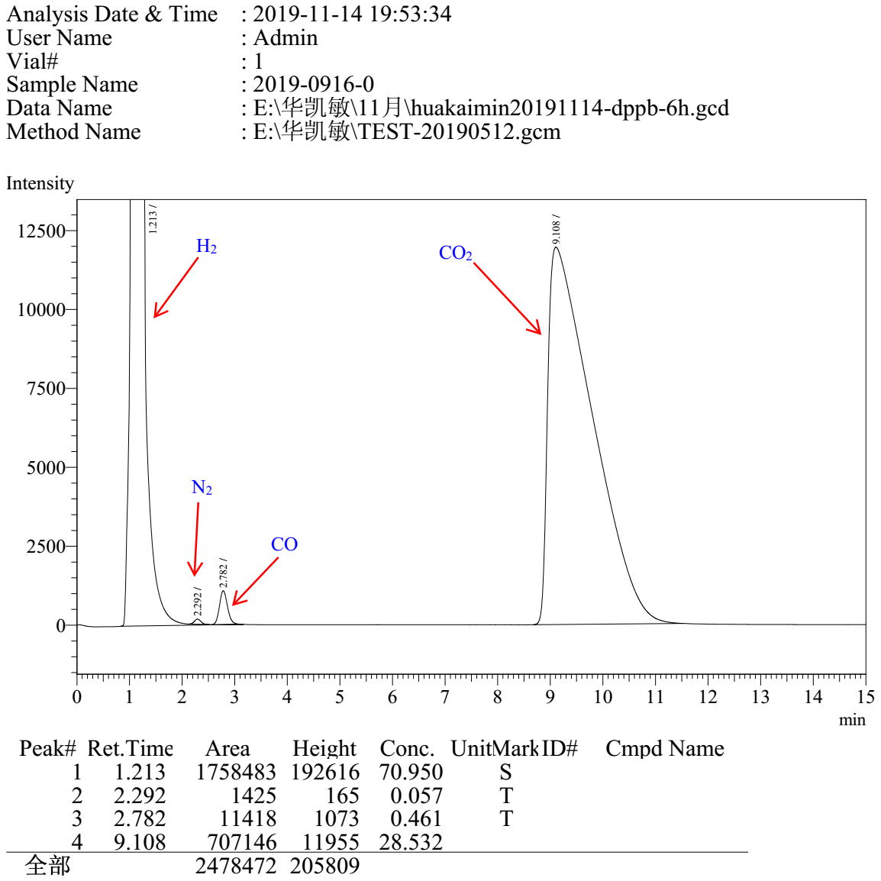

dppb Entry 5

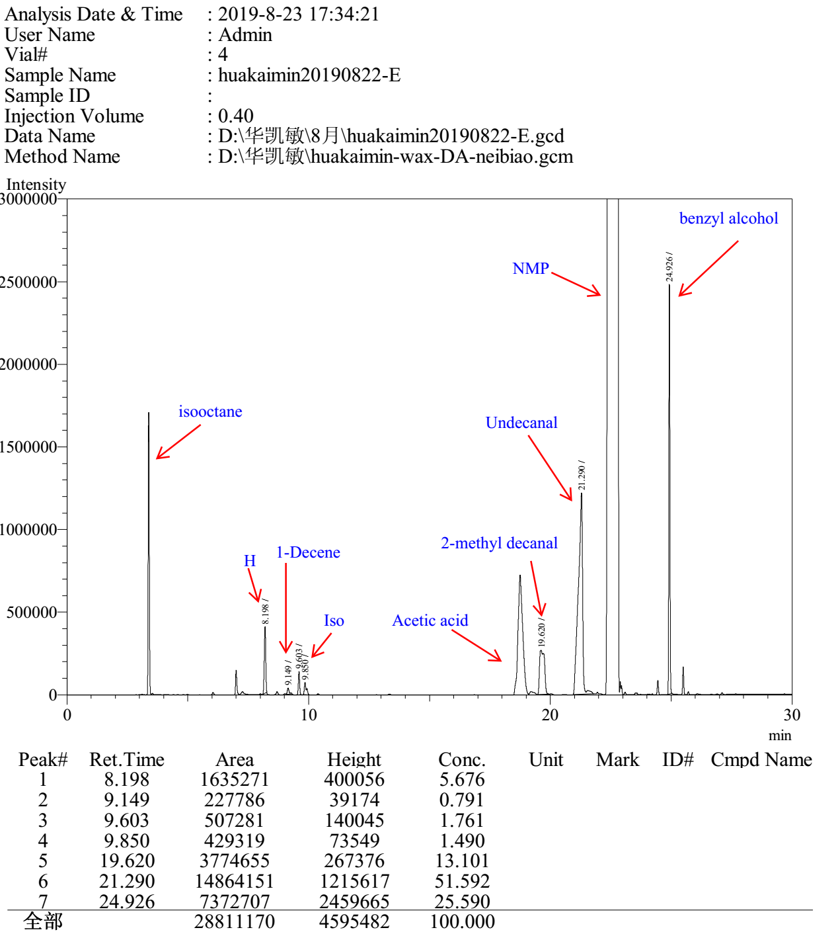

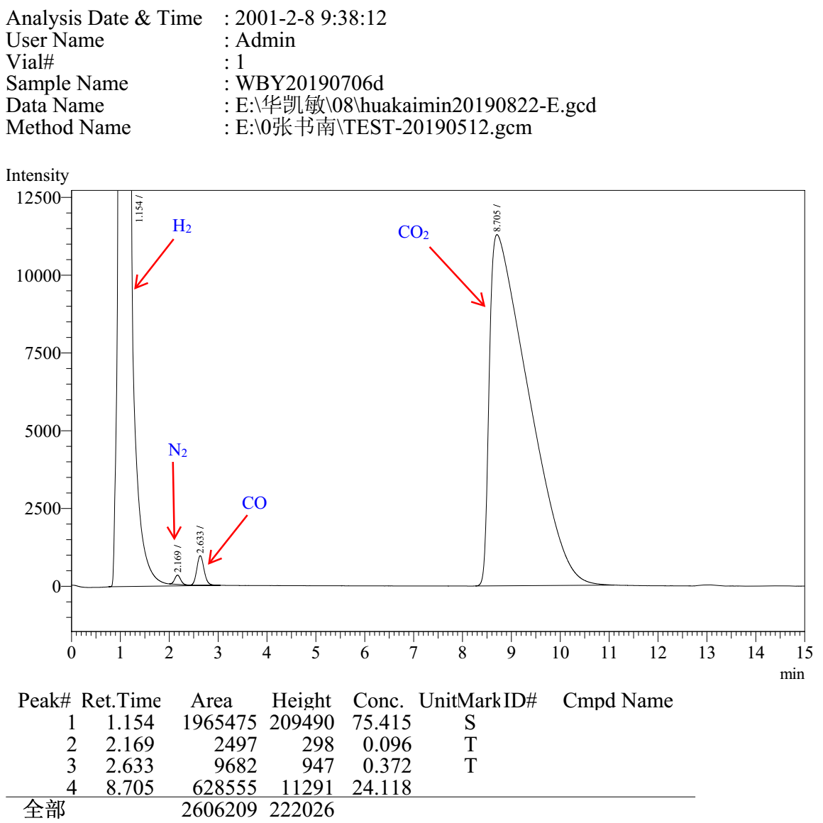

3.10 Gas chromatograms to Table S10

Entry 1

Entry 2

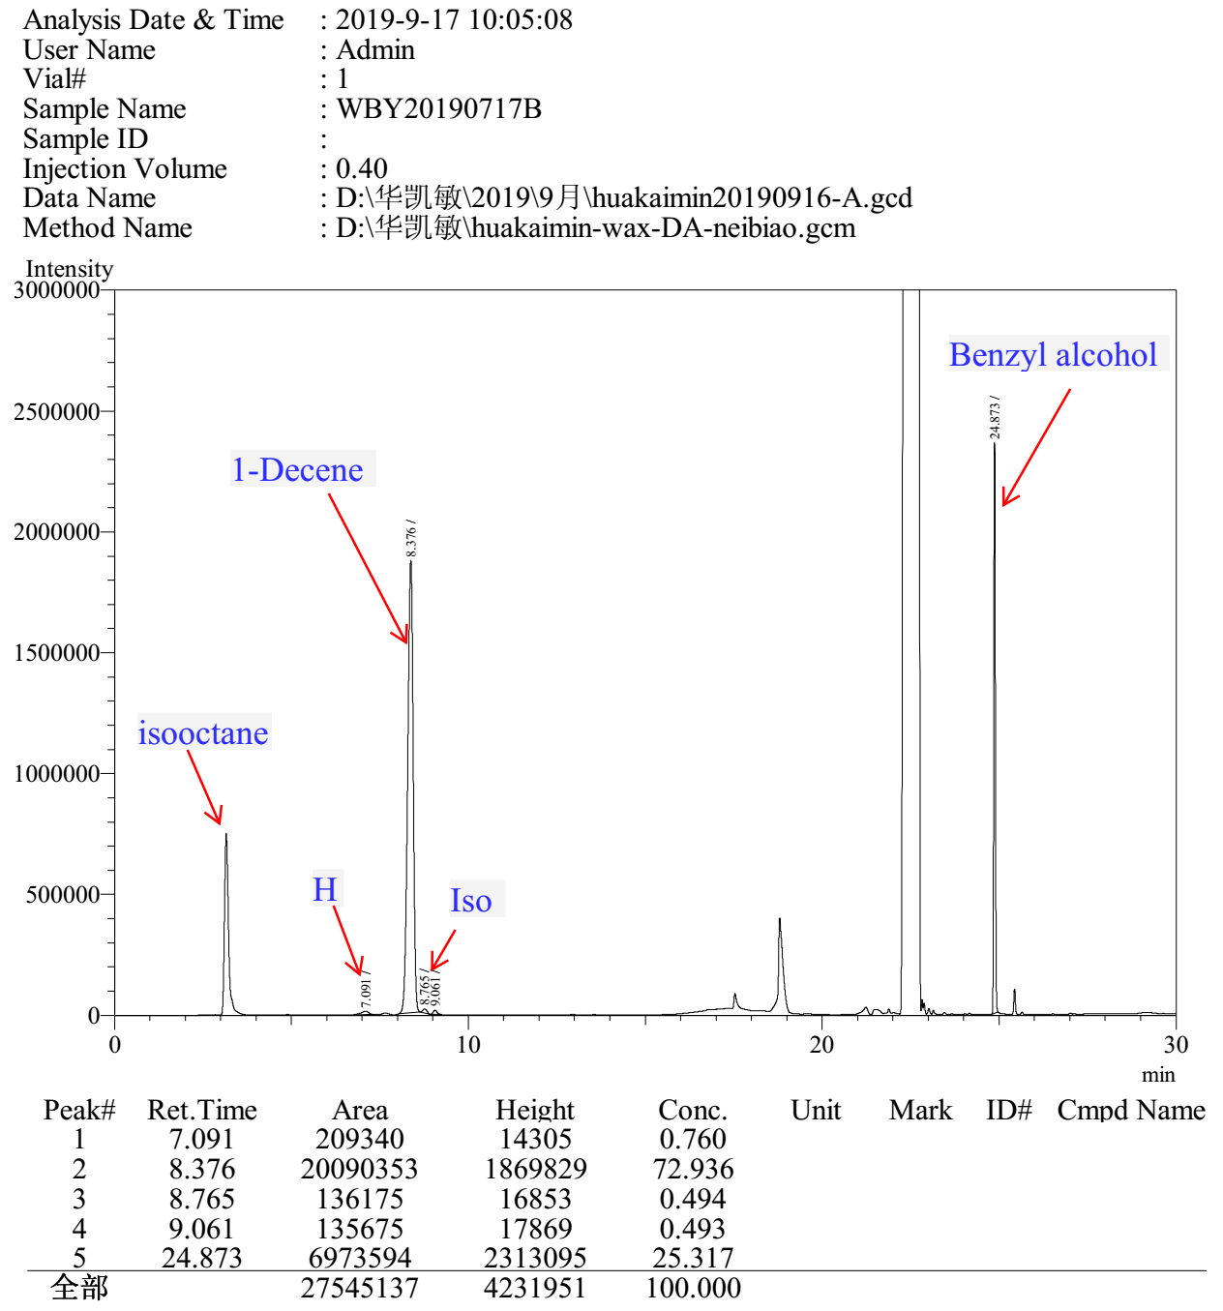

Entry 3

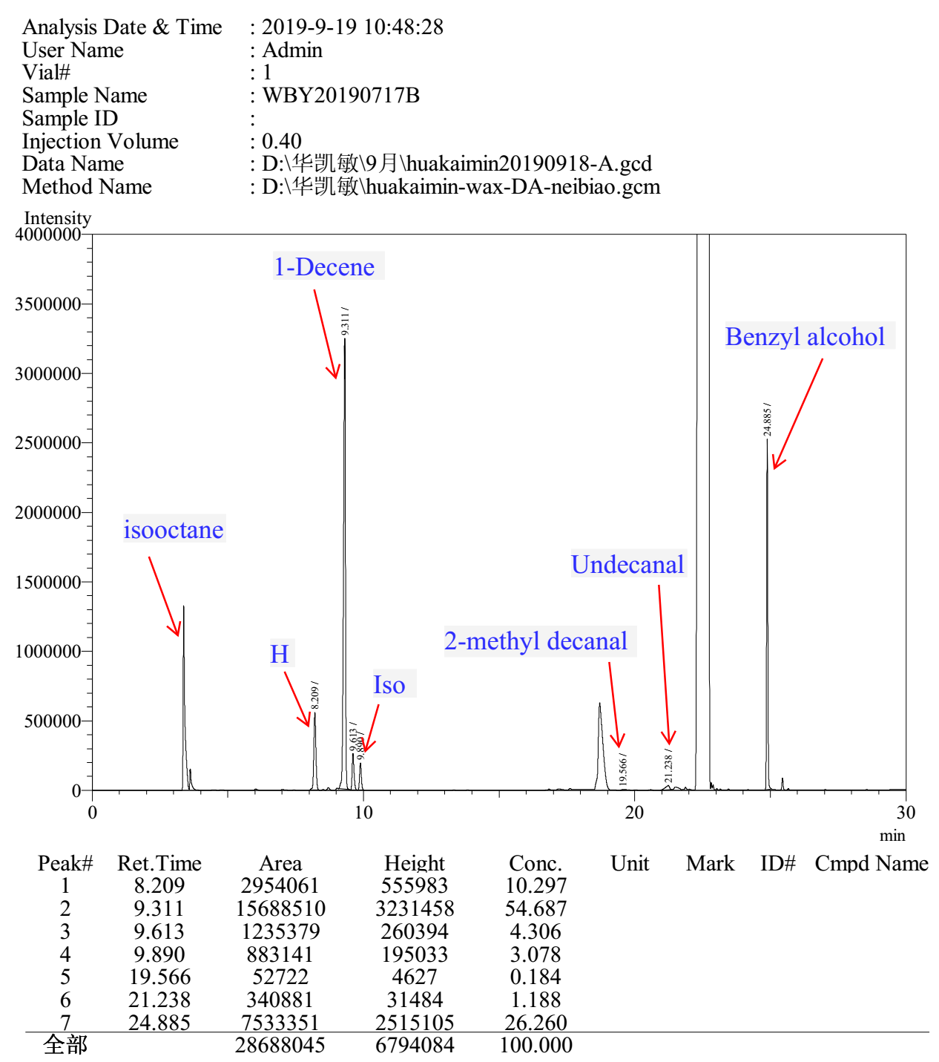

Entry 4

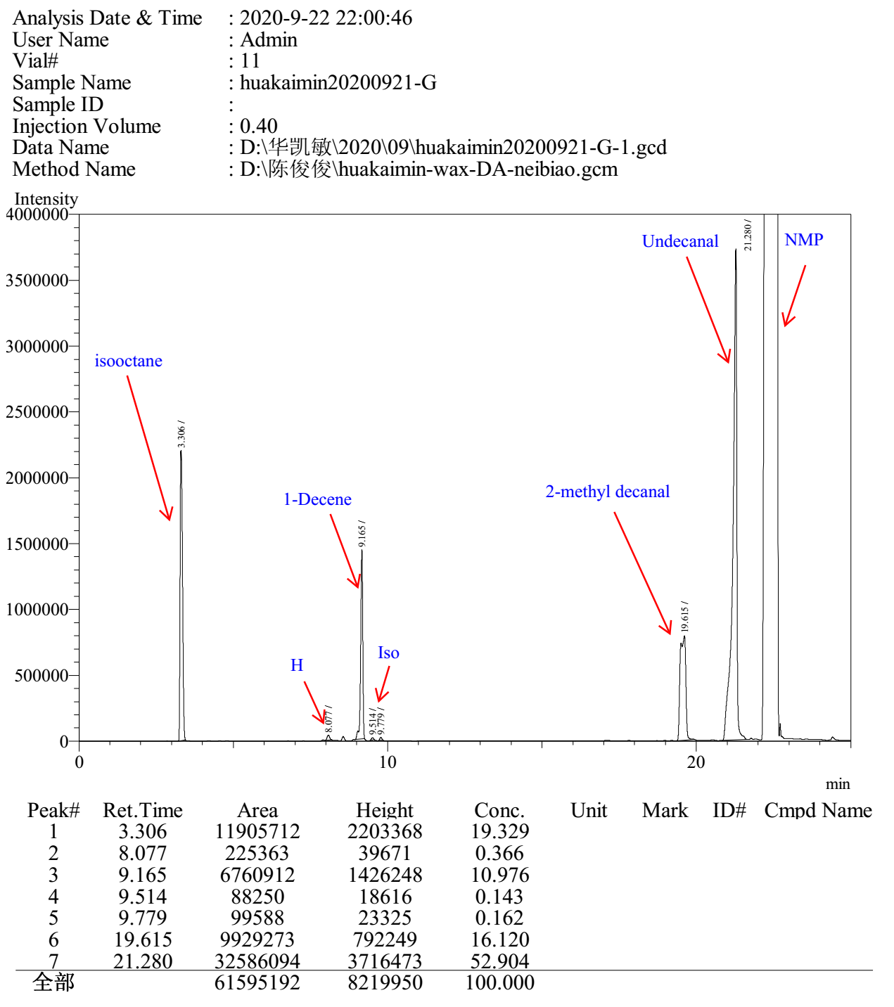

Entry 5

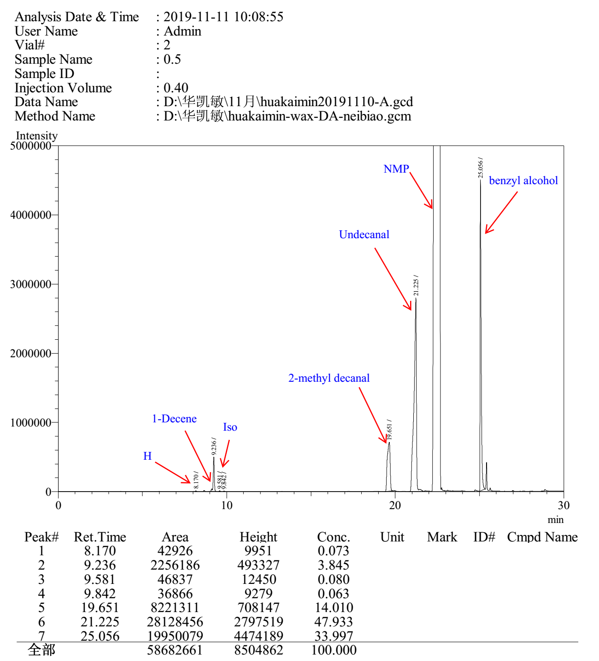

Entry 6

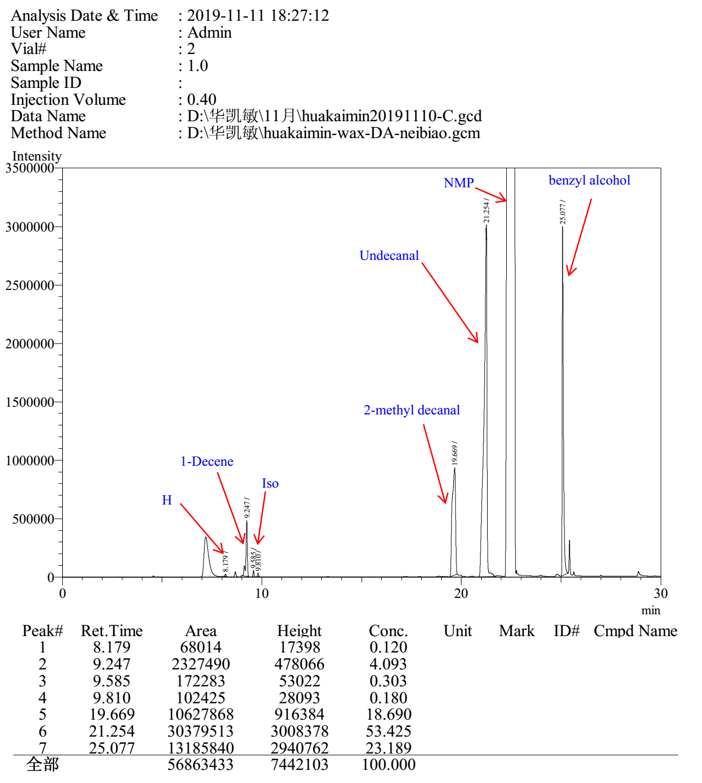

Entry 7

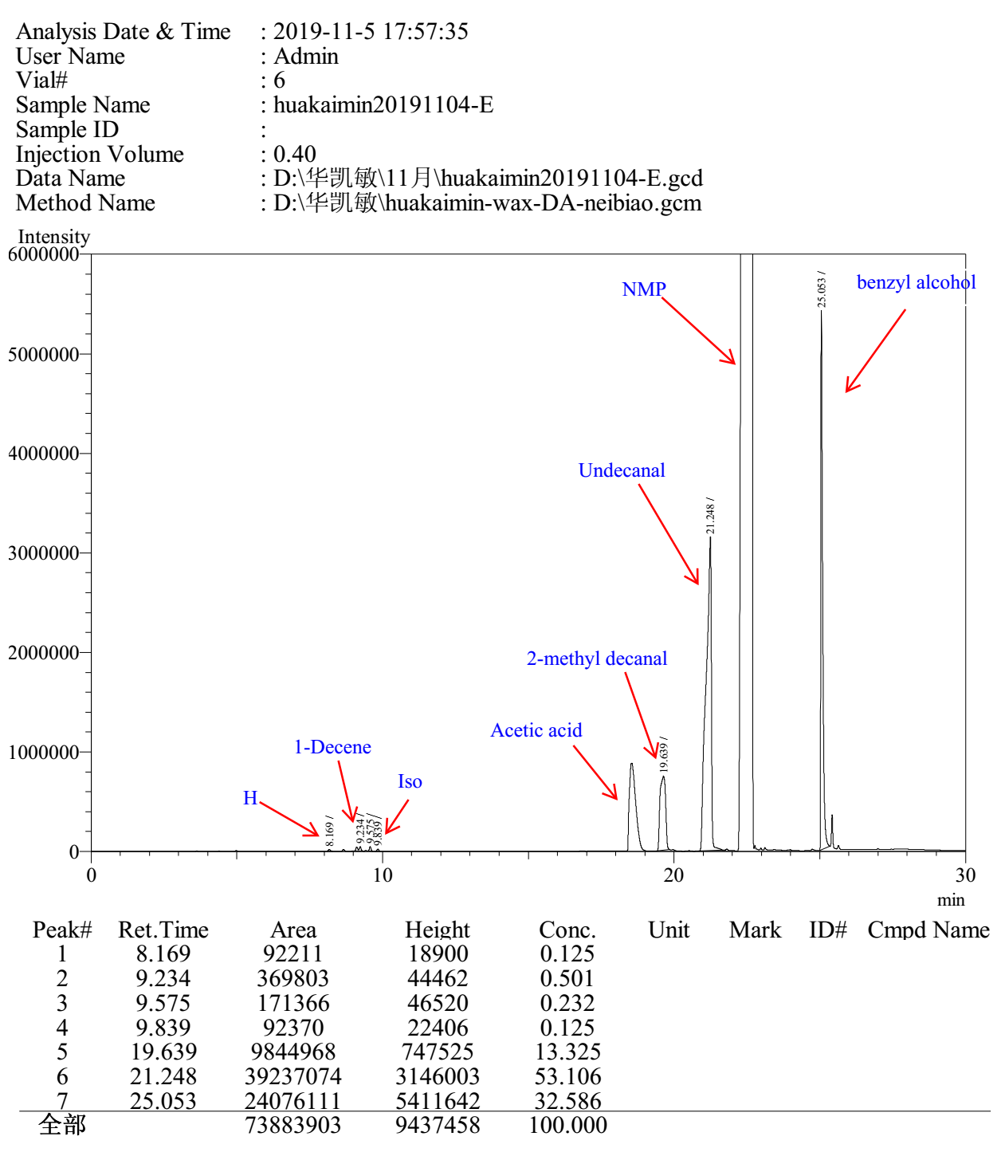

Entry 8

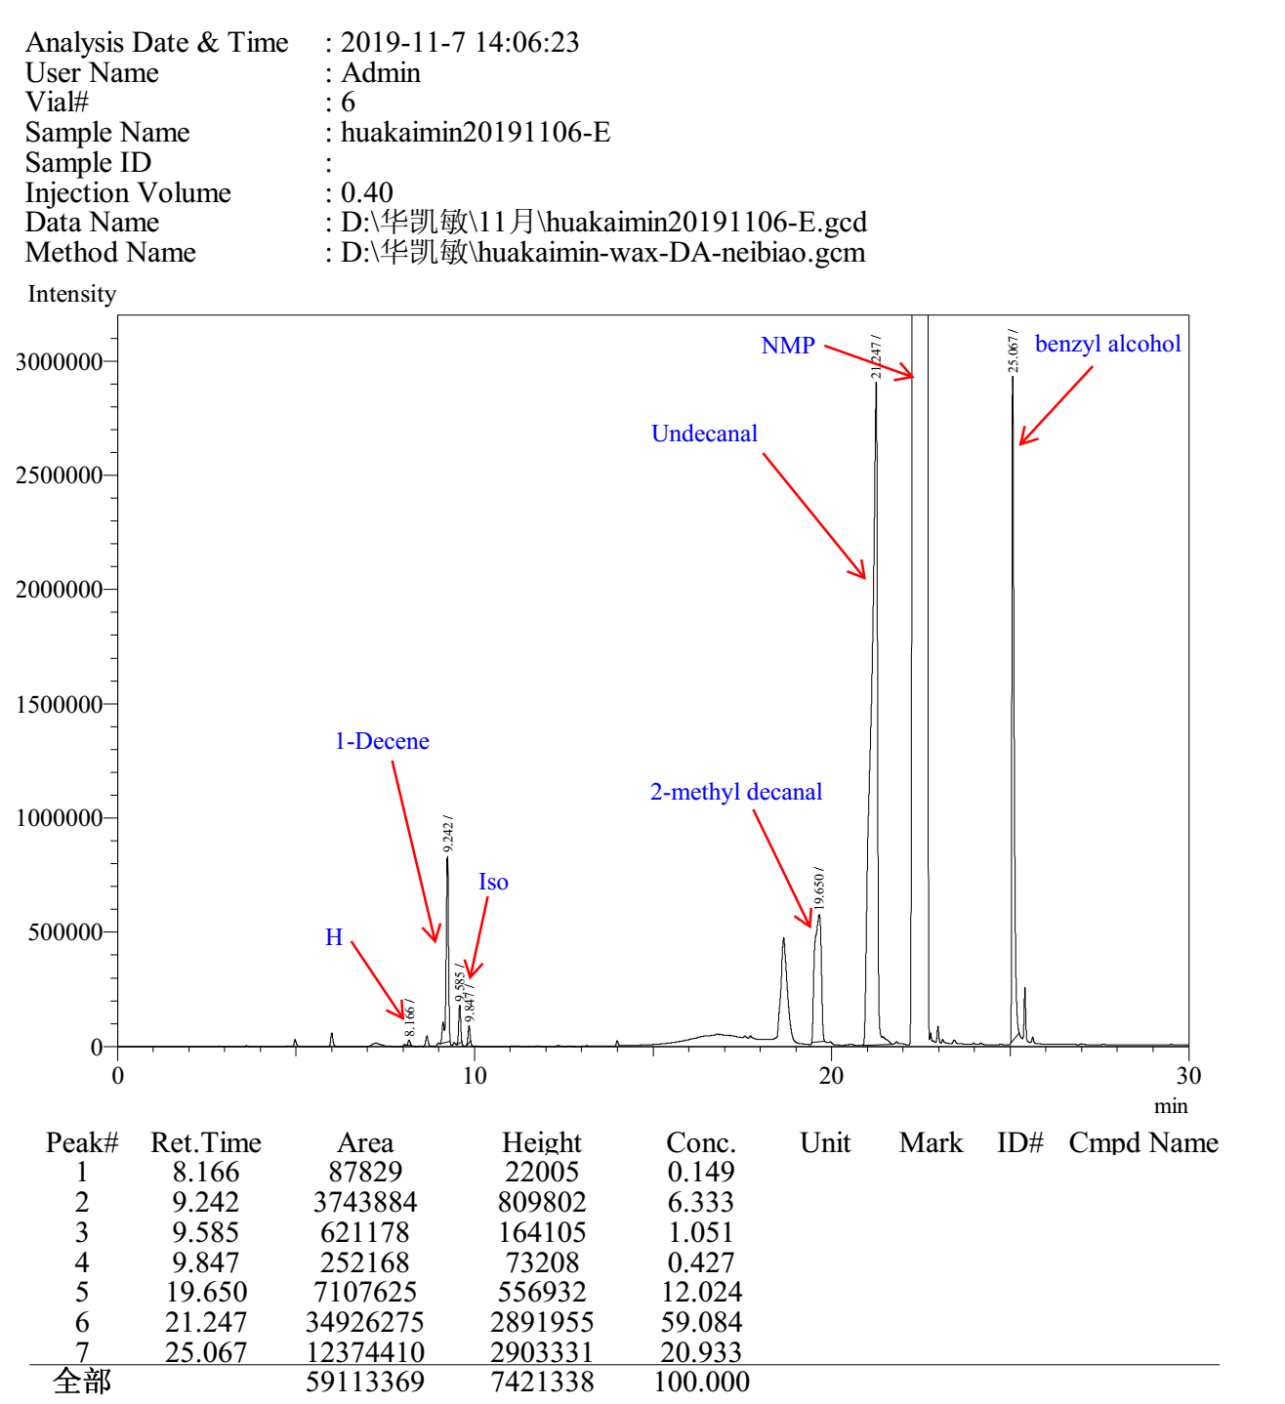
3.11 Gas chromatograms to Table S11

equation (c) without Ac₂O

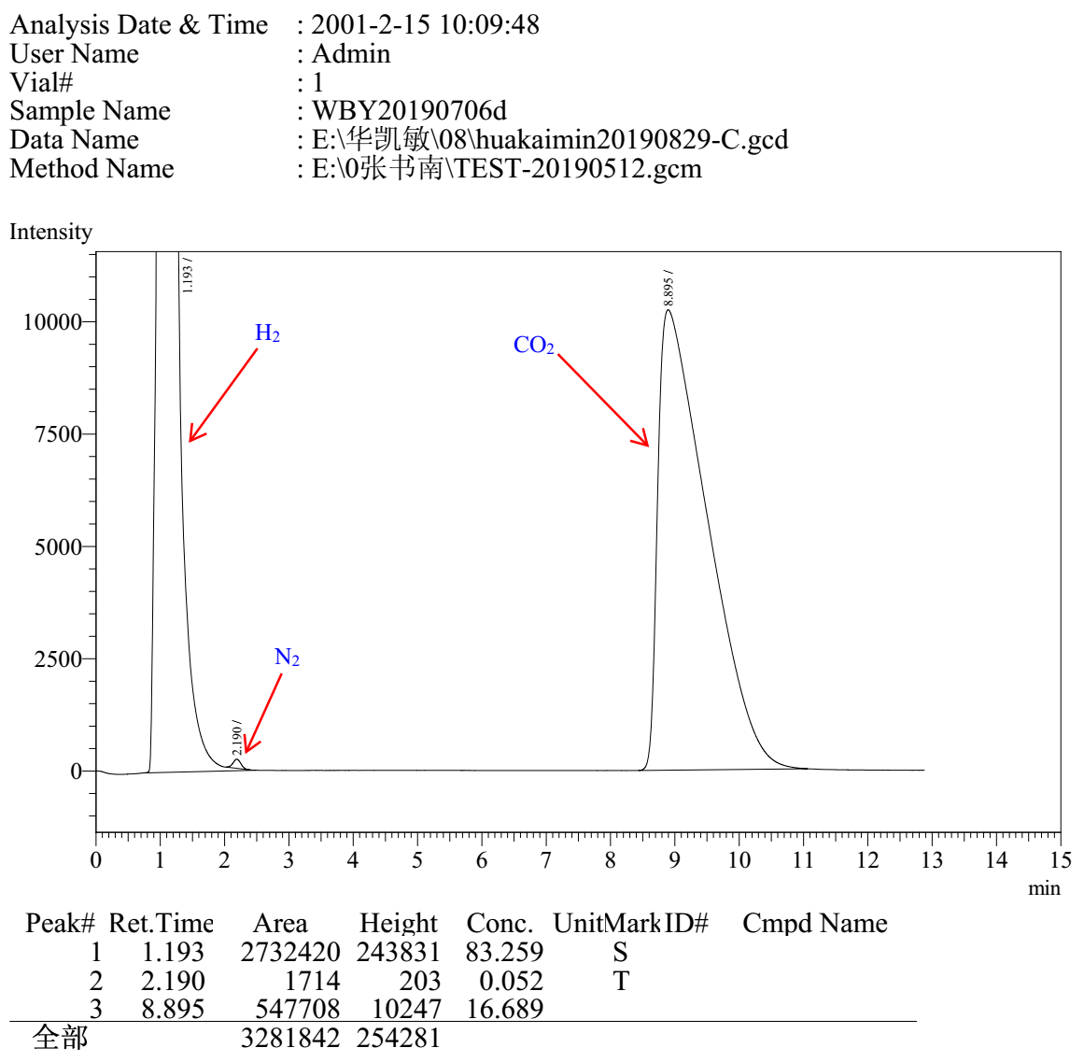

equation (c) with Ac₂O

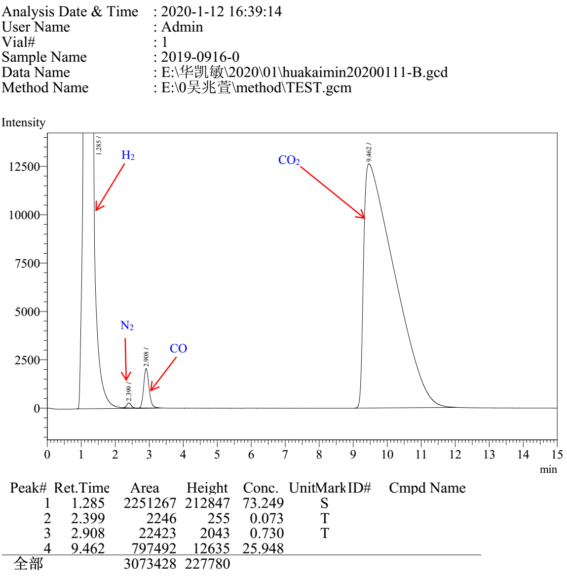

equation (d) Entry 1

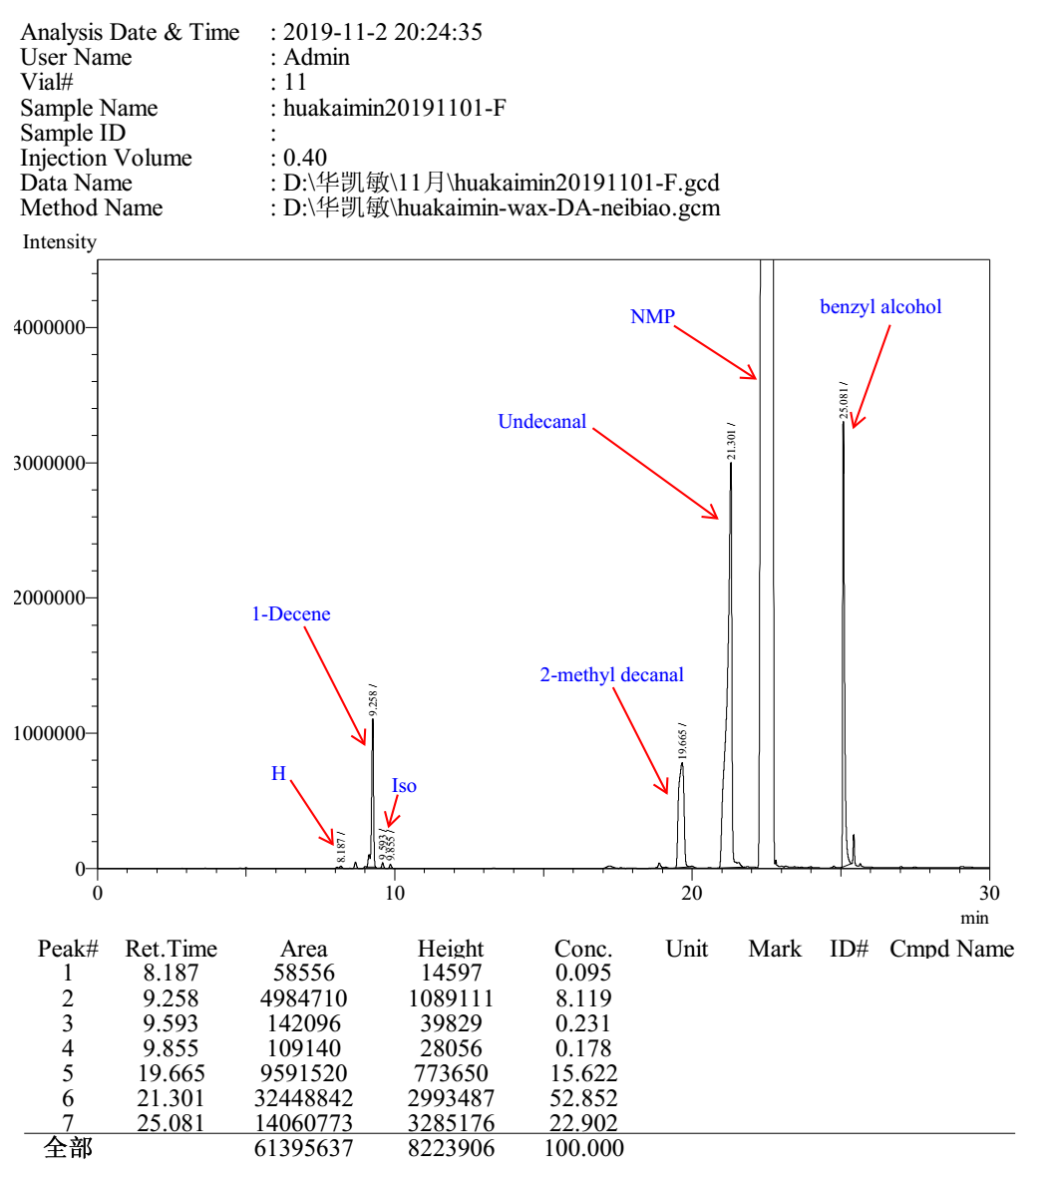

equation (d) Entry 2

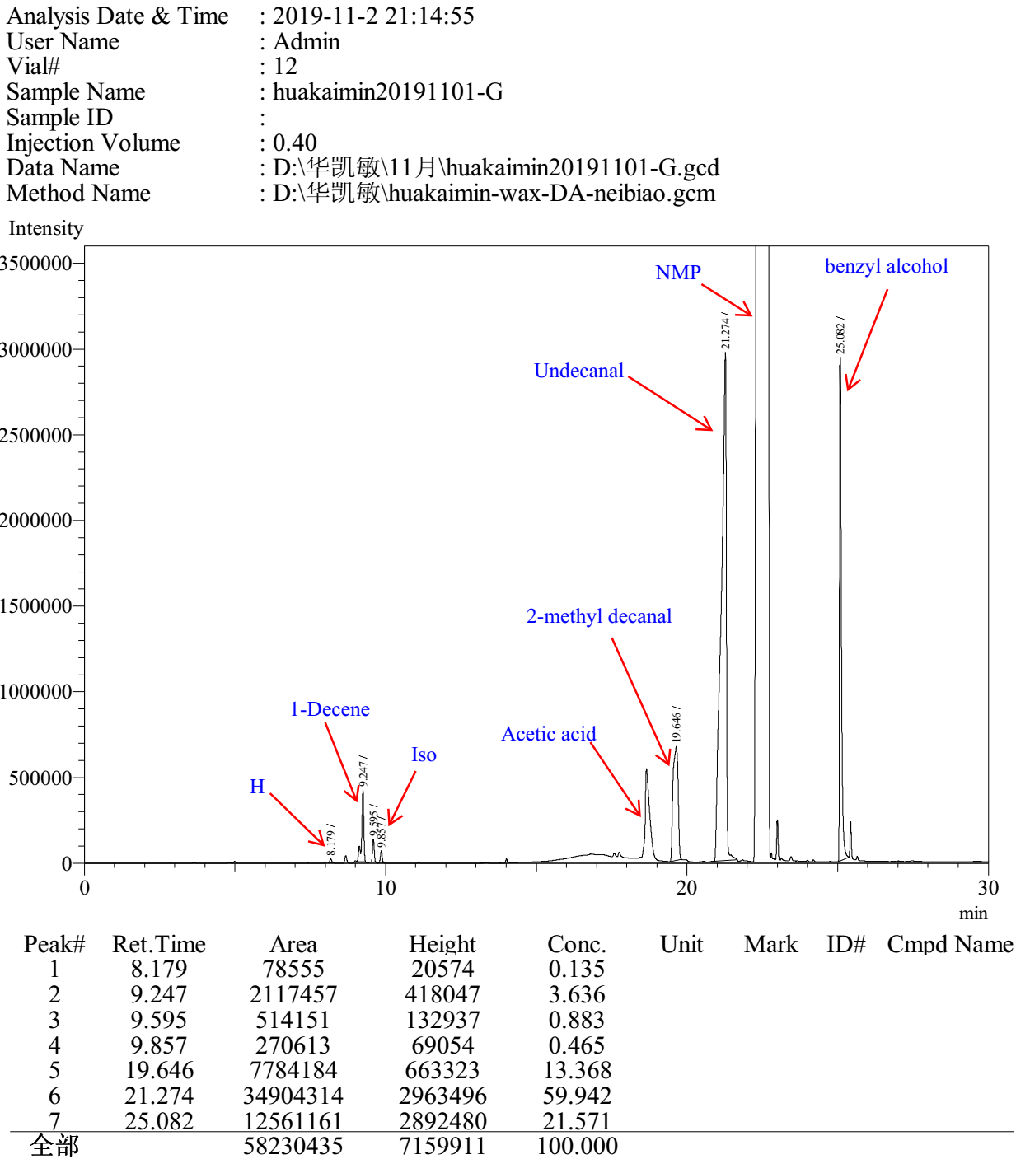

equation (d) Entry 3

equation (d) Entry 4
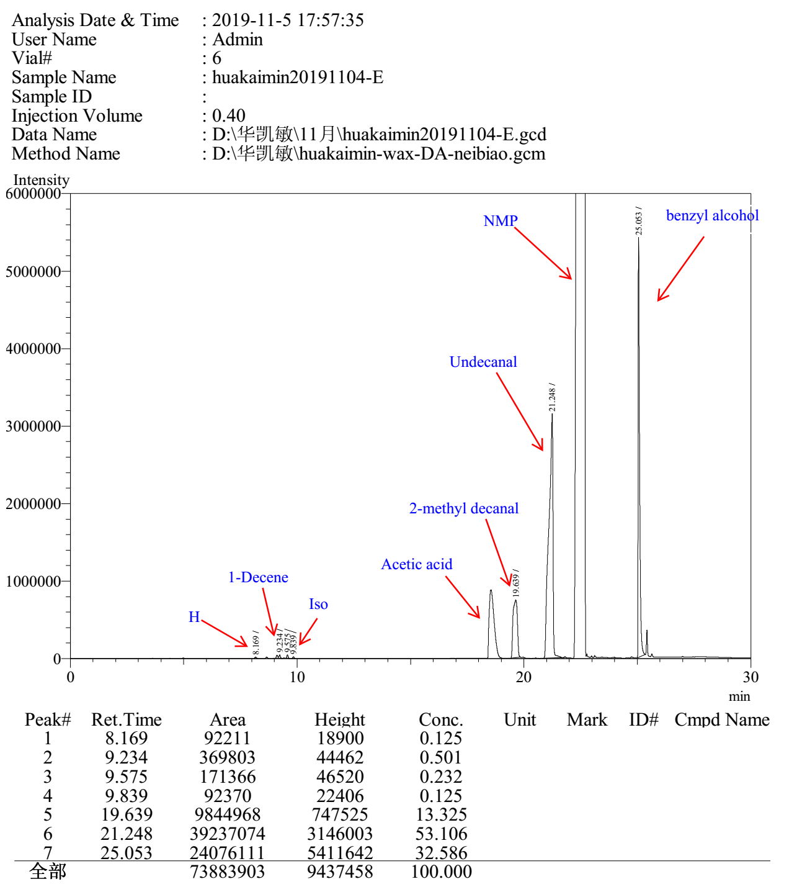
equation (e) Entry 1

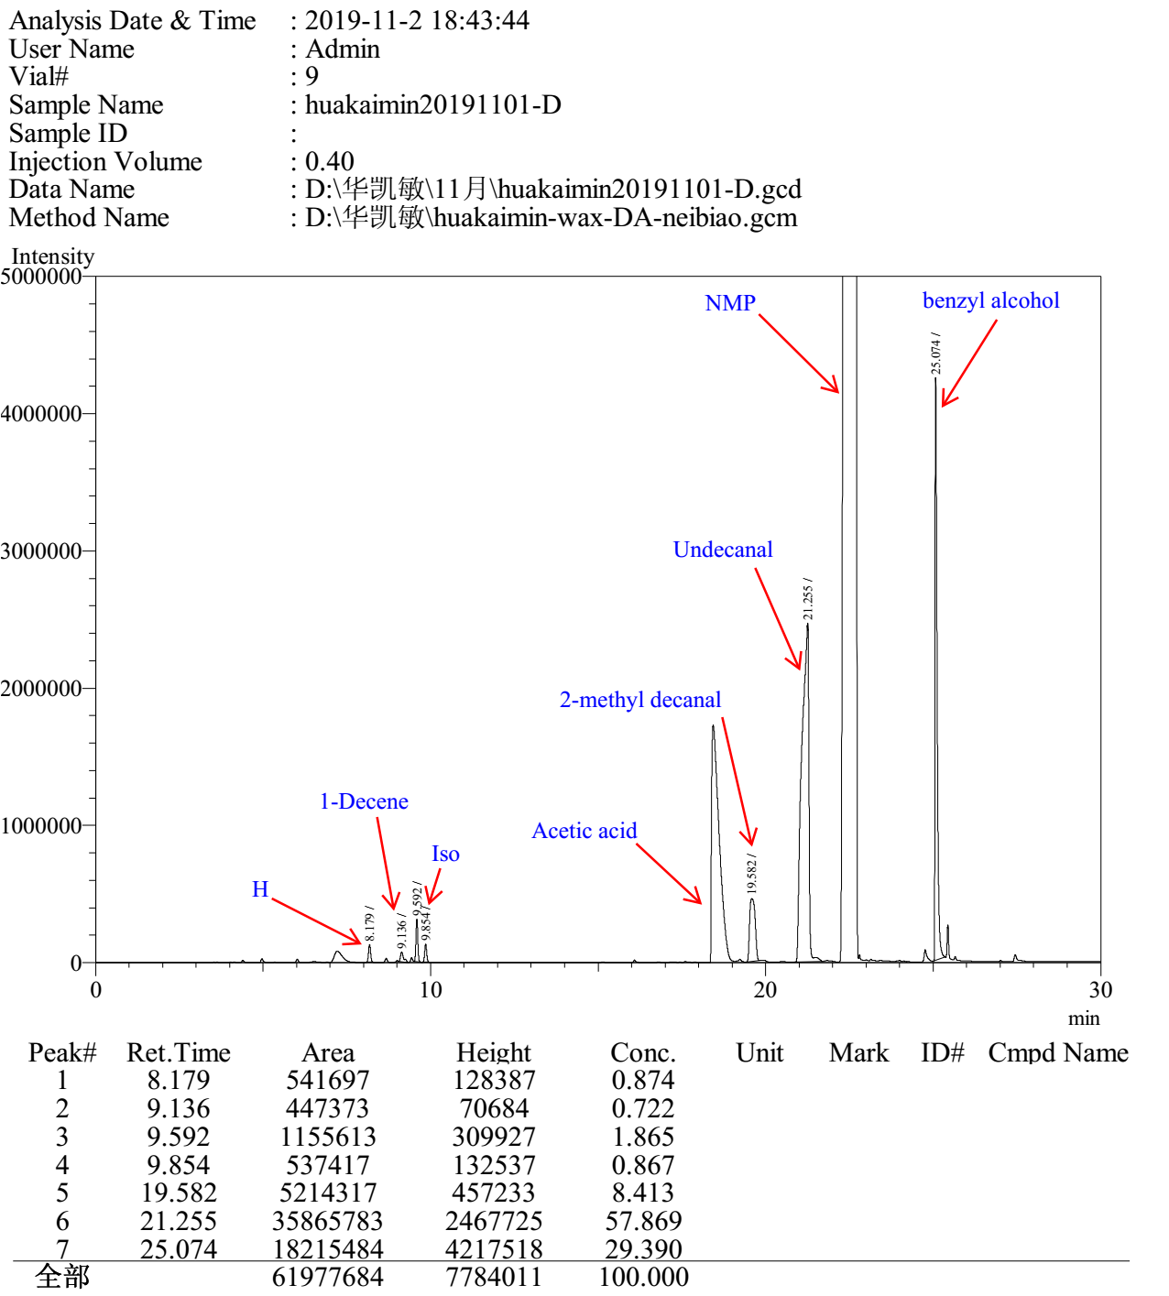

equation (e) Entry 2

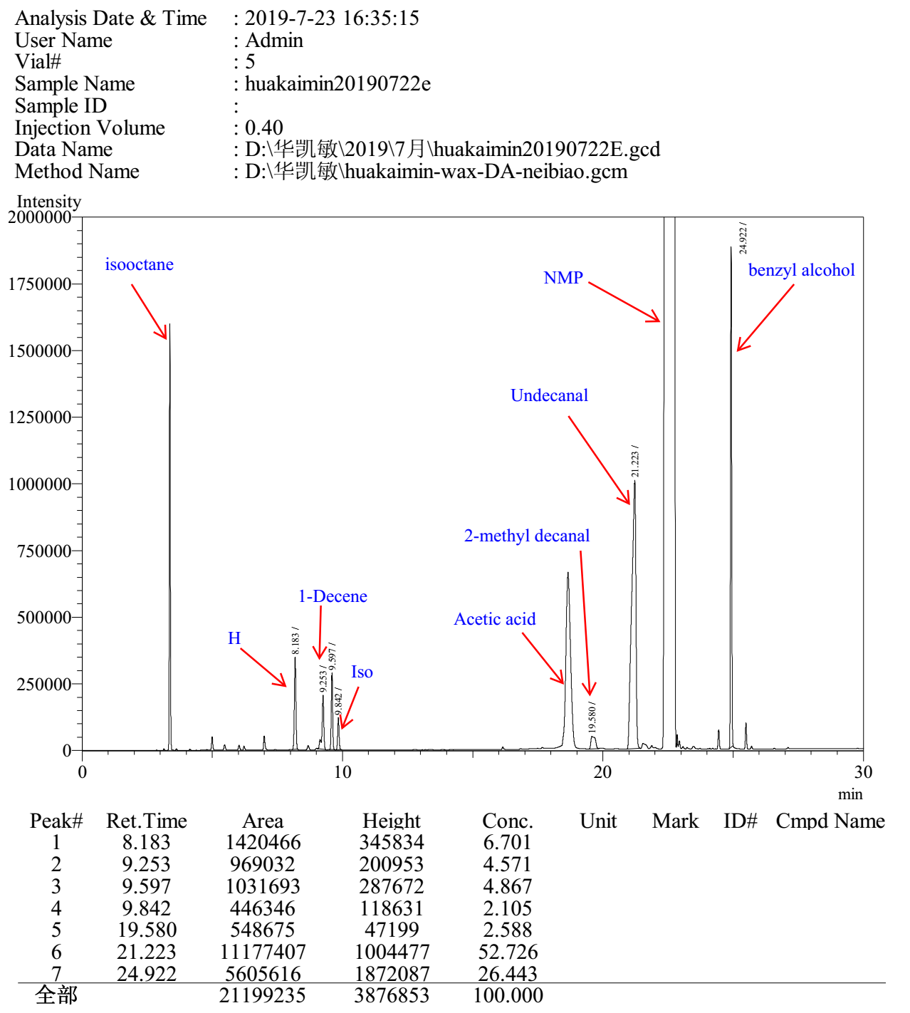

equation (f) Entry 1

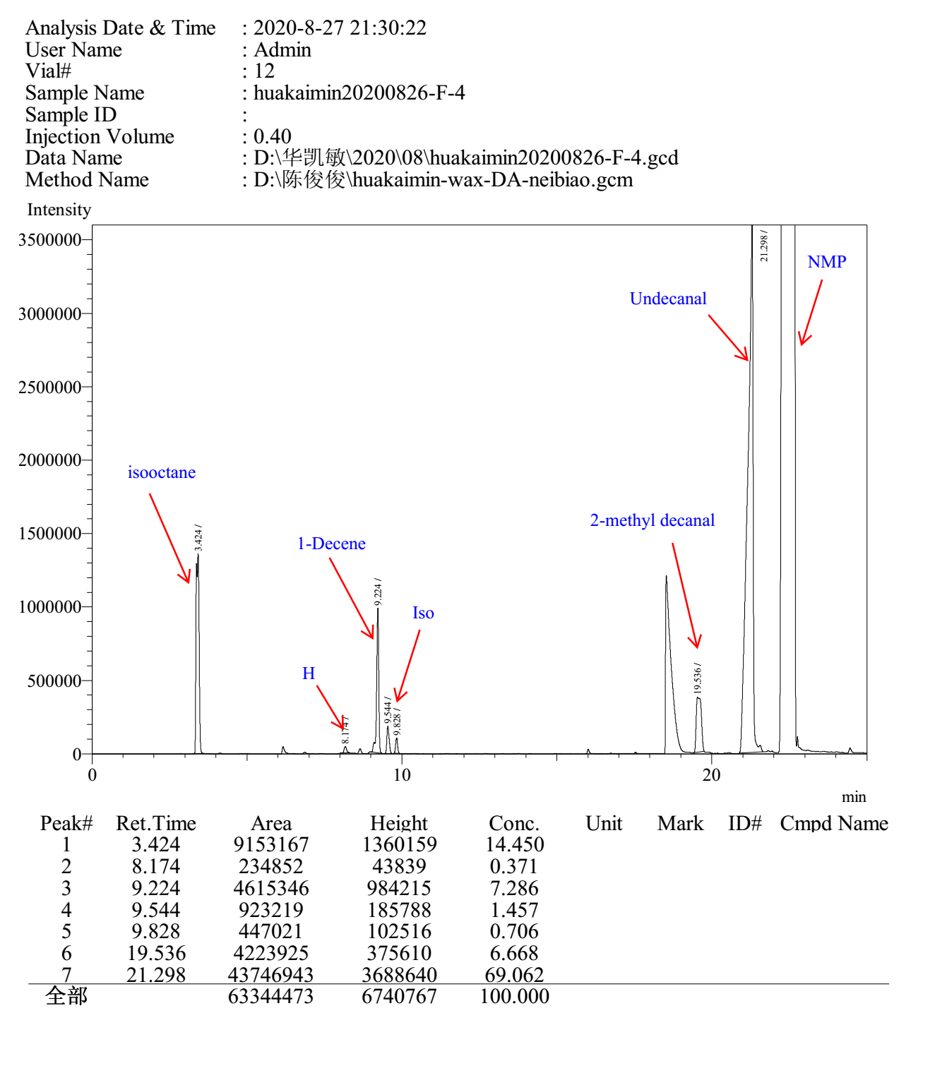

3.12 Gas chromatograms to Table S12

Entry 1

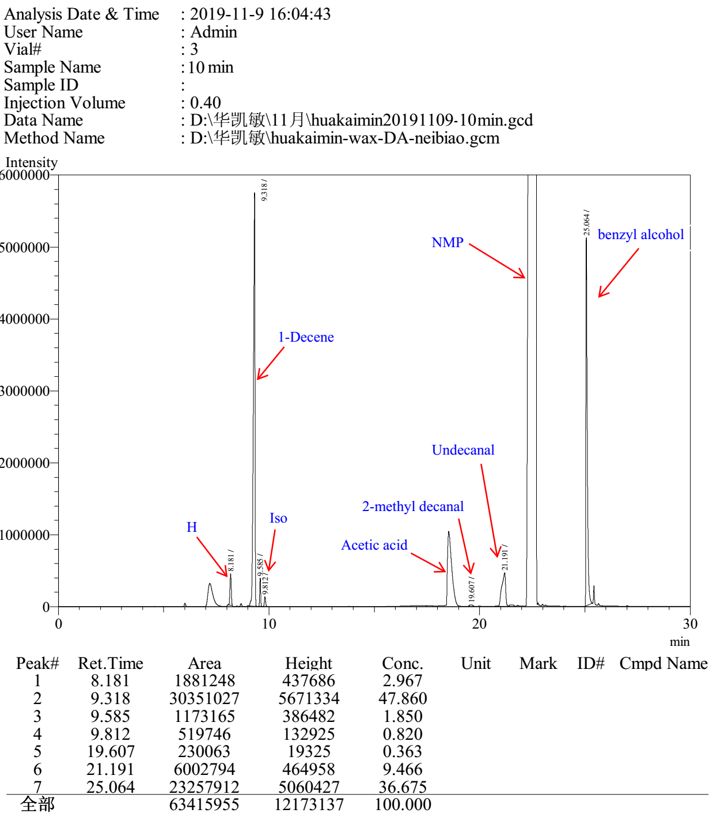

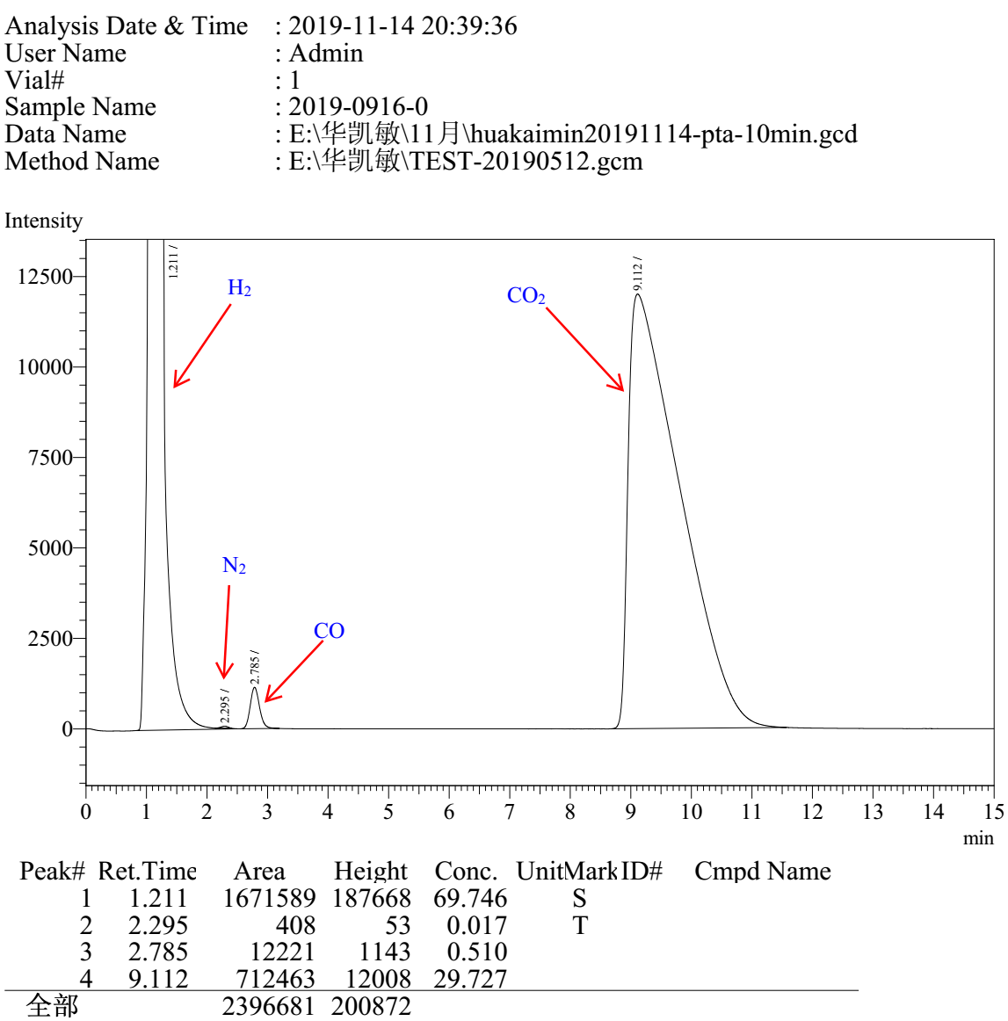

Entry 2

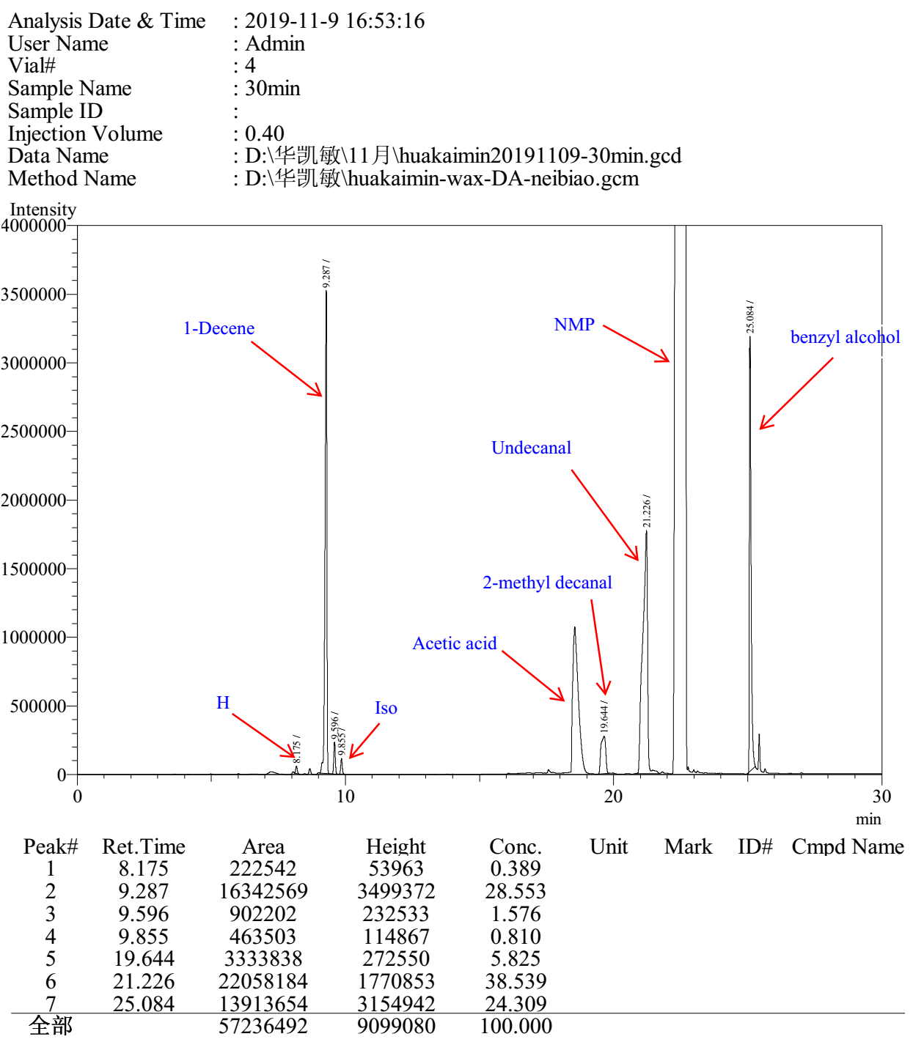

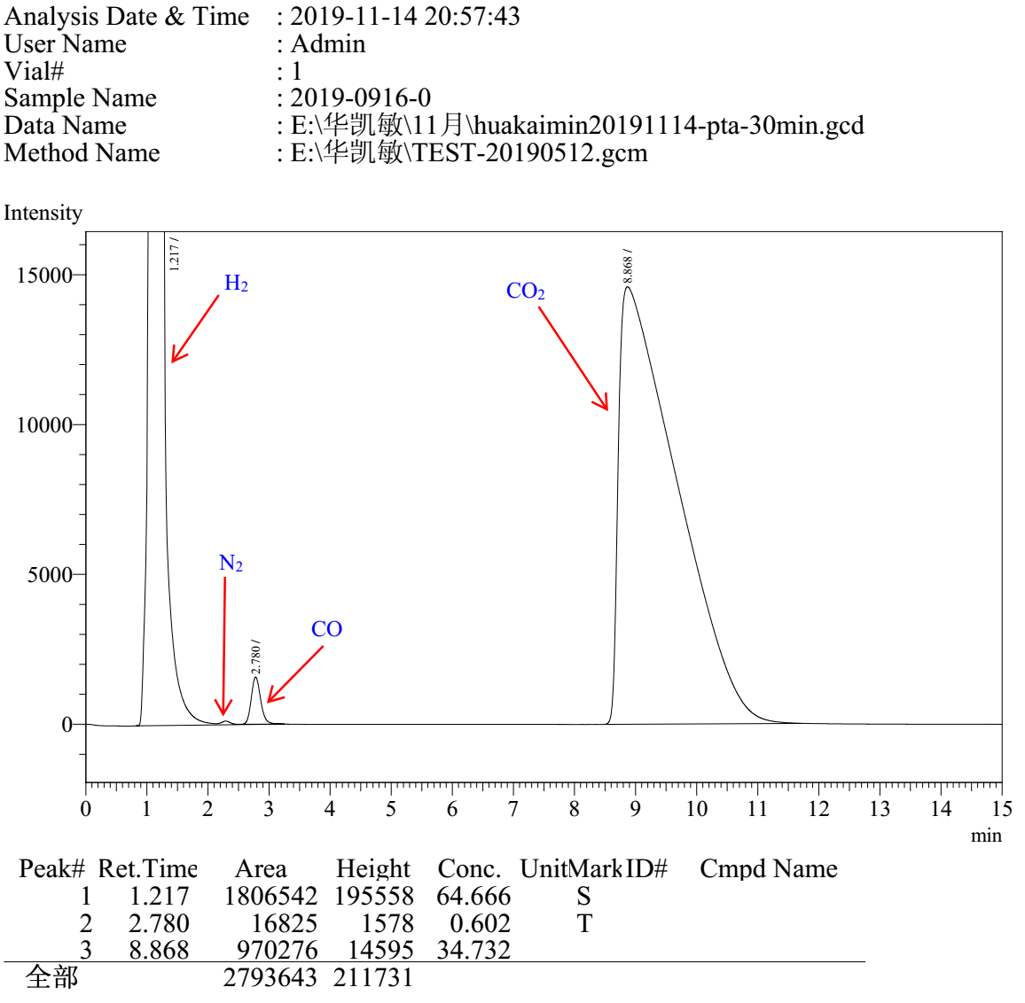

Entry 3

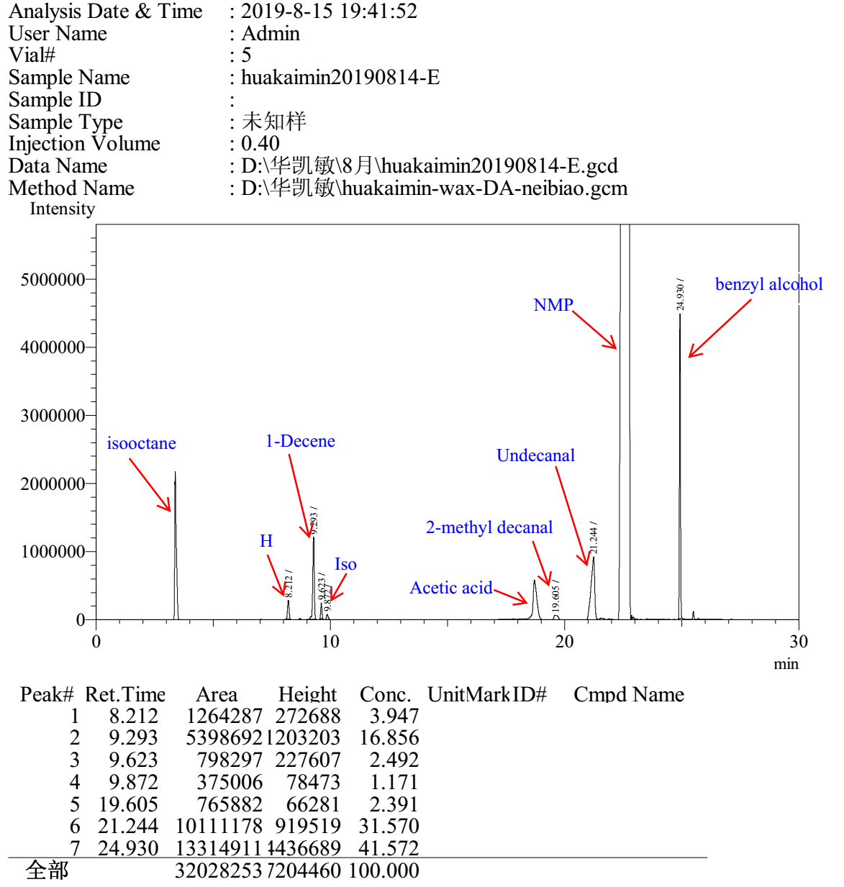

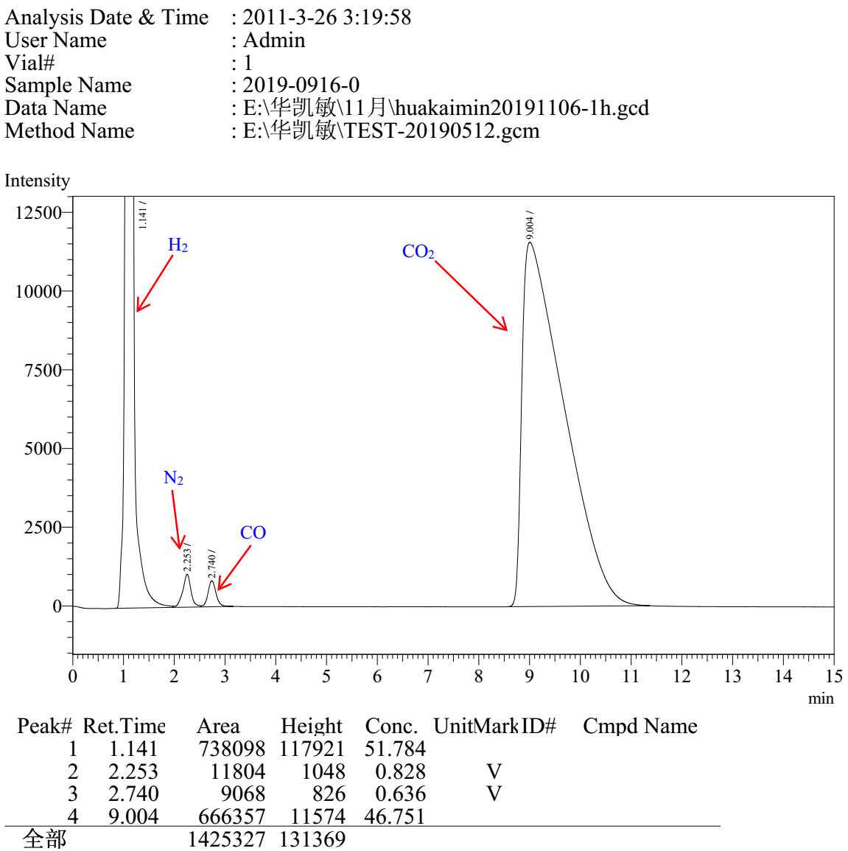

Entry 4

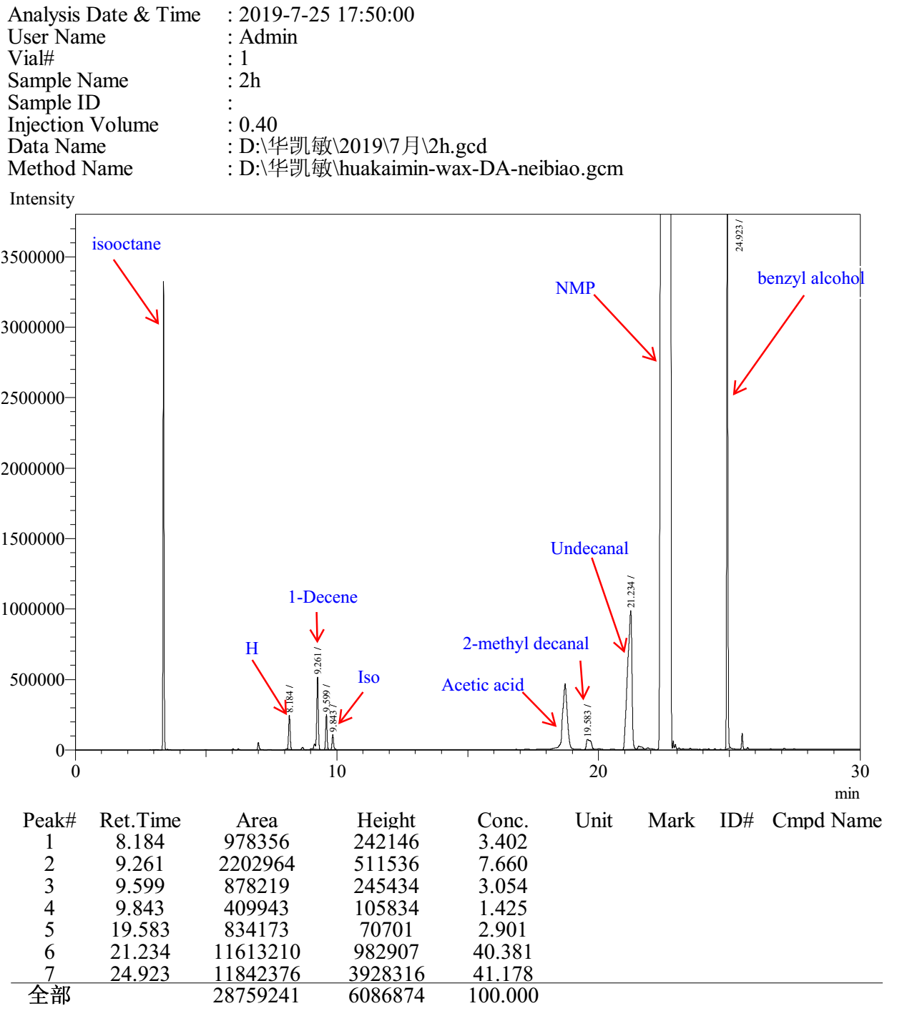

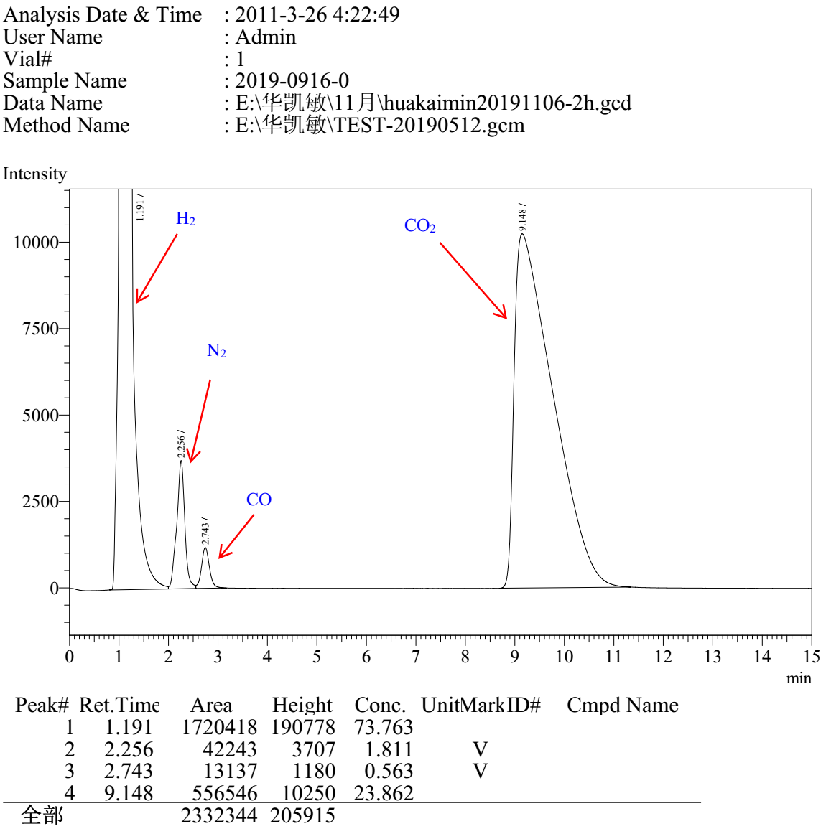

Entry 5

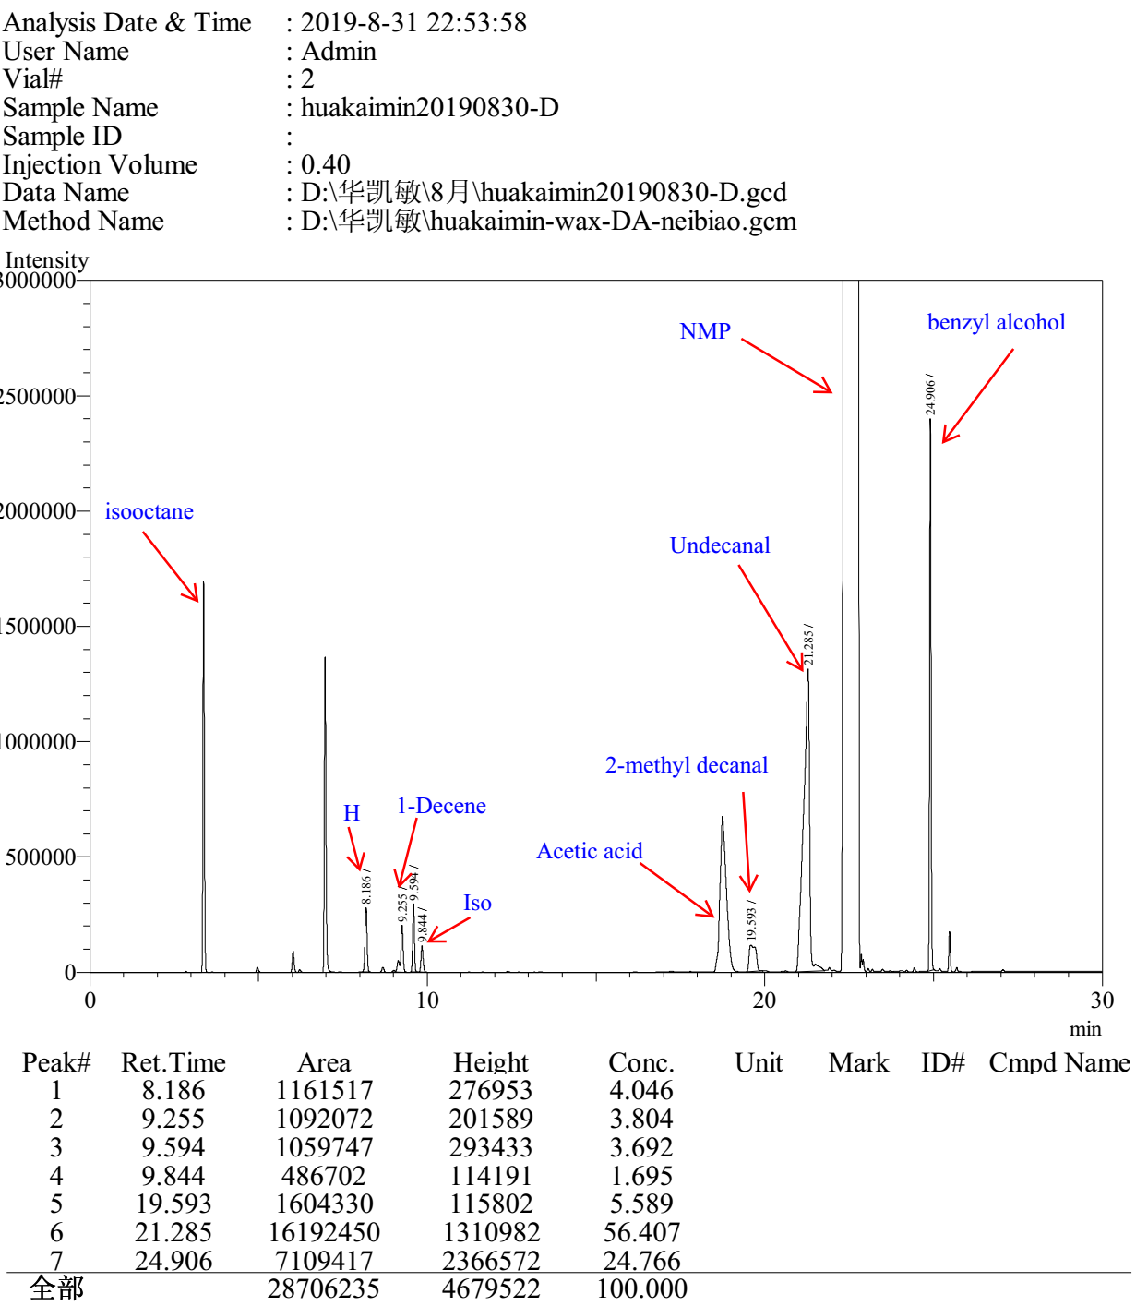

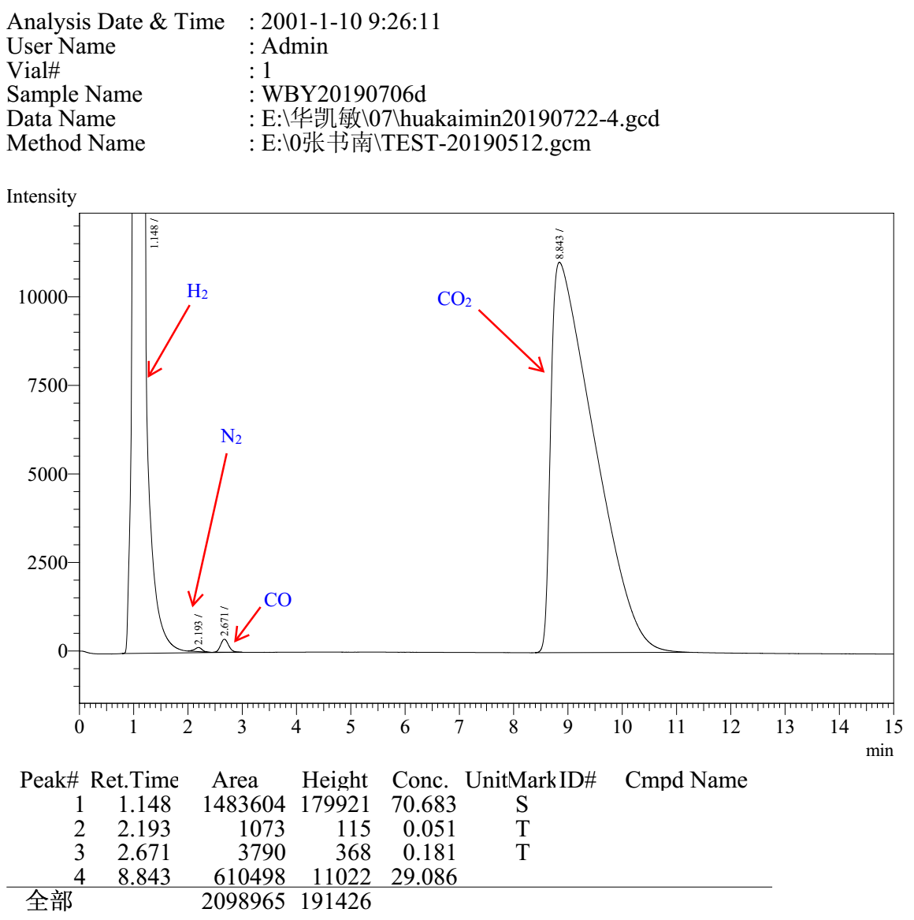

Entry 6

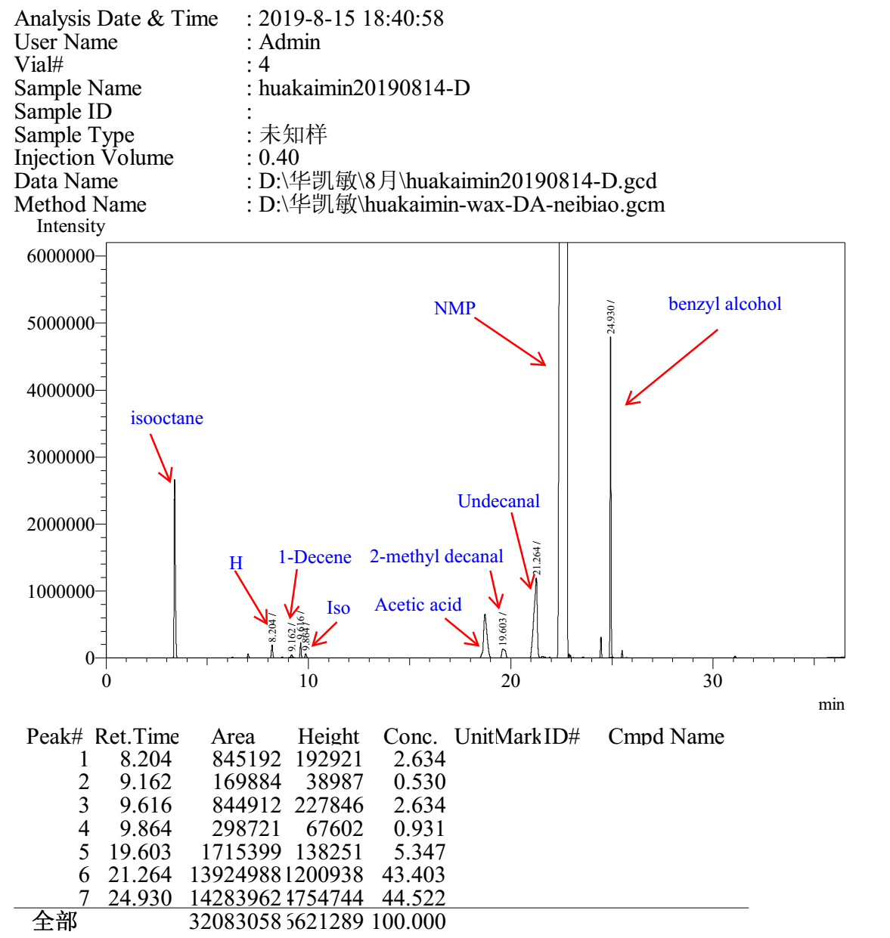

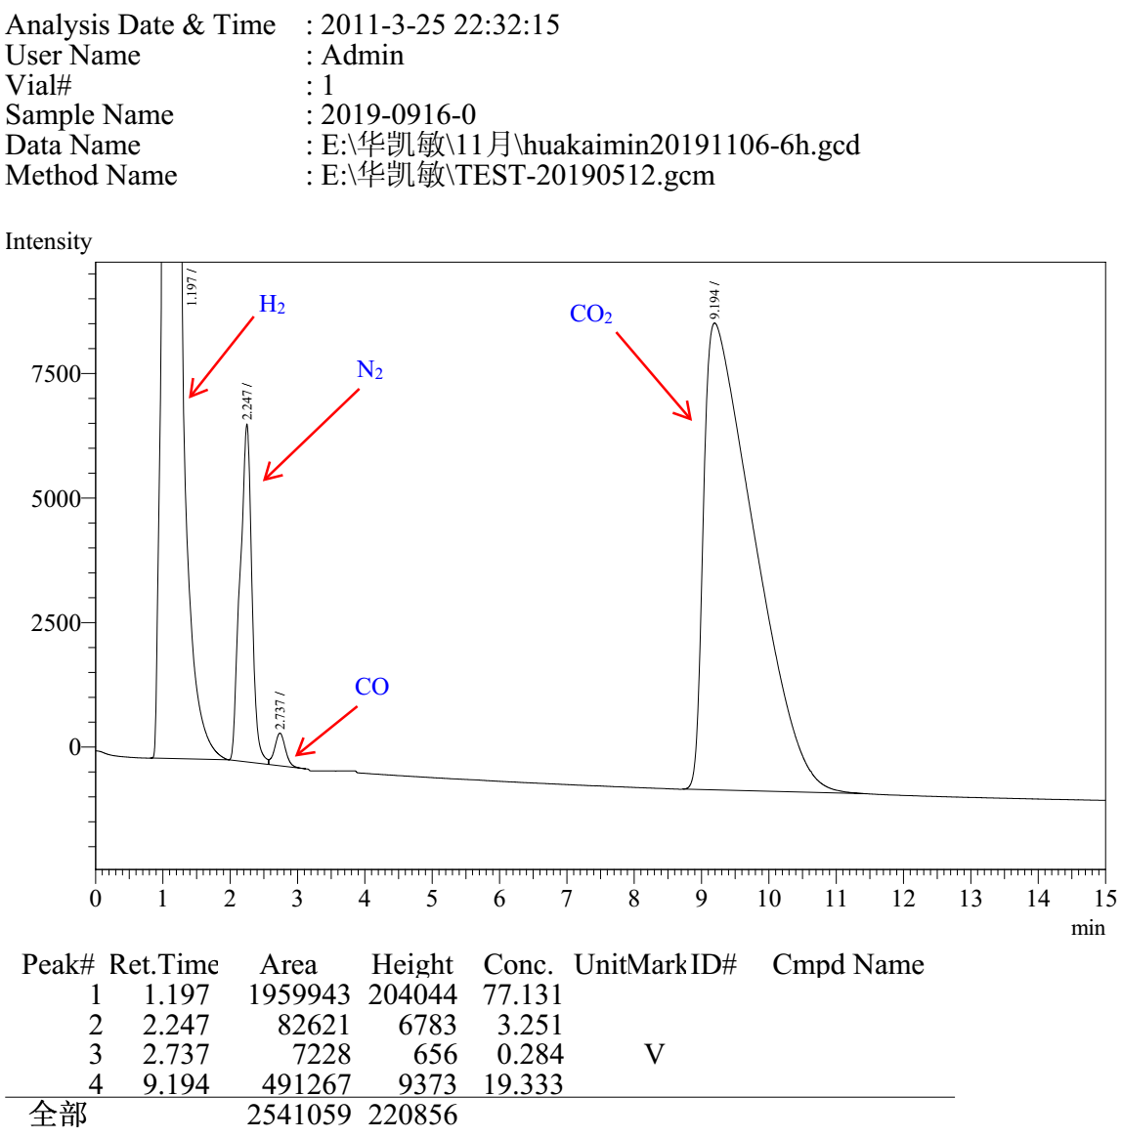

Entry 7

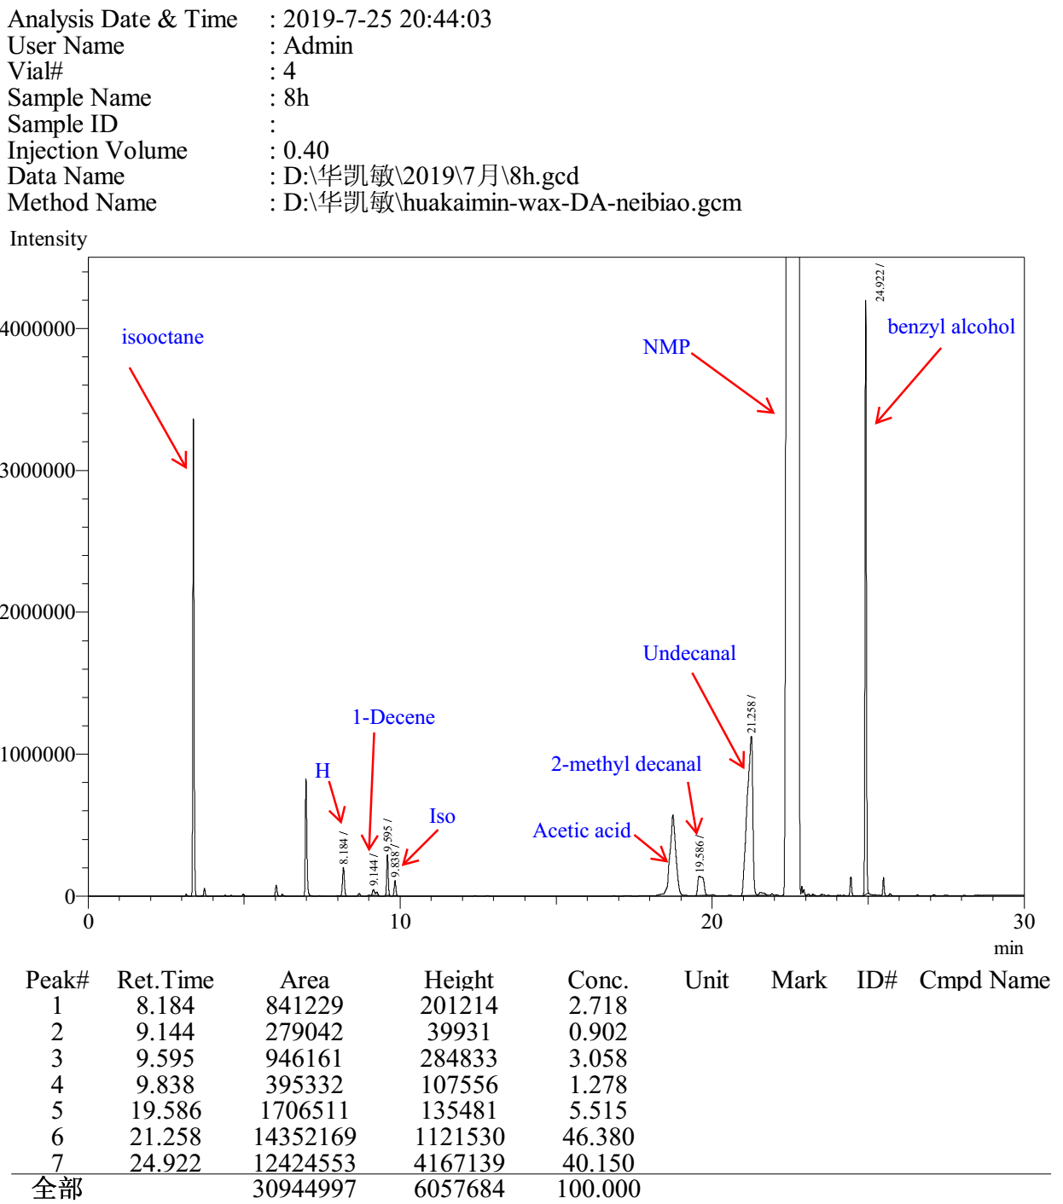

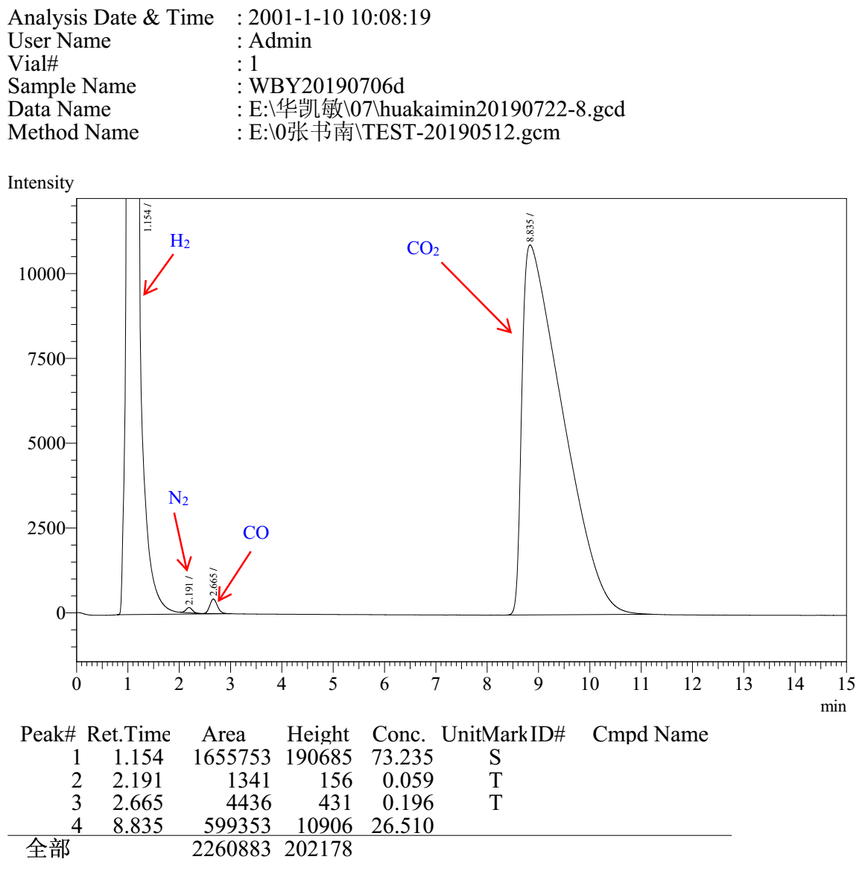

Entry 8

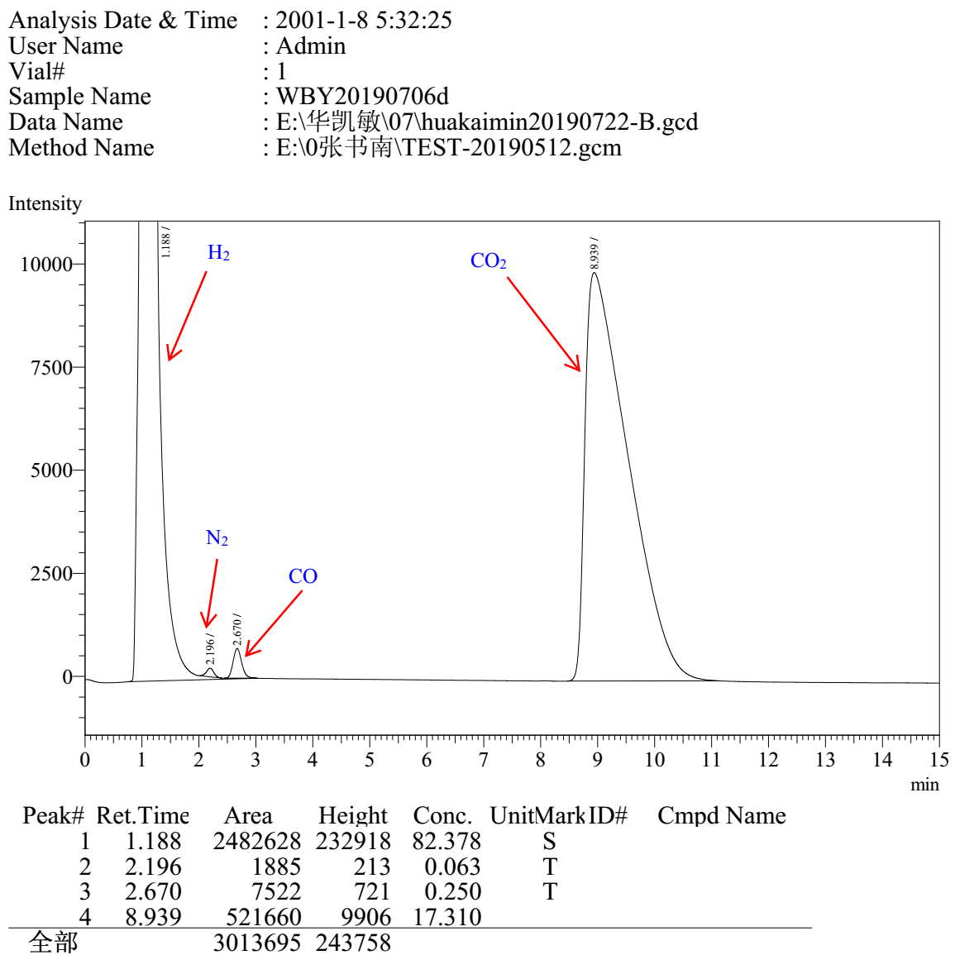

4 NMR, ESI-MS and Mass Spectra
Figure S2 ¹H NMR (CDCl₃, 400 MHz) spectra of the reaction mixture for CO₂ hydrogenation in NMP
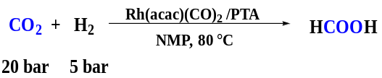
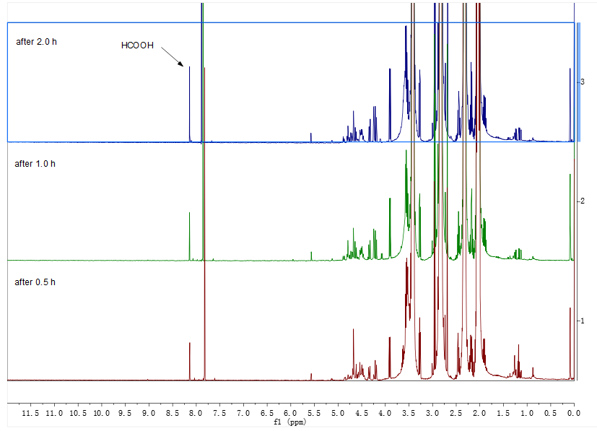

Figure S3 ESI-MS spectra of the Rh/PTA
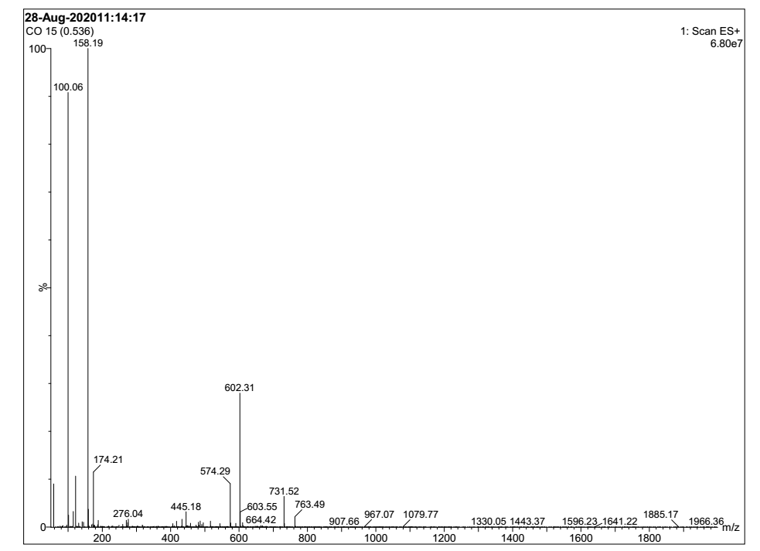
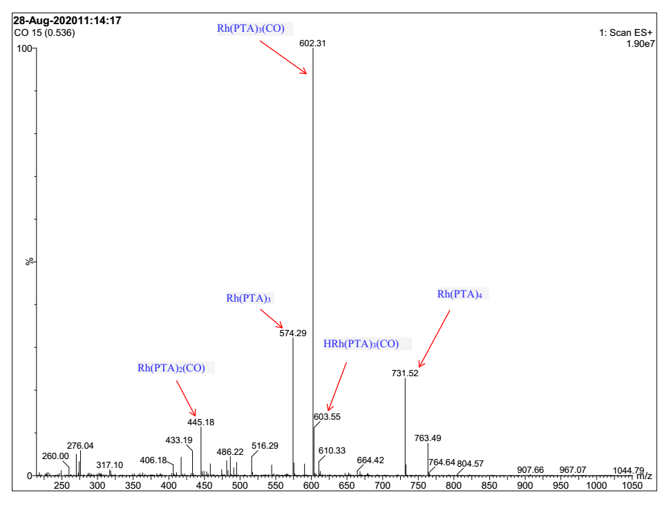

Figure S4 ¹³C NMR (CDCl₃, 100 MHz) spectra of the reaction system with ¹³CO₂ (Table S10 (a))

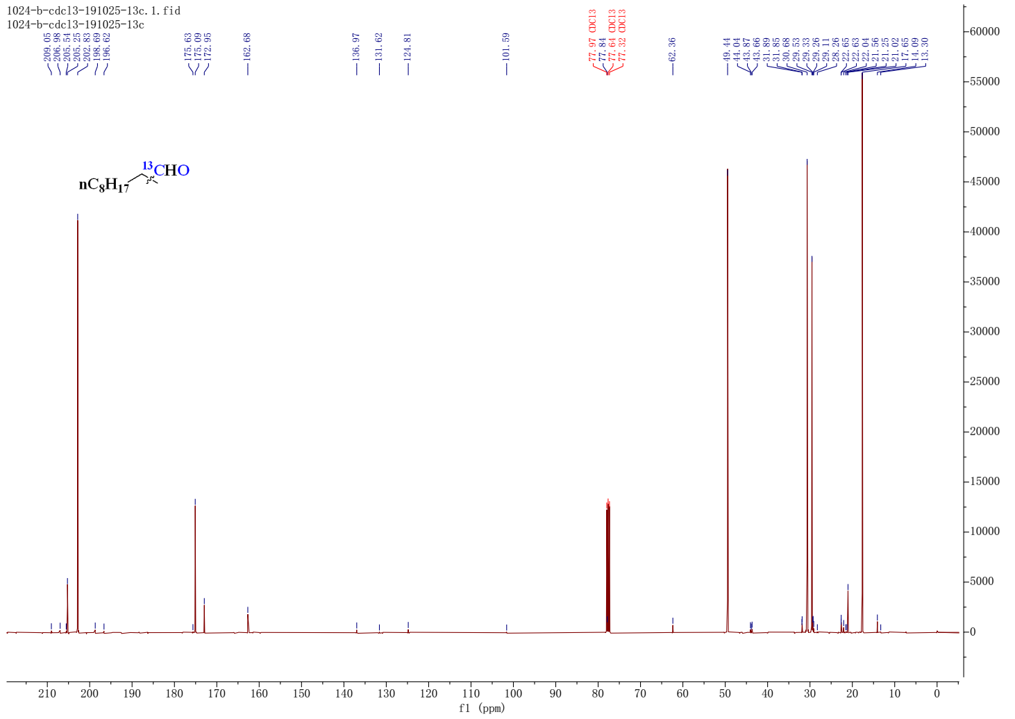

Figure S5 ¹H and ¹³C NMR (CDCl₃, 400 MHz) spectra of the reaction system (Table S10 (b))
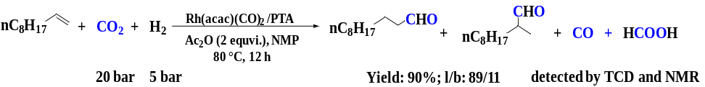
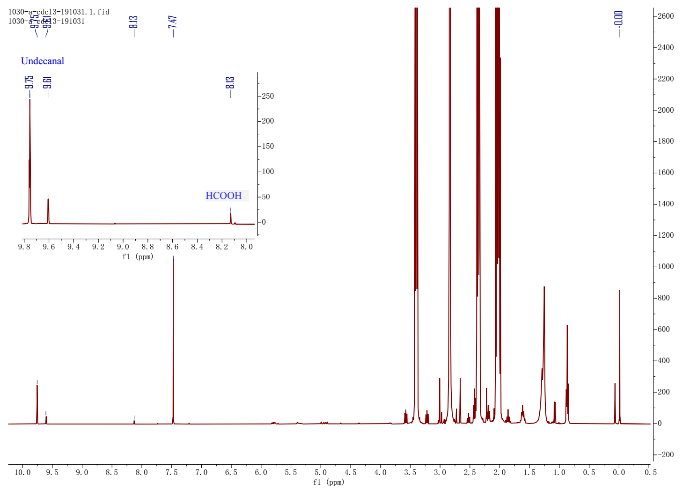
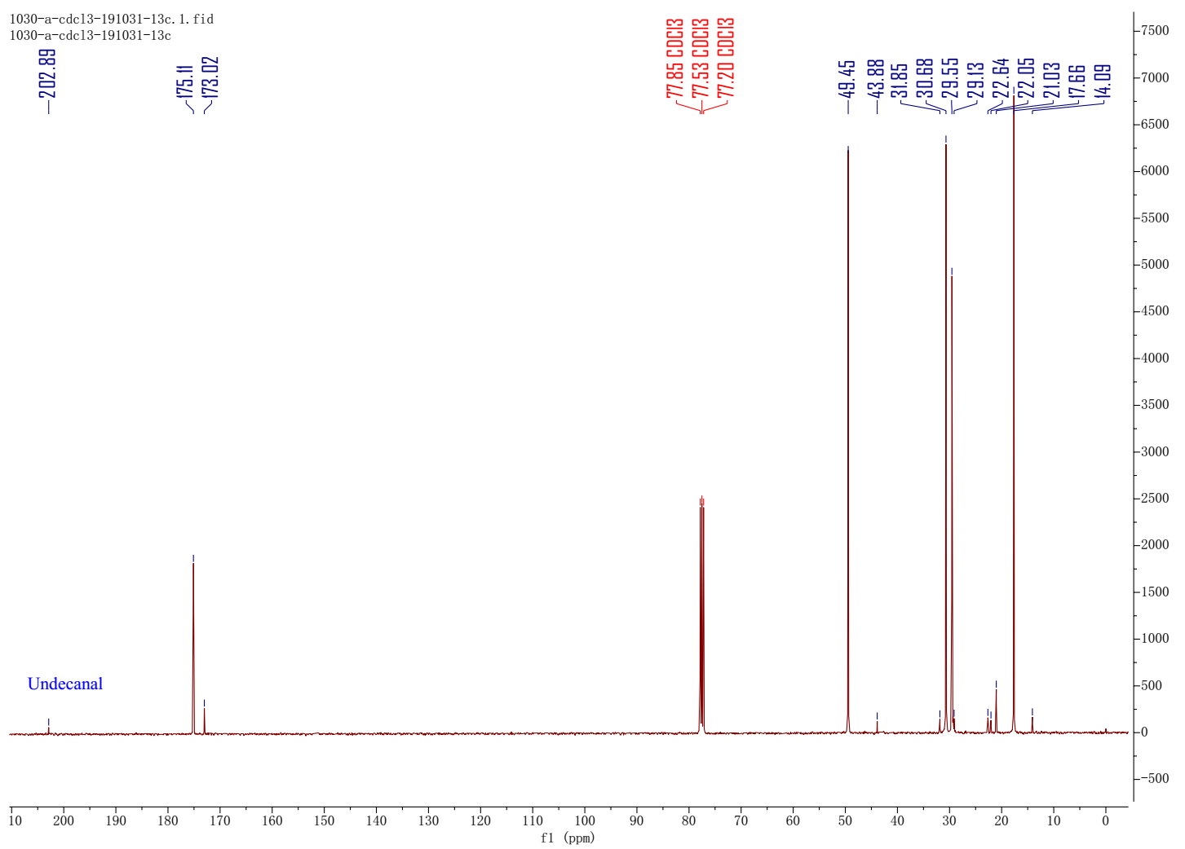
Figure S6 MS spectra of the reaction gas for the isotope-labeling experiments
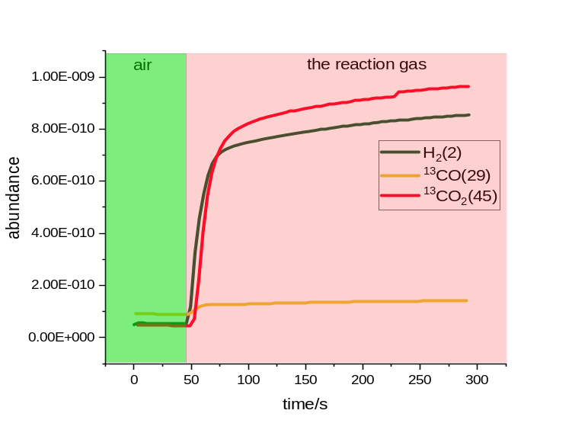

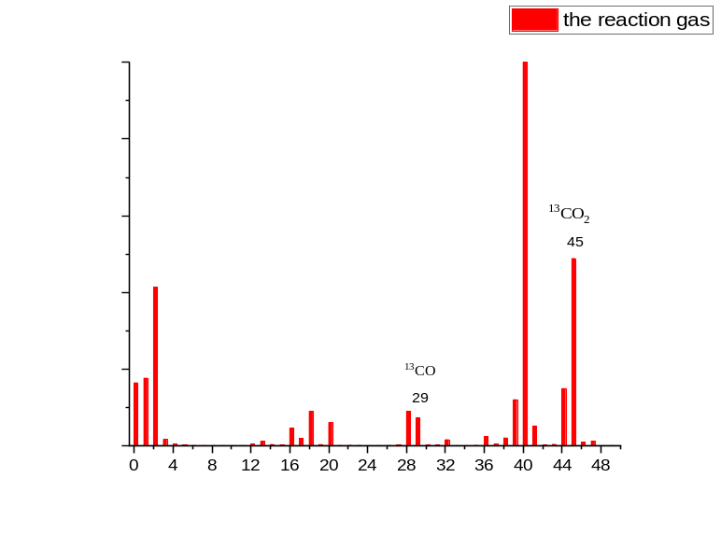

Figure S7 ¹H NMR (CDCl₃, 400 MHz) spectra of the reaction system (c, Table S10)

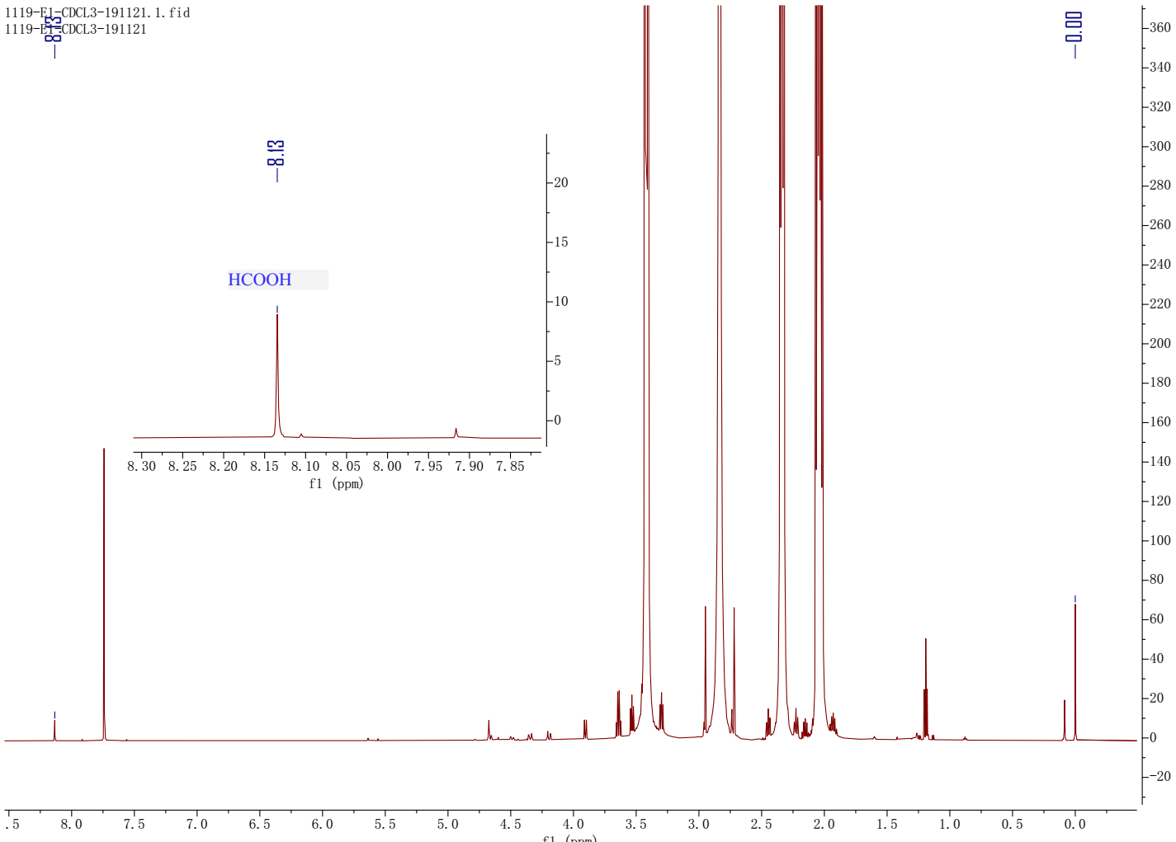
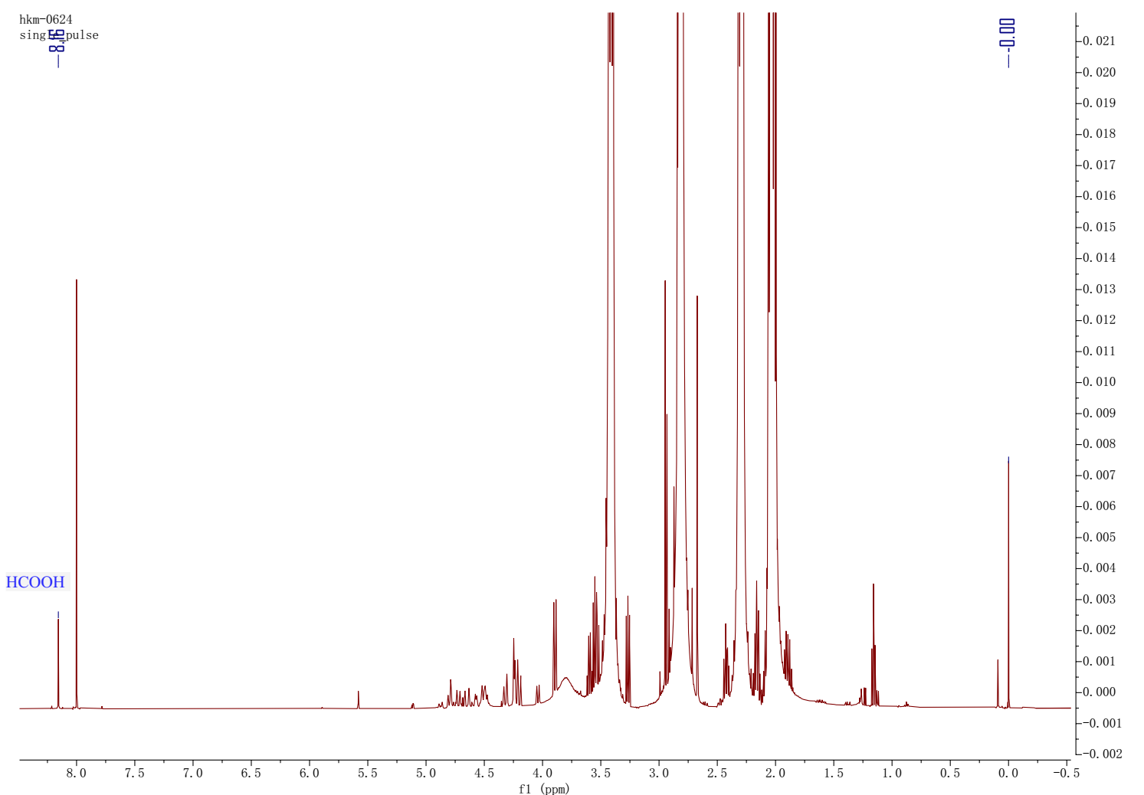

Figure S8 ¹H NMR (CDCl₃, 400 MHz) spectra of HCOOAc

