Supplementary Results

Stepping kinematics in a non-weight bearing environment in a non-SCI individual

Supplementary Figure 1 a, b shows the kinematics of hip, knee, ankle, and toe and associated hip-knee cyclograms during stepping in a non-weight bearing gravity-neutral device (GND). Thin gray lines represent movements of different joints during stepping behavior. The non-SCI participant was instructed to step in the GND while controlling all lower extremity joints in a and while controlling only movement of the hip and knee in b to more closely simulate the movement capacity of a participant with SCI. Supplementary Figure 1 c shows a representative cyclogram during weight-bearing stepping. Due to the nature of non-weight bearing stepping, cyclogram features such as heel-strikes are missing from the non-weight bearing cyclogram.
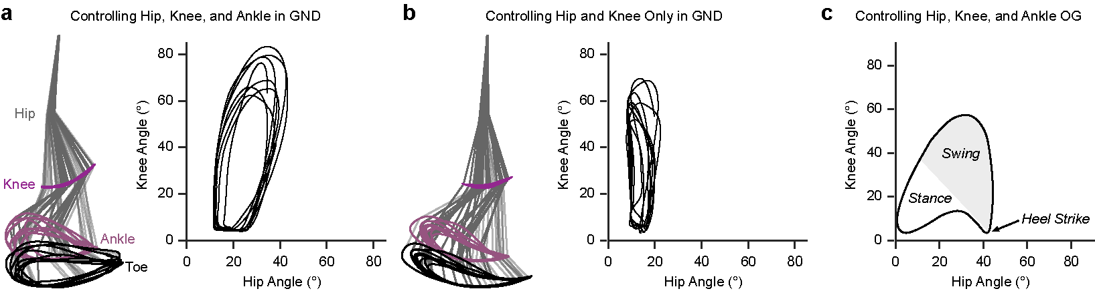

Supplementary Fig. 1 Representative cyclograms during gravity-neutral and weight-bearing stepping a-b, Kinematic data collected in a non-SCI individual during non-weight bearing stepping in a gravity-neutral device²⁵. c, Shown is a representative cyclogram obtained from the hip and knee kinematics during weight-bearing stepping (adapted from Park et. al. 2022). Due to the nature of non-weight bearing stepping, cyclogram features such as heel-strikes are missing from the non-weight bearing cyclogram.

Improved treadmill and overground stepping capabilities post multi-modal intervention
Similar to the left side (Fig. 2), a significant increase in the activation of right lower extremity muscles was observed post-intervention compared to baseline in participant A124. Supplementary Figure 2 a-e shows EMG activation and spectral properties of proximal and distal lower extremity muscles during manual-assisted stepping in a body-weight support treadmill (BWST) without scTS on the right side. Most muscles that exhibited minimal to no activation during baseline demonstrated robust and distinct rhythmic activation (Supplementary Fig. 2 a). The observed increase was statistically significant for all muscles (RF: p < 0.0001; VL: p < 0.0001; ST: p < 0.0001; SOL: p < 0.0001; TA: p< 0.0001, Paired t-test) (Supplementary Fig. 2 b). The spectral analysis demonstrated a significant increase in the peak and total power for all muscles compared to baseline (RF: p < 0.0001; VL: p < 0.0001; ST: p < 0.0001; SOL: p < 0.0001; TA: p < 0.0001, Paired t-test, only total power shown) (Supplementary Fig. 2 c, d). We also observed a significant reduction in the mean frequency for ST, SOL, and TA (Supplementary Fig. 2 e, ST: p = 0.005; SOL: p < 0.0001; TA: p < 0.0001, Paired t-test). The mean frequency for RF was increased, and VL did not demonstrate a significant change (RF: p = 0.0002; VL: p = 0.999, Paired t-test).
Visual inspection of the synergy weights and activation coefficients revealed that two distinct synergies were active during different phases of the gait cycle (Supplementary Fig. 2 f, g). Synergy 1 was dominant during 30-60% of the gait cycle (mid to late stance phase), with the highest contribution from the ST. Meanwhile, synergy 2 dominated the entire gait cycle, with greater activation between 50-100% and a predominant contribution from the VL. Post-intervention, synergy 1 did not demonstrate changes in the contributing muscles and activation coefficients. In contrast, synergy 2 showed decreased contribution from VL and increased contribution from RF. Observed synergies predominantly activated specific motor neuron pools along the lumbosacral spinal cord. At baseline and post-intervention, synergy 1 showed similar discrete hotspots around the ST innervation zone (L5-S2). Synergy 2 showed activation hotspots around VL and RF innervation zone (L2-L4) for the entire gait cycle at baseline. Post-intervention, spatial activation of the motoneuronal pool innervating VL and RF decreased during stance and increased during the swing phase (Supplementary Fig. 2 h).
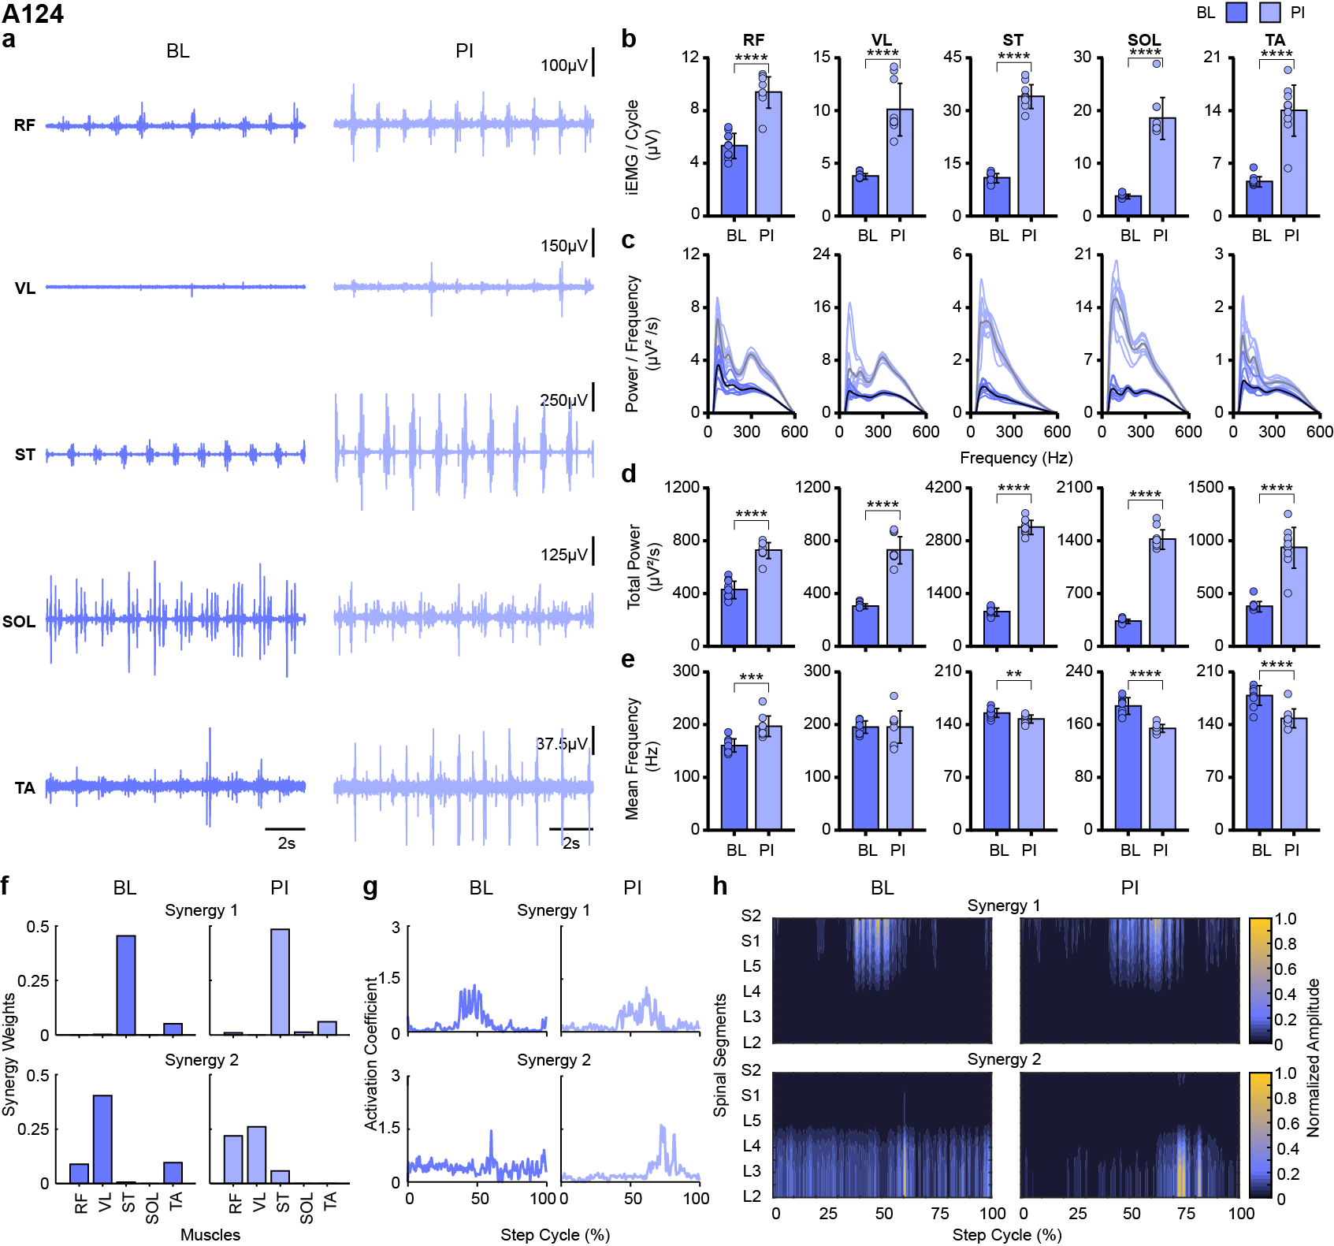
Supplementary Fig. 2 Assisted stepping pre and post multi-modal intervention for participant A124 a-b, EMG activity and associated bar graphs representing right lower extremity muscle activation during baseline (BL) and post-intervention (PI). Multimodal intervention significantly increased the activation levels of most muscles. c-e, Spectral plots and associated bar graphs show a significant increase in the total power and a decrease in the mean frequency PI for all muscles. Each thick spectral trace is the average of thin traces representing individual traces. Each bar represents the mean±SD and each dot represents the data for the individual step cycle. f-h, Bar graphs representing weights and line plots representing activation coefficients of identified predominant synergies based on NNMF. Heatmaps representing spatiotemporal activation pattern of lumbosacral motor neuron pool based on the identified synergy weights and activation coefficients. No changes in the lumbosacral motor pool during PI compared to BL were observed for synergy 1. For synergy 2, hotspots of decreased amplitude during stance and increased amplitudes during swing were observed during PI compared to BL. EMG: electromyography. *p < 0.05; **p < 0.01; ***p < 0.001; ****p < 0.0001, Paired t-test.
Improved overground locomotion post multi-modal intervention
Compared to the left, changes on the right side were less dramatic during post-intervention compared to the baseline in participant C56. Supplementary Figure 3 a-e shows EMG activation and spectral properties of proximal and distal lower extremity muscles during overground (OG) stepping without scTS on the right side. Greater changes in the bursting characteristics were seen for RF, ST, and SOL (Supplementary Fig. 3 a). RF and ST demonstrated a significant increase in the activity levels, SOL activity decreased, and VL and TA did not show differences post-intervention compared to the baseline (RF: p < 0.0001; VL: p = 0.401; ST: p < 0.0001; SOL: p < 0.0001; TA: p = 0.061, Paired t-test) (Supplementary Fig. 3 b). Similar associated changes were observed in the spectral plots for peak and total power (RF: p = 0.335; VL: p = 0.651; ST: p < 0.0001; SOL: p = 0.001; TA: p = 0.213, Paired t-test, only total power shown) (Supplementary Fig. 3 c, d). Unlike the left side, we observed a significant increase in the mean frequency for most of the muscles (VL: p < 0.0001; ST: p = 0.045; SOL: p < 0.0001, Paired t-test). For other muscles, no change in the mean frequency was observed (RF: p = 0.963; TA: p = 0.116) (Supplementary Fig. 3 e).
Unlike our expectation that proximal muscles will contribute more during swing and distal during stance phases, different muscles contributed to the synergy weights and activation coefficients. Synergy 1 dominated between 0-60% of the gait cycle (stance phase), with predominant contribution from VL and RF. Synergy 2 was active during 0-100% of the gait cycle (stance and swing phase) during baseline, and SOL contributed mainly to the synergy weight (Supplementary Fig. 3 f, g). Multi-modal training resulted in increased contribution from VL and RF during synergy 1 and was mostly seen during the stance phase. For synergy 2, we observed decreased contribution from SOL and increased contribution from RF. Spatiotemporal activation maps revealed greater activation of the lumbosacral motor neuronal pool innervating VL and RF (L2-L4) during the stance phase for synergy 1 post-intervention compared to baseline. For synergy 2, we observed reduced activation of the motor neuron pool innervating TA and SOL (L5-S2) during stance and greater activation of the motor neuron pool innervating RF (L2-L4) during the swing phase (Supplementary Fig. 3 h).
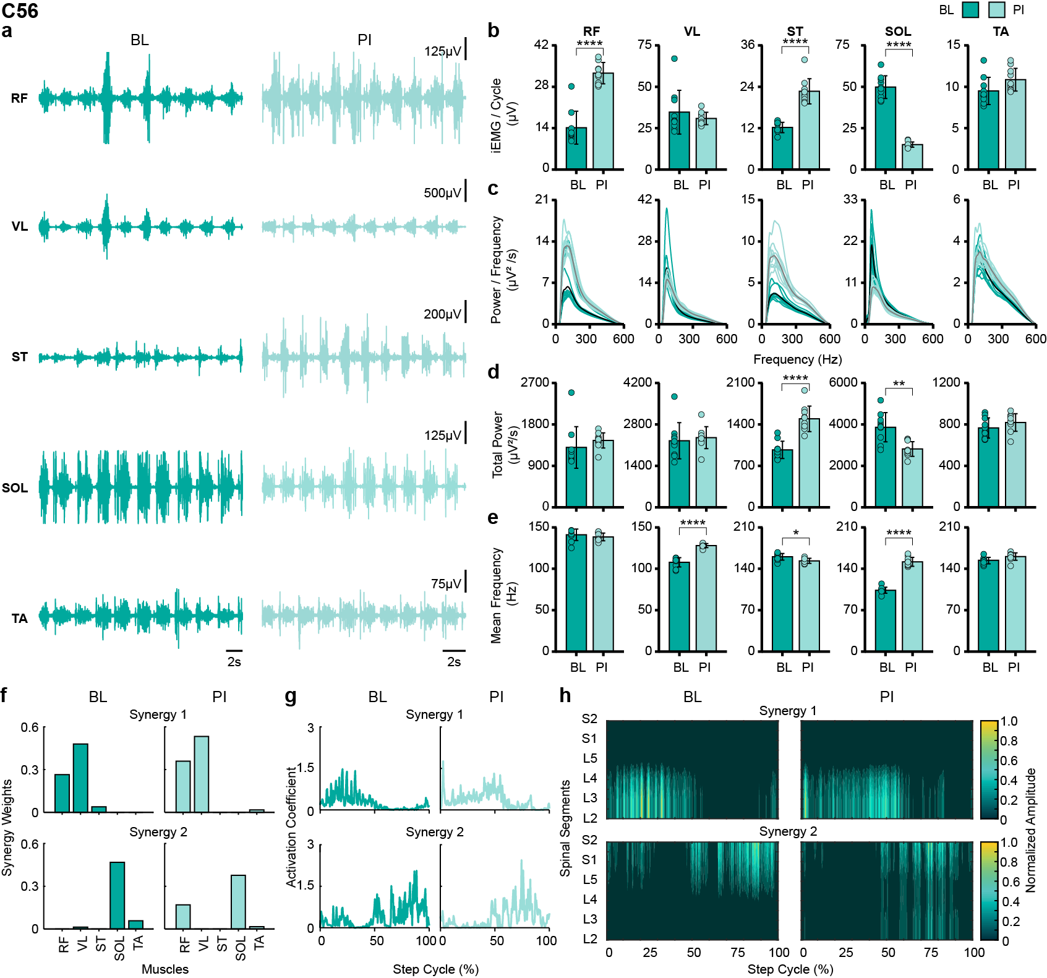
Supplementary Fig. 3 Overground stepping during 6-minute walk test pre and post multi-modal intervention for participant C56 a-b, EMG activity and associated bar graphs representing right lower extremity muscle activation during baseline (BL) and post-intervention (PI). Multimodal intervention significantly increased the activation levels of most proximal muscles. c-e, spectral density plots and associated bar graphs show a significant increase in the total power and a decrease in the mean frequency for ST and SOL post-intervention. No change or increase in total power was observed for other muscles. Mean frequency additionally decreased in VL post-intervention. Each thick spectral trace is the average of thin traces representing individual traces. Each bar represents the mean±SD and each dot represents the data for the individual step cycle. f-h, Bar graphs representing weights and line plots representing activation coefficients of identified predominant synergies based on NNMF. Heatmaps representing spatiotemporal activation pattern of lumbosacral motor neuron pool based on the identified synergy weight and activation coefficients. Hotspots of increased amplitudes were observed during PI compared to BL for synergy 1. For synergy 2, hotspots of decreased amplitude during stance and increased amplitudes during swing were observed during PI compared to BL. EMG: electromyography. *p < 0.05; **p < 0.01; ***p < 0.001; ****p < 0.0001, Paired t-test.
Supplementary Table 1 | Inclusion and exclusion criteria by study group
Participants with Motor Complete SCI | Participants with Motor Incomplete SCI
Inclusion Criteria  18-65 years old,  Stable medical condition,  At least 1-year post-injury,  Non-progressive SCI,  Motor complete paraplegia: Unable to voluntarily move any joint of the lower limbs,  Inability to walk independently due to SCI,  Presence of active spinally evoked responses over the lumbo-sacral spinal cord using scTS. | Inclusion Criteria  18-65 years old,  Stable medical condition,  At least 1-year post-injury,  Non-progressive SCI,  Motor incomplete paraplegia: Able to voluntarily move at least 1 joint of the lower limbs bilaterally,  Inability to walk independently in the community due to SCI,  Presence of active spinally evoked responses over the lumbo-sacral spinal cord using scTS.
Exclusion Criteria
Untreated pressure sores,
Unhealed bone fractures,
Untreated active urinary tract infections,
Peripheral lower limb neuropathies unrelated to SCI,
Seizure disorders,
Cardiopulmonary disease unrelated to SCI,
Untreated anemia,
Ventilator dependency,
Female participants: Pregnant or planning to become pregnant during the time course of study, or nursing,
Healing wounds/surgical sites along the spine, levels T9-L5,
Anti-spasticity implantable pumps,
Untreated clinically significant depression, psychiatric disorders, or ongoing drug abuse,
Colostomy bag, urostomy,
Individuals with abnormal blood panel results related to hepatic function,
Individuals with abnormal estimated glomerular filtration rate (eGFR) and increase Creatinine Clearance (CrCl) levels above the normal range,
Individuals unwilling or unable to wean from drug(s) that interact(s) with buspirone, such as: Monoamine oxidase inhibitors (MAOIs) – Selegiline (Emsam), Isocarboxazid (Marplan), Phenelzein (Nardil), and Tranylcypromine (Parnate)

Supplementary Table 1 Eligibility criteria for study participation for participants with motor complete and motor incomplete SCI.SCI: spinal cord injury, scTS: spinal cord transcutaneous stimulation.

Supplementary Table 2 | scTS parameters used during multi-modal intervention sessions
Participant A124
scTS site | C3-C4 |  |  | T11-T12 |  | L T12-L1 |  |  | R T12-L1 |  |  | L L2-L3 |  | R L2-L3 |  |  |  | Co1
 | Amp. (mA) | Freq. (Hz) |  | Amp. (mA) | Freq. (Hz) | Amp. (mA) |  | Freq. (Hz) | Amp. (mA) | Freq. (Hz) |  | Amp. (mA) | Freq. (Hz) | Amp. (mA) |  | Freq. (Hz) |  | Amp. (mA) |  | Freq. (Hz)
GND | 40-45 | 30 |  | 55-90 | 30 | 35-140 |  | 15, 40 | 35-140 | 15, 40 |  | 35-140 | 15, 40 | 30-100 |  | 15, 40 |  | 30-100 |  | 30
BWST | 30-50 | 30, 40 |  | 35-85 | 30, 60 | 40-110 |  | 30, 40 | 40-105 | 30, 40 |  | 40-120 | 30, 60 | 35-120 |  | 30, 60 |  | 60-140 |  | 30, 60
OG | 15-70 | 30, 60 |  | 20-80 | 30 | 30-85 |  | 30, 40 | 35-95 | 30, 40 |  | 45-100 | 30, 40 | 40-100 |  | 30, 40 |  | 55-100 |  | 30, 40
Participant C56
scTS site | C3-C4 |  |  |  | T11-T12 |  |  |  | L L2-L3 |  |  |  | R L2-L3 |  |  |  | Co1
 | Amp. (mA) |  | Freq. (Hz) |  | Amp. (mA) |  | Freq. (Hz) |  | Amp. (mA) |  | Freq. (Hz) |  | Amp. (mA) |  | Freq. (Hz) |  | Amp. (mA) |  | Freq. (Hz)
GND | 20-30 |  | 30 |  | 40-65 |  | 30 |  | 15-50 |  | 30 |  | 10-55 |  | 30 |  | 20-65 |  | 30
BWST | 10-25 |  | 30 |  | 40-85 |  | 30 |  | 15-75 |  | 30 |  | 15-75 |  | 30, 50 |  | 10-55 |  | 30
OG | 10-30 |  | 30 |  | 35-75 |  | 30, 50 |  | 10-60 |  | 30, 50 |  | 20-70 |  | 30, 50 |  | 20-55 |  | 30

Supplementary Table 2 scTS parameters during multi-modal intervention sessions. scTS: spinal cord transcutaneous stimulation; GND: gravity-neutral device; BWST: body-weight support treadmill; OG: overground; L: Left; R: Right.

Supplementary Table 3 | Muscle innervation chart
Spinal  segment | Muscle
Spinal  segment | SOL | MG | TA | MH | VL | RF
L2
L3 |  |  |  |  | x | x
L4 |  |  | X |  | X | X
L5 | x |  | X | x | X | X
S1 | X | X | X | X
S2 | X | X |  | X
X = high, x = low. X and x are weighted as 1 and 0.5, respectively during motor neuron pool activation plotting. Data are adapted from[38, 55].

Supplementary Table 2: Motor neuronal pool innervating different lower extremity muscles in adult humans.

