Supplementary Information

Attributing child undernutrition in Burkina Faso to climate change-induced crop yield losses

Supplementary Note 1. Yield model evaluation
In the first analysis stage, we develop a machine-learning model for predicting factual and counterfactual crop yields based on six observationally derived agro-climatic variables (details in Methods). The model explains a substantial share of yield variability, with strong correspondence between observed yields and those predicted solely from climate factors. The Nash–Sutcliffe Efficiency (NSE; a goodness-of-fit metric where 1 indicates perfect agreement) indicated moderate predictive skill: 0.63 (out-of-sample = 0.16) for maize, 0.50 (0.23) for millet, and 0.59 (0.24) for sorghum.

Supplementary Table 1. Agro-climatic input variables used in the maize crop model. All variables were calculated for the specific growing season for maize per year and then aggregated (mean, minimum, and maximum) over a 39-year period (1984-2022). See Supplementary Fig. 6 for the crop-specific growing season for maize.
Climate variable | Abbreviation | Mean |  | Minimum |  | Maximum
 |  | Factual | Counterfactual | Factual | Counterfactual | Factual | Counterfactual
Mean daily mean temperature (°C) | tas_mean | 27.83 | 26.10 | 25.12 | 23.59 | 31.95 | 30.76
Mean daily range between maximum and minimum temperature (°C) | tasrange_mean | 8.07 | 7.74 | 6.42 | 6.06 | 10.96 | 10.81
Number of days with daily maximum temperatures above the 95th percentile of the daily maximum temperature of the reference period (1984-2013) | tasmax_p95 | 36.83 | 34.20 | 32.02 | 29.78 | 41.62 | 39.77
Number of days with daily minimum temperatures below the 5th percentile of daily minimum temperature of the reference period (1984-2013) | tasmin_p05 | 22.09 | 20.64 | 20.23 | 19.08 | 24.37 | 23.33
Precipitation sum in mm | pr_sum | 506.55 | 543.96 | 104.18 | 139.62 | 959.85 | 1113.40
Number of days with precipitation sums equal or below 1 mm | pr_b1mm | 50.37 | 44.69 | 15.00 | 13.00 | 95.75 | 85.75

Supplementary Table 2. Agro-climatic input variables used in the crop models for millet and sorghum. All variables were calculated for the specific growing seasons for these crops per year and then aggregated (mean, minimum, and maximum) over a 39-year period (1984-2022). See Supplementary Fig. 7 for the crop-specific growing seasons for millet and sorghum.
Climate variable | Abbreviation | Mean |  | Mininum |  | Maximum
 |  | Factual | Counterfactual | Factual | Counterfactual | Factual | Counterfactual
Mean daily mean temperature (°C) | tas_mean | 27.48 | 26.03 | 24.62 | 23.35 | 31.85 | 30.73
Mean daily range between maximum and minimum temperature (°C) | tasrange_mean | 8.38 | 8.15 | 6.57 | 6.27 | 11.20 | 11.08
Number of days with daily maximum temperatures above the 95th percentile of the daily maximum temperature of the reference period (1984-2013) | tasmax_p95 | 36.06 | 34.42 | 31.11 | 29.42 | 40.99 | 39.49
Number of days with daily minimum temperatures below the 5th percentile of daily minimum temperature of the reference period (1984-2013) | tasmin_p05 | 21.87 | 20.54 | 18.33 | 18.04 | 24.32 | 23.28
Precipitation sum in mm | pr_sum | 488.19 | 493.93 | 100.69 | 128.71 | 915.26 | 911.65
Number of days with precipitation sums equal or below 1 mm | pr_b1mm | 53.03 | 49.93 | 17.00 | 14.00 | 98.25 | 89.50

Supplementary Table 3: Adjusted associations of crop yield anomaly index and sociodemographic characteristics with child undernutrition indicators (for the models included in the health impact attribution analysis)
 | Stunted  (HAZ<-2) | Severely  stunted  (HAZ<-3) | Underweight  (WAZ<-2) | Severely  underweight  (WAZ<-3)
Crop Yield Anomaly Index at birth  (calendar year) | 0.92 (0.89, 0.96) *** | 0.91 (0.86, 0.95) **
Crop Yield Anomaly Index 6 months prior to interview |  |  | 0.87 (0.82, 0.93) *** | 0.87 (0.79, 0.96) **
Male child  (ref. = Female) | 1.25 (1.18, 1.34) *** | 1.28 (1.18, 1.39) *** | 1.18 (1.11, 1.26) *** | 1.25 (1.15, 1.37) ***
Urban residence  (ref. = Rural) | 0.67 (0.60, 0.76) *** | 0.67 (0.56, 0.80) *** | 0.73 (0.64, 0.83) *** | 0.68  (0.54, 0.85) ***
Wealth category
(ref. = Poorer)
Middle | 0.90 (0.82, 0.98) * | 0.88 (0.80, 0.98) * | 0.92 (0.84, 1.00) | 0.90 (0.79, 1.02)
Richer | 0.67 (0.60, 0.75) *** | 0.66 (0.57, 0.76) *** | 0.75 (0.67, 0.85) *** | 0.72  (0.61, 0.86) ***
Mother’s education (ref. = No education)
Primary | 0.77 (0.69, 0.87) *** | 0.70 (0.59, 0.83) *** | 0.82 (0.72, 0.93) ** | 0.74 (0.6, 0.90) **
Secondary | 0.67 (0.55, 0.83) *** | 0.54 (0.38, 0.76) *** | 0.64 (0.53, 0.78) *** | 0.52  (0.35, 0.77) **
Higher | 0.58 (0.27, 1.25) | 0.48 (0.11, 2.13) | 0.70 (0.29, 1.67) | 0.69  (0.17, 2.84)
Mother's age at birth (in years) | 0.97 (0.96, 0.98) *** | 0.97 (0.96, 0.98) *** | 0.98 (0.97, 0.99) ** | 0.97  (0.96, 0.99) ***
Mother's height | 0.96 (0.95, 0.97) *** | 0.97 (0.96, 0.98) *** | 0.97 (0.96, 0.98) *** | 0.98  (0.97, 0.99) ***
Male household head (ref. = Female) | 0.94 (0.82, 1.09) | 0.93 (0.76, 1.13) | 1.01 (0.86, 1.18) | 0.94  (0.74, 1.18)
Occupation of household head not in agriculture  (ref. = Agriculture) | 0.96 (0.87, 1.05) | 0.95 (0.84, 1.07) | 0.90 (0.82, 0.98) * | 0.99  (0.86, 1.15)
Number of children under 5 years of age in household | 1.06 (1.04, 1.09) *** | 1.07 (1.04, 1.1) *** | 1.04 (1.02, 1.07) ** | 1.05  (1.01, 1.09) **
Religion
(ref. = Christian)
Muslim | 1.10 (1.01, 1.19) * | 1.14 (1.02, 1.27) * | 1.07 (0.98, 1.17) | 1.10 (0.97, 1.25)
Traditional | 1.15 (1.01, 1.31) * | 1.32 (1.12, 1.54) *** | 1.18 (1.03, 1.36) * | 1.39  (1.16, 1.66) ***
Other | 1.26 (0.95, 1.66) | 1.36 (1.05, 1.77) * | 1.06 (0.82, 1.38) | 1.34 (1.00, 1.78) *
Birth order | 1.05 (1.02, 1.08) *** | 1.06 (1.02, 1.09) ** | 1.03 (1.00, 1.05) * | 1.07  (1.03, 1.11) **
Season of birth
(ref. = September to November)
December to March | 1.10 (1.01, 1.19) * | 1.15 (1.03, 1.28) *
April to June | 1.20 (1.10, 1.31) *** | 1.14 (1.02, 1.29) *
July to August | 1.19 (1.07, 1.31) ** | 1.12 (0.98, 1.29)
Child age FEs  (months) | Yes | Yes | Yes | Yes
Month of interview FEs |  |  | Yes | Yes
Survey round FEs | Yes | Yes | Yes | Yes
Region (admin_1) FEs | Yes | Yes | Yes | Yes
Region x Survey round (interaction) FEs | Yes | Yes | Yes | Yes
Obs. | 26564 | 26564 | 25362 | 25362
Pseudo R² | 0.135 | 0.124 | 0.082 | 0.109
Note: p < 0.1, *p < 0.05, **p < 0.01, ***p < 0.001. Cell entries are odds ratios with robust standard errors reported in parenthesis. Standard errors are clustered at the primary sampling unit (PSU) level.
FE stands for Fixed Effects.

Supplementary Table 4: Sensitivity of inference to clustering level. 95% CIs are based on cluster-robust standard errors clustered at the indicated level.

Outcome | Exposure window | OR (95% CI), province-clustered standard errors | OR (95% CI), region-clustered standard errors
Stunting | 12 months before conception | 1.00 (0.93, 1.07) | 1.00 (0.94, 1.06)
Stunting | During gestation | 0.98 (0.92, 1.05) | 0.98 (0.92, 1.05)
Stunting | At birth (agricultural year) | 0.94 (0.90, 0.98) | 0.94 (0.90, 0.98)
Stunting | At birth (calendar year) | 0.92 (0.89, 0.96) | 0.92 (0.88, 0.97)
Stunting | Birth to 6 months | 0.91 (0.87, 0.95) | 0.91 (0.86, 0.97)
Stunting | Birth to 12 months | 0.93 (0.87, 0.99) | 0.93 (0.86, 1.00)
Stunting | Ages 6 months to 24 months | 1.02 (0.93, 1.11) | 1.02 (0.92, 1.12)
Stunting | Birth to 24 months | 0.94 (0.83, 1.06) | 0.94 (0.82, 1.08)
Stunting | First 1,000 days from conception | 0.9 (0.77, 1.05) | 0.9 (0.73, 1.10)
Severe Stunting | 12 months before conception | 1.05 (0.99, 1.13) | 1.05 (0.99, 1.12)
Severe Stunting | During gestation | 1.02 (0.95, 1.09) | 1.02 (0.95, 1.09)
Severe Stunting | At birth (agricultural year) | 0.98 (0.94, 1.03) | 0.98 (0.92, 1.04)
Severe Stunting | At birth (calendar year) | 0.91 (0.86, 0.95) | 0.91 (0.86, 0.95)
Severe Stunting | Birth to 6 months | 0.92 (0.87, 0.98) | 0.92 (0.86, 0.99)
Severe Stunting | Birth to 12 months | 0.89 (0.82, 0.96) | 0.89 (0.80, 0.97)
Severe Stunting | Ages 6 months to 24 months | 0.91 (0.81, 1.02) | 0.91 (0.83, 1.00)
Severe Stunting | Birth to 24 months | 0.82 (0.71, 0.96) | 0.82 (0.71, 0.96)
Severe Stunting | First 1,000 days from conception | 0.83 (0.70, 0.98) | 0.83 (0.68, 1.00)
Wasting | 6 months prior to interview | 0.97 (0.87, 1.07) | 0.97 (0.85, 1.09)
Wasting | 12 months prior to interview | 0.97 (0.85, 1.12) | 0.97 (0.82, 1.15)
Wasting | 24 months prior to interview | 0.91 (0.71, 1.16) | 0.91 (0.73, 1.14)
Severe Wasting | 6 months prior to interview | 0.88 (0.79, 0.99) | 0.88 (0.75, 1.04)
Severe Wasting | 12 months prior to interview | 0.99 (0.80, 1.21) | 0.99 (0.8, 1.21)
Severe Wasting | 24 months prior to interview | 0.75 (0.44, 1.31) | 0.75 (0.5, 1.13)
Underweight | 6 months prior to interview | 0.87 (0.82, 0.93) | 0.87 (0.83, 0.91)
Underweight | 12 months prior to interview | 0.89 (0.81, 0.98) | 0.89 (0.82, 0.97)
Underweight | 24 months prior to interview | 0.84 (0.7, 1.01) | 0.84 (0.66, 1.08)
Severe Underweight | 6 months prior to interview | 0.87 (0.79, 0.96) | 0.87 (0.77, 0.99)
Severe Underweight | 12 months prior to interview | 0.86 (0.73, 1.02) | 0.86 (0.7, 1.06)
Severe Underweight | 24 months prior to interview | 0.85 (0.64, 1.13) | 0.85 (0.62, 1.18)

Supplementary Table 5: Estimated impact of climate change on the burden of child undernutrition in Burkina Faso across survey years. Predicted prevalence of (severe) child stunting and (severe) underweight under factual and counterfactual climate scenarios. The difference between these scenarios represents the estimated climate change-attributable prevalence (percentage-point difference). Estimated attributable cases (in thousands) and their proportion of total undernutrition cases are also shown. Values in parentheses represent 95% uncertainty intervals.

 | Survey year | Prevalence in factual  scenario | Prevalence in counterfactual  scenario | Climate change-attributable prevalence | Attributable cases  in thousands | Proportion of total under-nutrition  attributable to climate change
 |  | %  (95% UI) | %  (95% UI) | %  (95% UI) | %  (95% UI) | %  (95% UI)
Stunted | 1993 | 40.5  (38.9, 42.1) | 39.5  (37.9, 41.0) | 1.1  (0.5, 1.6) | 20.4  (9.3, 29.6) | 2.7  (1.2, 4.0)
Stunted | 1999 | 46.0  (44.5, 47.3) | 44.6  (43.1, 46.2) | 1.3  (0.6, 2.1) | 27.7  (12.8, 44.7) | 2.8  (1.3, 4.6)
Stunted | 2003 | 40.4  (39.0, 41.9) | 39.6  (38.0, 41.2) | 0.9  (0.4, 1.4) | 21.4  (9.5, 33.3) | 2.1  (0.9, 3.2)
Stunted | 2010 | 34.9  (33.7, 36.1) | 33.6  (32.1, 35.1) | 1.3  (0.6, 2.1) | 38.5  (17.8, 62.2) | 3.7  (1.7, 6)
Stunted | 2021 | 22.3  (21.4, 23.3) | 22.0  (21.0, 22.9) | 0.4  (0.2, 0.6) | 13.5  (6.8, 20.3) | 1.8  (0.9, 2.7)
Stunted | 1993-2021 | 34.9  (34.3, 35.5) | 34.0  (33.2, 34.8) | 0.9  (0.4, 1.5) | 121.5  (56.1, 190) | 2.7  (1.2, 4.2)
Severely stunted | 1993 | 18.6  (17.3, 19.9) | 17.7  (16.5, 18.9) | 0.9  (0.4, 1.4) | 16.7  (7.4, 25.9) | 4.9  (2.2, 7.6)
Severely stunted | 1999 | 24.1  (22.9, 25.5) | 22.8  (21.5, 24.2) | 1.3  (0.6, 2.0) | 27.7  (12.8, 42.6) | 5.4  (2.5, 8.4)
Severely stunted | 2003 | 21.6  (20.5, 22.8) | 20.8  (19.6, 22.2) | 0.8  (0.3, 1.2) | 19.0  (7.1, 28.5) | 3.4  (1.3, 5.1)
Severely stunted | 2010 | 14.7  (13.8, 15.6) | 13.7  (12.6, 14.8) | 1.0  (0.4, 1.5) | 29.6  (11.9, 44.4) | 6.8  (2.7, 10.2)
Severely stunted | 2021 | 7.0  (6.4, 7.6) | 6.8  (6.2, 7.4) | 0.2  (0.1, 0.3) | 6.8  (3.4, 10.2) | 2.9  (1.4, 4.3)
Severely stunted | 1993-2021 | 15.8  (15.3, 16.2) | 15.0  (14.4, 15.7) | 0.8  (0.3, 1.2) | 99.7  (42.5, 152) | 4.8  (2.0, 7.3)
Under-weight | 1993 | 32.5  (31.0, 34.1) | 31.1  (29.7, 32.6) | 1.4  (0.8, 2.1) | 23.0  (13.1, 34.5) | 4.4  (2.5, 6.6)
Under-weight | 1999 | 37.0  (35.7, 38.4) | 34.4  (32.7, 36.1) | 2.6  (1.4, 3.8) | 49.1  (26.4, 71.7) | 7.1  (3.8, 10.4)
Under-weight | 2003 | 37.2  (36, 38.6) | 34.7  (33.0, 36.6) | 2.5  (1.4, 3.7) | 52.7  (29.5, 78.0) | 6.6  (3.7, 9.8)
Under-weight | 2010 | 27.1  (25.9, 28.2) | 24.5  (22.7, 26.2) | 2.6  (1.5, 3.8) | 68.6  (39.6, 100) | 9.5  (5.5, 13.9)
Under-weight | 2021 | 17.6  (16.7, 18.5) | 17.3  (16.3, 18.2) | 0.3  (0.2, 0.5) | 9.1  (6.1, 15.2) | 1.7  (1.1, 2.8)
Under-weight | 1993-2021 | 28.8  (28.2, 29.3) | 27.0  (25.9, 28.0) | 1.8  (1.0, 2.6) | 202.5  (115, 300) | 6.2  (3.5, 9.2)
Severely under-weight | 1993 | 12.2  (11.2, 13.4) | 11.6  (10.6, 12.7) | 0.6  (0.2, 1.1) | 9.8  (3.3, 18.1) | 5.0  (1.7, 9.2)
Severely under-weight | 1999 | 16.9  (15.9, 18.0) | 15.4  (14.1, 16.9) | 1.5  (0.5, 2.5) | 28.3  (9.4, 47.2) | 9.1  (3.0, 15.2)
Severely under-weight | 2003 | 17.7  (16.7, 18.9) | 16.3  (14.9, 17.8) | 1.5  (0.5, 2.5) | 31.6  (10.5, 52.7) | 8.4  (2.8, 14)
Severely under-weight | 2010 | 8.7  (8.1, 9.4) | 7.7  (6.7, 8.7) | 1.0  (0.3, 1.6) | 26.4  (7.9, 42.2) | 11.5  (3.5, 18.4)
Severely under-weight | 2021 | 4.4  (3.9, 4.9) | 4.3  (3.8, 4.8) | 0.1  (0.0, 0.1) | 3.0  (0.0, 3.0) | 2.3  (0.0, 2.3)
Severely under-weight | 1993-2021 | 11.0  (10.7, 11.4) | 10.2  (9.5, 10.9) | 0.9  (0.3, 1.4) | 99.2  (31.2, 163) | 8.0  (2.5, 13.1)

Supplementary Table 6: Main and sensitivity analyses of climate-attributable undernutrition
prevalence. Shown are central estimates and 95% uncertainty intervals for main and sensitivity analyses. In the sensitivity analyses, we excluded the five conflict-affected provinces missing from the 2021 DHS (Oudalan, Tapoa, Yagha, Komondjari, Kompienga) from all survey rounds. Differences are reported as percentage points (pp).

Outcome | Year | Main analysis %  (95% UI) | Sensitivity analysis % (95% UI) | Difference (pp)
Stunting | 1993 | 1.1 (0.5, 1.6) | 1.1 (0.5, 1.6) | 0.0
Stunting | 1999 | 1.3 (0.6, 2.1) | 1.3 (0.6, 2.1) | 0.0
Stunting | 2003 | 0.9 (0.4, 1.4) | 0.9 (0.4, 1.4) | 0.0
Stunting | 2010 | 1.3 (0.6, 2.1) | 1.3 (0.6, 2.0) | 0.0
Stunting | 2021 | 0.4 (0.2, 0.6) | 0.4 (0.2, 0.6) | 0.0
Stunting | 1988-2021 | 0.9 (0.4, 1.5) | 0.9 (0.4, 1.4) | 0.0
Severe stunting | 1993 | 0.9 (0.4, 1.4) | 0.9 (0.4, 1.4) | 0.0
Severe stunting | 1999 | 1.3 (0.6, 2.0) | 1.3 (0.6, 2.0) | 0.0
Severe stunting | 2003 | 0.8 (0.3, 1.2) | 0.8 (0.3, 1.2) | 0.0
Severe stunting | 2010 | 1.0 (0.4, 1.5) | 1.0 (0.4, 1.4) | 0.0
Severe stunting | 2021 | 0.2 (0.1, 0.3) | 0.2 (0.1, 0.3) | 0.0
Severe stunting | 1988-2021 | 0.8 (0.3, 1.2) | 0.8 (0.3, 1.1) | 0.0
Underweight | 1993 | 1.4 (0.8, 2.1) | 1.5 (0.8, 2.1) | 0.1
Underweight | 1999 | 2.6 (1.4, 3.8) | 2.6 (1.4, 3.8) | 0.0
Underweight | 2003 | 2.5 (1.4, 3.7) | 2.5 (1.4, 3.7) | 0.0
Underweight | 2010 | 2.6 (1.5, 3.8) | 2.5 (1.4, 3.7) | -0.1
Underweight | 2021 | 0.3 (0.2, 0.5) | 0.3 (0.2, 0.5) | 0.0
Underweight | 1988-2021 | 1.8 (1.0, 2.6) | 1.8 (1.0, 2.6) | 0.0
Severe underweight | 1993 | 0.6 (0.2, 1.1) | 0.7 (0.2, 1.1) | 0.1
Severe underweight | 1999 | 1.5 (0.5, 2.5) | 1.4 (0.5, 2.4) | -0.1
Severe underweight | 2003 | 1.5 (0.5, 2.5) | 1.5 (0.5, 2.5) | 0.0
Severe underweight | 2010 | 1.0 (0.3, 1.6) | 0.9 (0.3, 1.5) | -0.1
Severe underweight | 2021 | 0.1 (0.0, 0.1) | 0.1 (0.0, 0.1) | 0.0
Severe underweight | 1988-2021 | 0.9 (0.3, 1.4) | 0.8 (0.3, 1.4) | -0.1

Supplementary Table 7: Descriptive characteristics of children under 5 years in Burkina Faso, across five Demographic and Health Surveys (1993–2021). Freq (%) for categorical variables; mean (SD) in italics for continuous variables. Sample means, standard deviations, and proportions are unweighted.

Characteristic | BF1993DHS  n = 4,559 | BF1999DHS  n = 4,614 | BF2003DHS  n = 8,659 | BF2010DHS  n = 6,293 | BF2021DHS  n = 5,737 | Total  n = 29,862
Stunted | 1,603 (37%) | 1,985 (45%) | 3,619 (43%) | 2,164 (35%) | 1,238 (22%) | 10,609 (37%)
Severely stunted | 704 (16%) | 1,028 (23%) | 1,927 (23%) | 891 (14%) | 385 (6.8%) | 4,935 (17%)
Wasted | 623 (14%) | 704 (16%) | 1,861 (23%) | 957 (16%) | 556 (9.7%) | 4,701 (16%)
Severely wasted | 229 (5.3%) | 247 (5.5%) | 886 (11%) | 366 (5.9%) | 113 (2.0%) | 1,841 (6.4%)
Underweight | 1,221 (27%) | 1,518 (33%) | 3,153 (37%) | 1,614 (26%) | 926 (16%) | 8,432 (28%)
Severely underweight | 449 (9.9%) | 666 (15%) | 1,506 (18%) | 509 (8.1%) | 227 (4.0%) | 3,357 (11%)
Child sex
Female | 2,235 (49%) | 2,275 (49%) | 4,187 (48%) | 3,063 (49%) | 2,830 (49%) | 14,590 (49%)
Male | 2,324 (51%) | 2,339 (51%) | 4,472 (52%) | 3,230 (51%) | 2,907 (51%) | 15,272 (51%)
Child age (months) | 28  (17) | 28 (17) | 28 (17) | 28 (17) | 29 (17) | 28 (17)
Residence
Rural | 3,034 (67%) | 3,862 (84%) | 7,268 (84%) | 4,864 (77%) | 4,111 (72%) | 23,139 (77%)
Urban | 1,525 (33%) | 752 (16%) | 1,391 (16%) | 1,429 (23%) | 1,626 (28%) | 6,723 (23%)
Mother's age at birth | 27 (7) | 28 (7) | 28 (7) | 27 (7) | 28 (7) | 28 (7)
Number of children under 5 in household | 3 (2) | 3 (2) | 3 (2) | 2 (1) | 2 (1) | 3 (2)
Mother's educational level
No education | 3,788 (83%) | 4,114 (89%) | 7,560 (87%) | 5,179 (82%) | 4,041 (70%) | 24,682 (83%)
Primary | 530 (12%) | 326 (7.1%) | 764 (8.8%) | 748 (12%) | 729 (13%) | 3,097 (10%)
Secondary | 214 (4.7%) | 164 (3.6%) | 319 (3.7%) | 347 (5.5%) | 905 (16%) | 1,949 (6.5%)
Higher | 27 (0.6%) | 10 (0.2%) | 16 (0.2%) | 19 (0.3%) | 62 (1.1%) | 134 (0.4%)
Mother's height (cm) | 161.1 (10.2) | 161.3 (8.5) | 161.6 (6.0) | 161.7 (5.8) | 162.1 (6.1) | 161.6 (7.2)
Wealth tertile of household
Lowest | 2,374 (53%) | 2,676 (59%) | 4,364 (51%) | 2,224 (35%) | 598 (10%) | 12,236 (41%)
Middle | 1,169 (26%) | 1,247 (27%) | 2,439 (28%) | 1,863 (30%) | 1,246 (22%) | 7,964 (27%)
Highest | 950 (21%) | 623 (14%) | 1,806 (21%) | 2,199 (35%) | 3,893 (68%) | 9,471 (32%)
Occupation of household head
Agriculture | 2,934 (66%) | 3,424 (75%) | 6,857 (80%) | 4,435 (71%) | 2,541 (45%) | 20,191 (69%)
Non-agriculture | 1,539 (34%) | 1,161 (25%) | 1,662 (20%) | 1,805 (29%) | 3,049 (55%) | 9,216 (31%)
Sex of household head
Female | 189 (4.1%) | 198 (4.3%) | 398 (4.6%) | 516 (8.2%) | 569 (9.9%) | 1,870 (6.3%)
Male | 4,370 (96%) | 4,416 (96%) | 8,261 (95%) | 5,777 (92%) | 5,168 (90%) | 27,992 (94%)
Mother's religion
Christian | 1,309 (29%) | 1,259 (27%) | 2,389 (28%) | 1,754 (28%) | 1,664 (29%) | 8,375 (28%)
Muslim | 2,632 (58%) | 2,618 (57%) | 4,851 (56%) | 3,940 (63%) | 3,766 (66%) | 17,807 (60%)
Traditional | 568 (13%) | 549 (12%) | 1,251 (14%) | 523 (8.3%) | 248 (4.3%) | 3,139 (11%)
Other | 28 (0.6%) | 187 (4.1%) | 167 (1.9%) | 76 (1.2%) | 59 (1.0%) | 517 (1.7%)
Birth order | 4.13 (2.55) | 4.21 (2.60) | 4.05 (2.54) | 3.83 (2.37) | 3.43 (2.06) | 3.92 (2.44)
Season at birth
April to June | 1,078 (24%) | 1,062 (23%) | 2,401 (28%) | 1,706 (27%) | 1,592 (28%) | 7,839 (26%)
July to August | 758 (17%) | 807 (17%) | 1,524 (18%) | 1,089 (17%) | 917 (16%) | 5,095 (17%)
September to November | 1,337 (29%) | 1,286 (28%) | 2,088 (24%) | 1,612 (26%) | 1,496 (26%) | 7,819 (26%)
December to March | 1,386 (30%) | 1,459 (32%) | 2,646 (31%) | 1,886 (30%) | 1,732 (30%) | 9,109 (31%)
Month of interview
January | 1,292 (28%) | 1,733 (38%) | 0 (0%) | 0 (0%) | 0 (0%) | 3,025 (10%)
February | 1,102 (24%) | 1,298 (28%) | 0 (0%) | 0 (0%) | 0 (0%) | 2,400 (8.0%)
March | 1,324 (29%) | 131 (2.8%) | 0 (0%) | 0 (0%) | 0 (0%) | 1,455 (4.9%)
April | 9 (0.2%) | 0 (0%) | 0 (0%) | 0 (0%) | 0 (0%) | 9 (<0.1%)
May | 0 (0%) | 0 (0%) | 0 (0%) | 109 (1.7%) | 0 (0%) | 109 (0.4%)
June | 0 (0%) | 0 (0%) | 282 (3.3%) | 155 (2.5%) | 0 (0%) | 437 (1.5%)
July | 0 (0%) | 0 (0%) | 1,109 (13%) | 475 (7.5%) | 10 (0.2%) | 1,594 (5.3%)
August | 0 (0%) | 0 (0%) | 1,508 (17%) | 1,077 (17%) | 1,506 (26%) | 4,091 (14%)
September | 0 (0%) | 0 (0%) | 2,425 (28%) | 1,239 (20%) | 2,164 (38%) | 5,828 (20%)
October | 0 (0%) | 0 (0%) | 2,468 (29%) | 1,187 (19%) | 1,508 (26%) | 5,163 (17%)
November | 0 (0%) | 144 (3.1%) | 862 (10.0%) | 1,256 (20%) | 549 (9.6%) | 2,811 (9.4%)
December | 832 (18%) | 1,308 (28%) | 5 (<0.1%) | 795 (13%) | 0 (0%) | 2,940 (9.8%)
Supplementary Table 8: Selected hyperparameters used to tune the gradient boosting algorithm (XGboost) model. The listed hyperparameters were chosen to maximize overall model performance based on cross-validation on the training set. The test set was not used during hyperparameter tuning. "Number of estimators" refers to the number of trees that are sequentially built and added to the model. "Learning rate" controls the contribution of each new tree, "maximum depth" defines the maximum number of splits allowed per tree and restricts the model complexity, "sub-sample" represents the fraction of training data that is randomly sampled to fit each tree and it is used to reduce overfitting, and "gamma" and "lambda" control regularization strength to prevent overfitting. These choices reflect the best-performing combination across model iterations.

Number of estimators | 100
Learning rate | 0.1
Maximum depth | 4
Sub-sample | 0.9
Gamma | 0.1
Lambda | 1.5

Supplementary Table 9: Mean and standard deviation of the Crop Yield Anomaly Index (CYAI) across exposure windows for stunting outcomes.
 | Stunted |  | Severely stunted
 | No  n = 18436 | Yes  n = 10609 | Not  n = 24110 | Yes  n = 4935
12 months before conception | 0.05 (0.76) | -0.07 (0.75) | 0.03 (0.76) | -0.08 (0.73)
In-utero | 0.09 (0.78) | -0.05 (0.76) | 0.06 (0.78) | -0.07 (0.74)
Agricultural year of birth | 0.12 (0.83) | -0.06 (0.83) | 0.08 (0.83) | -0.08 (0.80)
Calendar year of birth | 0.14 (0.78) | -0.04 (0.81) | 0.11 (0.79) | -0.10 (0.80)
Age <6 months | 0.11 (0.79) | -0.07 (0.78) | 0.07 (0.79) | -0.10 (0.74)
Age <12 months | 0.11 (0.74) | -0.06 (0.72) | 0.07 (0.74) | -0.11 (0.69)
Age 6 to 24 months | 0.09 (0.67) | -0.05 (0.65) | 0.07 (0.67) | -0.11 (0.63)
Age <24 months | 0.10 (0.65) | -0.05 (0.62) | 0.07 (0.64) | -0.10 (0.59)
First 1,000 days from conception | 0.11 (0.63) | -0.04 (0.61) | 0.08 (0.63) | -0.08 (0.59)

Supplementary Table 10: Mean and standard deviation of the Crop Yield Anomaly Index (CYAI) across exposure windows for wasting and underweight outcomes.
 | Wasted |  | Severely wasted |  | Underweight |  | Severely underweight
 | No  freq 24,140 | Yes  freq 4,701 | No  freq 27,000 | Yes  freq 1, 841 | No  freq 21,298 | Yes  freq 8,432 | No  freq 26,373 | Yes  freq 3,357
6 months prior to interview | 0.27 (0.67) | 0.21 (0.65) | 0.27 (0.67) | 0.20 (0.63) | 0.30 (0.67) | 0.19 (0.67) | 0.28 (0.67) | 0.17 (0.66)
12 months prior to interview | 0.21 (0.69) | 0.16 (0.66) | 0.21 (0.69) | 0.14 (0.64) | 0.24 (0.69) | 0.11 (0.68) | 0.22 (0.69) | 0.08 (0.67)
24 months prior to interview | 0.16 (0.59) | 0.13 (0.58) | 0.16 (0.59) | 0.05 (0.55) | 0.19 (0.59) | 0.04 (0.57) | 0.17 (0.59) | -0.03 (0.56)

Supplementary Table 11: Sample sizes and number of unique province×survey-year and province×birth-year exposure units by outcome and exposure window. CYAI is assigned at the province–year level. We report two counts of unique exposure units: province×birth-year units (relevant for early-life exposure windows used in the stunting models) and province×survey-year units (relevant for pre-interview exposure windows used in the wasting and underweight models). For exposure windows spanning two agricultural years, CYAI is constructed as a month-weighted average across the relevant years.
Outcome | Exposure window | N children | Provinces (N) | Province× survey-year units (N) | Province× birth-year units (N)
Stunting | 12 months before conception | 25557 | 45 | 213 | 1116
Stunting | Ages 6 months to 24 months | 13061 | 45 | 212 | 713
Stunting | At birth (agricultural year) | 26464 | 45 | 213 | 1170
Stunting | At birth (calendar year) | 26564 | 45 | 214 | 1123
Stunting | Birth to 12 months | 18968 | 45 | 212 | 932
Stunting | Birth to 24 months | 13036 | 45 | 212 | 713
Stunting | Birth to 6 months | 22602 | 45 | 213 | 1124
Stunting | During gestation | 25214 | 45 | 213 | 1117
Stunting | First 1,000 days from conception | 12972 | 45 | 211 | 706
Severe stunting | 12 months before conception | 25557 | 45 | 213 | 1116
Severe stunting | Ages 6 months to 24 months | 13061 | 45 | 212 | 713
Severe stunting | At birth (agricultural year) | 26464 | 45 | 213 | 1170
Severe stunting | At birth (calendar year) | 26564 | 45 | 214 | 1123
Severe stunting | Birth to 12 months | 18968 | 45 | 212 | 932
Severe stunting | Birth to 24 months | 13036 | 45 | 212 | 713
Severe stunting | Birth to 6 months | 22602 | 45 | 213 | 1124
Severe stunting | During gestation | 25214 | 45 | 213 | 1117
Severe stunting | First 1,000 days from conception | 12972 | 45 | 211 | 706
Underweight | 12 months prior to interview | 20289 | 45 | 204 | 955
Underweight | 24 months prior to interview | 11841 | 45 | 165 | 629
Underweight | 6 months prior to interview | 25362 | 45 | 210 | 1122
Severe underweight | 12 months prior to interview | 20289 | 45 | 204 | 955
Severe underweight | 24 months prior to interview | 11841 | 45 | 165 | 629
Severe underweight | 6 months prior to interview | 25362 | 45 | 210 | 1122
Wasting | 12 months prior to interview | 19839 | 45 | 204 | 956
Wasting | 24 months prior to interview | 11616 | 45 | 165 | 628
Wasting | 6 months prior to interview | 24720 | 45 | 210 | 1122
Severe wasting | 12 months prior to interview | 19839 | 45 | 204 | 956
Severe wasting | 24 months prior to interview | 11616 | 45 | 165 | 628
Severe wasting | 6 months prior to interview | 24720 | 45 | 210 | 1122

Supplementary Fig. 1: Factual (orange) and counterfactual (green) climate variables used as input for the crop model for maize over the growing season from 1984 to 2021 over all provinces in Burkina Faso. a. Mean daily mean temperature in °C (tas_mean), b. Number of days with daily minimum temperatures below the 5th percentile of daily minimum temperature of the reference period 1984-2013 (tasmin_p05), c. Number of days with daily maximum temperatures above the 95th percentile of the daily maximum temperature of the reference period 1984-2013 (tasmax_p95), d. Mean daily range between maximum and minimum temperature in °C (tasrange_mean), e. Precipitation sum in mm (pr_sum), f. Number of days with precipitation sums equal or below 1mm (pr_b1mm). The lines show the mean values, the shaded areas show the 95th confidence intervals of the mean, computed using bootstrapping. Additionally, linear trend lines were added to the plots.

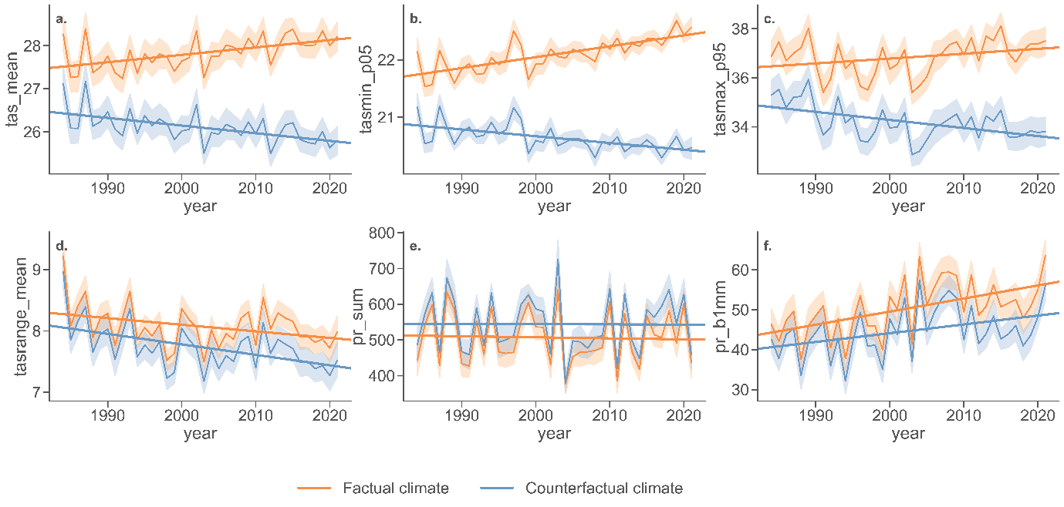

Supplementary Fig. 2: Prevalence of child undernutrition in Burkina Faso attributable to climate change-induced crop yield deficits. Bars show differences in prevalence between factual and counterfactual scenarios and brackets indicate 95% uncertainty intervals (UI).

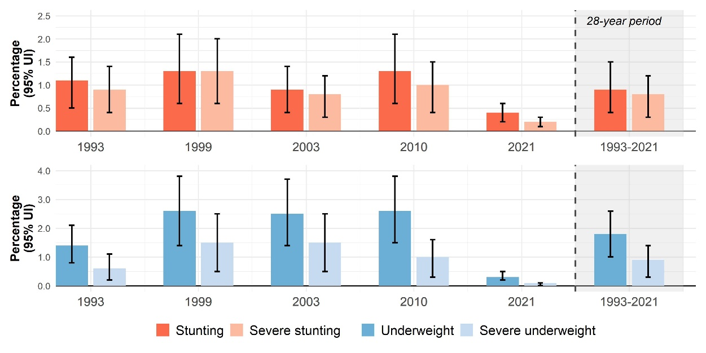
Supplementary Fig. 3: Mean yield difference (%) between factual and counterfactual scenarios (1984–2021), by crop and province.
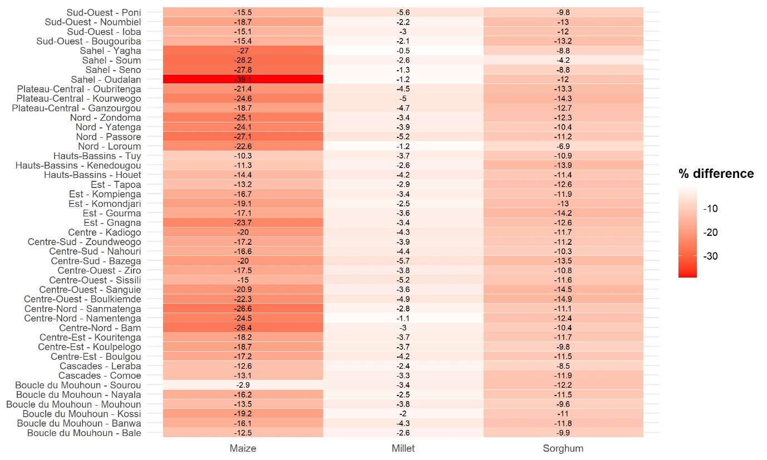

Supplementary Fig. 4: Provinces of Burkina Faso without Demographic and Health Survey (DHS) data in the (a) 1993, (b) 1999, and (c) 2021 survey rounds. Provinces without DHS data: 1993 – Oubritenga, Komondjari, Kompienga; 1999 – Noumbiel, Ioba, Kompienga; 2021 – Oudalan, Tapoa, Yagha, Komondjari, Kompienga. There were no provinces missing in the 2003 and 2010 DHS survey rounds.

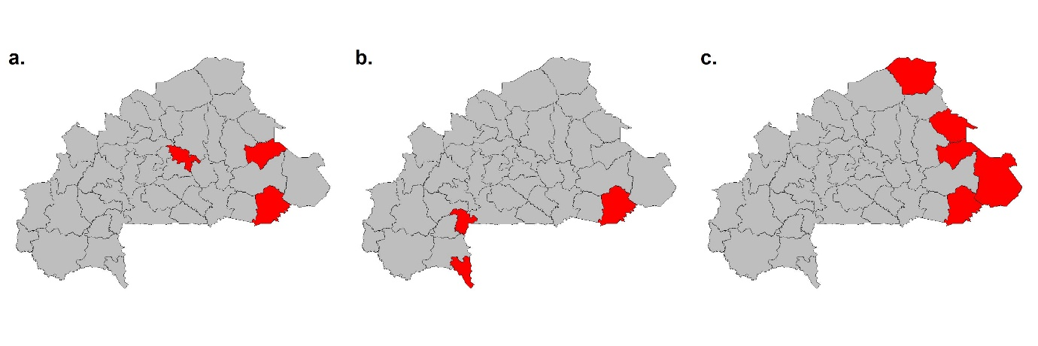

Supplementary Fig. 5: Regional distribution of child undernutrition and its co-occurrence with climate-attributed yield change in Burkina Faso (2003–2021). a. Stunting prevalence, b. Underweight prevalence, c. Bivariate map of climate-attributed yield losses and stunting prevalence, d. Bivariate map of climate-attributed yield losses and underweight prevalence. Prevalence is estimated using the re-scaled sampling weights. Estimates are based on survey rounds 2003, 2010 and 2021. Earlier DHS rounds (1993 and 1998) were excluded because regional boundaries and geographic identifiers are not comparable across time. The 2021 DHS survey round excluded the following provinces – Oudalan, Tapoa, Yagha, Komondjari, Kompienga. Yield losses show the province-level difference in production-weighted mean yields of the three crops between the factual and counterfactual scenarios (factual − counterfactual), averaged over 2003–2021.

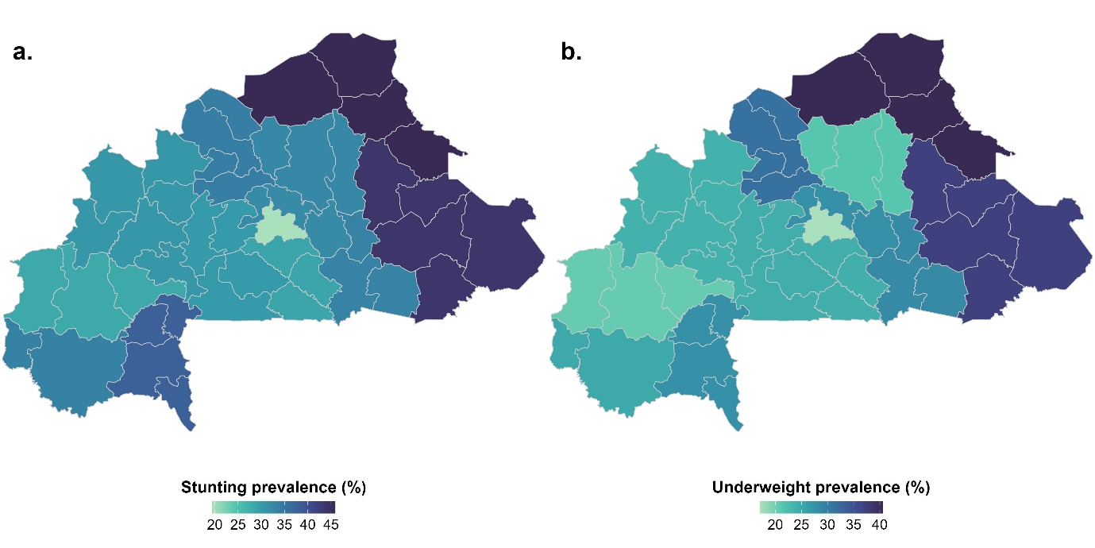
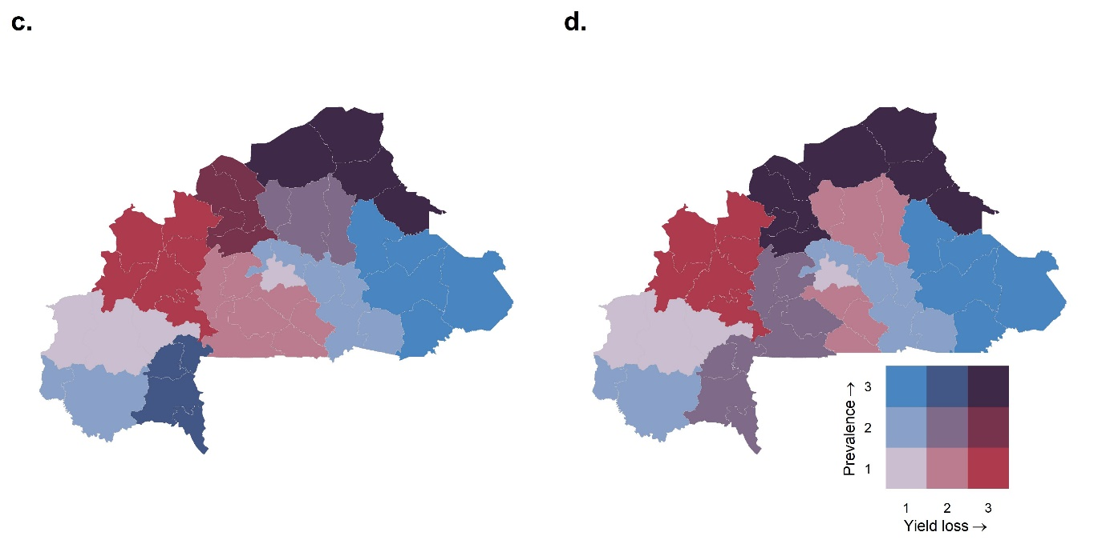

Supplementary Fig. 6: Spatial and temporal variation in observed yields of (a) maize, (b) millet, and (c) sorghum, by harvest year and province. White areas indicate missing yield data, or excluded values due to implausibly high yields (sorghum in 2001).
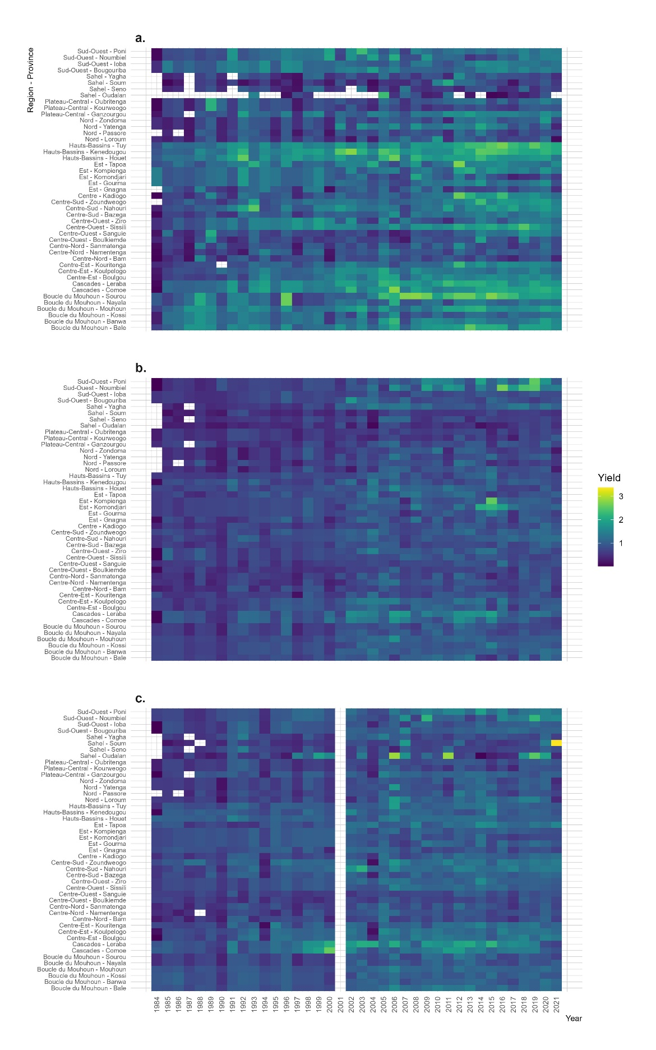

Supplementary Fig. 7: Crop calendar for maize for Burkina Faso based on the FAO crop calendar. Sowing is defined as the onset of the sowing period and harvest is defined as the end of the harvest period. The values represent the median onset of the growing season (left panel) and the median end of the harvesting season (right panel) over all available varieties (i.e. FBC 6, K.E.J. Barka, K.P.B. Wari, Espoir, SR 21, SR 22). Please note that information for the four Northern provinces Yagha, Soum, Seno and Oudalan in the Sahel zone (bordered in red lines) was not available. Therefore, we used the sowing and harvest dates of the neighboring provinces.
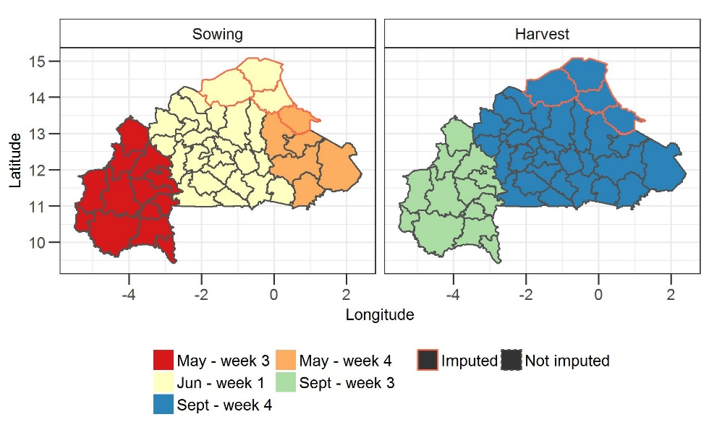
Source: https://cropcalendar.review.fao.org/home

Supplementary Fig. 8: Crop calendar for millet and sorghum for Burkina Faso based on the FAO crop calendar. Sowing is defined as the onset of the sowing period and harvest is defined as the end of the harvest period. The values represent the median onset of the growing season (left panel) and the median end of the harvesting season (right panel) over all available varieties of the crop calendar (i.e. IKMP1, IKMP2, IKMP3, IKMP5, IKMV 8201). This calendar was used for millet and for sorghum, because the FAO does not provide a separate calendar for sorghum and due to the similarity in sowing and harvest dates.
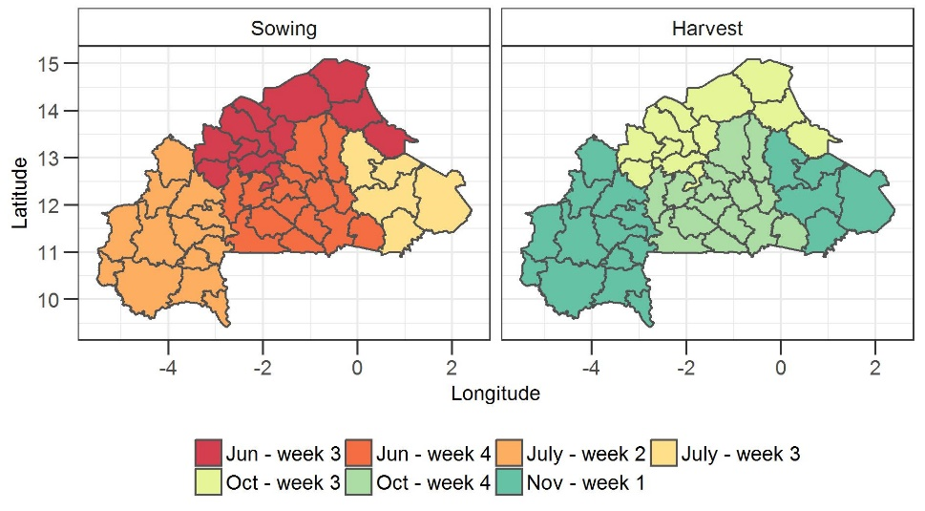
Source: https://cropcalendar.review.fao.org/home

Supplementary Fig. 9: Share of per capita daily dietary energy supply from maize, sorghum and millet in Burkina Faso (2010–2021)
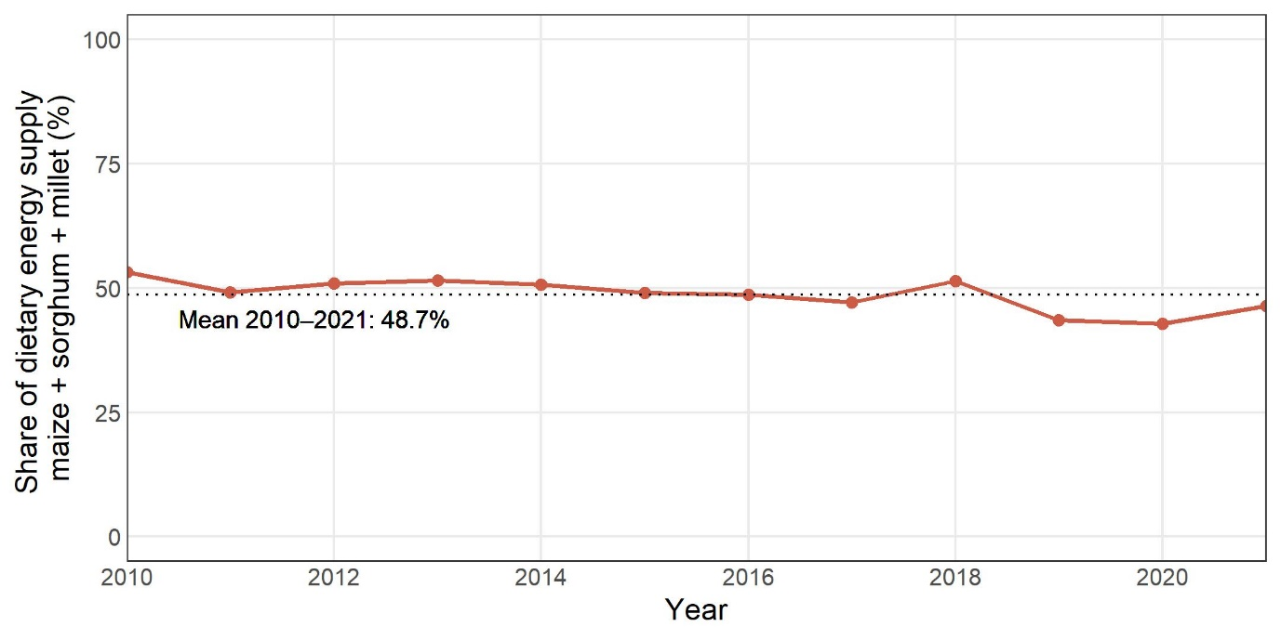
Source: authors’ illustration based on FAOSTAT (https://www.fao.org/faostat/en/#data/FBS).
Supplementary Fig. 10: Trends in maize, millet, and sorghum production in Burkina Faso (1960-2021). a. Combined share in total primary crop production, b. Individual crop shares within the three-crop total, and c. Total production compared with imports and exports.
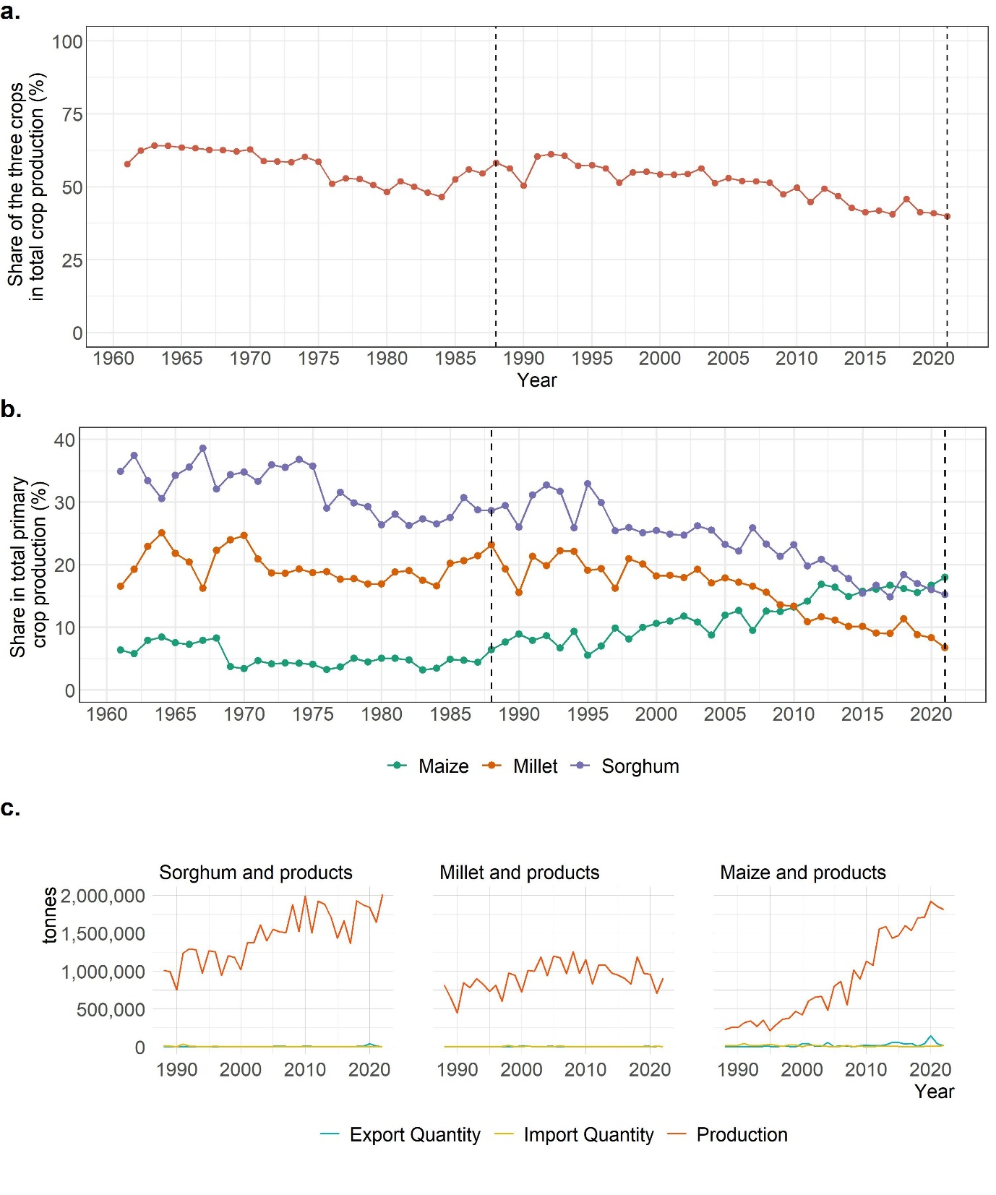
Source: Authors’ illustration based on FAOSTAT (https://www.fao.org/faostat/en/#data/FBS).

Supplementary Fig. 11: Flowchart of child data from Demographic Health Surveys (DHS). The figure depicts the number of children in the original datasets, any exclusions (in the order listed) and the final analytic sample.
DHS Burkina Faso Children’s recode data from five survey waves: 1993, 1999, 2003, 2010, 2021
(N = 49,813)
- Missing geographic coordinates of Primary Sampling Units: N = 1,024
- Child not alive at the time of interview: N = 4,587
- Non-permanent resident at the place of interview: N = 767
- All three anthropometric measurements missing: N = 13,527
- Implausible values for all three anthropometric measurements: N= 46

Data included in the analysis
(N = 29,862)

Supplementary Fig. 12: Geographical location of Demographic and Health Survey clusters (Primary Sampling Units) in Burkina Faso by survey round.
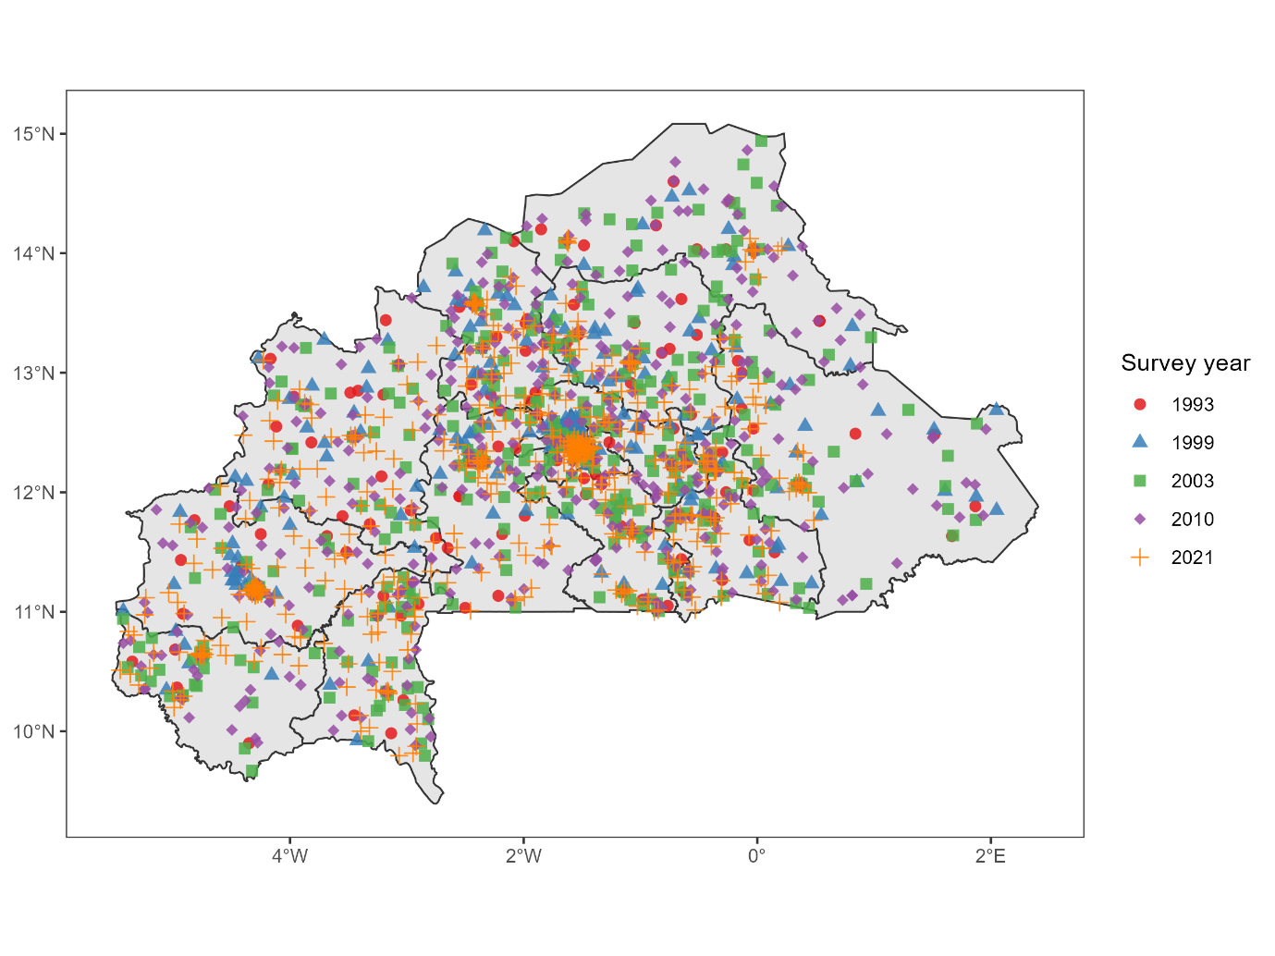

Supplementary Fig. 13: Spatial and temporal variation in Crop Yield Anomaly Index (CYAI) in the a. factual and b. counterfactual scenario by harvest year and province. The CYAI captures the weighted annual deviation of the three crops (sorghum, millet and maize) from their long-term means. Grey areas indicate missing values due to unavailable yield data for one or more of the three crops, or excluded values due to implausibly high sorghum yields in 2001.
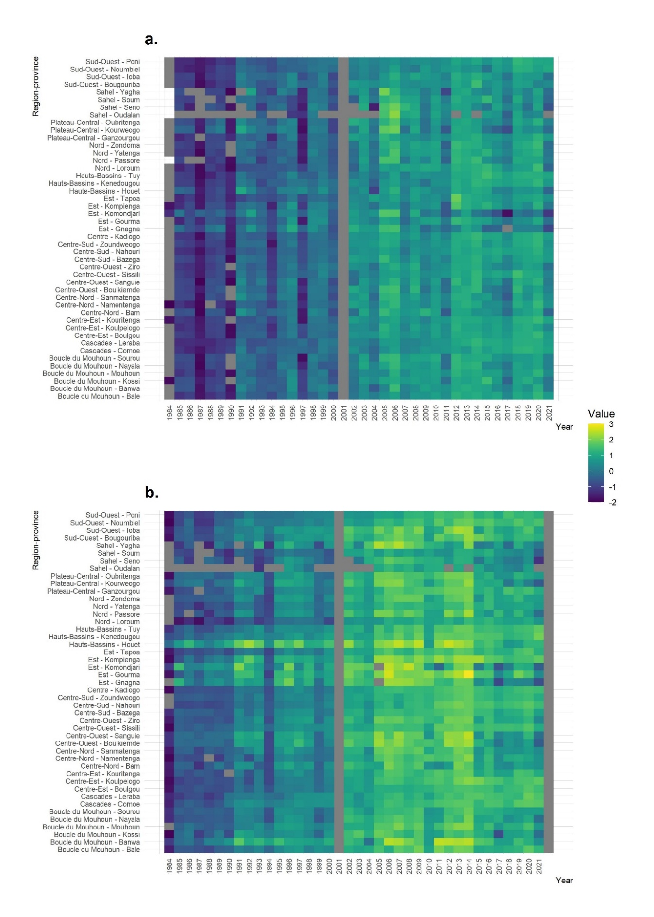
Supplementary Fig. 14: Distribution of children's exposure to yield anomalies (Crop Yield Anomaly Index) by scenario and exposure period. The CYAI captures the weighted annual deviation of the three crops (sorghum, millet and maize) from their long-term means.
