- Supplementary Material
- Metabologenomic assessment of biosynthetic capabilities in the genus Salinibacterium: untapped bioactive chemistry produced by marine strain AL4.1 from the Chilean Patagonia
- Eduardo Sánchez-Carvajal^{1,2}, Nestor Serna-Cardona^{1,2}, Fernanda P. Claverías^{1,2}, Neri Vargas^{1#}, Thomas Dacal-Barahona^{1,2}, Valentina González^{1,2,3}, Melissa González-Sanabria⁴, Jonathan Parra^{4,5}, Beatriz Cámara^{1,2*}
¹ActinoLab USM, Centro de Biotecnología “Daniel Alkalay Lowitt” & Departamento de Química, Universidad Técnica Federico Santa María, General Bari 699, 2390136 Valparaíso, Chile.
²Millennium Nucleus Bioproducts, Genomics and Environmental Microbiology (BioGEM), Avenida España 1680, 2390123 Valparaíso, Chile.
³Departamento de Química y Medio Ambiente, Sede Viña del Mar, Universidad Técnica Federico Santa María, Avenida Federico Santa María 6090, 2430020 Viña del Mar, Chile.
⁴Centro Nacional de Innovaciones Biotecnológicas (CENIBiot), Programa CeNAT, Consejo Nacional de Rectores (CONARE), San José 1174-1200, Costa Rica.
⁵Centro de Investigaciones en Productos Naturales (CIPRONA), Universidad de Costa Rica, San José 11501-2060, Costa Rica.
# Current address: Instituto de Biología, Pontificia Universidad Católica de Valparaíso, Avenida Universidad 330, Curauma, Valparaíso, Chile.
*Correspondence:
Beatriz Cámara: beatriz.camara@usm.cl

List of Supplementary Figures | Page No.
Fig. S1. Bioactivity and Feature-Based Molecular Networking. | 2
Fig. S2. Circular map and COG genes classification of Salinibacterium sp. AL4.1 genome. | 3
Fig. S3. Circular map and COG genes classification of Salinibacterium sp. VpJ6 genome. | 4
Fig. S4. Whole-genome sequence-based phylogeny derived from TYGS. | 5

Fig. S1 Bioactivity and Feature-Based Molecular Networking. Bioactivity assays for extracts obtained from strains a AL4.1 and b VpJ6 at days 3, 5 and 7, with three replicates each and a respective control, at concentrations of 5mg/ml and 1mg/ml. c Venn diagram depicting shared and unique features between both strains. d Molecular networks, where node size represents bioactivity correlation, node color represents the producing strain, and nodes annotated by spectral similarity are highlighted with a green border.
Fig. S2 Circular map and COG genes classification of Salinibacterium sp. AL4.1 genome. a) Map of features for the draft assembly of the genome of Salinibacterium sp. AL4.1 B) Classification of genes into COG categories, showing the count of genes for each.
Fig S3. Circular map and COG genes classification of Salinibacterium sp. VpJ6 genome. a) Map of features for the draft assembly of the genome of Salinibacterium sp. VpJ6 B) Classification of genes into COG categories, showing the count of genes for each.
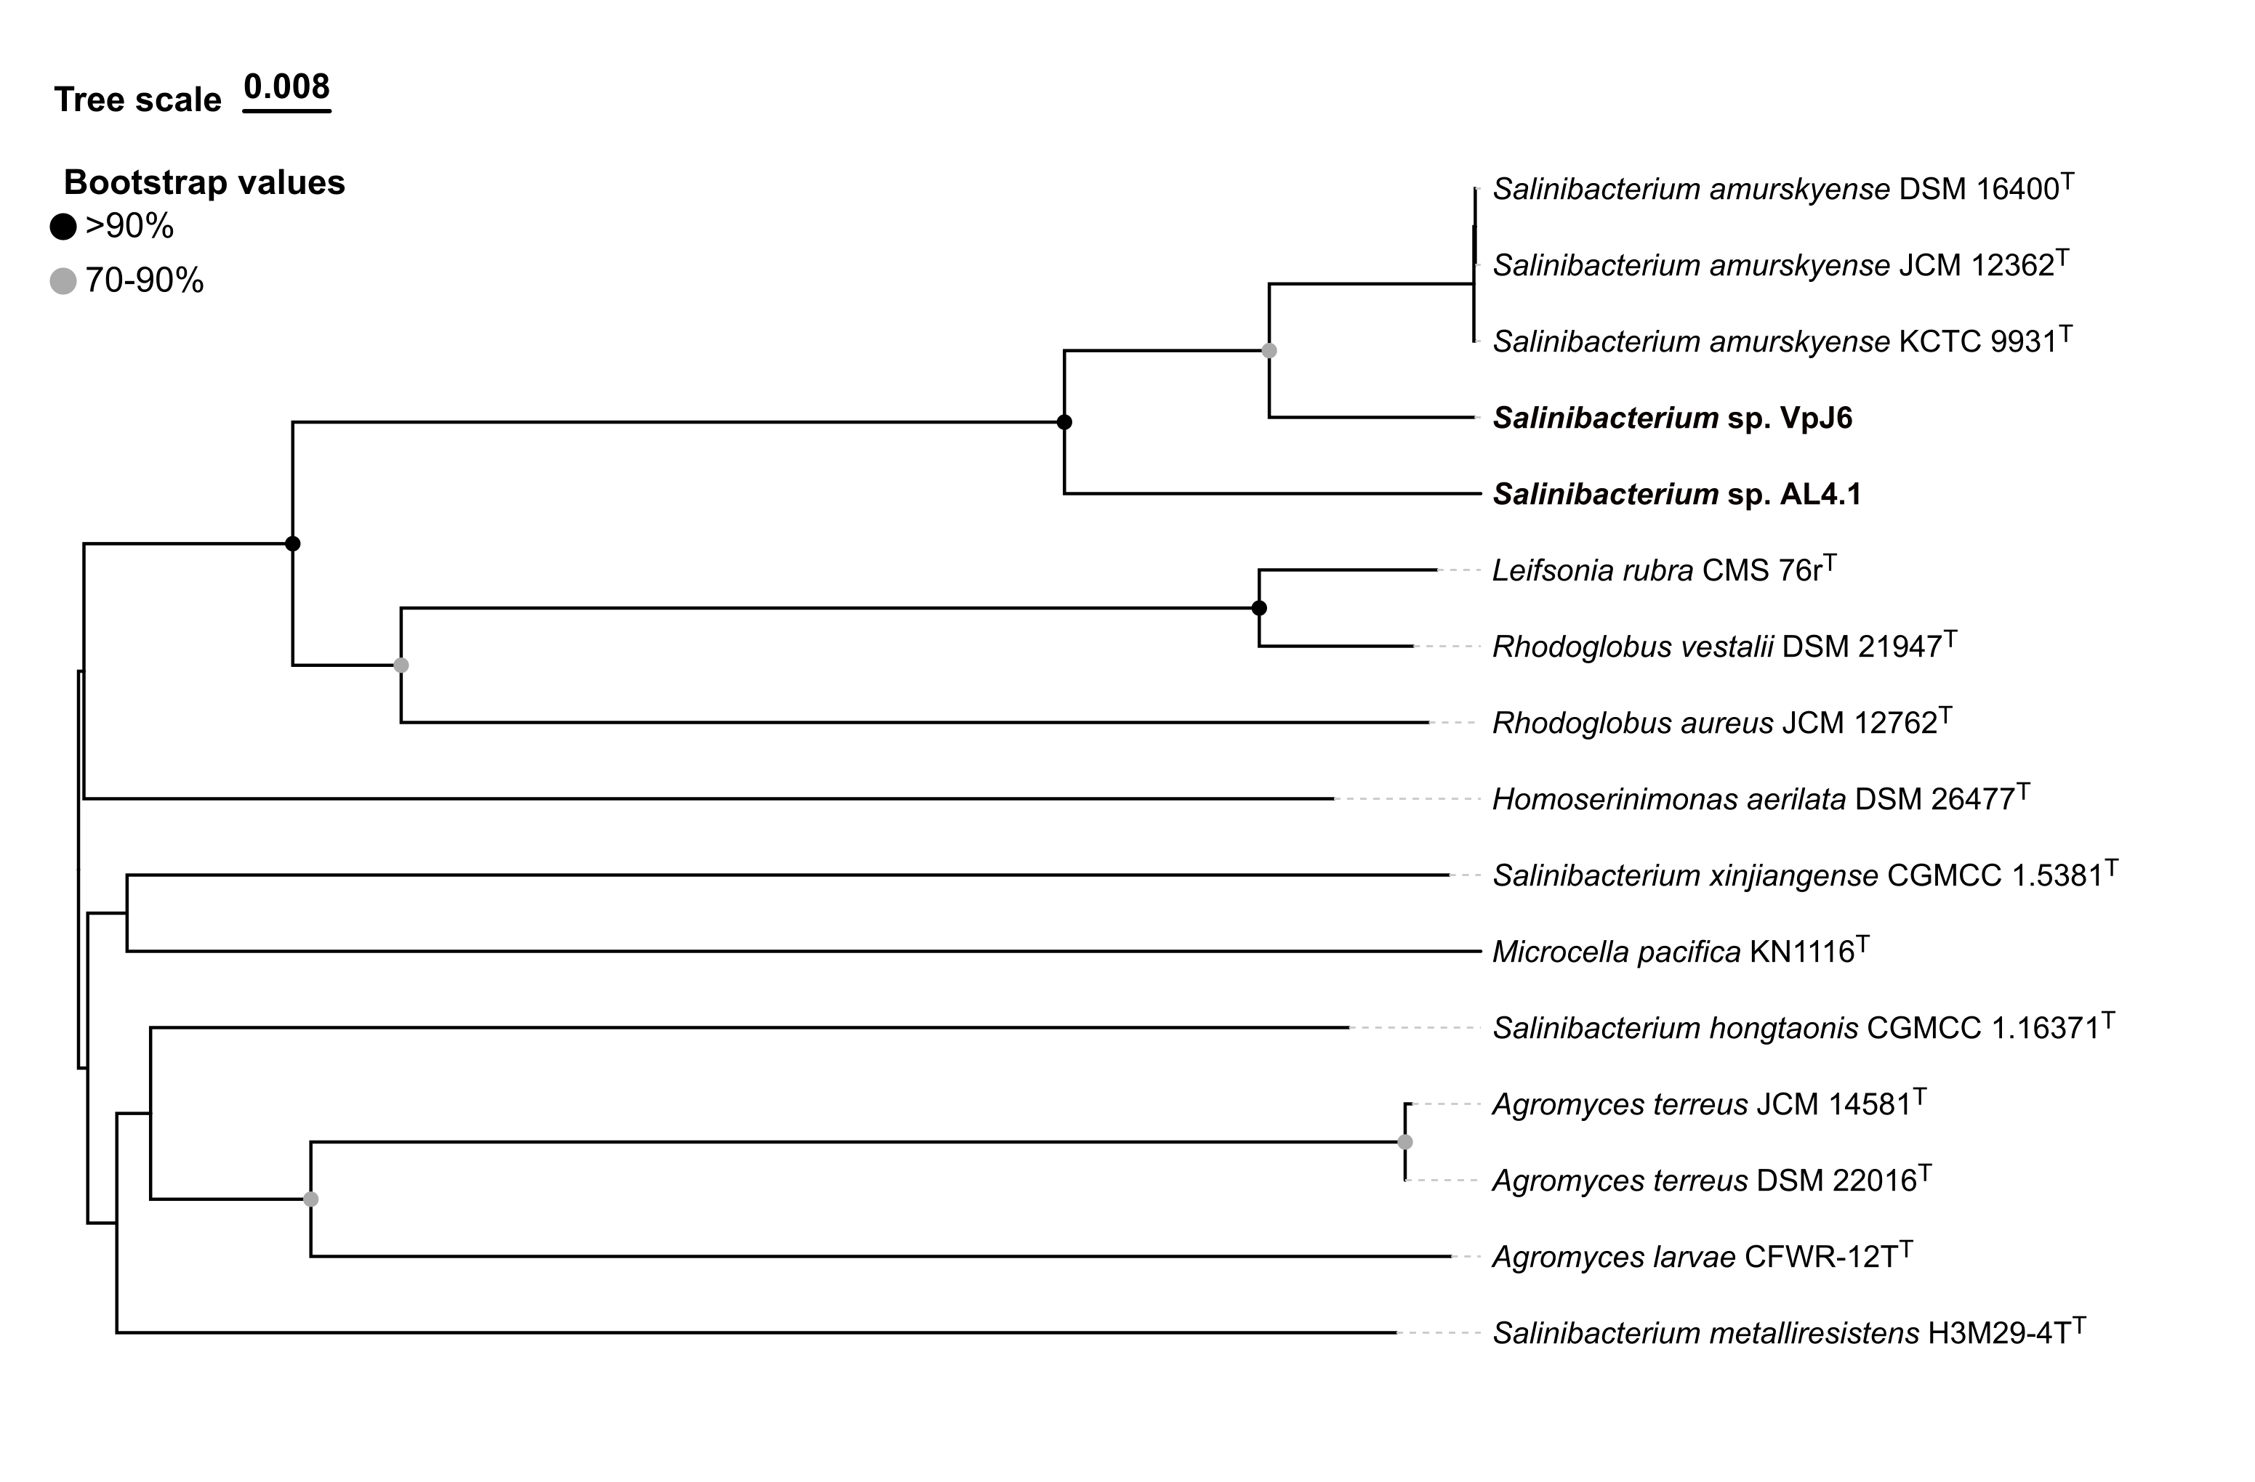
Fig S4. Whole genome-based phylogeny derived from the Type (Strain) Genome Server (TYGS) using the genome assemblies of strains AL4.1 and VpJ6 as queries.

