Supplementary Material

We used Truvari [1] to evaluate the performance of BioGraph in detecting SVs compared with other SV calling tools (Table 1). In the challenging medically relevant gene (CMRG) regions , where short-reads have difficulty detecting SVs, all tools showed lower performance compared to their reported genome-wide performance. Among them, BioGraph achieved the highest recall of 0.51, outperforming Manta (0.16), Parliament2 (0.16), and Smoove (0.05). When comparing true positive SVs discovered by each tool, BioGraph identified 75 of the 80 variants (93.7%) discovered by at least one short-read SV caller, with 36 (45%) uniquely detected by BioGraph. Only four variants were missed by BioGraph but detected by other tools (Figure 1). We further investigated performance on insertions specifically, where BioGraph again showed the highest recall (0.34), followed by Manta (0.10) and Parliament2 (0.02) (Table 2). Smoove did not discover any insertions but reported a number of breakend events, which may be due to misclassified repeat extensions [2].
SV discovery, particularly from short reads, has been shown to have a high false discovery rate (FDR). To reduce FDR, we explored the utility of filtering SVs based on quality scores provided by each SV discovery tool. Our analysis showed that BioGraph outperforms Manta, Parliament2, and Smoove in terms of the quality scores it provides. Specifically, receiver operating characteristic (ROC) analysis revealed that BioGraph achieved an area under the curve (AUC) of 0.787, compared to an AUC of 0.678 for Manta (Figure 2). Although Parliament2 and Smoove yielded higher AUC values (0.790 and 0.838, respectively), their quality scores demonstrated poor separation between true and false positives (Figure 3). This suggests that despite their high AUCs, their quality metrics may be less reliable for downstream analysis.
To assess the exactness of SV representations, we evaluated each tool’s true positive (TP) calls based on SV size, breakpoint accuracy (using a stringent overlap), and SV sequence similarity when available. To summarize the consistency between pairs of matched SV calls, we used Truvari’s annotated ‘TruScore’, which is an average of sequence similarity, size similarity, and reciprocal overlap between matched calls. BioGraph demonstrated the highest consistency in SV representation, with 88 of 112 (78.57%) TPs having TruScores ≥90. In comparison, 32 out of 44 (72.72%) of Manta's TP reached the same threshold. Parliament2 and Smoove do not produce sequence resolved calls, limiting their maximum TruScore to 66 (Figure 4).
The reference guided assembly approach of BioGraph annotates all reported SV as either insertions or deletions, based on the relative lengths of the reference and alternate sequences. However, this approach can also capture inversions. To classify such events, we developed a procedure to identify and reannotate potential, improving their identification in the call set. A total of 887,178 (87%) variants from the unfiltered SV call set had reference and alternate sequence lengths greater than or equal to 50bp. Of these, we identified 159 that showed at least 50% reciprocal overlap with known inversions reported in the TopMed dataset [3]. When aligning these variants’ reference sequence to the reverse complement of their alternate sequence, these overlapping variants showed higher sequence similarity (Figure 5). Therefore, we reclassified SVs as inversions if they have reference and alternate sequences ≥50bp, and sequence similarity with the reverse complements > 80%.
Table 1. CMRG Performance

Program | Call Set | Parameters | TP-  base | TP-  call | FP | FN | Precision | Recall | F1 | GT Concordance
BioGraph | All | Default | 112 | 125 | 1134 | 107 | 0.10 | 0.51 | 0.17 | 0.84
Manta | All | Default | 35 | 35 | 70 | 184 | 0.33 | 0.16 | 0.22 | 1.00
Parliament | All | NoSim* | 35 | 35 | 137 | 184 | 0.20 | 0.16 | 0.18 | 0.80
Smoove | All | NoSim* | 10 | 10 | 37 | 209 | 0.21 | 0.05 | 0.08 | 0.90
BioGraph | Pass | Default | 77 | 78 | 226 | 142 | 0.26 | 0.35 | 0.30 | 0.91
Manta | Pass | Default | 34 | 34 | 60 | 185 | 0.36 | 0.16 | 0.22 | 1.00
Parliament | Pass | NoSim* | 33 | 33 | 64 | 186 | 0.34 | 0.15 | 0.21 | 0.85
BioGraph | Pass | NoSim* | 77 | 78 | 226 | 142 | 0.26 | 0.35 | 0.30 | 0.91
Manta | Pass | NoSim* | 43 | 44 | 50 | 176 | 0.47 | 0.20 | 0.28 | 0.95
BioGraph | All | NoSim* | 112 | 125 | 1134 | 107 | 0.10 | 0.51 | 0.17 | 0.84
Manta | All | NoSim* | 44 | 45 | 60 | 175 | 0.43 | 0.20 | 0.27 | 0.95

* NoSim - No Sequence Similarity (looser matching)

Figure 1. Venn Diagram of TPs by program

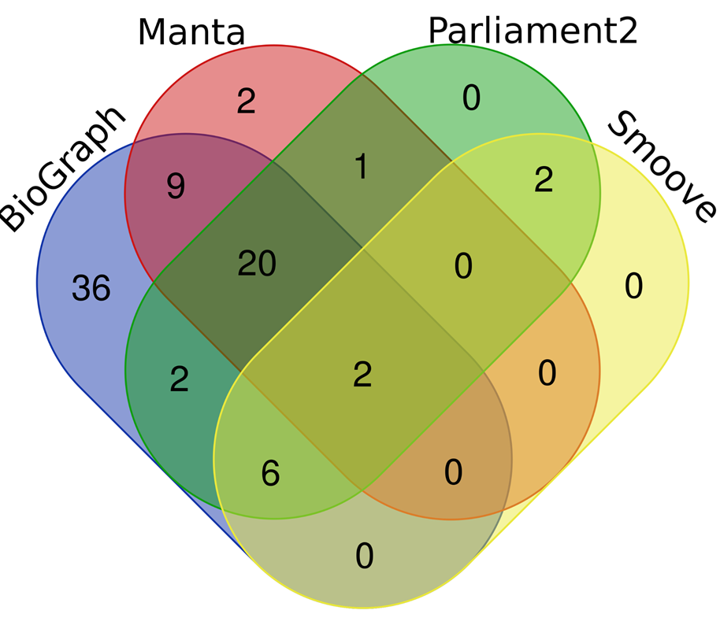

Table 2. CMRG Insertion Recall

Program | INS Count | TP INS Count | Recall
BioGraph | 125 | 43 | 0.344
Manta | 125 | 12 | 0.096
Parliament2 | 125 | 2 | 0.016
Smoove | 125 | 0 | 0

Figure 2. CMRG Tools’ ROC curves
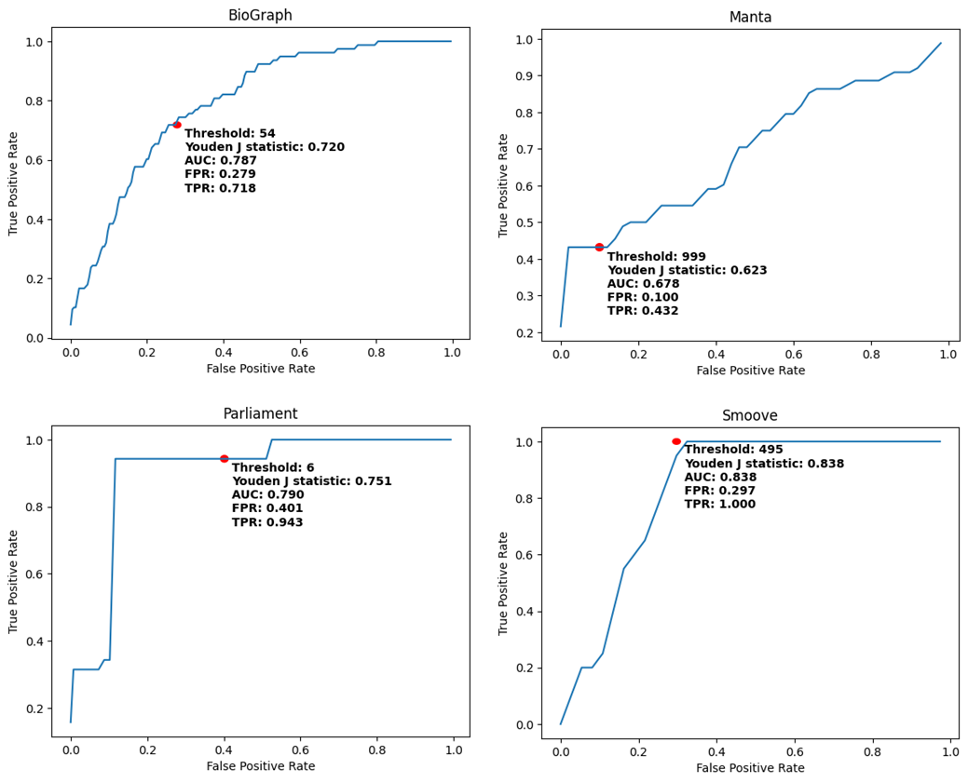

Figure 3. QUAL score distribution in callers

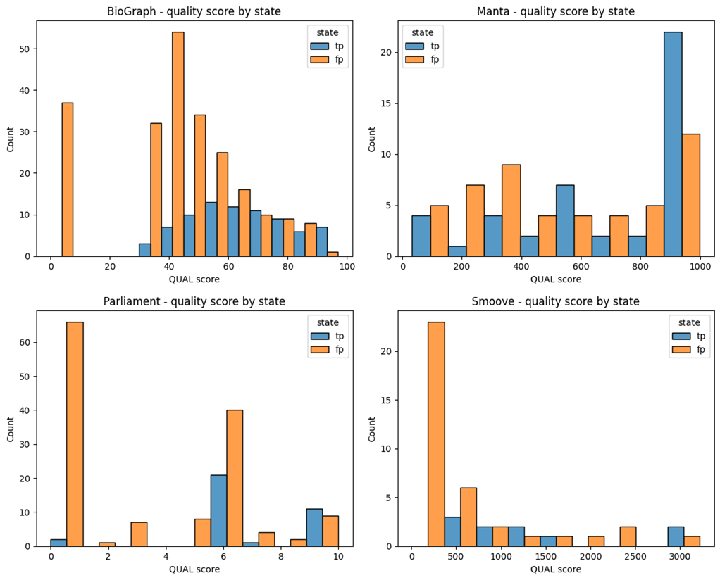

Figure 4. TruScore distribution 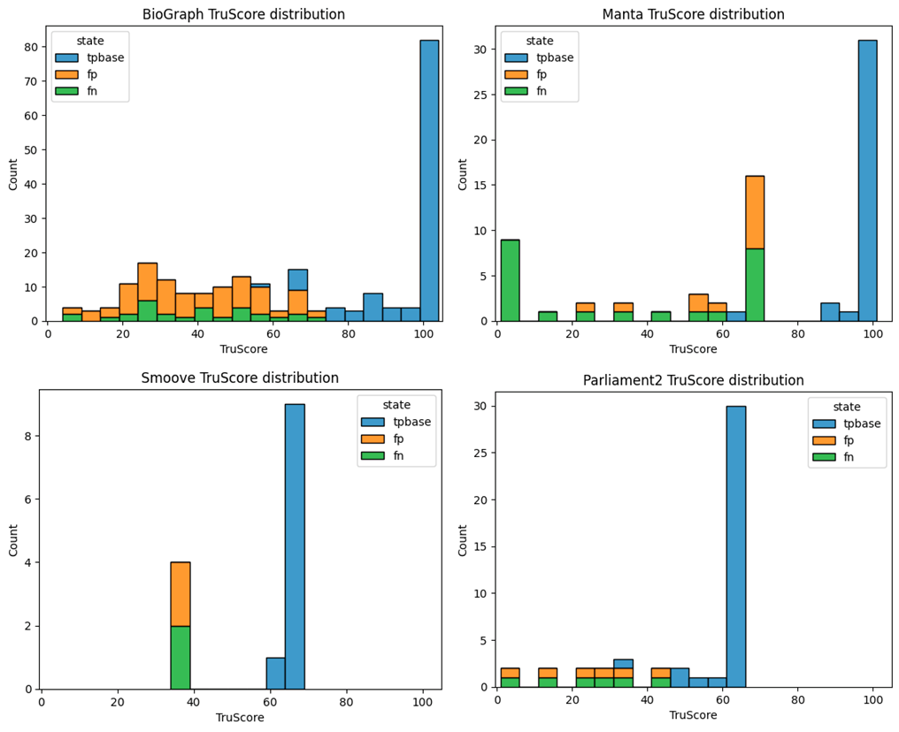

Figure 5. Inversion’s reference and alternate reverse complement sequence similarity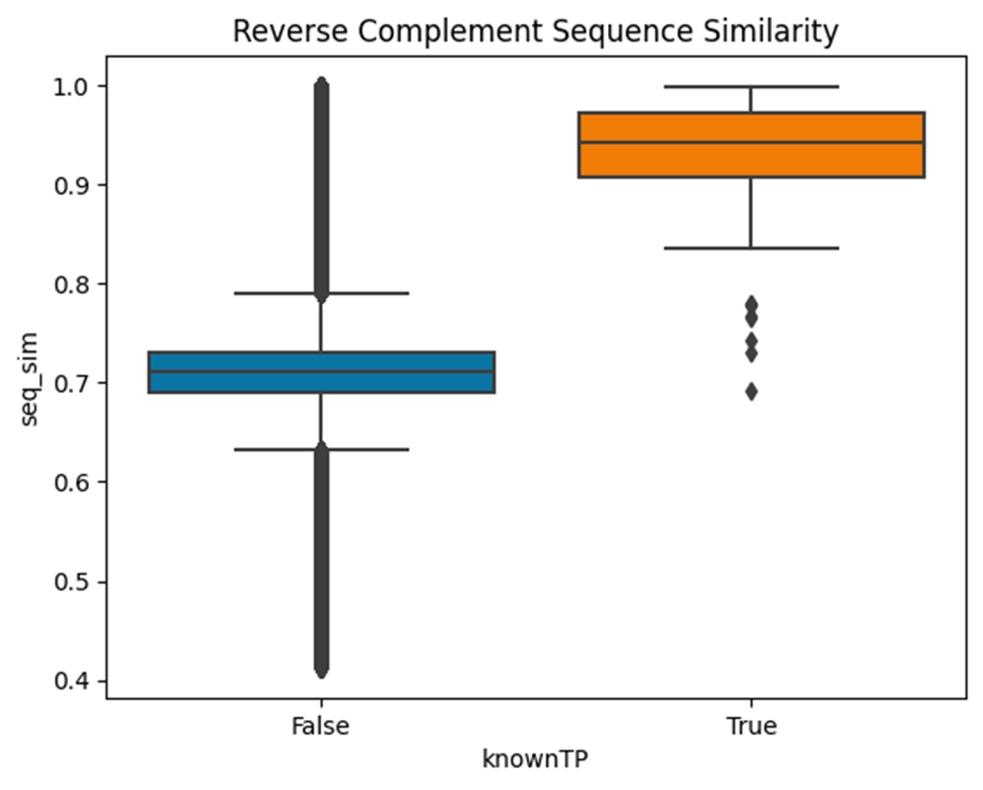

References

1. English AC, Menon VK, Gibbs RA, Metcalf GA, Sedlazeck FJ: Truvari: refined structural variant comparison preserves allelic diversity. Genome Biol 2022, 23:271.
2. Sedlazeck FJ, Rescheneder P, Smolka M, Fang H, Nattestad M, von Haeseler A, Schatz MC: Accurate detection of complex structural variations using single-molecule sequencing. Nat Methods 2018, 15:461-468.
3. Jun G, English AC, Metcalf GA, Yang J, Chaisson MJ, Pankratz N, Menon VK, Salerno WJ, Krasheninina O, Smith AV, et al: Structural variation across 138,134 samples in the TOPMed consortium. bioRxiv 2023.

