Supplementary Figure 1. Replicates variants quality score distributions
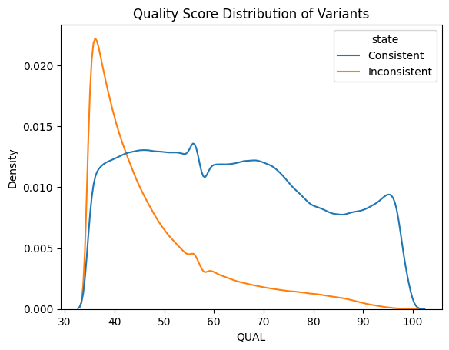

Supplementary Figure 2. Principal component analysis of SVs indicating a potential batch effect from read length
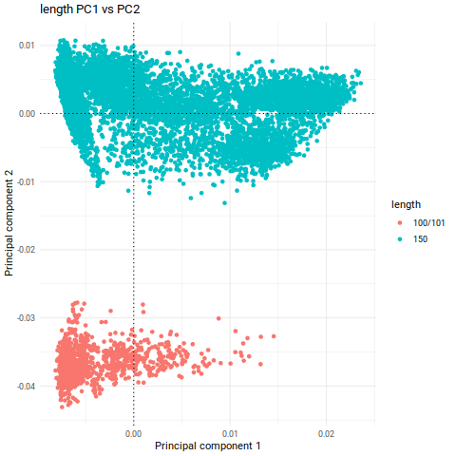
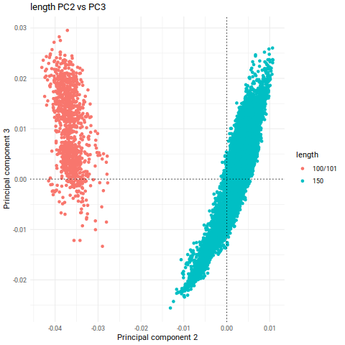

PC1 vs PC2
PC2 vs PC3

Supplementary Figure 3. PCA similarities between SVs and SNVs

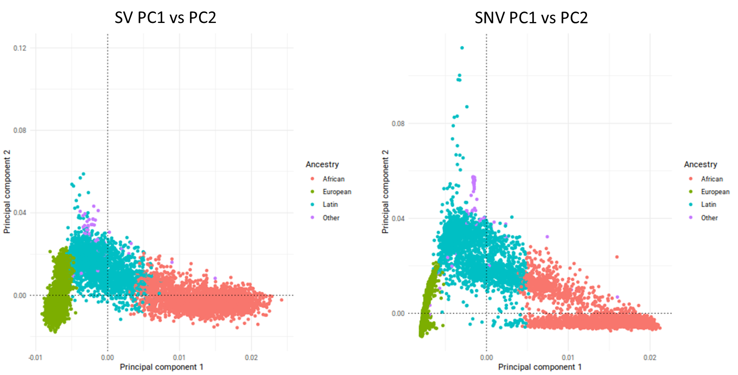

Supplementary Figure 4. Global ancestry inference using GrafPop
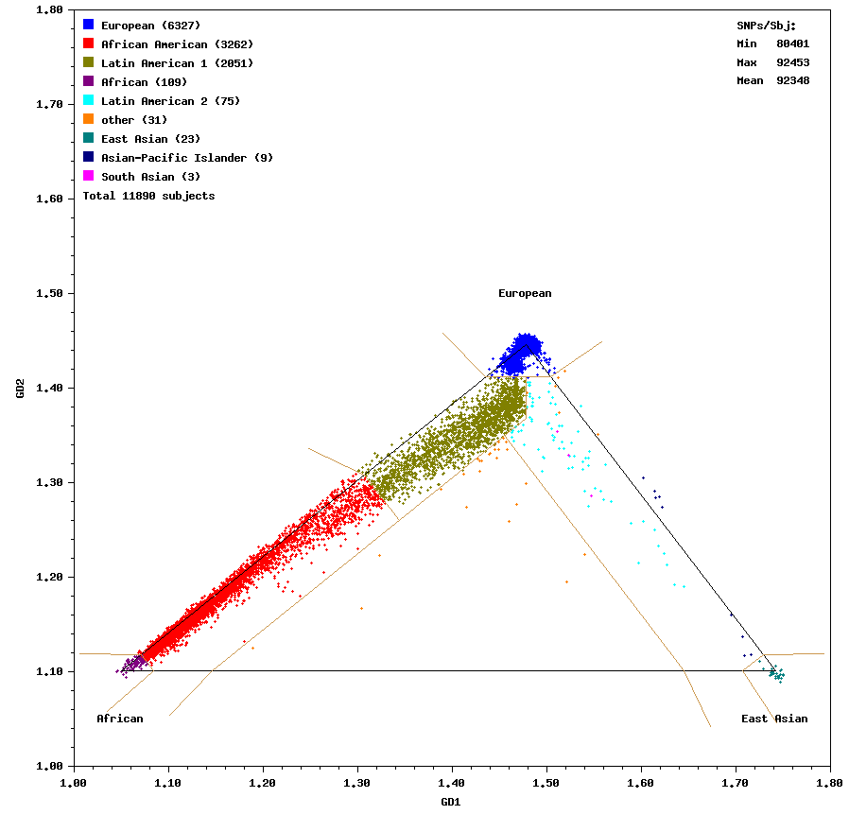

Supplementary Figure 5. Haplotype estimation of TPCN locus in EUR and LAT group
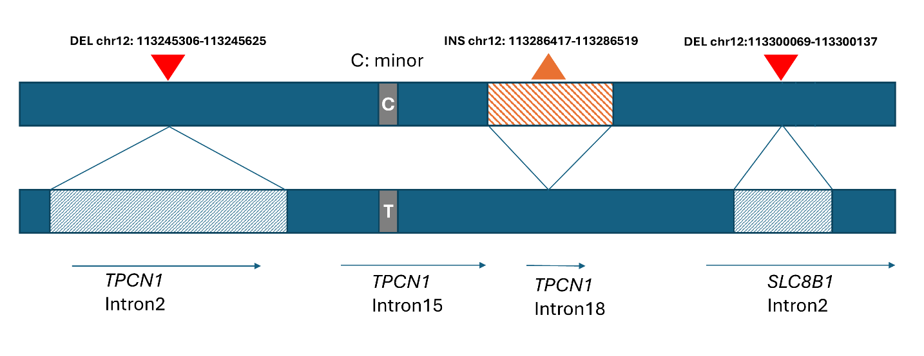
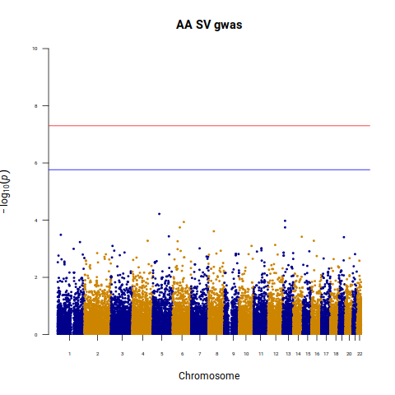
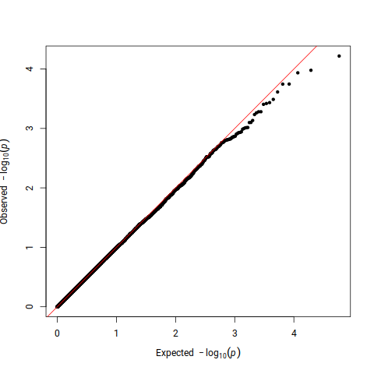
Supplementary Figure 6. Ancestry-specific GWAS and meta-analyses of common or low-frequency SVs

AFR

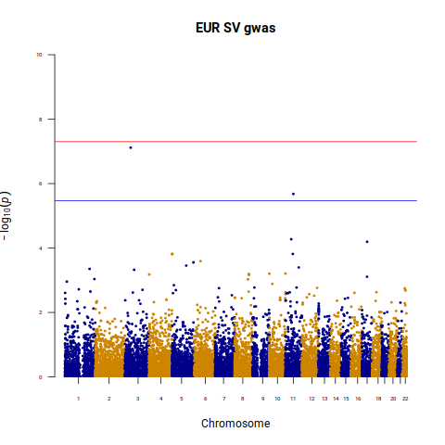
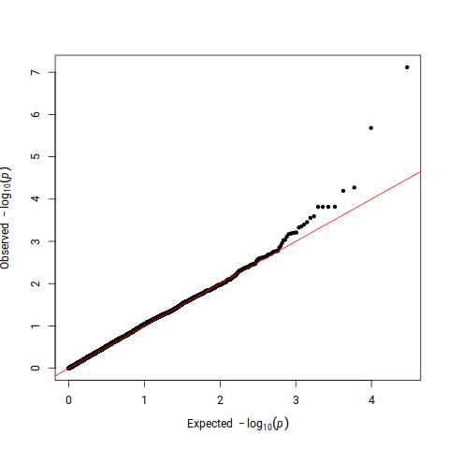

EUR

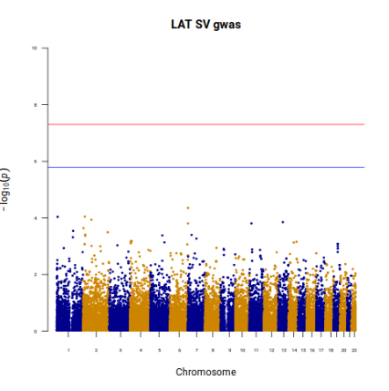
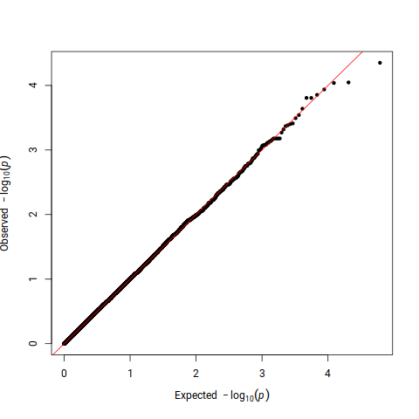

LAT

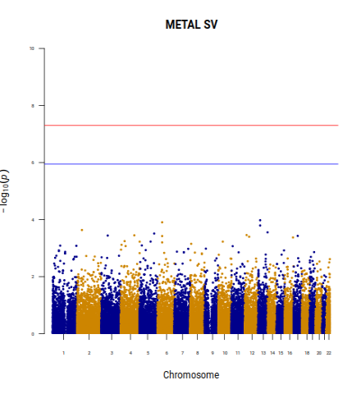
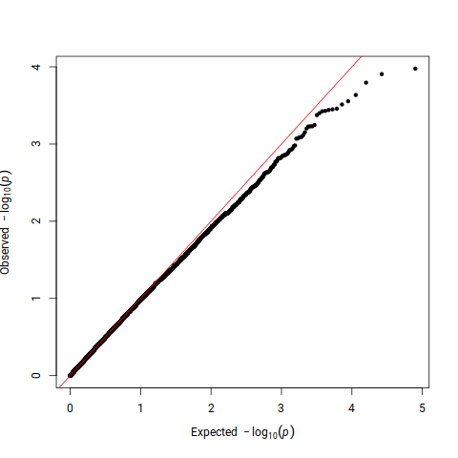

META analysis

Supplementary Figure 7. Primary gene-based association analyses of coding SVs
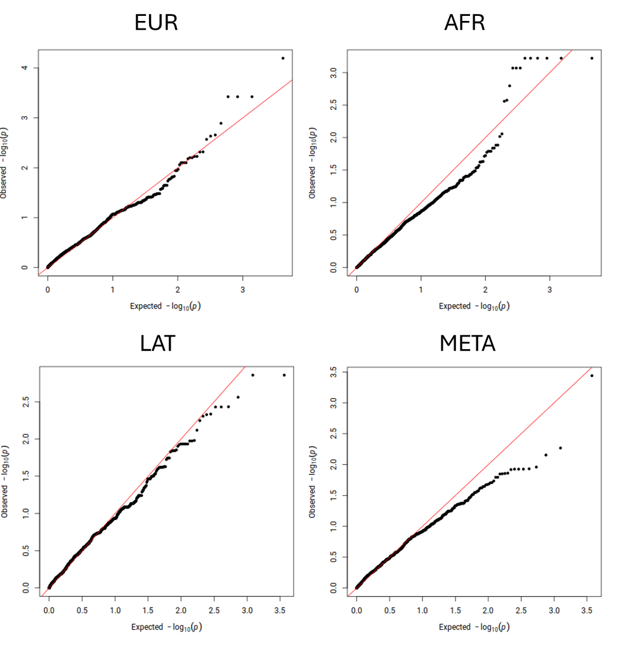

Supplementary Figure 8. Primary gene-based association analyses of noncoding SVs
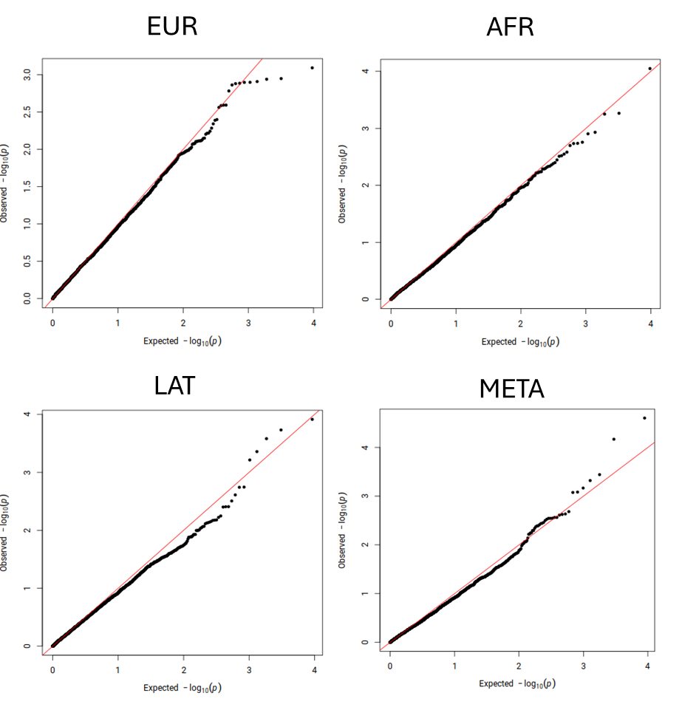
Supplementary Figure 9. Secondary gene-based association analyses of coding SNVs/INDELs and SVs

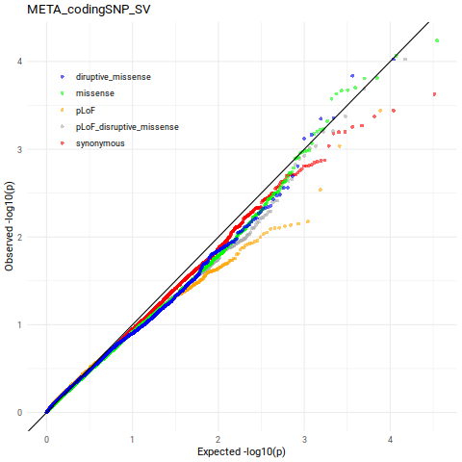
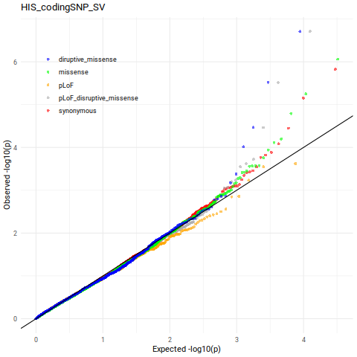
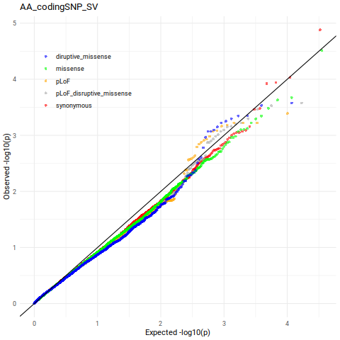
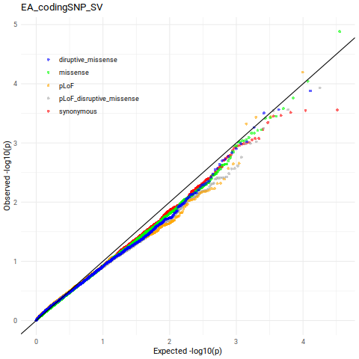

EUR
AFR
LAT
META

Supplementary Figure 10. Secondary gene-based association analyses of non-coding SNVs/INDELs and SVs

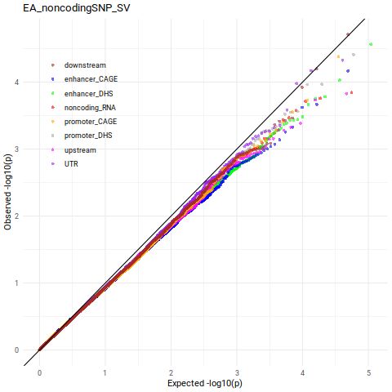
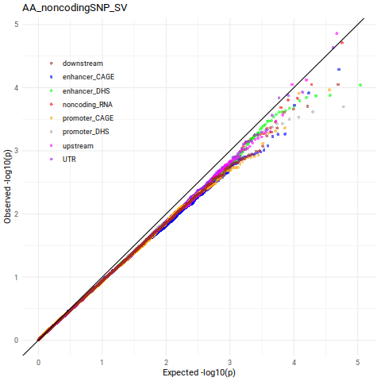
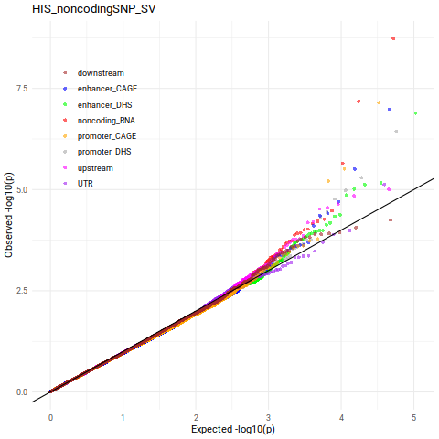
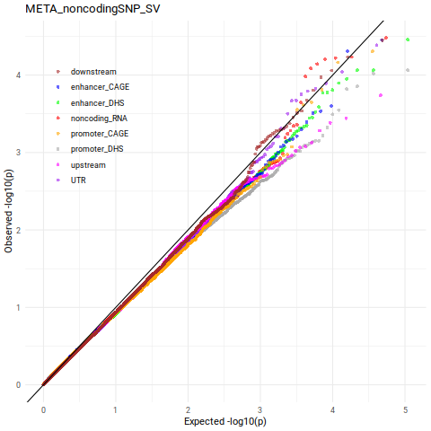

AFR
META
LAT
EUR

