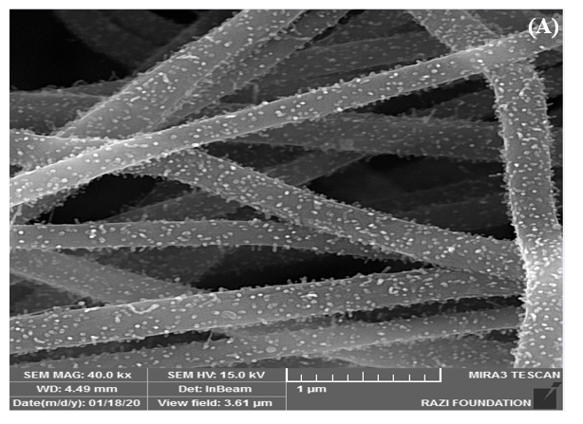 | 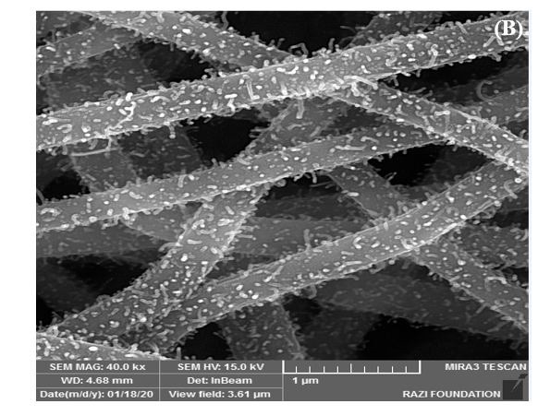
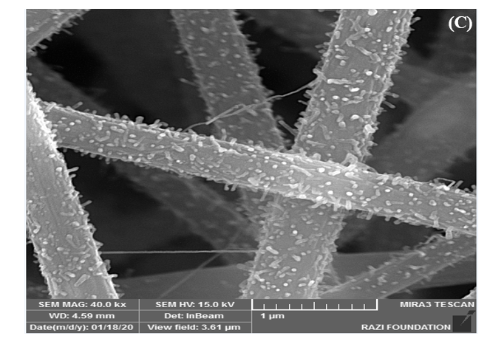 | 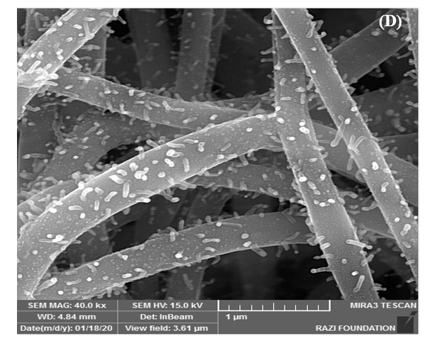

Fig. S1. FESEM images of Ni-Co/ ECNF nanocomposites with different mass percentages of primary precursors: (A) Ni₁₀Co₉₀/ ECNF-5h; (B) Ni₃₀Co₇₀/ ECNF-5h; (C) Ni₅₀Co₅₀/ ECNF5h and (D) Ni₉₀Co₁₀/ ECNF-5h.

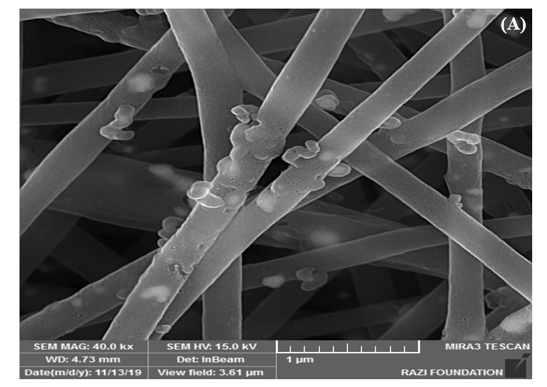 | 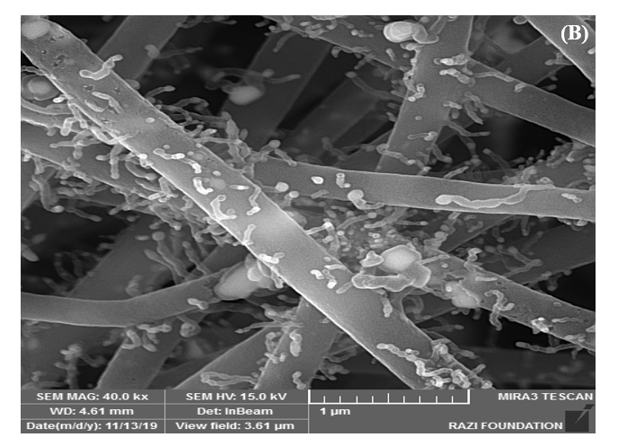 | 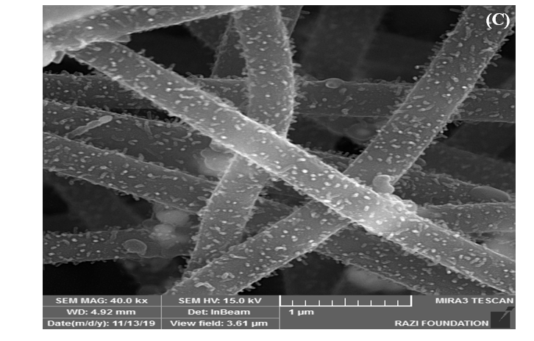
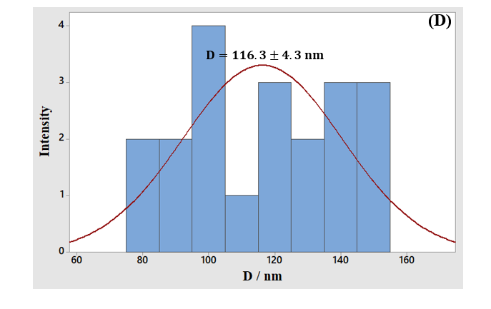 | 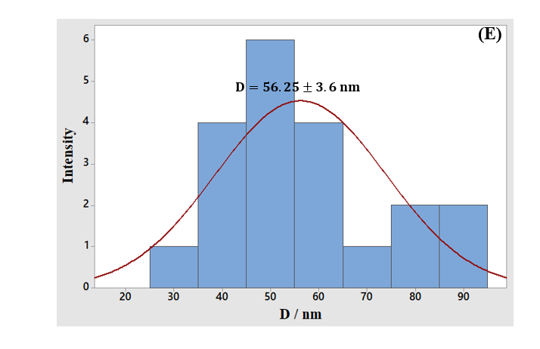 | 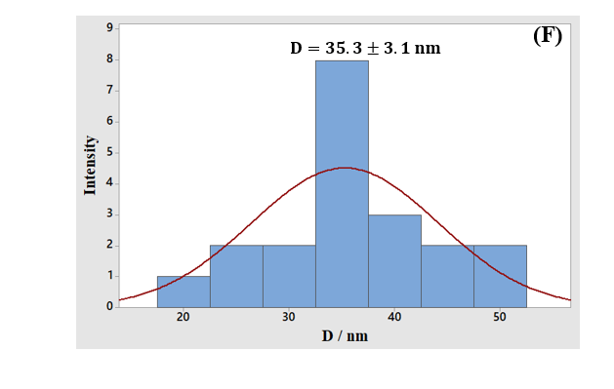

Fig. S2. (A-C) FESEM images of Ni/ ECNF nanocomposites with different carbonization times (1, 3, and 5 h.) with a same molar Ni feed ratio and with the same carbonization temperature. (D-F) Ni Particles size distribution histograms.

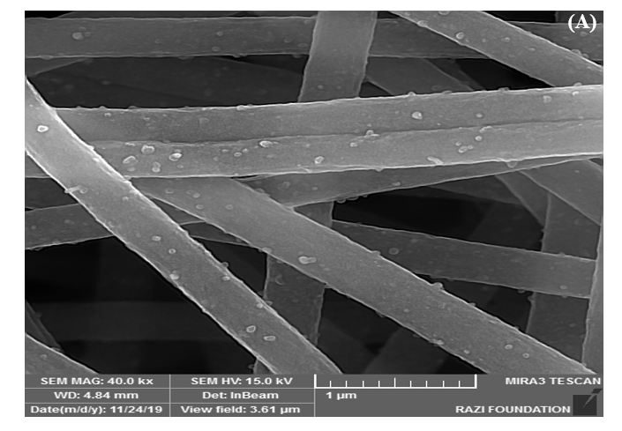 | 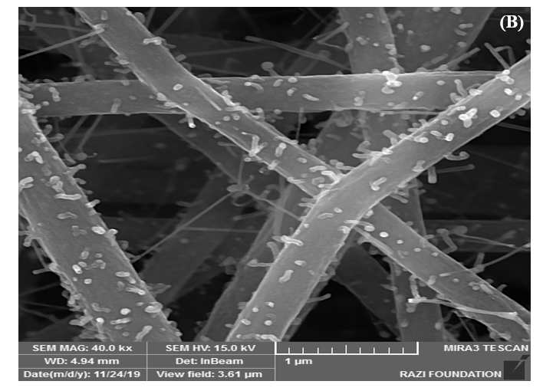 | 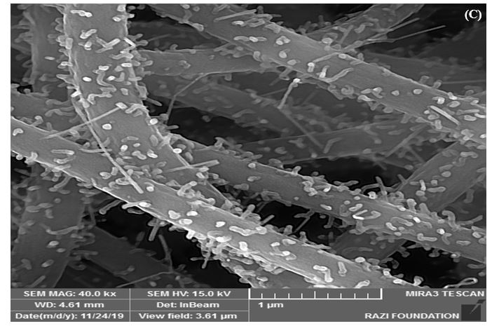
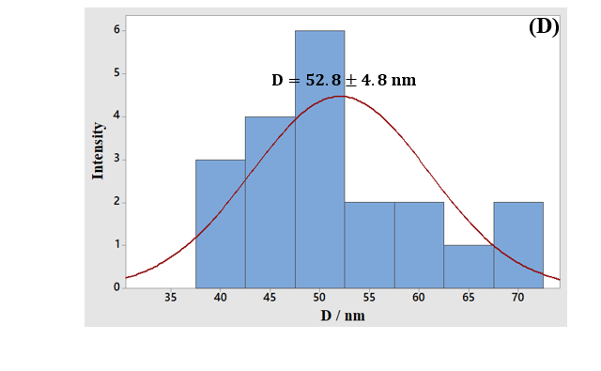 | 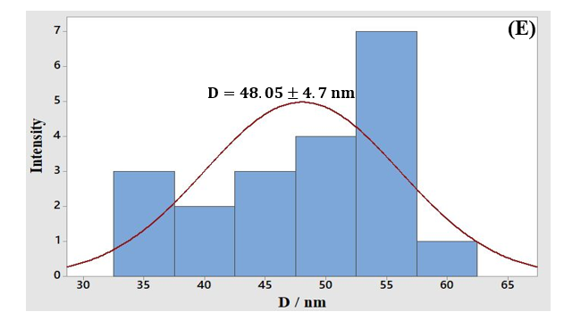 | 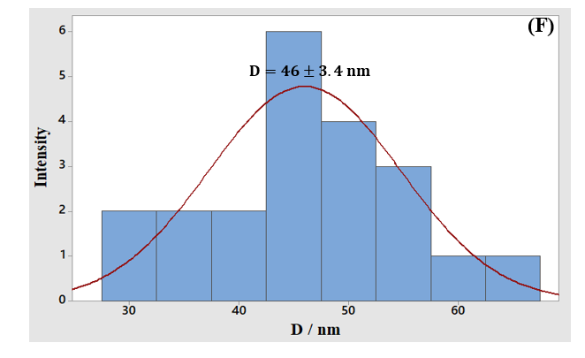

Fig. S3. (A-C) FESEM images of Co/ ECNF nanocomposites with different carbonization times (1, 3, and 5 h.) with a specific molar Co feed ratio and with the same carbonization temperature. (D-F) Co Particles size distribution histograms.

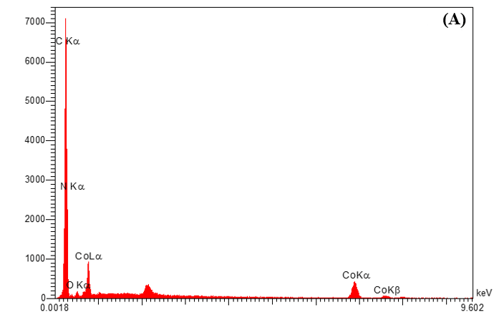 | 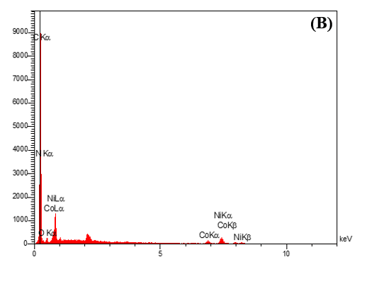
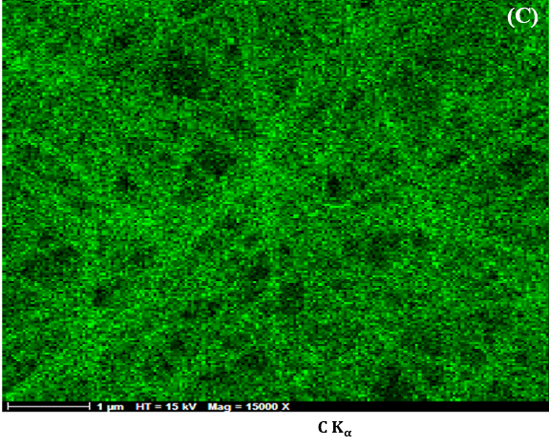 | 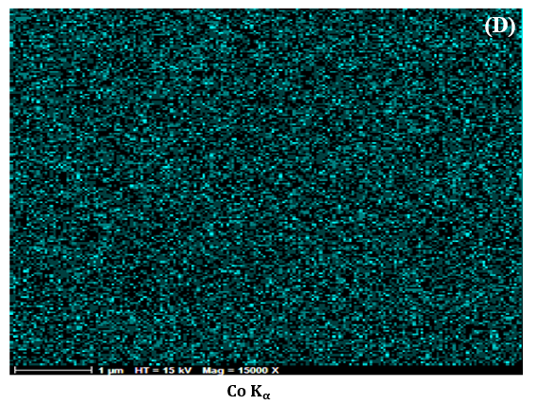
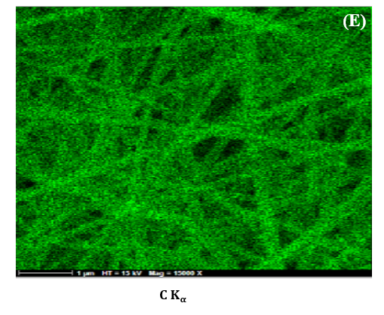 | 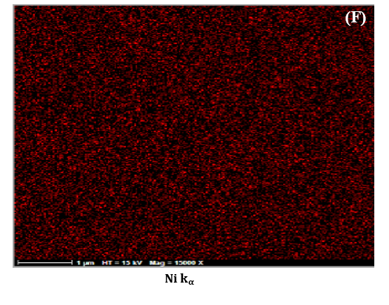
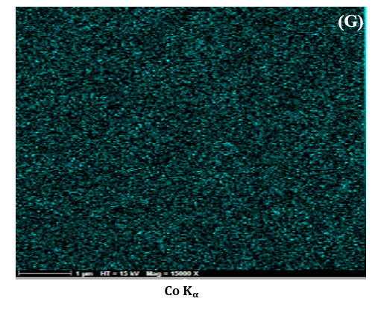
Fig. S4. EDX spectra of (A) 0.5 Co/ ECNF-5h and (B) Ni₇₀Co₃₀/ ECNF-5h. (C-D) map images of C and Co elements in 0.5 Co/ ECNF-5h. (E-G) map images of C, Ni and Co elements in Ni₇₀Co₃₀/ ECNF-5h.

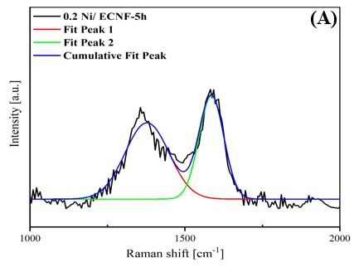 | 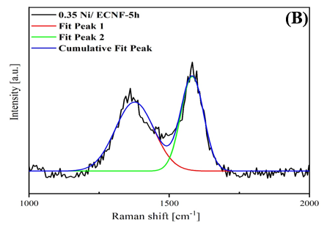
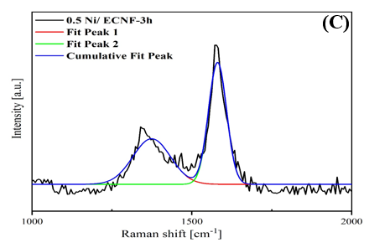 | 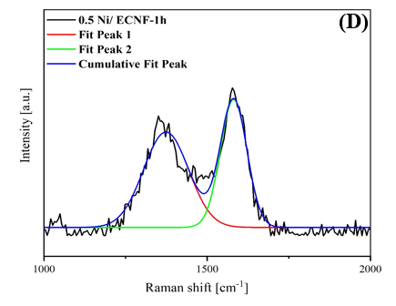
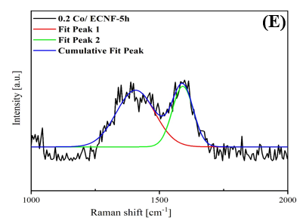 | 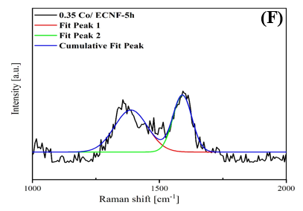
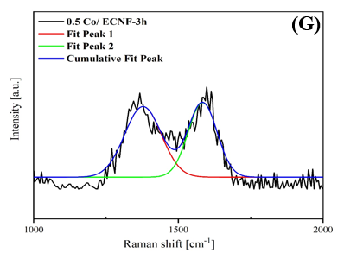 | 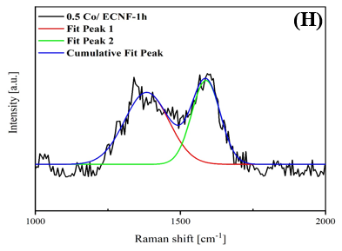
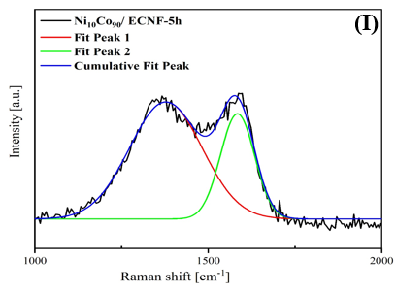 | 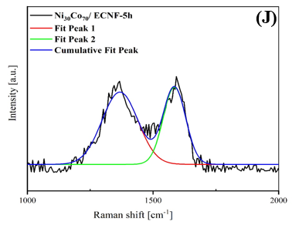
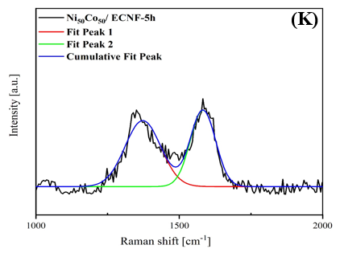 | 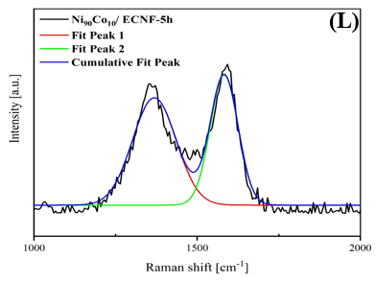

Fig. S5. Raman spectra : (A-H) Ni/ ECNF and Co/ ECNF nanocomposites prepared using different metal precursor contents and different carbonization times, (I-L) Ni-Co/ ECNF nanocomposites prepared using different percentage of Ni and Co precursors.

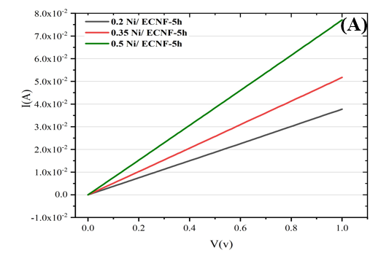 | 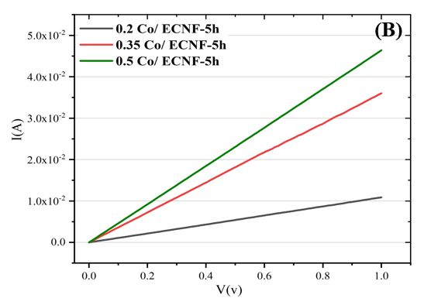
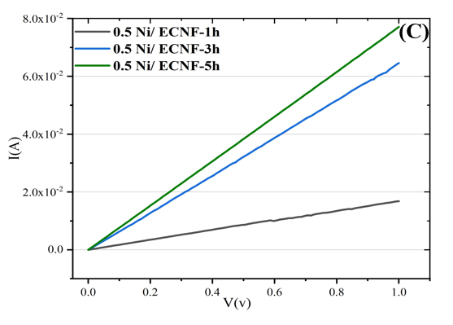 | 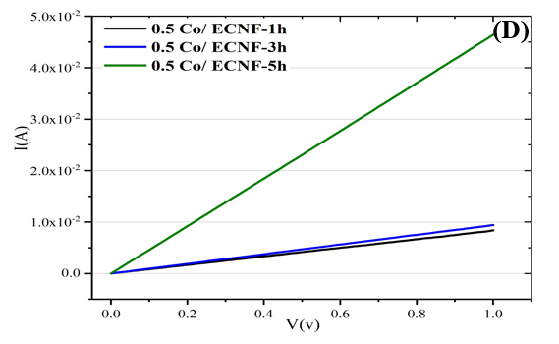
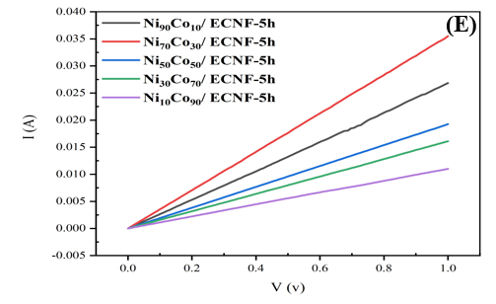

Fig. S6. I -V curves of nanocomposites.

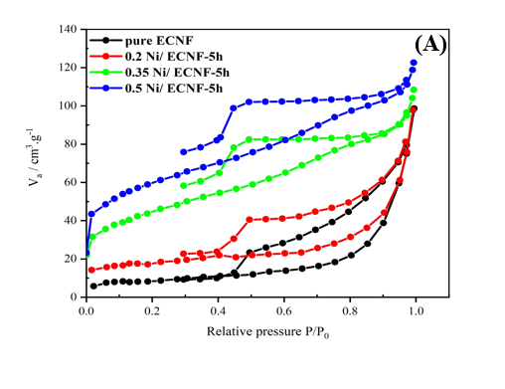 | 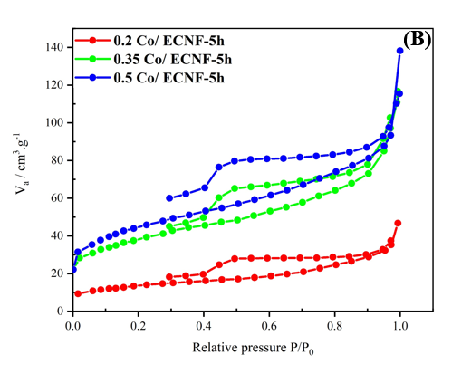

Fig. S7. Nitrogen absorption/desorption isotherms of Ni/ ECNF and Co/ ECNF nanocomposites prepared with different metal precursor contents.

Table S1
D and G peaks intensity, R ratios, degree of graphitization, and estimated La values of Ni-Co / ECNF Nanocomposites.
Sample name | $$I_{D}\left(\%\right)$$  $$1300-1400 {cm}^{-1}$$ | $$I_{G}\left(\%\right)$$  $$1580-1600 {cm}^{-1}$$ |  | $R=\frac{I_{D}}{I_{G}}$ | $$Degree of graphitization$$ |  | $$La(average crystallite sise)$$
Ni₁₀Co₉₀/ ECNF-5h | 66.561 | 67.912 | 0.98 |  | 50.502 |  | 4.468
Ni₃₀Co₇₀/ ECNF-5h | 49.519 | 52.056 | 0.95 |  | 51.248 |  | 4.604
Ni₅₀Co₅₀/ ECNF5h | 40.823 | 46.250 | 0.88 |  | 53.116 |  | 4.962
Ni₇₀Co₃₀/ ECNF-5h | 43.06 | 52.925 | 0.81 |  | 55.138 |  | 5.383
Ni₉₀Co₁₀/ ECNF-5h | 57.089 | 65.645 | 0.87 |  | 53.485 |  | 5.036

Table S2
Electrical Conductivities of Ni-Co/ ECNF Nanocomposites.
Sample name | Conductance=1/R (S) | Thickness of samples (µm) | Electrical conductivity (S/cm)
Ni₁₀Co₉₀/ ECNF-5h | 0.011 | 70 | 1.57
Ni₃₀Co₇₀/ ECNF-5h | 0.016 | 78 | 2.05
Ni₅₀Co₅₀/ ECNF5h | 0.019 | 76 | 2.5
Ni₇₀Co₃₀/ ECNF-5h | 0.035 | 73 | 4.79
Ni₉₀Co₁₀/ ECNF-5h | 0.026 | 71 | 3.66

