Supplementary Information

Deploying coal for grid flexibility increases power sector costs for China’s carbon neutrality

AFM Kamal Chowdhury¹, Ryna Cui^{2*}, Jacob Wessel³, Yang Ou⁴, Thomas B Wild^{1, 2}, Gokul Iyer², Jonathan Lamontagne⁵, Ranjit Deshmukh⁶, Xiaoyu Jin⁷, Stefano Galelli⁸, Matthew J Gidden²

¹ Earth System Science Interdisciplinary Center (ESSIC), University of Maryland, College Park, MD, USA
² Center for Global Sustainability (CGS), School of Public Policy, University of Maryland, College Park, MD, USA
³ School of Public and International Affairs, Princeton University, Princeton, NJ, USA
⁴ College of Environmental Sciences and Engineering, Peking University, Beijing, China
⁵ School of Civil and Environmental Engineering, Tufts University, Medford, MA, USA
⁶ Environmental Studies Department, University of California, Santa Barbara, CA, USA
⁷ Institute of Hydropower and Hydro informatics, Dalian University of Technology, Dalian, China
⁸ School of Civil and Environmental Engineering, Cornell University, Ithaca, NY, USA

*Corresponding author: ycui10@umd.edu

Contents in this document
Supplementary texts
Text S1. What drives the modelled expansion of generation and storage technologies
Text S2. Robustness of results under sensitivity scenarios
Supplementary figures S1 to S33
Supplementary tables S1 to S8
References

Supplementary texts

Text S1. What drives the modelled expansion of generation and storage technologies
While the main text focuses on electricity generation results from the GridPath-CSPG¹ model, here we compare those outputs with annual generation data from GCAM-China² to assess consistency between the models and explore the drivers of generation technology expansion. In both frameworks, technology expansion is primarily influenced by cost-competitiveness and resource availability. However, in GridPath-CSPG, the need for flexible resources to maintain grid reliability under high renewable penetration also plays a critical role.

Across both decarbonization pathways, GCAM-China and the corresponding GridPath-CSPG scenarios generally yield consistent trends in generation mixes, with a few key differences (Supplementary Fig. S29). For example, coal, nuclear, and hydropower generation in GridPath-CSPG’s Base scenario closely aligns with GCAM-China projections for both near-term (2035) and long-term (2060) horizons. The key differences include a greater expansion of rooftop solar in GCAM-China, driven by a policy constraint that allocates a portion of future building energy demand to rooftop solar (Supplementary Fig. S28), regardless of its utility-scale cost competitiveness—an assumption aligned with some real-world practices in China. We did not apply this constraint as a default condition in the GrdiPath-CSPG scenarios, considering uncertainty in this assumption, but tested its implications with a sensitivity scenario (Supplementary Text S2). GridPath-CSPG also projects a relatively lower expansion of concentrated solar power (CSP) than GCAM-China, which is related to the cost-competitiveness and resource availability, as explained below. This result, however, is consistent with similar studies using coupled integrated assessment and power system models that also reported lower solar uptake in power system models^{3,4}, likely because deployment of solar in the power models is intertwined with additional costs for transmission, storage, and curtailments. Other key differences include a greater preference for onshore wind in GridPath-CSPG scenarios, with reliance on CCS and battery storage for grid flexibility. Interestingly, in the NoCCS scenario, the generation mix is nearly identical to that of GCAM-China—but with a substantial expansion of battery storage—highlighting the value of GridPath-CSPG’s operational granularity in representing flexible resource needs.

In GridPath-CSPG, expansion decisions are primarily governed by technology-level cost-competitiveness and productivity, reflected in their levelized cost of electricity (LCOE)⁵ and capacity factors, respectively (Supplementary Fig. S13). Technologies with lower LCOEs are prioritized under cost optimization. For example, even after 2050, the LCOEs of rooftop solar, CSP, and onshore wind remain higher than that of nuclear (Supplementary Fig. S13a), despite costs substantially declining for variable renewable energy (VRE) technologies. These higher LCOEs, driven in part by declining capacity factors (Supplementary Fig. S13b), help explain their limited expansion in the Base scenario. The falling capacity factors of VRE technologies over time result from earlier deployment of the most productive (i.e., highest capacity factor) sites.

Resource availability constraints further shape expansion patterns. Rooftop solar and CSP generally expand only after cost-competitive options—such as utility-scale solar PV, hydropower, and onshore wind—reach their resource or policy limits (Supplementary Fig. S14). For example, rooftop solar expansion becomes significant only once PV, wind, and hydro potential are fully utilized and when nuclear and CCS-based technologies are constrained. Solar CSP follows a similar trajectory. As GridPath-CSPG minimizes total system costs—including capital, operating, and transmission investments—rooftop and CSP remain secondary options unless cheaper alternatives are no longer feasible. However, it is worth noting that GridPath-CSPG does not capture certain distributed benefits of rooftop solar, such as alleviating local transmission congestion or reducing distribution losses. These potential advantages, though not modeled here, could make rooftop solar more attractive in real-world planning contexts.

Text S2. Robustness of results under sensitivity scenarios
To test the robustness of our conclusions, we assess sensitivity scenarios focusing on generation and capacity mixes, total system costs, and underutilized capacity. The three scenarios based on alternative cost trajectories from ATB-2019 and ATB-2023 exhibit greater long-term (2060) integration of solar technologies compared to the Base scenario (Supplementary Fig. S30), reflecting the relatively conservative cost assumptions for solar in our default setup (Supplementary Figs. S25–S27). As a result, these scenarios yield lower overall system costs compared to the DispCoal scenario (Supplementary Fig. S31), reinforcing our main findings.
The two climate-impacted hydropower scenarios, based on RCP 4.5 and RCP 8.5, show higher hydropower dispatch despite similar capacity levels by 2060 (Supplementary Fig. S30). This appears to be driven by higher capacity factors during typically dry months (e.g., November–January) under climate-forced conditions (Supplementary Fig. S32). The increased hydropower dispatch in these months reduces reliance on CCS, solar PV, and curtailment (Supplementary Fig. S33). The NoPRM scenario shows no expansion of gas-fired generation compared to the Base case, confirming the role of gas as a capacity reserve under the planning reserve margin constraint. Both the climate-impacted and NoPRM scenarios yield significantly lower system costs and underutilized capacities than the DispCoal case, further supporting our conclusions.
In the RPS Rooftop scenario, mandated rooftop deployment leads to higher battery storage requirements and system costs that are 4% above the DispCoal scenario. However, this cost gap may be overstated, as our model does not fully capture the potential grid benefits of distributed rooftop solar. Overall, these sensitivity analyses affirm the robustness of our conclusions across a range of uncertainties, including future technology costs, climate impacts on hydropower, and policy and reliability constraints.

Supplementary figures
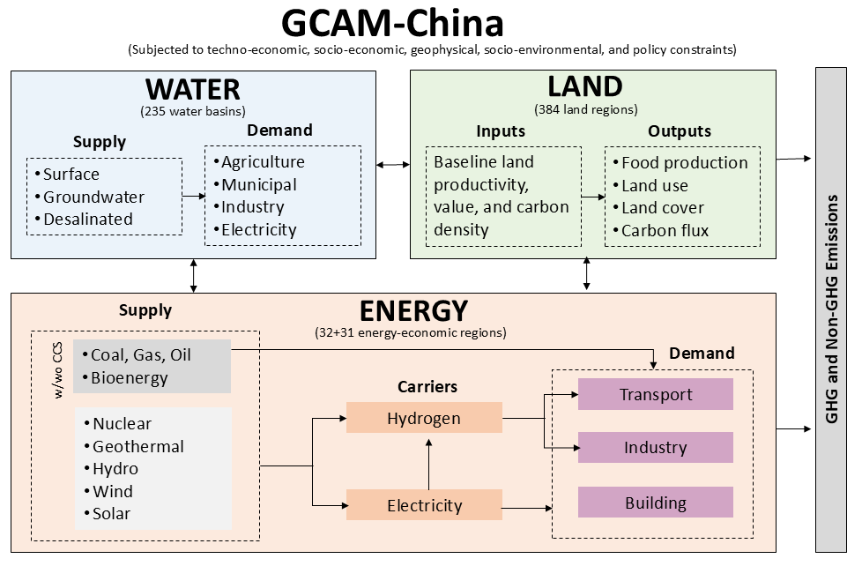
Fig. S1: Key inputs and outputs of GCAM-China’s energy, water, and land modules as part of an integrated global multi-sectoral model.

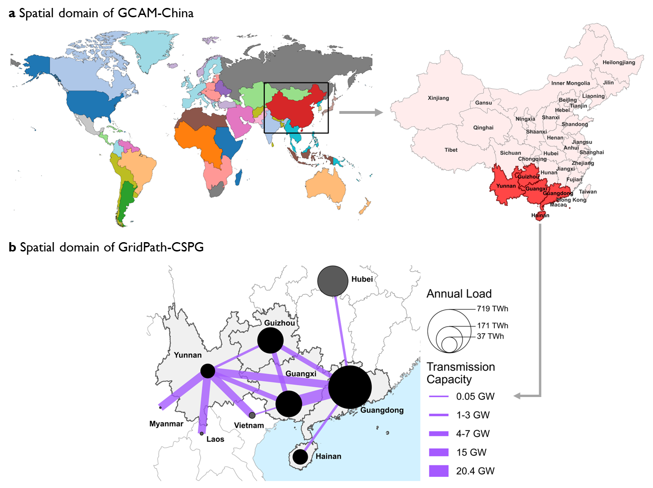
Fig. S2: Spatial domains of (a) GCAM-China and (b) GridPath-CSPG with annual electricity demand and transmission capacity, as of 2020. GCAM-China disaggregates the energy-economic system of the China region into 31 province-level sub-regions and six electricity grid regions that are also embedded in the global GCAM model.

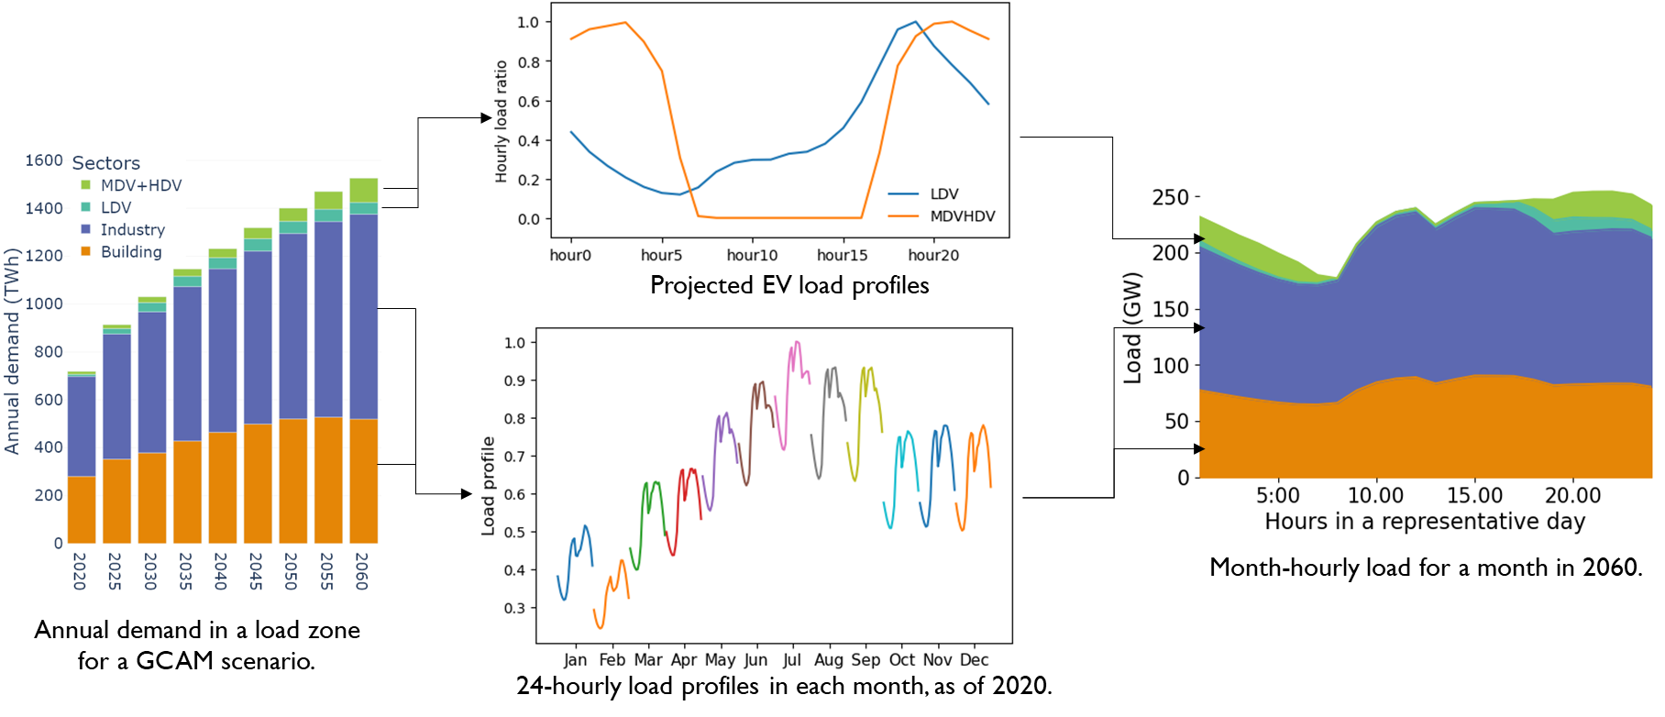
Fig. S3: For a typical load zone, disaggregation of GCAM-China’s annual electricity demand for the building, industry, and transport sectors into month-hourly loads, which serve as inputs to GridPath-CSPG.

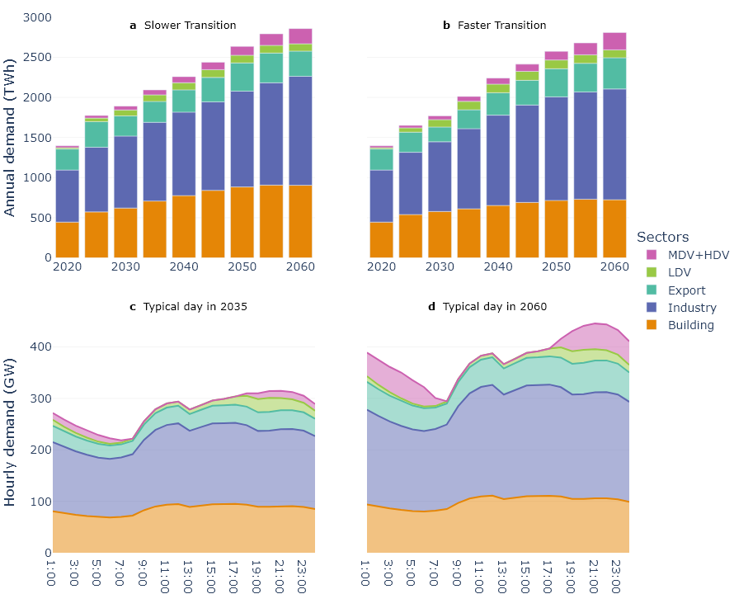
Fig. S4: For the Slower and Faster Transition pathways in GCAM-China, (a-b) annual electricity demand by three sectors and export nodes, and (c-d) corresponding hourly demand for typical days in July (as an example) for 2035 and 2060. Electricity demand from buildings, industry, and transport follows similar patterns in both pathways (a-b), with industry accounting for about half of annual demand. Notably, the electrification of transport (e.g., EV charging) is projected to substantially increase nighttime peak demand in future years (c-d).

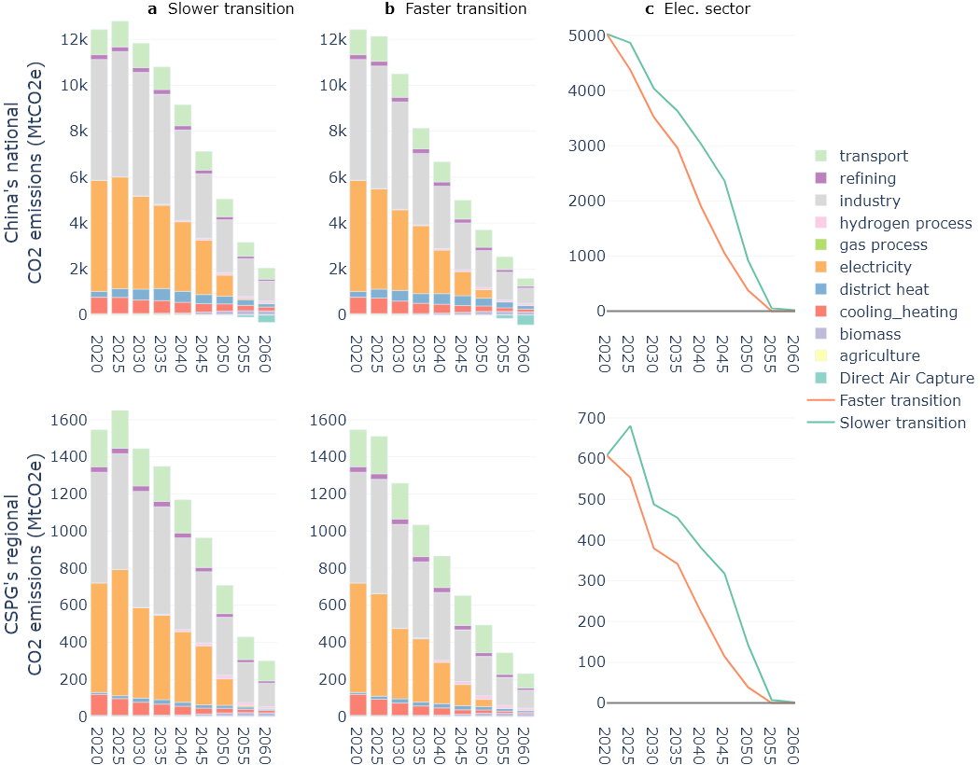
Fig. S5: For the two decarbonization pathways in GCAM-China, annual fossil fuel and industrial processes (FFI) CO₂ emissions by sectors under (a) Slower Transition and (b) Faster Transition to carbon neutrality, and (c) only the electricity sector. The national-level results are shown in the top panels, while the bottom panels show the regional results for the five provinces within CSPG.

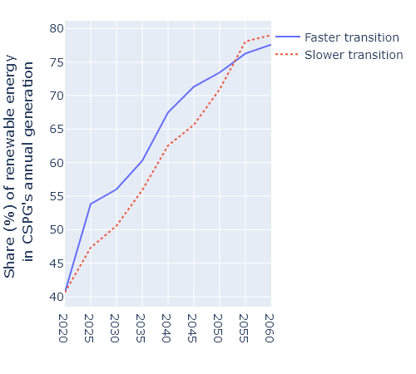
Fig. S6: Share of electricity generation from renewable resources (i.e., solar, wind, and hydropower technologies, but excluding bioenergy) in annual electricity generation over 2020-2060 for the two decarbonization pathways in GCAM-China.

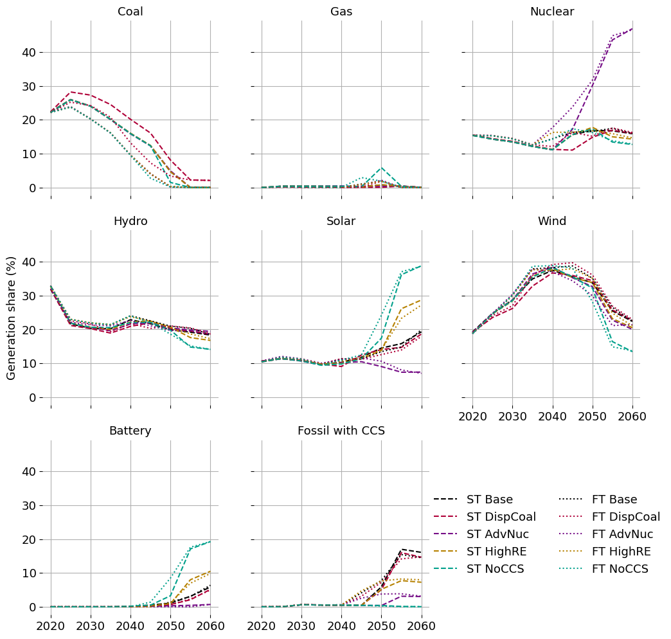
Fig. S7: Shares of the key technologies in CSPG’s annual electricity generation for the 2020-2060 period in the core GridPath-CSPG scenarios under the two decarbonization pathways. To compare the results under the two pathways, the results for ‘Faster’ and ‘Slower’ transitions are shown in dotted and dashed lines, respectively, while the line colors represent the GridPath-CSPG scenarios.

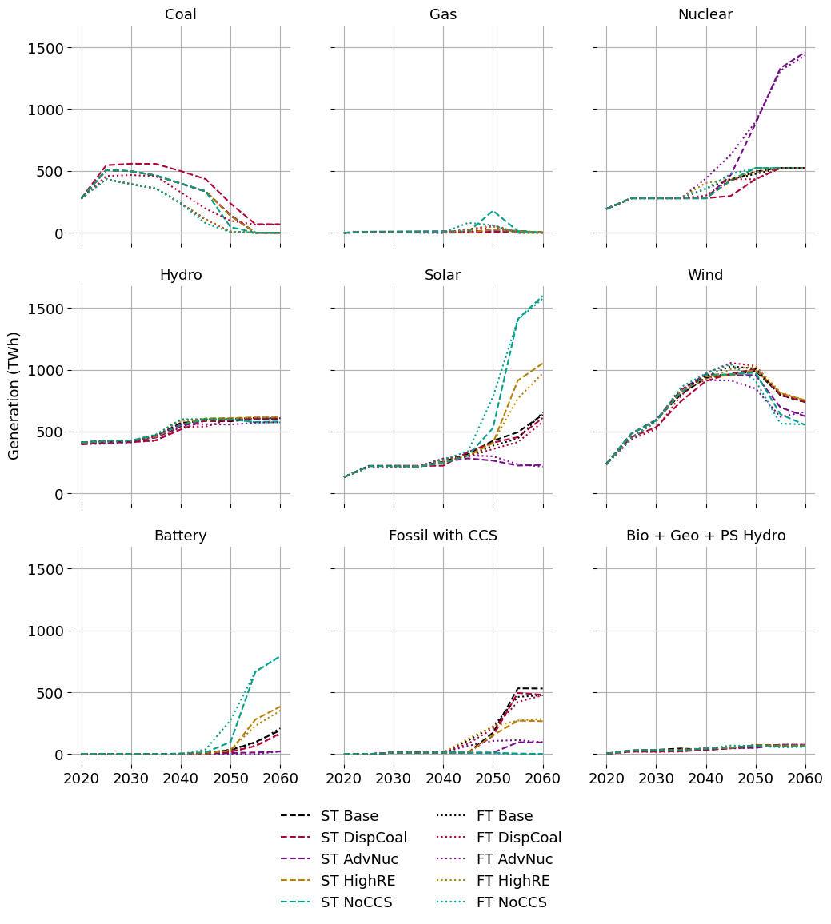
Fig. S8: Annual generation (TWh) by key technologies in CSPG for the 2020-2060 period in the core GridPath-CSPG scenarios under the two decarbonization pathways. To compare the results under the two pathways, the results for ‘Faster’ and ‘Slower’ transitions are shown in dotted and dashed lines, respectively, while the line colors represent the GridPath-CSPG scenarios.
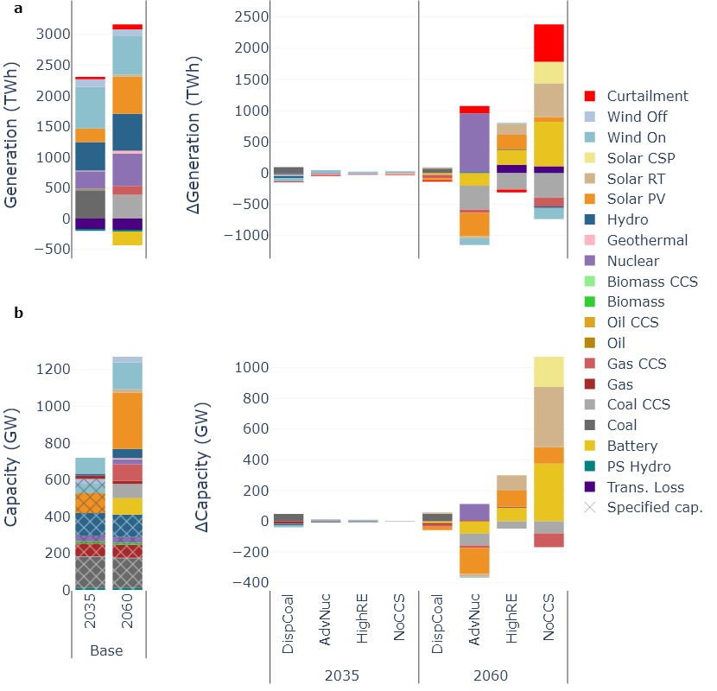
Fig. S9: Under the ‘Slower Transition’, annual electricity generation mix (a) and capacity mix (b) for 2035 and 2060 in the five core scenarios in GridPath-CSPG. The results for the alternative scenarios are shown as a difference from the ‘Base’ scenario. Specified capacities include existing and under-construction capacities.
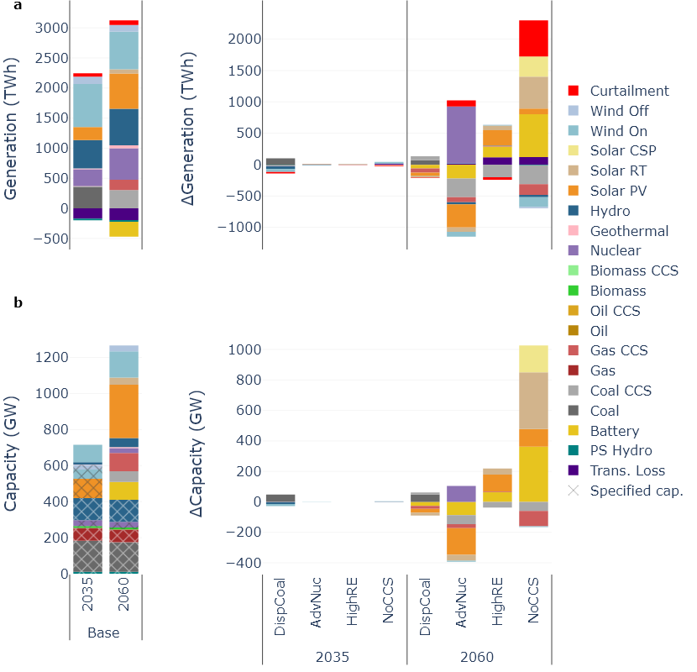
Fig. S10: Under the ‘Faster Transition’, annual electricity generation mix (a) and capacity mix (b) for 2035 and 2060 under the core scenarios in GridPath.

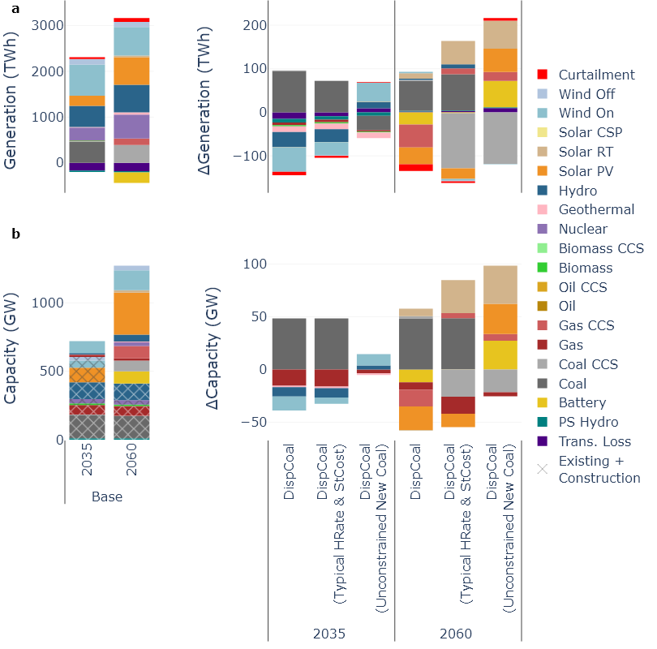
Fig. S11: Under the ‘Slower Transition’, annual electricity generation mix (a) and capacity mix (b) for 2035 and 2060 in the three variations of the ‘DispCoal’ scenario, compared to the ‘Base’ scenario.

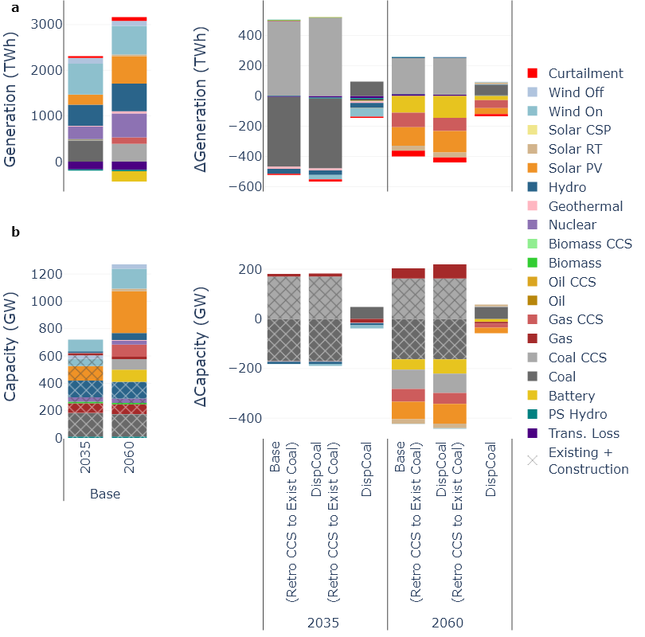
Fig. S12: Under the ‘Slower Transition’, annual electricity generation mix (a) and capacity mix (b) for 2035 and 2060 in the two variations of the ‘Base’ and ‘DispCoal’ scenarios, where the existing coal power plants are assumed to be retrofitted with CCS by 2035. The results of the CCS retrofit scenarios are compared with the core ‘Base’ and ‘DispCoal’ scenarios.

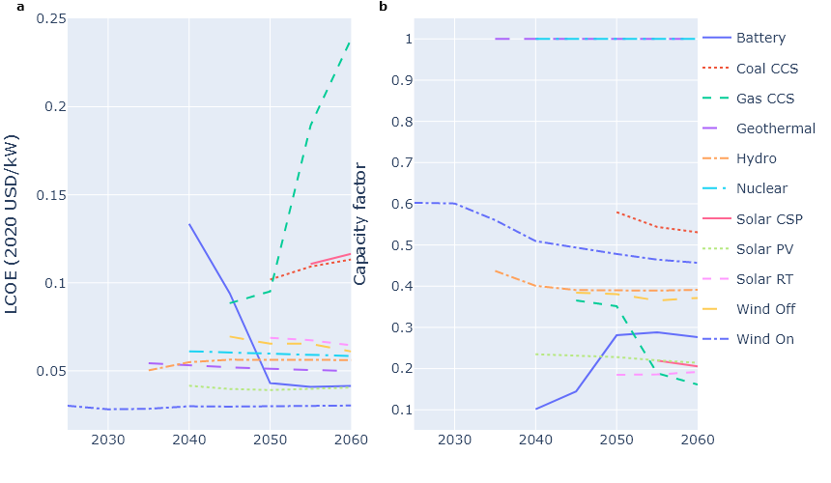
Fig. S13: Technology-wise average (a) levelized cost of electricity (LCOE) and (b) capacity factors of the newly selected generation capacities across the core GridPath-CSPG scenarios.

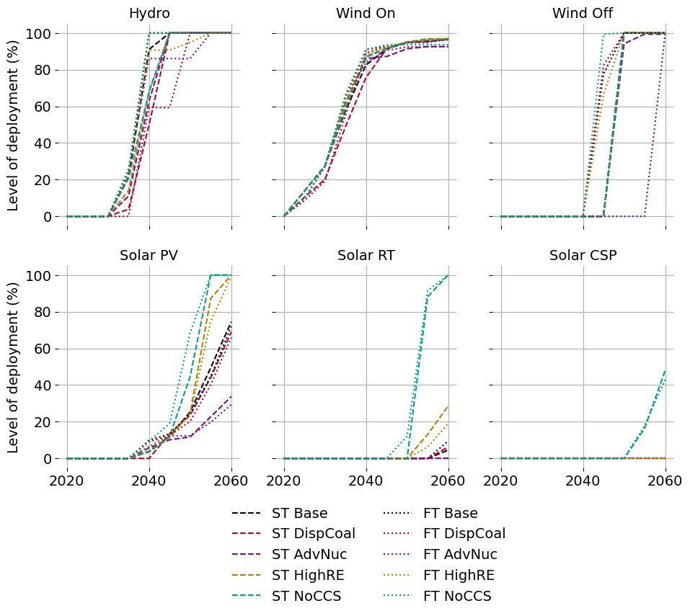
Fig. S14: Level of deployment of the candidate capacities of hydro, wind, and solar technologies in the GridPath-CSPG scenarios.

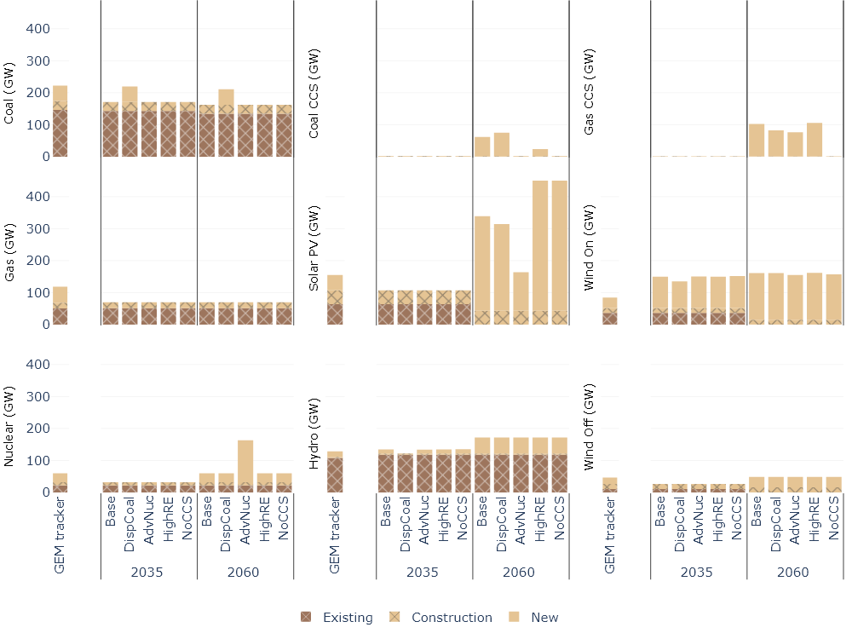
Fig. S15: Under the ‘Faster Transition’, the existing, under-construction, and new capacities of key generation technologies for 2035 and 2060 in the core GridPath-CSPG scenarios, compared to the corresponding GEM data. The ‘new’ capacity for GEM data represent the capacities under development at various pre-construction (e.g., pre-permitted, permitted, and announced) stages.
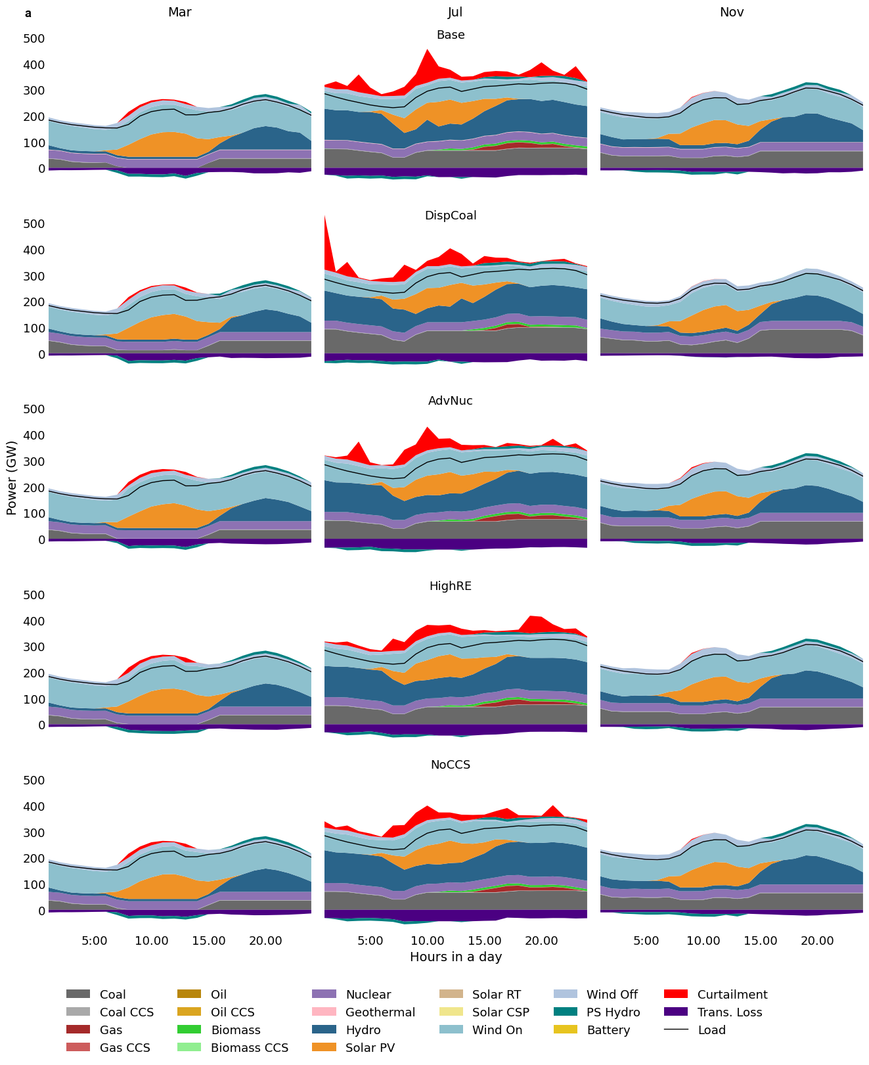
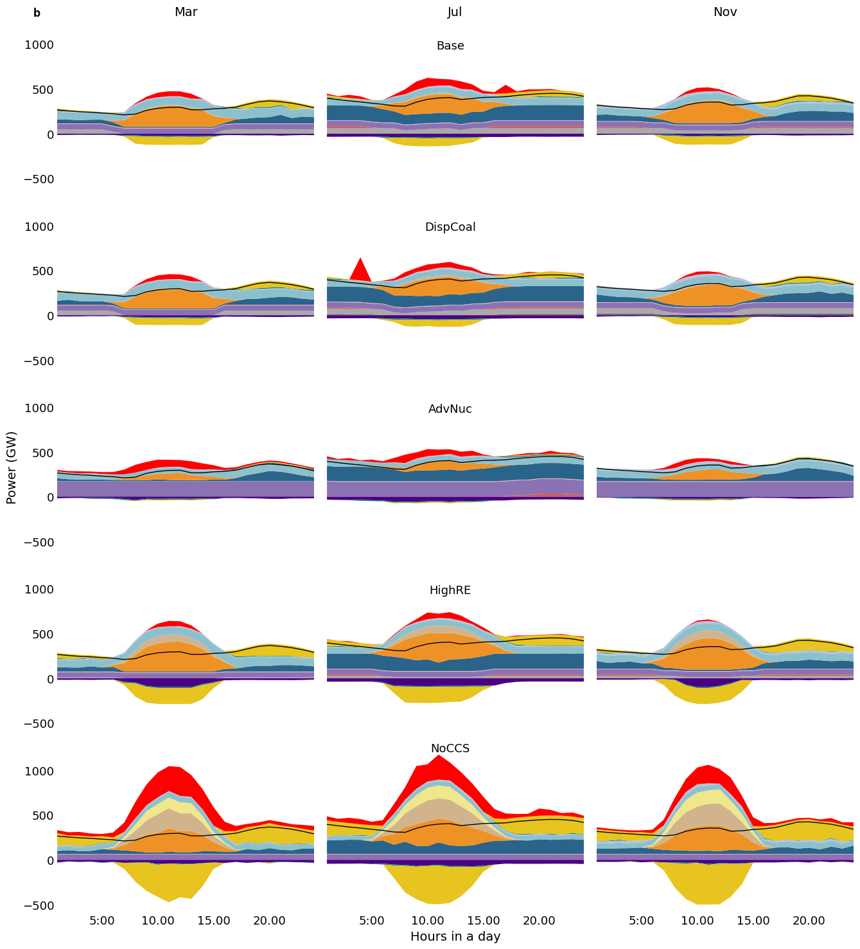
Fig. S16: CSPG’s hourly electricity generation in (a) 2035 and (b) 2060 for the GridPath-CSPG scenarios under the Slower Transition. The results are presented for three representative months to illustrate the impact of seasonal variability. The results for Faster Transition are similar and hence, not shown.
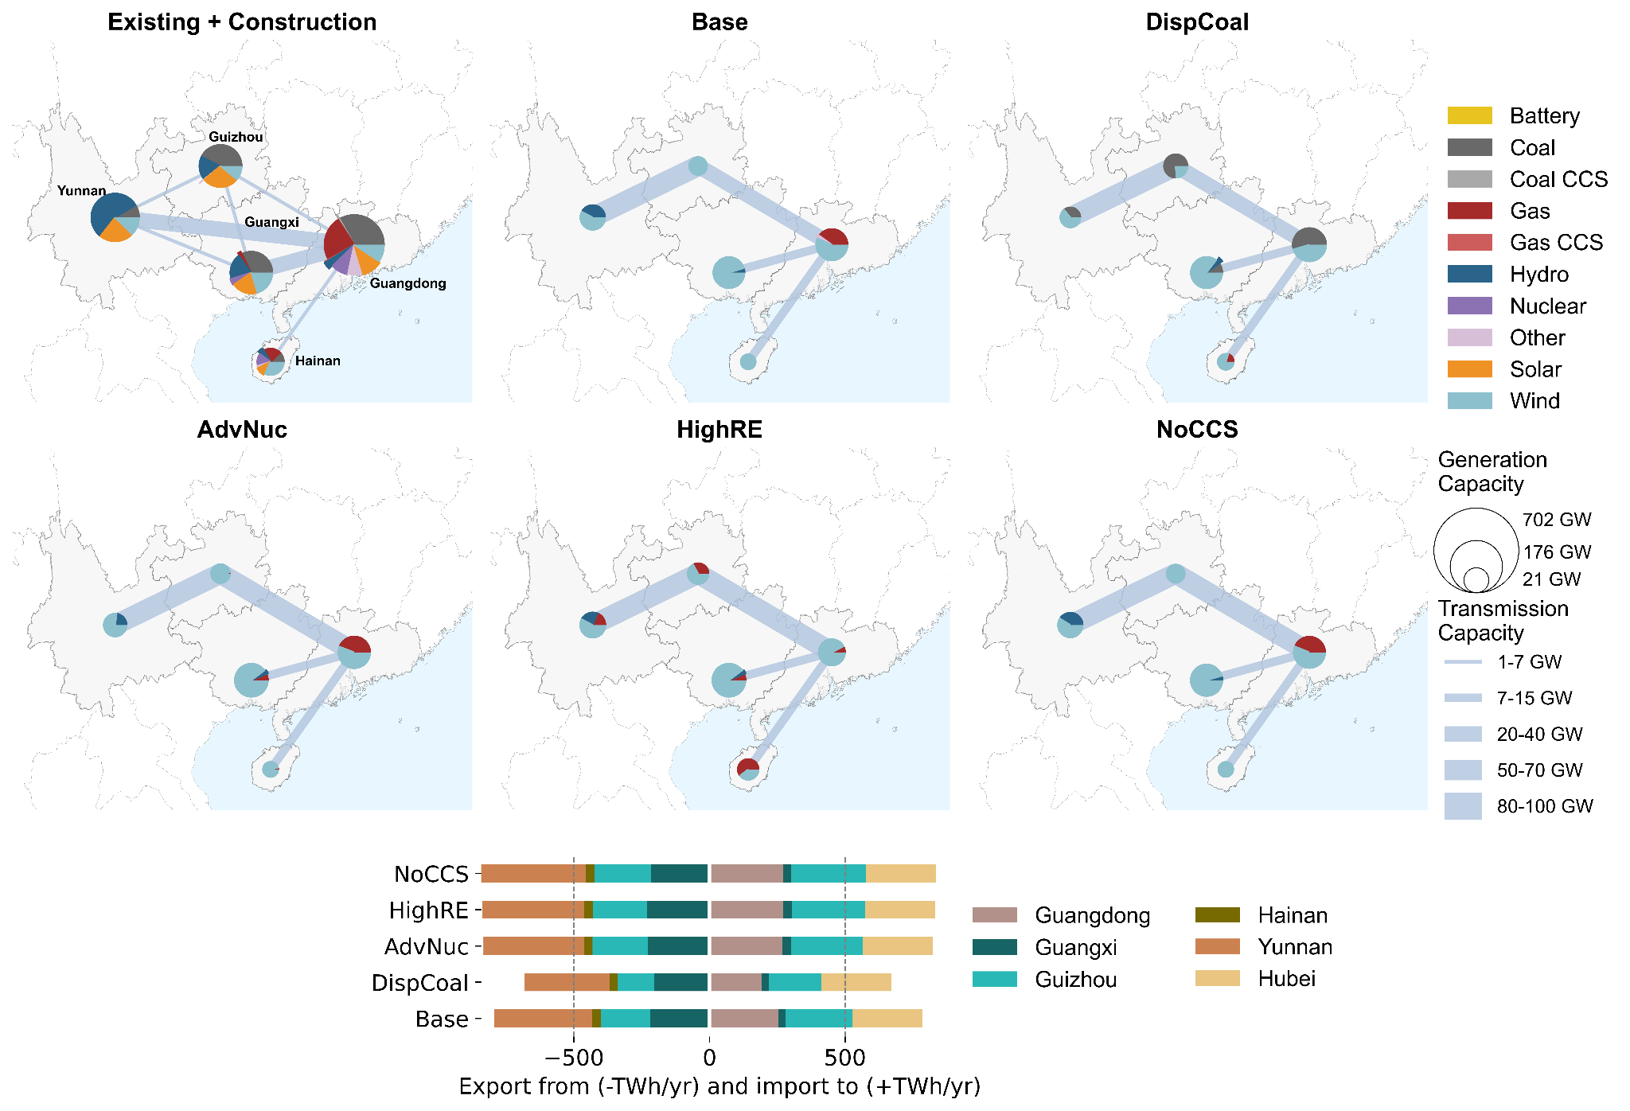
Fig. S17: For 2035, province-level new generation and transmission capacity, and inter-provincial flow of electricity in the GridPath-CSPG scenarios under the ‘Slower Transition’.

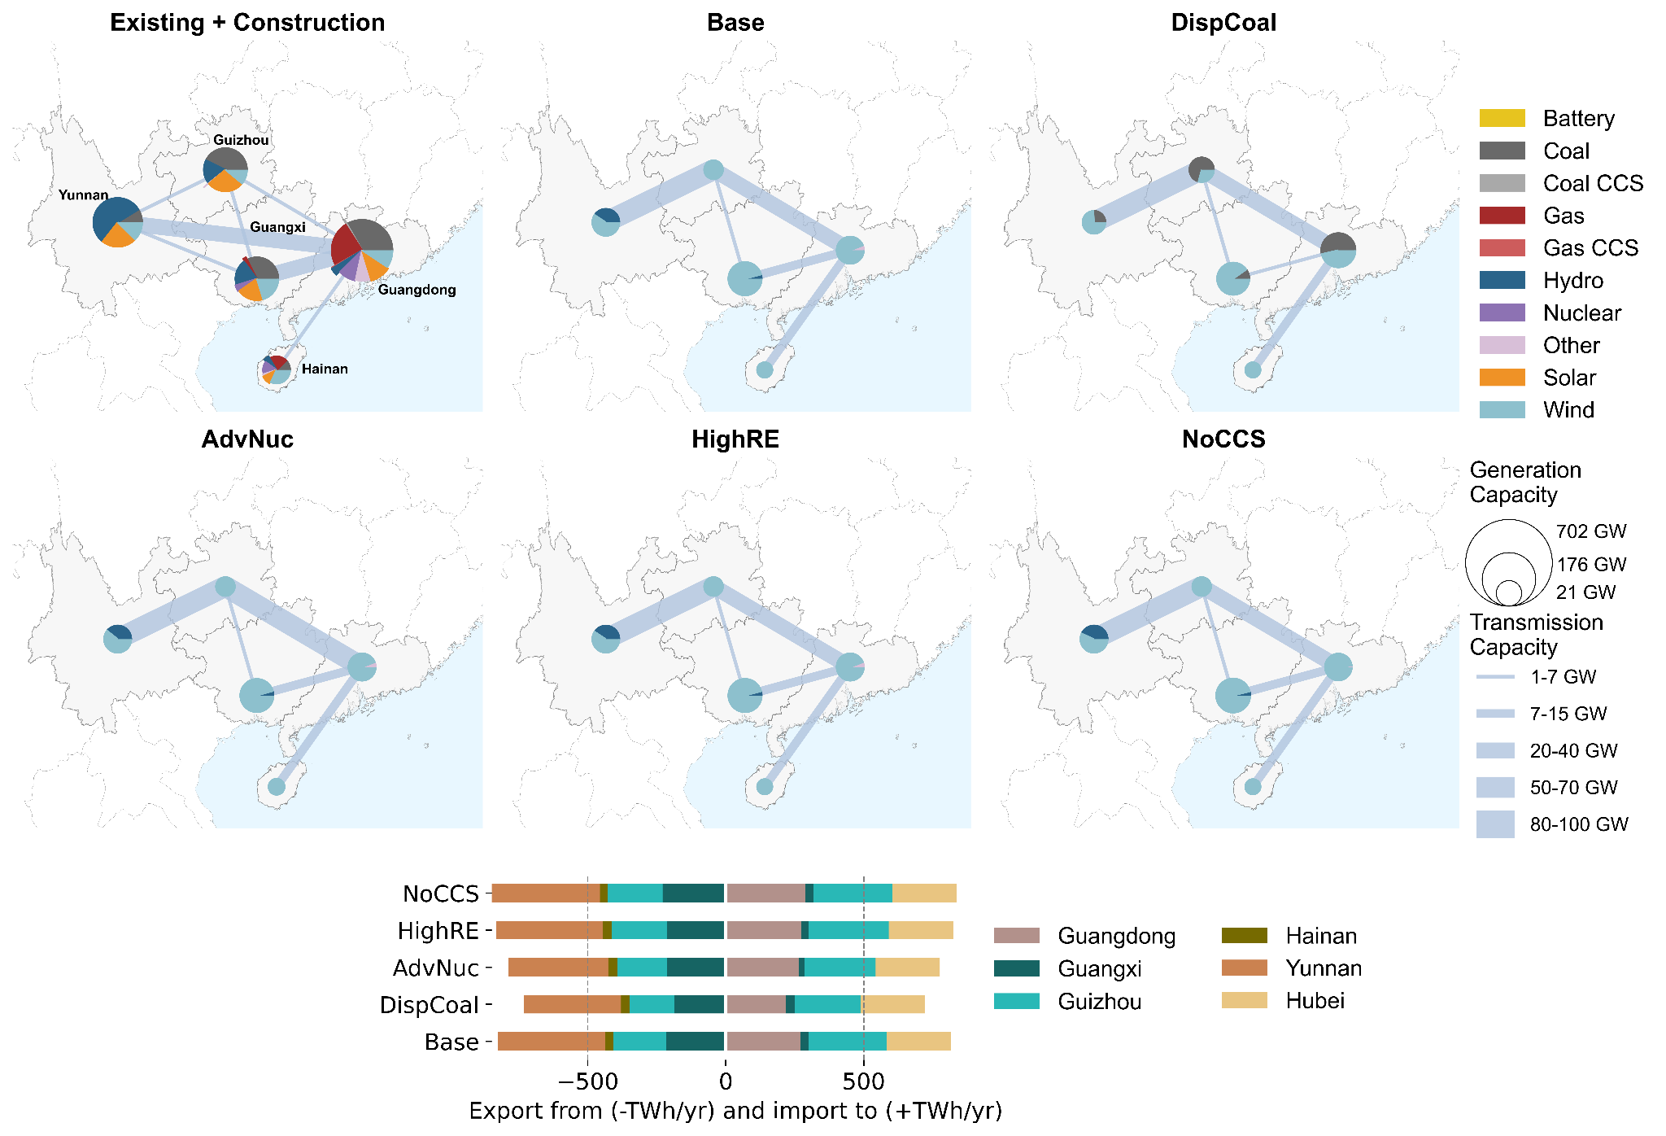
Fig. S18: For 2035, province-level new generation and transmission capacity, and inter-provincial flow of electricity in the GridPath-CSPG scenarios under the ‘Faster Transition’.

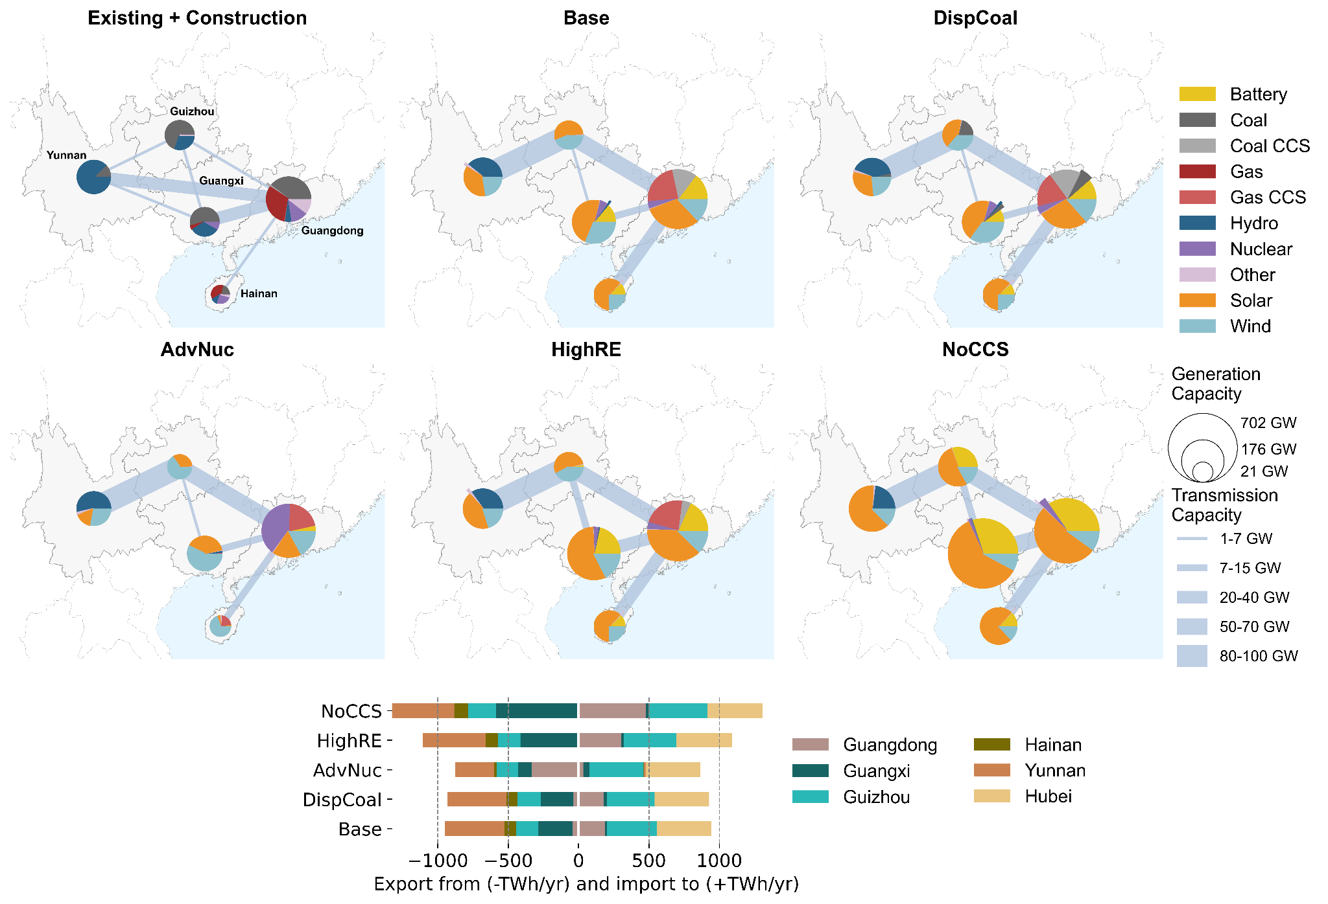
Fig. S19: For 2060, province-level new generation and transmission capacity, and inter-provincial flow of electricity in the GridPath-CSPG scenarios under the ‘Faster Transition’.
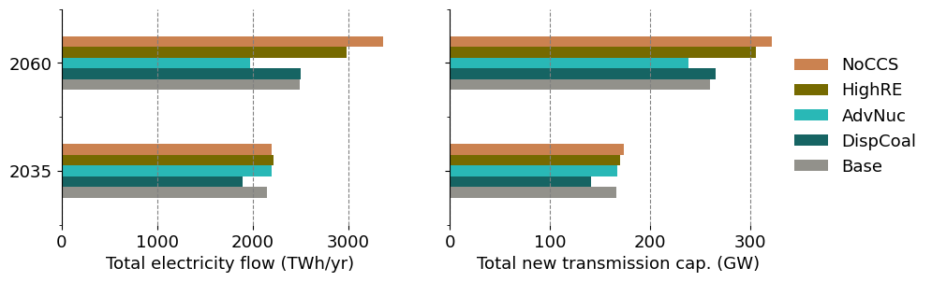
Fig. S20: Under Slower Transition, total electricity flow and required new transmission capacities across the GridPath-CSPG scenarios for 2035 and 2060. The results for the Faster Transition are similar and hence, not shown.
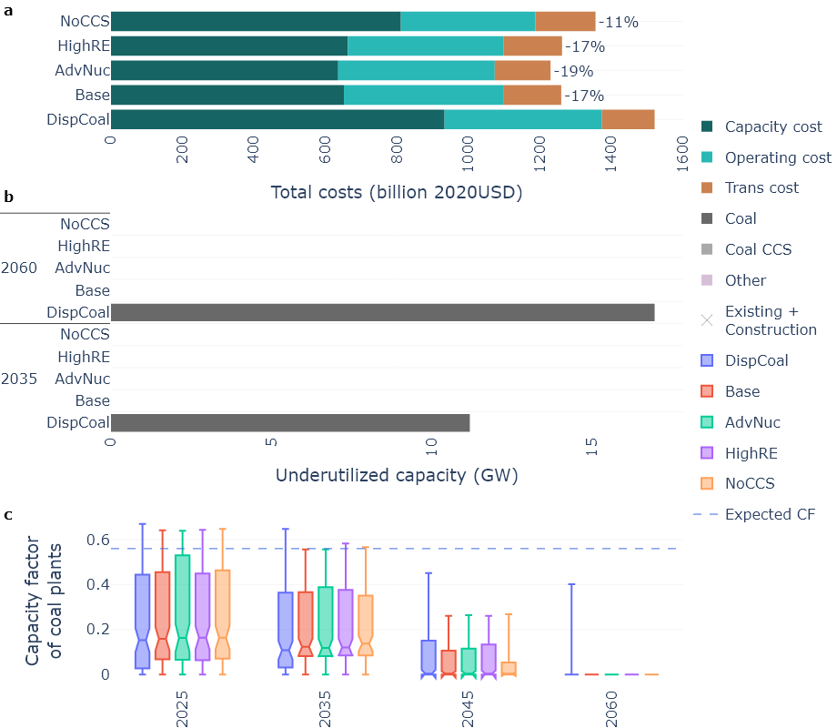
Fig. S21: In the GridPath-CSPG scenarios under the ‘Faster Transition’, (a) net present value of the system-wide total costs over 2020-2060, (b) underutilized generation capacities by technologies (all non-coal technologies are aggregated as ‘Other’) for 2035 and 2060, and (c) box plot distribution of the annual capacity factors (CFs) of the coal power fleets (including existing, under-construction, and newly-selected fleets) under each core scenario. The box plot and estimation of underutilized capacities are typical of Fig. 5.

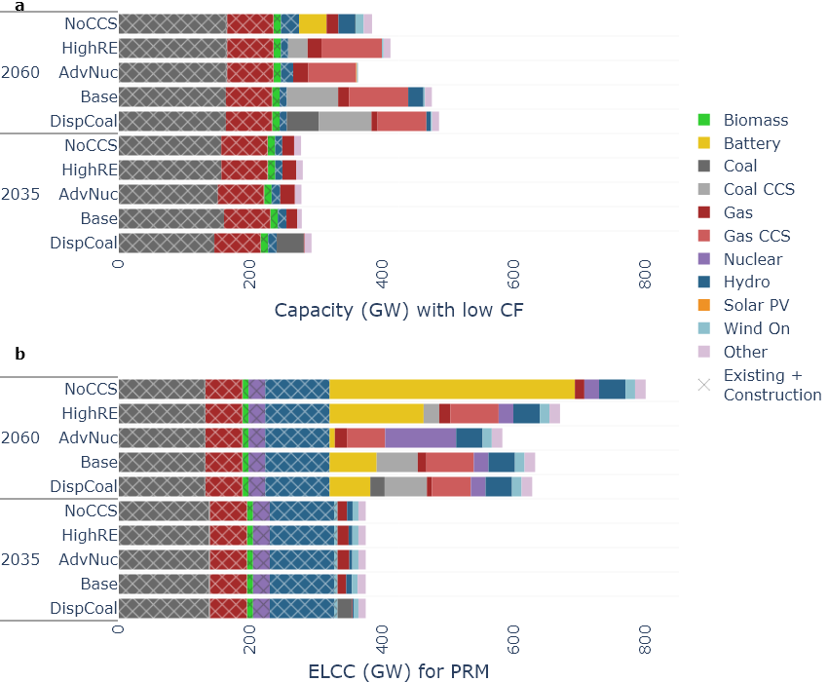
Fig. S22: In the GridPath-CSPG scenarios under the ‘Slower Transition’ and for 2035 and 2060, technology-wise aggregated (a) capacity of power plants with capacity factors below their technology-specific expected benchmark, as shown in Table S8, and (b) effective load-carrying capacity (ELCC) of power plants that contribute to satisfy the planning reserve margin (PRM). The PRM is assumed to be 15% higher than the system-wide annual peak demand for each period.

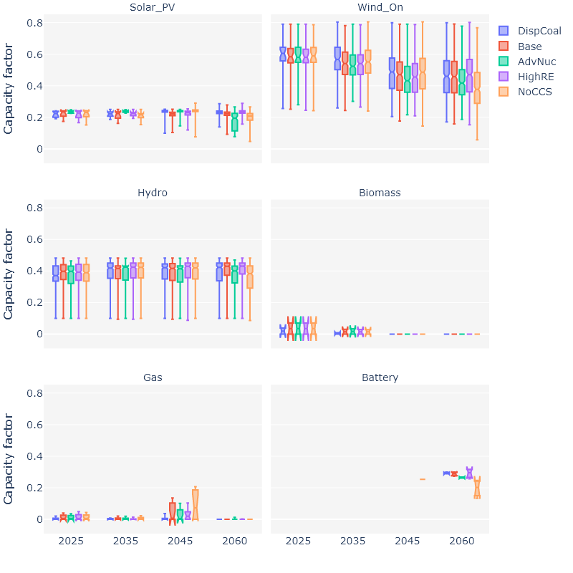
Fig. S23: In the GridPath-CSPG scenarios under the ‘Slower Transition’, box plot distribution of the annual capacity factors (CFs) of the key generation and storage technologies. The box plot shows the inter-quartile range of the plant- or fleet-level capacity factors, defined as the distance between the first and third quartiles with the median shown by notch (and horizontal line), whereas the lower (upper) whiskers extend up to the minimum (maximum) value.

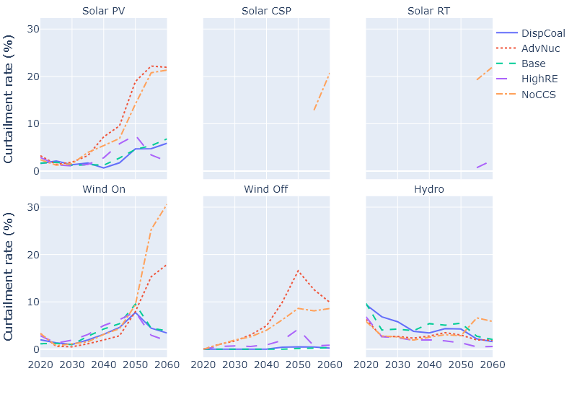
Fig. S24: Curtailment rates of the hydro, wind, and solar technologies in the GridPath-CSPG scenarios under the Slower Transition.
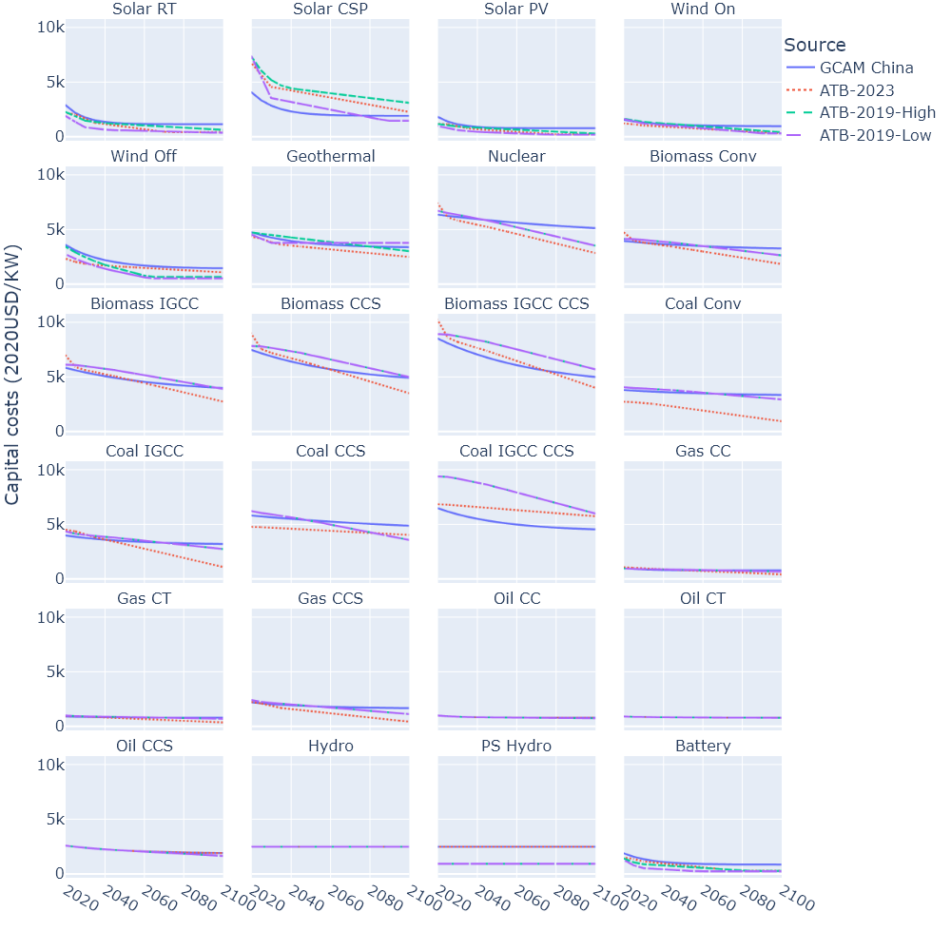
Fig. S25: Trajectories of capital costs of the generation technologies in GCAM-China (also used in GridPath-CSPG), compared to ATB-2023⁶ and ATB-2019’s ‘Low’ and ‘High’ projections⁷.

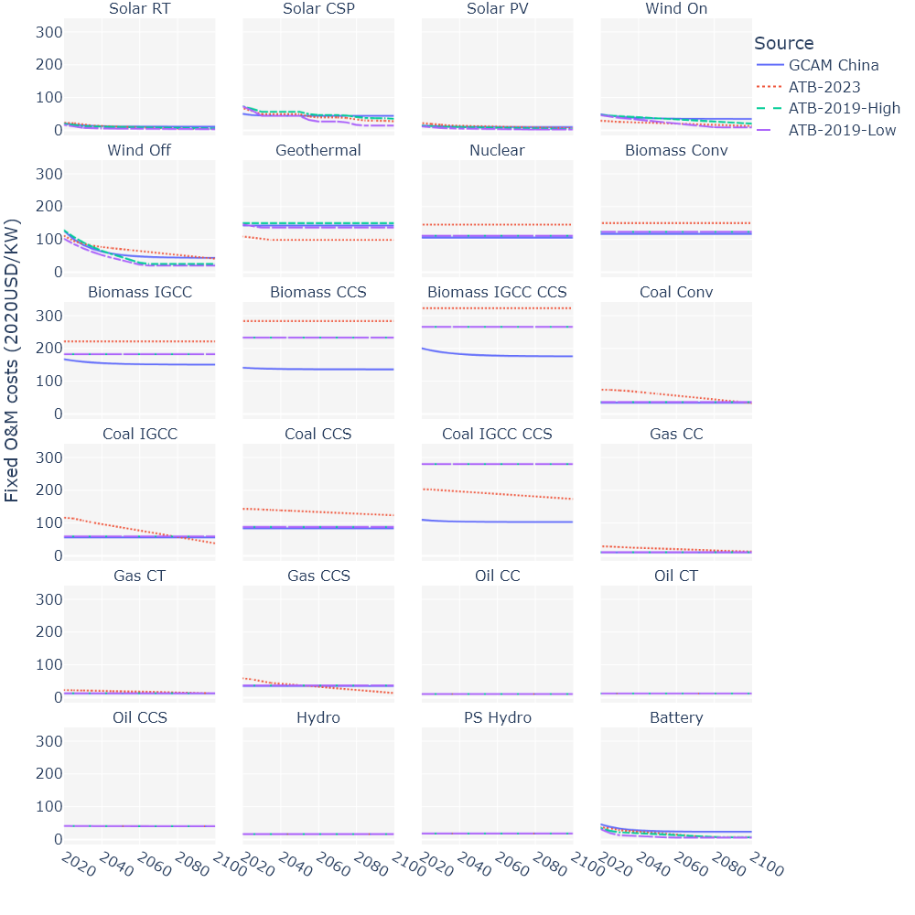
Fig. S26: Trajectories of fixed O&M costs of the generation technologies in GCAM-China (also used in GridPath-CSPG), compared to ATB-2023 and ATB-2019’s ‘Low’ and ‘High’ projections.
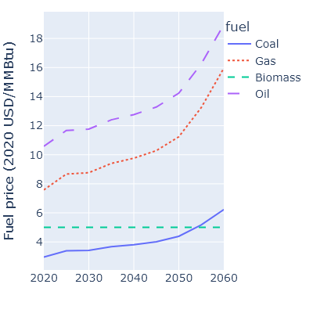
Fig. S27: Trajectories of fuel prices in GridPath-CSPG, adapted from ref.¹.
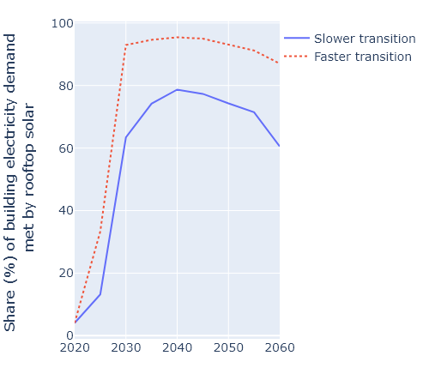
Fig. S28: Share of future building electricity demand assumed to be met by rooftop solar under the two decarbonization pathways in GCAM-China.

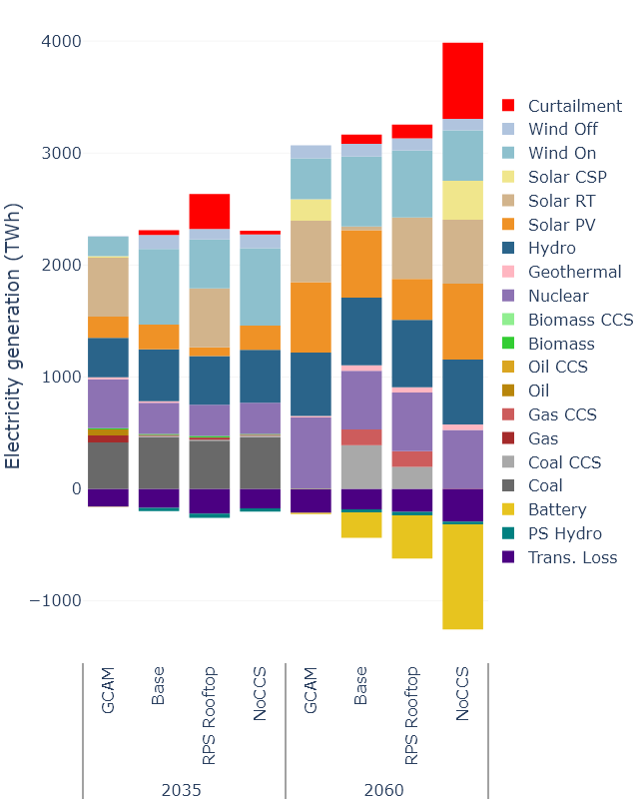
Fig. S29: For 2035 and 2060, comparison of electricity generation mix between GCAM-China and three corresponding scenarios in GridPath-CSPG under Slower Transition.

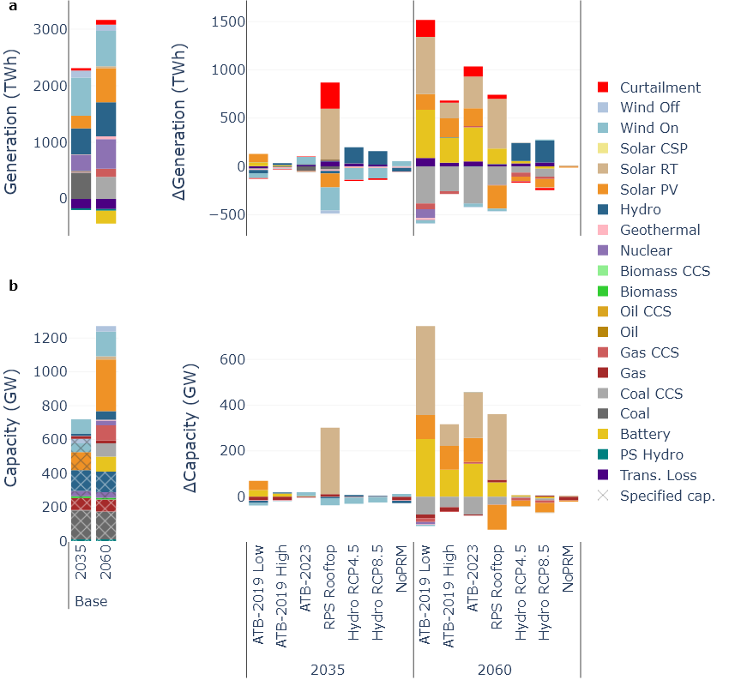
Fig. S30: Annual electricity generation mix (a) and capacity mix (b) for 2035 and 2060 in the seven sensitivity scenarios in GridPath, shown as a difference from the ‘Base’ scenario. Typical results for the GridPath-CSPG scenarios under ‘Slower Transition’ are shown.

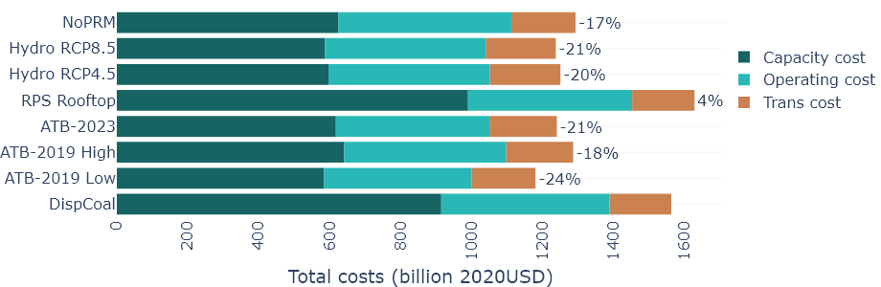
Fig. S31: Net present value of the system-wide total costs over 2020-2060 for seven sensitivity scenarios compared to the DispCoal scenario.

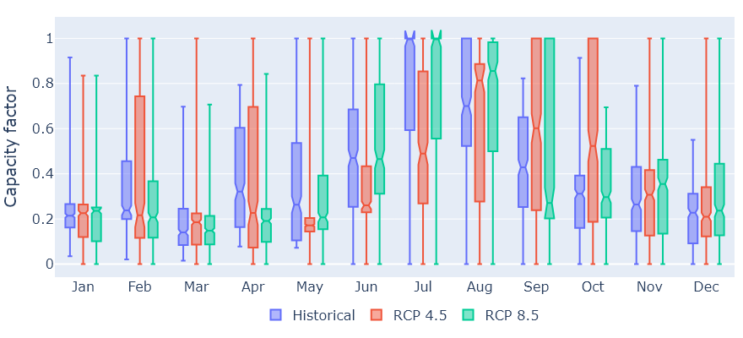
Fig. S32: Monthly capacity factors of CSPG’s existing and planned hydropower sites under historical and two future climate conditions (represented by two RCPs). Each box represents the distribution of the site-level capacity factors, with the lower and upper bounds representing the minimum and maximum, boxes representing the second and third quartiles, and the notch in the middle representing the median.

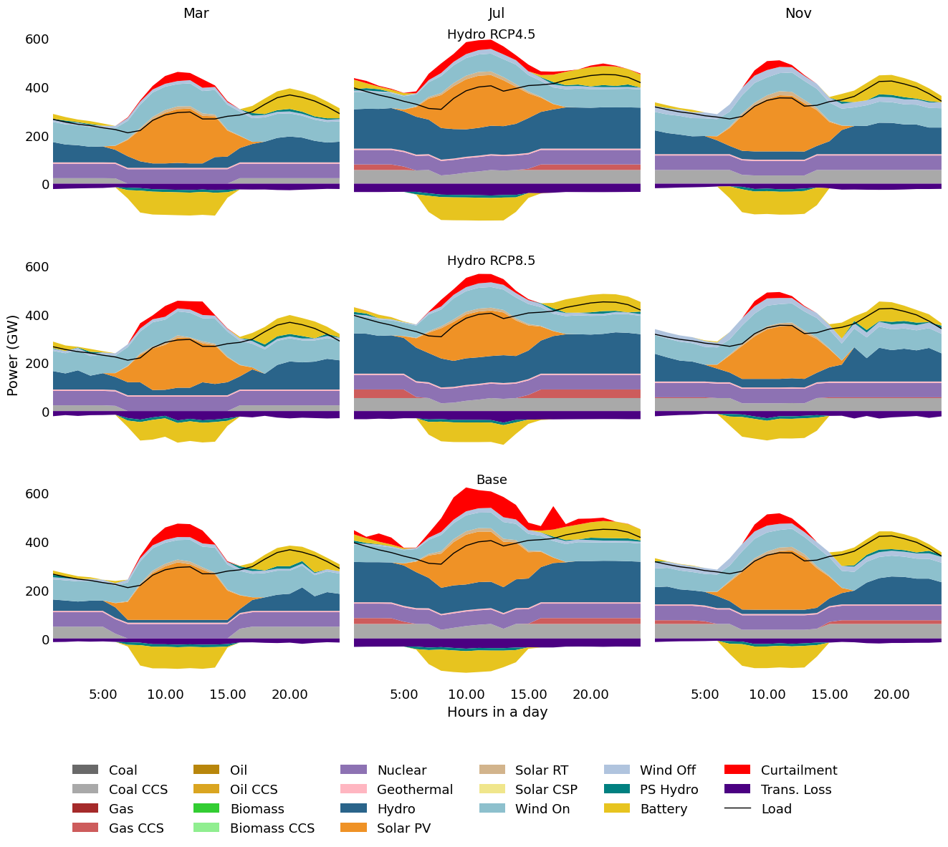
Fig. S33: CSPG’s hourly electricity generation in 2035 for the two sensitivity scenarios with climate-impacted hydropower availability compared to the Base scenario.

Supplementary tables
Table S1: List of generation technologies and their capital and O&M costs (for 2020), and lifetime assumptions used in GCAM-China and GridPath-CSPG. The trajectories of the capital and O&M costs out to 2100 are shown in Figs. S25 and S26. The data is adopted from ref.².
Technologies |  | Costs for 2020 (in 2020USD)
GCAM-China | GridPath-CSPG | Capital costs (USD/KW) | Fixed O&M costs (USD/MWh) | Var O&M costs (USD/MWh) | Lifetime (yrs)
biomass (conv) | Biomass_Conv | 3979 | 118 | 6 | 60
biomass (IGCC) | Biomass_IGCC | 5858 | 167 | 8 | 60
biomass (conv CCS) | Biomass_CCS | 7493 | 142 | 8 | 60
biomass (IGCC CCS) | Biomass_IGCC_CCS | 8535 | 201 | 10 | 60
coal (conv pul) | Coal_Conv | 3815 | 35 | 5 | 60
coal (IGCC) | Coal_IGCC | 4018 | 57 | 8 | 60
coal (conv pul CCS) | Coal_CCS | 5843 | 84 | 10 | 60
coal (IGCC CCS) | Coal_IGCC_CCS | 6511 | 111 | 12 | 60
gas (steam/CT) | Gas_CT | 913 | 13 | 8 | 45
gas (CC) | Gas_CC | 1001 | 11 | 3 | 45
gas (CC CCS) | Gas_CCS | 2204 | 35 | 8 | 45
refined liquids (steam/CT) | Oil_CT | 913 | 13 | 8 | 45
refined liquids (CC) | Oil_CC | 1001 | 11 | 3 | 45
refined liquids (CC CCS) | Oil_CCS | 2608 | 42 | 9 | 45
Nuclear | Nuclear | 6397 | 106 | 2 | 60
geothermal | Geothermal | 4778 | 143 | 0 | 30
hydro | Hydro | 2500 | 17 | 0 | 100
 | PS Hydro | 2500 | 19 | 0 | 100
wind (onshore) | Wind_On | 1550 | 49 | 0 | 30
wind (offshore) | Wind_Off | 3632 | 127 | 0 | 25
solar (PV) | Solar_PV | 1825 | 15 | 0 | 30
solar (csp) | Solar_CSP | 4086 | 50 | 4 | 30
solar (rooftop) | Solar_RT | 2914 | 21 | 0 | 30
Battery | Battery | 1898 | 47 | 0 | 30
PV_storage | As battery
CSP_storage | As battery
wind_storage | As battery

Table S2: Number of candidate sites and potential capacities (with data sources) of hydro, wind, solar, and geothermal technologies used in GridPath-CSPG.
Technology | Projects | Capacity (GW) | Spatial resolution | Source
Geothermal | 5 | 5.5 | lumped by provinces | Shi et al.⁸ and Luo et al.⁹
Hydro | 22 | 50.1 | site level | Jin et al.^{1,10} and ref. therein
PS Hydro | 44 | 53.7 | site level | As Hydro
Solar PV | 451 | 411 | site level | RE-Zoning¹¹ and GEM data¹²
Solar RT | 451 | 411 | site level | As Solar PV
Solar CSP | 451 | 411 | site level | As Solar PV
Wind Off | 3 | 32.7 | site level | As Solar PV
Wind On | 364 | 151 | site level | As Solar PV

Table S3: Operational techno-economic parameters of thermal generation technologies in GridPath-CSPG. The data is adopted from ref.^{1,10}.
Technologies | Operation type | Min stable fraction | Heat rate (MMBtu/MWh) | Start-up cost (USD/MW) | Ramping rate | Min up time (hrs) | Min down time (hrs)
Biomass_Conv | commit-dispatch | 0.7 | 13.50 | 88 | 3% | 8 | 8
Biomass_IGCC | commit-dispatch | 0.7 | 13.55 | 88 | 3% | 8 | 8
Biomass_CCS | commit-dispatch | 0.7 | 13.55 | 88 | 3% | 8 | 8
Biomass_IGCC_CCS | commit-dispatch | 0.7 | 13.60 | 88 | 3% | 8 | 8
Coal_Conv | commit-dispatch | 0.6 | 8.49 | 147 | 1% | 8 | 10
Coal_IGCC | commit-dispatch | 0.6 | 9.20 | 119 | 2% | 12 | 12
Coal_CCS | commit-dispatch | 0.6 | 8.49 | 147 | 1% | 8 | 10
Coal_IGCC_CCS | commit-dispatch | 0.6 | 9.30 | 119 | 2% | 12 | 12
Gas_CT | commit-dispatch | 0.3 | 9.72 | 88 | 8% | 4 | 8
Gas_CC | commit-dispatch | 0.3 | 9.63 | 88 | 7% | 4 | 10
Gas_CCS | commit-dispatch | 0.3 | 9.72 | 88 | 7% | 4 | 10
Oil_CT | commit-dispatch | 0.7 | 11.48 | 69 | 10% | 0 | 0
Oil_CC | commit-dispatch | 0.7 | 11.48 | 69 | 10% | 0 | 0
Oil_CCS | commit-dispatch | 0.7 | 11.48 | 69 | 10% | 0 | 0
Nuclear | must run | 0.8
Geothermal | must run | 0.9

Table S4: Operational techno-economic parameters of power storage technologies used in GridPath-CSPG. The data is adopted from ref.¹.
Technologies | Operation type | Dis/Charging efficiency | Min op. duration (hrs) | Max op. duration (hrs)
Battery | storage | 0.92 | 2 | 12
PS Hydro | storage | 0.88 | 2 | 24

Table S5: CO₂ emission factors by fuel type, used in GridPath-CSPG. The emission factors for other generation technologies, including fossil-fired and biomass power plants with CCS, are assumed as zero. The data is based on ref.¹³, adopted from ref.¹.
Fuel | CO₂ intensity (tons/MMBtu)
Coal (without CCS) | 0.106
Gas (without CCS) | 0.058
Oil (without CCS) | 0.058
Biomass (without CCS) | 0.029

Table S6: Sensitivity scenarios in GridPath-CSPG, with default conditions shown in italic font.
Scenario names | Expansion of conventional coal plants | Operational parameters of coal plants | CCS retrofit to existing coal plants | Expansion of renewable technologies | Expansion of CCS technologies | Future capital and O&M costs of generation technologies | Climate conditions of hydropower availability | Planning reserve margin (PRM)
DispCoal (Unconstrained New Coal) | Unconstrained | Similar gas-fired plants with combustion turbines (see Table S7) | Not considered | No RPS strategy | Unconstrained | As in GCAM-China | Historical | 15% of annual peak demand
DispCoal (Typical HRate & StCost) | The planned coal-fired (without CCS) capacity in the GEM data is assumed to be installed by 2035 | Similar to gas-fired plants with combustion turbines, except that typical values of heat rate and start-up costs are used | As default | As default | As default | As default | As default | As default
Base (Retro CCS to Exist Coal) | As default | Typical parameters as in Table S3 | Existing coal plants are assumed to be retrofitted with CCS from 2035 | As default | As default | As default | As default | As default
DispCoal (Retro CCS to Exist Coal) | As ‘DispCoal’ | Typical parameters as in Table S3 | Ás above | As default | As default | As default | As default | As default
RPS Rooftop | As default | As default | As default | Generation floor for Rooftop Solar is set above the GCAM-China level | As default | As default | As default | As default
ATB-2023 | As default | As default | As default | As default | As default | As per ATB-2023’s projection | As default | As default
ATB-2019 Low | As default | As default | As default | As default | As default | As per ATB-2019’s ‘low’ projection | As default | As default
ATB-2019 High | As default | As default | As default | As default | As default | As per ATB-2019’s ‘high’ projection | As default | As default
Hydro RCP4.5 | As default | As default | As default | As default | As default | As default | RCP 4.5 | As default
Hydro RCP8.5 | As default | As default | As default | As default | As default | As default | RCP 8.5 | As default
NoPRM | As default | As default | As default | As default | As default | As default | As default | No PRM constraints

Table S7: Operational techno-economic parameters of conventional coal power plants used in different variations of the ‘DispCoal’ scenario, compared to the typical values used in the rest of the scenarios.
Operational parameters | Typical values | In the 'DispCoal' and 'DispCoal (Unconstrained New Coal)' scenarios | In the 'DispCoal (Typical HRate & StCost)' scenario
Ramping rate | 1% | 8% | 8%
Min up time (hrs) | 8 | 4 | 4
Min down time (hrs) | 10 | 8 | 8
Min stable fraction | 0.6 | 0.3 | 0.3
Heat rate (MMBtu/MWh) | 8.49 | 9.72 | 8.49
Start-up cost (USD/MW) | 147 | 88 | 147

Table S8: Global and Asia’s average capacity factors (CFs) of key generation technologies (assumed the same for sub-technologies), as presented in Bolson et al.¹⁴, based on which the minimum expected CFs are determined in this study.
Technologies | Global average over 2000-2015 | Asia’s average over 2000-2015 | Minimum expected CF
Battery | - | - | 0.20
Biomass | 0.55 | 0.37 | 0.37
Coal | 0.60 | 0.56 | 0.56
Gas | 0.46 | 0.38 | 0.38
Oil | 0.28 | 0.28 | 0.28
Nuclear | 0.81 | 0.76 | 0.80
Geothermal | 0.74 | 0.65 | 0.65
Hydropower | 0.43 | 0.37 | 0.35
Solar | 0.12 | 0.12 | 0.10
Wind | 0.22 | 0.23 | 0.20

References
1. Jin, X., Chowdhury, A. K., Cheng, C. & Galelli, S. CSPG GridPath Model Input and Output Data. Zenodo (2023).
2. Center for Global Sustainability at University of Maryland, Department of Earth System Science at Tsinghua University, & College of Environmental Sciences and Engineering at Peking University. GCAM-China. Zenodo https://doi.org/10.5281/zenodo.10819115 (2024).
3. Brinkerink, M. et al. Assessing global climate change mitigation scenarios from a power system perspective using a novel multi-model framework. Environ. Model. Softw. 150, 105336 (2022).
4. Gong, C. C. et al. Bidirectional coupling of the long-term integrated assessment model REgional Model of INvestments and Development (REMIND) v3.0.0 with the hourly power sector model Dispatch and Investment Evaluation Tool with Endogenous Renewables (DIETER) v1.0.2. Geosci. Model Dev. 16, 4977–5033 (2023).
5. National Renewable Energy Laboratory (NREL). Simple Levelized Cost of Energy (LCOE) Calculator Documentation. https://www.nrel.gov/analysis/tech-lcoe-documentation (2025).
6. Mirletz, B. et al. 2023 Annual Technology Baseline (ATB) Cost and Performance Data for Electricity Generation Technologies. 10 files DOE Open Energy Data Initiative (OEDI); National Renewable Energy Laboratory (NREL) https://doi.org/10.25984/1987306 (2023).
7. National Renewable Energy Laboratory (NREL). Annual Technology Baseline (ATB) Data 2019. (2019).
8. Shi, H. et al. Predicting the Potential of China’s Geothermal Energy in Industrial Development and Carbon Emission Reduction. Sustainability 15, 7508 (2023).
9. Luo, Z. & Lu, X. Characteristics and prospect of geothermal industry in China under the “dual carbon” target. Energy Geosci. 4, 100199 (2023).
10. Jin, X., Chowdhury, A. F. M. K., Liu, B., Cheng, C. & Galelli, S. China Southern Power Grid’s decarbonization likely to impact cropland and transboundary rivers. Commun. Earth Environ. 5, 192 (2024).
11. Energy Sector Management Assistance Program (ESMAP). REZoning: The Renewable Energy Zoning Tool. (2022).
12. Global Energy Monitor (GEM). GEM’s Trackers Data. (2024).
13. Energy Information Administration (EIA). How much carbon is produced when different fuels are burned? (2019).
14. Bolson, N., Prieto, P. & Patzek, T. Capacity factors for electrical power generation from renewable and nonrenewable sources. Proc. Natl. Acad. Sci. 119, e2205429119 (2022).

