Supplemental Figures

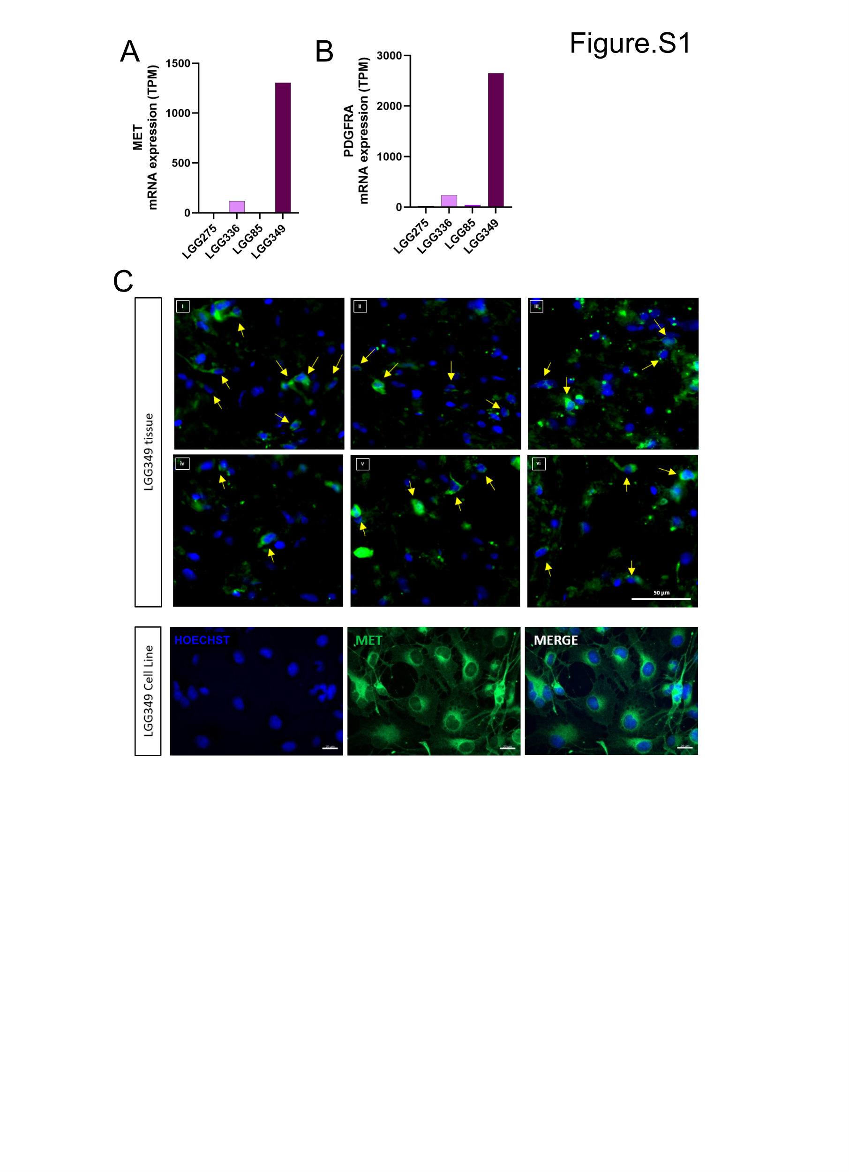
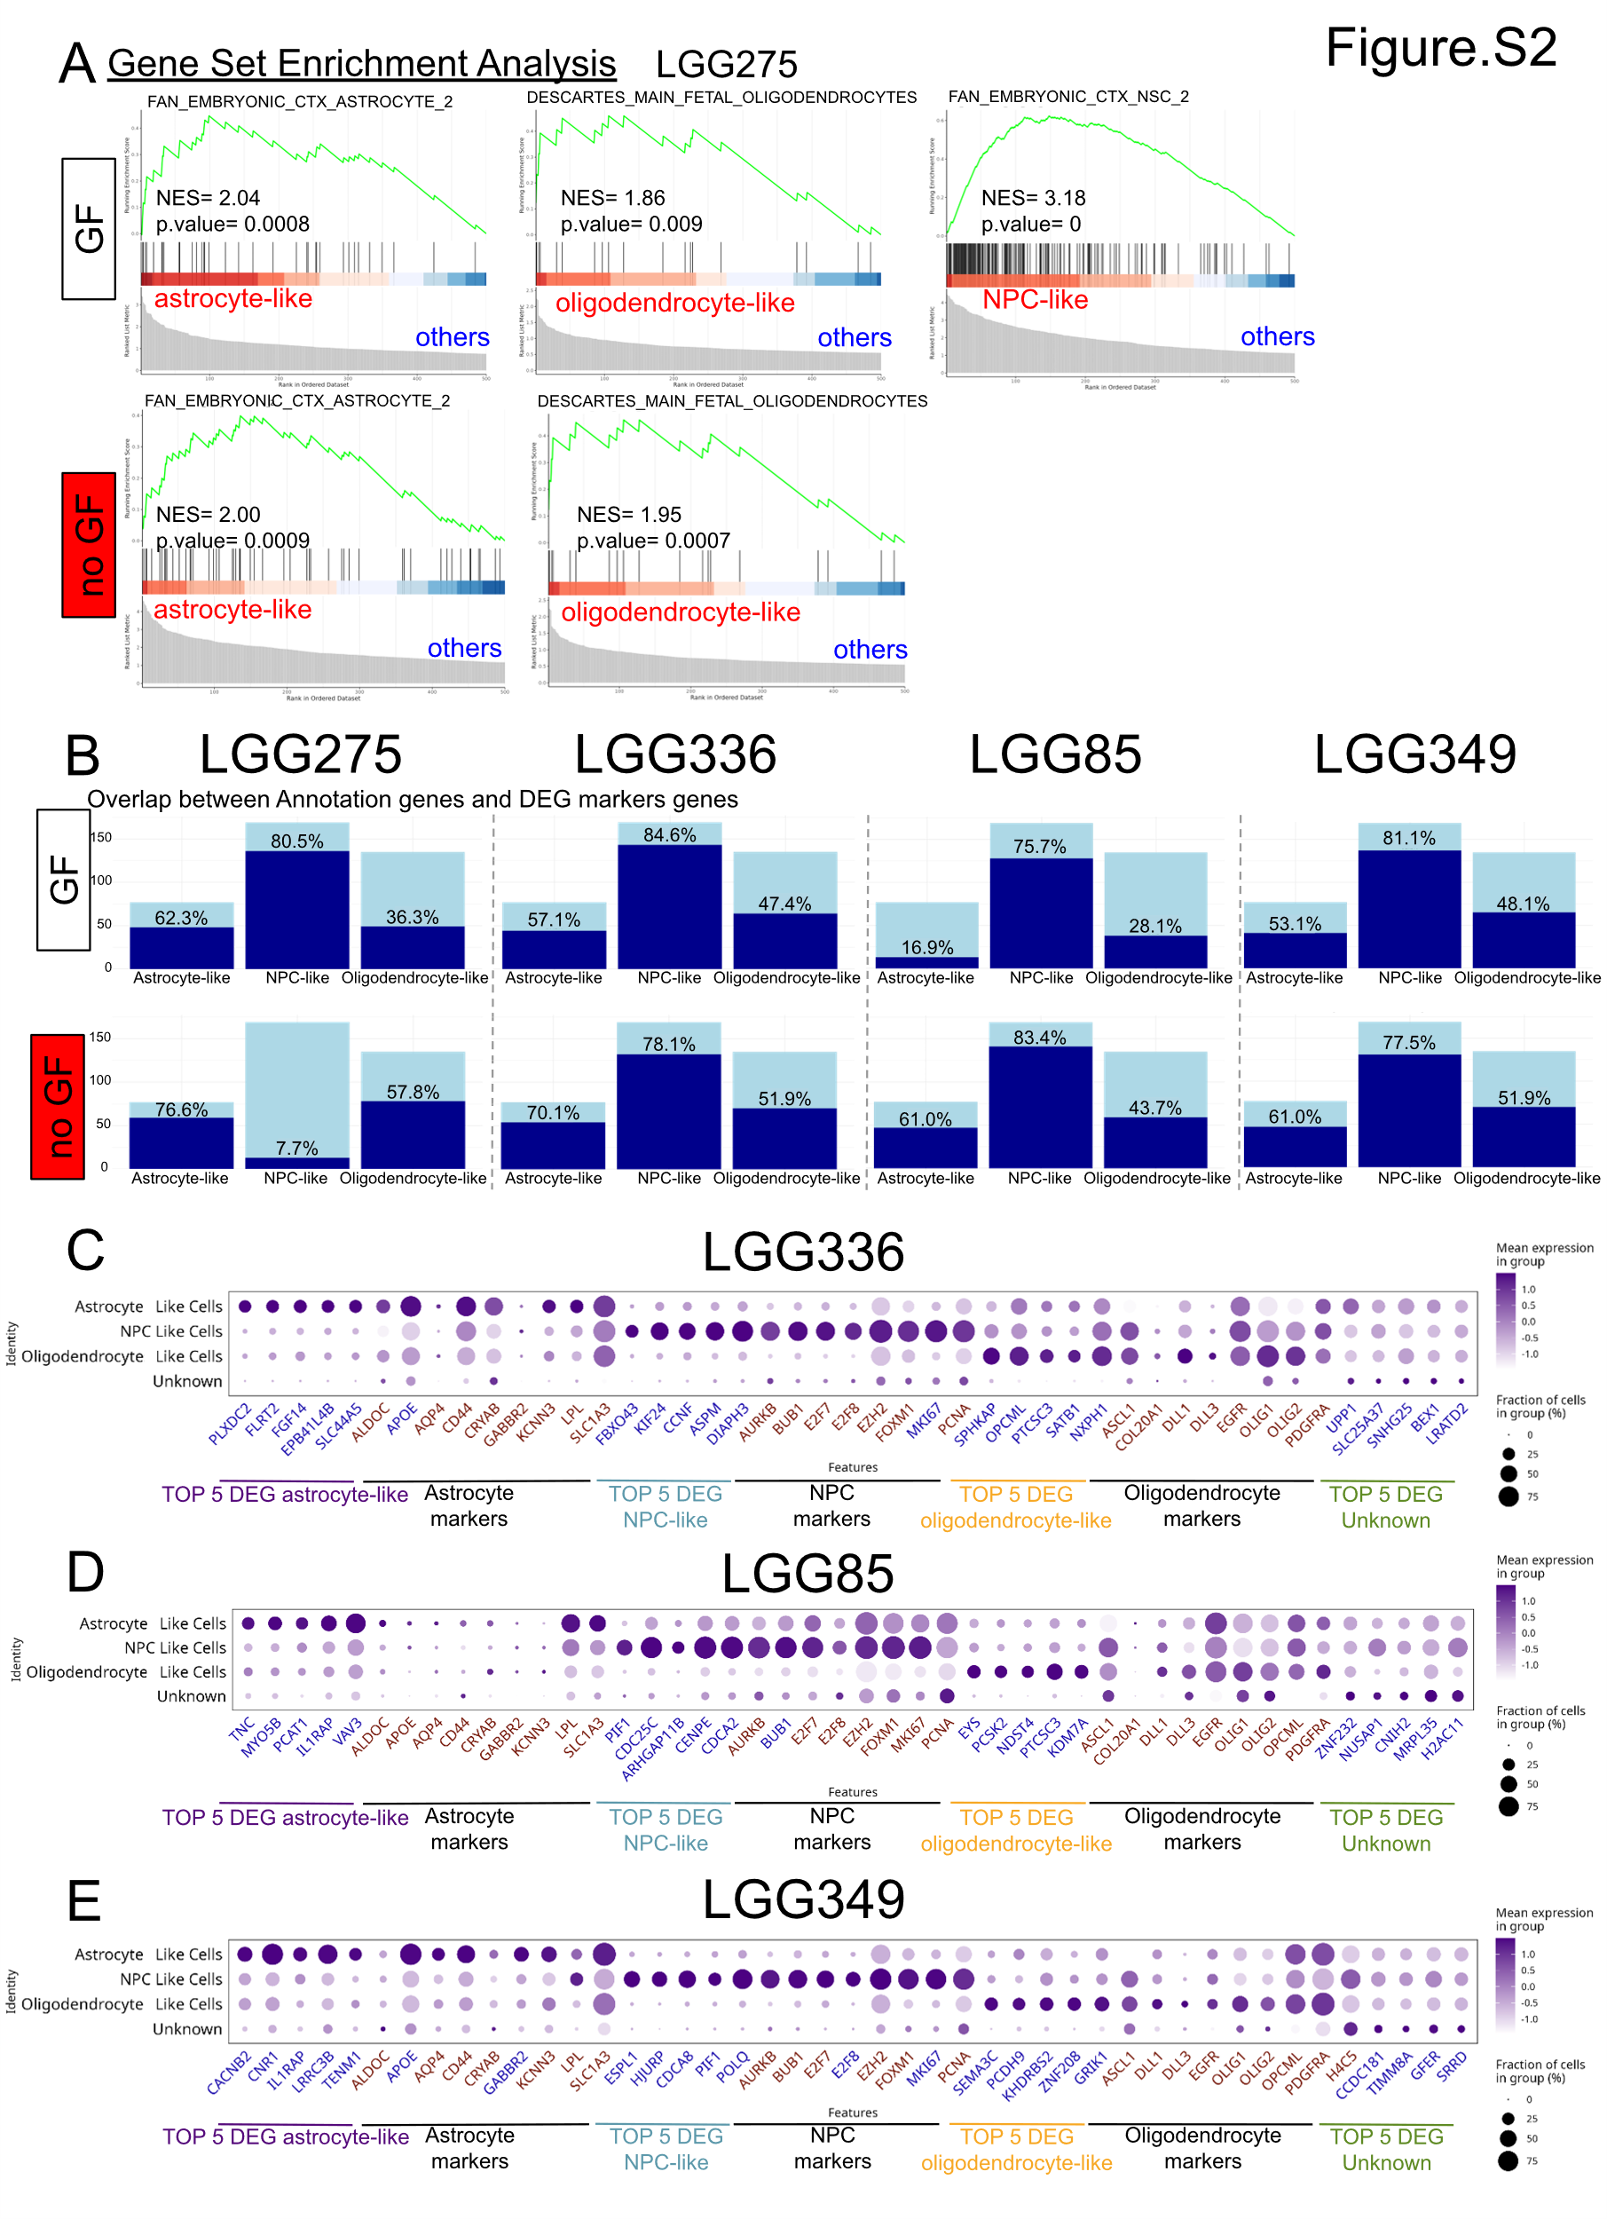
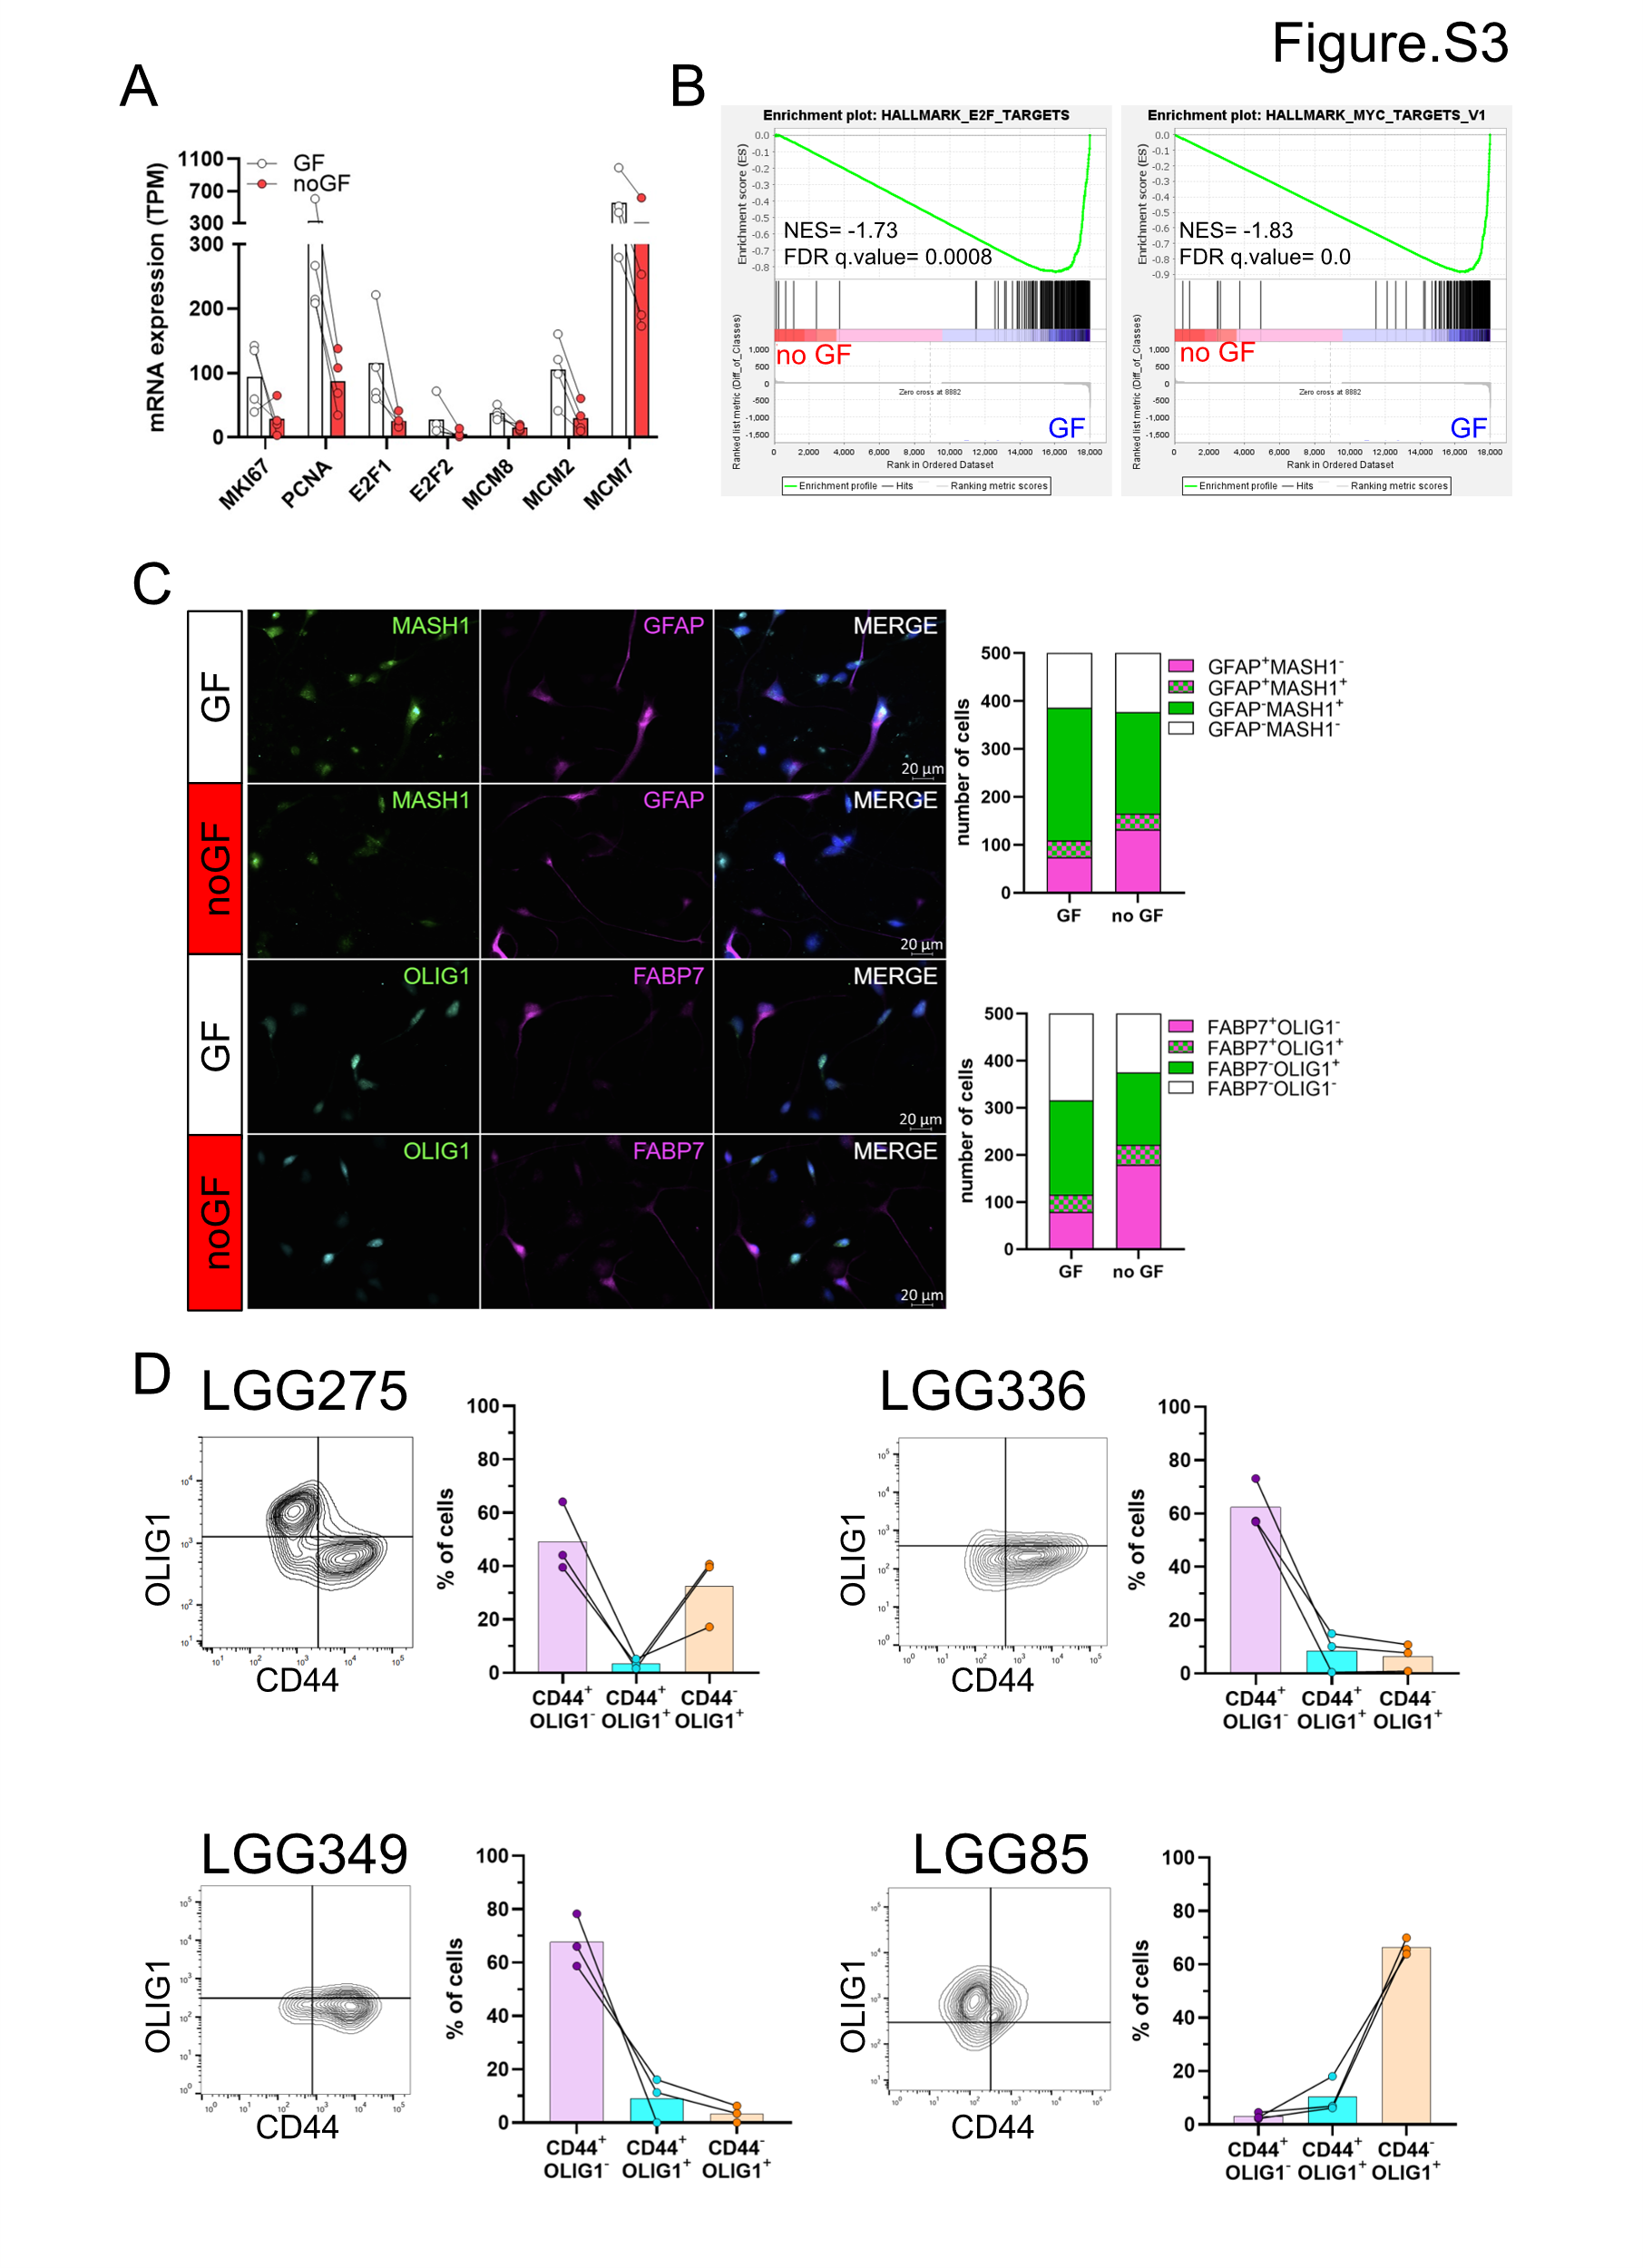
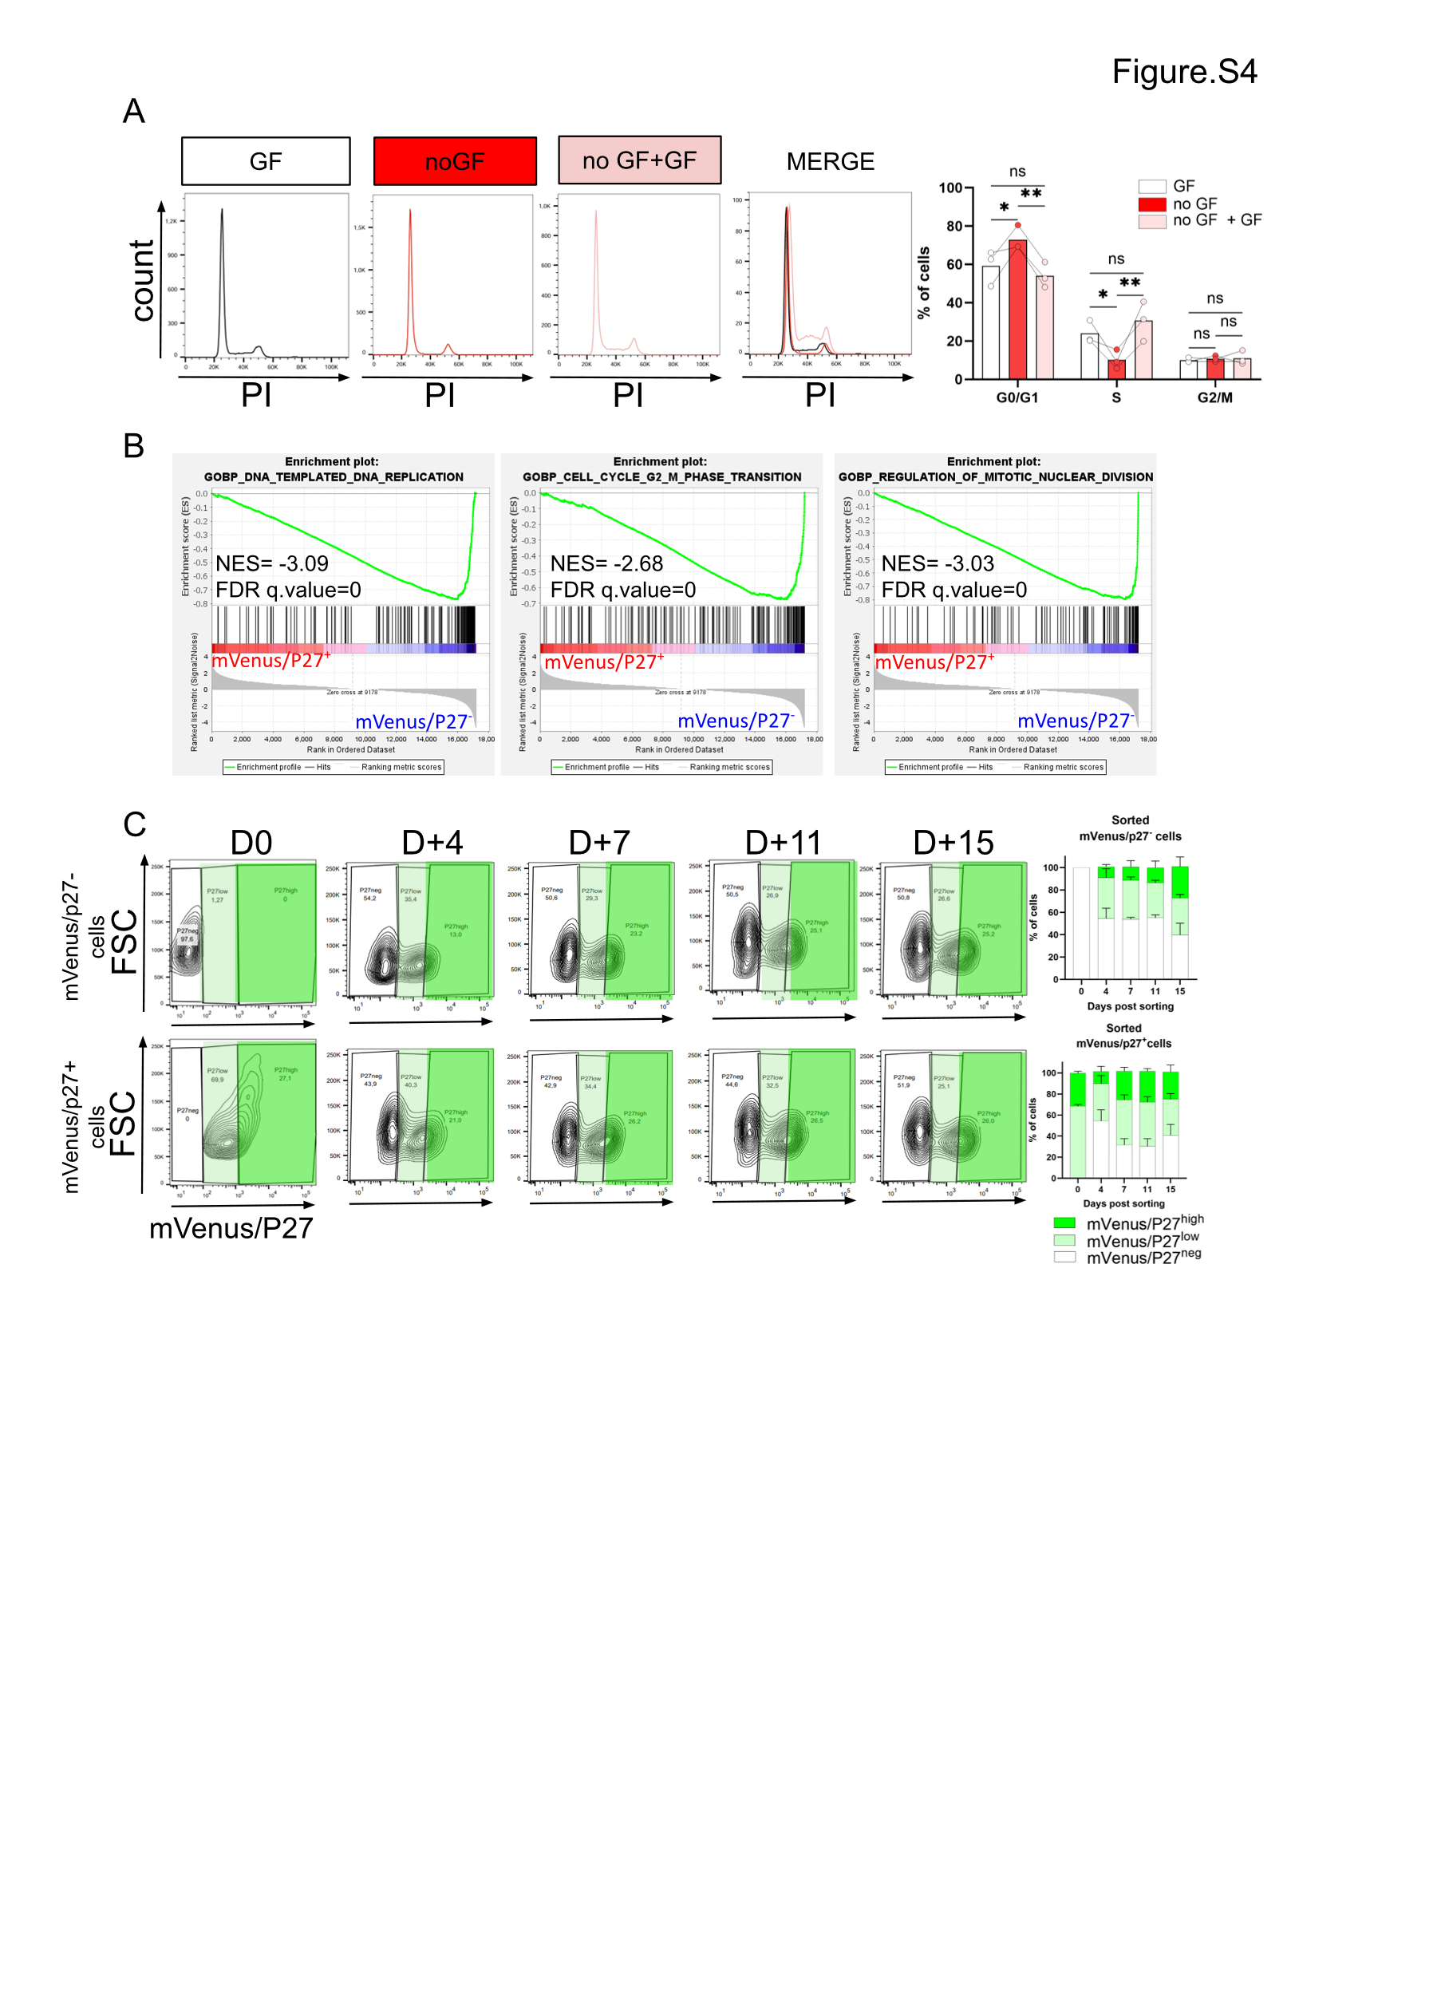
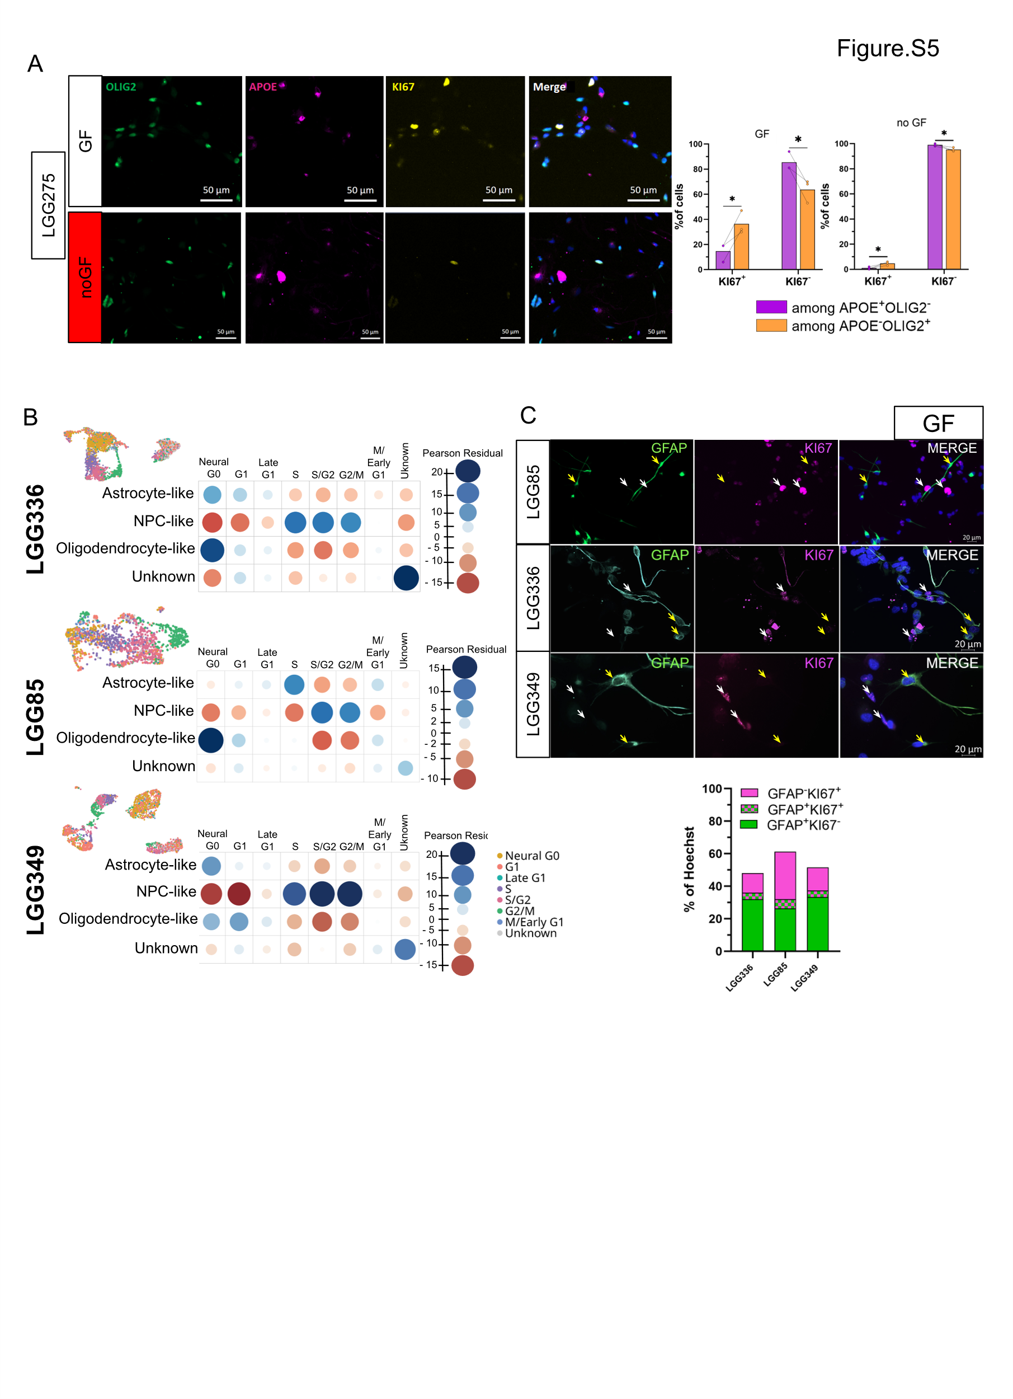
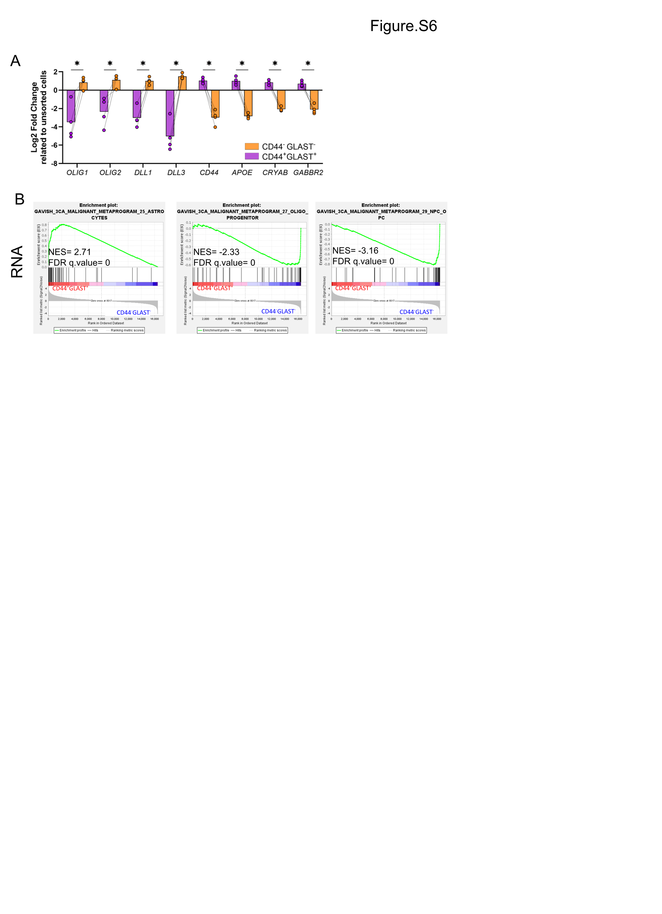
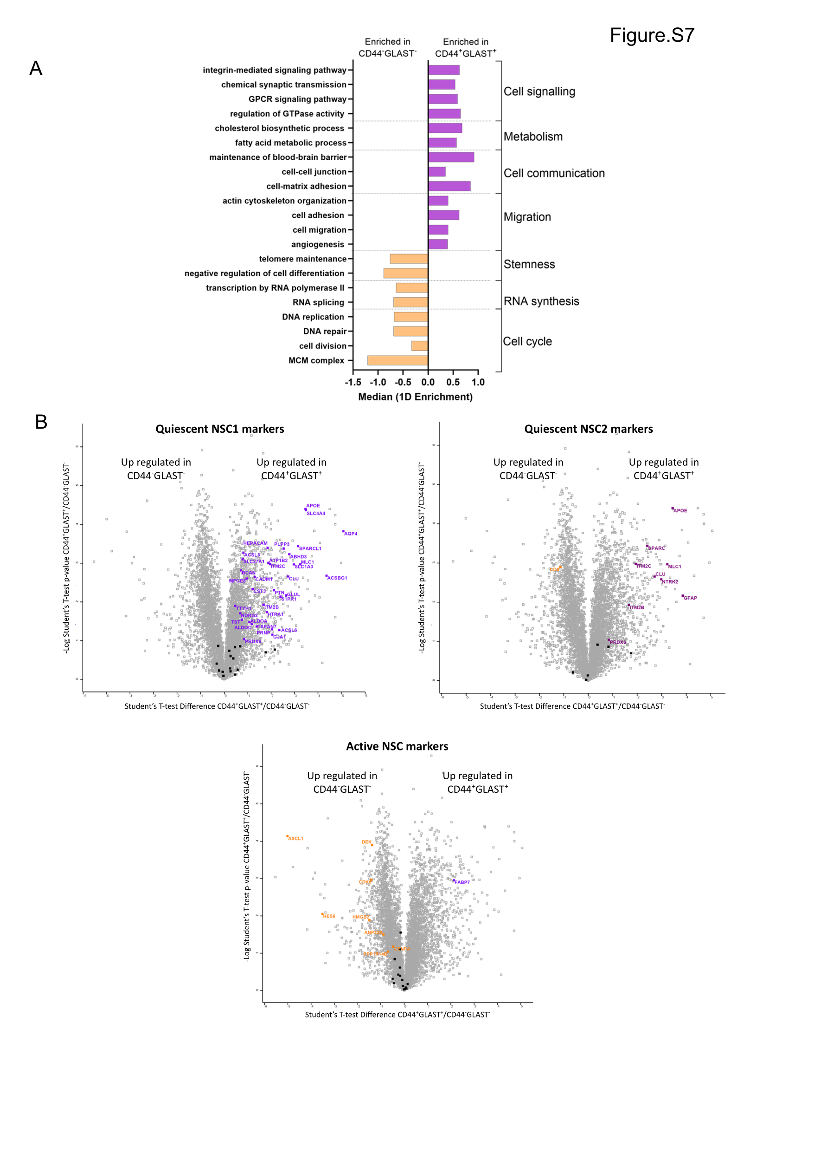
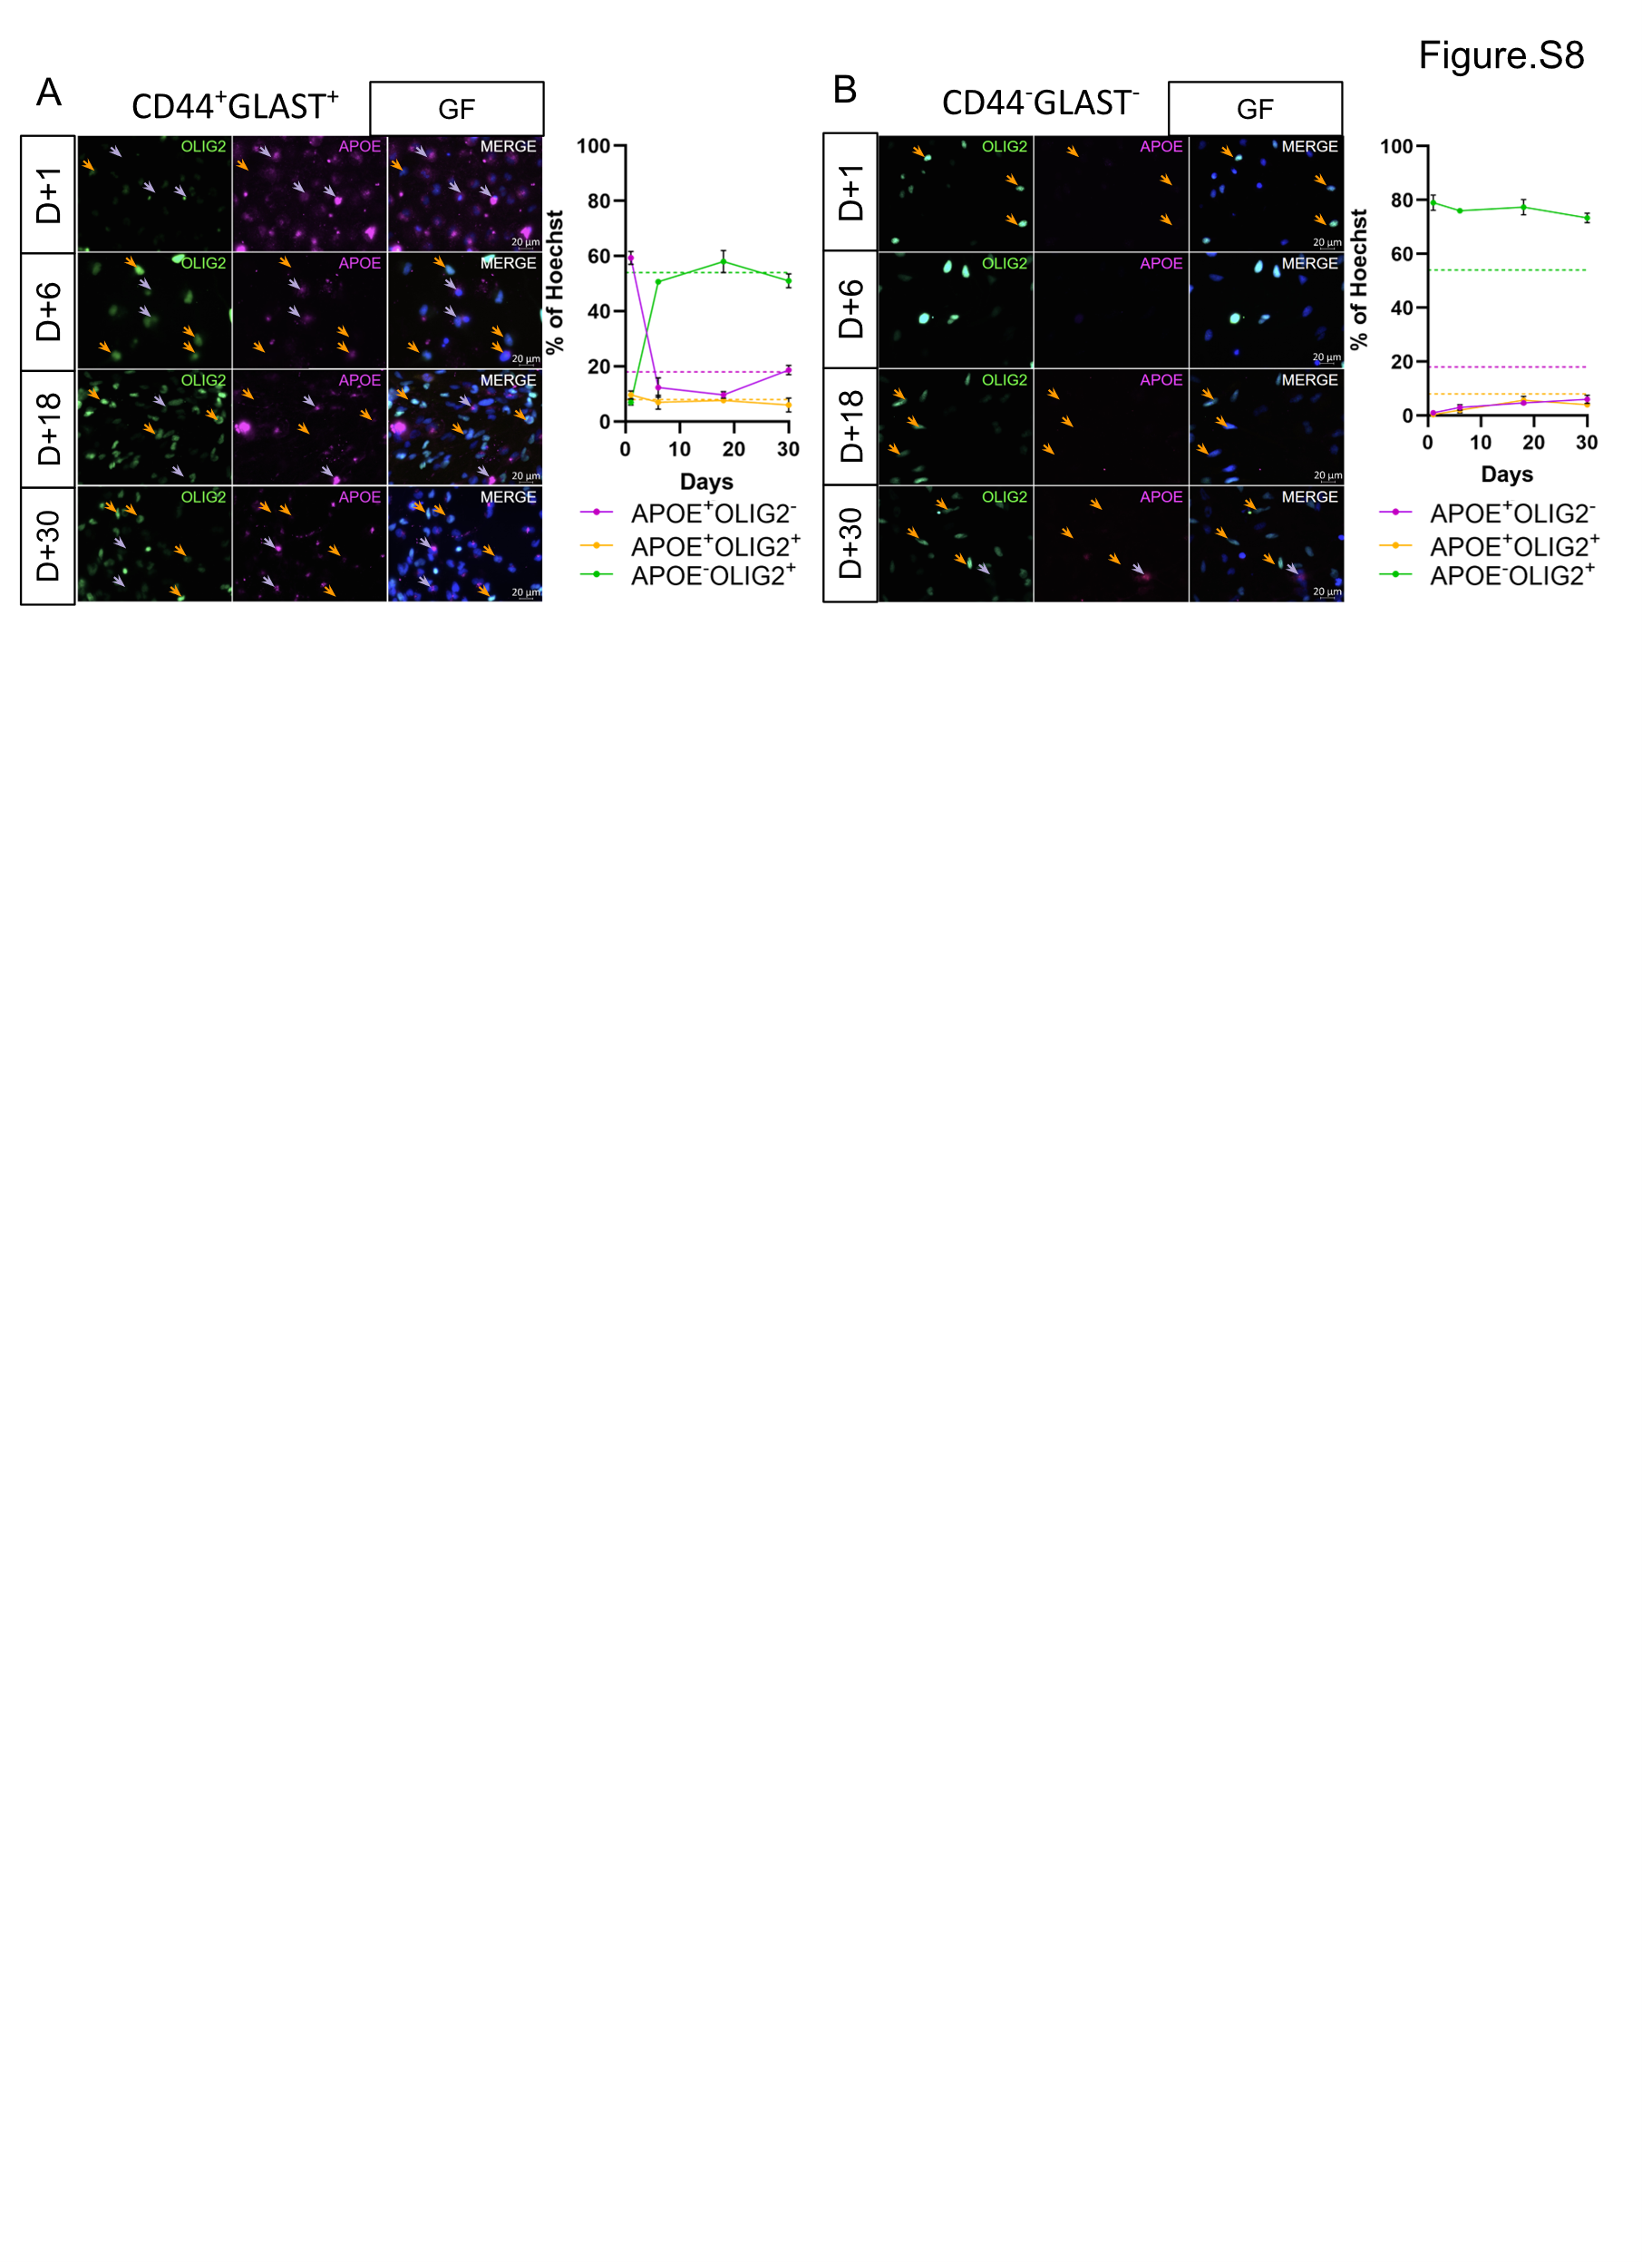
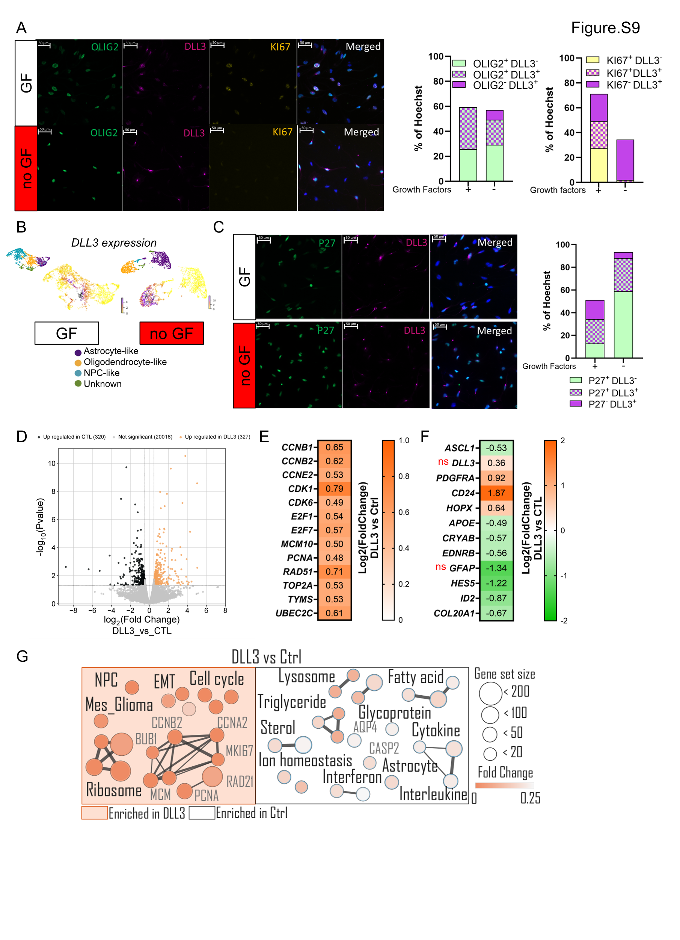
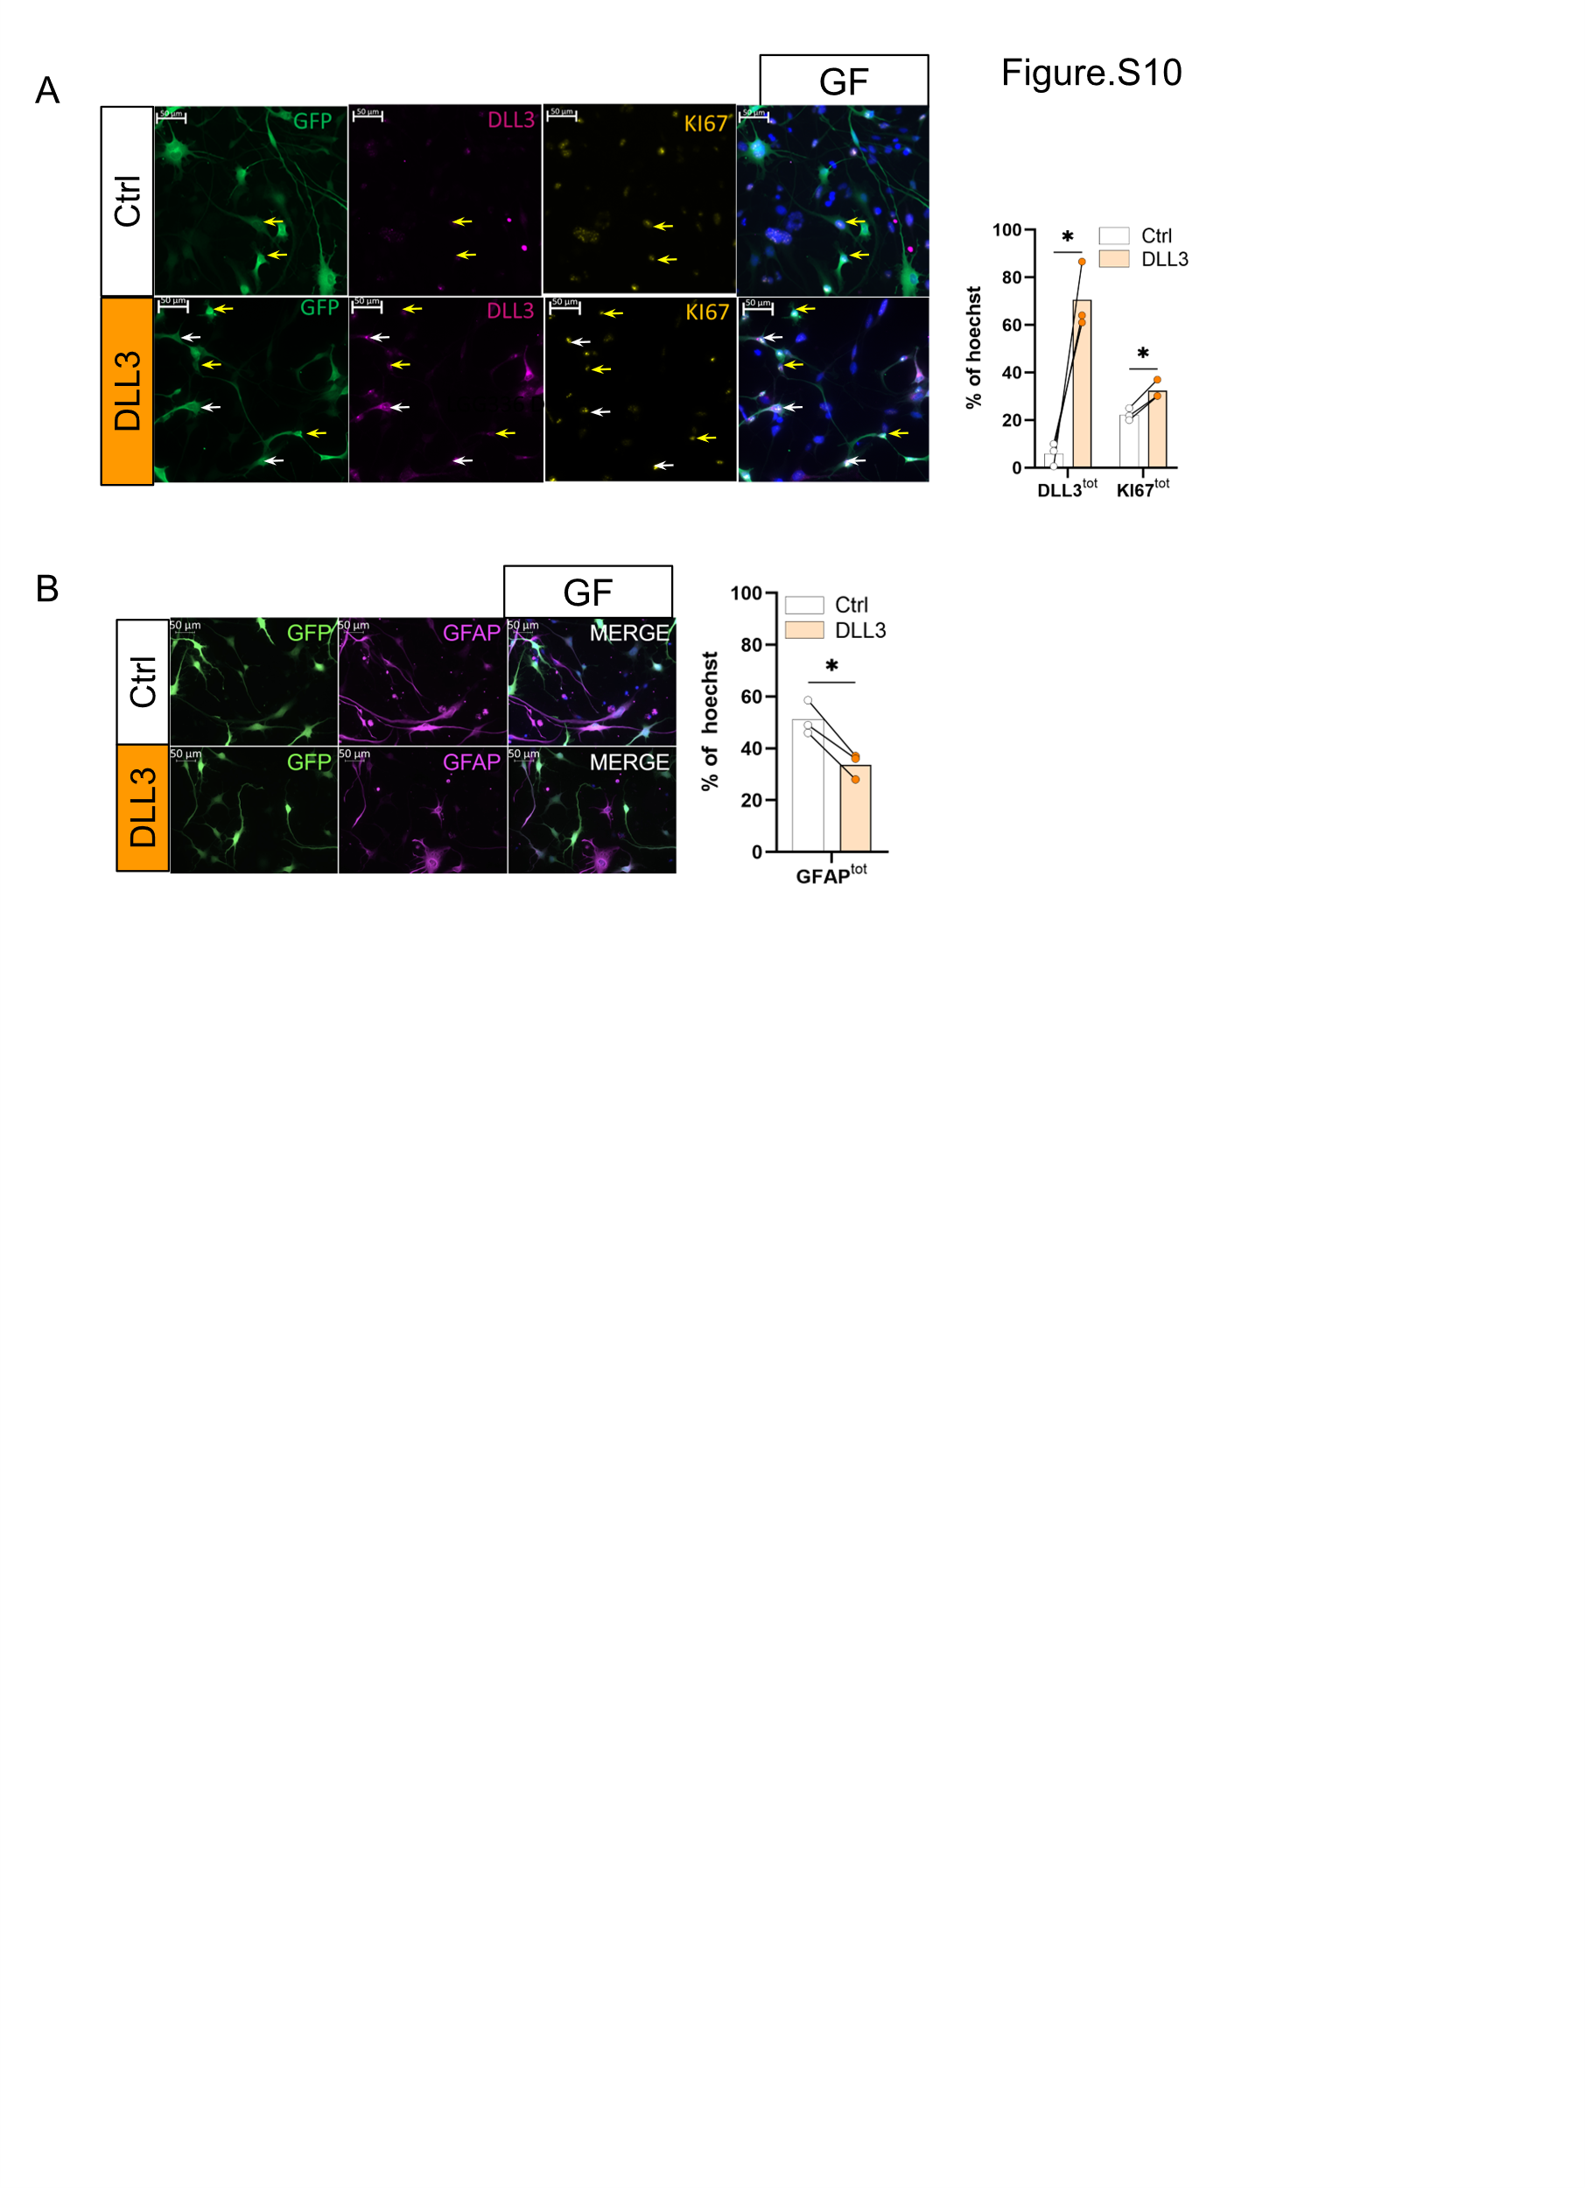
Figure S1: Altereted gene expression in the 4 astrocytoma cell lines
(A) MET and (B) de PDGFRA mRNA expression (TPM = Transcript Per Million) in LGG275, 336, 85 and 349 (n=1) (C) IF analysis of MET expression in 349 tumor resection and LGG349 cell line, scale bar = 50µm for tissue, 20µm for cell line.

Figure S2: scRNA sequencing and RNA sequencing analysis of 4 astrocytoma cell lines (A) GSEA analysis showing enrichment of astrocyte, oligodendrocyte and NPC signatures in astrocyte-like, oligodendrocyte-like and NPC-like subpopulation, respectively, in LGG275 cell lines, with or without (growth factors. P.value was calculated using Benjamini-Hochberg methods. NES = Normalized Enrichment Score, FDR = False Discovery Rate (B) Stacked bar plots showing, for each glioma cell line (LGG275, 336, 85, 349), the proportion of reference signature genes (light blue; astrocyte-like, NPC-like, and oligodendrocyte-like gene sets) that are recovered among significant differentially expressed marker genes (dark blue). The y-axis indicates the number of genes in each list (total reference set in light blue, with the overlapping significant DEGs highlighted in dark blue). Reference signature gene lists were curated in-house as described in the Materials and Methods. Percentages indicate the fraction of each reference gene set overlapping with the significant DEG. (C) Dot Plot of astrocyte, oligodendrocyte and proliferative markers expression in each subpopulation of LGG336 (E) LGG85 and (F) LGG349 with growth factors.

Figure S3: Growth factor withdrawal differentially reduces proliferation across astrocytoma cell lines and identification of distinct cellular states
(A) mRNA expression (TPM) of proliferation-associated genes in four astrocytoma cell lines cultured with growth factors (GF) or without growth factors (noGF). Bars show the mean across cell lines; dots represent individual cell lines (LGG275, LGG336, LGG349, LGG85; n = 4). Lines connect matched GF and noGF values for each cell line (B) Gene set enrichment analysis (GSEA) of RNA-seq data from four astrocytoma cell lines cultured with growth factors (GF) versus without growth factors (noGF) shows reduced enrichment of proliferation-associated programs upon GF withdrawal (HALLMARK_E2F_TARGETS and HALLMARK_MYC_TARGETS_V1). NES, normalized enrichment score; FDR, false discovery rate (C) IF analysis of astrocytic markers (GFAP, FABP7) and oligodendrocyte/NPC-associated markers (MASH1, OLIG1) in the LGG275 cell line cultured with (GF) or without growth factors (noGF). Representative images (scale bar, 20 µm) and quantification of marker-defined subpopulations are shown (right). Cell counts were performed on 500 cells per condition (n = 1). (D) Flow cytometry analysis of CD44 and OLIG1 expression in the four astrocytoma cell lines cultured without growth factors (noGF), identifying astrocyte-like (CD44⁺OLIG1⁻; purple) and oligodendrocyte/NPC-like (CD44⁻OLIG1⁺; orange) populations (representative density plots shown). Barplot shows quantification as % of cells (Bars = mean, dots = n = 3).

Figure S4: Identification of a subpopulation of quiescent cells within LGG275 cell line
(A) Cell cycle analysis by flow cytometry using propidium iodide in LGG275 cell line after 20 days with (GF) or without (no GF) GF or 10 days without GF following by 10 days with GF (no GF + GF). Right Panel: Barplot shows quantification as % of cells (bars = mean, dots = n = 3) (ns = non-significant, * p<0, 05, **<0,01, multiple comparison Turkey test) (B) GSEA analysis of RNA sequencing comparing mVenus/P27⁺ cells versus mVenus/P27⁻ cells shows a enrichment of cell cycle gene signatures in mVenus/P27⁻ cells in LGG275 line. q.value was calculated using Benjamini-Hochberg method. NES = Normalized Enrichment Score, FDR = False Discovery Rate. (C) Flow-cytometry analysis of mVenus–P27 fusion protein expression at 0, 4, 7, 11, and 15 days in sorted mVenus/P27⁻ and mVenus/P27⁺ populations. Representative density plots (FSC vs mVenus/P27) are shown. Right, quantification of mVenus/P27-negative, -low, and -high fractions as % of total cells. (bars = mean ± S.E.M, n=3).

Figure S5: Link between cellular state and quiescence in astrocytoma cell lines
(A) IF analysis of APOE, OLIG2 and KI67 expression in LGG275 line, identifying KI67 preferential expression in oligodendrocyte/NPC-like (APOE⁻OLIG2⁺) rather than in astrocyte-like cells (APOE⁺OLIG2⁻) with and without GF, scale bar = 50µm. Right panels: Barplot shows quantification as % of Hœchst⁺ cells (bars = mean, dots = n = 3) (* p<0, 05, multiple comparison Turkey test) (B) left corner: UMAP colored by ccAFv2 cell-cycle state classifier, including Neural G0. Right, dot plot showing the association between phenotypic states (astrocyte-like, NPC-like, oligodendrocyte-like, unknown) and ccAFv2 cell-cycle classes (Pearson residual) in LGG336, LGG85 and LGG349 lines. Significance was assessed by a χ² test (p < 0.01) (C) IF staining of GFAP and KI67 in LGG85, LGG336, and LGG349 cells cultured with growth factors (GF), illustrating largely non-overlapping astrocyte-like (GFAP⁺; yellow arrows) and mitotic (KI67⁺; white arrows) populations. Representative images are shown; scale bar, 20 µm. Bottom: quantification of GFAP⁺KI67⁻, GFAP⁻KI67⁺, and GFAP⁻KI67⁻ fractions expressed as % of Hoechst⁺ nuclei (n=1, count = 500 cells).

Figure S6: CD44/GLAST-based cell sorting enables efficient isolation of astrocyte-like and oligodendrocyte-like states
(A) Log2(FoldChange) of astrocyte and oligodendrocyte gene markers expression in CD44⁺GLAST⁺ (purple) and CD44⁻GLAST⁻ (orange) populations. Unsorted cells were used as control to calculate the Log2(FoldChange) (bars = mean, dots = n = 3) (* p<0,05, multiple Student test) (B) GSEA analysis of RNA sequencing comparing CD44⁺GLAST⁺ versus CD44⁻GLAST⁻ populations shows enrichment of astrocyte signatures in CD44⁺GLAST⁺ cells, and OPC and NPC metaprogram signatures in CD44⁻GLAST⁻ cells (n=3). NES = Normalized Enrichment Score, FDR = False Discovery Rate. P.value has been calculated using the Benjamini-Hochberg method.

Figure S7: Proteomic analysis of of astrocyte-like and oligodendrocyte-like states
(A) 1D enrichment and fisher analyses in CD44⁺GLAST⁺ versus CD44⁻GLAST⁻ cells (n=3). Bars represent the median enrichment. All signaling pathways are significant a p.value <0,01 as determined by a Fisher’s exact test (B) Volcano plots showing proteins differentially expressed between CD44⁺GLAST⁺ and CD44⁻GLAST⁻ cells, focusing on markers associated with quiescent NSC1/NSC2 and active NSC phenotypes. Colored dots indicate significantly differentially expressed proteins (Student’s t-test with permutation-based FDR correction; FDR = 0.05, s₀ = 0.1), with purple indicating proteins enriched in CD44⁺GLAST⁺ cells and orange indicating proteins enriched in CD44⁻GLAST⁻ cells. Black dots represent non-significant proteins.

Figure S8: Astrocyte-like cells display plasticity and can transition toward an oligodendrocyte/NPC-like state in the presence of growth factors
(A, B) IF analysis of APOE and OLIG2 expression in (A) FACS-sorted CD44⁺GLAST⁺ and (B) CD44⁻GLAST⁻ LGG275 cells grown with GF. Representative images were acquired at days 1, 6, 18, and 30 post-sorting, identifying astrocyte-like (APOE⁺OLIG2⁻; purple arrows) and oligodendrocyte/NPC-like (APOE⁻OLIG2⁺; orange arrows) cells. scale bar = 20µm. Right panels: quantification of each phenotype as a percentage of Hoechst⁺ nuclei; (dots on curve = mean ± S.E.M, n=3)

Figure S9: DLL3 expression and overexpression in LGG275 cells
(A) IF analysis of OLIG2 (green), DLL3 (magenta), and KI67 (yellow) in LGG275 cells cultured with growth factors (GF) or after GF withdrawal (no GF). Images illustrate DLL3 expression in both oligodendrocyte/NPC-like (OLIG2⁺) and OLIG2⁻ populations, as well as KI67 labelling among DLL3⁺ cells. Scale bar, 50 µm. Right panels: quantification of OLIG2/DLL3 and KI67/DLL3 subpopulations as % of Hœchst ⁺ cells (n=1, count = 500 cells) (B) scVelo embedding of single-cell RNA-seq data from LGG275 cells cultured with growth factors (GF) or after GF withdrawal (no GF), showing DLL3 expression across annotated cell states (astrocyte-like, oligodendrocyte-like, NPC-like, and unknown). DLL3 expression is enriched in, and largely restricted to, the oligodendrocyte-like population (C) IF analysis of P27 and DLL3 expression in LGG275 cells grown with or without GF, showing DLL3⁺ quiescent (P27⁺) or non-quiescent (P27⁻) cells, scale bar = 50µm. Right panel: Barplot shows quantification as % of Hœchst ⁺ cells (n=1, count = 500 cells) (D) Volcano plot of differentially expressed genes comparing DLL3-overexpressing cells versus control (CTL). significantly upregulated genes in DLL3 are highlighted in orange and genes upregulated in CTL in black (n=3) (E) Heatmap showing log2(Fold change) in the expression of selected proliferation-associated genes in DLL3-overexpressing cells relative to control (DLL3 vs Ctrl) (F) Heatmap showing log2(Fold change) in the expression of selected oligodendrocyte-lineage, stemness, and astrocyte markers in DLL3-overexpressing cells relative to control (DLL3 vs Ctrl). All genes shown are significantly differentially expressed (P < 0.05), except those labeled “ns” (not significant) (G) Cytoscape visualization of enrichment signaling pathways between DLL3 overexpression vs Ctrl. P.value<0.05 and FDR q.value < 0.25 as determinate by the Benjamini-Hochberg method (n=3), with node size proportional to gene set size and node color intensity reflecting the magnitude of enrichment. Edges indicate gene overlap between gene sets (n = 3).

Figure S10: DLL3 overexpression leads a decrease of “astrocyte-like” GFAP⁺ in LGG336 cell lines
(A) IF analysis of DLL3 (magenta) and KI67 (yellow) in the LGG336 cell line transduced with a GFP–DLL3 lentiviral vector and cultured with growth factors (GF). Representative images show DLL3⁺ cells (white arrows) and mitotic KI67⁺ cells (yellow arrows) in the DLL3-overexpression and Ctrl condition. Right panel: Barplot shows quantification as % of Hœchst⁺ cells (bars = mean, dots = n = 3) (*p<0.05, Dunnett’s multiple comparison test). (B) IF analysis of GFAP (magenta) in LGG336 cells transduced with a GFP–DLL3 lentiviral vector and cultured with growth factors (GF), comparing control (Ctrl) and DLL3-overexpressing conditions to quantify the astrocyte-like (GFAP⁺) population. Scale bar, 50 µm. Right panel: quantification of GFAPtot cells as % of Hœchst⁺ cells (bars = mean, dots = n = 3) (*p<0.05, Dunnett’s multiple comparison).

Supplemental Material and methods
Whole Exome Sequencing
DNA extraction from the four astrocytoma cell lines was performed using Wizard Genomic DNA Purification kit. DNA extracts were then sent to the DNBSEQ BGI platform for sequencing. BGI supervised all procedures, including sample preparation, sequencing, and bioinformatics analyses. Raw data were cleaned using SOAPnuke filter. Clean datas were then aligned using the human reference genome GRCh38-p13, Burrows-Wheeler Aligner (BWA V0.7.17 - http://bio-bwa.sourceforge.net/) and BWA-MEM method. Duplicate reads were removed using GATK MarkDuplicates tool (v4.1.4.1, https://gatk.broadinstitute.org/hc/en-us/articles/360037225972-MarkDuplicates). Base quality values have been improved using GATK BaseRecalibrator (v4.1.4.1, https://gatk.broadinstitute.org/hc/en-us/articles/360037593511-BaseRecalibrator) and GATK ApplyBQSR (v4.1.4.1, http://bio-bwa.sourceforge.net/) softwares. To detect known mutations and SNP in each cell line, we used VarDecrypt software, developed by Salma and al[1].
RNA Extraction and qPCR
Cells were scraped on ice in cold PBS, then RNA was extracted using the RNeasy mini or micro kit according to the manufacturer’s instructions. 200 ng of cDNA were synthesized with random primers and GoScriptTM reverse transcriptase. Quantitative PCR was performed using 2 ng of cDNA in triplicate. Primers are listed in Table.S3. The KAPA SYBR® FAST kit was used and qPCR reaction was performed on Light Cycler 480, (Roche). Gene expression was calculated using the Log(2^{−ΔΔCt}) method, with β-actin (ACTB) as a housekeeping gene for normalization.
RNA Sequencing
For each experiment, RNA samples were extracted, as described previously. RNA was sent to the BGI Genomics DNBSEQ platform (Poland or Hong Kong - China). RNA library construction, sequencing, quality control, and bioinformatics analysis were all performed by the platform. Library preparation was performed using an Optimal Dual-mode mRNA Library Prep Kit. RNA was denatured at a suitable temperature to open the secondary structure, and mRNA is enriched by oligo (dT) attached magnetic beads. After reacting at a suitable temperature for a fixed time period, RNAs were fragmented with fragmentation reagents. Then first-strand cDNA was generated using random hexamer-primed reverse transcription with the fragmented RNA as a template. To synthesize the second-strand cDNA, the synthesis reaction system was prepared and dUTP is used to replace dTTP. After obtaining the double strand cDNA product, it was converted to a blunt end with an end repair reaction. After cDNA end repair, a single ‘A’ nucleotide was added to the 3’ ends of the blunt fragments through A tailing reaction. Then the library adapters were ligated to the two ends of the cDNA with a ligation reaction. Finally, the library products were amplified through PCR reaction and subjected to quality control. Next, the single-stranded library products were produced via denaturation. The reaction system for circularization was set up to get the single-stranded circularized DNA products. Any single stranded linear DNA molecules were digested. The final single-stranded circularized library was amplified by phi29 and rolling circle amplification (RCA) to make a DNA nanoball (DNB), which carries more than 300 copies of the initial single-stranded circularized library molecule. The DNBs were loaded into the patterned nanoarray and sequencing reads with PE 150 bases length are generated on the DNBSEQ-T7 platform, generating 20M paired reads per sample. Raw sequencing data were filtered using SOAPnuke (v1.5.2), a quality control software independently developed by BGI. The following parameters were used: -l 15, -q 0.2, and -n 0.05. RNA-seq data were analyzed using the DESeq2 package. Volcano plots and bubble charts were generated using the SRPlot web tool (https://www.bioinformatics.com.cn).
Cell Cycle Analysis
Cells were seeded at a density of 30 000 cells/cm², then maintained in culture for 20 days in the presence or absence of growth factors, or 10 days without growth factors, then 10 days adding growth factors. For cell cycle analysis, cells were dissociated according to the previous protocol. 70% ethanol was added to cell pellets and stored at -20°C until the experiment. Samples were centrifuged for 2 minutes at 4 200 rpm, then incubated for 30 minutes with RNAse, DNAse ree, followed by incubation with propidium iodide for 10 minutes before analysis. Flow cytometry recording was performed using the MACS Quant and analyzed using FlowJo software.
Gene Set Enrichment Analysis (GSEA)
The GSEA analysis software (Version 4.3.3) was used to perform a comparative analysis of differentially expressed genes and molecular profiles between different conditions after RNA sequencing. The compared gene lists are the “normalized read count”. The gene ranking method is the “Signal2Noise” method for groups consisting of triplicates and “Diff of class” for groups com+ed of duplicates. The collections used for comparison in this paper are the “Curated c2” collections (c2.all. v2024.1.Hs.symbols.gmt), “Cell types c8” (c8.all. v2024.1.Hs.symbols.gmt), “Gene Ontology c5” (c5.all. v2024.1.Hs.symbols.gmt) and “Computational c4” (c4.all. b2024.Hs.symbols.gmt). The “quiescent NSC1” (qNSC1), qNSC2 and “active NSC” (aNSC) gene lists were established from Kalamakis et al[2]. The p.value was calculated using the Benjamini-Hochberg method. NOTCH_UP and NOTCH_DOWN genelist were constructed by treated cells with DLL4, an activator of NOTCH, then isolate significant up (NOTCH_UP) and down (NOTCH_DOWN) regulated genes following NOTCH activation (Table.S18).
Cytoscape Mapping
Visualization of GSEA analyses related to the gene ontology collection c5 is performed using Cytoscape software (Version 3.3) by filtering the results and keeping only data with a p.value less than 0.05 and FDR q.value less than 0.25, with an overlap coefficient less than 0.5. This visualization highlights genes common to different signaling pathways.
Proteome Analysis by Mass Spectrometry
Sample Preparation
Protein digestion from CD44⁺GLAST⁺ and CD44⁻GLAST⁻ populations of the LGG275 Sample preparation was performed on S-TrapTM micro columns following the manufacturer’s instructions. In brief, protein extracts were diluted in 40 µL of final 5% SDS / 50 mM triethylammonium bicarbonate (TEAB), reduced by 20 mM dithiothreitol (DTT) and held for 10 min at 95°C. Samples were cooled to room temperature and alkylated with 40 mM iodoacetamide (IAA) for 30 min at room temperature in dark. Samples were acidified with phosphoric acid at a final concentration of 1.2% and diluted 6 times in the S-Trap binding buffer (90% methanol / 100 mM TEAB). The resulting protein suspension was transferred to the S-Trap filter via centrifugation at 4000g for 1 min. Trapped proteins were washed three times with a 150 µL S-Trap binding buffer. 1 µg of trypsin in 50 mM TEAB were added to the filter surface and incubated for 2 hours at 47°C. Tryptic peptides were eluted sequentially with 40 µl of 50 mM TEAB / 0.2% aqueous formic acid, and then with 50% of acetonitrinile (ACN) via centrifugation at 4000g. Eluted peptides were vacuum-dried.
Mass spectrometry
Experiments were performed on a nano-flow HPLC coupled to a mass spectrometer equipped with a nanoelectrospray source. Peptide samples were solubilized in 0.05% trifluoroacetic acid (TFA) / 2% ACN, and were injected for desalting and pre-concentration on a PepMap®100 C18 precolumn (0.3 mm x 5 mm). Peptide’s separation was done on a 25 cm analytical reversed-phase column (75 mm inner diameter)) using a 60 min gradient of 2 to 40% of buffer B (80% ACN, 0.1% formic acid) and a flow rate of 300 nL/min. Spectra were recorded using Xcalibur 4.2 software. MS analyses were performed in data-independent mode (DIA) using 49 windows (13.7 Th) covering a mass range of 361–1033 m/z. Resolution was set to 120,000 for MS1 and 15,000 for MS2. NCE was set to 27%.
Data analysis
Spectral data were analyzed via DIANN v1.8.2b27 software [ https://github.com/vdemichev/DiaNN;[3]], using the DIAgui v1.4.2 tool [https://github.com/mgerault/DIAgui;[4]]. For protein databases, we used the Homo sapiens Reference Proteome (UP000005640; release 2025_01; https://www.uniprot.org/) and a homemade contaminant database with the following fixed modification: Carbamidomethylation^{(C)}. Data reprocessing, statistical analyses and graphical representations were performed using Perseus v1.6.15.0 software[5].
The mass spectrometry proteomics data have been uploaded to the ProteomeXchange Consortium via the PRIDE partner repository with the dataset identifier PXD064235[6].
1. Salma M, Alaterre E, Moreaux J, Soler E. Var∣Decrypt: a novel and user-friendly tool to explore and prioritize variants in whole-exome sequencing data. Epigenetics Chromatin. 2023;16(1). doi:10.1186/S13072-023-00497-4
2. Kalamakis G, Brüne D, Ravichandran S, et al. Quiescence Modulates Stem Cell Maintenance and Regenerative Capacity in the Aging Brain. Cell. 2019;176(6):1407–1419.e14. doi:10.1016/j.cell.2019.01.040
3. Ianevski A, Giri AK, Aittokallio T. Fully-automated and ultra-fast cell-type identification using specific marker combinations from single-cell transcriptomic data. Nature Communications 2022 13:1. 2022;13(1):1-10. doi:10.1038/s41467-022-28803-w
4. Hu C, Li T, Xu Y, et al. CellMarker 2.0: an updated database of manually curated cell markers in human/mouse and web tools based on scRNA-seq data. Nucleic Acids Res. 2023;51(D1):D870-D876. doi:10.1093/NAR/GKAC947
5. Zhong S, Zhang S, Fan X, et al. A single-cell RNA-seq survey of the developmental landscape of the human prefrontal cortex. Nature 2018 555:7697. 2018;555(7697):524-528. doi:10.1038/nature25980
6. Tirosh I, Venteicher AS, Hebert C, et al. Single-cell RNA-seq supports a developmental hierarchy in human oligodendroglioma. Nature. 2016;539(7628):309. doi:10.1038/NATURE20123
7. O‘Connor SA, Garcia L, Hoover R, et al. Classifying cell cycle states and a quiescent-like G0 state using single-cell transcriptomics. bioRxiv. Published online April 20, 2025. doi:10.1101/2024.04.16.589816
8. Jin S, Plikus M V., Nie Q. CellChat for systematic analysis of cell-cell communication from single-cell and spatially resolved transcriptomics. bioRxiv. Published online November 5, 2023:2023.11.05.565674. doi:10.1101/2023.11.05.565674
9. Bergen V, Lange M, Peidli S, Wolf FA, Theis FJ. Generalizing RNA velocity to transient cell states through dynamical modeling. Nature Biotechnology 2020 38:12. 2020;38(12):1408-1414. doi:10.1038/s41587-020-0591-3
10. Demichev V, Messner CB, Vernardis SI, Lilley KS, Ralser M. DIA-NN: neural networks and interference correction enable deep proteome coverage in high throughput. Nature Methods 2019 17:1. 2019;17(1):41-44. doi:10.1038/s41592-019-0638-x
11. Gerault MA, Camoin L, Granjeaud S. DIAgui: a Shiny application to process the output from DIA-NN. Bioinformatics Advances. 2024;4(1). doi:10.1093/BIOADV/VBAE001
12. Tyanova S, Temu T, Sinitcyn P, et al. The Perseus computational platform for comprehensive analysis of (prote)omics data. Nature Methods 2016 13:9. 2016;13(9):731-740. doi:10.1038/nmeth.3901
13. Perez-Riverol Y, Csordas A, Bai J, et al. The PRIDE database and related tools and resources in 2019: improving support for quantification data. Nucleic Acids Res. 2018;47 D442. doi:10.1093/NAR/GKY1106

