SUPPLEMENTARY INFORMATION

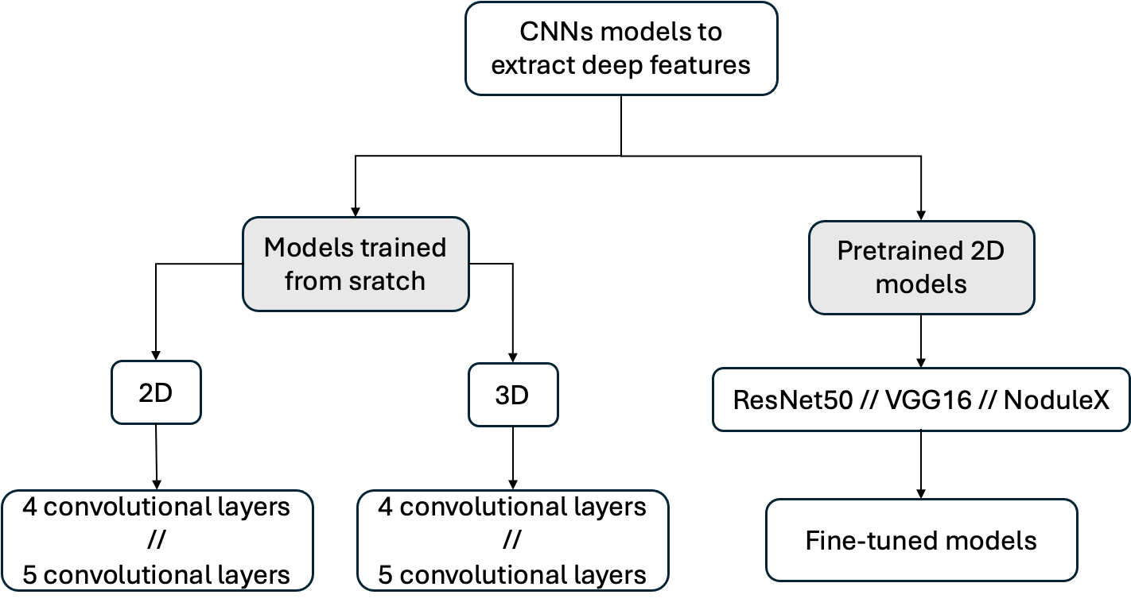
Supplementary Figure S1. Strategies explored for extracting deep features using CNN-based architectures. Both models trained from scratch and pre-trained models further fine-tuned were tested. CNN, convolutional neural network.

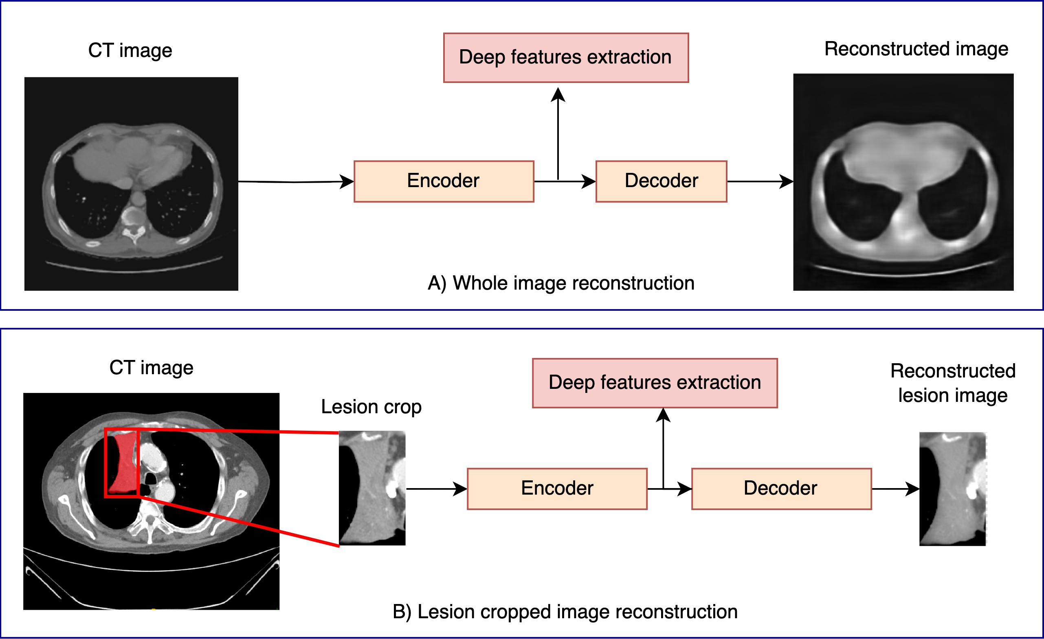
Supplementary Figure S2. Different image field-of-views used as input to the network. The top panel shows the entire image, whereas the bottom panel illustrates the cropped view centered on the largest lesion. CT, computed tomography.

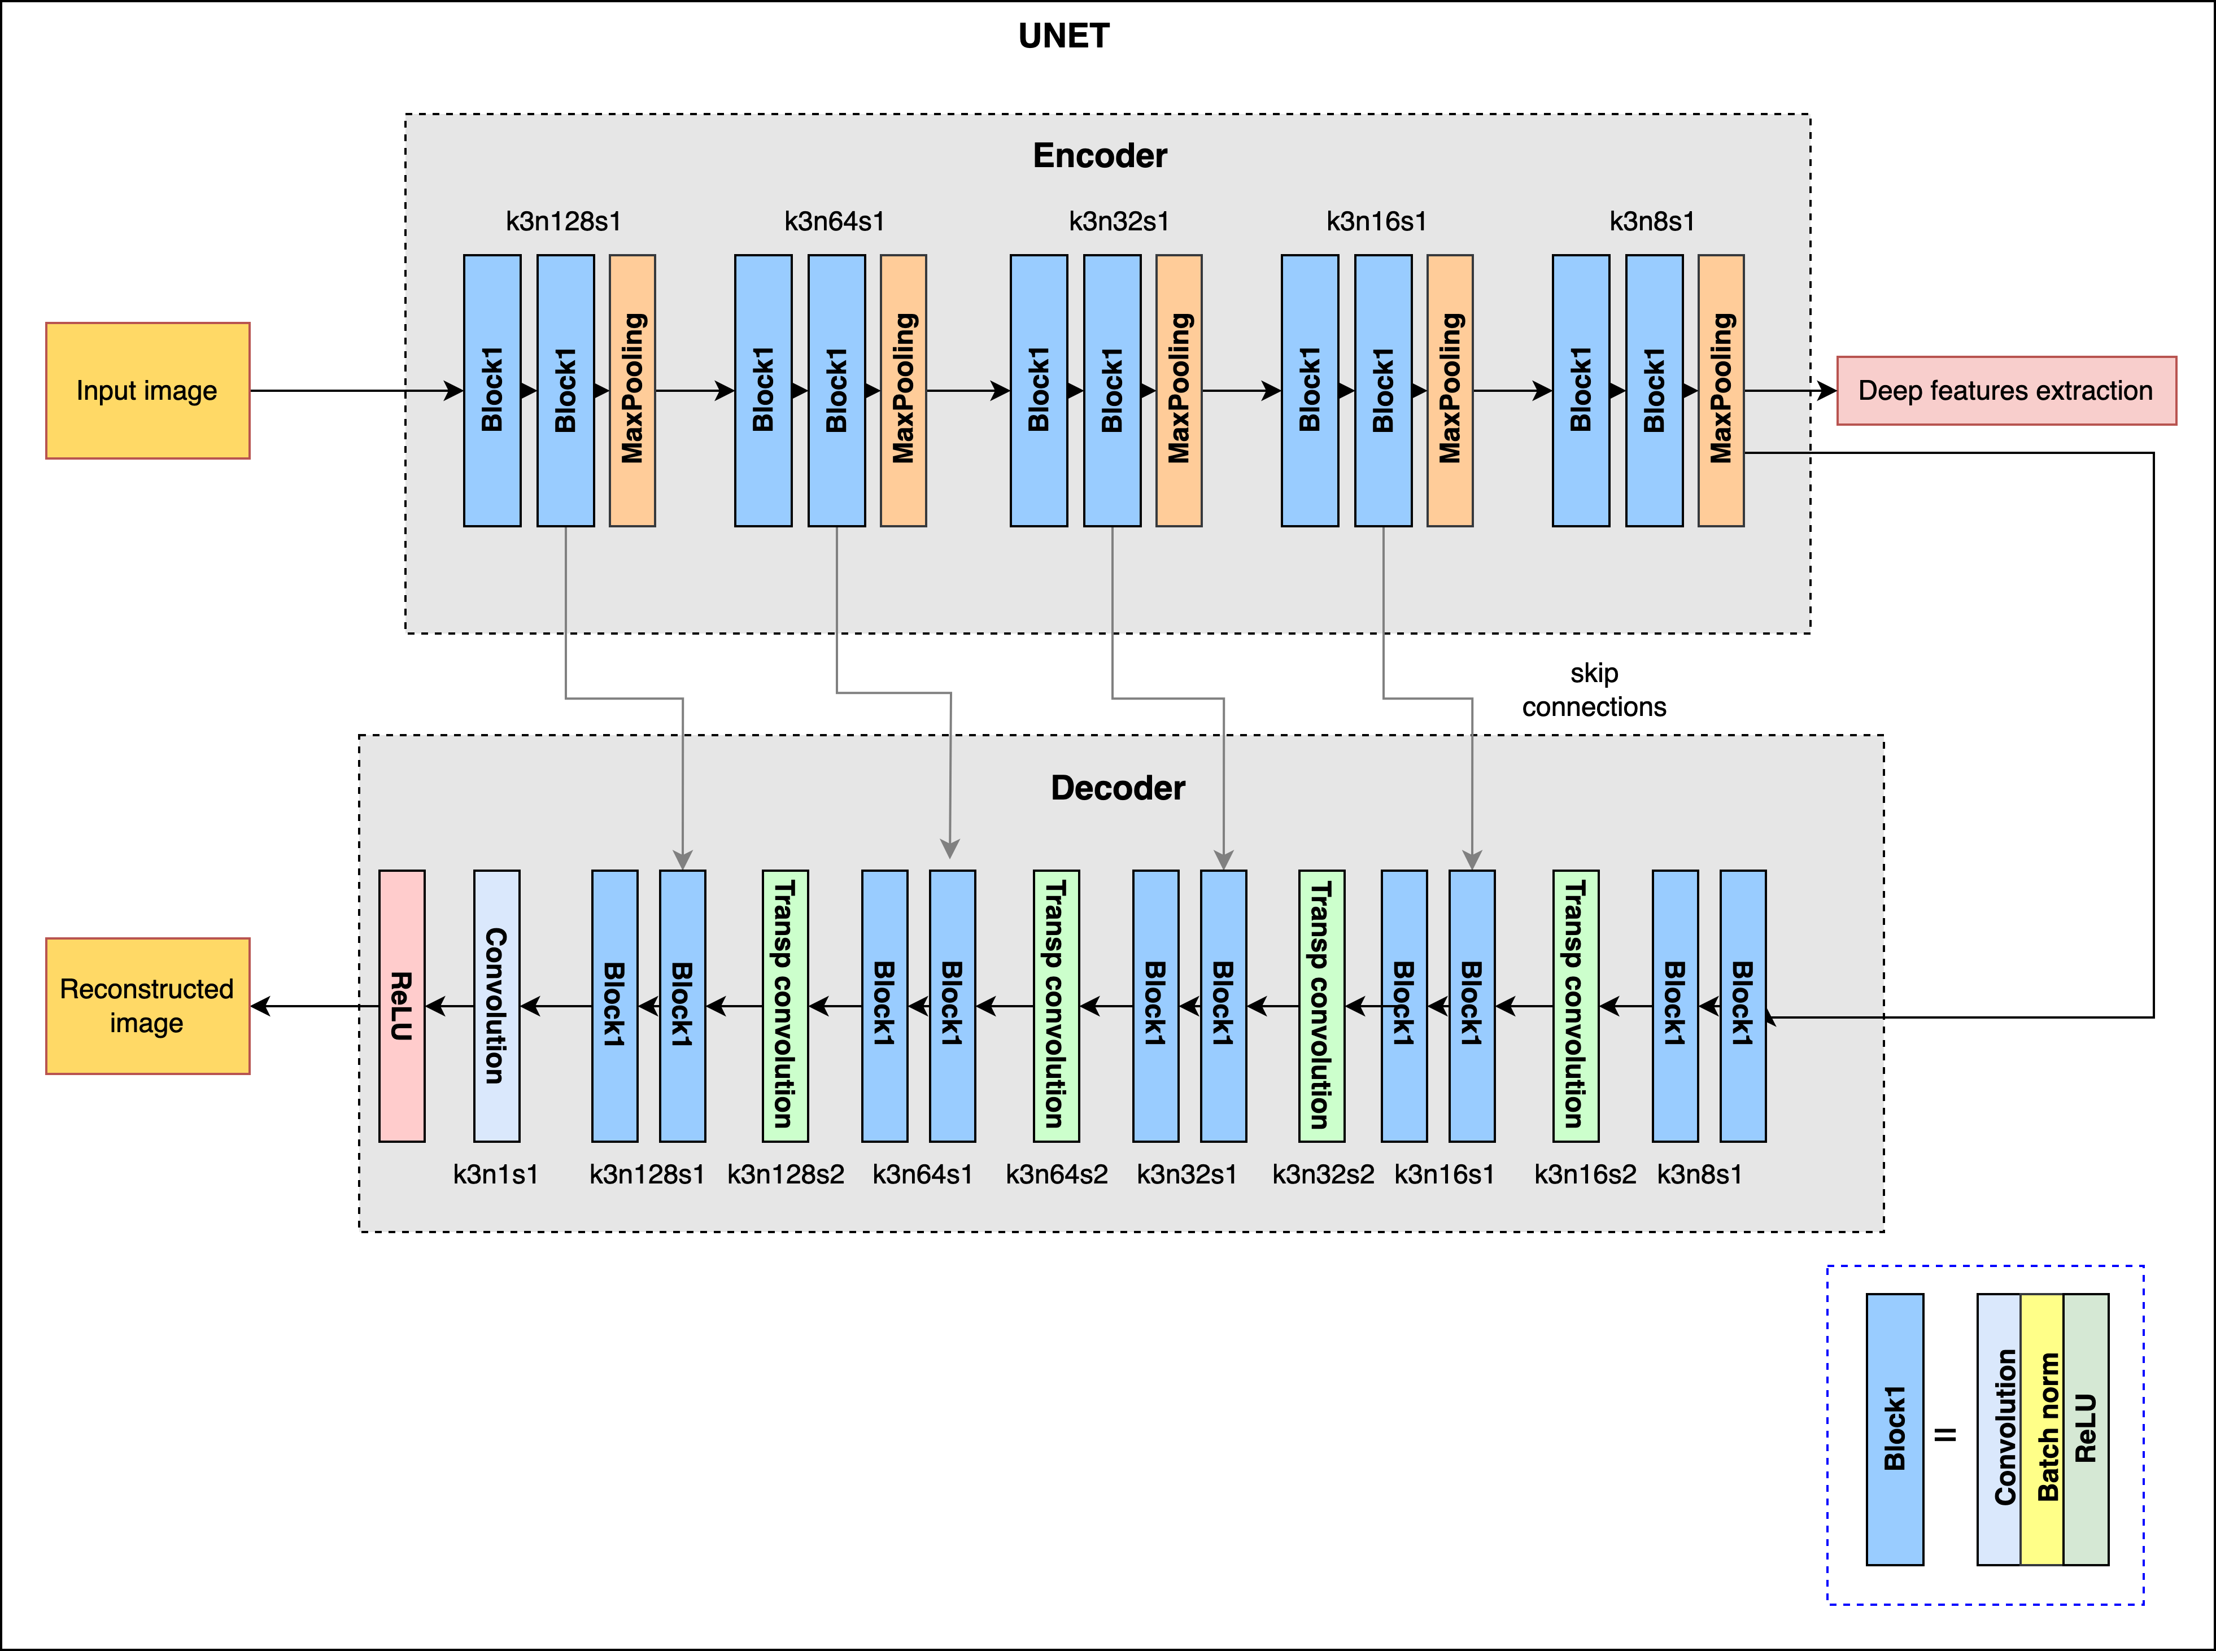
Supplementary Figure S3. Architecture of 2D and 3D UNET-based models

Supplementary Table S1. Hyperparameters of the best models obtained in each outer fold of the nested cross-validation across the different experiments: autoencoders trained from scratch, pretrained models, and transfer learning.
Training |  | Architecture | Region methodology | Image Size | Outer fold | Model | Feature selection | Outliers remove | Data balancing
Model trained from scratch | Autoencoder 2D |  | Whole image | 224x224x3 | 1 | RF | MRMR10 | Yes | No
 |  |  |  |  | 2 | ExtraRF | MRMR20 | No | No
 |  |  |  |  | 3 | RF | MRMR20 | No | No
 |  |  |  |  | 4 | RF | MRMR10 | No | No
 |  |  |  |  | 5 | ExtraRF | MRMR20 | Yes | No
Pretrained model |  | NoduleX | Cropped image | 47x47x5 | 1 | ExtraRF | MRMR10 | Yes | No
 |  |  |  |  | 2 | ExtraRF | MRMR20 | No | No
 |  |  |  |  | 3 | ExtraRF | MRMR20 | Yes | No
 |  |  |  |  | 4 | ExtraRF | MRMR20 | Yes | No
 |  |  |  |  | 5 | RF | MRMR20 | Yes | No
Fine-tuned model |  | NoduleX | Cropped image | 47x47x5 | 1 | ExtraRF | MRMR10 | No | No
 |  |  |  |  | 2 | ExtraRF | MRMR20 | No | No
 |  |  |  |  | 3 | RF | MRMR20 | No | No
 |  |  |  |  | 4 | RF | MRMR30 | No | No
 |  |  |  |  | 5 | ExtraRF | MRMR20 | No | No

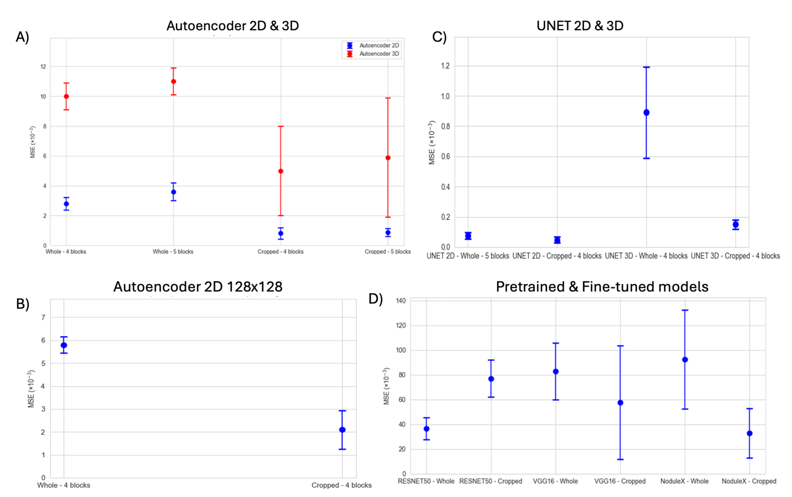
Supplementary Figure S4. Reconstruction error distribution in autoencoder-based architectures. The vertical axis represents the MSE (×10⁻³) in the test set, with the mean shown as a dot and the bars indicating the standard deviation. The horizontal axis displays the different architectures analyzed, using either whole or cropped images. (A) 2D and 3D autoencoders trained from scratch with varying numbers of convolution blocks. (B) Reconstruction error of 128x128 input images using 2D autoencoder architecture with four convolutional blocks using either whole or cropped images MSE, mean squared error. (C) Reconstruction errors of 2D and 3D UNET-based architectures with five convolutional blocks using either whole or cropped images. MSE, mean squared error. (D) Fine-tuned versions of the tested architectures. MSE, mean squared error.

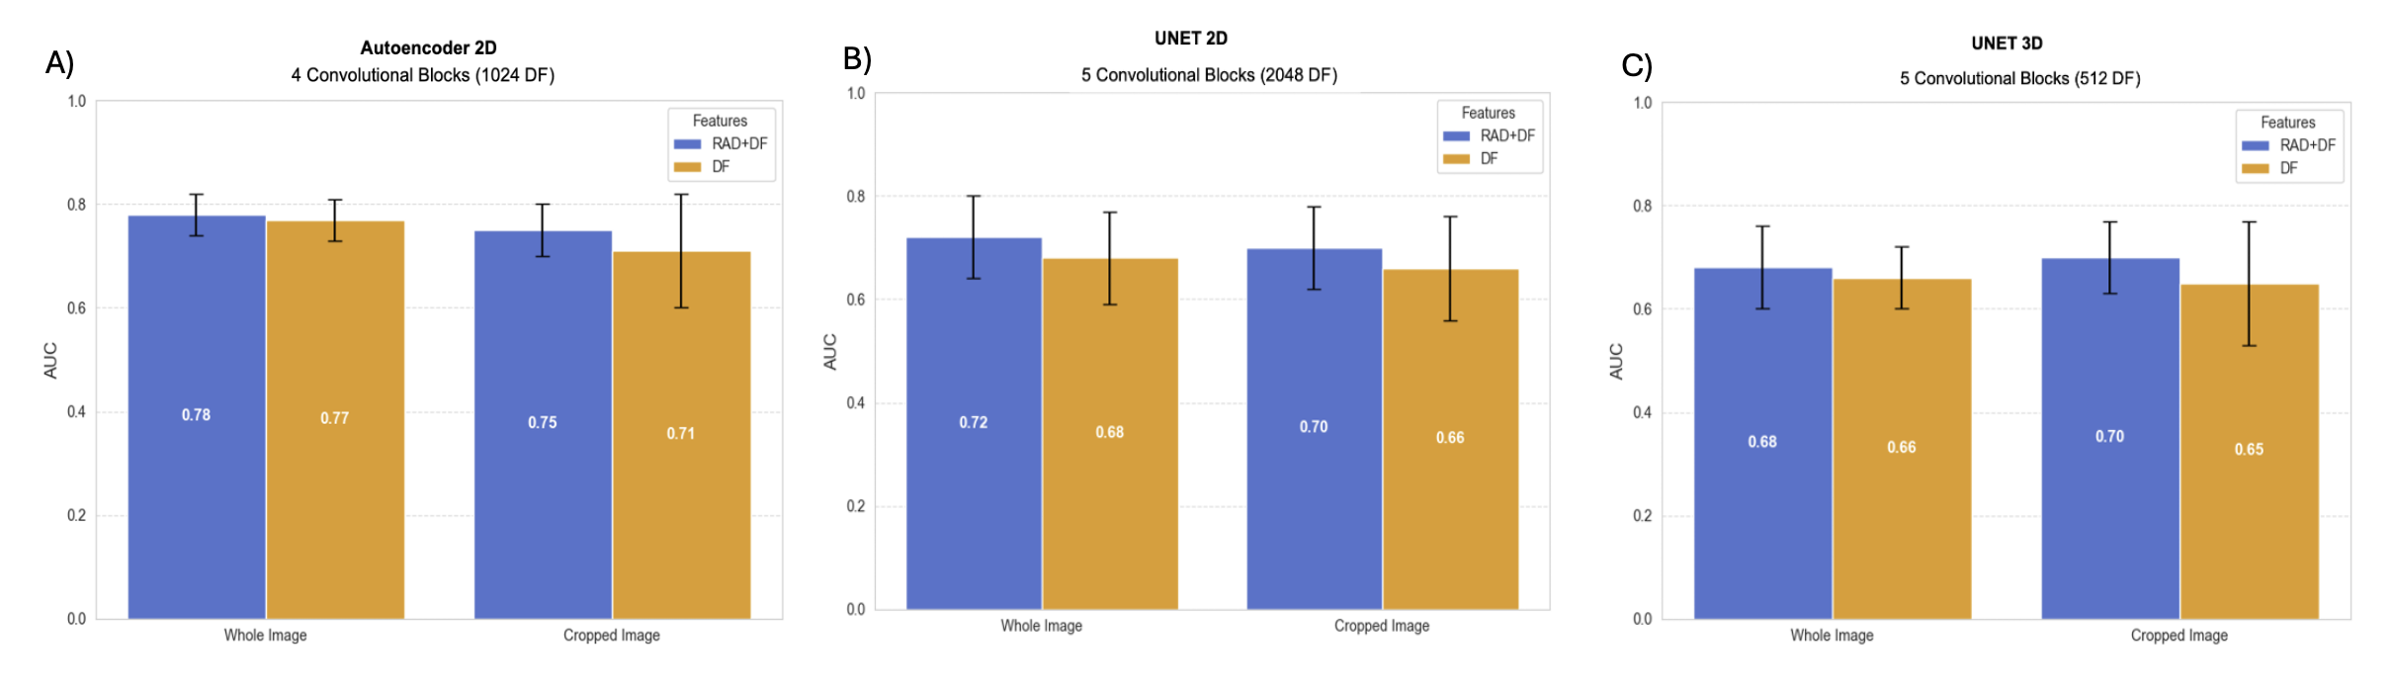
Supplementary Figure S5. Mean AUC and 95% CI results for models (A) trained from scratch with 128x128 images. (B) 2D UNET with five convolutional blocks (C) 3D UNET with five convolutional blocks; CI, confidence intervals; DF, deep features; RAD, radiomics.

Supplementary Table S2. Overview of all combinations of architectures, preprocessing strategies, and input configurations evaluated in the experiments.
Strategy | Architecture | Region | Layers | Image size | N deep features | Input features
Models trained from scratch | Autoencoder 2D | Whole image | 4 convolutional blocks | 256x256 | 4096 | RAD+DF
 |  |  |  |  |  | DF
 |  |  |  | 128x128 | 1024 | RAD+DF
 |  |  |  |  |  | DF
Models trained from scratch | Autoencoder 2D | Whole image | 5 convolutional blocks | 256x256 | 2048 | RAD+DF
 |  |  |  |  |  | DF
Models trained from scratch | Autoencoder 2D | Cropped image | 4 convolutional blocks | 256x256 | 4096 | RAD+DF
 |  |  |  |  |  | DF
 |  |  |  | 128x128 | 1024 | RAD+DF
 |  |  |  |  |  | DF
Models trained from scratch | Autoencoder 2D | Cropped image | 5 convolutional blocks | 256x256 | 2048 | RAD+DF
 |  |  |  |  |  | DF
Models trained from scratch | UNET 2D | Whole image | 5 convolutional blocks | 256x256 | 2048 | RAD+DF
 |  |  |  |  |  | DF
Models trained from scratch | UNET 2D | Cropped image | 5 convolutional blocks | 256x256 | 2048 | RAD+DF
 |  |  |  |  |  | DF
Models trained from scratch | Autoencoder 3D | Whole image | 4 convolutional blocks | 128x128x16 | 1024 | RAD+DF
 |  |  |  |  |  | DF
Models trained from scratch | Autoencoder 3D | Whole image | 5 convolutional blocks | 128x128x16 | 512 | RAD+DF
 |  |  |  |  |  | DF
Models trained from scratch | Autoencoder 3D | Cropped image | 4 convolutional blocks | 128x128x16 | 1024 | RAD+DF
 |  |  |  |  |  | DF
Models trained from scratch | Autoencoder 3D | Cropped image | 5 convolutional blocks | 128x128x16 | 512 | RAD+DF
 |  |  |  |  |  | DF
Models trained from scratch | UNET 3D | Whole image | 5 convolutional blocks | 128x128x16 | 2048 | RAD+DF
 |  |  |  |  |  | DF
Models trained from scratch | UNET 3D | Cropped image | 5 convolutional blocks | 128x128x16 | 2048 | RAD+DF
 |  |  |  |  |  | DF
Pre-trained models | RESNET50 | Whole image | 16 residual blocks  1 | 224x224x3 | 2048 | RAD+DF
 |  |  |  |  |  | DF
Pre-trained models | RESNET50 | Cropped image | 16 residual blocks  1 | 224x224x3 | 2048 | RAD+DF
 |  |  |  |  |  | DF
Pre-trained models | VGG16 | Whole image | 5 convolutional blocks | 224x224x3 | 4096 | RAD+DF
 |  |  |  |  |  | DF
Pre-trained models | VGG16 | Cropped image | 5 convolutional blocks | 224x224x3 | 4096 | RAD+DF
 |  |  |  |  |  | DF
Pre-trained models | NoduleX | Whole image | 5 convolutional blocks | 47x47x5 | 3240 | RAD+DF
 |  |  |  |  |  | DF
Pre-trained models | NoduleX | Cropped image | 5 convolutional blocks | 47x47x5 | 3240 | RAD+DF
 |  |  |  |  |  | DF
Fine-tuned models | RESNET50 | Whole image | 16 residual blocks | 224x224x3 | 2048 | RAD+DF
 |  |  |  |  |  | DF
Fine-tuned models | RESNET50 | Cropped image | 16 residual blocks | 224x224x3 | 2048 | RAD+DF
 |  |  |  |  |  | DF
Fine-tuned models | VGG16 | Whole image | 5 convolutional blocks | 224x224x3 | 4096 | RAD+DF
 |  |  |  |  |  | DF
Fine-tuned models | VGG16 | Cropped image | 5 convolutional blocks | 224x224x3 | 4096 | RAD+DF
 |  |  |  |  |  | DF
Fine-tuned models | NoduleX | Whole image | 5 convolutional blocks | 47x47x5 | 3240 | RAD+DF
 |  |  |  |  |  | DF
Fine-tuned models | NoduleX | Cropped image | 5 convolutional blocks | 47x47x5 | 3240 | RAD+DF
 |  |  |  |  |  | DF

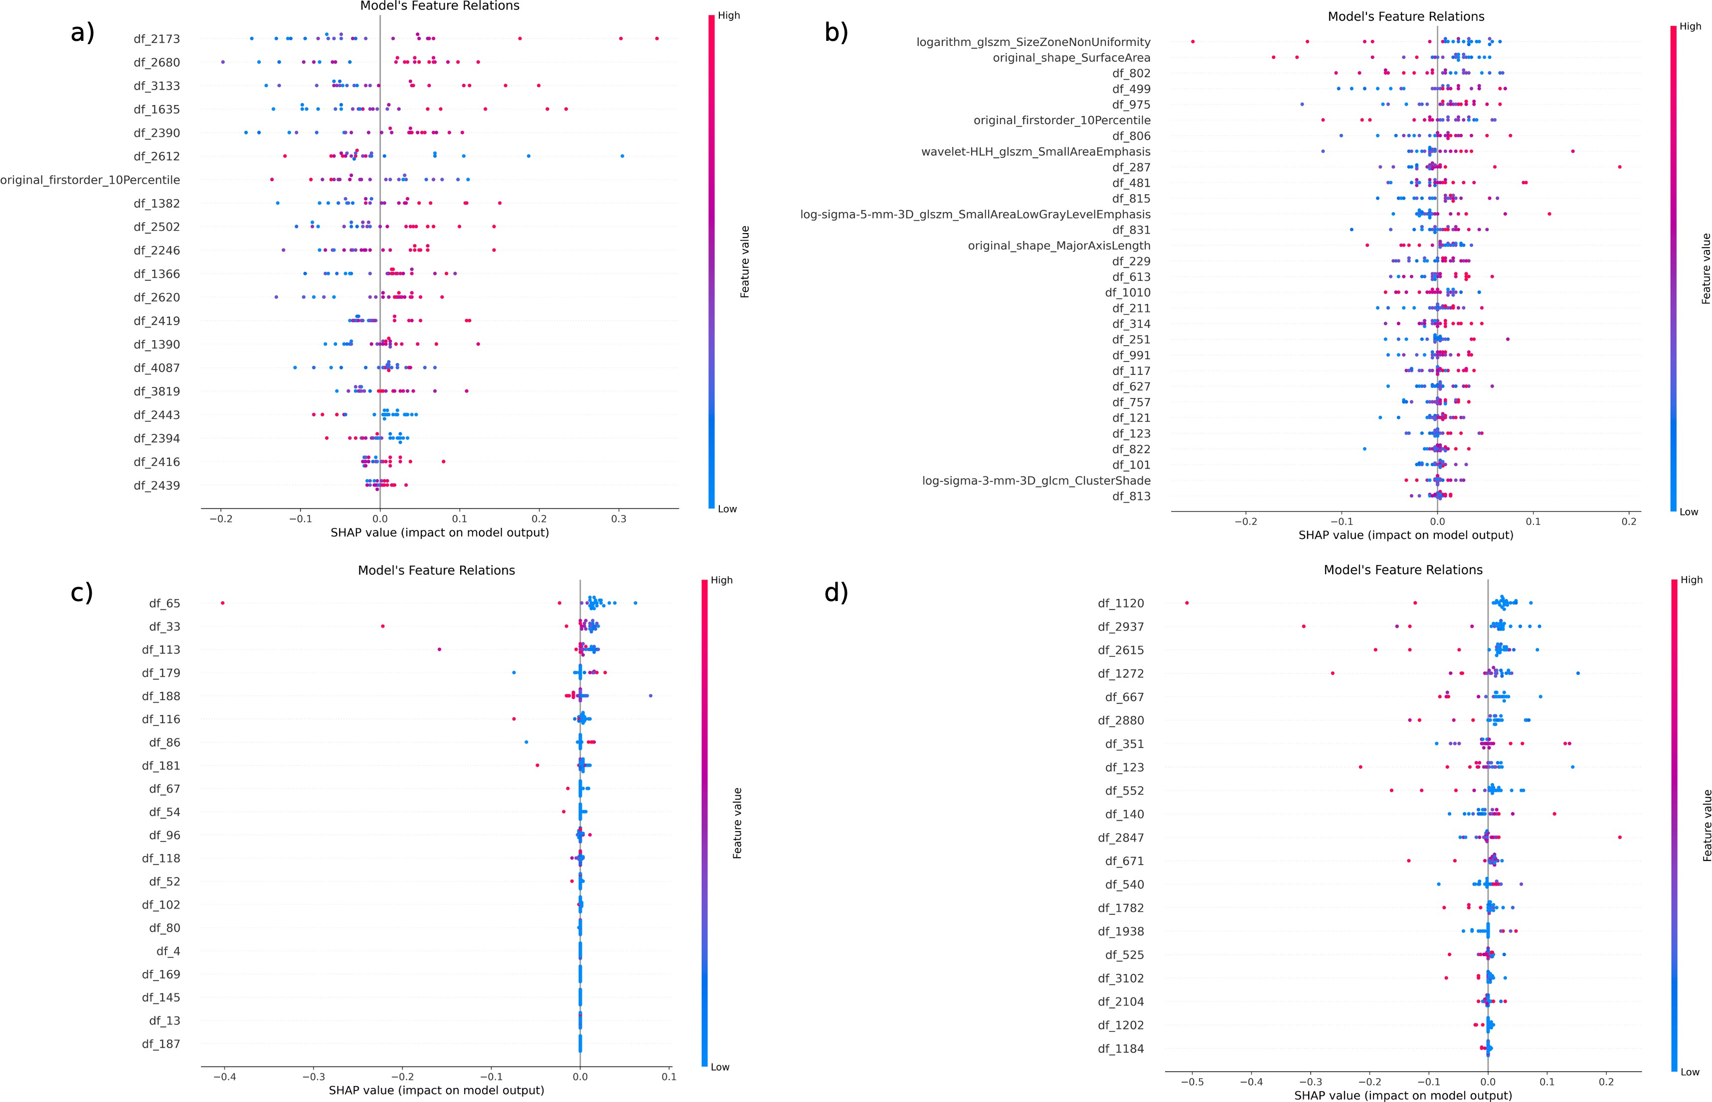
Supplementary Figure S6. SHAP values of the best-performing models across different architectures. (A) A 2D autoencoder trained from scratch with four convolutional blocks, whole-image input (256 x 256), combining radiomicss and deep features. (B) A 3D architecture autoencoder trained from scratch with four convolutional blocks, cropped image input, combining radiomics and deep features. (C) Pretrained NoduleX model with cropped image input using only deep features. (D) Fine-tuned NoduleX model with cropped image input using only deep features. DF, deep features; SHAP, SHapley Additive exPlanations.

Supplementary Table S3. Comparison of survival classification performance between our models and published studies. Threshold = survival cut-off used for classification.
Model / Study | Modalities used | Threshold (OS) | AUC | Accuracy
Autoencoder 2D  (this study) | 1 modality | 12 months | 0.82 | 0.78
VGG16 finetuned  (this study) | 1 modality | 12 months | 0.87 | 0.81
Lyu et al., 2024  (SurvNet)1 | 4 modalities + segmentation | 12 months | 0.788 | 0.771
Lyu et al., 2024  (SurvNet)1 | 1 modality | 12 months | 0.690 | 0.686
Ben Ahmed et al.,  20222 | 3 modalities | 15 months | 0.67 | 0.67

References
- Lyu, Q., Parreno-Centeno, M., Papa, J.P., O¨ ztu¨rk-Isik, E., Booth, T.C., Costen, F.: Survnet: A low-complexity convolutional neural network for survival time classification of patients with glioblastoma. Heliyon 10(12) (2024)
- Ben Ahmed, K., Hall, L.O., Goldgof, D.B., Gatenby, R.: Ensembles of convolu- tional neural networks for survival time estimation of high-grade glioma patients from multimodal mri. Diagnostics 12(2), 345 (2022)

