Supplementary material:

Supplementary 1: Additional data information
1.A. Habitat categories and proportions
1.B. Environmental trends and summaries

Supplementary 2: Sensitivity analyses
2.A. Sensitivity of the models performances to buffer size
2.B. Sensitivity of variance partitioning to environmental drivers grouping

Supplementary 3: Additional results
3.A. Occurrence results
3.B. Posterior uncertainty estimation
3.C. Evaluation of the relative dominance of drivers
3.D. Shared importance of environmental drivers

Supplementary 1: Additional data information
1.A. Habitat categories and proportions
The habitat types considered in this study were Urban, Crops, semi natural – herbaceous – pastures, forests and wetlands. They were defined based on CORINE land cover categories (CLC) as shown by Table S1.1. The relative proportions of each habitat type around the sampling sites within buffers of varying sizes are summarized in Table S1.2.
Table S1.1: Habitat types used in this study (first column) and how they were formed from the CORINE land cover categories (CLC; second column).
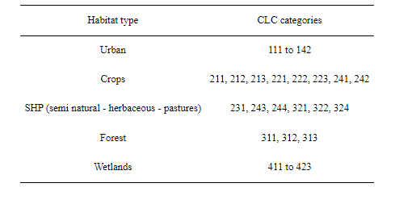
Table S1.2: Median and interquartile range (IQR) of proportion of habitat types considered in this study per taxa within buffers of varying sizes around the sampling sites.
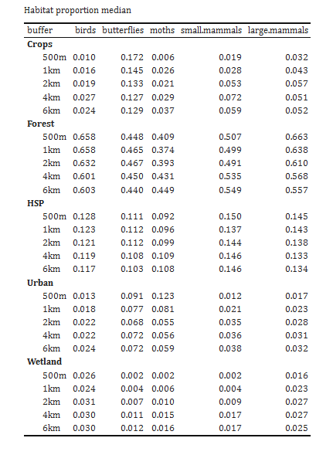
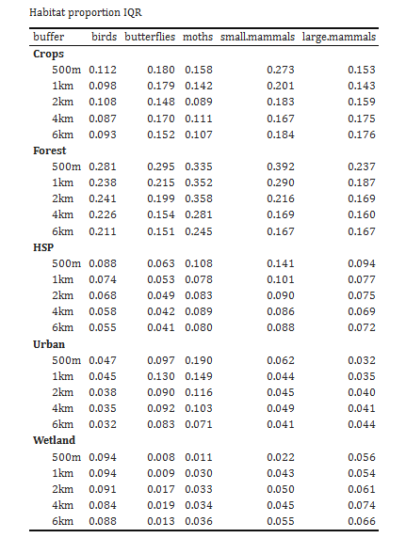

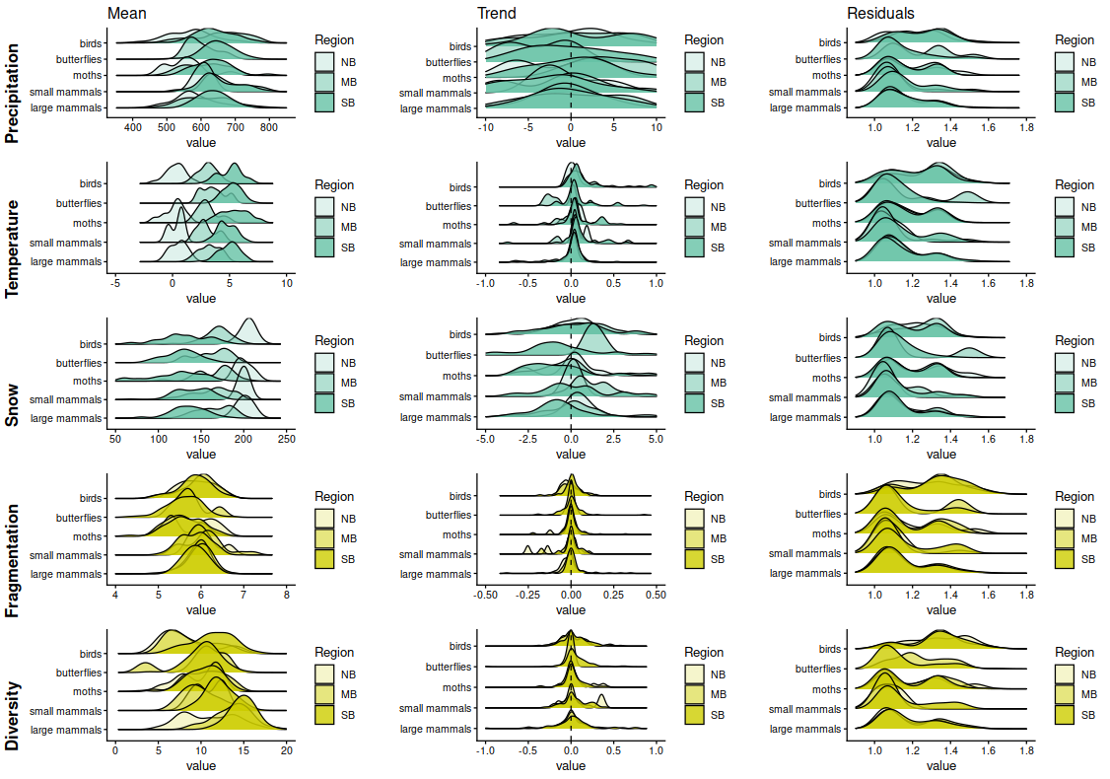
1.B. Environmental trends and summaries

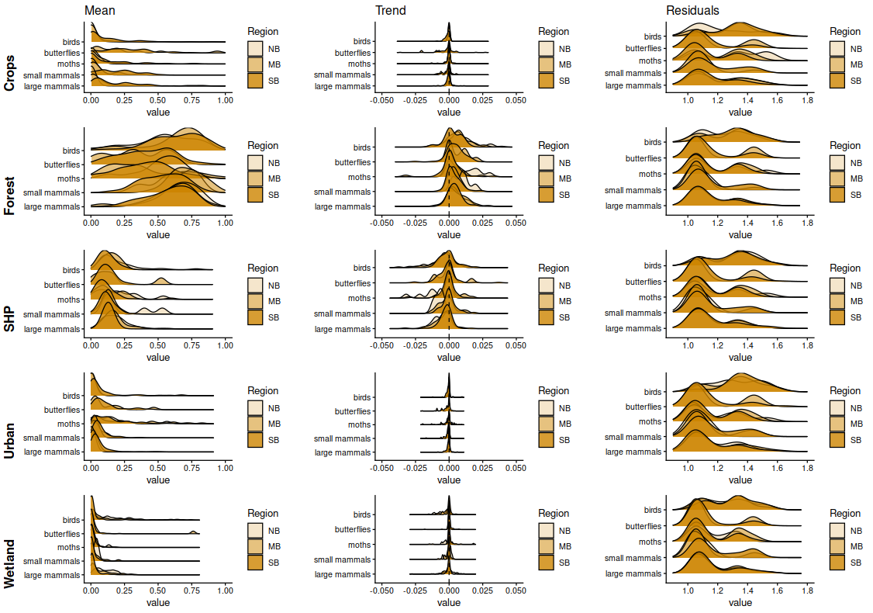

Figure S1.1: Summary of environmental changes at our monitoring sites per biogeographical region. The three columns of panels report the distributions of the local (site-wise) mean across years (leftmost column), trend estimated from a linear model (middle column), and the standardized residuals (rightmost column) for each taxa (Winter game, small mammal, moth, butterflies, birds) and biogeographical region (NB: north boreal, MB: middle boreal and SB: south boreal). We display the climatic variables in blue, while the landscape configuration variables are shown in yellow, and the habitat composition variables are shown in orange.

Overall, climatic covariates showed gradients towards the northern biogeographical regions, with increasing snow cover but decreasing temperature and precipitation across all monitoring sites (Figure S1.1). Across the study period (1999-2019), precipitation trends varied considerably among monitoring sites, as shown by large spread in the site-wise trend values. Temperature increased across Finland, while snow cover increased in the north and decreased in the south. Habitat diversity increased towards the north, whereas habitat diversity trends were similar across the biogeographical regions. Habitat composition (plots in orange) was relatively constant across time in terms of proportion of crops, urban and wetlands area apart from some specific location. The main habitat types which also showed the largest changes were forest and semi-natural, herbaceous or pasture (SHP) proportions. We detected an increase in forest proportions and a decrease in SHP habitat proportions. Birds showed the largest residual variability around the temporal trends for most environmental drivers.
Supplementary 2: Sensitivity analyses
2.A. Sensitivity of the models performances to buffer size
The first buffer analysis was used to choose the optimal buffer size for habitat extraction (See Methods, Joint species distribution modelling). Figure S2.1 shows that the 1-km buffer for the small mammal taxa had a larger tjurR² value on average and thus was chosen for the final full model. Other taxa did not show difference in average performances. Thus, we chose an ‘ecologically sound’ buffer size for the final analysis, for which we considered the size and the home range of the different species within the taxa. Thus, for the extraction of habitat information, we chose a 500-m buffer size for moths and butterflies^{78–80} and a 1-km buffer size for large mammals and birds^{81,82}.

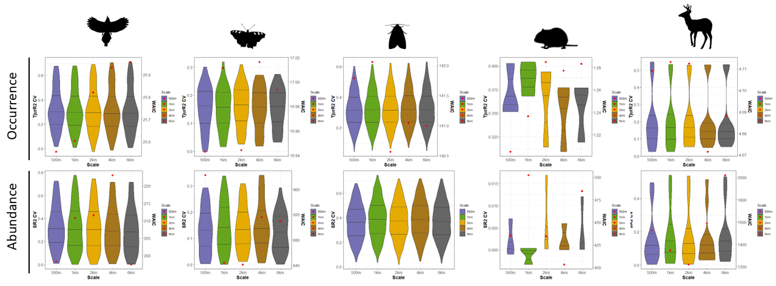
Figure S2.1: Buffer analysis performances (TjurR2 and WAIC) for each group of species occurrence (top line) and abundance (bottom line). The left axis and the boxplots show the TjurR2 values from the cross validation for each buffer size (500 m, 1 km, 2 km, 4 km and 6 km). The right axis and the red dots refer to the models’ WAIC.

2.B. Sensitivity of variance partitioning to environmental drivers
The second sensitivity analysis looked at the relative importance of climate versus habitat partitions, while testing models with different number of covariates for climate and habitat groups (Figure S2.2a and b & see Methods, Joint species distribution modelling). On average, the relative proportions between the drivers are similar across the models tested. We note that the ‘default’ model tends to show lower average value of climate variance partition and larger habitat variance partition. However, the credible interval higher value of the ‘normal’ model matches with the results from the proportion grouping model. The ‘ordination’ model tends to lightly diverge in average and credible interval values, but the 3 axes chosen to match the dimensions of the habitat group are not always enough to fully represent the PCA results. For most taxa, the analysis is robust, however care needs to be taken regarding more disputed variance partition relative values such as for the moths.
Figure S2.2: Climate and habitat variance partitioning sensitivity analysis for occurrence data (a) and abundance data (b). For each taxa, we evaluate the variance partition for models: Default - the habitat covariates group was composed of 5 habitat proportions (and their polynomial term); 'Ordination’ - the habitat covariates group was composed of 3 principal component analysis axes (and their polynomial term); ’Proportion grouping’ - the habitat covariates group was composed of 3 habitat proportions that summarized the previous 5 categories (and their polynomial term). We combined habitat proportion and configuration variance partition to one group ’Habitat’ given the low average value of the latest category and to simplify the comparison. The smaller and darker coloured bars represent the mean values for each taxon, and the larger and lighter bars represent the lower and upper bound of the 95% credible interval of the variance partition for a taxon.
Supplementary 3: Additional results
3.A. Occurrence results
Figures S3.1 and S3.2 display the occurrence results of the spatial and functional context dependence of the variance partitioning. The main findings are discussed in the manuscript in Habitat variables explain most variation in Finnish taxa and in Spatial context-dependency of driver's importance.
Figure S3.1: Conditional, within- and between-regions relative variance partition for occurrence data. Ternplots show the distribution in relative variance partition between the three drivers (sum to 100) among species in each taxon (colours); the kernel densities represent the joint values, while the density plots outside the triangles show the marginal values for each driver. Each subplot shows the relative variance partition for each biogeographical region (A, B & C), between (D) and within (E) regions. Each subplot shows the relative variance partition for each biogeographical region (A, B &C), between (D) and within (E) regions.

Figure S3.2: Trait-based relative variance partitioning for occurrence data. Trait-based relative variance partitioning summaries for occurrence data. Ternplots show the distribution in relative variance partition between the three drivers (sum to 100) among species in each taxon (colours); the kernel densities represent the joint values, while the density plots outside the triangles show the marginal values for each driver. Each column represents a taxon and each row a trait: 1. Life history pace (slow versus fast), 2. habitat/diet specialization (specialist versus generalist) and 3. Body size (small vs large), represented by different colours.

3.B. Posterior uncertainty estimation
Figure S3.3 provides posterior distribution of the variance partition mean and interquartile range of each driver for each taxon.
Figure S3.3: (Diagonal) Variance partitioning posterior summaries for all taxa (on a scale 0–100). The density plots show the posterior distribution of the mean over species variance partition and interquartile over species variance partition (columns) for each taxon, for each driver (climate, habitat composition, landscape configuration as well as site, year and region random effects; line) for a) occurrence models and b) abundance models.

3.C. Drivers' dominance evaluation
We evaluated the dominance between drivers by assessing the 90% [75%; 95%] posterior probability of the proportion of species for which a particular driver is the most important (i.e. highest variance partition). The results are displayed for all sites (Figure S3.4 & Habitat variables explain most variation in Finnish taxa) and – for evaluating spatial context dependence – across each biogeographical region, as well as between and within biogeographical regions (Figure S3.5 & Spatial context-dependency of driver's importance).
Figure S3.4: Comparison of the dominant driver across taxa for occurrence (a) and abundance (b). Each plot shows the proportion of species for which either climate (in turquoise), habitat fragmentation (in yellow) or habitat composition (in orange) is the most important driver with a 90% posterior probability (the error bar displays the 75%–95% posterior probability).

Figure S3.5: Comparison of the dominant driver across taxa for each biogeographical region, as well as between- and within-regions for occurrence (a) and abundance (b). Each plot shows the proportion of species for which either climate (in blue), habitat fragmentation (in yellow) and habitat composition (in orange) is the most important driver with a 90% posterior probability (the error bar displays the 75%–95% posterior probability).

3.D. Shared importance of environmental drivers
We investigated shared importance of linear terms by classifying the proportion of species into different cases based on Quantifying the relationship between drivers and species occurrences and abundances using variance and covariance partitioning (Figure S3.6 and Figure S3.7). The main findings are discussed in the manuscript in Shared importance of environmental drivers.
Figure S3.6: Proportions of species expressing independent variation along the focal (rows) environmental/random driver or suppressing, amplifying, or confounded joint variation between the focal and another (columns) environmental/random driver in their occurrence. Each panel displays one pairwise covariance partition (posterior mean with a bar and the 95% credible interval with error whiskers).

Figure S3.7: Proportions of species expressing independent variation along the focal (rows) environmental/random driver or suppressing, amplifying, or confounded joint variation between the focal and another (columns) environmental/random driver in their abundance. Each panel displays one pairwise covariance partition (posterior mean with a bar and the 95% credible interval with error whiskers).

