Functional Re-tooling of Rhizosphere Guilds Is Driven by Agricultural Management and Scion Genotype
Mohammad Zarrabian¹, Sherif M. Sherif^{1*}
1. Virginia Tech, School of Plant and Environmental Sciences, Alson H. Smith Jr. Agricultural Research and Extension Center, Winchester, VA, 22602, United States.
* Corresponding author: Sherif M. Sherif; E-mail address: ssherif@vt.edu; Tel: +1 (540)- 232-6035

Fig. S1 Rarefaction curves for bacterial and fungal communities. The plots show sample-based rarefaction curves for (A) bacterial (16S) and (B) fungal (ITS) communities. The y-axis represents the number of observed species (ASVs), and the x-axis represents the sequencing depth (sample size). Each line represents an individual sample (n=15 for each plot). The clear approach of all curves toward an asymptote indicates that the sequencing depth was sufficient to capture the vast majority of microbial richness within each sample.

Fig. S2 Total microbial richness (ASV count) across management systems and treatment groups. Bar plots show the total number of Amplicon Sequence Variants (ASVs) for (A) Bacteria and (B) Fungi, pooled at different levels. The numbers above each bar indicate the ASV count. The Total bar represents all ASVs found across all 15 samples (all 5 treatment groups). The Organic (n=6) and Conventional (n=6) bars represent the pooled ASVs from the 12-sample subset (Liberty and Enterprise scions on MM.111 rootstock only). This is the valid, unconfounded management comparison. The five individual bars show the pooled ASVs for each respective treatment group, including the confounded Conventional X6398 group (G210 rootstock).

Fig. S3 Separation of soil microbial communities by scion-rootstock combinations under Conventional management. Principal Coordinates Analysis (PCoA) plots display the Bray-Curtis dissimilarity between samples. The figure compares two scions on MM.111 rootstock (Enterprise and Liberty) versus the X6398 combination on G.20 rootstock within the conventional orchard system. (A) Bacterial Community. (B) Fungal Community.
Fig S4. Biomarker taxa differentially abundant between management systems identified by LEfSe. The analysis was based on the 12-sub sample containing the Liberty and Enterprise in both framing systems, excluding X6398. Plots show the results of a Linear discriminant analysis Effect Size (LEfSe) analysis comparing organic (green) and conventional (red) management systems for (A) bacterial and (B) fungal communities. The length of the bar represents the LDA Score (log10), indicating the effect size of each taxon as a statistically significant biomarker. Taxa are considered significant biomarkers if their LDA score is > 2.0.

Fig S5. Heatmap of predicted bacterial functional profiles (FAPROTAX). The heatmap illustrates the relative abundance (Z-score) of predicted bacterial functions across all 12 samples, excluding X6398. Functions (rows) and samples (columns) are clustered using hierarchical clustering based on Euclidean distance. Red cells indicate a higher relative abundance of a specific function compared to the mean, while blue cells indicate a lower relative abundance.

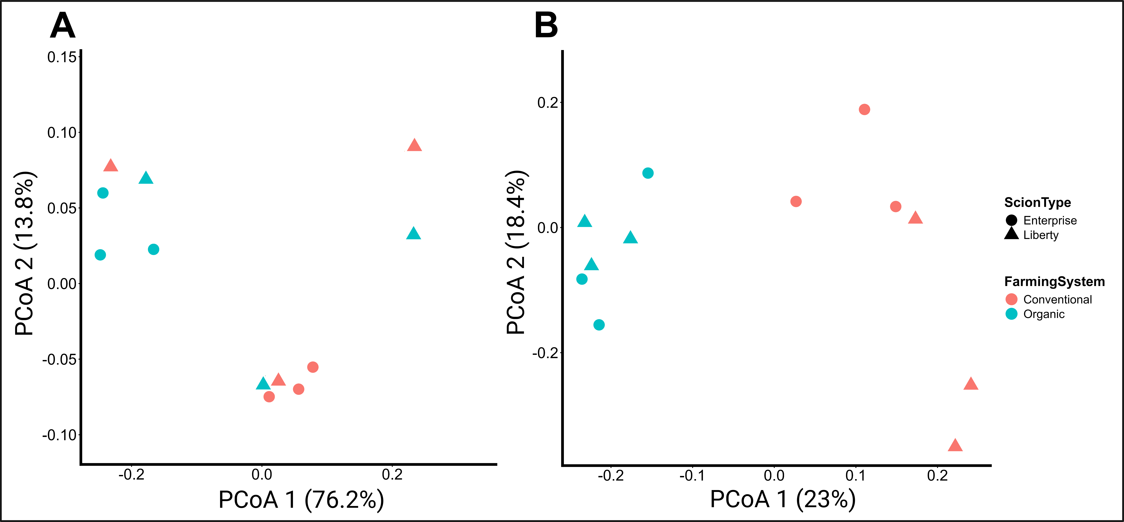
Fig. S6 Principal Coordinates Analysis (PCoA) of predicted functional profiles. PCoA plots based on Bray-Curtis dissimilarity of predicted functional profiles for (A) bacterial communities (FAPROTAX) and (B) fungal communities (FUNGuild). Points are colored by Farming System (Conventional = orange, Organic = blue) and shaped by Scion Type (Enterprise = circle, Liberty = triangle, X6398 = square). The percent variation explained by each principal coordinate axis is shown in parentheses. The bacterial functional plot (A) shows high variability and no clear clustering by management. The fungal functional plot (B) shows a clear and significant separation between organic and conventional systems.

Fig. S7 Predicted bacterial functions (FAPROTAX) differ significantly between management systems. The analysis was based on the 12-sub sample containing the Liberty and Enterprise in both framing systems excluding the X6398. Boxplots show the predicted relative abundance (%) of key bacterial functions comparing Organic (green) and Conventional (orange) management systems (n=6). Boxes represent the interquartile range (IQR) with the central line denoting the median. Statistical significance was determined by a one-way ANOVA comparing the two management groups. The resulting p-value is displayed for each comparison. Different letters above bars indicate significant differences between individual treatment groups (p < 0.05) determined by a Fisher's LSD post-hoc test.

Fig. S8 Scion-level comparison of significant FAPROTAX functions within each management system. The analysis was based on the 12-sub sample containing the Liberty and Enterprise in both framing systems excluding the X6398. The box plot related to X6398 is provided for visualization. Boxplots show the relative abundance (%) of the three bacterial functions that were found to be significantly different in the main management comparison (from Fig. 6). The analysis is faceted by Management System (Conventional, left; Organic, right) to visualize the effect of Scion Type (x-axis) within each system. Statistical p-values shown are from a one-way ANOVA comparing scion types within that management system. Different letters above bars indicate significant differences between individual treatment groups (p < 0.05) determined by a Fisher's LSD post-hoc test.

Fig. S9 Heatmap of predicted fungal ecological guilds (FUNGuild). The heatmap illustrates the relative abundance (Z-score) of predicted fungal ecological guilds across all 12 samples excluding the X6398. Guilds (rows) and samples (columns) are clustered using hierarchical clustering based on Euclidean distance. Red cells indicate a higher relative abundance of a specific guild compared to the mean, while blue cells indicate a lower relative abundance.

Fig. S10 Comparison of major fungal ecological guilds (FUNGuild) between management systems. The analysis was based on the 12-sub sample containing the Liberty and Enterprise in both framing systems excluding the X6398. Boxplots show the relative abundance (%) of four major ecological guilds (Plant Pathogenic Fungi, Fungal Parasites, Decomposer Saprotrophs, and Endophytic Fungi) comparing Conventional (red) and Organic (blue) systems (n=9 and n=6, respectively). Boxes represent the interquartile range (IQR) with the central line denoting the median. Statistical p-values shown are from a one-way ANOVA comparing scion types within that management system. Different letters above bars indicate significant differences between individual treatment groups (p < 0.05) determined by a Fisher's LSD post-hoc test.

Fig. S11 Scion-level comparison of major fungal ecological guilds (FUNGuild) within each management system. The analysis was based on the 12-sub sample containing the Liberty and Enterprise in both framing systems excluding the X6398. The box plot related to X6398 is provided for visualization. Boxplots show the relative abundance (%) of four major FUNGuilds (Plant Pathogens, Fungal Parasites, Decomposer Saprotrophs, and Endophytes). The analysis is faceted by Farming System (Conventional, left; Organic, right) to visualize the effect of Scion Type (x-axis) within each system. Boxes represent the interquartile range (IQR) with the central line denoting the median. Statistical p-values shown are from a one-way ANOVA comparing scion types within that management system. Different letters above bars indicate significant differences between individual treatment groups (p < 0.05) determined by a Fisher's LSD post-hoc test.

Fig. S12 Differential abundance analysis of the X6398 scion within the conventional system. The volcano plots show the left column (A, B) displays bacterial taxa, and the right column (C, D) displays fungal taxa, while the rows show the comparison of X6398 against Enterprise (A, C) and Liberty (B, D). The x-axis represents the log2 fold change, and the y-axis represents the -log10 adjusted p-value (padj). Taxa with a padj < 0.05 and a log2 fold change > |1.0| are highlighted in color and labeled. Grey points represent non-significant taxa. These plots highlight the unique microbial taxa significantly enriched in the X6398 scion compared to the other two conventional scions.

