Title
Ubiquitination of secretory granules promotes crinophagic degradation in Drosophila
Authors
Tamás Csizmadia¹, Anna Dósa^{1,2}, Asha Kiran Maddali^{3,4}, András Jipa⁴, Hajnalka Laczkó-Dobos⁴, Péter Lőw^{1*} and Gábor Juhász^{1,4*}

Affiliations
¹Department of Anatomy, Cell and Developmental Biology, Eötvös Loránd University, Budapest, Hungary
²Research Institute of Molecular Pathology (IMP), Vienna BioCenter PhD Program
³Heidelberg University Biochemistry Center (BZH), Heidelberg, Germany
⁴Institute of Genetics, HUN-REN Biological Research Centre, Szeged, Hungary
*These authors contributed equally

Contact information:
Corresponding authors: tamas.csizmadia@ttk.elte.hu; gabor.juhasz@ttk.elte.hu

Running title:
Secretory granule ubiquitination triggers crinophagy

SUPPLEMENTARY MATERIALS

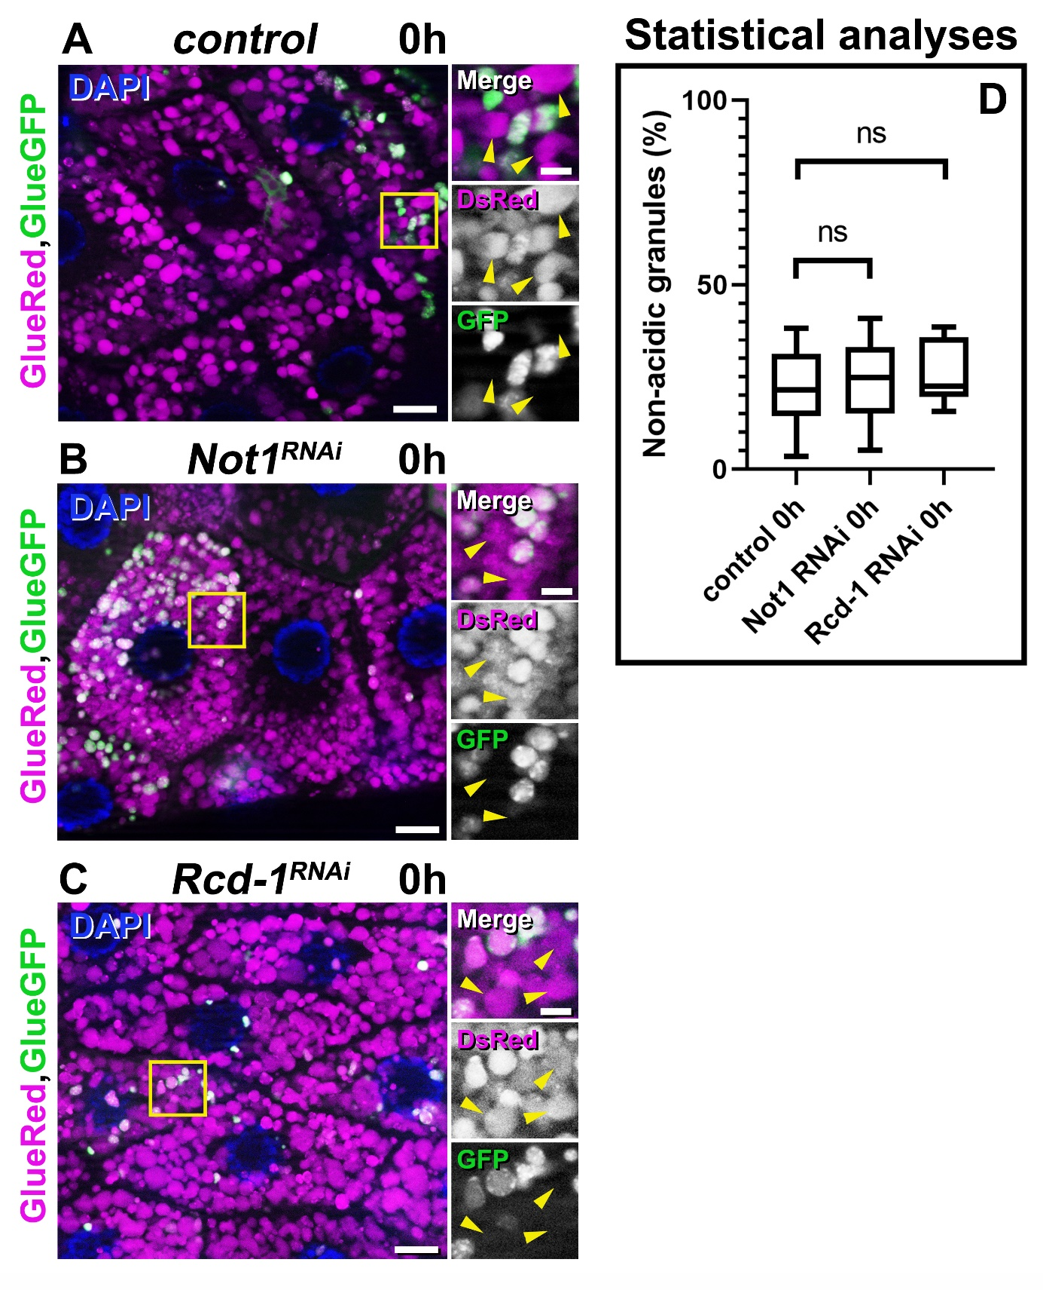
Figure S1. Silencing genes encoding subunits of the CCR4-CNOT complex other than Cnot1 does not influence glue granule acidification
(A-D) Prepupal salivary gland cells co-expressing glue-GFP and glue-DsRed reporters and transgenic RNA interference constructs for genes encoding subunits of the CCR4-CNOT complex. Salivary gland-specific knockdown of Not1 (B) or Rcd-1 (C) did not disrupt the developmentally programmed quenching of GFP fluorescence within glue granules: these are similar to control cells (A, yellow arrowheads). (D) Quantification of data from A-C, n=6-9 animals, Mann-Whitney tests. P values are (ns) p=0.6842 and (ns) p=0.3527, respectively.

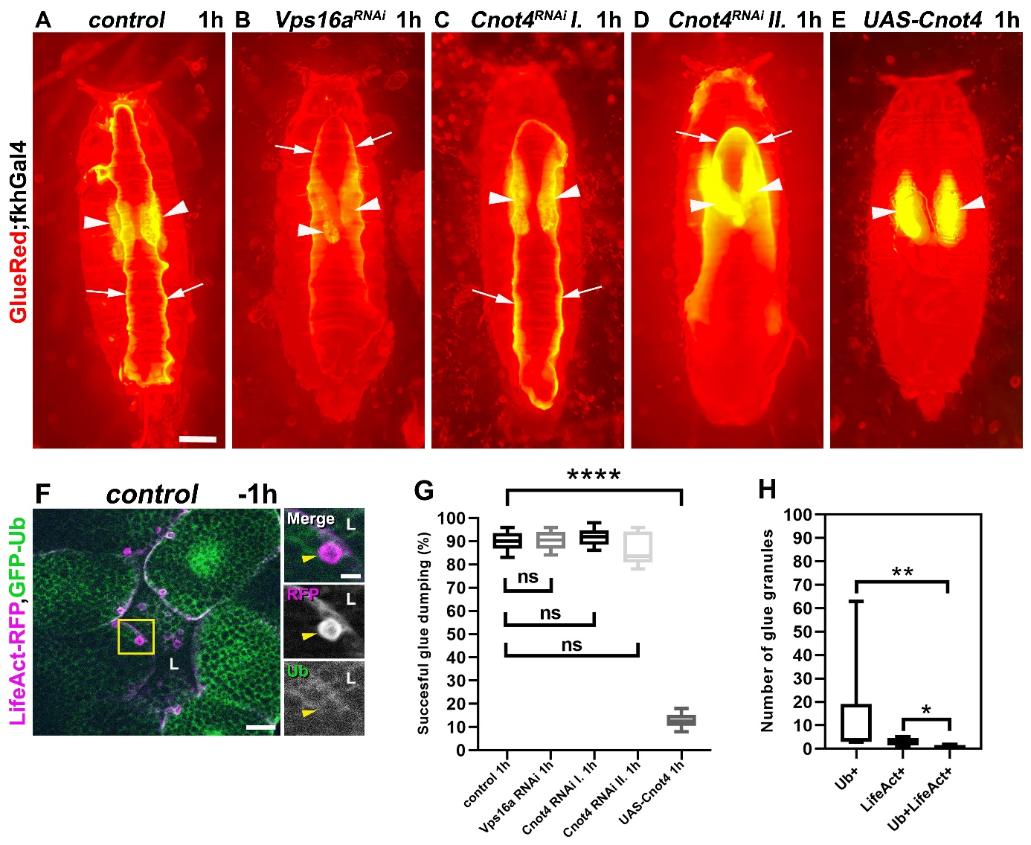
Figure S2. Ubiquitin is not required for normal glue release from the salivary gland, while premature crinophagy induced by Cnot4 overexpression prevents glue secretion
(A-E) Secretion assays using glue-DsRed animals in different genetic background. (A) Control animals display an obvious glue-DsRed patch under the prepupa (white arrows denote the border of the glue patch), which indicate the successful glue secretion and release from the salivary gland (glands are marked by white arrowheads). Silencing of the crinophagic gene Vps16a (B) or Cnot4 (Cnot4 RNAi I - C and II - D) did not perturb the salivary gland’s secretory process. Importantly, the overexpression of Cnot4 protein clearly results in strong defects in glue release from the gland (E). (G) Quantification of data from panels A-E (G) was performed on samples from 300 animals using Mann-Whitney tests. P values are **** p<0.0001.
(F) Ubiquitin does not colocalize with the exocytotic marker LifeAct-Ruby on glue granules in the salivary gland cells from the secretion period. The large LifeAct-Ruby positive structures are glue granules undergoing exocytosis [8,9], but they exhibit no GFP-Ub signal (yellow arrowheads). Sec: secretion period, L: lumen. (H) Quantification of data of panel F, n=6-8 animals, Mann-Whitney tests. P values are **p<0.0022 and *p<0.0108.

Table S1. Results of the RNAi screen of the Drosophila E3 enzyme encoding genes.
Potential Drosophila E3 Ub ligases examined in this study
Type of E3 enzyme/domain | Number | Name or CG number | RNAi line | Source | Crinophagy status | Other comment
Goliath type | 1 | gol | 2679R-2 | NigFly | no effect | —
Goliath type | 2 | gzl | 10277R-3 | NigFly | no effect | —
HECT type | 3 | CG3356 | 3356R-1 | NigFly | no effect | —
HECT type | 4 | CG4238 | v41982 | VDRC | no effect | —
HECT type | 5 | CG5087 | 5087R-3 | NigFly | no effect | —
HECT type | 6 | CG42797 | 3003Ra-4 | NigFly | no effect | —
HECT type | 7 | ctrip | HMS00322 | NigFly | no effect | —
HECT type | 8 | HERC2 | 11734R-3 | NigFly | no effect | —
HECT type | 9 | Herc4 | v37220 | VDRC | no effect | —
HECT type | 10 | HUWE1 | 8184R-1 | NigFly | no effect | —
HECT type | 11 | hyd | 9484R-2 | NigFly | no effect | small salivary glands and granules
HECT type | 12 | Nedd4 | 7555R-3 | NigFly | no effect | —
HECT type | 13 | Smurf | 4943R-2 | NigFly | no effect | —
HECT type | 14 | Su(dx) | 4244R-1 | NigFly | no granules | very small salivary gland
HECT type | 15 | Ube3a | 31972 | BDSC | no effect | —
HECT type | 16 | Ufd4 | 5604R-3 | NigFly | persisting GFP | —
IAP type | 17 | Diap1 | 12284R-2 | NigFly | no effect | —
IAP type | 18 | Diap2 | 8293R-1 | NigFly | no effect | —
Kcmf1 type | 19 | CG3526 | v26214 | VDRC | no effect | —
Kcmf1 type | 20 | CG15286 | 15286R-3 | NigFly | no effect | —
Kcmf1 type | 21 | CG31642 | HMJ21895 | NigFly | no effect | —
Kcmf1 type | 22 | CG31835 | 31835R-2 | NigFly | no effect | —
Kcmf1 type | 23 | CG42585 | HMJ23964 | NigFly | no effect | —
Kcmf1 type | 24 | Kcmf1 | 11984R-2 | NigFly | no granules | —
Other type | 25 | CG3894 | 42618 | BDSC | no effect | —
Other type | 26 | CG7326 | 7326R-1 | NigFly | no effect | —
Other type | 27 | CG13994 | 13994R-2 | NigFly | no effect | —
Other type | 28 | CG14646 | 14646R-4 | NigFly | persisting GFP | variable effect
Other type | 29 | I-3 | v45386 | VDRC | no effect | —
Other type | 30 | Neurl4 | 44094 | BDSC | no effect | —
Other type | 31 | poe | 14472R-1 | NigFly | no effect | —
Other Ring types | 32 | Bre1 | HMJ22277 | NigFly | no effect | —
Other Ring types | 33 | Cbl | 7037R-1 | NigFly | no effect | —
Other Ring types | 34 | CG1317 | HMJ21301 | NigFly | no effect | —
Other Ring types | 35 | CG1909 | HMC02933 | NigFly | no effect | —
Other Ring types | 36 | CG2617 | 2617R-1 | NigFly | no effect | —
Other Ring types | 37 | CG2617 | HMJ21915 | NigFly | no effect | —
Other Ring types | 38 | CG2681 | 2681R-1 | NigFly | no effect | —
Other Ring types | 39 | CG2926 | 2926R-2 | NigFly | persisting GFP | very small gland
Other Ring types | 40 | CG2991 | 2991R-3 | NigFly | no effect | —
Other Ring types | 41 | CG4080 | 4080R-2 | NigFly | no effect | —
Other Ring types | 42 | CG4325 | v34829 | VDRC | no effect | —
Other Ring types | 43 | CG4813 | 4813R-1 | NigFly | persisting GFP | small granules
Other Ring types | 44 | CG5071 | 5071R-1 | NigFly | no effect | —
Other Ring types | 45 | CG5334 | 5334R-1 | NigFly | no effect | —
Other Ring types | 46 | CG5347 | 5347R-1 | NigFly | persisting GFP | small granules
Other Ring types | 47 | CG5382 | v101394 | VDRC | no effect | —
Other Ring types | 48 | CG5555 | 5555R-2 | NigFly | persisting GFP | —
Other Ring types | 49 | CG6752 | 6752R-1 | NigFly | no effect | —
Other Ring types | 50 | CG6923 | 6923Ra-3 | NigFly | no effect | —
Other Ring types | 51 | CG7376 | v35222 | VDRC | no effect | —
Other Ring types | 52 | CG7694 | 7694R-1 | NigFly | no effect | —
Other Ring types | 53 | CG8141 | HMJ23674 | NigFly | no effect | —
Other Ring types | 54 | CG8910 | 8910R-3 | NigFly | persisting GFP | variable effect,  small granules
Other Ring types | 55 | CG8974 | not available | — | — | —
Other Ring types | 56 | CG9014 | 9014R-1 | NigFly | no effect | —
Other Ring types | 57 | CG9855 | HMJ23874 | NigFly | no effect | —
Other Ring types | 58 | CG9941 | v29596 | VDRC | no effect | —
Other Ring types | 59 | CG10761 | v5474 | VDRC | no effect | —
Other Ring types | 60 | CG10916 | HMJ23868 | NigFly | no effect | —
Other Ring types | 61 | CG11360 | 11360R-4 | NigFly | no effect | —
Other Ring types | 62 | CG11414 | 11414R-3 | NigFly | no effect | —
Other Ring types | 63 | CG12099 | v18734 | VDRC | no effect | —
Other Ring types | 64 | CG12477 | v31944 | VDRC | no effect | —
Other Ring types | 65 | CG13025 | 13025R-2 | NigFly | no effect | —
Other Ring types | 66 | CG13344 | 13344R-2 | NigFly | no effect | —
Other Ring types | 67 | CG13442 | HMS01518 | NigFly | no effect | —
Other Ring types | 68 | CG13481 | v103527 | VDRC | no effect | —
Other Ring types | 69 | CG13605 | v105112 | VDRC | no effect | —
Other Ring types | 70 | CG14435 | 14435R-4 | NigFly | no granules | very small salivary gland
Other Ring types | 71 | CG14983 | HMJ23801 | NigFly | no effect | —
Other Ring types | 72 | CG15011 | 15011R-3 | NigFly | no effect | —
Other Ring types | 73 | CG15141 | 15141R-1 | NigFly | no effect | —
Other Ring types | 74 | CG15814 | v30430 | VDRC | no effect | —
Other Ring types | 75 | CG16781 | v7020 | VDRC | no effect | —
Other Ring types | 76 | CG17019 | 17019R-6 | NigFly | no effect | —
Other Ring types | 77 | CG17048 | v8780 | VDRC | no effect | —
Other Ring types | 78 | CG17260 | 17260R-1 | NigFly | no effect | —
Other Ring types | 79 | CG17329 | v19171 | VDRC | no effect | —
Other Ring types | 80 | CG17717 | 17717R-2 | NigFly | no effect | —
Other Ring types | 81 | CG17721 | v6036 | VDRC | no effect | —
Other Ring types | 82 | CG17991 | 17991R-1 | NigFly | no effect | —
Other Ring types | 83 | CG31807 | 31807R-2 | NigFly | no effect | —
Other Ring types | 84 | CG32369 | 64028 | BDSC | no effect | —
Other Ring types | 85 | CG32581 | not available | — | — | —
Other Ring types | 86 | CG32847 | v48423 | VDRC | no effect | —
Other Ring types | 87 | CG32850 | HMJ22085 | NigFly | no effect | —
Other Ring types | 88 | CG33552 | HMJ23596 | NigFly | no effect | —
Other Ring types | 89 | CG34289 | HMJ21306 | NigFly | no effect | —
Other Ring types | 90 | CG34308 | not available | — | — | —
Other Ring types | 91 | CG34375 | 13835R-2 | NigFly | no effect | —
Other Ring types | 92 | Cnot4 | 31716R-1 | NigFly | persisting GFP | —
Other Ring types | 93 | Cnot4 | v10850 | VDRC | persisting GFP | —
Other Ring types | 94 | d4 | 2682R-1 | NigFly | persisting GFP | —
Other Ring types | 95 | dgrn | 10981R-3 | NigFly | no effect | —
Other Ring types | 96 | dnr1 | 12489R-1 | NigFly | persisting GFP | small granules
Other Ring types | 97 | dor | 3093R-2 | NigFly | persisting GFP | —
Other Ring types | 98 | dx | 3929R-1 | NigFly | no effect | —
Other Ring types | 99 | elfless | 15150R-1 | NigFly | no effect | —
Other Ring types | 100 | elgi | 17033R-3 | NigFly | no effect | —
Other Ring types | 101 | Fancl | 12812R-1 | NigFly | no effect | —
Other Ring types | 102 | Ltn1 | 9268R-3 | NigFly | no effect | —
Other Ring types | 103 | Mat1 | 7614R-1 | NigFly | no effect | —
Other Ring types | 104 | mdlc | 4973R-1 | NigFly | no effect | —
Other Ring types | 105 | Hakai | 2LG-0654 | NigFly | no effect | —
Other Ring types | 106 | hiw | 28031 | BDSC | no effect | —
Other Ring types | 107 | Iru | 11982R-3 | NigFly | no effect | —
Other Ring types | 108 | CG4195 | 4195R-1 | NigFly | no effect | —
Other Ring types | 109 | ImgA | 2LG-0313 | NigFly | no effect | —
Other Ring types | 110 | Lpt | 25994 | BDSC | no effect | —
Other Ring types | 111 | lt | 18028R-2 | NigFly | persisting GFP | —
Other Ring types | 112 | Mi-2 | HMS00301 | NigFly | no effect | —
Other Ring types | 113 | mib1 | 27320 | BDSC | no effect | —
Other Ring types | 114 | mib2 | HMJ21843 | NigFly | no effect | —
Other Ring types | 115 | Mkrn1 | v34373 | VDRC | no effect | —
Other Ring types | 116 | msl-2 | 31627 | BDSC | no effect | —
Other Ring types | 117 | Mul1 | 1134R-2 | NigFly | no effect | —
Other Ring types | 118 | Mura | GL00121 | NigFly | no effect | —
Other Ring types | 119 | neur | 11988R-1 | NigFly | no effect | —
Other Ring types | 120 | nopo | v22013 | VDRC | no effect | —
Other Ring types | 121 | Nse1 | 2LG-0755 | NigFly | no effect | —
Other Ring types | 122 | Pex2 | 7081R-2 | NigFly | no effect | —
Other Ring types | 123 | Pex10 | v46613 | VDRC | no effect | —
Other Ring types | 124 | Pex12 | 3639R-1 | NigFly | no effect | —
Other Ring types | 125 | Pli | 5212R-3 | NigFly | no effect | —
Other Ring types | 126 | POSH | 4909R-1 | NigFly | no effect | —
Other Ring types | 127 | Psc | 3886R-1 | NigFly | no effect | —
Other Ring types | 128 | qin | HMJ21020 | NigFly | no effect | —
Other Ring types | 129 | Rbpn-5 | 4030R-3 | NigFly | no effect | —
Other Ring types | 130 | Rchy1 | HMJ22014 | NigFly | no effect | —
Other Ring types | 131 | Rnf146 | 8786R-4 | NigFly | no effect | —
Other Ring types | 132 | roq | HMJ21890 | NigFly | no effect | —
Other Ring types | 133 | Sce | 5595R-1 | NigFly | persisting GFP | very few and small granules
Other Ring types | 134 | sina | 9949R-1 | NigFly | no effect | —
Other Ring types | 135 | sinah | 13030R-2 | NigFly | no effect | —
Other Ring types | 136 | sip3 | 1937R-3 | NigFly | no effect | —
Other Ring types | 137 | snama | 3231R-3 | NigFly | no effect | —
Other Ring types | 138 | snky | HMJ21388 | NigFly | no effect | —
Other Ring types | 139 | stc | HMS02768 | NigFly | no effect | —
Other Ring types | 140 | Su(z)2 | HMS00281 | NigFly | no effect | —
Other Ring types | 141 | Topors | 15104R-2 | NigFly | no effect | —
Other Ring types | 142 | Traf6 | 10961R-1 | NigFly | no effect | —
Other Ring types | 143 | Trc8 | v4449 | VDRC | no effect | —
Other Ring types | 144 | trx | HMS00580 | NigFly | no effect | —
Other Ring types | 145 | Ubr1 | 9086R-3 | NigFly | no effect | —
Other Ring types | 146 | Ubr3 | v22901 | VDRC | no effect | —
Other Ring types | 147 | Unk | 57026 | BDSC | no effect | —
Other Ring types | 148 | Vps8 | 10144R-2 | NigFly | no effect | —
Other Ring types | 149 | Vps11 | v24731 | VDRC | persisting GFP | —
Other Ring types | 150 | ari-1 | 29416 | BDSC | no effect | —
Ring btw Ring | 151 | ari-2 | 5709R-1 | NigFly | no effect | —
Ring btw Ring | 152 | CG12362 | 12362R-1 | NigFly | no effect | —
Ring btw Ring | 153 | CG33144 | 64033 | BDSC | no effect | —
Ring btw Ring | 154 | LUBEL | 11321R-3 | NigFly | no effect | —
Ring btw Ring | 155 | park | 10523R-2 | NigFly | no effect | —
Roc types | 156 | Roc1a | HMS00353 | NigFly | no effect | —
Roc types | 157 | Roc1b | 31067 | BDSC | no effect | —
Roc types | 158 | Roc2 | v28103 | VDRC | no effect | —
Trim types | 159 | bon | 27047 | BDSC | no effect | —
Trim types | 160 | CG8419 | v107626 | VDRC | no effect | —
Trim types | 161 | mei-P26 | 12218R-1 | NigFly | no effect | —
Trim types | 162 | tn | HMS02508 | NigFly | no effect | —
Trim types | 163 | Trim9 | 31721R-2 | NigFly | no effect | —
U-box types | 164 | CG2218 | 2218R-4 | NigFly | no effect | —
U-box types | 165 | CG6197 | 6179R-1 | NigFly | no effect | —
U-box types | 166 | CG7747 | v44854 | VDRC | no effect | —
U-box types | 167 | CG9934 | HMJ21044 | NigFly | no effect | —
U-box types | 168 | CG11070 | v110416 | VDRC | no effect | —
U-box types | 169 | Prp19 | 5519R-1 | NigFly | no effect | —
U-box types | 170 | STUB1 | 5203R-3 | NigFly | no effect | —

