Additional materials
Clustering analysis

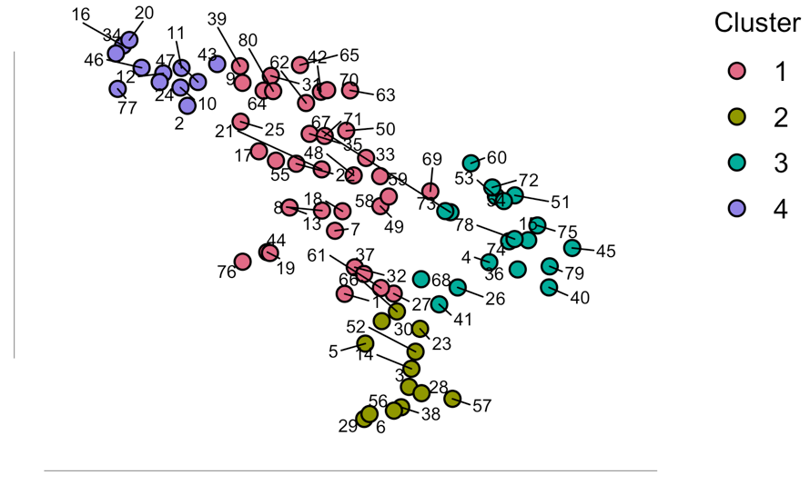
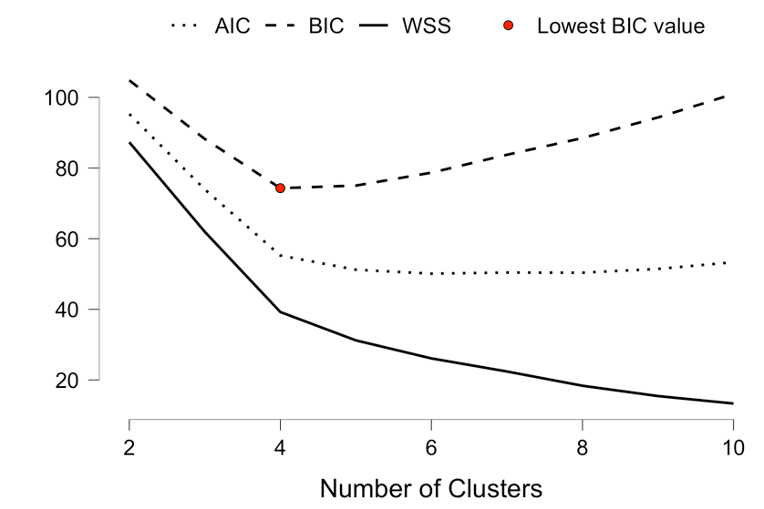
Additional Figure 1: Unbiased clustering analysis. Left: Elbow method for determining the number of clusters. Right: Scree plot of the four clusters based on consumption (g/kg) and time to achieve 50% of total rewards.

Clusters |  | N |  | R² |  | AIC |  | BIC |  | Silhouette
4 |  | 80 |  | 0.752 |  | 55.240 |  | 74.290 |  | 0.430
Additional Table 1. Values enabling adjustment of the best model obtained from the K-means clustering method.

