Figure A1 shows axial images, A2 displays coronal images, and A3 presents sagittal images, all demonstrating the implant (yellow, star), the 1 cm anterior edge around the implant (pink, thin arrow), and the 5 mm posterior margin around the implant (orange, thick arrow).
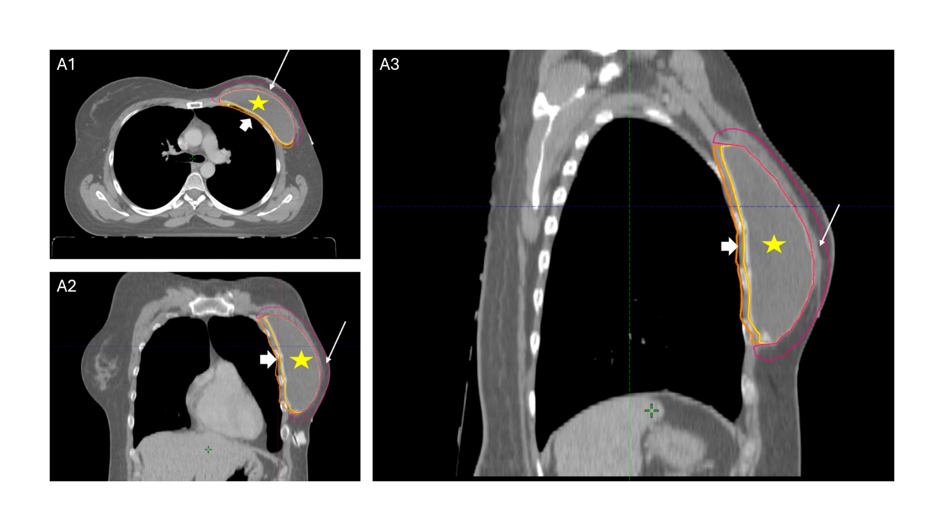

Figure B illustrates the delineation of the anterior edge of the implant, the implant itself, and the posterior edge, which is divided into parts located between the pectoralis minor and major muscles, as well as parts outside the pectoralis minor. B1 and B2 show the segments between and outside the muscles, on the axial section of the planning CT. B3 presents the coronal section, and B4 displays the sagittal section of the same planning CT (Thick arrow demonstrates the PMI, green star indicates the implant situated between the pectoralis minor and pectoralis major muscles, orange star indicates the part of the implant outside the pectoralis minor muscles, blue arrow illustrates the AEI for the part between the pectoralis minor and pectoralis major muscles, the purple arrow illustrates the AEI for the part located outside the pectoralis minor).
