Supplementary Information
The Supplementary Information contains complete information on the sixty different ecosystem structures that were studied in this work. This includes:
- Tables S1 through S4 listing the species composition of each ecosystem structure.
- Caricature representations of the complete ecosystem structure with all known species interactions, and the corresponding P-graph representation which we term the maximal structure (Figure S1). This maximal structure includes all of the following feasible structures.
- The corresponding P-graph representations of Structures 1-15 are illustrated in Figures S2-S12. Flows have been omitted, but details can be obtained from the excel file in the supplementary information or by running the accompanying P-graph model file. It is also worth noting that Figures S9 and S10 show that given the same structure with increased composition of benthic bacteria will reduce the harvest of crayfish.

Table S1. Species composition of the first 15 ecosystem structures. The entries indicate the amounts of species present in 10⁻² kg species/kg rice for each structure. Structures are organized in decreasing order of productivity which is defined as kg crayfish/kg rice. Further details can be found in the “Supplementary Information Ecosystem Solution Structures: Species-Trophic Links”.
Structures | P. Clarkii (Crayfish, 1) | Snail (2) | Aquatic Worm (3) | Chironomidae Larvae (4) | Copepoda (5) | Cladocera (6) | Rotifera (7) | Benthic Bacteria (8) | Bacterio-  plankton (9) | Aquatic Plants (10) | Rice (11) | Phyto-  plankton  (12) | Detritus (13)
Structure1 | 80.23 |  |  |  |  |  |  |  |  | 38.00 | 100.00 | 0.39 | 16.80
Structure2 | 79.87 |  |  |  |  |  | 0.53 | 0.04 | 0.05 | 38.00 | 100.00 | 0.39 | 16.80
Structure3 | 79.85 |  |  |  |  | 0.42 | 0.15 | 0.02 | 0.04 | 38.00 | 100.00 | 0.39 | 16.80
Structure4 | 79.84 |  |  |  |  |  |  |  |  | 38.00 | 100.00 | 0.39 | 16.80
Structure5 | 64.61 |  |  | 7.80 |  |  |  | 9.39 |  | 38.00 | 100.00 | 0.39 | 16.80
Structure6 | 64.61 |  |  | 7.80 |  |  |  |  | 9.39 | 38.00 | 100.00 | 0.39 | 16.80
Structure7 | 64.21 |  | 3.90 |  |  |  |  | 13.29 |  | 38.00 | 100.00 | 0.39 | 16.80
Structure8 | 64.21 |  | 3.90 |  |  |  |  |  | 13.29 | 38.00 | 100.00 | 0.39 | 16.80
Structure9 | 63.81 | 7.65 |  |  |  |  |  | 9.42 | 0.21 | 38.00 | 100.00 | 0.39 | 16.80
Structure10 | 63.81 | 7.65 |  |  |  |  |  |  | 9.63 | 38.00 | 100.00 | 0.39 | 16.80
Structure11 | 63.44 |  |  |  |  |  |  |  |  | 38.00 | 100.00 | 0.39
Structure12 | 63.26 |  |  |  |  |  | 0.53 | 16.65 | 0.05 | 38.00 | 100.00 | 0.39 | 16.80
Structure13 | 63.22 |  |  |  |  | 0.42 | 0.15 | 16.66 | 0.04 | 38.00 | 100.00 | 0.39 | 16.80
Structure14 | 63.14 |  |  |  | 0.23 | 0.27 | 0.19 | 16.67 | 0.04 | 38.00 | 100.00 | 0.39 | 16.80
Structure15 | 63.05 |  |  |  |  |  |  |  |  | 38.00 | 100.00 | 0.39

Table S2. Species composition ecosystem structures 16 to 30. The entries indicate the amounts of species present in 10⁻² kg species/kg rice for each structure. Structures are organized in decreasing order of productivity which is defined as kg crayfish/kg rice. Further details can be found in the “Supplementary Information Ecosystem Solution Structures: Species-Trophic Links”.
Structures | P. Clarkii (Crayfish, 1) | Snail (2) | Aquatic Worm (3) | Chironomidae Larvae (4) | Copepoda (5) | Cladocera (6) | Rotifera (7) | Benthic Bacteria (8) | Bacterio-  plankton (9) | Aquatic Plants (10) | Rice (11) | Phyto-  plankton  (12) | Detritus (13)
Structure16 | 55.19 |  |  |  |  |  |  |  |  | 38.00 | 100.00 | 0.39 | 16.80
Structure17 | 54.82 |  |  |  |  |  | 0.53 | 0.04 | 0.05 | 38.00 | 100.00 | 0.39 | 16.80
Structure18 | 54.80 |  |  |  |  | 0.42 | 0.15 | 0.02 | 0.04 | 38.00 | 100.00 | 0.39 | 16.80
Structure19 | 54.80 |  |  |  |  |  |  |  |  | 38.00 | 100.00 | 0.39 | 16.80
Structure20 | 42.23 |  |  |  |  |  |  |  |  | 38.00 | 100.00 | 0.39 | 16.80
Structure21 | 41.87 |  |  |  |  |  | 0.53 | 0.04 | 0.05 | 38.00 | 100.00 | 0.39 | 16.80
Structure22 | 41.85 |  |  |  |  | 0.42 | 0.15 | 0.02 | 0.04 | 38.00 | 100.00 | 0.39 | 16.80
Structure23 | 41.84 |  |  |  |  |  |  |  |  | 38.00 | 100.00 | 0.39 | 16.80
Structure24 | 39.56 |  |  | 7.80 |  |  |  | 9.39 |  | 38.00 | 100.00 | 0.39 | 16.80
Structure25 | 39.56 |  |  | 7.80 |  |  |  |  | 9.39 | 38.00 | 100.00 | 0.39 | 16.80
Structure26 | 39.17 |  | 3.90 |  |  |  |  | 13.29 |  | 38.00 | 100.00 | 0.39 | 16.80
Structure27 | 39.17 |  | 3.90 |  |  |  |  |  | 13.29 | 38.00 | 100.00 | 0.39 | 16.80
Structure28 | 38.76 | 7.65 |  |  |  |  |  | 9.42 | 0.21 | 38.00 | 100.00 | 0.39 | 16.80
Structure29 | 38.76 | 7.65 |  |  |  |  |  |  | 9.63 | 38.00 | 100.00 | 0.39 | 16.80
Structure30 | 38.39 |  |  |  |  |  |  |  |  | 38.00 | 100.00 | 0.39

Table S3. Species composition of ecosystem structures 31 to 45. The entries indicate the amounts of species present in 10⁻² kg species/kg rice for each structure. Structures are organized in decreasing order of productivity which is defined as kg Crayfish/kg rice. Further details can be found in the “Supplementary Information Ecosystem Solution Structures: Species-Trophic Links”.
Structures | P. Clarkii (Crayfish, 1) | Snail (2) | Aquatic Worm (3) | Chironomidae Larvae (4) | Copepoda (5) | Cladocera (6) | Rotifera (7) | Benthic Bacteria (8) | Bacterio-  plankton (9) | Aquatic Plants (10) | Rice (11) | Phyto-  plankton  (12) | Detritus (13)
Structure31 | 38.21 |  |  |  |  |  | 0.53 | 16.65 | 0.05 | 38.00 | 100.00 | 0.39 | 16.80
Structure32 | 38.17 |  |  |  |  | 0.42 | 0.15 | 16.66 | 0.04 | 38.00 | 100.00 | 0.39 | 16.80
Structure33 | 38.09 |  |  |  | 0.23 | 0.27 | 0.19 | 16.67 | 0.04 | 38.00 | 100.00 | 0.39 | 16.80
Structure34 | 38.00 |  |  |  |  |  |  |  |  | 38.00 | 100.00 | 0.39
Structure35 | 26.61 |  |  | 7.80 |  |  |  | 9.39 |  | 38.00 | 100.00 | 0.39 | 16.80
Structure36 | 26.61 |  |  | 7.80 |  |  |  |  | 9.39 | 38.00 | 100.00 | 0.39 | 16.80
Structure37 | 26.22 |  | 3.90 |  |  |  |  | 13.29 |  | 38.00 | 100.00 | 0.39 | 16.80
Structure38 | 26.22 |  | 3.90 |  |  |  |  |  | 13.29 | 38.00 | 100.00 | 0.39 | 16.80
Structure39 | 25.81 | 7.65 |  |  |  |  |  | 9.42 | 0.21 | 38.00 | 100.00 | 0.39 | 16.80
Structure40 | 25.81 | 7.65 |  |  |  |  |  |  | 9.63 | 38.00 | 100.00 | 0.39 | 16.80
Structure41 | 25.44 |  |  |  |  |  |  |  |  | 38.00 | 100.00 | 0.39
Structure42 | 25.26 |  |  |  |  |  | 0.53 | 16.65 | 0.05 | 38.00 | 100.00 | 0.39 | 16.80
Structure43 | 25.22 |  |  |  |  | 0.42 | 0.15 | 16.66 | 0.04 | 38.00 | 100.00 | 0.39 | 16.80
Structure44 | 25.14 |  |  |  | 0.23 | 0.27 | 0.19 | 16.67 | 0.04 | 38.00 | 100.00 | 0.39 | 16.80
Structure45 | 25.05 |  |  |  |  |  |  |  |  | 38.00 | 100.00 | 0.39

Table S4. Species composition of the ecosystem structures 46 to 60. The entries indicate the amounts of species present in 10⁻² kg species/kg rice for each structure. Structures are organized in decreasing order of productivity which is defined as kg crayfish/kg rice. Further details can be found in the “Supplementary Information Ecosystem Solution Structures: Species-Trophic Links”.
Structures | P. Clarkii (Crayfish, 1) | Snail (2) | Aquatic Worm (3) | Chironomidae Larvae (4) | Copepoda (5) | Cladocera (6) | Rotifera (7) | Benthic Bacteria (8) | Bacterio-  plankton (9) | Aquatic Plants (10) | Rice (11) | Phyto-  plankton  (12) | Detritus (13)
Structure46 | 17.19 |  |  |  |  |  |  |  |  | 38.00 | 100.00 | 0.39 | 16.80
Structure47 | 16.82 |  |  |  |  |  | 0.53 | 0.04 | 0.05 | 38.00 | 100.00 | 0.39 | 16.80
Structure48 | 16.80 |  |  |  |  | 0.42 | 0.15 | 0.02 | 0.04 | 38.00 | 100.00 | 0.39 | 16.80
Structure49 | 16.80 |  |  |  |  |  |  |  |  | 38.00 | 100.00 | 0.39 | 16.80
Structure50 | 1.56 |  |  | 7.80 |  |  |  | 9.39 |  | 38.00 | 100.00 | 0.39 | 16.80
Structure51 | 1.56 |  |  | 7.80 |  |  |  |  | 9.39 | 38.00 | 100.00 | 0.39 | 16.80
Structure52 | 1.17 |  | 3.90 |  |  |  |  | 13.29 |  | 38.00 | 100.00 | 0.39 | 16.80
Structure53 | 1.17 |  | 3.90 |  |  |  |  |  | 13.29 | 38.00 | 100.00 | 0.39 | 16.80
Structure54 | 0.76 | 7.65 |  |  |  |  |  |  | 9.63 | 38.00 | 100.00 | 0.39 | 16.80
Structure55 | 0.76 | 7.65 |  |  |  |  |  | 9.42 | 0.21 | 38.00 | 100.00 | 0.39 | 16.80
Structure56 | 0.39 |  |  |  |  |  |  |  |  | 38.00 | 100.00 | 0.39
Structure57 | 0.21 |  |  |  |  |  | 0.53 | 16.65 | 0.05 | 38.00 | 100.00 | 0.39 | 16.80
Structure58 | 0.17 |  |  |  |  | 0.42 | 0.15 | 16.66 | 0.04 | 38.00 | 100.00 | 0.39 | 16.80
Structure59 | 0.09 |  |  |  | 0.23 | 0.27 | 0.19 | 16.67 | 0.04 | 38.00 | 100.00 | 0.39 | 16.80
Structure60 |  |  |  |  |  |  |  |  |  | 38.00 | 100.00 | 0.39

(a)
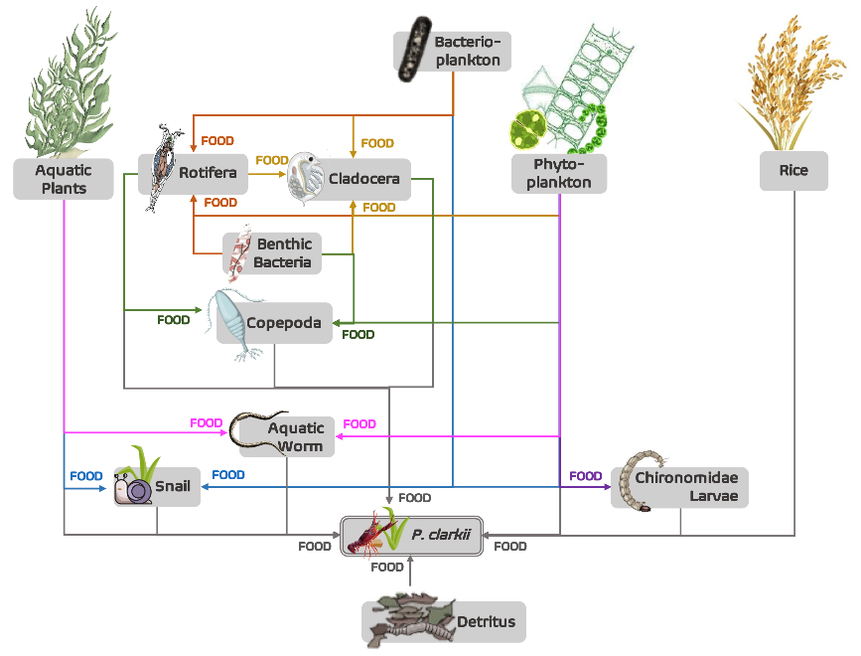
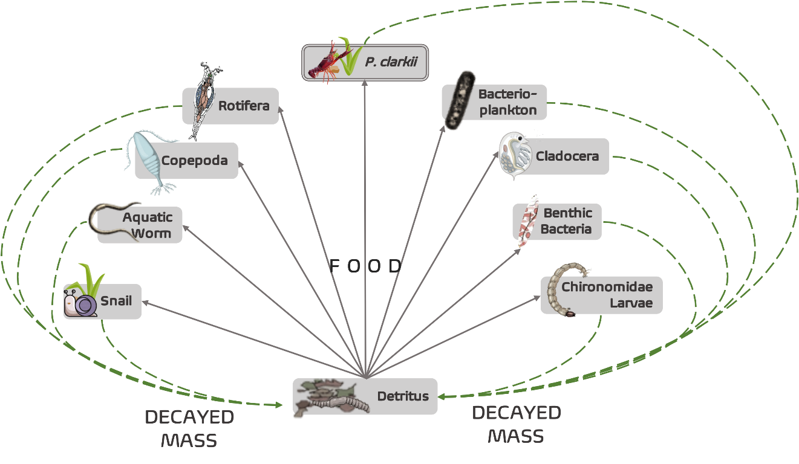
(b)
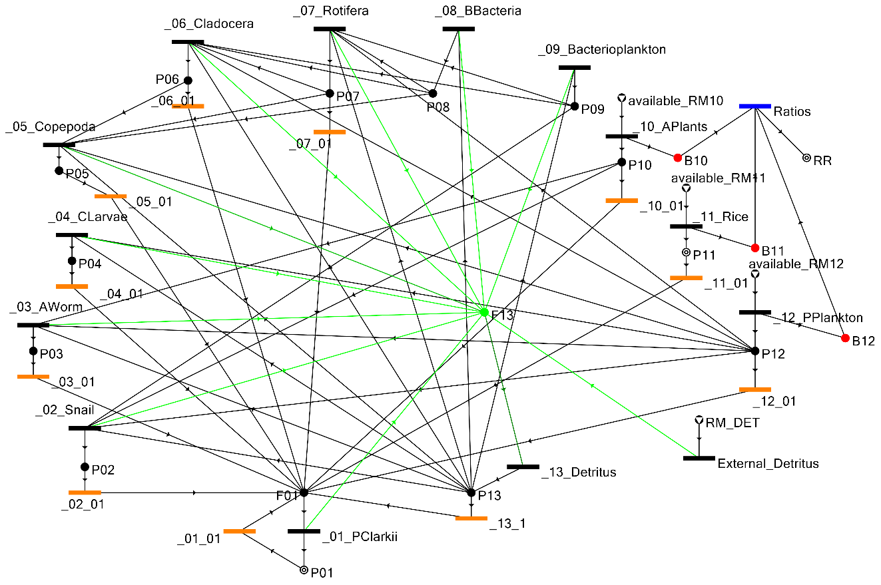
Figure S1. The rice-crayfish co-culture system described in [5]. In (a), the schematic diagram of the diet composition of species in co-production of rice and crayfish systems (left) and the role of the detritus in the ecosystem (right) are illustrated. The corresponding socio-ecological process graph, that is a superstructure of the rice-crayfish ecosystem, describing the interaction between species is presented in (b). Note that the species number label corresponds to the species name and number enumerated in Table S1.

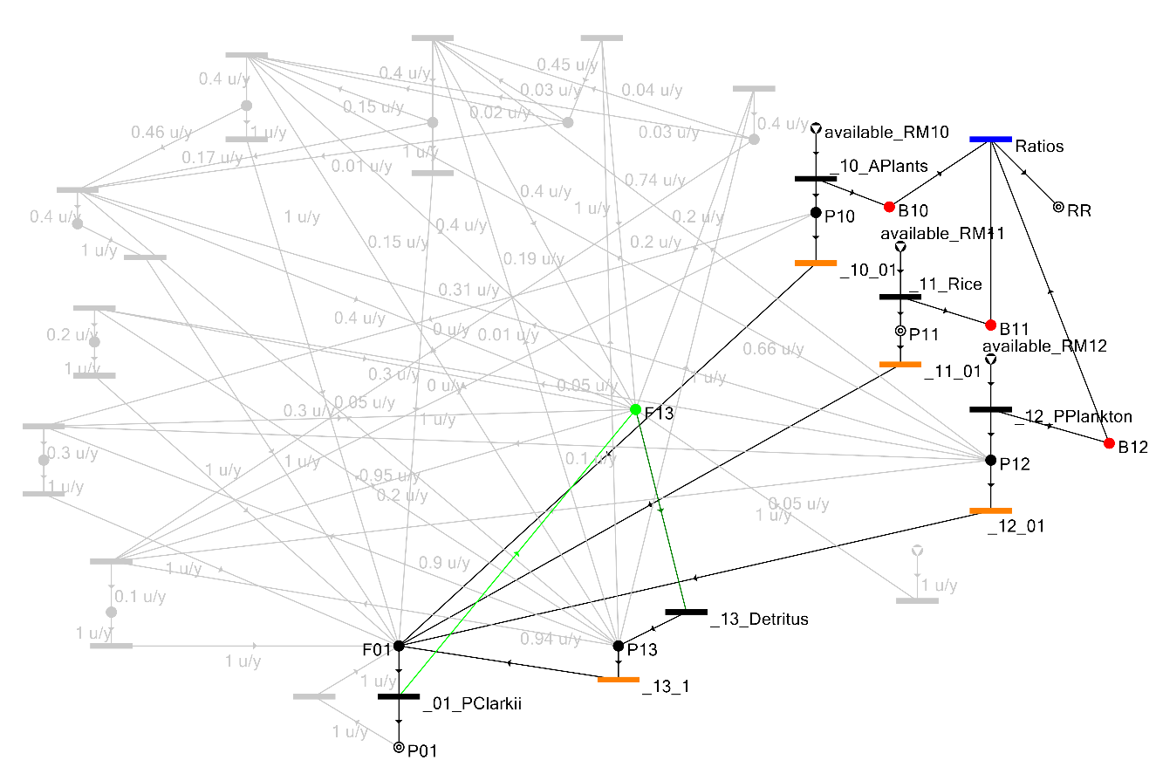
Figure S2. The optimal socio-ecological process graph Structure 1. Given the fixed/assumed supply of aquatic plants, rice, phytoplankton, and detritus (shown in Table S1) as food sources of crayfish, Structure 1 is generated through ABB providing optimal harvest or production of 80.23 × 10⁻² kg crayfish/kg rice.

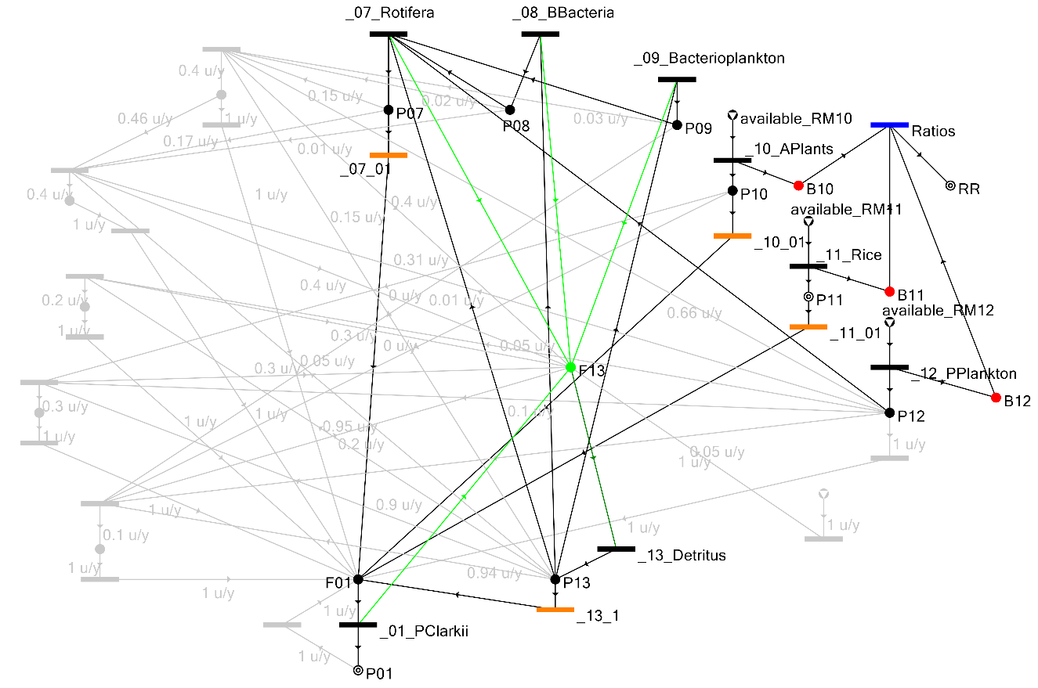
Figure S3. Near Optimal socio-ecological process graph Structure 2. Aside from the food sources defined in Structure 1, Structure 2 also included Rotifera, Benthic Bacteria, and Bacterioplankton as food sources of crayfish. With these additional food sources, the harvest of crayfish is reduced (by a very small difference) to 79.87 × 10⁻² kg crayfish/kg rice.

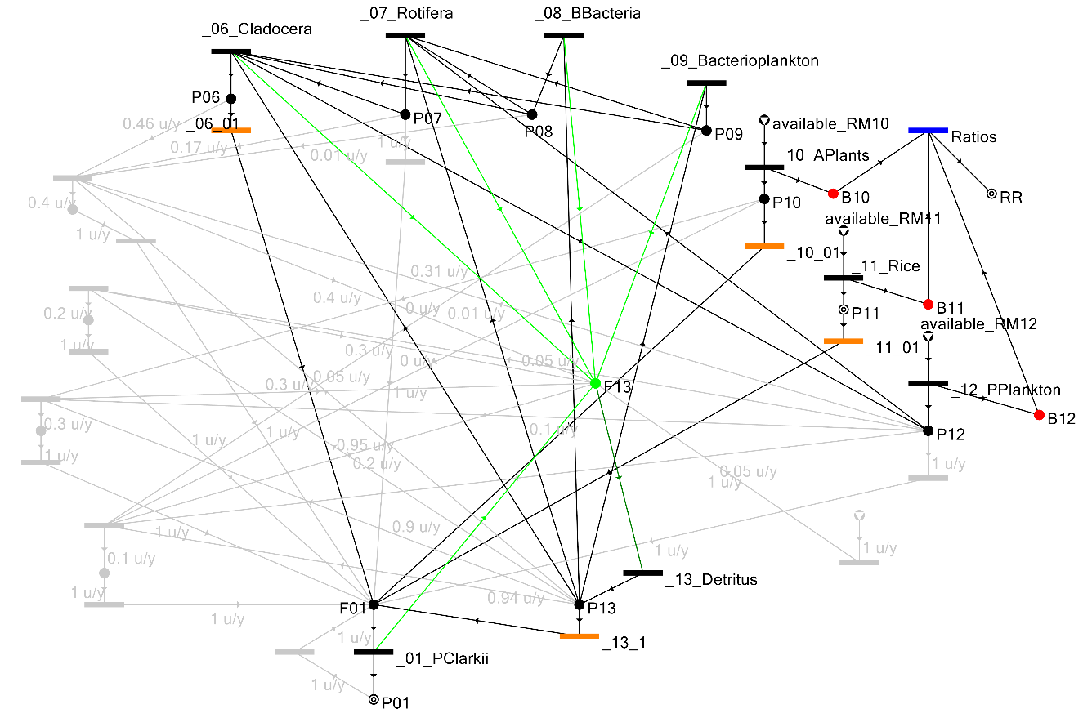
Figure S4. Near Optimal socio-ecological process graph Structure 3. Adding Cladocera to Structure 2 as food source of crayfish and having different species compositions, Structure 3’s crayfish harvest is reduced (by a very small fraction) to 79.85 × 10⁻² kg crayfish/kg rice.

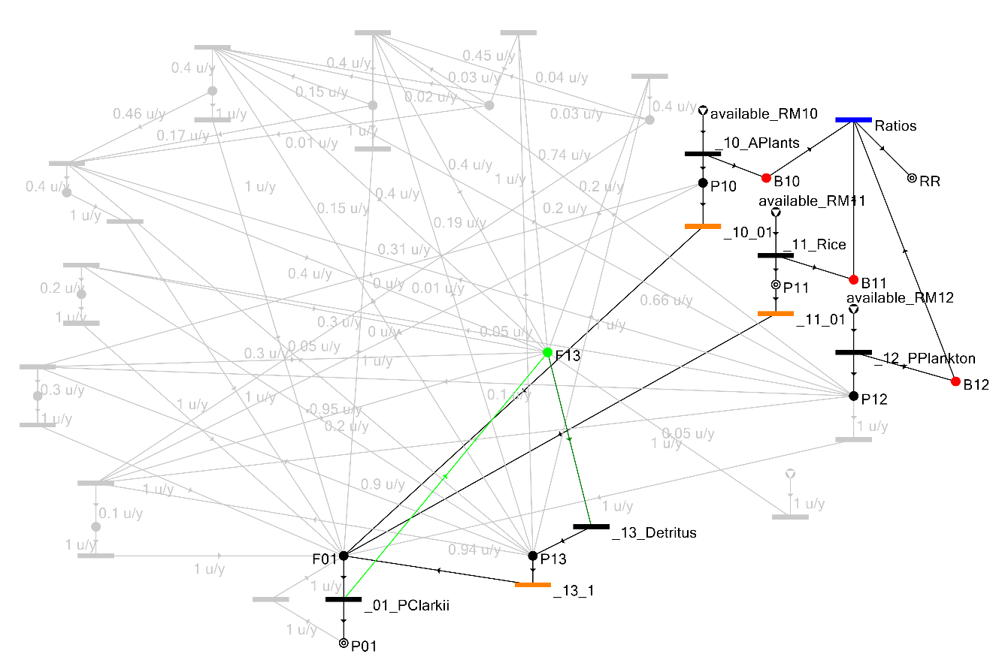
Figure S5: Near Optimal socio-ecological process graph Structure 4 is like Structure 1 but the Phytoplankton is not used as a food source by the crayfish resulting in a crayfish harvest of 79.84 × 10⁻² kg crayfish/kg rice. In this case, the food sources for the crayfish are Aquatic Plants and Rice.

(a)
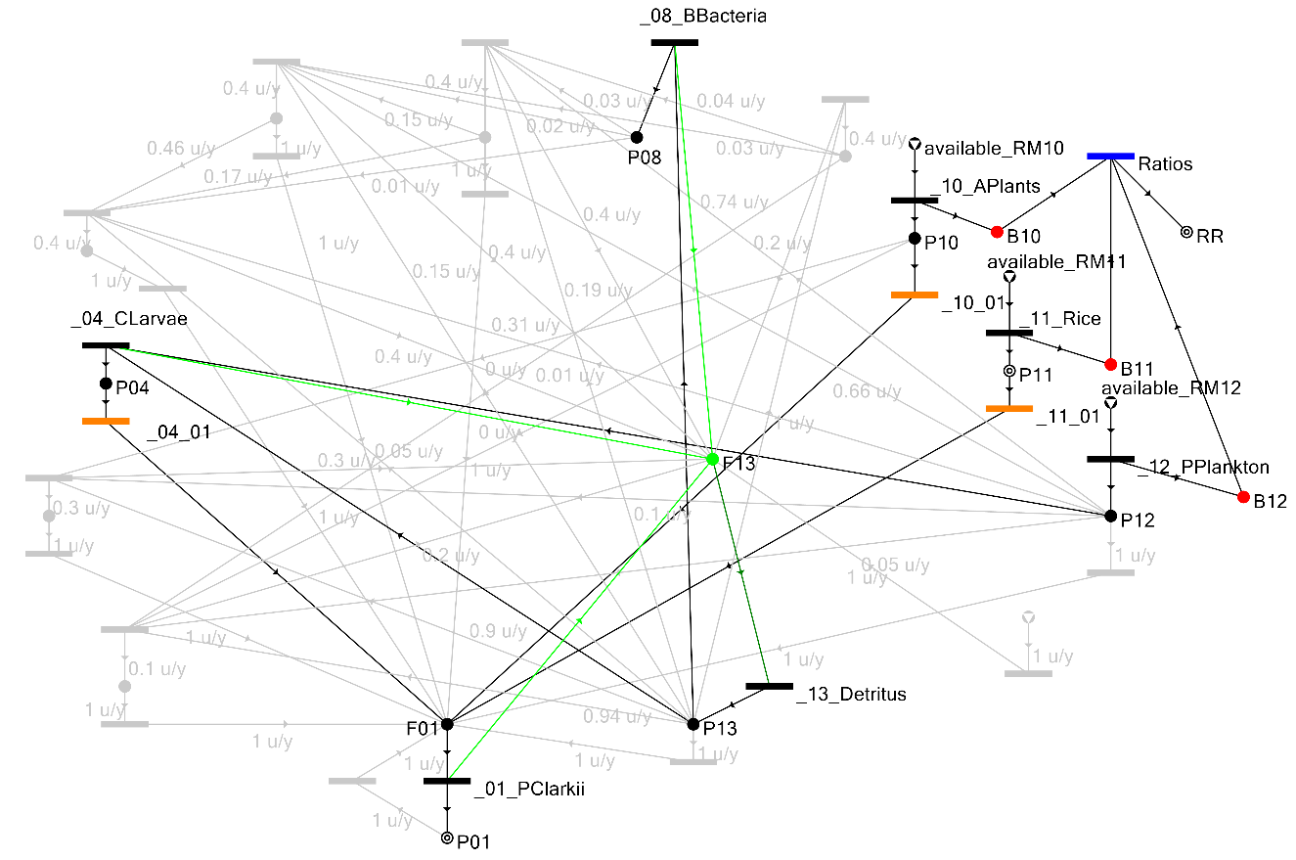
(b)
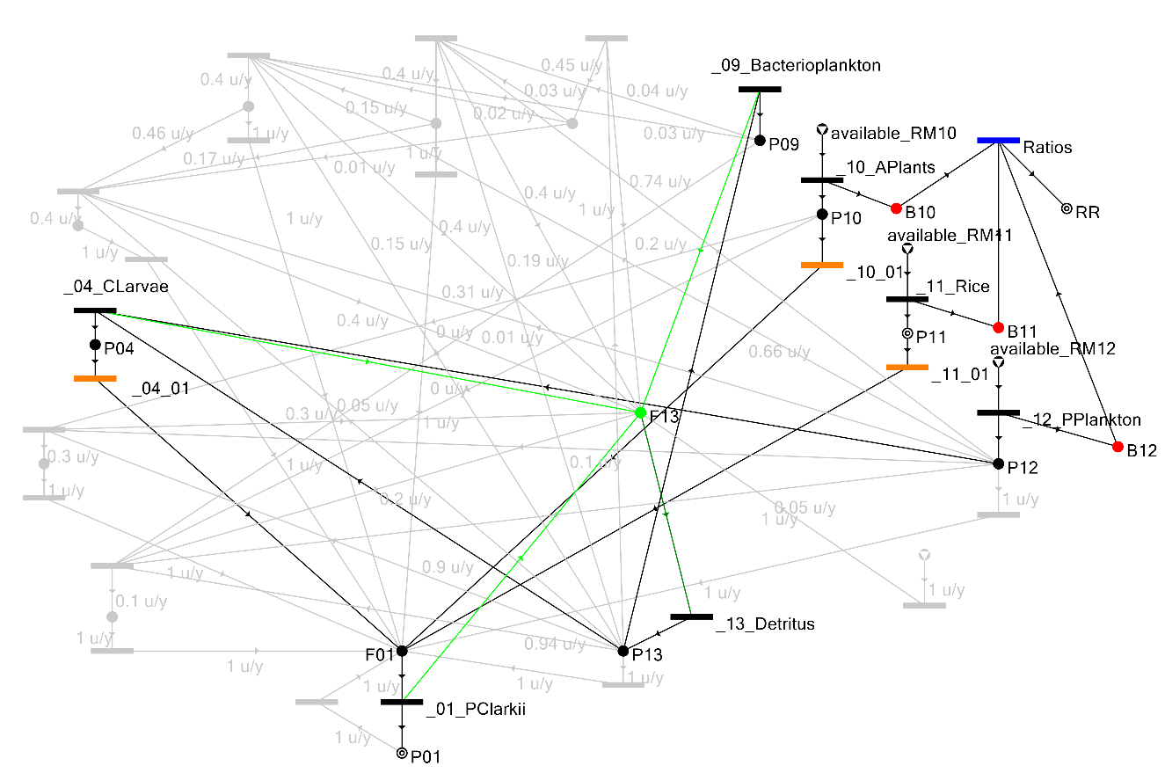
Figure S6. Near Optimal socio-ecological process graph Structures 5 (a) and 6 (b). These two feasible structures harvest the same amounts of crayfish (i.e. 64.61 × 10⁻² kg crayfish/kg rice) and have the following common food sources: Chironomidae larvae, aquatic plants, rice, phytoplankton, and detritus. The socio-ecological process graph Structures 5 and 6 contain Benthic Bacteria and Bacterioplankton as unique food sources for crayfish, respectively.

(a)
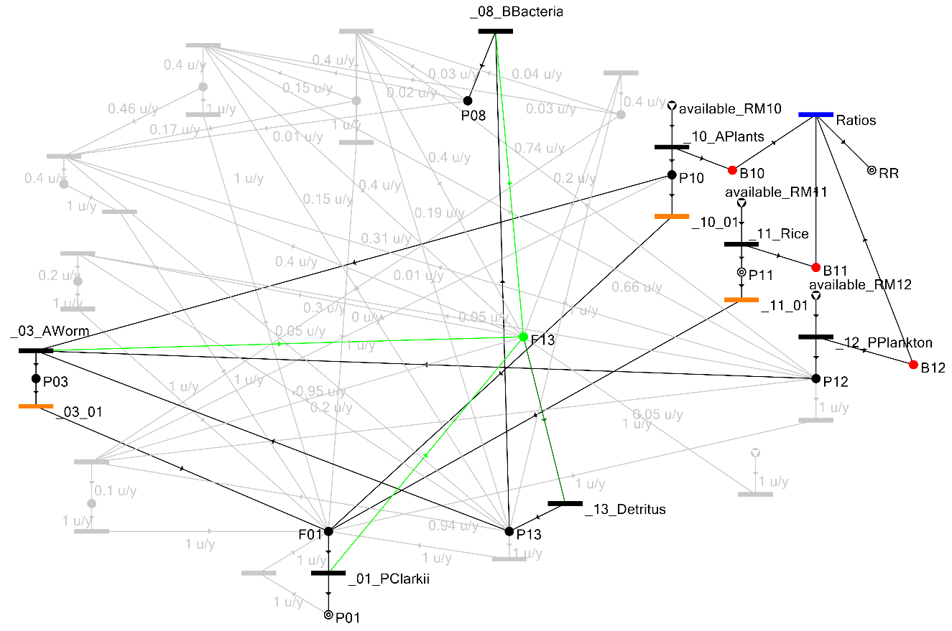
(b)
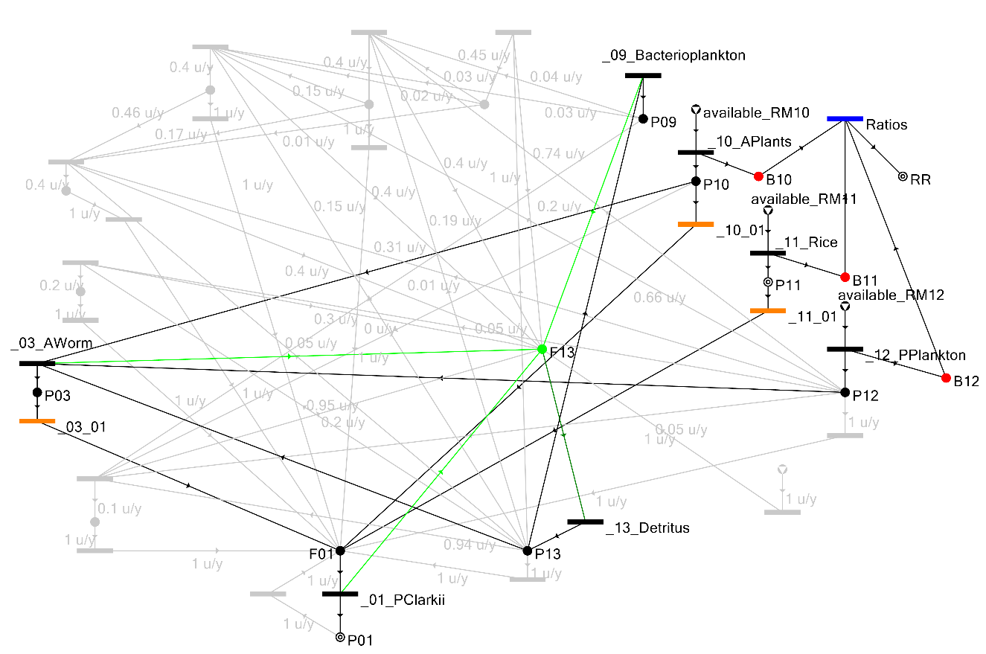
Figure S7. Near Optimal socio-ecological process graph Structures 7 (a) and 8 (b). These two feasible structures harvest the same amounts of crayfish (i.e. 64.21 × 10⁻² kg crayfish/kg rice) and have the following common food sources: aquatic worm, aquatic plants, rice, phytoplankton, and detritus. The socio-ecological process graph Structures 7 and 8 contain Benthic Bacteria and Bacterioplankton as unique food sources for crayfish, respectively.

(a)
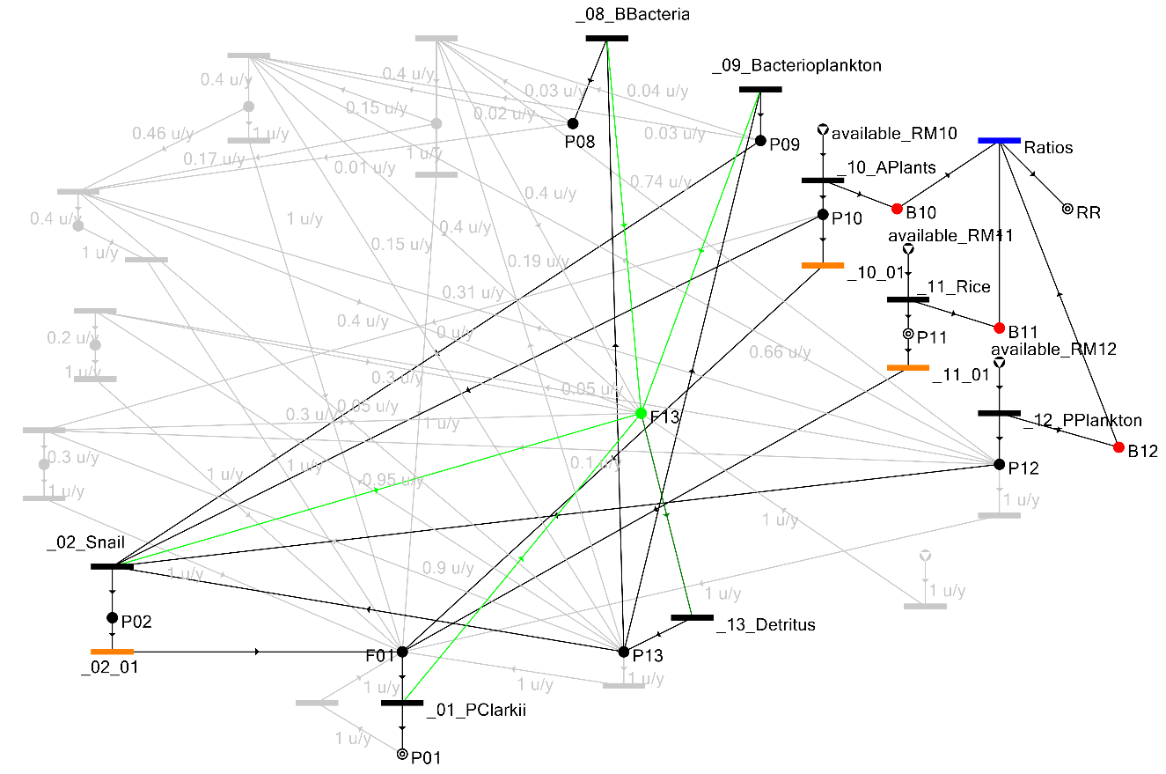
(b)
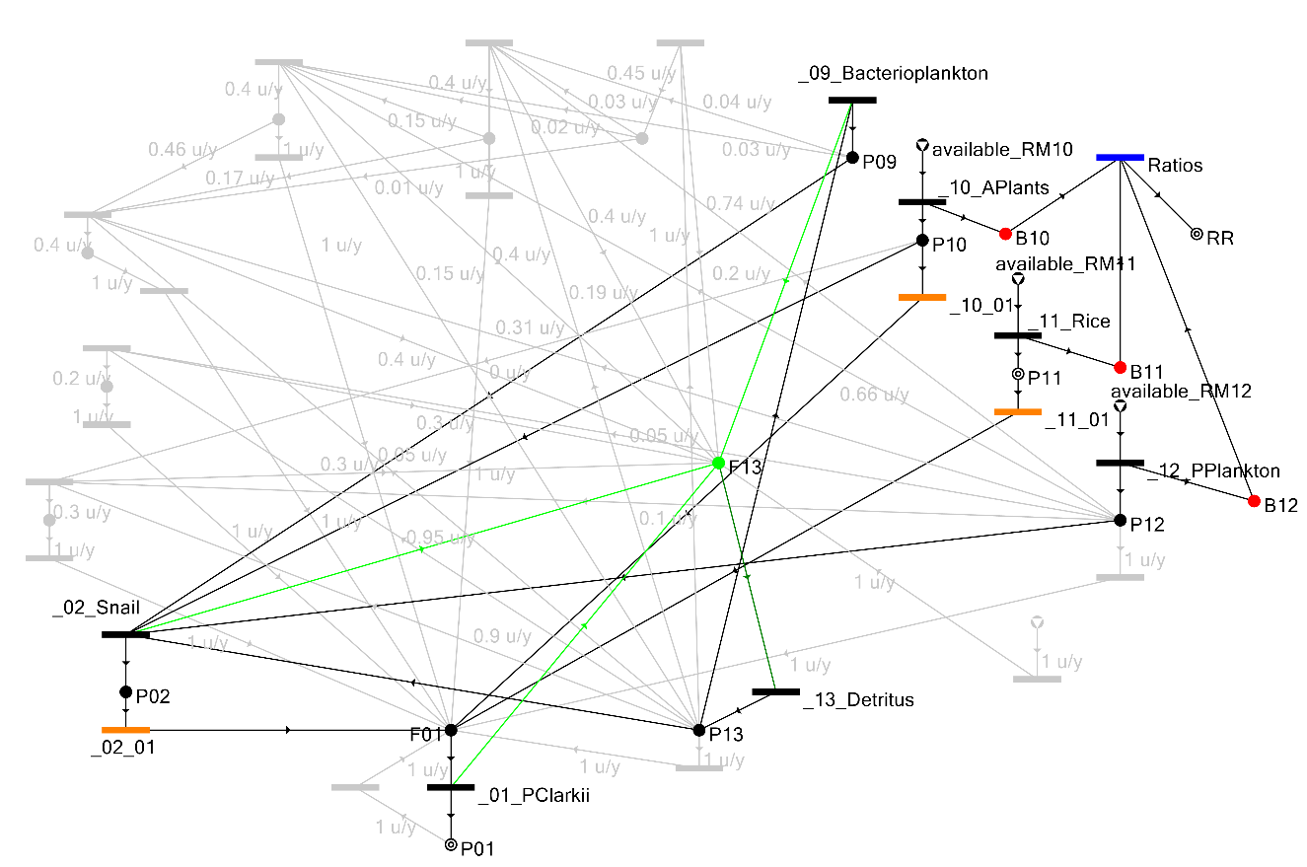
Figure S7. Near Optimal socio-ecological process graph Structures 9 (a) and 10 (b). These two feasible structures harvest the same amounts of crayfish (i.e. 63.81 × 10⁻² kg crayfish/kg rice) and have the following common food sources: snail, bacterioplankton, aquatic plants, rice, phytoplankton, and detritus. The socio-ecological process graph Structure 9 has Benthic Bacteria as an additional food source for crayfish without affecting the amounts of crayfish being harvested.

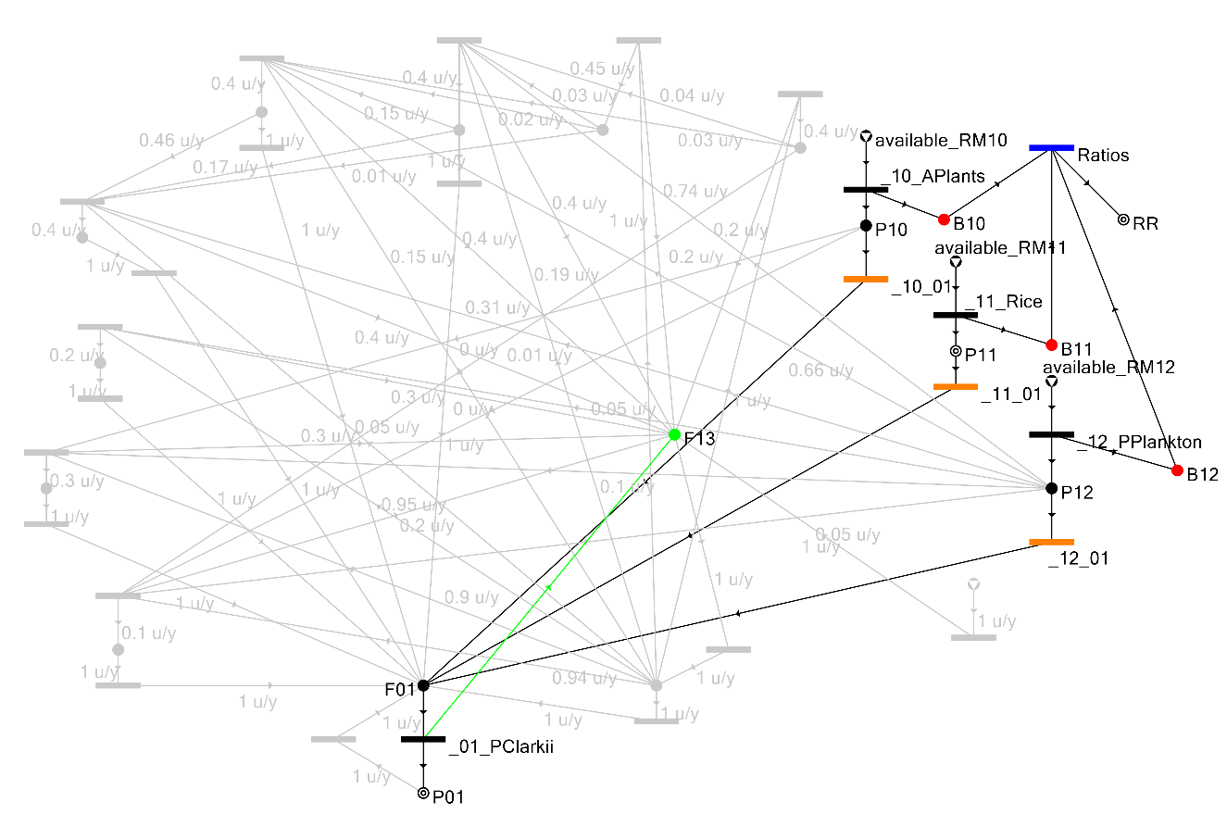
Figure S8. Near Optimal socio-ecological process graph Structure 11. This feasible structure is almost similar to the optimal Structure 1 except that it excluded Detritus. Without Detritus as the food source of Crayfish, the harvest is drastically reduced to 63.44 × 10⁻² kg crayfish/kg rice from 80.23 × 10⁻² kg crayfish/kg rice of Structure 1.

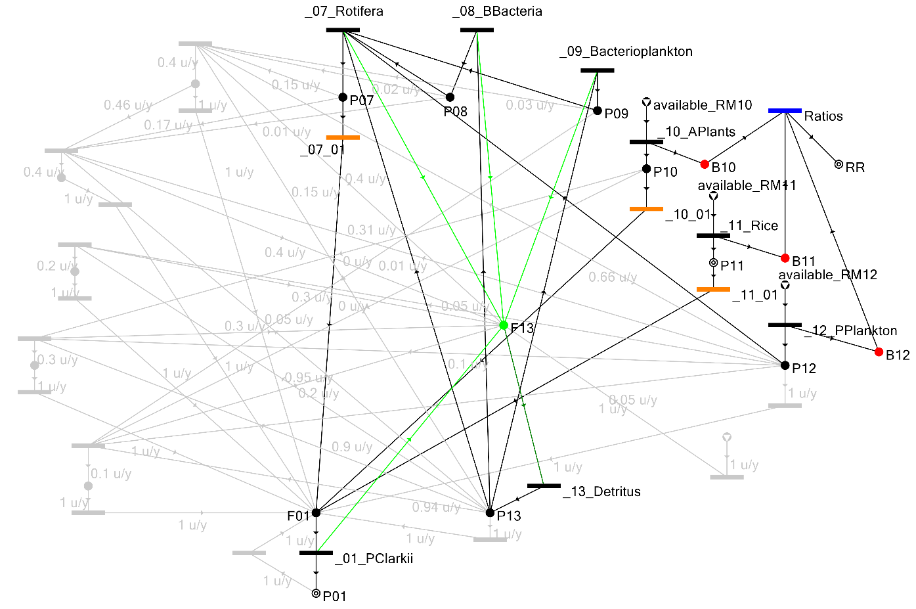
Figure S9: Near Optimal socio-ecological process graph Structure 12. This feasible structure is exactly the same as that of Structure 2 but with different compositions of Benthic Bacteria (0.04 × 10⁻² kg benthic bacteria/kg rice for Structure 2 and 16.65 × 10⁻² kg benthic bacteria/kg rice for Structure 12). With more compositions of Benthic Bacteria, the harvest is reduced to 63.26 × 10⁻² kg crayfish/kg rice from 79.87 × 10⁻² kg crayfish/kg rice of Structure 2.

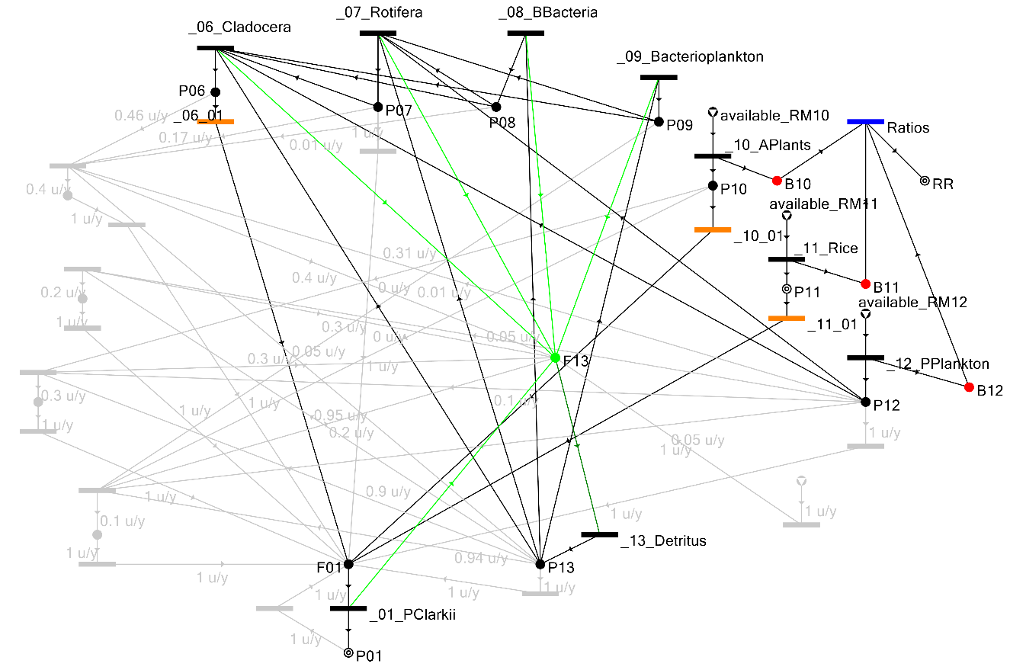
Figure S10. Near Optimal socio-ecological process graph Structure 13. This feasible structure is exactly the same as that of Structure 3 but with different compositions of Benthic Bacteria (0.02 × 10⁻² kg benthic bacteria/kg rice for Structure 3 and 16.66 × 10⁻² kg benthic bacteria/kg rice for Structure 13). With more compositions of Benthic Bacteria, the harvest is reduced to 63.22 × 10⁻² kg crayfish/kg rice from 79.85 × 10⁻² kg crayfish/kg rice of Structure 3.

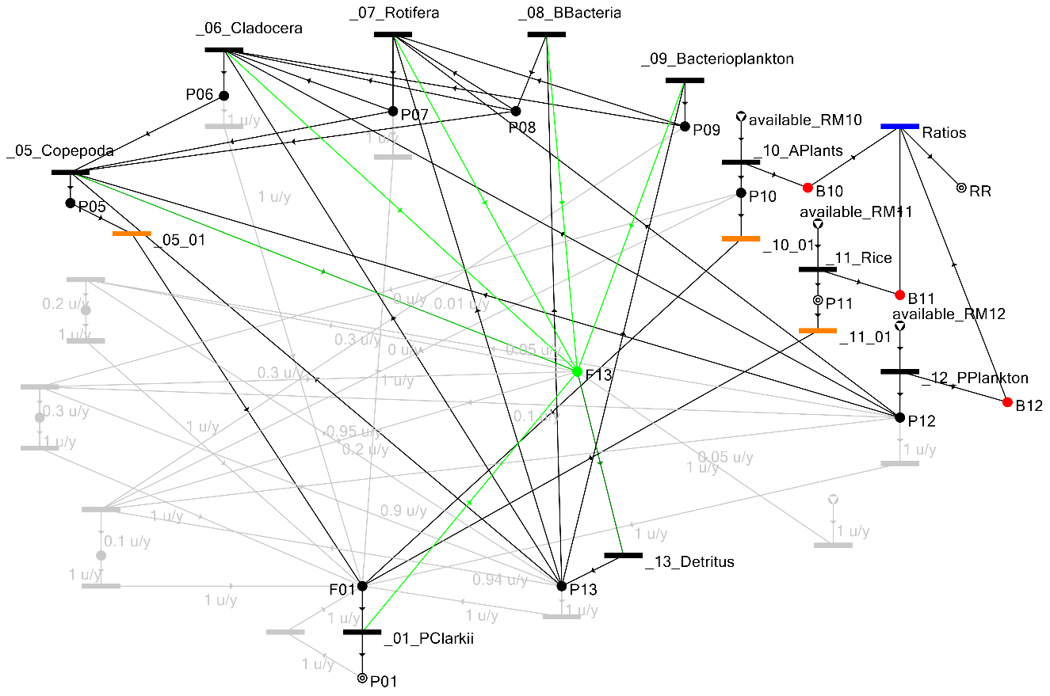
Figure S11. Near Optimal socio-ecological process graph Structure 14. Adding Copepoda to Structures 3 and 13, as food source of crayfish and having different species compositions, the crayfish harvest is almost the same as Structure 13, i.e., 63.14 × 10⁻² kg crayfish/kg rice.

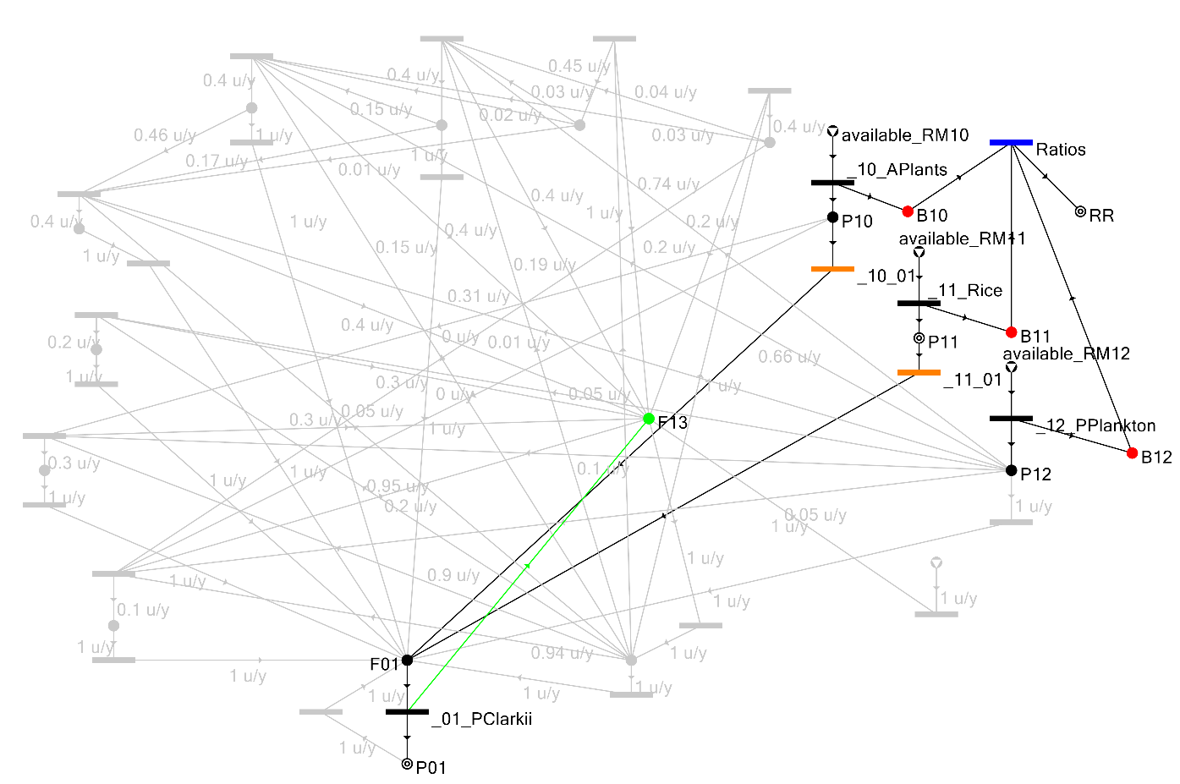
Figure S12. Near Optimal socio-ecological process graph Structure 15. This structure is like Structure 11 except that Phytoplankton is not used as a food source of the Crayfish. Because of this, the harvested crayfish is reduced from 63.44 × 10⁻² kg crayfish/kg rice to 63.05 × 10⁻² kg crayfish/kg rice

