Additional files

1. Additional file 1- PRISMA checklist
2. Additional file 2 - Electronic database search
2. Additional file 3 - Full article screening results with levels of agreement
4. Additional file 4 - Extraction file for the Primary outcome
5. Additional file 5 - Funnel plot for systolic blood pressure for 14 articles included
6. Additional file 6 - Funnel plot for diastolic blood pressure for 14 articles included
7. Additional file 7 - Funnel plot for systolic blood pressure for 12 articles included
8. Additional file 8 - Funnel plot for diastolic blood pressure for 12 articles included
9. Additional file 9 - Results showing synthesis of secondary outcome
10. Additional file 10- GRADE results

Additional file 1: PRISMA Checklist
Section/topic | # | Checklist item | Reported on page #
TITLE
Title | 1 | Identify the report as a systematic review, meta-analysis, or both. | 1
ABSTRACT
Structured summary | 2 | Provide a structured summary including, as applicable: background; objectives; data sources; study eligibility criteria, participants, and interventions; study appraisal and synthesis methods; results; limitations; conclusions and implications of key findings; systematic review registration number. | 2-3
INTRODUCTION
Rationale | 5 | Describe the rationale for the review in the context of what is already known. | 4-6
Objectives | 4 | Provide an explicit statement of questions being addressed with reference to participants, interventions, comparisons, outcomes, and study design (PICOS). | 6
METHODS
Protocol and registration | 5 | Indicate if a review protocol exists, if and where it can be accessed (e.g., Web address), and, if available, provide registration information including registration number. | 6
Eligibility criteria | 6 | Specify study characteristics (e.g., PICOS, length of follow-up) and report characteristics (e.g., years considered, language, publication status) used as criteria for eligibility, giving rationale. | 7
Information sources | 7 | Describe all information sources (e.g., databases with dates of coverage, contact with study authors to identify additional studies) in the search and date last searched. | 8
Search | 8 | Present full electronic search strategy for at least one database, including any limits used, such that it could be repeated. | Page 8,Additional file 2
Study selection | 9 | State the process for selecting studies (i.e., screening, eligibility, included in systematic review, and, if applicable, included in the meta-analysis). | 9
Data collection process | 10 | Describe method of data extraction from reports (e.g., piloted forms, independently, in duplicate) and any processes for obtaining and confirming data from investigators. | 9 -10
Data items | 11 | List and define all variables for which data were sought (e.g., PICOS, funding sources) and any assumptions and simplifications made. | 10
Risk of bias in individual studies | 12 | Describe methods used for assessing risk of bias of individual studies (including specification of whether this was done at the study or outcome level), and how this information is to be used in any data synthesis. | 10,Figure 2
Summary measures | 13 | State the principal summary measures (e.g., risk ratio, difference in means). | 10-11
Synthesis of results | 14 | Describe the methods of handling data and combining results of studies, if done, including measures of consistency (e.g., I²) for each meta-analysis. | 10-11, Additional file 4,Additional file 9

Page 1 of 2
Section/topic | # | Checklist item | Reported on page #
Risk of bias across studies | 15 | Specify any assessment of risk of bias that may affect the cumulative evidence (e.g., publication bias, selective reporting within studies). | Additional file 5-8
Additional analyses | 16 | Describe methods of additional analyses (e.g., sensitivity or subgroup analyses, meta-regression), if done, indicating which were pre-specified. | NA
RESULTS
Study selection | 17 | Give numbers of studies screened, assessed for eligibility, and included in the review, with reasons for exclusions at each stage, ideally with a flow diagram. | 14
Study characteristics | 18 | For each study, present characteristics for which data were extracted (e.g., study size, PICOS, follow-up period) and provide the citations. | Table 1
Risk of bias within studies | 19 | Present data on risk of bias of each study and, if available, any outcome level assessment (see item 12). | Table 2
Results of individual studies | 20 | For all outcomes considered (benefits or harms), present, for each study: (a) simple summary data for each intervention group (b) effect estimates and confidence intervals, ideally with a forest plot. | Additional file 5- 8
Synthesis of results | 21 | Present the main results of the review. If meta-analyses are done, include for each, confidence intervals and measures of consistency. | 17,Figure3-6
Risk of bias across studies | 22 | Present results of any assessment of risk of bias across studies (see Item 15). | NA
Additional analysis | 23 | Give results of additional analyses, if done (e.g., sensitivity or subgroup analyses, meta-regression [see Item 16]). | NA
DISCUSSION
Summary of evidence | 24 | Summarize the main findings including the strength of evidence for each main outcome; consider their relevance to key groups (e.g., healthcare providers, users, and policy makers). | 22
Limitations | 25 | Discuss limitations at study and outcome level (e.g., risk of bias), and at review-level (e.g., incomplete retrieval of identified research, reporting bias). | 22-23
Conclusions | 26 | Provide a general interpretation of the results in the context of other evidence, and implications for future research. | 24-25
FUNDING
Funding | 27 | Describe sources of funding for the systematic review and other support (e.g., supply of data); role of funders for the systematic review. | 27

From: Moher D, Liberati A, Tetzlaff J, Altman DG, The PRISMA Group (2009). Preferred Reporting Items for Systematic Reviews and Meta-Analyses: The PRISMA Statement. PLoS Med 6(7): e1000097. doi:10.1371/journal.pmed1000097
For more information, visit: www.prisma-statement.org.
Page 2 of 2

Additional file 2: Electronic data base search results for title screening
Search Date | Search Engine | Keywords | Number of studies found | Number of studies included
23-03-2020 | EBSCOhost (included Academic Search Complete) | ( hypertension or high blood pressure or elevated blood pressure or htn or hypertensive ) AND ( adherence or compliance or non-adherence or noncompliance or treatment adherence or treatment compliance ) OR ( blood pressure control or blood pressure management ) AND ( (randomised controlled trial or randomized controlled trial or rct) ) OR ( (educational interventions or  strategies or self-monitoring or models on appointment reminder systems or organisational interventions) ) AND ( (lmic or low income countries or middle income countries or developing countries or low and middle income countries) ) | 15618 | 225
24 -03-2020 | EBSCOhost (included CINAHL Complete) | ( hypertension or high blood pressure or elevated blood pressure or htn or hypertensive ) AND ( adherence or compliance or nonadherence or noncompliance or treatment adherence or treatment compliance ) OR ( blood pressure control or blood pressure management ) AND ( (randomised controlled trial or randomized controlled trial or rct) ) OR ( (educational interventions or strategies or self monitoring or models on appointment reminder systems or organisational interventions) ) AND ( (lmic or low income countries or middle income countries or developing countries or low and middle income countries) ) | 9821 | 132
24 -03-2020 | EBSCOhost (included MEDLINE Complete) | ( hypertension or high blood pressure or elevated blood pressure or htn or hypertensive ) AND ( adherence or compliance or nonadherence or noncompliance or treatment adherence or treatment compliance ) OR ( blood pressure control or blood pressure management ) AND ( randomised controlled trial or randomized controlled trial or rct ) OR ( educational interventions or strategies or self-monitoring or models on appointment reminder systems or organisational interventions ) AND ( lmic or low income countries or middle income countries or developing countries or low and middle income countries ) | 20800 | 134
24 -03-2020 | PubMed | ((((((hypertension OR high blood pressure OR elevated blood pressure OR htn OR hypertensive)) AND (adherence OR compliance OR nonadherence OR noncompliance OR treatment adherence OR treatment compliance)) OR (blood pressure control OR blood pressure management)) AND (randomised controlled trial OR randomized controlled trial OR rct)) OR (educational interventions OR strategies OR self-monitoring OR models on appointment reminder systems OR organisational interventions)) AND (lmic OR low income countries OR middle income countries OR developing countries OR low and middle income countries) AND (("2005/01/01"[PDat] : "2020/12/31"[PDat])) | 35457 | 43
26 -03-2020 | Web of Science | (((TOPIC: ((((hypertension OR high blood pressure) OR elevated blood pressure) OR htn) OR hypertensive) AND TOPIC: (((((adherence OR compliance) OR nonadherence) OR noncompliance) OR treatment adherence) OR treatment compliance)) OR (TOPIC: (blood pressure control OR blood pressure management) AND TOPIC: ((randomised controlled trial OR randomized controlled trial) OR rct))) OR (TOPIC: ((((educational interventions OR strategies) OR self-monitoring) OR models on appointment reminder systems) OR organisational interventions) AND TOPIC: ((((lmic OR low income countries) OR middle income countries) OR developing countries) OR (low AND middle income countries))))  Indexes=SCI-EXPANDED, SSCI, A&HCI, ESCI Timespan=2005-2020 | 58510 | 208
26-03- 2020 | Cochrane Database of Systematic Reviews | ( hypertension or high blood pressure or elevated blood pressure or htn or hypertensive ) AND ( adherence or compliance or nonadherence or noncompliance or treatment adherence or treatment compliance ) OR ( blood pressure control or blood pressure management ) AND ( (randomised controlled trial or randomized controlled trial or rct) ) OR ( (educational interventions or strategies or self-monitoring or models on appointment reminder systems or organisational interventions) ) AND ( (lmic or low income countries or middle income countries or developing countries or low and middle income countries) ) | 2360 | 22
26-03-2020 | Cochrane Central Register of Controlled Trials | ( hypertension or high blood pressure or elevated blood pressure or htn or hypertensive ) AND ( adherence or compliance or nonadherence or noncompliance or treatment adherence or treatment compliance ) OR ( blood pressure control or blood pressure management ) AND ( (randomised controlled trial or randomized controlled trial or rct) ) OR ( (educational interventions or strategies or self-monitoring or models on appointment reminder systems or organisational interventions) ) AND ( (lmic or low income countries or middle income countries or developing countries or low and middle income countries) ) in Title Abstract Keyword - with Publication Year from 2005 to 2020, with Cochrane Library publication date Between Jan 2005 and Jan 2020, in Trials with 'Tobacco Addiction', 'Urology', 'Public Health', 'Acute Respiratory Infections', 'Cochrane Brazil', 'Vascular', 'Cochrane Germany', 'Emergency and Critical Care', 'Pain, Palliative and Supportive Care', 'Cochrane UK', 'Metabolic and Endocrine Disorders', 'Lung Cancer', 'Cochrane Australia', 'Cochrane Thailand', 'Effective Practice and Organisation of Care', 'Airways', 'Neuromuscular', 'Hypertension', 'Cochrane South Asia', 'Cochrane Nordic', 'Stroke', 'Cochrane Canada', 'Cochrane Iberoamerica', 'Drugs and Alcohol' in Cochrane Groups (Word variations have been searched) | 19874 | 122
27/03/2020 | Google Scholar | ( hypertension or high blood pressure or elevated blood pressure or htn or hypertensive ) AND ( adherence or compliance or nonadherence vs noncompliance or treatment adherence or treatment compliance ) OR ( blood pressure control or blood pressure management 2005-2020 | 466 | 29

Additional file 3: Full article screening-degree of agreement
1=yes 0=No
Author ad Date | Reviewer 1 (ON) | Reviewer 2 (PN)
Atulomoha,2014 | 1 | 1
Fretheim,2012 | 0 | 0
Taubert,2007 | 0 | 0
Adepu,2011 | 1 | 1
Aditya Khetan,2016 | 0 | 0
Adler AJ,2016 | 0 | 0
Alhalaiqa,2012 | 1 | 1
Andersen,2007 | 0 | 0
Anichkov,2005 | 0 | 0
Argano,2006 | 0 | 0
Berlowitz,2017 | 0 | 0
Bobrow,2016 | 1 | 1
Bokhour, 2006 | 0 | 0
Bosworth,2004 | 0 | 0
Bouchard, 2007 | 0 | 0
Bowles,2018 | 0 | 0
Bress,2017 | 0 | 0
Cai,2013 | 0 | 0
Cakir,2006 | 1 | 1
Carvalho,2006 | 1 | 1
Castellano,2014 | 0 | 0
Castro,2017 | 0 | 0
Chow,2009 | 0 | 1
Conn,2015 | 0 | 0
Crowley,2013 | 0 | 0
Czernichow,2011 | 0 | 1
De Simoni,2013 | 0 | 0
Delavar,2019 | 1 | 1
Du,2018 | 0 | 0
Duan,2017 | 0 | 0
Efanov,2017 | 0 | 1
Etminani,2020 | 0 | 0
Fathima MD,2013 | 0 | 0
Fretheim, 2006 | 0 | 0
Fukino,2006 | 0 | 0
Gandhi,2018 | 0 | 0
Garrison,2017 | 0 | 1
Georgiopoulos,2018 | 0 | 0
Gerin, 2007 | 0 | 0
Glynn,2010 | 0 | 0
Goruntla,2019 | 1 | 1
Graves,2012 | 0 | 0
He,2017 | 1 | 1
HjÃ¸rnholm,2019 | 0 | 0
Hongwen Cai1, 2013 | 0 | 0
Hunt,2008 | 0 | 0
Insel,2008 | 0 | 0
Jafar,2010 | 0 | 0
Jafar,2020 | 1 | 1
Jager,2018 | 0 | 0
Kathleen C. Insel,2008 | 0 | 0
Kharbanda,2018 | 0 | 0
Khetan, 2017 | 0 | 0
Khosravi,2010 | 0 | 1
Kiuchi,2018 | 0 | 0
Krieger,2018 | 1 | 1
Lacourcie`re1,2011 | 0 | 0
Laing,2014 | 0 | 0
Lee,2006 | 0 | 0
Li,2017 | 0 | 0
Littlejohn,2009 | 0 | 0
Lu,2012 | 0 | 0
Lv,2012 | 0 | 0
MacDonald,2008 | 0 | 0
Mann,2014 | 0 | 0
Mills,2018 | 0 | 0
Mirniam,2019 | 1 | 1
Morgado,2011 | 0 | 0
Musini,2017 | 0 | 0
Nieuwlaat,2014 | 0 | 0
Oh,2017 | 0 | 0
Palmer,2018 | 0 | 1
Palta,2012 | 0 | 0
Park,2011 | 1 | 1
Park,2016 | 1 | 1
Ramanath,2012 | 1 | 1
Ried,2017 | 0 | 1
Romero,2009 | 0 | 0
Saiz,2018 | 0 | 0
Saleem,2015 | 1 | 1
Sarfo,2018 | 0 | 0
Sharma,2018 | 0 | 0
Sheilini,2019 | 1 | 1
Sherwood,2017 | 0 | 0
Sirenko,2017 | 1 | 0
Stevenson JK,2018 | 0 | 0
Svarstad,2009 | 0 | 0
Teo, 2014 | 0 | 0
The Tamil Nadu,2017 | 1 | 1
Thomopoulos,2018 | 0 | 0
WahlstrÃ¶m,2019 | 0 | 0
Wan,2018 | 0 | 0
Wang,2011 | 1 | 1
Wei,2017 | 0 | 0
Xu,2018 | 0 | 0
Ye,2017 | 0 | 0
Yip,2018 | 1 | 1
Yue,2019 | 0 | 0
Zhai,2020 | 1 | 1
Zhou, 2016 | 1 | 1

Stata output
Expected Agreement Agreement Kappa Std. Err. Z Prob>Z
-----------------------------------------------------------------
92.00% 61.34% 0.7931 0.0988 8.03 0.0000

| Controls |
Cases | Exposed Unexposed | Total
-----------------+------------------------+------------
Exposed | 22 1 | 23
Unexposed | 7 70 | 77
-----------------+------------------------+------------
Total | 29 71 | 100

McNemar's chi2 (1) = 4.50 Prob > chi2 = 0.0339
Exact McNemar significance probability = 0.0703

Proportion with factor
Cases .23
Controls .29 [95% Conf. Interval]
--------- --------------------
difference -.06 -.1241745 .0041745
ratio .7931034 .639895 .9829943
rel. diff. -.084507 -.1658183 -.0031957

Odds ratio .1428571 .0031697 1.111976 (exact)

Additional file 4: Characteristics of randomised controlled trials marching eligibility criteria testing effectiveness of included randomised controlled trials

Author, Publication Year | Intervention Group |  |  |  | Control Group |  |  | Outcomes | Significant Findings/ Interpretation
Author, Publication Year | Population Details, Age (y) | Sample Size, Gender |  |  | Population Details, Age (y) | Sample Size, Gender |  | Outcomes | Significant Findings/ Interpretation
Alhalaiqa,2012 | All BP patients in the intervention group received Adherence Therapy (AT) in addition to Treatment As Usual (TAU). AT included seven one-to-one sessions of AT lasting 20 min over seven weeks. AT sessions were delivered in the hospital outpatient by trained Field Assistants clinics (25% of all sessions) or at the patient's home (75% of all sessions) depending on the patient preference, ≥18 years | 68 | M=37%  F=63% |  | All BP patients in the control group received TAU, which consisted of monthly outpatient clinics where BP was measured, medication reviewed, laboratory investigations, and other care was delivered depending on individual needs. Consisted of clinician-led team of medical and nursing staff based in the outpatient clinic, ≥18 years | 68 | M=56%  F= 44% | Intervention Group  Baseline  SBP=165.6 (10.1)  DBP-=103.2 (7.0)  Outcome  SBP= 143.5 (9.7)P=<0.01  DBP= 88.5 (8.6)P=<0.01  Control group  baseline  SBP = 163.4(9.7)  DBP =101.3(6.9)  Outcome  SBP-= 162.4 (5.5)P=<0.01  DBP-= 100.8 (3.9)P=<0.01 | Adherence therapy lowered both SBP /DBP after 11 weeks(2 months and three weeks
Bobrow,2016(A) | Informational SMS texting: All participants received written information about hypertension and healthy living and continued to receive care from the clinic. Personalized SMS text messages were sent to information-only. Adherence support groups were sent messages to motivate collecting and taking medicines and provide education about hypertension and its treatment. Additional reminders were sent when medicines were ready for collection or about scheduled clinic appointments.  ,≥ 21 years | 457 | M= 28%  F= 72% |  | Usual care: All participants received written information about hypertension and healthy living and continued to receive care from the clinic, ≥ 21 years | 457 | M=28%  F=72% | Intervention Group  Baseline  SBP=135.1(16.9)  DBP=83.1(11.9)  Outcome  SBP= 132.1 (16.6)P=<0.046  Control group  baseline  SBP = 135.4(17.6)  DBP = 83.6(12.4)  Outcome  SBP= 134.3(17.3)P=<0.01 | Behavioural intervention to support adherence to blood pressure treatment delivered via SMS text message can moderately decrease blood pressure at 12 months.
Bobrow,2016(B) | Interactive SMS texting: All participants received written information about hypertension and healthy living and continued to receive care from the clinic. Personalized SMS text messages were sent to interactive message group participants at weekly intervals. Messages were sent to motivate collecting and taking medicines and to provide education about hypertension and its treatment. Additional reminders were sent when medicines were ready for collection or about scheduled clinic appointments.  Participants allocated to the interactive adherence support received the same messages as the information-only group but could also respond to selected messages using free-to-user "Please-Call-Me" requests,≥ 21 years | 458 | M= 28%  F= 72% |  | Usual care: All participants received written information about hypertension and healthy living and continued to receive care from the clinic, ≥ 21 years | 457 | M=28%  F=72% | Intervention Group  Baseline (Interactive)  SBP=135.6(18.1)  DBP=83.6(12.0)  Outcome(interactive)  SBP= 132.7(17.5)P=0.046  Control group  baseline  SBP = 135.4(17.6)  DBP = 83.6(12.4)  Outcome  SBP= 134.3(17.3)P=<0.01 | Behavioural intervention to support adherence to blood pressure treatment delivered via SMS text message can moderately decrease blood pressure at 12 months. There was no evidence that an interactive intervention increased this effect.
Cakir,2006 | Comprehensive lifestyle modification, including DASH diet, reduced weight and sodium intake, reduces alcohol consumption, increases physical exercise to a moderate degree, gives up cigarette smoking, and learns stress management.  Classes were given by nurses on how to control hypertension to prevent heart diseases and stroke and included core knowledge and information on the behavioural skills necessary to manage hypertension | 30 | M=47%  F=63% |  | Usual lifestyles including dietary and exercise habits for 6 months | 30 | M=40%  F=60% | Intervention group  Baseline  SBP=144.2(11.8)  DBP=91.0(8.9)  Outcome  SBP= 135.3(9.9)P=<0.001  DBP= 84.0 (6.9)P=<0.001  Control group  baseline  SBP =141.5(9.7)  DBP =86.9(6.9)  Outcome  SBP = 142.6(8.6)P=<0.05  DBP = 88.5 (6.3)P=<0.05 | Both SBP and DBP decreased in the intervention group but increased in the control group after 6 months. Comprehensive lifestyle intervention is feasible and has beneficial effects on BP and other CVD risks and on promoting a healthy lifestyle
Calvaho,2006 | Blood pressure patients with or without co-morbidities were provided with education on BP, medication, and lifestyle modifications by a community pharmacist for 3 months,≥18years | 26 | M= 53.85%  F=46.15% |  | BP patients with or without co-morbidities were provided with basic education on the correct way to take medication for three months,≥ 18 years | 21 | M=38.1%  F=61.9% | Intervention  Baseline  SBP=149.3  DBP=91.69  outcome  SBP=135.6(6.02)P<0.01  DBP= 82.3 (6.71)P<0.01  Control group  Baseline  SBP= 148.85  DBP= 91.71  outcome  SBP= 142.66 (6.02)P<0.07  DBP= 86.13 (3.56)P<0.08 | Community pharmacists can play an essential role in improving the treatment outcomes and quality of life of patients with hypertension. After 3 months of follow-up, a significant number of BP patients have achieved better blood pressure control improvement than baseline.
Delavar,2019 | Elderly primary BP patients who received SME tailored Patient Health Literacy for 3 months (HL) face to face weekly sessions and telephone-based educational sessions twice weekly. Given educational materials by  - Four experts(one critical care and three health promotion specialists) Educational materials were related to hypertension definition and its risk factors, complications, medications, medication side effects, medication side effect management, medication adherence importance, and the impor- tance of regular medical visits for blood pressure monitoring. Because of participants' old age and their inadequate HL, the teach- back method was used to provide educational materials in both face-to-face and telephone-based educational sessions,≥60 years | 54 | M=41.6%  F=57.4% |  | Elderly primary BP patients received routine care services, including routine medical visits, medical prescriptions, and blood pressure management. ,≥60 years | 58 | M=55.2%  F=44.8% | Intervention  baseline  SBP=156.43(12.38)P=0.370  DBP=96.11(6.85)P=0.954  Outcome  SBP=142.59(11.56)=0.011  DBP=88.52(7.99)=0.029  Control group  baseline  SBP=154.22(13.73)=0.370  DBP=96.03(7.06)=0.954  Outcome  SBP=148.45(12.32)P=0.011  DBP=92.15(9.33)P=0.029 | A 1-month SME tailored to patients' health literacy (based on HLI) can decrease the mean SBP and DBP among elderly patients with uncontrolled primary hypertension and inadequate HL and significantly promote medication adherence Despite the effect of study intervention on the mean of systolic and diastolic blood pressure, in post-test, the proportion of people in the intervention group with controlled blood pressure did not differ significantly from the control group. This may be due to the short intervention and follow-up periods.
He,2017 | BP patients received an 18-month multicomponent intervention program including a community health worker-led home-based intervention(health coaching and home BP monitoring and audit), physical education, BP feedback, and weekly text messaging,≥21 years. | 743 | M=47.4%  F=52.6% |  | Neither physicians nor community health workers were trained to conduct study interventions. Additionally, participants did not receive home visits, home BP monitors, or text messages. Participants were encouraged to follow the clinical visit schedule of the Remediar+Redes Program, ≥21 years | 689 | M=46.6%  F=53.4% | Intervention group  baseline  SBP=151.7(16.8)P=0.03  DBP=92.2(12.2)P=0.002  SBP= 151.7(150.5-152.9)  DBP=92.2(91.3-93.0)  Outcome  SBP=132.4(7.63)  DBP= 79.5(10.4)  SBP=132.4(131.2-133.5)  DBP=79.5(98.7-80.2)  Control group  baseline  SBP=149.8(15.5)P=0.03  DBP=90.1(12.9)P=0.002  SBP=149.8(148.7-151.0)  DBP=90.1(89.1-91.1)  Outcome  SBP=137.7(17.4)  DBP= 83.7(11.4)  SBP=137.7mmHg(136.4-139.0)  DBP= 83.7(82.9-84.6) | Community health worker-led multicomponent intervention  significantly reduced systolic blood pressure by 6.6mmHg and  diastolic blood pressure by 5.4mmHg compared with usual care over 18 months
Jafar,2020 | Twenty-four months Multicomponent intervention: blood-pressure monitoring by physicians and the use of checklists to guide monitoring and referral to physicians. Involvement of government community health workers to measure blood pressure; Home health education by government community health workers. Hypertension triage reception desk and hypertension care coordinator at the government clinics. ,≥40years | 1330 | M=34.1%  F=65.9% |  | 24 months Usual care consisted of existing services in the community, with routine home visits by community health workers for maternal and child care only. The clinics did not have designated triage reception desks or care coordinators for hypertension. ,≥40 years | 1315 | M=37.3%  F=62.7% | Intervention  baseline  SBP=146.7(22.4)  DBP=89.1(14.7)  Outcome  SBP= 137.7 (25.7)  DBP = 83.03( 14.5)  Control group  baseline  SBP=144.7(21.0)  DBP=87.8(13.8)  outcome  SBP= 140.8 (25.9)  DBP= 84.56(14.6) | In rural communities in Bangladesh, Pakistan, and Sri Lanka, a 24-month multicomponent intervention that was centred on proactive home visits by trained government community health workers who were linked with existing public health care infrastructure led to a greater reduction in blood pressure than usual care among adults with hypertension
Mirniam,2019 | BP patients who received Mmultifaceted intervention including motivational interviews and 90 minutes of training sessions, use of a drug reminder box, family support, and 4 phone call follow-ups. The content of the training sessions consisted of the nature and side effects of the disease, the consequences of not taking HTN medication, methods of controlling the disease via appropriate lifestyle changes, and etcetera, The content of the phone calls included questions and answer sessions regarding the reinforcement of the content of the training sessions, techniques of strengthening family support, utilization of the medication reminder box, and answers to possible problems of the participants  ≥18years | 36 | M=47.2%  F=52.8% |  | BP patients who did not receive multifaceted intervention only traditional usual care, ,≥18years | 36 | M=50.0%  F=50.0% | Intervention  baseline  SBP=162.79(14.21)P=0.260  DBP=84.08(10.79)P=0.430  outcome  SBP=137.04(14.21)P=<0.001  DBP=77.90(8.74)P=0.230  Control  baseline  SBP=166.69(15.29)P=0.260  DBP=81.84(13.17)P=0.430  outcome  SBP=163.80(14.90)P<0.001  DBP=80.77(11.57)P=0.010 | Multifaceted 3-month intervention focusing on healthy lifestyle education, strengthening patient support for drug use by its most important supporter, the family, and using a drug reminder box to eliminate untimely medication intake can significantly affect the reduction of BP and its control, and therefore, reduce systolic and diastolic BP by more than 25mmHg and 6mmHg, respectively.
Ramanath,2012 | BP patients were provided with Clinical pharmacist intervention: ppatient counselling, patient information leaflets (PILS), and frequent telephonic reminding. patients were counselled on various aspects such as drugs, lifestyle changes, and their disease management,≥18years | 26 | M=61.5%  F=38.5% |  | Patients were not provided with any counselling and PILS at the baseline and in the first follow-up. However, they were provided with oral instruction and PIL at the end of the second follow-up. ,≥18years | 26 | M=80.8%  F=19.2% | Intervention  baseline  SBP=147.54(20.45)P=0.094  DBP=86.62(11.35)P=0.042  outcome  SBP=128.27(6.35)P=0.086  DBP=77.73(3.63)P=0.500  Control group  baseline  SBP=138.85(16.03)P=0.094  DBP=81.12(7.16)P=0.042  outcome  SBP=131.08(5.16)P=0.086  DBP=78.46(4.12)P=0.500 | Seven months(7) Clinical pharmacist intervention among the rural population has a powerfully positive impact in creating awareness about the disease and its maintenance by increasing their medication adherence and QOL
Saleem,2015 | BP patients who received pharmaceutical care, consisting of follow-up by the trained hospital pharmacist 9 months. At each visit, the hospital pharmacist conducted a thorough interview with the patient, identified problems leading to poor medication adherence, and provided patient education. Patients in the IG were also provided with a pocket-sized educational book on hypertension, information leaflets, and medication adherence cards (all in Urdu) during the counselling process,≥18years | 193 | M=64.8%  F=35.2% |  | BP patients who were not provided with pharmaceutical care, no hospital pharmacist involvement. Control patients received the traditional service provided by the hospitals (receiving prescription orders, counselling about medication use, and information about follow-up visits). ,≥18years | 192 | M=72.9%  F=27.1% | Intervention  baseline  SBP=144.5(16.9)P=0.419  DBP=90.5(10.2)P=0.784  outcome  SBP=137.5(17.2)P=0.004  DBP=84.6(9.9)P=0.009  Control  baseline  SBP=144.1(16.5)P=0.419  DBP=90.9(11.1)P=0.784  outcome  SBP=143.9(19.4)P=0.004  DBP=90.1(10.5)P=0.009 | Significantly lower systolic and diastolic blood was observed among the interventional group after completion of the intervention. The interventional group, however, reported decreased yet significant health-related quality of life. The intervention lasted for 9 months. Pharmacist–initiated educational interventions increase patients' knowledge about their condition to modify their beliefs about medicines positively. Health care professionals should develop strategies that enlist the patient as a participant in the management of his /her health through the help of patient education and counselling
Zhai,2020 | BP patients who receive intervention for 3 months program comprised 2 components. Personal consultations by trained pharmacy students. The second component was SMS text messages s Regarding  patients with poor knowledge were given education on BP adherence and lifestyle modification  ,≥18years | 192 | M=35.4%  F=64.6% |  | BP patients received a welcome SMS text  message and an end-of-trial SMS text message, but they did not  receive a personal consultation.  ,≥18years | 192 | M=35.4%  F=64.6% | Intervention  baseline  SBP=146(18.1)P=0.05  DBP=77.9(10.7)=0.06  outcome  SBP=134.5(15.5)P=0.06  DBP=78.2(9.0)P=0.04  Control group  baseline  SBP=149.9(21.7)P=0.05  DBP=79.9(10.6)P=0.06  outcome  SBP=140.7(15.2)P=0.06  DBP=77.2(10.3)P=0.04 | The use of SMS text messaging and consultation to manage SBP and improve medication adherence is effective, feasible, and acceptable among Chinese patients with hypertension, although a significant difference was not observed concerning DBP. It is important to maximize the potential of SMS text messaging and consultation by increasing the feasibility and acceptance of mobile interventions and conduct a cost-effectiveness analysis on this method. The intervention period was 3 months
Park,2011 | BP patients who were given HAHA program (education counselling delivered by trained nurses and exercise program for 12 weeks) ≥65years | 18 | M=33.3%  F=66.7% |  | BP who received Usual care and did not receive HAHA ≥65years | 22 | M=31.8%  F=68.2% | Intervention  baseline  SBP=134.6(14.6)P=0.371  DBP=77.9(11.5)P=0.069  outcome  SBP=122.3(11.1)P=0.001  DBP=77.0(6.2)P=0.750  Control group  baseline  SBP=130.3(15.4)P=0.371  DBP=84.3(10.0)P=0.069  outcome  SBP=133.1(9.3)P=0.437  DBP=79.1(9.2)P=0.046 | The HAHA 3 month’s program, an integrated health education and exercise program in community-dwelling older adults with hypertension effectively controlled systolic BP and improved self-efficacy for exercise and health-related quality of life. Findings highlight the need for an intervention that focuses on self-management and lifestyle modification with multidisciplinary collaboration.
Wang,2011 | BP patients given pharmaceutical care for 12 months. Patients randomized to the intervention group met with clinical pharmacists every 2 months. Individual education was performed to inform participants about drug names, indications, strengths, adverse effects, and usage instructions.  Pharmacists also introduced accurate BP measurements (i.e., body position, arm position, cuff placement, stethoscope, cuff size), medication compliance, healthy lifestyle behaviors (i.e., vegetarian diet, sodium intake, weight, and physical activity) to patients. ≥18years | 29 | M=51.72%  F=48.2% |  | BP patients were given regular medical-care, ≥18years | 30 | M=46.67%  F=53.33% | Intervention  baseline  SBP=136.89(14.97)P=0.034  DBP=88.93(9.31)P=0.044  outcome  SBP=127.14(11.17)P=0.034  DBP=83.05(7.45)P=0.044  Control group  baseline  SBP=136.52(15.16)P=0.843  DBP=88.16(11.54)P=0.612  outcome  SBP=135.45(17.14)P=0.843  DBP=86.49(7.61)P=0.612 | Patients included in the intervention group achieved more positive outcomes than the patients in the control group. Pharmaceutical care, behavioural intervention could contribute to significant decreases in BP by influencing patients' understanding of their treatment regimen or increasing patients' knowledge about the ways of performing pre-set medication programs.  Pharmaceutical care could also enhance the patient's medication compliance. The intervention lasted for 12 months

Additional file 5: Funnel plots showing systolic blood pressure of 14 included articles
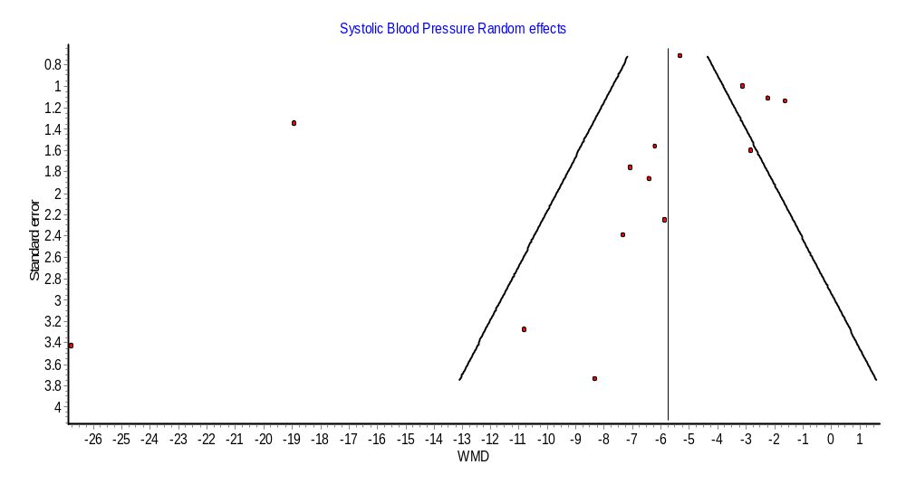
Additional file6: Funnel plots for diastolic blood pressure of 14 included articles

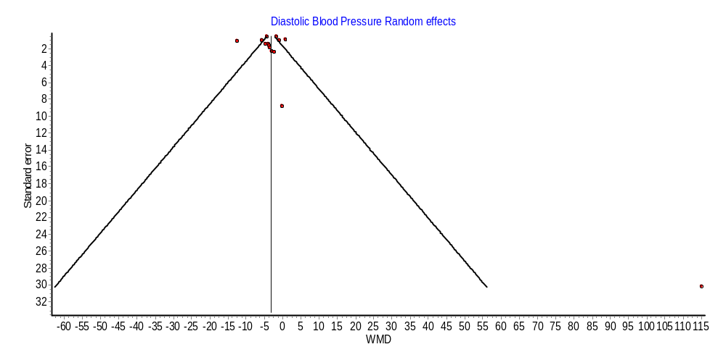

Additional file7: Funnel plots for systolic blood pressure of 14 included articles

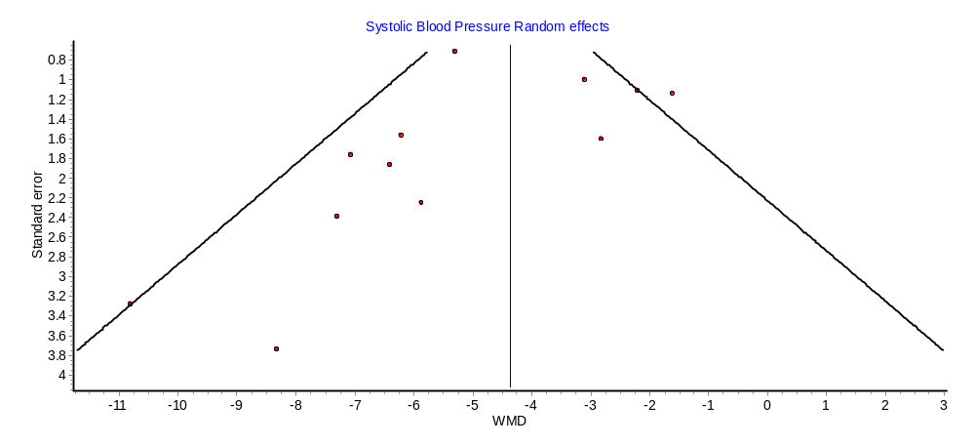

Additional file8: Funnel plots for diastolic blood pressure of 12 included articles

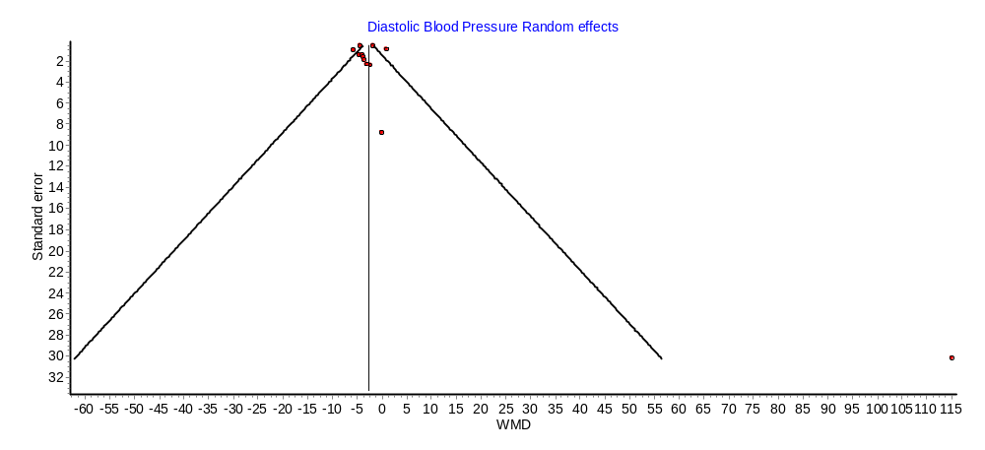

Additional file 9: Secondary outcome results showing BP medication adherence outcome

Author, year | Method of medication adherence ascertainment | The difference in medication adherence between Intervention and control group | Other medication adherence outcomes
Alhalaiqa, 2012 | MMAS)before trial; BMQ- from baseline to follow up (11 weeks after randomisation) | Adherence measured by Pill Counting was improved in the AT group by 37% at 11 weeks compared with TAU.  No significant adverse events were reported.  AT increases adherence to medication for hypertension which then leads to clinically important reduction in BP  Effect difference 26.4(23,4,29.4)P<0.01 | BMQ scores show that beliefs about medications in the AT group have moved away from a view that medications are intrinsically harmful (G-H-5.7)and recognise the benefits of the medications (G-B 2.7) with little or no change in attitudes throughout the study in TAU group.  AT increases adherence to medication for hypertension which then leads to a clinically important reduction
Bobrow, 2016 | MMAS  Euro-Qol 5 Dimension | Adherence in the Information only group was 62.8% compared to 49.4% in usual care  Effect difference IO vs. UC 1.86(1.39 to 2.49)P<0.001 | Quality of life effect difference (OR, 95% CI)  IO vs UC0.01(-0.01 to 0.02)  Retention in clinical care  IO vs UC  0.93(0.66 to 1.32)  Hospital admissions  IO vs UC (OR,95% CI)  1.18(0.88 to 1.57)
Bobrow (B), 2016 | MMAS  Euro-Qol 5 Dimension | Adherence in the interactive group was 59.7% compared to 49.4% in usual care  Effect difference IO vs UC 1.60(1.20 to 2.16)P=0.002 | Quality of life effect difference  IG vs UC (95% CI)  0.003(-0.02 to 0.02  Retention in clinical care effect difference  IN vs UC  0.90(0.64 to 1.28)  Hospital admissions effect difference  IG vs UC  (OR, 95% CI)  0.94(0.57 to 1.55)
Cakir, 2006 | .. | .. | ..
Calvaho, 2006 | BMQ , Quality of life, Knowledge, Attitude and  Practice(KAP) | Significant improvement in quality of life and KAP outcomes P=<0.05 | ..
Delavar, 2019 | MMAS | Increase adherence to medication due to intervention (P=0.05).The proportions of controlled systolic and diastolic blood pressure were not statistically significant difference between-group(P<0.05) | ..
He, 2017 | Self-report | Controlled hypertension increased from 17.0% at baseline to 72.9% at 18 months ad from 17.6% to 52.2% in the usual care group. The difference in the increase was 20.6%(15.4% -25.9%)P<0.001)  Effect difference 20.6(15.4 -25.9)P= <0.001) | Cost effectiveness: Mean intervention cost per patient was $114.6 (95%CI, $113.7-$115.6) or$6.36perpatient per month. There were not significant differences in mean healthcare costs per patient between groups: $62.2 (95%CI, $44.6-$79.7) in the intervention group and $67.6 (95%CI, $41.9-$93.3) in the control group. The total cost per patient over the 18-month follow-up was $178.6 (95%CI, $161.0-$196.1) in the intervention groupand$67.6(95%CI, $41.9-$93.3) in the control group. The mean adjusted total cost difference was $102.7 (95% CI, $61.0-$144.4), and the incremental cost-effectiveness ratio was $464.7 per additional percentage of patients achieving hypertension control at 18 months (95%CI, $335.2-$771.7).
Jafar, ,2020 | Mean MMAS-8 scores for adherence to antihypertensive medications and statins, and participant-reported health status according to the mean score on the visual analogue scale of the Europol 5-Dimension 5-Level questionnaire (EQ-5D-5L; | Blood pressure control(<140/90 mm Hg)was achieved in 55.2% of the participants in the intervention group as compared with 44.7% of those in the control group(RR= 1.22(1.10 to 1.35) | Quality of life :Participants in the intervention group reported  Better overall health status than those in the control group: the mean increase in the score on the EQ-5D-5L visual-analogue scale was greater by 2.41 with the intervention (95% CI, 0.15 to 4.66). Similar results were observed for the EQ-5D-5L utility index. The mean MMAS-8 score for adherence to statins increased more in the intervention group than in the control group (mean difference, 0.42; 95% CI, 0.15 to 0.68)  Safety and Mortality=  There was no intervention-related serious adverse event in either group. All-cause mortality was 2.9% (39 deaths) in the intervention group and 4.3% (56 deaths) in the control group (P = 0.06). The number of deaths from cardiovascular events was lower in the intervention group (8 deaths, 0.6%) than in the control group (23 deaths,  Cost effectiveness:  The estimated cost of scale-up per eligible patient with hypertension in rural areas in Bangladesh, Pakistan, and Sri Lanka was $10.70, $10.50, and $4.70 (US dollars)
Mirniam, 2019 | MMAS-8 | The mean changes in post-intervention MA in the intervention group and control group was 2.91(1.64) and -0.36(0.36). The difference was statistically significant(P<0.001) | Although there was no significant difference between the two groups before the intervention in terms of the MA score, there was a significant difference between the two groups after the study. The MA score of the intervention group had increased, while the MA score of the control group had decreased. In fact, this multifaceted intervention has been able to notably enhance this substantial element in controlling and treating HTN.
Ramanath, 2012; | MMAS and Medication Adherence Report Scale(MARS) Questionnaires and SF-12v2 quality of life | The mean(SD) score in the intervention group was 3.92(0.27) compared to control group 3.12(0.71) P=<0.001 | The QOL score P values of physical component scale and mental component scale showed highly significant  clinical pharmacist intervention  among rural population has a very strong positive impact  in creating awareness about the disease, and its maintenance by increasing their medication adherence and QOL.
Saleem, 2015 ; | Drug Attitude Inventory (DAI-10) for medication adherence, European Quality of life(EQ-5D);Hypertension Fact Questionnaire(HFQ) for knowledge | Adherence in the intervention group was 89.1% compared to 70.1% in control group P=0.023  Effect difference in the increase in proportion of controlled hypertension 20.6(15.4-25.9 %)p=<0.001  Significance increase in participants medication adherence among intervention group | Significance increase in the participants levels of knowledge about hypertension and medication adherence among interventional group Interventional group reported decreased yet significant health-related quality of life at the end of the intervention programme
Zhai, 2020 | .. | 176 patients had controlled BP at the 3-month follow-up(98 patients in the intervention group vs 78 patients in the control group)  Not significant(P=0.08) | Patients in the intervention group showed significant improvements in knowledge about hypertension
Park, 2011 | Quality of life-SF-36 | .. | Scores of exercise,self-efficacy,general health,vitality,social functioning and mental health in SF-36 were statistically higher than those of control group
Wang, 2011 | MMAS | 72.41% adherence in the intervention group ,control group hardly had changes in medication compliance

Additional file 10 : Grade Assessment Results

Authors | Risk of  bias | Inconsistency | Indirectness | Imprecision | Publication  bias | Estimate
Type of Intervention and number of studies: Educational intervention directed to the patient, 14
Bobrow,2016(A); Bobrow, 2016; | not serious | serious | not serious | not serious | none | ⨁⨁⨁◯  MODERATE
He,2017; Jafar,2020; | not serious | not serious | not serious | not serious | none | ⨁⨁⨁⨁  HIGH
Saleem,2015;Zhai,2020 | not serious | serious | not serious | not serious | none | ⨁⨁⨁◯  MODERATE
Alhalaiqa,2012;Mirniam,2019 | not serious | serious | serious | not serious | publication bias strongly suspected | ⨁◯◯◯  VERY LOW
Park,2011; Wang,2011; Cakir,2006;Calvaho,2006;Delavar,2019;  Ramanath,2012 | serious | serious | not serious | very serious | publication bias strongly suspected | ⨁◯◯◯  VERY LOW
Type of Intervention and number of studies: Educational intervention directed to the health professional, 2
He,2017;Jafar,2020 | not serious | not serious | not serious | not serious | none | ⨁⨁⨁⨁  HIGH
Type of Intervention and number of studies: Appointment reminder systems, 5
Bobrow,2016(A); Bobrow, 2016;Zhai,2020 | not serious | serious | not serious | not serious | none | ⨁⨁⨁◯  MODERATE
Type of Intervention and number of studies: Organizational interventions, 2

He,2017; Jafar,2020 | not serious | not serious | not serious | not serious | none | ⨁⨁⨁⨁  HIGH

