Comprehensive Characterization of Viticultural Biomass and Its Derived Biochars: Insights into Copper Sorption Potential
Hugo Henaut¹, Yassine Chafik¹, Marta Sena-Velez¹, Benoît Cagnon² Sylvain Bourgerie¹⁺ and Domenico Morabito¹⁺
¹Université d’ Orléans, P2E INRAE USC 1328, rue de Chartres 6759, 45067 Orléans Cedex 2, BP, France.
²Université d’Orléans, CNRS, ICMN, UMR 7374, Orléans, France.
⁺ These authors contributed equally to this work
HH: hugo.henaut@univ-orleans.fr; YC: yassine.chafik@univ-orleans.fr; MSV: marta.sena-velez@univ-orleans.fr; BC: benoit.cagnon@univ-orleans.fr; SB: sylvain.bourgerie@univ-orleans.fr; DM: domenico.morabito@univ-orleans.fr
Corresponding author email address and phone number: domenico.morabito@univ-orleans.fr; +33(0)2 38 41 72 35

Supplementary Information

Additional material and methods
Feedstock and biochar characterization
Feedstock composition and thermogravimetric analysis
The extractives, hemicellulose, cellulose and lignin content of feedstock were determined following protocol described by Samba et al. (2025). Thermogravimetric analysis (TGA) spectra were obtained by heating feedstock samples using a NETZSCH STA 449 G5 Jupiter device from 30°C to 750°C at 20°C/min under argon. The oil content of feedstocks was determined by hexane extraction using the Soxhlet method, following ISO 734:2023.
Proximate analysis
The pH, electrical conductivity (EC), bulk density, Water Holding Capacity (WHC) and ash content of both feedstock and derived biochar were measured according to Chafik et al. (2024). Moisture content (M) was determined by heating samples at 100°C overnight and measuring mass loss. Volatile matter (VM) was measured by heating samples 7 min. at 950°C with low oxygen environment. Fixed carbon (FC) was calculated as 100 - (VM + Ash + M).
Water retention curves of biochar in a sandy soil (2% w/w) was assessed following NF EN 13041. Cation Exchange Capacity (CEC) was assessed following Munera-Echeverri et al. (2018), while Anion Exchange Capacity (AEC) was assessed following process of Lawrinenko and Laird (2015). Zeta potential (ZP) was measured across a pH range of 2-12, following Yuan et al. (2011) using a Malvern Zetasizer Pro Blue with a reflective index of 2.4 (Marshall et al. 2019).
Toxicity test
The Seed Vigor Index (SVI) was determined following the method of Bożym et al. (2021) adapted from standard NF EN ISO 18763 to evaluate toxicity of various tested solutions using Lepidium sativum seed germination. Results were then normalized with respect to control (deionized water). Detailed results without normalization were displayed in Table S2.
FTIR-ATR spectroscopy
Surface functional group variations were analyzed using Fourier Transform Infrared Spectroscopy (FT-IR) with a Thermo Scientific Nicolet IS50 FT-IR spectrophotometer. Spectra were recorded in the range of 500–4000 cm⁻¹ for the feedstock, as well as for both pristine and Cu(II)-loaded biochar. Prior to analysis, biochar samples were finely ground and homogenized with potassium bromide (KBr).
Brunauer – Emmett – Teller analysis and porosity
Specific surface area (S_{BET}) of biochar and biomass were measured using an ASAP 2020 Micromeritics using N₂ adsorption at 77 K. The device’s standard error was set at ± 6 m².g⁻¹. Prior to measurements, samples were degassed under vacuum at 250°C. True particle density was determined using a helium displacement pycnometer (AccuPyc 1330, USA). Moreover, porosity percentages were calculated according to Chafik et al. (2024).
SEM-EDS
Surface and morphology of pristine and Cu²⁺ loaded biochars were analyzed using a scanning electron microscope (SEM Model IT800SHL, JEOL, USA) with acceleration voltage of 5 kV and 20 kV. Metal distribution and semi-quantitative elemental analysis were performed using Energy-dispersive X-ray spectroscopy (EDS) at x600 magnification and 20 kV. Element weight and atomic percentages were determined through stoichiometry and carbon combination, with data processed with Aztec® software.
Ultimate analysis
Carbon, hydrogen, nitrogen, oxygen and sulfur contents were determined using a Thermo Scientific FLASH 2000 automatic analyzer. Higher and Lower Heating Value (HHV and LHV) were calculated following the equation from Frikha et al. (2021). Ion’s concentrations were determined using a Thermo Scientific DIONEX AQUION Ion Chromatography System. Metals contents were analyzed using ICP-OES (ULTIMA2, HORIBA, San Francisco, USA).
Copper Sorption tests, kinetics and isotherms
Sorption tests
Cu(II) sorption by biochar was evaluated following procedure from Chafik et al. (2024). Briefly, a mass of 0.1 g of dried biochar was shaken at 200 rpm for 24 hours at room temperature with 10 mL of ultrapure water containing copper (CuCl₂) at various concentrations (0.1, 0.5, 1.0, 1.5, 2.0, or 2.5 g.L⁻¹). After agitation, supernatants were filtered (0.45 µm nitrocellulose filter) and pH and EC were measured. Copper concentrations were recorded by ICP-OES. Following the same method, more precise Cu(II) sorption by BM was conducted at concentrations of 0.05, 0.1, 0.2, 0.25, 0.3, 0.4, 0.5, 0.75, 1.0, 1.25, 1.5, 2.0 and 2.5 g.L⁻¹ at solution pH.
Sorption isotherms
Langmuir and Freundlich sorption isotherm models were used to compare biochar’s Cu(II) sorption capacities and were calculated following Chafik et al. 2024 procedure. The Langmuir model assumes monolayer sorption on a homogeneous surface whereas the Freundlich model is based on multilayer sorption on a heterogeneous surface.
Kinetics tests
Cu (II) sorption kinetic study was conducted with various contact times with agitation at 200 rpm (5, 10, 15, 30, 45 minutes and 1, 2, 3,4, 5, 6, 12, 24 hours) between 0.1g of biochar and 10 mL of a 2.0 g.L⁻¹ Cu (II) solution. After agitation, supernatants were filtered (0.45 µm nitrocellulose filter) and pH and EC were measured. Copper concentrations were recorded by ICP-OES
Kinetics isotherms
Kinetics pseudo-first-order (PFO), pseudo-second-order (PSO), Elovich and intra-particle diffusion models were determined following Wang and Guo (2020) procedure. Pseudo first order model assumes that sorption is proportional to the difference between the adsorption capacity at equilibrium and the amount adsorbed at a given time, whereas and second first order model is based on chemical mechanisms. Elovich model indicate a sorption on heterogeneous surface while Intra particle diffusion model describes the diffusion of adsorbates inside the pores (Wang and Guo 2020; Jin et al. 2021; Wang and Guo 2023).
Copper Desorption & Sorption mechanism
Copper desorption from biochar
Dried biochar was shaken at room temperature at 200 rpm with ultrapure water containing 1.5 g.L⁻¹ Cu(II) for 24 hours to reach equilibrium. Saturated biochar was recovered and dried overnight at 80°C.
Copper desorption was evaluated using various desorbing agents as described in Liu et al. (2024). Briefly, a mass of 0.2 g of Cu-loaded biochar previously prepared was added to 50 mL of either H₂O; 0.1 M HCl; 0.1 M NaOH, or 0.1M EDTA. Samples were shaken for 6 hours at 200 rpm at room temperature. After agitation, supernatants were filtered (0.45 µm nitrocellulose filter) and pH measured. Copper concentrations were determined by ICP-OES.
Copper desorption kinetics from BM
To assess desorption kinetics from BM, various contact times (10, 30, 60, 120, 240, 360, 720 and 1440 minutes) between desorbing agents and Cu(II) loaded biochar were tested using method previously mentioned, with a 2.0 g.L⁻¹ solution utilized instead.
Quantification of copper sorption mechanism
Contributions of different Cu(II) adsorption mechanisms of biochar (ion exchange, complexation, precipitation and π interaction) were determined following Liu et al. (2024). Briefly, ion exchange (q_{exc}) was determined by measuring K⁺, Na⁺, Ca²⁺, Mg²⁺ concentration differences between pristine and Cu(II) loaded biochar. Complexation (q_{com}) was evaluated by measuring pH shifts before and after Cu(II) sorption on acid washed biochar. Precipitation (q_{pre}) by comparing Cu(II) sorption on pristine and on acid washed biochar. Finally, π interaction (q_{π}) was determined by the difference.

Additional Tables and Figures
Fig S1 Thermogravimetric (TG, mass loss %) and Differential Thermogravimetric (DTG) analysis of feedstocks over 30–750°C: (A) Grape Marc (GM), (B) Pruning (P), (C) Grape Seed (GS), (D) Extracted Grape Seed (EGS). Red line: TG; Blue line: DTG

Fig S2 Differential Scanning Calorimetry (DSC, red line) and Differential Thermogravimetric (DTG, blue line) curves of feedstocks over 30–750°C: (A) GM: Grape Marc; (B) P: Pruning; (C) GS: Grape Seed; (D) EGS: Extracted Grape Seed

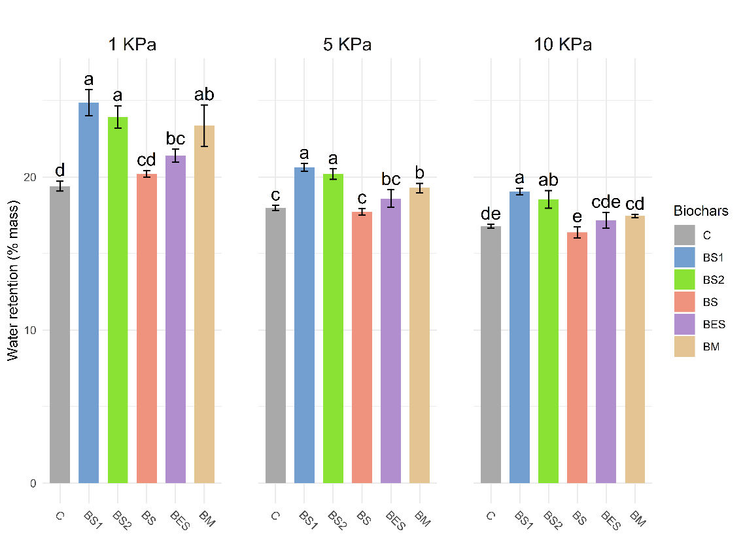
Fig. S3 Water retention curves showing soil moisture (%) at 1–10 kPa suction for control soil and soils amended with 2% (w/w) of different biochars. Values are mean ± SD (n = 4). Letters indicate significant differences between treatments at each suction force (p < 0.05)
Fig. S4 Van Krevelen diagram showing the atomic H/C and O/C ratios of feedstocks and their corresponding biochars, illustrating the progression of carbonization during pyrolysis

Table S1 Major and minor elemental composition of feedstocks (GM, P, GS, EGS) and their corresponding biochars (BM, BS, BES, BP1, BP2). Results are in mg/kg; “<DL” indicates below detection limit. (GM: Grape Marc; P: Prunning; GS: Grape Seed; EGS: Extracted Grape Seed). and Biochar (BM: Marc Biochar; BS: Seed Biochar; BES: Biochar Extracted seed; BP1: Pruning Biochar; BP2: Pruning Biochar with two pyrolysis)

Feedstock | GP | P | GS | EGS |  | Biochar | BM | BP1 | BP2 | BS | BES
Major Elements (mg.kg⁻¹) |  |  |  |  |  | Major Elements (mg.kg⁻¹)
F⁻ | 4156 ± 87.4 | 293.3 ± 6.1 | 968.5 ± 28 | 417.8 ± 6.4 |  | F⁻ | 115.2 ± 5.2 | <DL | <DL | 16.2 ± 2 | 11.7 ± 1.7
Cl⁻ | 237.7 ± 8.3 | 154.4 ± 5.2 | 115.8 ± 2.2 | 175.9 ± 0.7 |  | Cl⁻ | 536.2 ± 8.3 | 466.2 ± 5.7 | 566.3 ± 13 | 232.6 ± 0.8 | 183.8 ± 1.2
NO₂⁻ | <DL | <DL | <DL | <DL |  | NO₂⁻ | 62.9 ± 24.8 | <DL | <DL | <DL | <DL
Br⁻ | <DL | <DL | <DL | <DL |  | Br⁻ | <DL | <DL | <DL | <DL | <DL
NO₃⁻ | 257.3 ± 28 | 91.1 ± 10.6 | 77.9 ± 2.1 | 242.1 ± 7.2 |  | NO₃⁻ | 47.7 ± 21.2 | 43.9 ± 20.4 | 44.9 ± 20.4 | 38.9 ± 16.9 | 40.3 ± 18
PO₄³⁻ | 5572.1 ± 111.9 | 2293.4 ± 46.1 | 2611 ± 3.4 | 7976.1 ± 252.8 |  | PO₄³⁻ | 4812.2 ± 246.3 | 163.6 ± 22.5 | 90.1 ± 19 | 456.3 ± 20.6 | 671.7 ± 19.6
SO₄²⁻ | 857.6 ± 70.8 | 235.2 ± 5.8 | 354.1 ± 10.2 | 190.7 ± 35.9 |  | SO₄²⁻ | 888.6 ± 26.5 | 998.6 ± 14.7 | 222.8 ± 25.5 | 90.4 ± 26.7 | 78.5 ± 25.1
Li⁺ | 0.58 ± 0.58 | 0.74 ± 0.27 | 1.14 ± 0.84 | 1.23 ± 0.7 |  | Li⁺ | <DL | <DL | <DL | 0.01 ± 0.02 | 0.01 ± 0.01
Na⁺ | 111.01 ± 28.65 | 148.08 ± 5.8 | 57.5 ± 10.1 | 88.44 ± 9.73 |  | Na⁺ | 821.65 ± 7.92 | 122.45 ± 0.88 | 141.73 ± 0.4 | 161.54 ± 143.07 | 106.26 ± 14.59
NH₄⁺ | 647.21 ± 70.92 | 98.02 ± 49.86 | 196.83 ± 36.47 | 58.25 ± 24.8 |  | NH₄⁺ | <DL | <DL | <DL | <DL | <DL
K⁺ | 20510.18 ± 2528.25 | 4500.42 ± 787.56 | 6612.87 ± 741.92 | 5997.69 ± 676.85 |  | K⁺ | 41824.8 ± 262.8 | 11760.36 ± 73.89 | 8895.95 ± 11.65 | 2738.35 ± 1804.87 | 2267.13 ± 309.19
Mg²⁺ | 666.6 ± 69.75 | 295.49 ± 60.7 | 1001.51 ± 101.43 | 1190.82 ± 116.01 |  | Mg²⁺ | 19.35 ± 16.82 | 9.26 ± 0.41 | 9.08 ± 0.62 | 3.42 ± 4.22 | 5.21 ± 1.29
Ca²⁺ | 894.99 ± 112.63 | 825.4 ± 83.08 | 745.98 ± 11.85 | 706.85 ± 29.53 |  | Ca²⁺ | 120.48 ± 1.04 | 31.02 ± 0.19 | 20.21 ± 0.2 | 15.95 ± 15.56 | 20.98 ± 2.7
Minor Elements (mg.kg⁻¹) |  |  |  |  |  | Minor Elements (mg.kg⁻¹)
Cu | 205.11 ± 75.94 | 150.8 ± 19.44 | 109.09 ± 30.38 | 103.52 ± 12.76 |  | Cu | 90.23 ± 1.16 | 33.47 ± 3.06 | 31.02 ± 2.78 | 30.54 ± 0.72 | 19.27 ± 1.98
Zn | 21.59 ± 5.47 | 16.13 ± 3.33 | 17.55 ± 3.55 | 15.39 ± 1.87 |  | Zn | 49.41 ± 4.44 | 66.12 ± 13.07 | 41.7 ± 2.57 | 24.78 ± 2.89 | 27.04 ± 4.22
Pb | 29.42 ± 56.49 | <DL | <DL | <DL |  | Pb | 1.44 ± 1.08 | <DL | 0.52 ± 0.08 | 0.37 ± 0.38 | <DL
Mn | 28.91 ± 4.16 | 18.35 ± 1.21 | 17.26 ± 1.24 | 16.35 ± 0.85 |  | Mn | 123.58 ± 18.75 | 92.81 ± 15.34 | 79.68 ± 4 | 44.37 ± 6.19 | 52.26 ± 6.15
Fe | 227.36 ± 40.79 | 57.66 ± 9.88 | 198.85 ± 24.72 | 116.07 ± 7.58 |  | Fe | 1098.66 ± 199.02 | 956.69 ± 167.53 | 1407.26 ± 262.33 | 484 ± 218.15 | 925.52 ± 539.44
Cd | <DL | <DL | <DL | <DL |  | Cd | 0.22 ± 0.02 | 0.13 ± 0.02 | 0.13 ± 0.05 | 0.1 ± 0.01 | 0.11 ± 0.01
As | 2.93 ± 1.56 | 2.33 ± 0.16 | 1.85 ± 0.73 | 1.86 ± 0.73 |  | As | 4.82 ± 0.47 | 2.41 ± 0.42 | 3.27 ± 0.19 | 2.18 ± 0.3 | 2.15 ± 0.21

Table. S2 Seed germination parameters for Lepidium sativum exposed to aqueous extracts from feedstocks and biochars. Includes Germination Rate (GR), Radicle Length (RL), and Seed Vigor Index (SVI). Values are mean ± SD (n = 3); letters indicate significant differences (p < 0.05) (GM: Grape Marc; P: Prunning; GS: Grape Seed; EGS: Extracted Grape Seed) and biochars (BM: Marc Biochar; BS: Seed Biochar; BES: Biochar Extracted seed; BP1: Pruning Biochar; BP2: Pruning Biochar with two pyrolysis)
Feedstock | GR (%) |  | RL (cm) |  | SVI
GM | 0 | c | 0 | c | 0 | c
P | 40 | b | 8,6 | b | 337 | b
GS | 0 | c | 0 | c | 0 | c
EGS | 50 | b | 8,15 | b | 397 | b
Control | 92.5 | a | 15,92 | a | 1477 | a
Biochar | GR (%) |  | RL (cm) |  | SVI
BM | 13.33 | b | 2 | c | 40 | c
BP1 | 86.67 | a | 9.53 | b | 833.33 | ab
BP2 | 76.67 | a | 8.77 | b | 680 | b
BS | 76.67 | a | 9.95 | b | 760.74 | b
BES | 80 | a | 11.17 | ab | 880 | ab
Control | 83.33 | a | 11.41 | ab | 953.33 | a

Table S3 Literature review summary of biochars produced from grape-derived feedstocks via pyrolysis (500–800°C). Data include elemental composition and physicochemical properties, presented as mean ± SD and range
Feedstocks | Parameters | Mean ± SD | Range of value | Authors
GRAPE MARC | %C | 73.42 ± 13.78 | 56.2 - 96.03 | (Encinar et al. 1996; Demiral and Ayan 2011; Manolikaki et al. 2016; Volpe et al. 2018; Zabaniotou et al. 2018; Duman et al. 2018; Ibn Ferjani et al. 2019; Vamvuka et al. 2020; Ismail et al. 2020; Jin et al. 2020; Ferreira et al. 2021; Frikha et al. 2021; Lin et al. 2021; Yoon et al. 2021; Petrova et al. 2023)
GRAPE MARC | %H | 2.47 ± 0.7 | 1.19 - 3.52
GRAPE MARC | %N | 2.01 ± 0.55 | 1.4 - 3.1
GRAPE MARC | %O* | 18.23 ± 8.63 | 4.76 - 34.9
GRAPE MARC | HHV (Mj.kg-1)** | 24.09 ± 2.04 | 17.78 - 28.06
GRAPE MARC | LHV (Mj.kg-1)** | 23.56 ± 2.04 | 19.87 - 27.81
GRAPE MARC | H/C | 0.4 ± 0.12 | 0.16 - 0.61
GRAPE MARC | O/C | 0.19 ± 0.1 | 0.04 - 0.44
GRAPE MARC | pH | 10.05 ± 0.75 | 8.8 - 11.08
GRAPE MARC | EC (µs.cm⁻¹) | 1475.83 ± 1524.07 | 528 - 3400
GRAPE MARC | CEC (cmol.kg⁻¹) | 85.08 ± 105.72 | 6.15 - 205.2
GRAPE MARC | %WHC | 110 ± 0 | -
GRAPE MARC | %FC | 65.51 ± 11.98 | 38.7 - 81.11
GRAPE MARC | %VM | 21.01 ± 6.47 | 11.1 - 36.5
GRAPE MARC | %Ash | 14.45 ± 11.75 | 3.89 - 48.39
GRAPE MARC | Sbet*** | 192.91 ± 73.04 | 43.5 - 293.27
Feedstocks | Parameters | Mean ± SD | Range of value | Authors
GRAPE SEED | %C | 82.94 ± 5.57 | 64 - 90.3 | (Jimenez-Cordero et al. 2013; Ferreira et al. 2015; Fidalgo et al. 2015; Mena et al. 2017; De Almeida et al. 2023; Pardo et al. 2023)
GRAPE SEED | %H | 1.98 ± 0.73 | 0.9 - 3.1
GRAPE SEED | %N | 1.82 ± 0.42 | 0.4 - 2.3
GRAPE SEED | %O* | 11.26 ± 3.58 | 4.7 - 21
GRAPE SEED | HHV (Mj.kg-1)** | 26.39 ± 1.42 | 21.55 - 27.81
GRAPE SEED | LHV (Mj.kg-1)** | 25.97 ± 1.48 | 20.89 - 27.62
GRAPE SEED | H/C | 0.29 ± 0.12 | 0.12 - 0.58
GRAPE SEED | O/C | 0.1 ± 0.04 | 0.04 - 0.25
GRAPE SEED | pH | - | -
GRAPE SEED | EC (µs.cm⁻¹) | - | -
GRAPE SEED | CEC (cmol.kg⁻¹) | - | -
GRAPE SEED | %WHC | - | -
GRAPE SEED | %FC | 64.56 ± 11.82 | 56.2 - 72.92
GRAPE SEED | %VM | 32.29 ± 7.37 | 37.5 - 27.08
GRAPE SEED | %Ash | 9.87 ± 1.56 | 8.6 - 12.42
GRAPE SEED | Sbet*** | 58.82 ± 41.62 | 13 - 124
Feedstocks | Parameters | Mean ± SD | Range of value | Authors
GRAPE PRUNING | %C | 76.15 ± 5.24 | 67.69 - 90.4 | (Gómez et al. 2016; Tag et al. 2016; Marshall et al. 2017; Hamzenejad Taghlidabad and Sepehr 2018; Sfakiotakis and Vamvuka 2018; Gámiz et al. 2019; Marshall et al. 2019; Libutti et al. 2021; Gezović et al. 2022; Rivelli and Libutti 2022; Balmuk et al. 2023; Cárdenas-Aguiar et al. 2023; Khaledi et al. 2023;; Uysal et al. 2024)
GRAPE PRUNING | %H | 2.43 ± 0.78 | 1.44 - 3.97
GRAPE PRUNING | %N | 1.17 ± 0.5 | 0.21 - 2.41
GRAPE PRUNING | %O* | 15.65 ± 6.09 | 3.09 - 25.23
GRAPE PRUNING | HHV (Mj.kg-1)** | 24.72 ± 1.71 | 21.88 - 28.6
GRAPE PRUNING | LHV (Mj.kg-1)** | 24.21 ± 1.65 | 21.44 - 28.17
GRAPE PRUNING | H/C | 0.38 ± 0.12 | 0.22 - 0.57
GRAPE PRUNING | O/C | 0.16 ± 0.07 | 0.03 - 0.27
GRAPE PRUNING | pH | 9.78 ± 0.75 | 8.5 - 11.31
GRAPE PRUNING | EC (µs.cm⁻¹) | 4788.44 ± 6389.02 | 121.23 - 18200
GRAPE PRUNING | CEC (cmol.kg⁻¹) | 29.6 ± 7.94 | 20.1 - 40.38
GRAPE PRUNING | %WHC | 177 ± 67.88 | 129 - 225
GRAPE PRUNING | %FC | 75.81 ± 9.08 | 64.3 - 90
GRAPE PRUNING | %VM | 17.81 ± 5.51 | 9.3 - 28.91
GRAPE PRUNING | %Ash | 9.16 ± 3.12 | 4.71 - 16.9
GRAPE PRUNING | Sbet*** | 291.9 ± 207.47 | 13.9 - 577
* If missing, estimated by difference (100-%C-%H-%N)
** HHV and LHV were recalculated according to Frikha et al. (2021).
** too low values excluded (<10m²/g)

Table S4 Langmuir and Freundlich isotherm parameters for Cu²⁺ sorption on biochars. The reported parameters include the maximum sorption capacity (Q_{max} , mg·g⁻¹), the Langmuir constant (K_{L}, L·mg⁻¹), the Freundlich constants (K_{F}, (mg·g⁻¹)(L·mg⁻¹)ⁿ; n), and the regression coefficients (R²)
Biochar | Model | Parameter | Value | R²
BM | Langmuir | Q_{max} | 134.36 | 0.88
BM |  | K_{L} | 0.06
BM | Freundlich | n | 3.84 | 0.82
BM |  | K_{F} | 25.81
BS | Langmuir | Q_{max} | 44.03 | 0.93
BS |  | K_{L} | 0.003
BS | Freundlich | n | 2.29 | 0.92
BS |  | K_{F} | 1.46
BES | Langmuir | Q_{max} | 47.84 | 0.95
BES |  | K_{L} | 0.003
BES | Freundlich | n | 2.09 | 0.93
BES |  | K_{F} | 1.17
BP1 | Langmuir | Q_{max} | 56.41 | 0.89
BP1 |  | K_{L} | 0.006
BP1 | Freundlich | n | 3.97 | 0.93
BP1 |  | K_{F} | 7.91
BP2 | Langmuir | Q_{max} | 45.77 | 0.91
BP2 |  | K_{L} | 0.007
BP2 | Freundlich | n | 3.32 | 0.92
BP2 |  | K_{F} | 4.71

Fig S5 (A) Cu²⁺ sorption capacities of marc biochar (BM) fitted with isotherm models: Langmuir and Freundlich; and (B) adsorption kinetics of Cu²⁺ onto BM biochar fitted with kinetic models: pseudo-first-order (PFO), pseudo-second-order (PSO), Elovich, and intraparticle diffusion models (n = 4 ± SD)

Table S5 Langmuir and Freundlich isotherm parameters for Cu²⁺ sorption on marc biochar (BM). The reported parameters include the maximum sorption capacity (Q_{max} , mg·g⁻¹), the Langmuir constant (K_{L}, L·mg⁻¹), the Freundlich constants (K_{F}, (mg·g⁻¹)(L·mg⁻¹)ⁿ; n), and the regression coefficients (R²)
Model | Parameter | Value | R²
Langmuir | Q_{max} | 128.21 | 0.83
 | K_{L} | 0.07
Freundlich | n | 3.52
 | K_{F} | 22.77 | 0.78

Table S6 Evolution of solution pH, electrical conductivity (EC), and Cu²⁺ adsorption capacity (Q_{e}) during sorption tests with marc biochar (BM). Values are mean ± SD (n = 5); letters indicate significant differences (p < 0.05)
Cu (g.L⁻¹) | pH |  | EC |  | Qe (mgCu.g⁻¹)
0.05 | 10.72 ± 0.01 | a | 3148.14 ± 35.28 | h | 5.58 ± 0.09 | j
0.10 | 10.58 ± 0.03 | b | 3268 ± 264.75 | gh | 10.45 ± 0.34 | ij
0.20 | 10.42 ± 0.01 | c | 3531.86 ± 162.06 | fg | 20.58 ± 0.6 | hi
0.25 | 10.23 ± 0.03 | d | 3411.82 ± 191.55 | gh | 26.03 ± 0.4 | gh
0.30 | 9.95 ± 0.12 | e | 3070.64 ± 365.16 | h | 33.37 ± 1.24 | fg
0.40 | 9.84 ± 0.18 | e | 3522.12 ± 71.14 | fg | 41.62 ± 0.44 | ef
0.50 | 9.06 ± 0.07 | f | 3853.02 ± 47.65 | ef | 52.31 ± 1.37 | de
0.75 | 7.95 ± 0.14 | g | 4281.46 ± 130.99 | de | 75.89 ± 2.05 | d
1.00 | 6.76 ± 0.16 | h | 4605.6 ± 141.14 | cde | 101.66 ± 4.13 | c
1.25 | 6.43 ± 0.02 | i | 5225.22 ± 61.82 | bcd | 102.72 ± 7.36 | c
1.50 | 6.26 ± 0.02 | j | 5558.94 ± 165.07 | abc | 115.99 ± 2.56 | b
2.00 | 6 ± 0.05 | k | 6940.52 ± 102.67 | ab | 123.06 ± 11.11 | ab
2.50 | 5.68 ± 0.04 | l | 8380.5 ± 47.26 | a | 130.73 ± 6.1 | a

Table S7 Kinetic parameters and R² values of Cu²⁺ adsorption onto marc biochar (BM) at room temperature, fitted using first and second pseudo-order (PFO, PSO), Elovich, and intraparticle diffusion models. The reported parameters include the equilibrium adsorption capacity (Q_{e}, mg·g⁻¹), the kinetic constants of the pseudo-first-order (k₁, min⁻¹) and pseudo-second-order (k₂, g·mg⁻¹·min⁻¹) models, the Elovich constants (α, mg·g⁻¹·min⁻¹; β, g·mg⁻¹), the intraparticle diffusion parameters (K_{diff}, mg·g⁻¹·min⁻¹/²; C, mg·g⁻¹), and the regression coefficients (R²)
Model | Parameter | Value | R²
PFO (Pseudo First Order) | K₁ | 0.0014 | 0.33
 | Q_{e} | 25.76 | 0.33
PSO (Pseudo Second Order) | K₂ | 114.94 | 0.85
 | Q_{e} | 0.0007 | 0.85
Elovich | β | 0.0803 | 0.69
 | α | 267.03 | 0.69
Intraparticle Diffusion | K_{diff} | 1.56 | 0.4
 | C | 74.51 | 0.4

Table S8. Temporal evolution of solution pH, electrical conductivity (EC), and Cu²⁺ adsorption capacity (Q_{e}) during sorption kinetics tests. Values are mean ± SD (n = 5); letters indicate significant differences (p < 0.05)
Time (min.) | pH |  | EC (µS.m⁻¹) |  | Qe (mg.g⁻¹)
5 | 5.2 ± 0.08 | e | 6933.8 ± 171.25 | a | 38.08 ± 9.96 | e
10 | 5.24 ± 0.05 | de | 6989.26 ± 126.99 | a | 44.08 ± 11.92 | e
15 | 5.32 ± 0.03 | cd | 7021.2 ± 52.8 | a | 89.75 ± 1.93 | d
30 | 5.26 ± 0.04 | de | 6975.04 ± 48.96 | a | 92.46 ± 3.53 | cd
45 | 5.28 ± 0.04 | cde | 6954.94 ± 286.51 | a | 93.99 ± 4.13 | bcd
60 | 5.26 ± 0.03 | de | 6975.42 ± 97.75 | a | 98.04 ± 5.04 | bcd
90 | 5.36 ± 0.04 | c | 7116.4 ± 187.09 | a | 104.03 ± 5.99 | abc
120 | 5.92 ± 0.06 | a | 7051.44 ± 191.23 | a | 105.43 ± 4.26 | abc
180 | 5.85 ± 0.02 | ab | 7026.04 ± 67.08 | a | 106.87 ± 5.21 | abc
240 | 5.84 ± 0.03 | ab | 6994.18 ± 29.81 | a | 107.87 ± 2.56 | ab
300 | 5.79 ± 0.02 | b | 6993.4 ± 100.96 | a | 107.53 ± 5.65 | ab
360 | 5.82 ± 0.02 | ab | 6968.8 ± 93.31 | a | 110.21 ± 3.84 | ab
720 | 5.79 ± 0.04 | b | 6969.92 ± 49.09 | a | 114.12 ± 4.26 | a
1440 | 5.8 ± 0.05 | b | 6933.9 ± 80.06 | a | 116.26 ± 3.77 | a

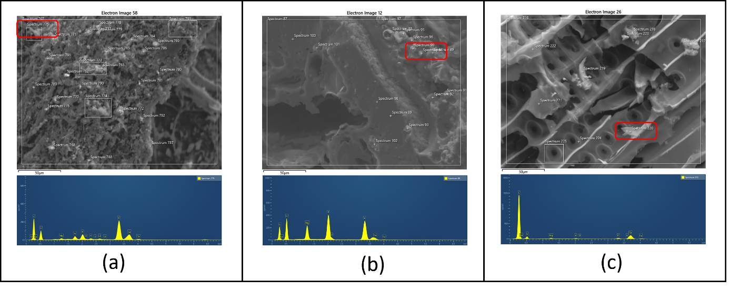
Fig. S6: SEM images and EDS spectra of selected red area showing mineral concretions in pristine biochars:
(a) BM (22.42% K, spectrum 775), (b) BS (12.01% P, spectrum 88), (c) BP1 (23.52% Ca, spectrum 220)
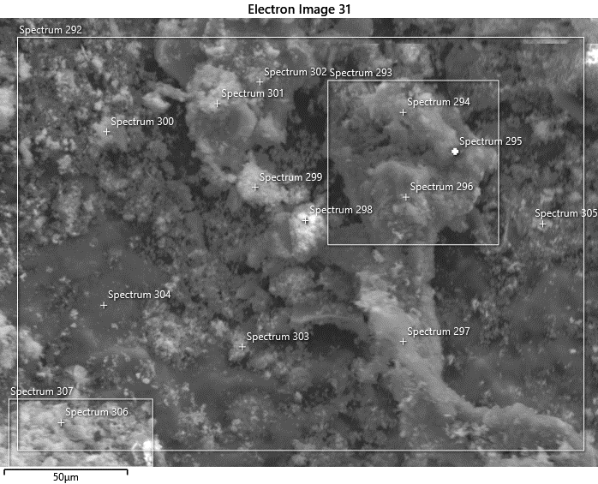
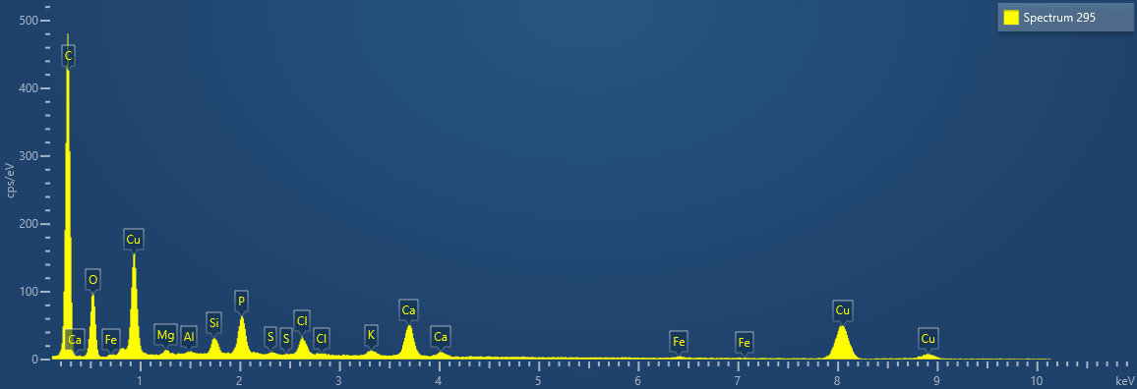
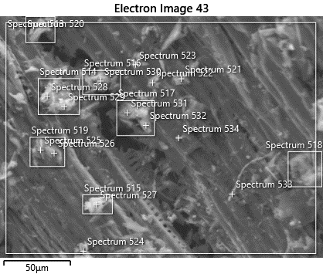
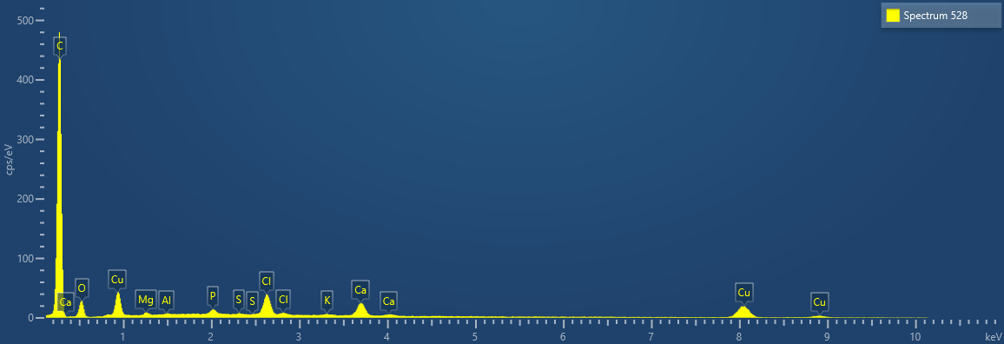
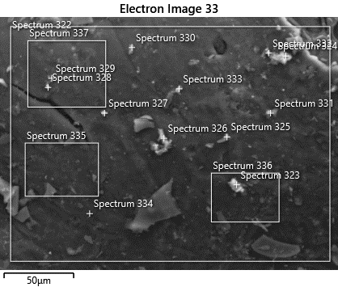
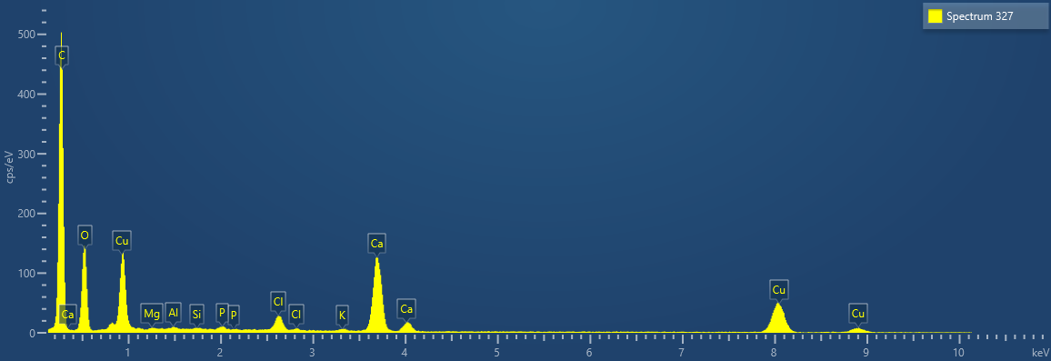
(a)
(c)
(b)

Fig. S7: SEM images and EDS spectra of selected red area showing Cu distribution on biochar surfaces after sorption: (a) BM (35.83% Cu, spectrum 295; associated with Ca & P), (b) BS (28.28% Cu, spectrum 327; associated with Ca), (c) BP1 (15.45% Cu, spectrum 528; associated with Ca & Mg)

Table S9 : EDS elemental analysis (weight % and atomic %) of pristine biochars (BM: Marc Biochar; BS: Seed Biochar; BES: Biochar Extracted seed; BP1: Pruning Biochar; BP2: Pruning Biochar with two pyrolysis step)
Element | BM |  | BS |  | BES |  | BP1 |  | BP2
Element | % weight | % atomic | % weight | % atomic | % weight | % atomic | % weight | % atomic | % weight | % atomic
O | 40.19 | 50.62 | 43.84 | 52.30 | 48.47 | 55.50 | 43.40 | 52.57 | 51.22 | 42.14
C | 15.12 | 15.08 | 16.46 | 26.16 | 18.20 | 27.76 | 16.29 | 13.17 | 25.83 | 18.22
Ca | 4.42 | 2.22 | 16.44 | 7.83 | 8.67 | 3.96 | 7.30 | 3.53 | 5.45 | 11.23
P | 2.97 | 1.93 | 10.32 | 5.04 | 3.22 | 1.91 | 0.62 | 0.39 | 1.21 | 1.93
K | 29.26 | 25.37 | 8.18 | 5.04 | 16.16 | 7.57 | 26.58 | 26.29 | 9.06 | 15.96
Mg | 0.78 | 0.64 | 4.04 | 3.17 | 1.62 | 1.22 | 2.30 | 1.83 | 3.33 | 4.16
Si | 2.27 | 1.00 | 0.39 | 0.26 | 1.02 | 0.67 | 0.72 | 0.50 | 0.35 | 0.50
S | 1.03 | 0.64 | 0.23 | 0.14 | 0.79 | 0.26 | 1.23 | 0.74 | 2.12 | 3.49
Cl | 0.40 | 0.27 | 0.11 | 0.06 | 0.09 | 0.05 | 0.01 | 0.01 | 0.90 | 1.64
Al | 0.49 | 0.37 | - | - | 0.97 | 0.66 | 0.74 | 0.53 | 0.54 | 0.75
Fe | 2.77 | 1.63 | - | - | 0.79 | 0.45 | 0.49 | 0.27 | - | -
Na | 0.31 | 0.23 | - | - | - | - | 0.33 | 0.17 | - | -
Cu | - | - | - | - | - | - | - | - | - | -

Table S10 : EDS elemental analysis (weight % and atomic %) of Cu-loaded biochars after sorption tests (BM: Marc Biochar; BS: Seed Biochar; BES: Biochar Extracted seed; BP1: Pruning Biochar; BP2: Pruning Biochar with two pyrolysis step).
Element | BM |  | BS |  | BES |  | BP1 |  | BP2
 | % weight | % atomic | % weight | % atomic | % weight | % atomic | % weight | % atomic | % weight | % atomic
O | 36.17 | 50.80 | 28.27 | 23.11 | 32.04 | 45.27 | 40.73 | 46.66 | 44.55 | 54.27
C | 32.28 | 25.98 | 11.40 | 11.04 | 21.11 | 24.04 | 29.63 | 24.70 | 17.19 | 27.89
Ca | 3.48 | 2.13 | 4.31 | 3.02 | 4.17 | 3.71 | 4.23 | 2.60 | 14.15 | 6.88
P | 3.80 | 2.53 | 1.56 | 1.22 | 7.22 | 5.27 | 2.46 | 1.95 | 0.48 | 0.30
K | 1.47 | 1.12 | 6.43 | 4.00 | 3.79 | 2.19 | 1.31 | 0.83 | 5.18 | 2.58
Mg | 1.83 | 1.36 | 2.91 | 2.62 | 6.57 | 3.88 | 1.69 | 1.75 | 1.72 | 1.38
Si | 1.94 | 1.46 | 3.49 | 2.91 | 1.68 | 1.35 | 0.25 | 0.22 | 0.23 | 0.16
S | 0.66 | 0.46 | 1.20 | 0.91 | - | - | - | - | - | -
Cl | 3.68 | 2.33 | 9.29 | 6.38 | 8.82 | 5.63 | 7.91 | 5.48 | 5.52 | 3.03
Al | 0.22 | 0.18 | 1.60 | 1.45 | 0.95 | 0.80 | - | - | 0.29 | 0.21
Fe | 0.59 | 0.24 | 0.75 | 0.33 | 0.88 | 0.35 | - | - | 0.18 | 0.06
Na | - | - |  |  | - | - | - | - | - | -
Cu | 13.89 | 11.41 | 28.81 | 43.02 | 12.77 | 7.51 | 11.79 | 15.81 | 10.51 | 3.23

Table S11 Values and statistical differences among biochars and mechanisms. Lowercase letters indicate significant differences among biochars within the same mechanisms; uppercase letters indicate significant differences among mechanisms for the same biochar (p < 0.05). (Q_{exch}: ion exchange, Q_{pre}: precipitation, Q_{com}: complexation, Q_{π}: π-cation interactions) for each biochar type (BM: Marc Biochar; BS: Seed Biochar; BES: Biochar Extracted seed; BP1: Pruning Biochar; BP2: Pruning Biochar with two pyrolysis step)
Biochar | Qexch (%) |  | Qpre (%) |  | Qcom (%) |  | Qπ (%)
BM | 9.25 ± 0.95 | aC | 47.42 ± 0.16 | cA | 3.39 ± 0.66 | aD | 39.94 ± 0.72 | aB
BP | 1.66 ± 0.61 | cC | 65.34 ± 1.07 | aA | 0.31 ± 0.04 | cC | 32.69 ± 1.04 | bcB
BPE | 2.69 ± 0.72 | bcC | 62.60 ± 0.96 | bA | 0.24 ± 0.03 | cD | 34.48 ± 0.95 | bB
BS1 | 4.25 ± 1.00 | bC | 64.77 ± 1.09 | aA | 1.20 ± 0.33 | bD | 29.78 ± 0.89 | dB
BS2 | 3.13 ± 1.00 | bcC | 64.31 ± 1.07 | abA | 0.79 ± 0.15 | bD | 31.77 ± 1.16 | cdB

Table S12 Copper desorption rates (%) of marc biochar (BM) samples after 6-hour contact with various desorbing agents (H₂O, 0.1 M HCl, 0.1 M NaOH, and 0.1 M EDTA). Lowercase letters indicate significant differences among contact time within the same desorbing agent; uppercase letters indicate significant differences among desorbing agents for the same contact time (p < 0.05, n = 4)
Contact time (min) | H2O |  | HCl |  | NaOH |  | EDTA
10 | 0.35 ± 0.08 | cdB | 73.19 ± 7.03 | Aa | 0.34 ± 0.02 | bcB | 54.85 ± 1.48 | abcA
30 | 0.25 ± 0.01 | dB | 66.09 ± 3.49 | aA | 0.2 ± 0.07 | cB | 53.07 ± 1.93 | bcA
60 | 0.33 ± 0.09 | cdB | 61.34 ± 2.92 | aA | 0.05 ± 0.02 | dB | 61.65 ± 3.66 | abA
120 | 0.25 ± 0.03 | dC | 66.57 ± 2.98 | aA | 0.44 ± 0.05 | abB | 60.85 ± 3.61 | abcC
240 | 0.47 ± 0.07 | bcC | 66.01 ± 6 | aA | 0.05 ± 0.01 | dD | 52.28 ± 2.35 | cB
260 | 0.52 ± 0.02 | bC | 66.24 ± 5.88 | aA | 0.36 ± 0.15 | bcC | 53.99 ± 4.3 | abcB
720 | 0.84 ± 0.12 | aB | 68.95 ± 9.34 | aA | 0.75 ± 0.07 | aB | 60.26 ± 4.8 | abcA
1440 | 0,48 ± 0,06 | bcB | 73,01 ± 8,67 | aA | 0,69 ± 0,06 | aC | 62,66 ± 6,66 | aA

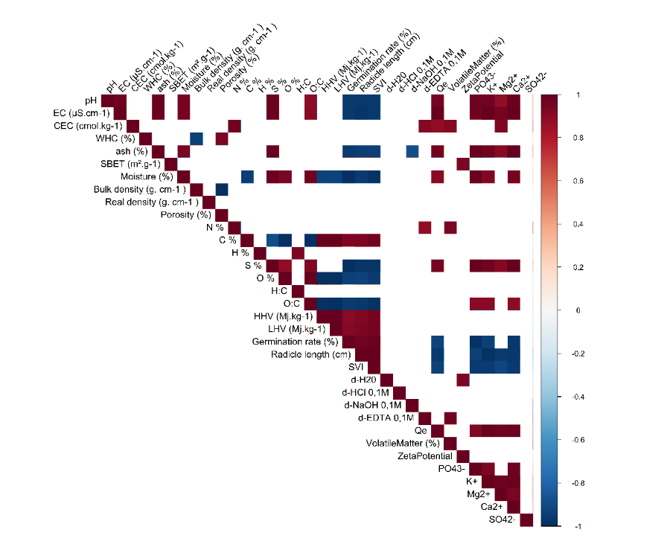
Fig. S8. Correlation matrix of biochar characteristics, showing significant correlations (p < 0.05). Positive correlations are shown in red, negative in blue; color intensity indicates correlation strength. (BM: Marc Biochar; BS: Seed Biochar; BES: Biochar Extracted seed; BP1: Pruning Biochar; BP2: Pruning Biochar with two pyrolysis step)

References
Balmuk G, Videgain M, Manyà JJ, Duman G, Yanik J (2023) Effects of pyrolysis temperature and pressure on agronomic properties of biochar. J Anal Appl Pyrolysis 169:105858. https://doi.org/10.1016/j.jaap.2023.105858
Bożym M, Król A, Mizerna K (2021) Leachate and contact test with Lepidium sativum L. to assess the phytotoxicity of waste. Int J Environ Sci Technol 18(7):1975–1990. https://doi.org/10.1007/s13762-020-02980-x
Cárdenas-Aguiar E, Gascó G, Lado M, Méndez A, Paz-Ferreiro J, Paz-González A (2023) New insights into the production, characterization and potential uses of vineyard pruning waste biochars. Waste Manag 171:452–462. https://doi.org/10.1016/j.wasman.2023.09.032
Chafik Y, Hassan SH, Lebrun M, Sena-Velez M, Cagnon B, Carpin S, Boukroute A, Bourgerie S, Morabito D (2024) Biochar characteristics and Pb2+/Zn2+ sorption capacities: the role of feedstock variation. Int J Environ Sci Technol 21(16):9829–9842. https://doi.org/10.1007/s13762-024-05646-0
De Almeida LC, Andrade ELO, Santos JCB, Santos RM, Fricks AT, Freitas LDS, Lima ÁS, Pereira MM, Soares CMF (2023) Novel Nanobiocatalyst Constituted by Lipase from Burkholderia cepacia Immobilized on Graphene Oxide Derived from Grape Seed Biochar. C 9(1):12. https://doi.org/10.3390/c9010012
Demiral İ, Ayan EA (2011) Pyrolysis of grape bagasse: Effect of pyrolysis conditions on the product yields and characterization of the liquid product. Bioresour Technol 102(4):3946–3951. https://doi.org/10.1016/j.biortech.2010.11.077
Duman G, Tag AT, Ucar S, Yanik J (2018) Comparative evaluation of dry and wet carbonization of agro industrial wastes for the production of soil improver. J Environ Chem Eng 6(2):3366–3375. https://doi.org/10.1016/j.jece.2018.05.009
Encinar JM, Beltran FJ, Bernalte A (1996) Pyrolysis of two agricultural residues: olive and grape bagasse. Influence of particle size and temperature. Biomass Bioenergy 11(5):397–409
Ferreira AF, Ribau JP, Costa M (2021) A decision support method for biochars characterization from carbonization of grape pomace. Biomass Bioenergy 145:105946. https://doi.org/10.1016/j.biombioe.2020.105946
Ferreira CIA, Calisto V, Santos SM, Cuerda-Correa EM, Otero M, Nadais H, Esteves VI (2015) Application of pyrolysed agricultural biowastes as adsorbents for fish anaesthetic (MS-222) removal from water. J Anal Appl Pyrolysis 112:313–324. https://doi.org/10.1016/j.jaap.2015.01.006
Fidalgo B, Berrueco C, Millan M (2015) Chars from agricultural wastes as greener fuels for electric arc furnaces. J Anal Appl Pyrolysis 113:274–280. https://doi.org/10.1016/j.jaap.2015.01.027
Frikha K, Limousy L, Arif MB, Thevenin N, Ruidavets L, Zbair M, Bennici S (2021) Exhausted Grape Marc Derived Biochars: Effect of Pyrolysis Temperature on the Yield and Quality of Biochar for Soil Amendment. Sustainability 13(20):11187. https://doi.org/10.3390/su132011187
Gámiz B, Hall K, Spokas KA, Cox L (2019) Understanding Activation Effects on Low-Temperature Biochar for Optimization of Herbicide Sorption. Agronomy 9(10):588. https://doi.org/10.3390/agronomy9100588
Gezović A, Mišurović J, Milovanović B, Etinski M, Krstić J, Grudić V, Dominko R, Mentus S, Vujković MJ (2022) High Al-ion storage of vine shoots-derived activated carbon: New concept for affordable and sustainable supercapacitors. J Power Sources 538:231561. https://doi.org/10.1016/j.jpowsour.2022.231561
Gómez N, Rosas JG, Singh S, Ross AB, Sánchez ME, Cara J (2016) Development of a gained stability index for describing biochar stability: Relation of high recalcitrance index (R50) with accelerated ageing tests. J Anal Appl Pyrolysis 120:37–44. https://doi.org/10.1016/j.jaap.2016.04.007
Hamzenejad Taghlidabad R, Sepehr E (2018) Heavy metals immobilization in contaminated soil by grape-pruning-residue biochar. Arch Agron Soil Sci 64(8):1041–1052. https://doi.org/10.1080/03650340.2017.1407872
Ibn Ferjani A, Jeguirim M, Jellali S, Limousy L, Courson C, Akrout H, Thevenin N, Ruidavets L, Muller A, Bennici S (2019) The use of exhausted grape marc to produce biofuels and biofertilizers: Effect of pyrolysis temperatures on biochars properties. Renew Sustain Energy Rev 107:425–433. https://doi.org/10.1016/j.rser.2019.03.034
Ismail IS, Singh G, Smith P, Kim S, Yang J-H, Joseph S, Yusup S, Singh M, Bansal V, Talapaneni SN, Vinu A (2020) Oxygen functionalized porous activated biocarbons with high surface area derived from grape marc for enhanced capture of CO2 at elevated-pressure. Carbon 160:113–124. https://doi.org/10.1016/j.carbon.2020.01.008
Jimenez-Cordero D, Heras F, Alonso-Morales N, Gilarranz MA, Rodriguez JJ (2013) Porous structure and morphology of granular chars from flash and conventional pyrolysis of grape seeds. Biomas Bioenergy 54:123–132. https://doi.org/10.1016/j.biombioe.2013.03.020
Jin Q, Wang Z, Feng Y, Kim Y-T, Stewart AC, O’Keefe SF, Neilson AP, He Z, Huang H (2020) Grape pomace and its secondary waste management: Biochar production for a broad range of lead (Pb) removal from water. Environ Res 186:109442. https://doi.org/10.1016/j.envres.2020.109442
Jin Y, Zhang M, Jin Z, Wang G, Li R, Zhang X, Liu X, Qu J, Wang H (2021) Characterization of biochars derived from various spent mushroom substrates and evaluation of their adsorption performance of Cu(II) ions from aqueous solution. Environ Res 196:110323. https://doi.org/10.1016/j.envres.2020.110323
Khaledi S, Delbari M, Galavi H, Bagheri H, Chari MM (2023) Effects of biochar particle size, biochar application rate, and moisture content on thermal properties of an unsaturated sandy loam soil. Soil Tillage Res 226:105579. https://doi.org/10.1016/j.still.2022.105579
Lawrinenko M, Laird DA (2015) Anion exchange capacity of biochar. Green Chem 17(9):4628–4636. https://doi.org/10.1039/C5GC00828J
Libutti A, Francavilla M, Monteleone M (2021) Hydrological Properties of a Clay Loam Soil as Affected by Biochar Application in a Pot Experiment. Agronomy 11(3):489. https://doi.org/10.3390/agronomy11030489
Lin J-C, Mariuzza D, Volpe M, Fiori L, Ceylan S, Goldfarb JL (2021) Integrated thermochemical conversion process for valorizing mixed agricultural and dairy waste to nutrient-enriched biochars and biofuels. Bioresour Technol 328:124765. https://doi.org/10.1016/j.biortech.2021.124765
Liu L, Fan S, Wang Z, Hu J (2024) Chemical speciation distribution, desorption characteristics, and quantitative adsorption mechanisms of cadmium/lead ions adsorbed on biochars. Arab J Chem 17(4):105669. https://doi.org/10.1016/j.arabjc.2024.105669
Manolikaki II, Mangolis A, Diamadopoulos E (2016) The impact of biochars prepared from agricultural residues on phosphorus release and availability in two fertile soils. J Environ Manage 181:536–543. https://doi.org/10.1016/j.jenvman.2016.07.012
Marshall JA, Morton BJ, Muhlack R, Chittleborough D, Kwong CW (2017) Recovery of phosphate from calcium-containing aqueous solution resulting from biochar-induced calcium phosphate precipitation. J Clean Prod 165:27–35. https://doi.org/10.1016/j.jclepro.2017.07.042
Marshall J, Muhlack R, Morton BJ, Dunnigan L, Chittleborough D, Kwong CW (2019) Pyrolysis Temperature Effects on Biochar–Water Interactions and Application for Improved Water Holding Capacity in Vineyard Soils. Soil Syst 3(2):27. https://doi.org/10.3390/soilsystems3020027
Mena IF, Diaz E, Rodriguez JJ, Mohedano AF (2017) CWPO of bisphenol A with iron catalysts supported on microporous carbons from grape seeds activation. Chem Eng J 318:153–160. https://doi.org/10.1016/j.cej.2016.06.029
Munera-Echeverri JL, Martinsen V, Strand LT, Zivanovic V, Cornelissen G, Mulder J (2018) Cation exchange capacity of biochar: An urgent method modification. Sci Total Environ 642:190–197. https://doi.org/10.1016/j.scitotenv.2018.06.017
Pardo R, Taboada-Ruiz L, Fuente E, Ruiz B, Díaz-Somoano M, Calvo LF, Paniagua S (2023) Exploring the potential of conventional and flash pyrolysis methods for the valorisation of grape seed and chestnut shell biomass from agri-food industry waste. Biomass Bioenergy 177:106942. https://doi.org/10.1016/j.biombioe.2023.106942
Petrova T, Naydenova I, Ribau J, Ferreira AF (2023) Biochar from Agro-Forest Residue: Application Perspective Based on Decision Support Analysis. Appl Sci 13(5):3240. https://doi.org/10.3390/app13053240
Rivelli AR, Libutti A (2022) Effect of Biochar and Inorganic or Organic Fertilizer Co-Application on Soil Properties, Plant Growth and Nutrient Content in Swiss Chard. Agronomy 12(9):2089. https://doi.org/10.3390/agronomy12092089
Samba P, Schaefer S, Cagnon B (2025) Impregnation by hydrothermal carbonization in the presence of phosphoric acid in the activated carbon production process from hemp residus: Impact on porous properties and ibuprofen adsorption. J Ind Eng Chem :S1226086X25001601. https://doi.org/10.1016/j.jiec.2025.02.060
Sfakiotakis S, Vamvuka D (2018) Thermal decomposition behavior, characterization and evaluation of pyrolysis products of agricultural wastes. J Energy Inst 91(6):951–961. https://doi.org/10.1016/j.joei.2017.09.001
Shah A, Darr MJ, Dalluge D, Medic D, Webster K, Brown RC (2012) Physicochemical properties of bio-oil and biochar produced by fast pyrolysis of stored single-pass corn stover and cobs. Bioresour Technol 125:348–352. https://doi.org/10.1016/j.biortech.2012.09.061
Tag AT, Duman G, Ucar S, Yanik J (2016) Effects of feedstock type and pyrolysis temperature on potential applications of biochar. J Anal Appl Pyrolysis 120:200–206. https://doi.org/10.1016/j.jaap.2016.05.006
Uysal Y, Doğaroğlu ZG, Makas MN, Çaylali Z (2024) Boosting Water Retention in Agriculture: Vine Biochar‐Doped Hydrogels’ Swelling and Germination Effects. Global Challenges 8(5):2300254. https://doi.org/10.1002/gch2.202300254
Vamvuka D, Esser K, Komnitsas K (2020) Investigating the Suitability of Grape Husks Biochar, Municipal Solid Wastes Compost and Mixtures of Them for Agricultural Applications to Mediterranean Soils. Resources 9(3):33. https://doi.org/10.3390/resources9030033
Volpe M, Fiori L, Panno D, Volpe R, Messineo A (2018) Assessment of bio-combustibles production via slow pyrolysis of wine industry residues. AIP Conf. Proc., Thessaloniki, Greece, p 140010. https://doi.org/10.1063/1.5079199
Wang J, Guo X (2020) Adsorption kinetic models: Physical meanings, applications, and solving methods. J Hazard Mater 390:122156. https://doi.org/10.1016/j.jhazmat.2020.122156
Wang J, Guo X (2023) Adsorption kinetics and isotherm models of heavy metals by various adsorbents: An overview. Crit Rev Environ Sci Technol 53(21):1837–1865. https://doi.org/10.1080/10643389.2023.2221157
Yoon J-Y, Kim JE, Song HJ, Oh KB, Jo JW, Yang Y-H, Lee SH, Kang G, Kim HJ, Choi Y-K (2021) Assessment of adsorptive behaviors and properties of grape pomace-derived biochar as adsorbent for removal of cymoxanil pesticide. Environ Technol Innov 21:101242. https://doi.org/10.1016/j.eti.2020.101242
Yuan J-H, Xu R-K, Zhang H (2011) The forms of alkalis in the biochar produced from crop residues at different temperatures. Bioresour Technol 102(3):3488–3497. https://doi.org/10.1016/j.biortech.2010.11.018
Zabaniotou A, Kamaterou P, Pavlou A, Panayiotou C (2018) Sustainable bioeconomy transitions: Targeting value capture by integrating pyrolysis in a winery waste biorefinery. J Clean Prod 172:3387–3397. https://doi.org/10.1016/j.jclepro.2017.11.077

