Supplementary Information
Nanoplatform self-assembly from small molecules of porphyrin derivatives for NIR-II fluorescence imaging guided photothermal-immunotherapy
Yanbing Cao^{1,2†}, De Wei^{6,7†}, Lixia Yang^{3†}, Zijin Luo³, Peiwen Yu^{2,4}, Hao Li^{2,4}, Cao Zhang^{2,4}, Xiaolong Liu^{1,2,4}, Fengshou Wu³*, Ming Wu^{2,4}*, Yongyi Zeng^{2,4,5}*

¹ College of Chemical Engineering, Fuzhou University, Fuzhou 350108, P. R. China.
² The United Innovation of Mengchao Hepatobiliary Technology Key Laboratory of Fujian Province, Mengchao Hepatobiliary Hospital of Fujian Medical University, Fuzhou 350025, P. R. China.
³ Key Laboratory for Green Chemical Process of the Ministry of Education, School of Chemical Engineering and Pharmacy, Wuhan Institute of Technology, Wuhan 430205, P. R. China.
⁴ Mengchao Med-X Center, Fuzhou University, Fuzhou 350116, P. R. China.
⁵ Liver Disease Center, The First Aﬃliated Hospital of Fujian Medical University, Fuzhou 350005, P. R. China.
⁶ Department of Neurosurgery, Fujian Provincial Hospital South Branch, Fuzhou 350001, P. R. China.
⁷ Department of Neurosurgery, Shengli Clinical Medical College of Fujian Medical University, Fuzhou 350001, P. R. China.

* Corresponding authors:
Fengshou Wu, fswu@wit.edu.cn; Ming Wu, wmmj0419@163.com; Yongyi Zeng, lamp197311@126.com
† These authors contributed equally to this work.

Experimental Sections
- Materials
All reagents for PPor synthesis were purchased from Aladdin Corporation and used as received. All the organic solvents were of analytical grade and used without further purification except for the special requirements for drying. DAPI, apoptosis detection kit and CCK-8 kit were purchased from Dojindo Laboratories (Japan); Calcein AM and propidium iodide (PI) were obtained from J&K Scientific Ltd (China); Anti-CD86-PE-cy7, anti-CD11c-APC and anti-CD80-PE were obtained from BioLegend, Inc. (USA); Antibodies for CRT, HMGB1 were purchased from Abcam; ELISA kits of IFN-γ and Granzyme B were obtained from Boster (China). Therapeutic PD-1 antibody (αPD1) was purchased from Bioxcell; mGM-CSF and IL-4 was obtained from R&D systems (USA). Double distilled water (18.2 MΩ resistivity) was prepared by a Milli-Q Gradient System that was purchased from Millipore Corporation (USA).
- Cell Lines
NIH 3T3 cells (fibroblasts cells of mouse) and 4T1 cells (breast cancer cells of mouse) were obtained from ATCC (Manassas, VA). The cells were cultured in DMEM medium containing 10% of FBS and 1% of Penicillin-streptomycin in an environment 37°C and 5% of CO₂.
- Animals
Female BALB/c mice were obtained from Wushi, Inc. Corp (China). All animal experiments were carried out in accordance with national animal management regulations of China and approved by the Animal Ethics Committee of Mengchao Hepatobiliary Hospital of Fujian Medical University.
- Synthesis of PPor and PPor NPs
The compound 1-3 was synthesized according to the routine methods. The compound 4-7, Por, and PPor were synthesized according to the following steps.
Synthesis of 4: A solution of compound 2 (386 mg, 1.367 mmol) and compound 3 (200 mg, 1.37 mmol) in CH₂Cl₂ (250 mL) was purged with nitrogen for 30 min, and then trifluoroacetic acid (TFA) (0.115 mL) was added. The mixture was stirred for 14 h at room temperature, and then 2,3-dichloro-5,6-dicyano-1,4-benzoquinone (DDQ) (465.8 mg, 2 mmol) was added. After the mixture was stirred at room temperature for an additional 4 h, the reaction was quenched by triethylamine (0.23 mL). Then the solvent was removed, and the residue was purified by column chromatography (silica gel, CH₂Cl₂/methanol (100:1) to afford 4 as a purple solid (300 mg, yield 27%). ¹H NMR (400 MHz, CDCl₃) δ 10.30 (s, 2H), 9.39 (d, J = 4.6 Hz, 4H), 9.10 (d, J = 4.6 Hz, 4H), 8.22-8.11 (m, 4H), 7.39-7.30 (m, 4H), 4.48 – 4.39 (m, 4H), 4.10-4.03 (m, 4H), 3.90 (dd, J = 5.9, 3.4 Hz, 4H), 3.82 (dd, J = 5.9, 3.5 Hz, 4H), 3.76 (dd, J = 5.9, 3.6 Hz, 4H), 3.68 (dd, J = 5.9, 3.5 Hz, 4H), 3.59 (q, J = 7.0 Hz, 4H), 1.27 (t, J = 7.0 Hz, 6H), -3.08 (s, 2H). ¹³C NMR (101 MHz, CDCl₃) δ 158.75, 147.52, 145.12, 135.85, 133.95, 131.55, 131.03, 118.84, 113.24, 105.20, 77.37, 77.06, 76.74, 71.17, 70.66, 69.95, 67.79, 66.75, 15.25. MALDI-TOF（C₄₈H₅₄N₄O₈）: m/z calcd. for [M]⁺= 815.4014, found 815.4029.
Synthesis of 5: Porphyrin 4 (240 mg, 0.295 mmol) was dissolved in 45 mL chloroform and then cooled to 0℃. To the cold solution, N-bromosuccinimide (107 mg, 0.601 mmol) was added and the mixture was stirred at 0 °C for 30 min. Then the reaction was quenched by acetone, and the mixture was washed with water and dried over anhydrous Na₂SO₄. After the solvent was removed, the purple solid was obtained as compound 5 (270 mg, 94%).¹H NMR (400 MHz, CDCl₃) δ 9.60 (d, J = 4.7 Hz, 4H), 8.85 (s, 4H), 8.04 (d, J = 8.6 Hz, 4H), 7.30 (d, J = 8.6 Hz, 4H), 4.46-4.41 (m, 4H), 4.09-4.05 (m, 4H), 3.90 (dd, J = 6.0, 3.5 Hz, 4H), 3.82 (dd, J = 5.8, 3.5 Hz, 4H), 3.76 (dd, J = 6.0, 3.6 Hz, 4H), 3.70-3.67 (m, 4H), 3.61-3.57 (m, 4H), 1.26 (s, 6H), -2.75 (s, 2H). ¹³C NMR (101 MHz, CDCl₃) δ 158.88, 135.58, 133.87, 121.17, 113.01, 103.68, 77.37, 77.05, 76.73, 71.21, 70.70, 69.93, 67.79, 66.75, 15.27. MALDI-TOF(C₄₈H₅₂Br₂N₄O₈): m/z calcd. for [M]⁺= 973.715, found 973.034.
Synthesis of 6: To a 100 mL-flask, compound 5 (270 mg, 0.2775 mmol)，DCM (45 mL), and a solution of Zn(OAc)₂ (1.22 g, 5.55 mol) in methanol (5 mL) were added. The reaction mixture was refluxed for 2 h and then washed with water and dried over anhydrous Na₂SO₄. After the solvent was removed, the residue was purified by column chromatography (silica gel, CH₂Cl₂/methanol (100:1)) to afford 6 as a purple solid (280 mg, yield 97.3%). ¹H NMR (400 MHz, CDCl₃) δ 9.59 (d, J = 4.7 Hz, 4H), 8.82 (d, J = 4.7 Hz, 4H), 7.97 (d, J = 8.5 Hz, 4H), 7.22 (d, J = 8.6 Hz, 4H), 4.38- 4.33 (m, 4H), 4.02-3.97 (m, 4H), 3.82 (dd, J = 5.9, 3.5 Hz, 4H), 3.74 (dd, J = 5.8, 3.5 Hz, 4H), 3.69 (dd, J = 6.0, 3.5 Hz, 4H), 3.61 (dd, J = 5.8, 3.5 Hz, 4H), 3.51 (q, J = 7.0 Hz, 4H), 1.19 (d, J = 1.6 Hz, 6H). ¹³C NMR (101 MHz, CDCl₃) δ 158.49, 151.09, 149.99, 149.54, 149.27, 149.00, 136.06, 135.35, 135.24, 133.25, 132.75, 123.42, 123.17, 122.93, 121.56, 112.62, 104.66, 77.45, 77.19, 76.87, 71.15, 70.60, 69.91, 67.73, 66.69, 29.70, 15.21. MALDI-TOF（C₄₈H₅₀Br₂N₄O₈Zn）: m/z calcd. for [M]⁺= 1036.1248, found 1036.0565.
Synthesis of 7: Compound 6 (150 mg, 0.145 mmoL) was dissolved in THF (40 mL) and triethylamine (20 mL) was added. The mixture was purged with nitrogen for 30 min. Then Pd(PPh₃)₂Cl₂ (7mg, 0.01mmoL), CuI (2 mg, 0.01 mmol), and trimethylsilyacetylene (56.96 mg, 0.580 mmol) were added. The mixture was stirred at room temperature for 36 h under nitrogen, the reaction was quenched with saturated brine. After the mixture was extracted with dichloromethane three times, the combined organic layer was dried with anhydrous Na₂SO₄ and concentrated. Finally, the residue was purified by column chromatography (silica gel, CH₂Cl₂/ methanol (150:1) to afford 7as a green solid (75 mg, yield 65%). ¹H NMR (400 MHz, CDCl₃): δ 9.64 (s, 4H, CH), 8.84 (s, 4H, CH), 7.96 (d, 4H, Ph-H), 6.89 (s, 4H, Ph-H), 3.75 (s, 4H, CH₂), 3.45 (s, 4H, CH₂), 3.21 (s, 4H, CH₂), 3.10 (s, 16H, CH₂), 1.25 (s, 6H, CH₃), 0.89 (s, 18H, CH₃). HRMS (ESI): m/z Calcd for C₅₈H₆₈N₄O₈Si₂Zn [M+H]⁺ 1069.3963, found 1069.3765.
Synthesis of Por: To a solution of compound 7 (20 mg, 0.028 mmoL) and THF (7 mL) in ice/water bath, tetrabutylammonium fluoride hydrate (20 mg, 0.052 mmoL) in THF (1 mL) was added dropwise. The reaction was monitored by thin layer chromatography (TLC). After solvent removal, the crude product was purified by silica column chromatography using CH₂Cl₂/methanol (90:1) as the eluent to give compound 4 as purple powders (15 mg, yield 90%), which was added to the next reaction without further characterization.
Synthesis of Por-DPP (PPor): To a 25 mL flask, PDI (90 mg, 0.108 mmol), Por (20 mg，0.022 mmol)，Pd₂(dba)₃ (2 mg, 0.0022 mmol), AsPh₃ (6 mg, 0.016 mmol)，anhydrous THF (7 mL) and TEA (7 mL) were added under an atmosphere of nitrogen. The resulting solution was reacted at 65 ºC for 18 h under these conditions. After the completion of reaction, the solvents were evaporated under vacuum. The residue was collected and purified by silica gel column chromatography (dichloromethane/methanol (100:1)) to obtain PPor as a dark solid (30 mg, 54.5%). ¹H NMR (400 MHz, CDCl₃) δ 10.27 (s, 2H), 9.17 (d, J = 43.5 Hz, 6H), 8.83 (d, J = 3.5 Hz, 4H), 8.73 – 8.46 (m, 10H), 8.16 (d, J = 7.9 Hz, 4H), 7.35 (d, J = 8.4 Hz, 4H), 5.27 (dd, J = 25.3, 5.2 Hz, 4H), 4.47 (t, J = 4.6 Hz, 4H), 4.11 (t, J = 4.9 Hz, 4H), 3.92 (dd, J = 5.8, 3.7 Hz, 4H), 3.83 (dd, J = 5.7, 3.8 Hz, 4H), 3.76 (dd, J = 5.8, 3.7 Hz, 4H), 3.67 (dd, J = 5.8, 3.7 Hz, 4H), 3.56 (q, J = 7.0 Hz, 4H), 1.42 – 1.18 (m, 80H), 0.95 – 0.62 (m, 30H). ¹³C NMR (101 MHz, CDCl₃) δ 157.69, 150.82, 149.65, 148.38, 148.10, 147.84, 134.66, 134.34, 133.57, 132.47, 128.92, 128.27, 127.40, 126.37, 123.07, 122.37, 122.12, 121.88, 119.67, 112.01, 76.36, 76.10, 75.78, 70.01, 69.80, 68.94, 66.71, 65.67, 53.97, 31.51, 30.76, 28.42, 28.08 – 27.90, 26.08, 21.61, 14.19, 13.06, 9.93. MALDI-TOF (C₁₅₂H₁₇₂N₈O₁₆Zn): m/z calcd. for [M]⁺= 2430.105, found 2430.3225.
- Characterization of PPor and PPor NPs
PPor NPs were morphologically characterized using JEM-1400Plus Transmission Electron Microscopy (JEOL, Japan). Their particle sizes, polydispersity indexes, and zeta potentials were detected by dynamic light scattering (Malvern, UK). NMR spectra were measured on an Agilent 400MR spectrometer. High resolution mass spectra were recorded using a Bruker Autoflex MALDI-TOF mass spectrometer. The absorption and fluorescence spectrum were measured using TU-1901 spectrophotometer and FLS1000 fluorescence spectrometer, respectively.
- Photothermal conversion efficiency of PPor NPs
The photothermal conversion efficiency (ƞ) of the PPor NPs was calculated according to the reported method. Under continuous laser irradiation, the temperature of the PPor NPs aqueous solution was recorded, until the solution had reached a steady-state temperature at 1200 s. The photothermal conversion efficiency (ƞ) was calculated according to Equation (1):

$η=\frac{hA\left(T_{Max}-T_{Surr}\right)-Q_{Dis}}{I(1-{10}^{-A808})}$ (1)
Where, h represented the heat transfer coefficient. A was the surface area of the quartz sample cell. T_{Max} and T_{Surr} were the maximum steady-state temperature and the surrounding temperature of the environment, respectively. Q_{Dis} is the heat dissipation from the light absorbed by the solvent and the quartz sample cell. I was the incident laser power, and A808 was the absorbance intensity of the sample at 808 nm. The value of $h$A was derived from Equation (2):

$τ_{s}=\frac{m_{D}*c_{D}}{h*A}$ (2)
Where τ was the time constant for heat transfer of the system which was determined to be τ=377 from Figure 2G. m_{D} and c_{D} were the mass (3.0 g) and heat capacity (4.2 J/g) of the deionized water utilized to dissolve the PPor NPs, respectively. Q_{Dis} represented the heat dissipation from the light absorbed by the water and the quartz sample cell, and Q_{Dis} was calculated according to Equation (3):

$Q_{Dis}=\frac{m_{D}*c_{D}\left(T_{Max\left(water\right)}-T_{Surr}\right)}{τ_{s(water)}}$ (3)
According to the obtained data and Equation (1), the photothermal conversion efficiency of the PPor NPs was determined to be 70%.
- In vitro cytotoxicity assay of PPor NPs
The cytotoxicity of PPor NPs against 4T1 cells and NIH 3T3 cells was determined by CCK-8 assay. Briefly, 4T1 cells or NIH 3T3 cells were seeded in a 96-well plate (10000 cells per well). After 24 h of incubation, the original medium was replaced by fresh one containing different concentrations of PPor NPs (0, 2.5, 5, 10, 15, 20, and 25 μg/mL). With further 24 h of incubation, the medium containing PPor NPs was removed, and the cells were washed twice with PBS. Then, 100 μL fresh medium with 10% CCK‑8 solution was added. After 1 h of incubation at 37 °C, the absorbance at 450 nm of each well was measured
Cell viability (%) = (A_{C}-A_{blank})/(A₀-A_{blank})×100%
where A_{C} is the absorbance value of the cells treated with diferent concentrations of PPor NPs, A₀ is the absorbance value of cells without treatment, and the A_{blank} is the absorbance value of the CCK‑8 medium solution itself at 450 nm. All samples were performed in four parallel repeats.

Results
Fig. S1 The synthesis procedure of small-molecule PPor.

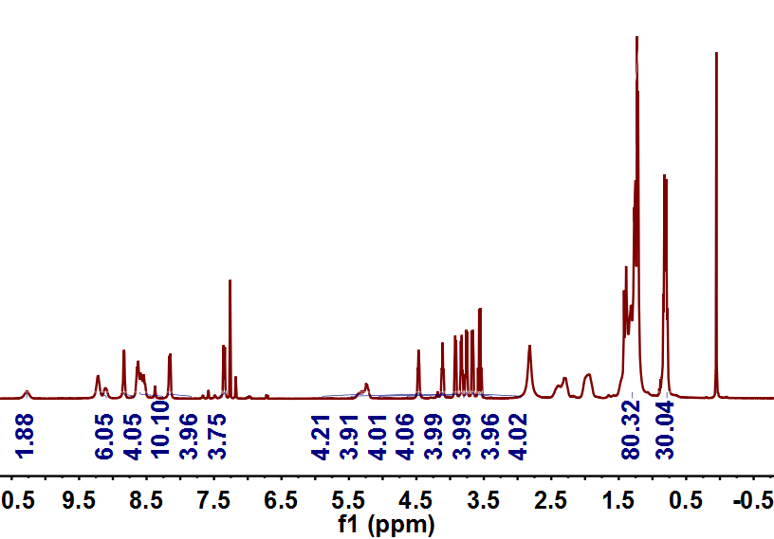
Fig. S2 ¹H NMR of PPor: ¹H NMR (400 MHz, CDCl₃) δ 10.27 (s, 2H), 9.17 (d, J = 43.5 Hz, 6H), 8.83 (d, J = 3.5 Hz, 4H), 8.73-8.46 (m, 10H), 8.16 (d, J = 7.9 Hz, 4H), 7.35 (d, J = 8.4 Hz, 4H), 5.27 (dd, J = 25.3, 5.2 Hz, 4H), 4.47 (t, J = 4.6 Hz, 4H), 4.11 (t, J = 4.9 Hz, 4H), 3.92 (dd, J = 5.8, 3.7 Hz, 4H), 3.83 (dd, J = 5.7, 3.8 Hz, 4H), 3.76 (dd, J = 5.8, 3.7 Hz, 4H), 3.67 (dd, J = 5.8, 3.7 Hz, 4H), 3.56 (q, J = 7.0 Hz, 4H), 1.42-1.18 (m, 80H), 0.95-0.62 (m, 30H).

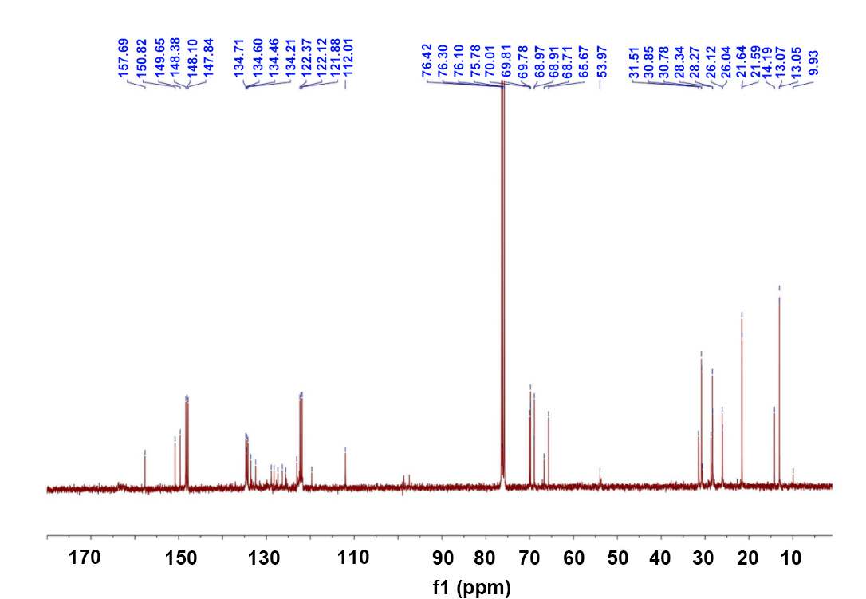
Fig. S3 ¹³C NMR of PPor: ¹³C NMR (101 MHz, CDCl₃) δ 157.69, 150.82, 149.65, 148.38, 148.10, 147.84, 134.66, 134.34, 133.57, 132.47, 128.92, 128.27, 127.40, 126.37, 123.07, 122.37, 122.12, 121.88, 119.67, 112.01, 76.36, 76.10, 75.78, 70.01, 69.80, 68.94, 66.71, 65.67, 53.97, 31.51, 30.76, 28.42, 28.08, 27.90, 26.08, 21.61, 14.19, 13.06, 9.93.

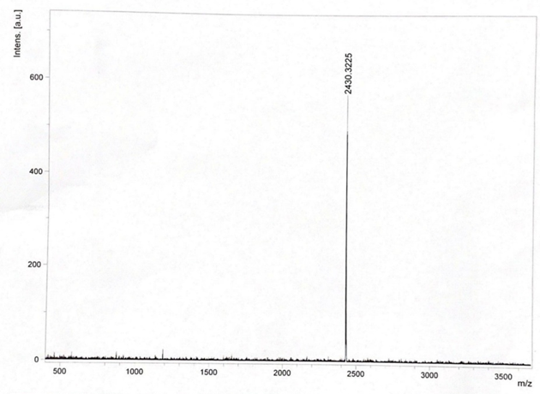
Fig. S4 Mass spectrum of PPor.

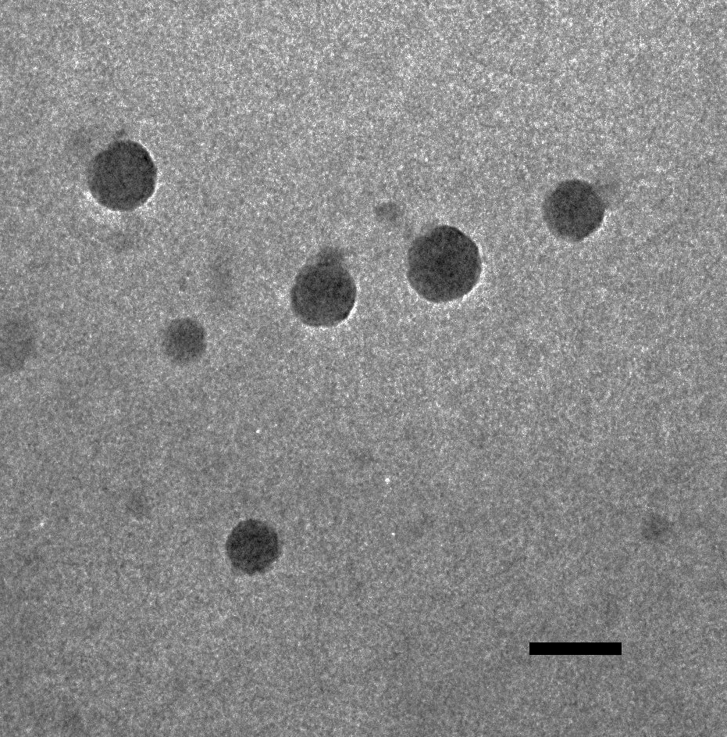
Fig. S5 The TEM image of PPor NPs. Scale bar: 100 nm.

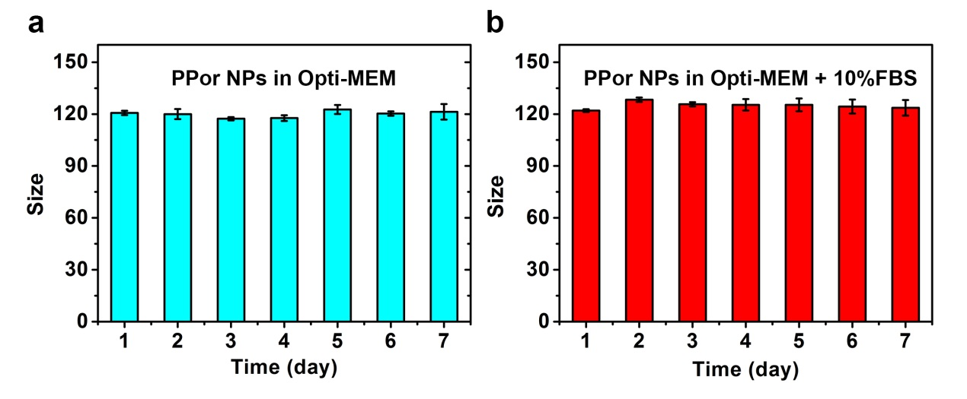
Fig. S6 Colloidal stability of PPor NPs in culture medium of Opti-MEM (a) and Opti-MEM supplemented 10% FBS (b), by monitoring particle size over a span of seven days.
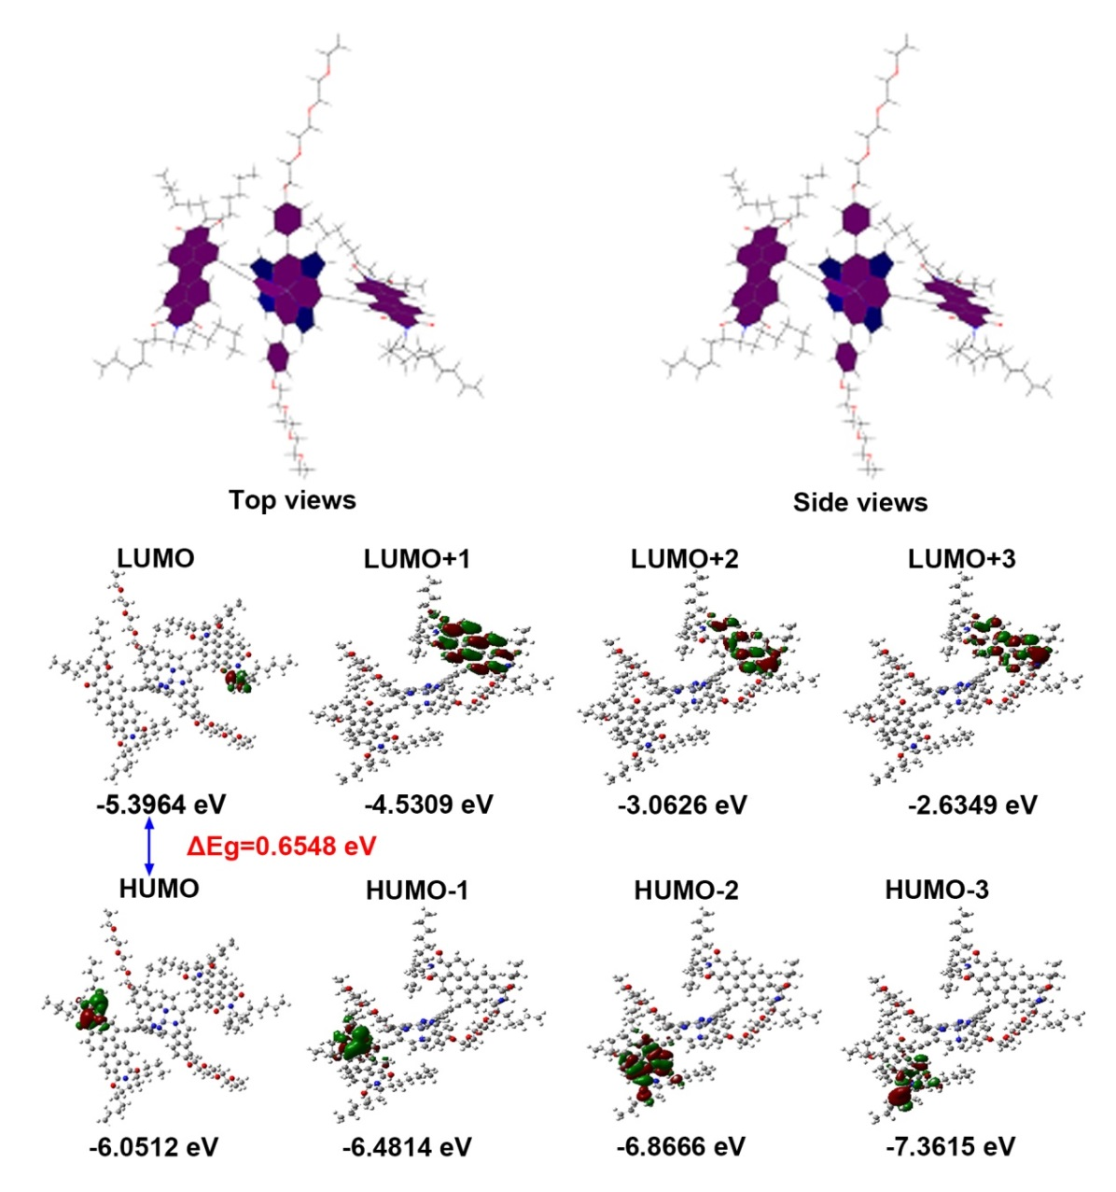
Fig. S7 Optimized geometry and the frontier molecular orbitals electron density distribution of PPor.

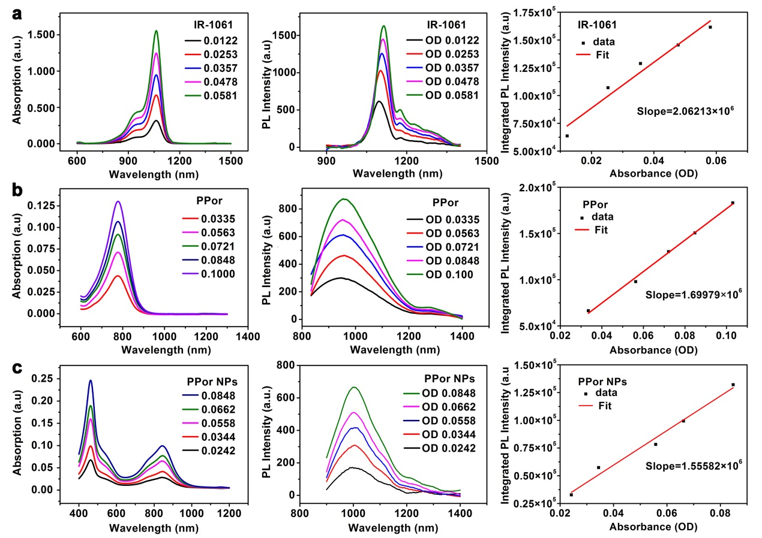
Fig. S8 NIR absorption spectra (left column), NIR-II fluorescence emission spectrum under 808 nm laser excitation (middle column), and integrated PL intensity of IR-1061(a), PPor (b) and PPor NPs (c).

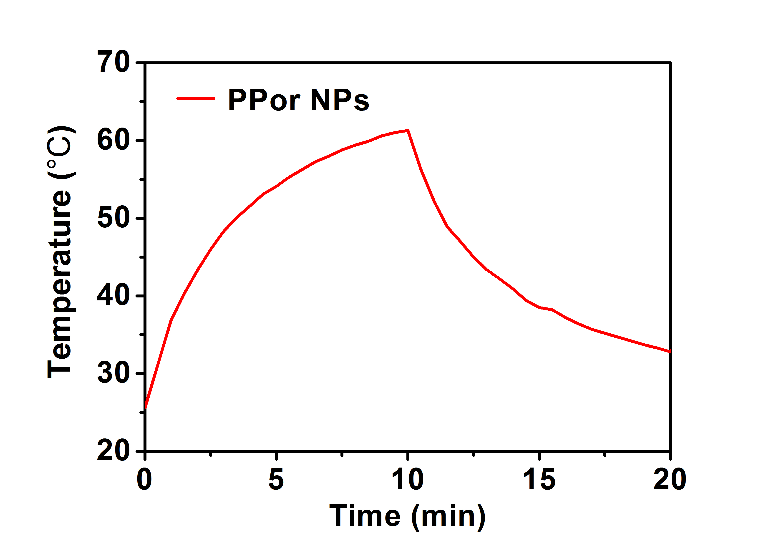
Fig. S9 Temperature curves of PPor NPs with laser irradiation for 10 min and then the laser was shut off.

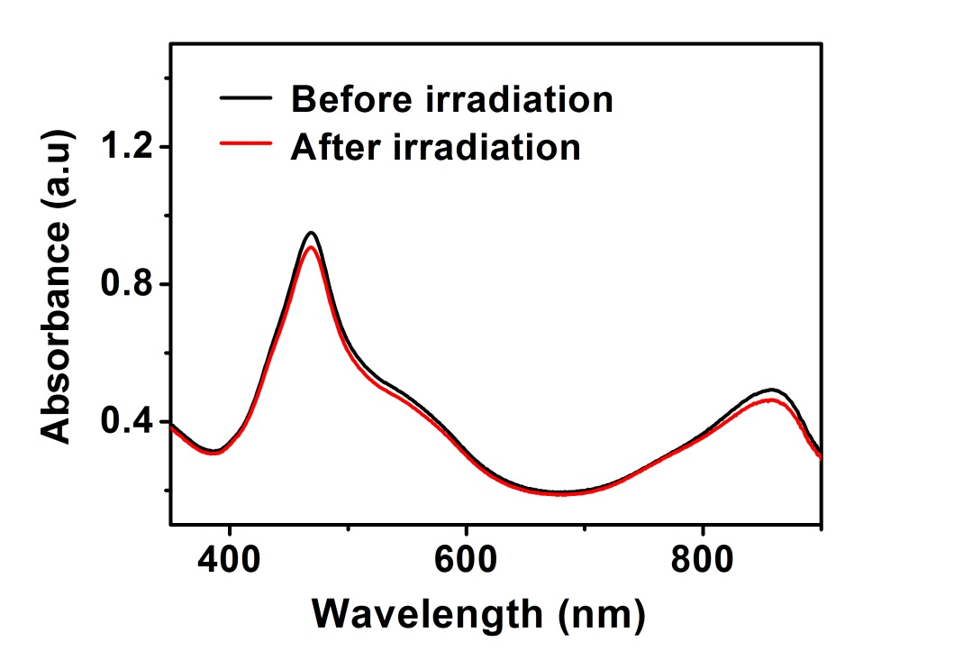
Fig. S10 UV-vis-NIR absorbance of PPor NPs before and after 808 nm laser irradiation.

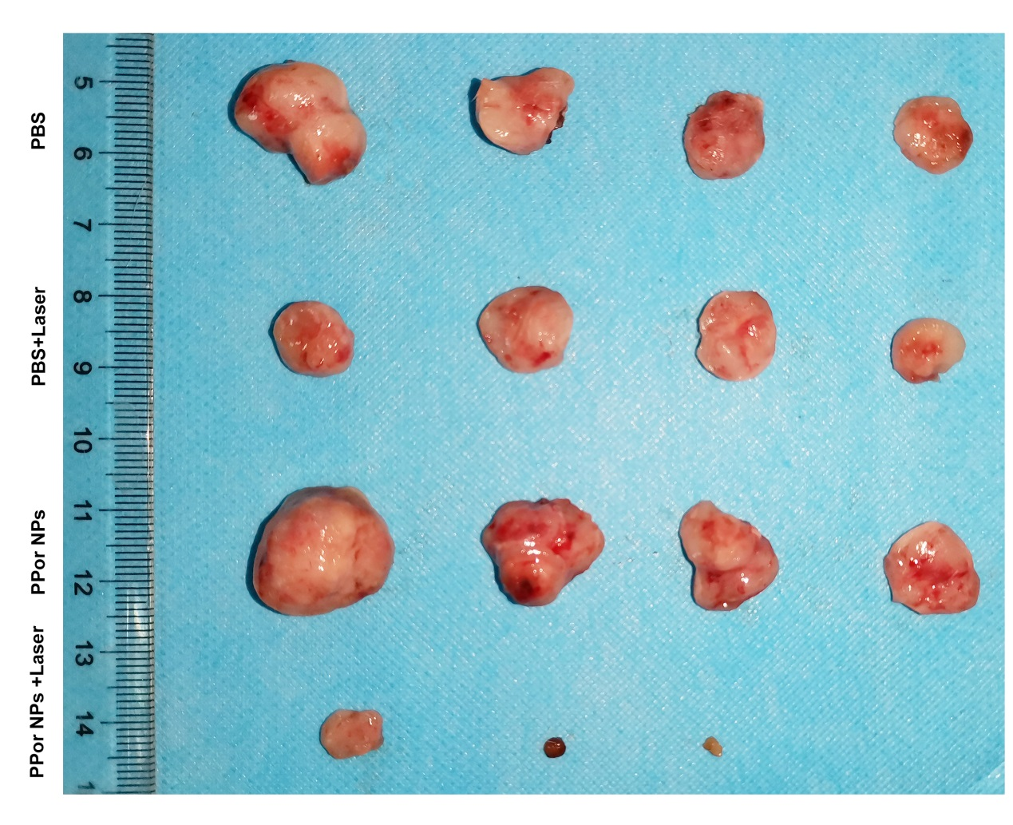
Fig. S11 Original photographs of tumor tissues after various treatments in Fig. 5g.

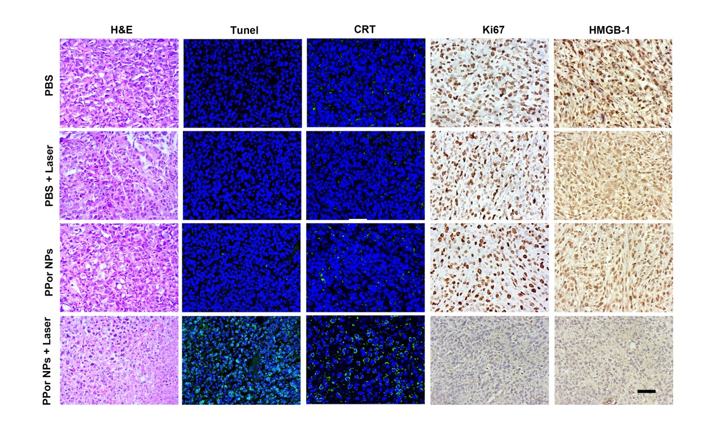
Fig. S12 Uncropped images of Fig. 5h. Scale bar:50 μm.
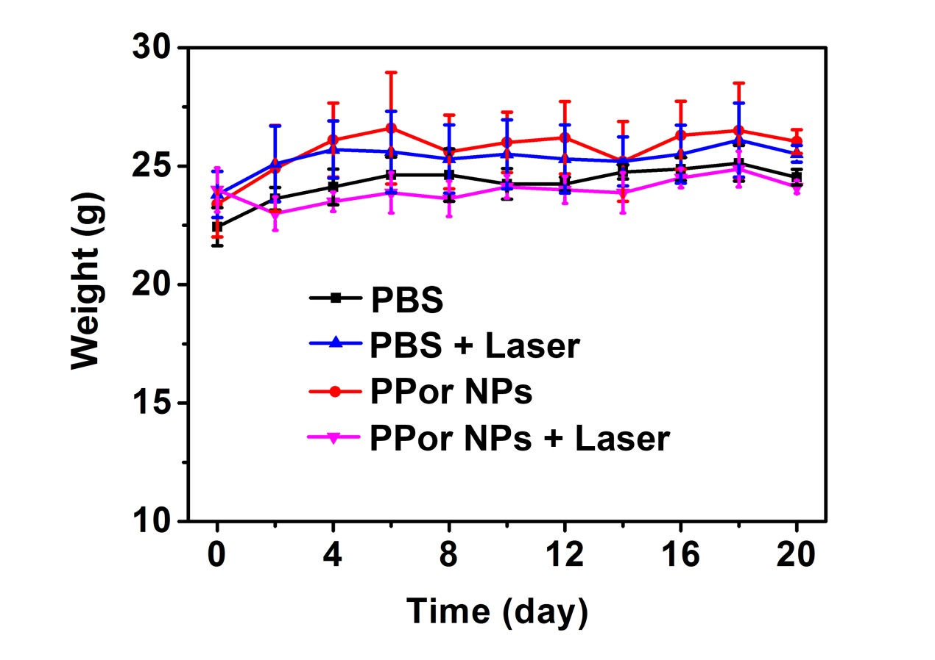
Fig. S13 Average body weight curves of mice by different treatments (PBS; PBS + Laser; PPor NPs; and PPor NPs + Laser) (n = 4).

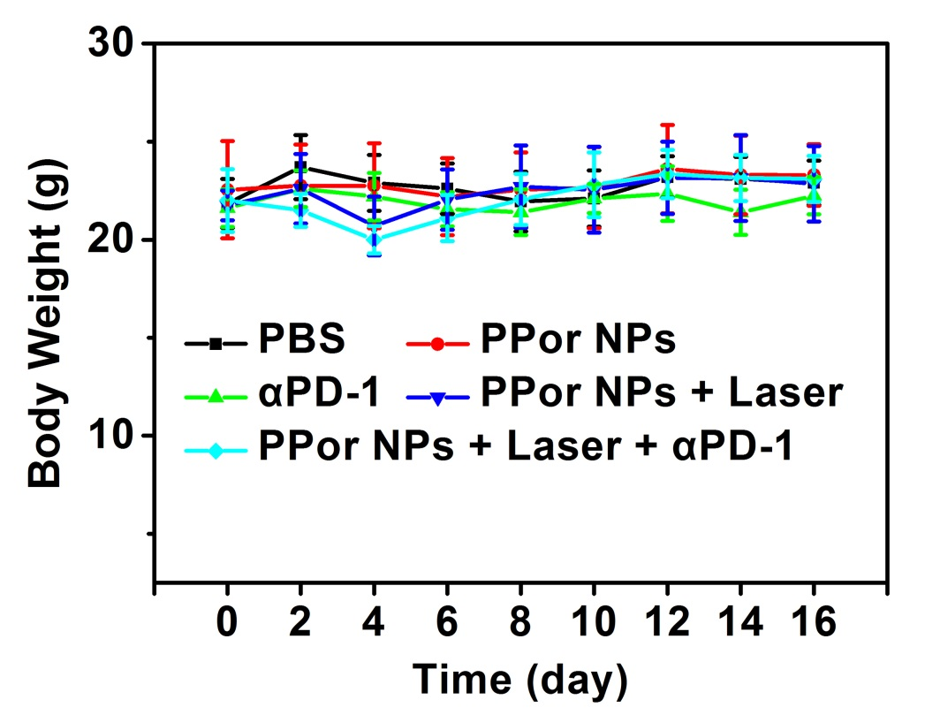
Fig. S14 Average body weight curves of mice by different treatments (PBS; PPor NPs; PPor NPs + Laser; αPD-1; PPor NPs + Laser + αPD-1) (n = 7).

