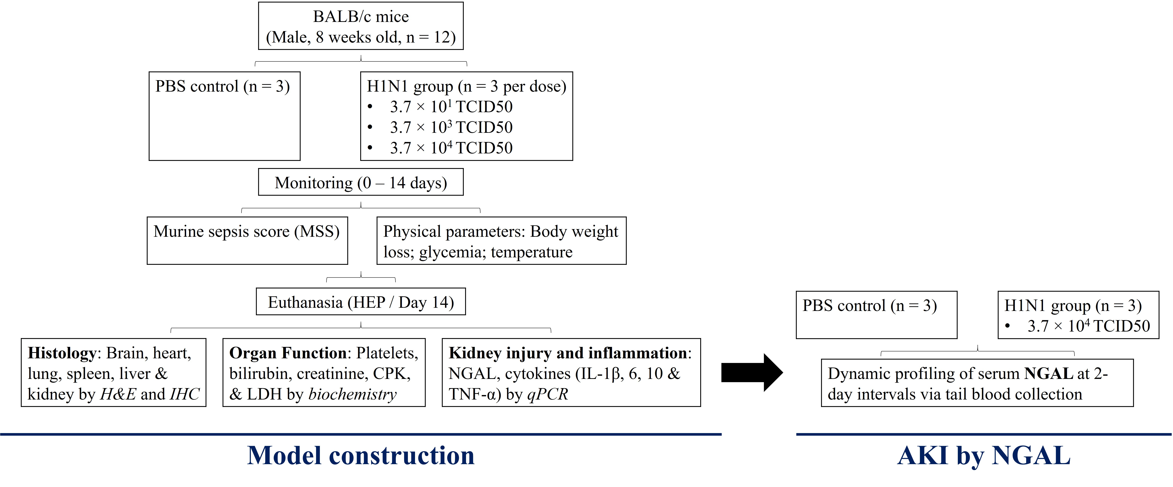
Supplementary file 1 Workflow for constructing an influenza-induced respiratory sepsis model and assessing AKI via dynamic profiling of serum NGAL.
Supplementary file 2 Semi-quantitative scoring systems for histological analysis.
Lung | None  = 0 |  | Minimal  = 1 |  | Mild  = 2 |  | Significant  = 3 |  | Severe  = 4
1. Edema in the alveolar spaces
2. Thickness of the alveolar wall
3. Infiltration of inflammatory cells
4. Haemorrhage
Sum score
Kidney | None  = 0 |  | Minimal  = 1 |  | Mild  = 2 |  | Significant  = 3 |  | Severe  = 4
1. Tubular degeneration
2. Glomerular enlargement
3. Infiltration of inflammatory cells
4. Haemorrhage
Sum score
Heart | None  = 0 |  | Mild  = 1 |  | Moderate  = 2 |  | Strong  = 3 |  | Intense  = 4
1. Wavy cardiac muscle fiber
2. Necrosis of cardiomyocytes
3. Infiltration of inflammatory cells
4. Haemorrhage
Sum score
Liver | None  = 0 |  |  | Mild  = 1 |  | Moderate  = 2 |  | Severe  = 3
1. Glycogen depletion
2. Cytoplasmic vacuolisation
3. Infiltration of inflammatory cells
4. Haemorrhage
Sum score

The degree of splenic injury | Score
Normal morphology | 0
Mild disorder of white pulp, characterised by local hyperplasia | 1
Moderate disorder of white pulp, blurring of the boundary between white pulp and red pulp, and the white pulp structures like follicles and marginal zones may vanish | 2
High disorder of white pulp, almost no significant difference between white pulp and red pulp | 3
Supplementary file 3 qPCR primers
 | Forward (5'->3') | Reverse (5'->3') | Product length | NCBI Ref. Seq.
NGAL | ATGTCACCTCCATCCTGGTCAG | GCCACTTGCACATTGTAGCTCTG | 145 | NM_008491.1
GADPH | CATCACTGCCACCCAGAAGACTG | ATGCCAGTGAGCTTCCCGTTCAG | 153 | NM_008084.4
IL-1β | TGGACCTTCCAGGATGAGGACA | GTTCATCTCGGAGCCTGTAGTG | 148 | NM_008361.4
IL-6 | TACCACTTCACAAGTCGGAGGC | CTGCAAGTGCATCATCGTTGTTC | 116 | NM_031168.2
IL-10 | CGGGAAGACAATAACTGCACCC | CGGTTAGCAGTATGTTGTCCAGC | 130 | NM_010548.2
TNF | GGTGCCTATGTCTCAGCCTCTT | GCCATAGAACTGATGAGAGGGAG | 139 | NM_013693.3

Supplementary file 4 Summary of individual mouse data across experimental groups and control group in H1N1 viral sepsis study.
Group | Mouse no. | Platelet counts, x10³/µL | Serum creatinine, μmol/L | Serum bilirubin, μmol/L | Serum CPK, U/L | Serum LDH, U/L
Sham (PBS control) | A1 | 2520 | 38 | 8.67 | 465 | 1432
Sham (PBS control) | A2 | 2066 | 32 | 6.86 | 336 | 1166
Sham (PBS control) | A3 | 1786 | 38 | 8.05 | 130 | 1005
3.7 × 10¹ TCID50 | B1 | 2357 | 54 | 15.93 | 438 | 1342
3.7 × 10¹ TCID50 | B2 | 1726 | 67 | 18.18 | 297 | 1436
3.7 × 10¹ TCID50 | B3 | 2742 | 50 | 11.62 | 401 | 1732
3.7 × 10³ TCID50 | C1 | 1526 | 166 | 35.84 | 1148 | 3274
3.7 × 10³ TCID50 | C2 | 1834 | 148 | 31.38 | 764 | 3018
3.7 × 10³ TCID50 | C3 | 1568 | 106 | 19.68 | 680 | 2086
3.7 × 10⁴ TCID50 | D1 | 1554 | 600 | 124.92 | 9822 | 6396
3.7 × 10⁴ TCID50 | D2 | 1477 | 204 | 40.62 | 11352 | 4716
3.7 × 10⁴ TCID50 | D3 | 2226 | 142 | 29.30 | 1272 | 2398

Supplementary file 5 Proposed murine-SOFA scoring criteria of platelets, bilirubin, creatinine, and CPK in assessing murine sepsis.
System Parameters | 0 | 1 | 2 | 3 | 4
Renal Creatinine, μmol/L | Normal (0 – 120) | 121 – 187 | 188 – 329 | 330 – 440 | > 440
Liver Bilirubin, μmol/L | Normal (0 – 28) | 29 – 46 | 47 – 144 | 145 – 290 | > 290
Coagulation Platelets, x10³/µL | Normal (≥ 1000) | < 1000 | < 667 | < 333 | < 133
Cardiac CPK, U/L | Normal (0 - 648) | 649 - 1296 | 1297 - 1944 | 1945 - 2592 | >2592
Note: The ranges for each criterion were assigned by proportion corresponding to human SOFA.

Supplementary file 6 Murine-SOFA score assessment in sham and influenza-infected mice. Organ dysfunction was evaluated using a modified murine-SOFA scoring system based on proportional thresholds derived from the human SOFA criteria. Score of serum creatinine (A), serum bilirubin (B), platelet counts (C), and serum creatinine phosphokinase (CPK) (D).

