Supplementary Materials
A1. Radiomics features
In our study, 1283 radiomics features were extracted from the US images using the Pyradiomics package (version 2.1.2). Radiomics features in each class was described below and can be divided into three categories: shape based features, the first-order statistics and the high-order textural features. The features we enrolled in this study were described in the Table S1.
- The shape-based features
In this group we included 9 features descriptors of two-dimensional shape and size of the breast lesion. These features are only calculated on the non-derived image and mask and are independent from the gray level intensity distribution in the ROI.
- The first-order statistics
First-order statistics describe the distribution of voxel intensities within the image region defined by the mask through commonly used and basic metrics. A total of 18 features were included in this study.
- The high-order textural features
- The statistics-based textural features

The statistics-based textural features represents the spatial patterns of voxel intensities and the homogeneity of the images. There are mainly 5 types of matrix features included in our textural features, Gray Level Co-occurrence Matrix (GLCM) Features, Gray Level Size Zone Matrix (GLSZM) Features, gray Level Run Length Matrix (GLRLM) Features, Neighbouring Gray Tone Difference Matrix (NGTDM) Features, Gray Level Dependence Matrix (GLDM) Features. The more details about the above features can be found at https://pyradiomics.readthedocs.io/en/latest/index.html.
- Wavelet features
The wavelet-based features were captured through the wavelet transform which was similar to the Fourier transform. After the breast images were decomposed by the wavelet, different scales of the wavelet transform coefficient can be obtained. Therefore, some of the wavelet features combined with the coefficient would be a subset associated with TNBC. A large amount of wavelet features could be extracted by analyzing the different scales of the decomposition results.

Reference
- Sun R, Limkin EJ, Vakalopoulou M, Dercle L, Champiat S, Han SR, et al. A radiomics approach to assess tumour-infiltrating CD8 cells and response to antiPD-1 or anti-PD-L1 immunotherapy: an imaging biomarker, retrospective multicohort study. Lancet Oncol 2018;19:1180–91
- Landis JR, Koch GG. The measurement of observer agreement for categorical data. Biometrics 1977;33:159-74.
3.Kim M, Jung SY, Park JE, et al. Diffusion- and perfusion-weighted MRI radiomics model may predict isocitrate dehydrogenase (IDH) mutation and tumor aggressiveness in diffuse lower grade glioma. Eur Radiol. 2020 Apr;30(4):2142-2151.

Table S1. The radiomics features extracted in the study.
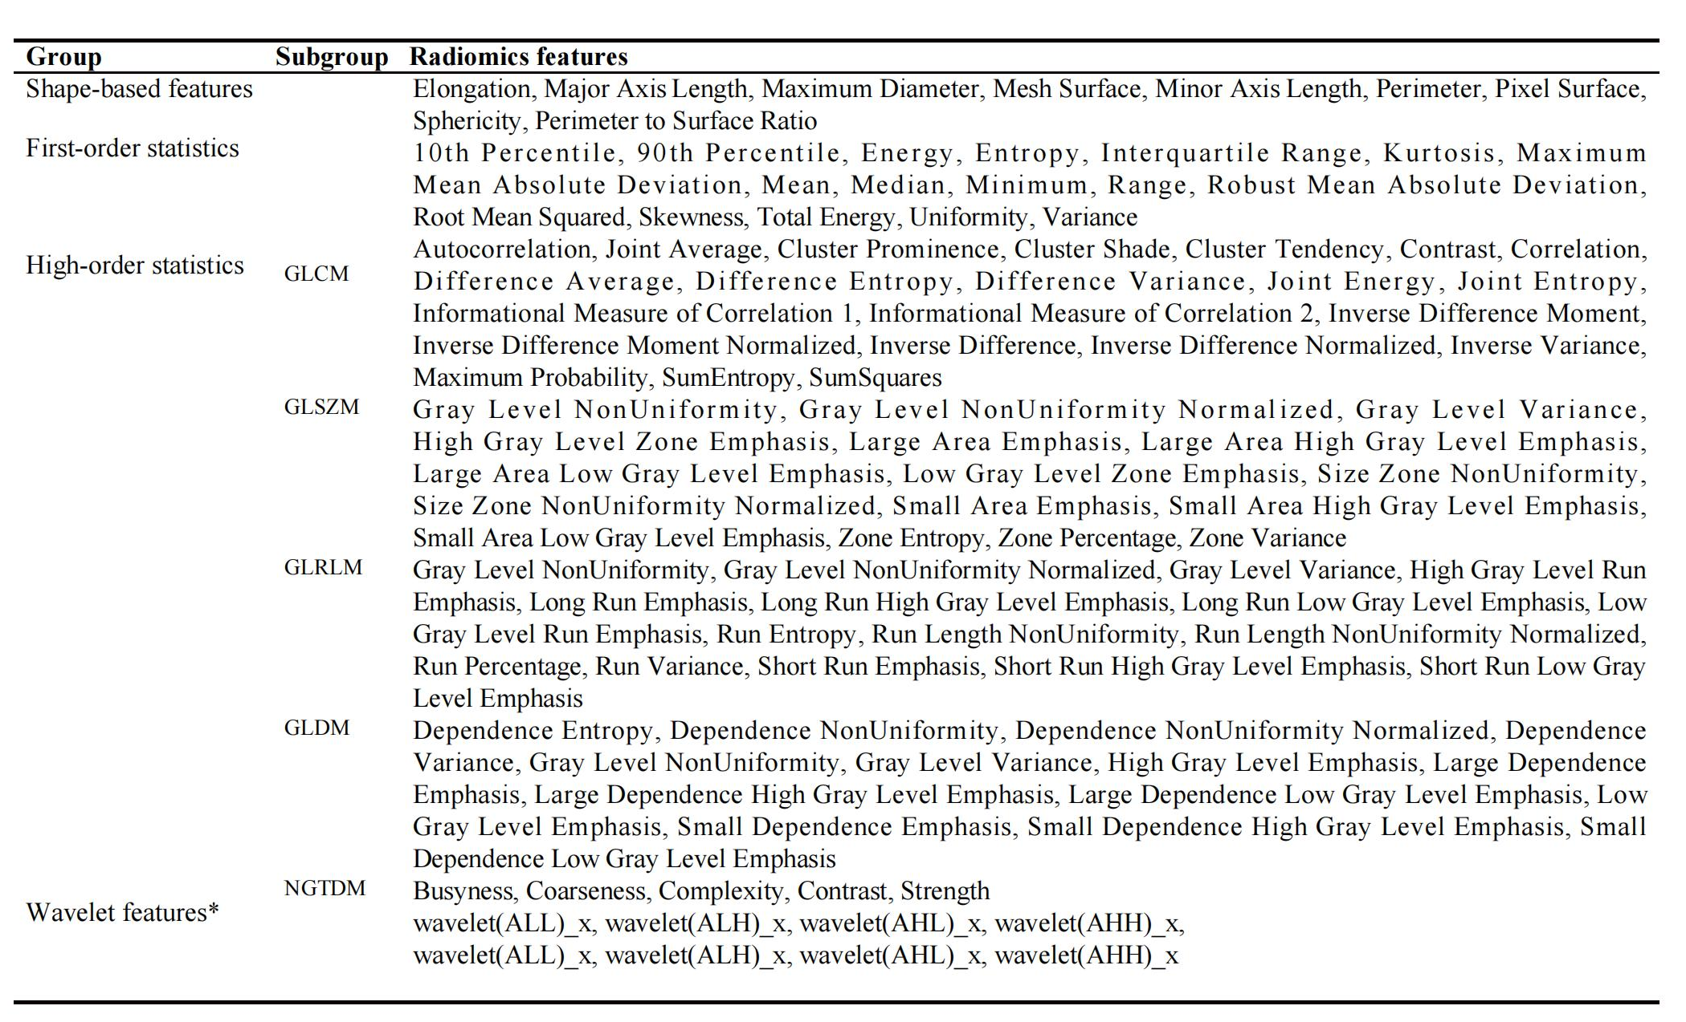*x indicates the first-order statistics features and high-order statistics features listed above.
Abbreviations: GLCM: Gray Level Cooccurence Matrix; GLSZM: Gray Level Size Zone Matrix; GLRLM: Gray Level Run Length Matrix; GLDM: Gray Level Dependence Matrix; NGTDM, neighboring gray tone difference matrix.

Table S2. Characteristics associated with TNBC and fibroadenoma in the training and validation cohorts
 | Training cohort (n=253)  TNBC Fibroadenoma P |  |  | Validation cohort (n=107）  TNBC Fibroadenoma P
No. of lesions | 125 | 128 |  | 53 | 54
Age* | 51.12±11.72 | 35.74±11.22 | <0.001 | 50.19±11.03 | 35.78±9.30 | <0.001
Tumor size  <3 cm  >3 cm | 96 (73.5%)  29 (26.5%) | 109 (79.5%)  19 (21.5%) | 0.287 | 44（86.0%）  9（14.0%） | 45（83.3%）  9（16.7%） | 0.717
Shape  Oval or round  Irregular | 44 (41.2%)  81 (59.8%) | 84 (64.6%)  44 (35.4%) | <0.001 | 17（34.9%）  36（65.1%） | 39（72.2%）  15（27.8%） | <0.001
Margin  Well-circumscribed  Non-circumscribed | 50 (48.0%)  75 (52.0%) | 78 (60.6%)  50 (39.4%) | 0.057 | 17（39.5%）  36（60.5%） | 40（74.1%）  14（25.9%） | 0.002
Orientation  Parallel  Nonparallel | 99 (76.5%)  26 (23.5%) | 114 (89.0%)  14 (11.0%) | 0.011 | 47（86.0%）  6（14.0%） | 51（94.4%）  3（5.6%） | 0.160
Echotexture  Hypoechoic  Heterogeneous | 92 (70.6%)  33 (29.4%) | 106 (82.7%)  22 (17.3%) | 0.030 | 43（79.1%）  10（6.9%） | 48（88.9%）  6（11.1%） | 0.188
Posterior echo feature  None  Enhancement | 92 (62.7%)  33 (37.3%) | 86 (66.9%)  42 (33.1%) | 0.511 | 40（72.1%）  13（27.9%） | 39（72.2%）  15（27.8%） | 1.000
BI-RADS category  3  4A  4B  4C  5 | 7 (5.9%)  24 (21.6%)  43 (31.4%)  31 (23.5%)  20 (17.6%) | 64 (49.6%)  42 (33.1%)  18 (14.2%)  3 (2.3%)  1 (0.8%) | <0.001 | 2（4.6%）  7（14.0%）  27（46.5%）  12（23.3%）  5（11.6%） | 30（55.6%）  19（35.2%）  4（7.4%）  1（1.8%）  0（0%） | <0.001
Rad-score | -1.34±1.96 | 1.16±1.25 | <0.001 | -0.97±1.70 | 1.47±1.34 | <0.001

NOTE: Unless otherwise noted, data are shown as number of patients, with the percentage in parentheses.
*Data are means ± standard deviations.

