SUPPLEMENTARY MATERIAL
Feature-Optimized Machine Learning Benchmarking for Protein Interface Prediction in Permanent Homodimer Complexes with Distinct Structural Features

Tayyip Topuz^{1,2}, Zeki Erdem^{3,4}, Halil Bisgin⁴, E. Demet Akten^{5*}

¹School of Graduate Studies, Ph.D. Program of Computer Engineering, Kadir Has University, 34083, Fatih, Istanbul, Turkey
²Core Program, Kadir Has University, 34083, Fatih, Istanbul, Turkey
³Department of Computer Engineering, Faculty of Engineering and Natural Sciences, Kadir Has University, 34083, Fatih, Istanbul, Turkey
⁴Computer Science Department, College of Innovation and Technology, University of Michigan-Flint, Flint, MI, USA
⁵Department of Molecular Biology and Genetics, Faculty of Engineering and Natural Sciences, Kadir Has University, 34083, Fatih, Istanbul, Turkey

*Corresponding Author
demet.akten@khas.edu.tr
tel. +90 212 533 65 32 (x1350)
fax. +90 212 631 91 50
https://orcid.org/0000-0002-0358-3171
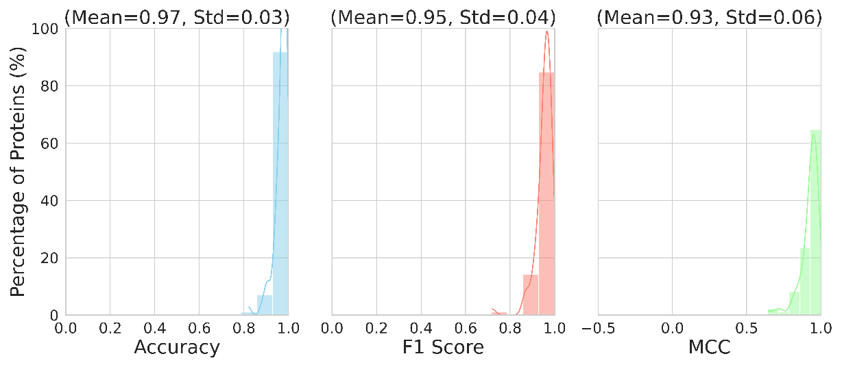
(a)
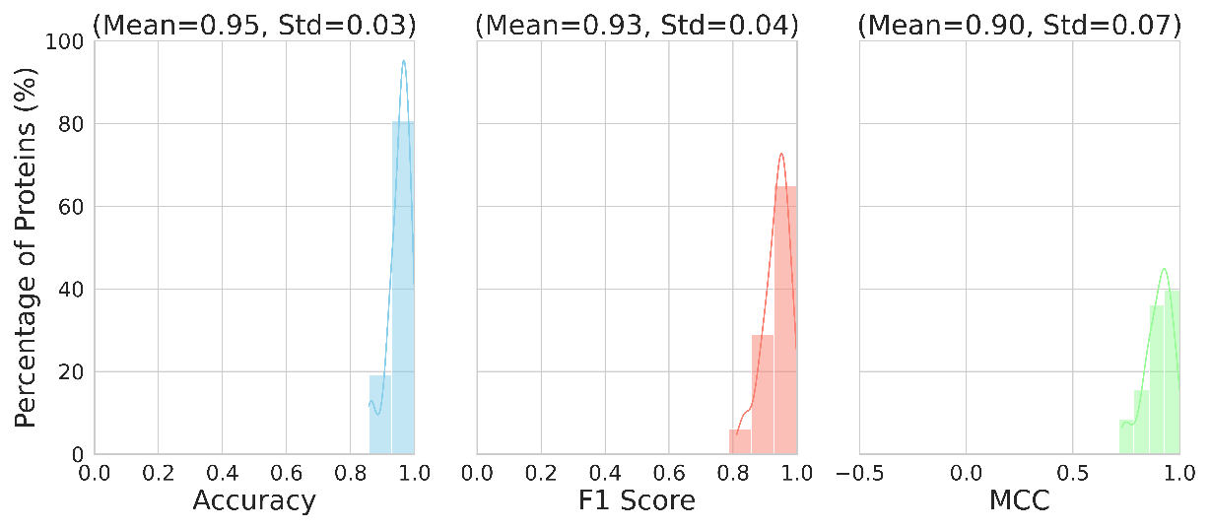
(b)
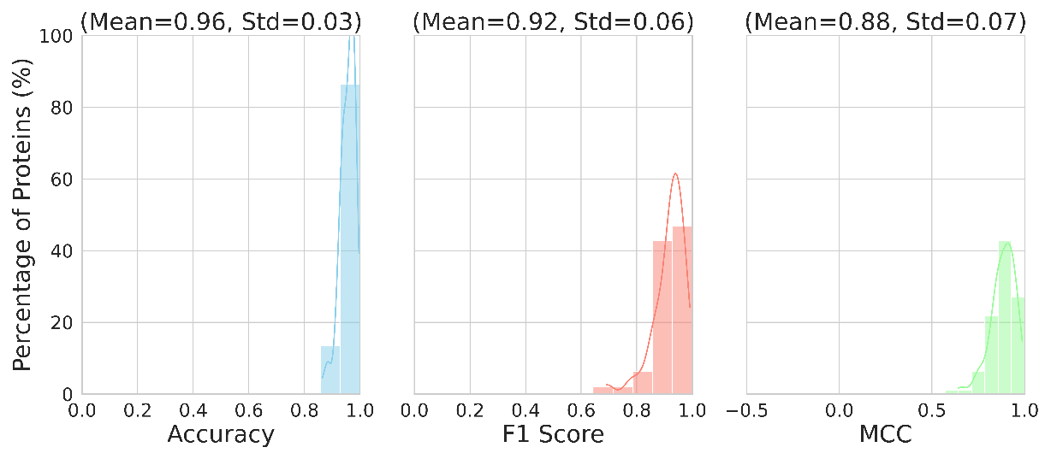
(c)
Supplementary Figure 1 α MLP model with minimal feature set on test sets (a) α, (b) β, (c) Mem
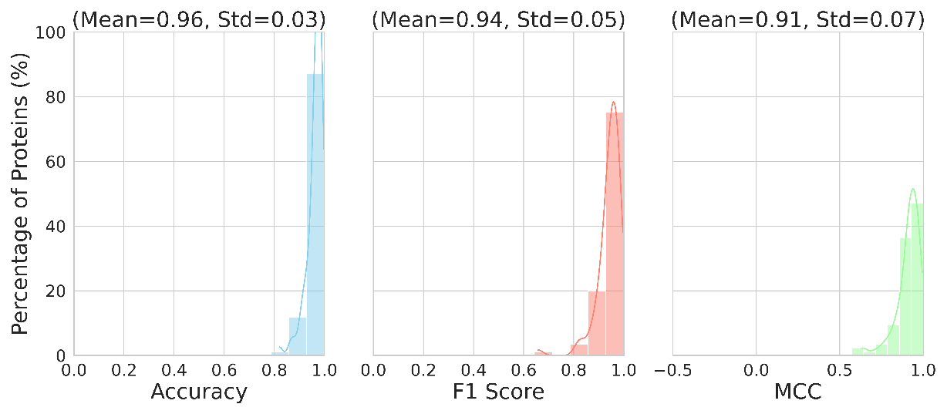
(a)
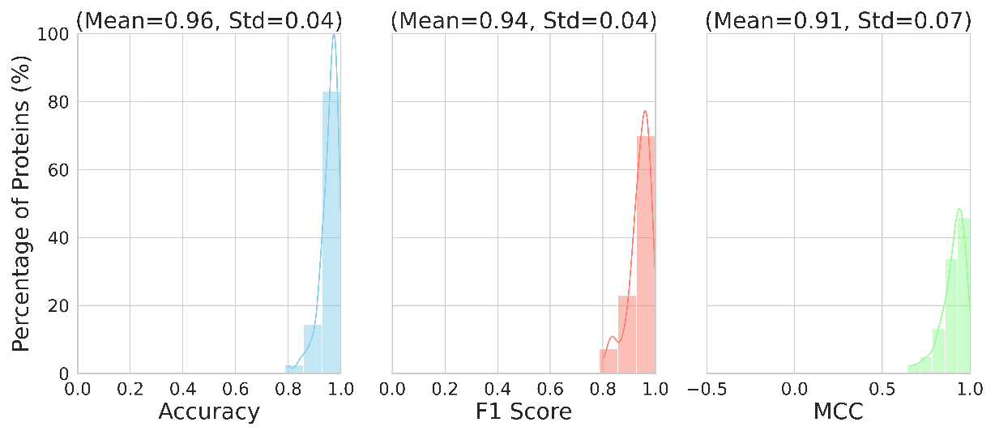
(b)
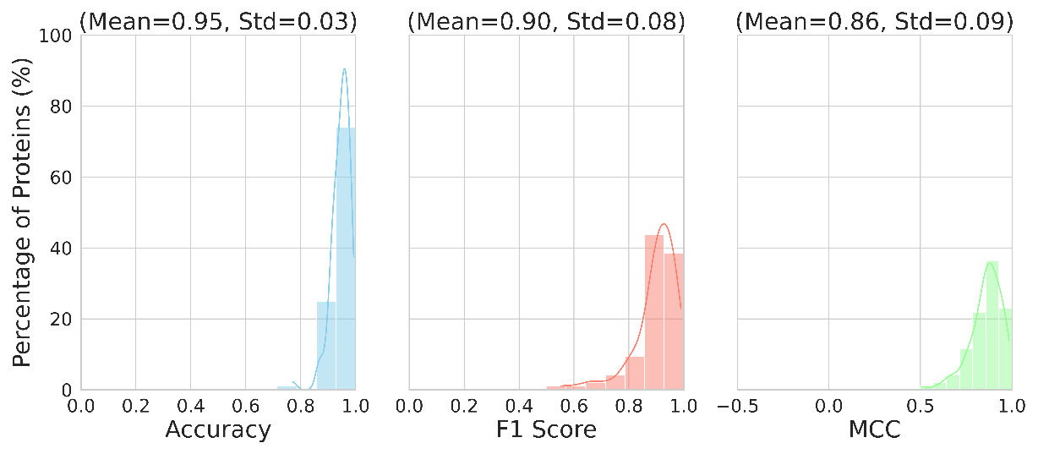
(c)
Supplementary Figure 2 β MLP model with minimal feature set on test sets (a) α, (b) β, (c) Mem
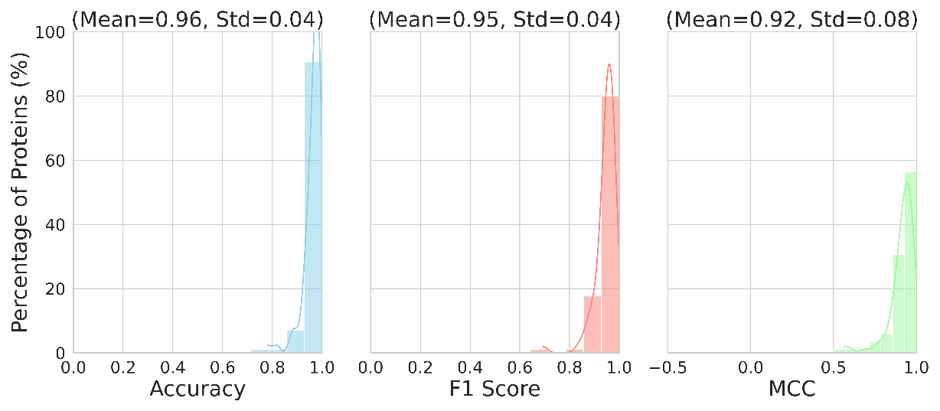
(a)
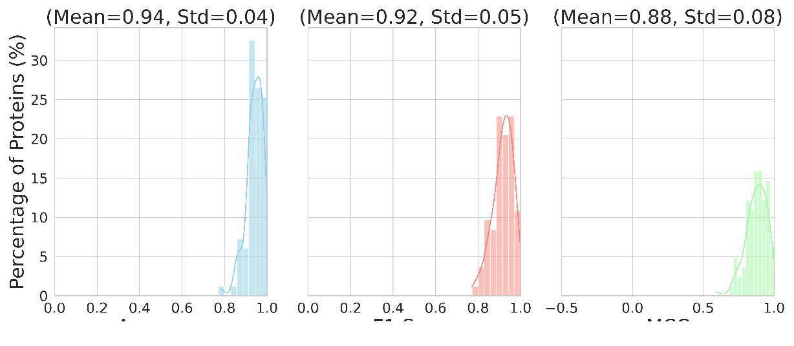
(b)
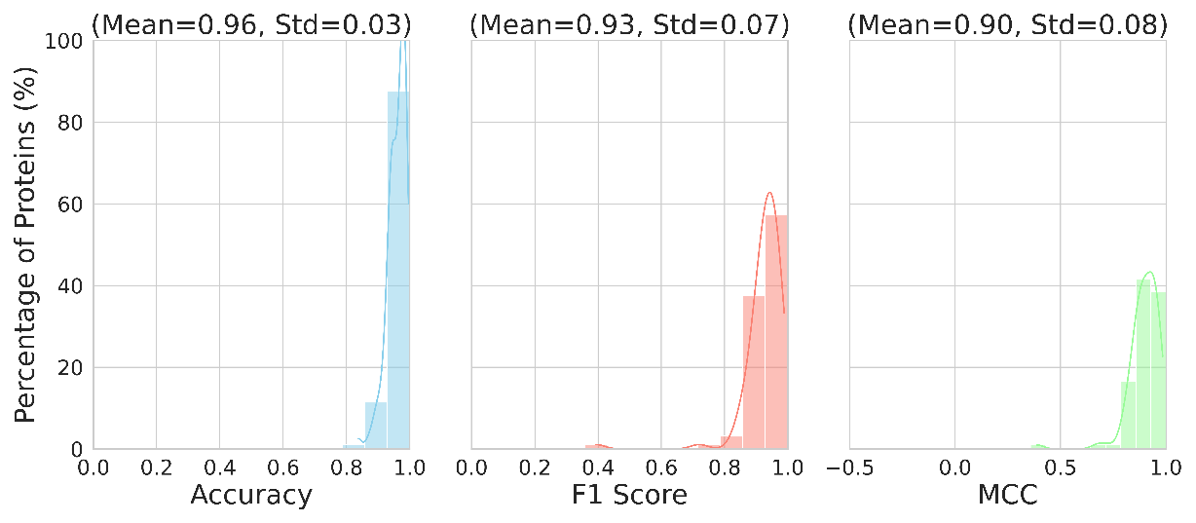
(c)
Supplementary Figure 3 Mem MLP model with minimal feature set on test sets (a) α, (b) β, (c) Mem
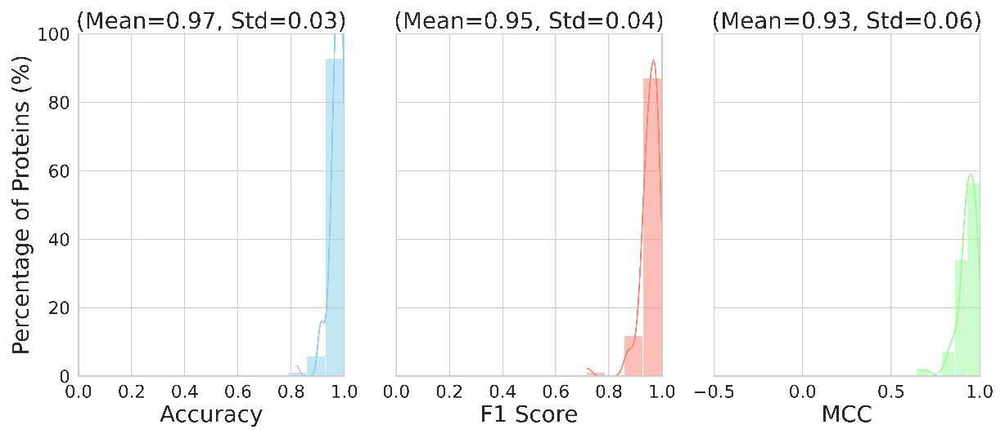
(a)
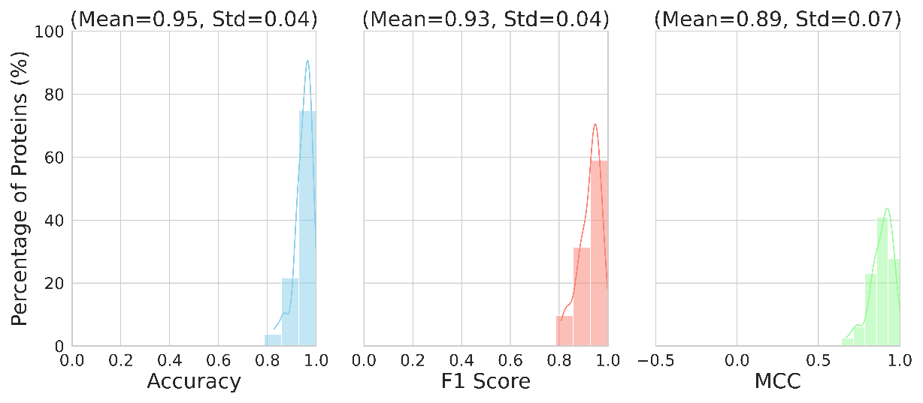
(b)
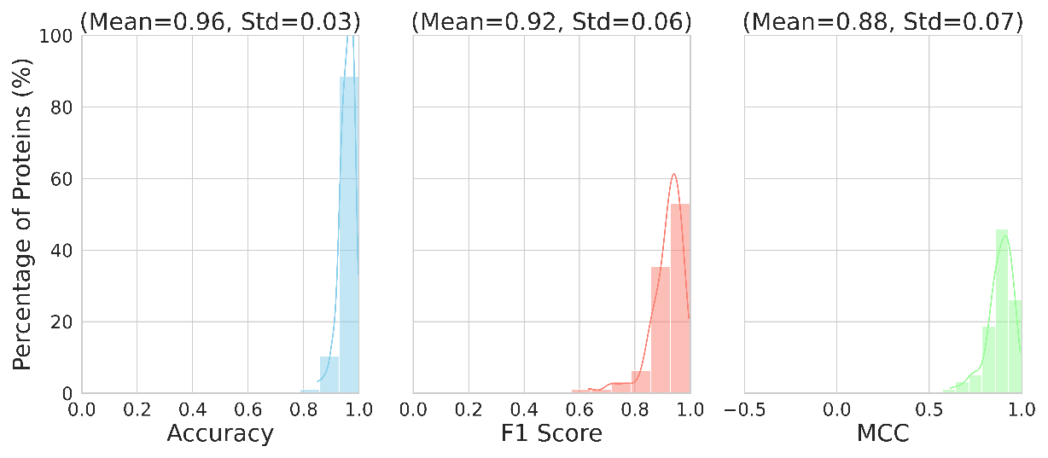
(c)
Supplementary Figure 4 α XGBoost model with minimal feature set on test sets (a) α, (b) β, (c) Mem
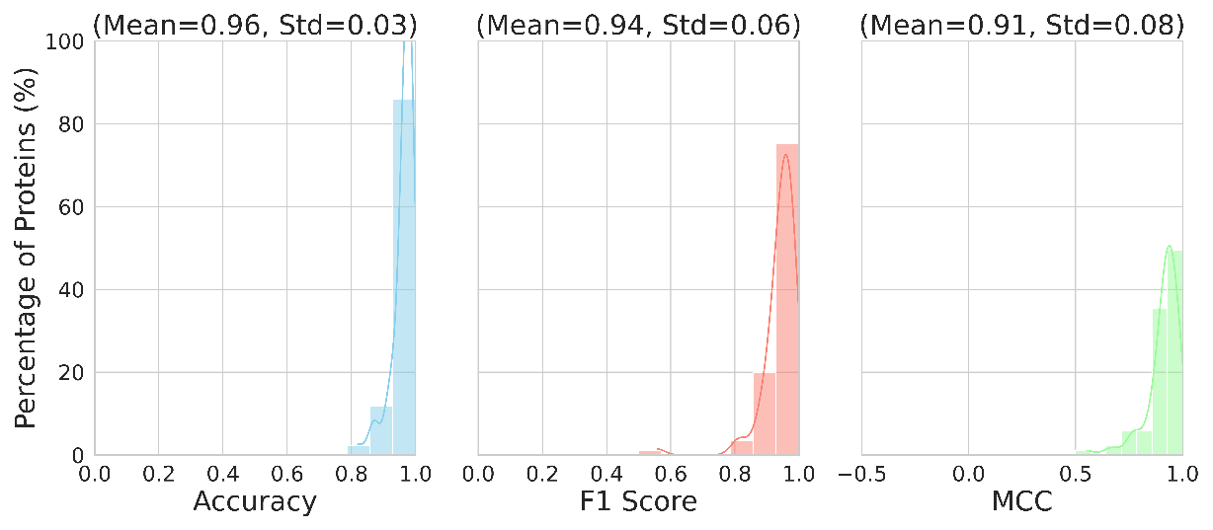
(a)
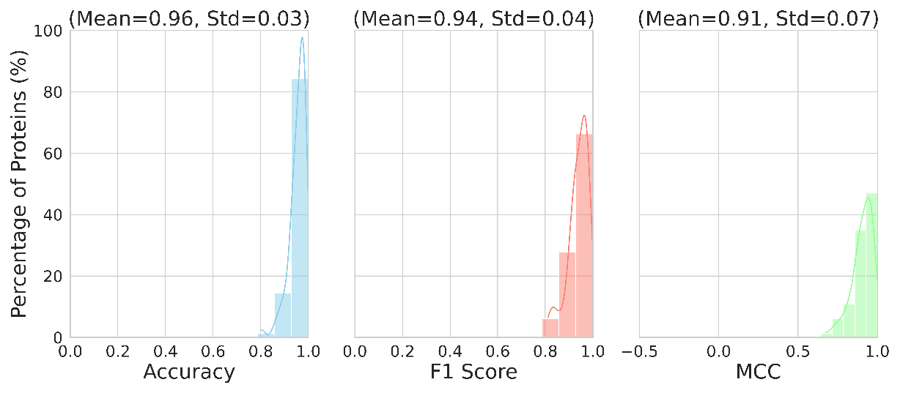
(b)
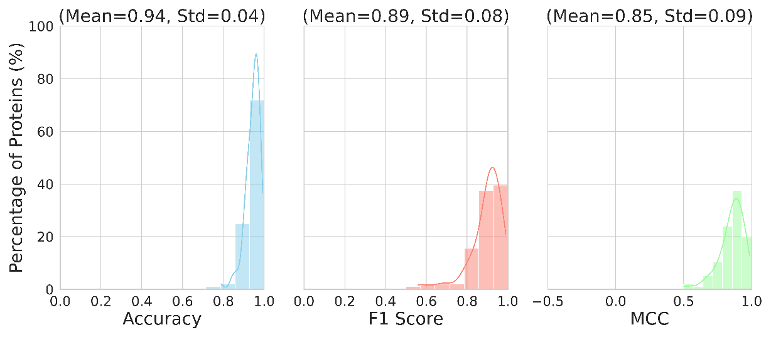
(c)
Supplementary Figure 5 β XGBoost model with minimal feature set on test sets (a) α, (b) β, (c) Mem
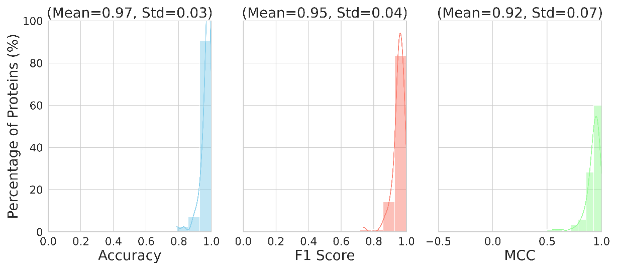
(a)
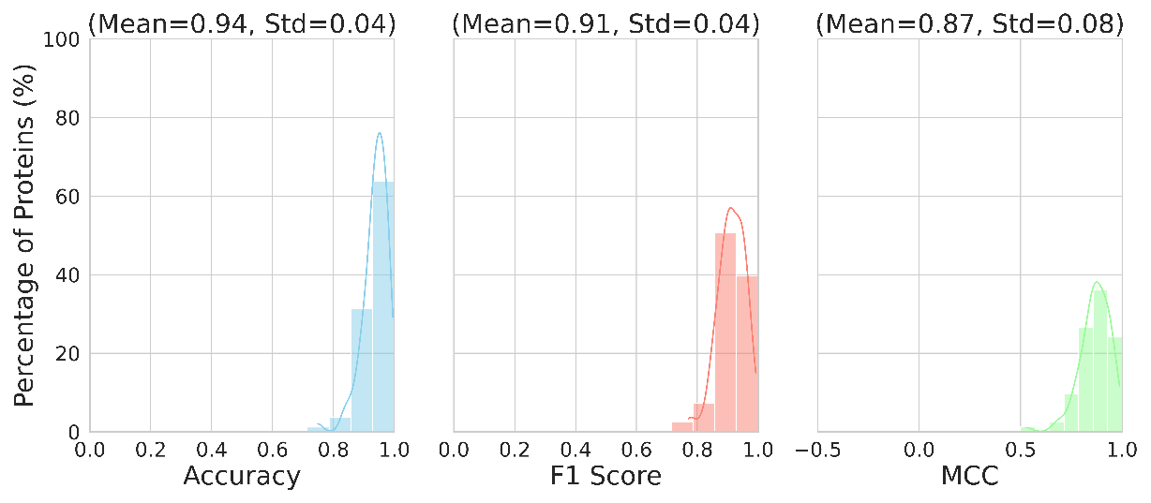
(b)
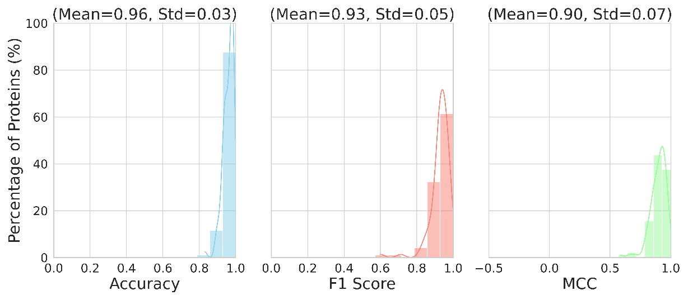
(c)
Supplementary Figure 6 Mem XGBoost model with minimal feature set on test sets (a) α, (b) β, (c) Mem
Supplementary Table 1 PDB id’s of the training and testing protein complexes grouped into three categories based on the secondary structure type of the interface and the surrounding environment.
Cytoplasmic alpha-helical Train Set | 139l-17gs-1a17-1a43-1ae7-1afr-1aj8-1al6-1aw1-1b43-1b57-1b8g-1b9b-1btm-1chu-1csm-1d2r-1dli-1e7d-1ee1-1ee8-1ek6-1f0y-1fp3-1g6w-1gmz-1gqi-1gsz-1gu6-1h1y-1hn4-1i2n-1i45-1i4s-1iom-1is2-1iyh-1j1a-1j1j-1j93-1j9i-1jfa-1ka8-1kbl-1kcf-1kea-1kgn-1kv5-1lns-1lon-1m6j-1mo0-1n0h-1n1q-1nox-1o5x-1oc2-1orr-1oyf-1p5z-1p7n-1p9b-1pvd-1pyd-1qmg-1r2f-1req-1rqg-1rqi-1rvg-1rxq-1s9c-1sb8-1so2-1szq-1txg-1tya-1tz9-1ubv-1uda-1udu-1ukw-1ulh-1v4e-1v4v-1vgv-1via-1vip-1vjt-1w07-1w2y-1w53-1x0x-1x94-1xg7-1xng-1xqi-1xzw-1y42-1yhk-1yi8-1ynf-1yv5-1yyq-1zch-1zkw-1zl7-2a6b-2a84-2a9u-2ahr-2ao2-2b0j-2b5d-2b67-2bwj-2c20-2c5e-2cya-2dh4-2e1e-2e21-2eja-2el7-2ev1-2f1k-2flo-2fon-2g36-2g4l-2g5c-2ggl-2ggp-2gi3-2h9c-2hrc-2hun-2hvg-2i22-2inf-2isv-2iz0-2j07-2k1r-2o70-2ocp-2oej-2oma-2opi-2p5u-2pbp-2pla-2pv7-2pw3-2pzb-2qaf-2rd3-2v6k-2w8z-2xiq-2xpk-2yaz-2yy2-2yyn-2zvi-2zya-3a04-3b9r-3bem-3beo-3bnx-3bsm-3cqh-3ct2-3d4j-3der-3dg7-3dpi-3dzc-3e7d-3enk-3fef-3fiu-3fq7-3g7i-3gwl-3hfr-3hmq-3hv0-3hwk-3i4k-3i6e-3itm-3jxe-3kbp-3kdy-3kt0-3m31-3m5w-3mzn-3n2s-3nav-3npk-3nz4-3o3m-3odm-3olj-3prh-3q58-3qn3-3qtp-3r12-3r89-3rk8-3ru7-3ssa-3sz3-3tw9-3vgj-3w6z-3wdk-3wjk-4au1-4cvp-4d7a-4d8f-4f1w-4f66-4fkz-4g8t-4i71-4j5p-4j75-4jwt-4kqx-4lkq-4mpf-4n5f-4neq-4ny7-4omg-4oun-4ppu-4q16-4q9o-4qss-4ri6-4u04-4u83-4wsh-4x4w-4yh2-4yio-4ywq-4yym-5ayp-5enz-5f05-5f23-5ihx-5je8-5jef-5k3g-5k3j-5lcz-5ltf-5lvr-5mux-5o5t-5syu-5ts9-5uqo-5v0i-5vkw-5w6y-5whr-5y8g-5y9z-5zka-6a71-6at7-6bej-6byq-6cnz-6dfu-6ebo-6egk-6ep7-6ex4-6ezu-6gsb-6gza-6i2z-6iv7-6mtk-6pro-6r6u-6zjk-7axy-7e1l-7el8-7eqe-7exe-7fg6-7kvh-7m32-7my0-7my6-7n9o-7ngj-7o04-7oom-7owv-7pp7-7pt0-7pv1-7q16-7qaa-7qbk-7qoc-7qp9-7r62-7r6u-7s3z-7s76-7sfo-7tdd-7te7-7twa-7vg4-7vwe-7y0y-8czj-8dsy-8eq8-8gxl-8nse
Cytoplasmic alpha-helical Test Set | 11ba-1aok-1bmt-1bxk-1cqx-1ddz-1dvj-1e2h-1f05-1g1a-1gy8-1hti-1idt-1jk0-1jqo-1jzt-1lxy-1n1b-1n3l-1nht-1np3-1nvd-1o0w-1o17-1o5h-1ogk-1ql0-1r3q-1r8g-1tj7-1uzr-1vbm-1ww1-1y44-1yxy-2ag6-2aq0-2gf2-2gn0-2gr9-2hbv-2jas-2par-2pid-2pv3-2yy5-3cky-3f0n-3fk4-3i05-3lom-3r11-3ro6-3tze-3uu0-3zcd-4aql-4bof-4e0h-4l5l-4lzj-4mf5-5ag2-5ks7-5uq9-5wp0-6c5c-6ex3-6fqx-6ncr-6qo5-6riv-6vo2-6vso-6yka-7eqf-7lbj-7vwt-7wbr-7wxz-7wze-7yxh-7zrn-8du6-8dub
Cytoplasmic beta-strand Train Set | 1a6u-1a78-1a7n-1aaq-1at0-1b8m-1bdy-1bso-1c12-1c1f-1c5b-1cd8-1cfv-1d2s-1d5i-1d9k-1dbn-1dn0-1dqt-1eap-1eeq-1eym-1f9k-1fl3-1ggb-1gnz-1h5b-1h91-1hq4-1hza-1iam-1igi-1jfq-1jhe-1jpy-1jv5-1kcu-1l4i-1mfa-1mi8-1my5-1n7m-1nj9-1njh-1nzi-1o4t-1oaq-1opa-1ouw-1p4i-1pdg-1pfs-1q0x-1qjg-1qmj-1sda-1se8-1spp-1tza-1usc-1usr-1uww-1uxm-1uzy-1vhz-1vj2-1wlc-1wlg-1wlh-1wq9-1wz1-1xe6-1xko-1xrk-1xvs-1y0g-1yai-1yt5-1z24-1z52-1zm1-1zmi-1zso-2aq6-2ar6-2axh-2b4h-2bdr-2c11-2c7w-2ck2-2co3-2cxk-2d6k-2dud-2e5y-2f4p-2fhq-2fvu-2fyr-2gi7-2gvb-2gx9-2h1t-2h2n-2hl0-2hq7-2huh-2i02-2i45-2i9x-2iep-2imm-2imz-2in5-2nu5-2o3o-2ooj-2ook-2oov-2ox5-2ozj-2p1r-2pyt-2q03-2q3a-2r4i-2rde-2snw-2vzx-2wo0-2xr4-2y0o-2yd6-2yn3-2z77-2zdo-2zf3-2zgm-2zhp-2zmk-2zo6-35c8-3a6q-3b76-3b83-3b9i-3c2s-3c8x-3caf-3cdc-3cfx-3cnk-3cvi-3czz-3d82-3d9r-3dh5-3dui-3ec6-3ejz-3emm-3eo0-3eo6-3er7-3ew1-3f1n-3fc0-3fgy-3g5x-3gb3-3h2d-3hds-3hpe-3hqx-3hzp-3i2z-3i9i-3ia8-3ipf-3ipt-3iy4-3js1-3jx8-3khf-3knf-3kyg-3l1o-3lgj-3lgm-3lsd-3lva-3lwc-3m8c-3mit-3mqi-3nn8-3o0l-3osv-3pgz-3ps4-3q5t-3qs2-3rfh-3rnk-3sed-3snm-3soy-3szh-3u0i-3wea-3wud-3zhk-43c9-4a6s-4aj0-4apv-4auy-4axo-4azo-4b53-4be5-4c83-4dz3-4g9m-4he4-4hpk-4jvw-4lsd-4m6a-4mir-4n04-4npr-4pib-4q14-4q26-4q97-4q9c-4r4u-4rr6-4x4z-4xin-4z27-4z6j-4zno-5a3l-5a9d-5b21-5b4m-5bnc-5cxo-5dd1-5dg2-5gal-5grv-5h23-5i8e-5jdj-5jny-5mh1-5moj-5mu8-5mwj-5niv-5nld-5t4z-5tfs-5u38-5uel-5v00-5v52-5vga-5vvf-5w05-5w12-5wqv-5wsd-5x5x-5xg7-5xgt-5xhg-5xli-5xna-5xqw-5xrg-5y03-5ykv-6a76-6aq6-6avn-6b3c-6b6i-6bpb-6c0m-6cqo-6dwi-6dzn-6e20-6ebx-6f83-6gc2-6h3h-6hds-6i1o-6j9o-6kjl-6l8t-6l98-6mee-6mg4-6mkb-6n3r-6p4y-6p79-6x7h-6y0w-6ya2-6z4u-7ah1-7byu-7c8p-7ezz-7jxd-7kkz-7obf-7vzo-7xmw-8dyg
Cytoplasmic beta-strand Test Set | 12e8-1ac6-1bet-1cdt-1cqk-1dl7-1dqd-1dql-1f4w-1f86-1fh5-1h9w-1i3g-1igm-1j05-1mkk-1moe-1mqk-1py9-1q8m-1qc6-1qu0-1rur-1rzi-1tvd-1uis-1vh4-1vsc-1w6m-1xhn-1xsq-1ylx-1yzz-1zhq-1zps-2amu-2cg6-2d6l-2dct-2i2l-2ig6-2ihp-2jjw-2ns9-2oyz-2rh7-2v6h-2vkw-2vnv-3axa-3b5g-3bx9-3exu-3k8a-3knb-3m3c-3mce-3rkc-3u1s-4b96-4d4t-4ko7-4z1b-5aze-5ews-5gvy-5h9q-5mvg-5noi-5szf-5t50-5v77-5wec-5yl0-6amj-6d38-6d9g-6hgu-6niw-7c28-7jo7-7skn-7v4s
Membrane Train Set | 1aa7-1aqt-1aua-1avv-1btn-1c3i-1cdt-1dfn-1dqt-1ea5-1eys-1fhx-1hfa-1hlg-1kpl-1ktj-1kxi-1l7v-1l9b-1lpp-1m7r-1mhs-1mm9-1ots-1pfo-1py9-1q16-1qs8-1rk4-1t6m-1tu5-1umv-1v3e-1vf6-1vsg-1wdz-1xu7-1xx1-1y0g-1y5m-1z9h-1zoy-1zwx-2a65-2bs2-2c08-2cfu-2d4c-2dtc-2efk-2fic-2h4c-2h88-2hih-2hyd-2mpn-2onk-2qk7-2vsg-2wli-2x72-2xq2-2yvx-2z0v-2z73-2zup-3ajm-3b5x-3b60-3brx-3c0m-3d31-3d34-3dhw-3dhx-3dih-3fo5-3fqm-3g8g-3gro-3h90-3hl4-3hpe-3i03-3icv-3j08-3k8i-3kgc-3l1l-3lll-3m31-3nd0-3ne5-3nvo-3odj-3oe0-3org-3p0c-3p94-3pjz-3puw-3q34-3qe6-3qnq-3rbx-3rfi-3sx6-3t0r-3ukm-3utv-3w54-3wme-3x3b-3zdq-3zux-4a01-4ab0-4av3-4avm-4bdt-4bw5-4bwz-4d9o-4djh-4dkl-4fkb-4fmm-4g1u-4g33-4gpo-4h8s-4huq-4hzu-4io2-4j72-4j7c-4jch-4jkv-4mnd-4ms3-4myc-4nc9-4njn-4o6m-4o9s-4oh3-4opm-4ors-4p2p-4p42-4pl0-4q2e-4qid-4qn9-4qnd-4r0c-4r1i-4rfs-4ri2-4rng-4rp8-4ry2-4ryi-4tl3-4tqu-4u14-4v2o-4wis-4x5m-4ymu-4ysx-4zhk-5a1s-5a3v-5a40-5a43-5a50-5b57-5bov-5c73-5cmk-5d92-5dhg-5do7-5doq-5dyy-5f19-5fn3-5fqu-5fwx-5gko-5h6b-5hh0-5i6c-5i7k-5iji-5iws-5ixg-5khn-5kn7-5ly9-5mkk-5mrw-5o5e-5o9h-5oc9-5och-5oge-5on7-5oyb-5tfv-5tkg-5u1d-5uhq-5unf-5v6p-5x3x-5x5y-5x61-5xls-5xmj-5xqp-5y78-5yqq-5z1f-5zih-5zlg-5zov-6a2w-6agi-6b3i-6b87-6bgi-6bq0-6btm-6bw5-6c5w-6c9a-6cb2-6csm-6e1m-6eid-6f0k-6fnp-6fv7-6i1z-6ig4-6iql-6is6-6iu3-6jbh-6jbj-6kob-6koi-6ksi-6kuw-6l85-6lod-6m32-6m96-6mfo-6mhu-6n1g-6n51-6n52-6nf4-6npl-6nq0-6nt5-6nt6-6nwd-6oce-6oht-6p2j-6p6i-6p6j-6pnw-6pt3-6q42-6qp6-6qq5-6qti-6qv0-6qvb-6r72-6rko-6rv3-6s3k-6su3-6tej-6tek-6tqe-6uo8-6usu-6uxm-6vja-6vp0-6vqt-6vyn-6w7b-6w8n-6wk5-6wm5-6wu4-6x3v-6xdc-6xfj-6xjo-6xyu-6y9a-6ykr-6yuz-6z3y-6zg3-7ad3-7ahd-7aip-7arh-7ark-7b9f-7bp3-7bve-7bvf-7bxu-7cad-7cff-7ch1-7ch6-7chf-7cj3-7d5i-7d7q-7d7r-7d99-7dgd-7drj-7e6t-7e9h-7ehl-7epa-7epc-7epd-7ezc-7f3t-7f4f-7fh1-7jk8-7jsj-7kyo-7lb8-7lgu-7m1u-7m33-7mbz-7n58-7nkz-7occ-7ojh-7oz1-7p1k-7p34-7p54-7p5c-7p5j-7psd-7psl-7qeo-7qp9-7she-7stl-7tak-7vfi-7voj-7vr1-7vwc-7w6k-7wks-7y5g-7znu-8b4o-8dku-8f4n
Membrane Test Set | 1a25-1djt-1dxr-1g5z-1hyn-1kf6-1lbq-1oja-1pp2-1tjj-1uzg-2bdm-2bhv-2f1m-2nq2-2p0m-2q63-2qpt-2r83-2rj6-2v0o-2vpx-2x3v-3ayg-3bl8-3ebw-3fvq-3j1z-3qni-3ug9-3vne-4cz8-4czb-4djk-4kbr-4klr-4mrs-4nsw-4o6y-4on3-4qin-4qnc-4rue-4u9n-4uc1-5c76-5d3m-5jnq-5l22-5lil-5tqq-5uvg-5wd6-5xu1-5yjy-6bym-6d0j-6dz7-6e7r-6h5a-6ijz-6l3h-6l47-6m1y-6m23-6m49-6nf6-6o84-6oop-6pv7-6rtc-6w2y-6wtw-6wu3-6xjh-6y3c-6z0f-6z79-7ahc-7b1k-7b4l-7cag-7d10-7dsv-7e9g-7f73-7j7t-7m94-7rit-7rtm-7tm9-7vgf-7wiv-7wjm-7z6m-7zgo

Supplementary Table 2 Feature Selection and Importance of α-β-Mem Dataset
No | Feature | Importance
1 | rASA | 0.314982
2 | C_{x}sum_v_max_m | 0.152198
3 | C_{x}sum_v_wei_m | 0.090955
4 | C_{x}sum_f_wei_m | 0.090461
5 | C_{x}sum_f_avg_m | 0.047733
6 | SASA | 0.039643
7 | C_{x}sum_v_wei_t | 0.035912
8 | C_{x}sum_v_avg_m | 0.034876
9 | hydroneg_m | 0.016979
10 | C_{x}sum_f_max_m | 0.014972
11 | C_{x}_f_wei | 0.014768
12 | C_{x}_v_avg | 0.012695
13 | C_{x}_f_avg | 0.011866
14 | SASAsum_m | 0.011725
15 | C_{x}sum_f_wei_t | 0.009661
16 | C_{x}_v_wei | 0.009215
17 | SASAsum_t | 0.008082
18 | C_{x}_v_max | 0.008005
19 | C_{x}sum_v_avg_t | 0.00796
20 | C_{x}_f_max | 0.007854
21 | C_{x}sum_f_max_t | 0.00743
22 | C_{x}sum_v_max_t | 0.007338
23 | C_{x}sum_f_avg_t | 0.007208
24 | rASAsum_m | 0.00719
25 | rASAsum_t | 0.007055
26 | hydropos_m | 0.007022
27 | hydropos_t | 0.005345
28 | hydro_neg_t | 0.004784
29 | Plan_9 | 0.00124
30 | Rough_9 | 0.001141
31 | Plan_15 | 0.000609
32 | Plan_11 | 0.000596
33 | Rough_20 | 0.000579
34 | Rough_11 | 0.000543
35 | Category_Mem | 0.0004
36 | Category_Beta | 0.000344
37 | Rough_15 | 0.000334
38 | Plan_20 | 0.0003

Supplementary Table 3 Feature Selection and Importance of α Dataset
No | Feature | Importance
1 | rASA | 0.298881
2 | Rough_20 | 0.163657
3 | Rough_15 | 0.122277
4 | Rough_11 | 0.081915
5 | Plan_20 | 0.068823
6 | Rough_9 | 0.057489
7 | SASA | 0.032755
8 | Plan_15 | 0.026129
9 | C_{x}_f_avg | 0.019774
10 | Plan_9 | 0.016214
11 | C_{x}_v_avg | 0.01614
12 | C_{x}_v_max | 0.01328
13 | C_{x}sum_f_avg_t | 0.01323
14 | Plan_11 | 0.012832
15 | C_{x}sum_v_avg_t | 0.011588
16 | C_{x}sum_v_avg_m | 0.011345
17 | C_{x}sum_f_max_t | 0.011334
18 | C_{x}sum_f_avg_m | 0.011271
19 | C_{x}_f_wei | 0.011067

Supplementary Table 4 Feature Selection and Importance of Mem Dataset
No | Feature | Importance
1 | rASA | 0.389638
2 | Plan_20 | 0.123818
3 | Rough_20 | 0.113492
4 | Rough_15 | 0.070868
5 | Plan_15 | 0.047004
6 | SASA | 0.040287
7 | Rough_11 | 0.03747
8 | Rough_9 | 0.026944
9 | C_{x}_f_avg | 0.020141
10 | C_{x}_v_avg | 0.018626
11 | Plan_11 | 0.017998
12 | C_{x}_f_max | 0.017364
13 | C_{x}sum_v_avg_m | 0.015976
14 | Plan_9 | 0.015504
15 | C_{x}_v_max | 0.015467
16 | SASAsum_m | 0.015237
17 | C_{x}sum_f_avg_m | 0.014166

Supplementary Table 5 Feature Importance of β Dataset
No | Feature | Importance
1 | rASA | 0.195054
2 | Rough_20 | 0.158914
3 | Rough_15 | 0.133731
4 | SASA | 0.11025
5 | Rough_11 | 0.061792
6 | Plan_20 | 0.056835
7 | Rough_9 | 0.039188
8 | Plan_15 | 0.027331
9 | C_{x}_v_avg | 0.018339
10 | C_{x}_f_avg | 0.012255
11 | Plan_9 | 0.010312
12 | C_{x}_v_wei | 0.009632
13 | C_{x}_v_max | 0.009448
14 | Plan_11 | 0.009125
15 | SASAsum_m | 0.0091
16 | C_{x}sum_v_avg_m | 0.008986
17 | C_{x}_f_max | 0.008534
18 | C_{x}_f_wei | 0.008514
19 | C_{x}sum_f_avg_m | 0.008514
20 | C_{x}sum_v_wei_m | 0.007371
21 | hydroneg_m | 0.007189
22 | SASAsum_t | 0.007138
23 | rASAsum_m | 0.006984
24 | hydropos_m | 0.006862
25 | C_{x}sum_f_wei_m | 0.006636
26 | C_{x}sum_f_avg_t | 0.006555
27 | rASAsum_t | 0.006219
28 | Cxsum_f_max_m | 0.006154
29 | C_{x}_v_max_m | 0.006084
30 | C_{x}sum_f_max_t | 0.00594
31 | C_{x}sum_v_avg_t | 0.005389
32 | C_{x}sum_f_wei_t | 0.005061
33 | C_{x}sum_v_wei_t | 0.004746
34 | C_{x}sum_v_max_t | 0.004723
35 | hydropos_t | 0.004337
36 | hydro_neg_t | 0.004239
37 | ResType_GLY | 0.000998
38 | ResType_SER | 0.000528
39 | ResType_PRO | 0.000499
40 | ResType_ALA | 0.000495

Supplementary Table 6 Hyperparameters of Machine Learning Models
Model | Features | ML | Parameters
α-β-Mem | Table 2 | RF | {'classifier__class_weight': 'balanced', 'classifier__criterion': 'entropy', 'classifier__max_depth': 30, 'classifier__min_samples_leaf': 1, 'classifier__min_samples_split': 5, 'classifier__n_estimators': 200}
α-β-Mem | Table 2 | XGBoost | {'classifier__learning_rate': 0.3, 'classifier__max_depth': 10, 'classifier__n_estimators': 200}
α-β-Mem | Table 2 | LR | {'classifier__C': 0.1, 'classifier__class_weight': 'balanced', 'classifier__penalty': 'l1', 'classifier__solver': 'saga'}
α-β-Mem | Table 2 | NB | {'classifier__var_smoothing': 1e-11}
α-β-Mem | Table 2 | MLP | {'classifier__activation': 'relu', 'classifier__alpha': 0.0001, 'classifier__hidden_layer_sizes': (74, 74), 'classifier__learning_rate': 'adaptive', 'classifier__solver': 'adam'}
α-β-Mem | Table 2 | KNN | {'classifier__metric': 'euclidean', 'classifier__n_neighbors': 5, 'classifier__weights': 'distance'}
α | Table 3 | RF | {'classifier__class_weight': 'balanced', 'classifier__criterion': 'entropy', 'classifier__max_depth': 20, 'classifier__min_samples_leaf': 1, 'classifier__min_samples_split': 2, 'classifier__n_estimators': 200}
α | Table 3 | XGBoost | {'classifier__learning_rate': 0.3, 'classifier__max_depth': 10, 'classifier__n_estimators': 200}
α | Table 3 | LR | {'classifier__C': 10, 'classifier__class_weight': 'balanced', 'classifier__penalty': 'l1', 'classifier__solver': 'saga'}
α | Table 3 | NB | {'classifier__var_smoothing': 1e-11}
α | Table 3 | MLP | {'classifier__activation': 'relu', 'classifier__alpha': 0.0001, 'classifier__hidden_layer_sizes': (74, 37), 'classifier__learning_rate': 'adaptive', 'classifier__solver': 'adam'}
α | Table 3 | KNN | {'classifier__metric': 'euclidean', 'classifier__n_neighbors': 5, 'classifier__weights': 'distance'}
Mem | Table 4 | RF | {'classifier__class_weight': 'balanced', 'classifier__criterion': 'entropy', 'classifier__max_depth': 30, 'classifier__min_samples_leaf': 1, 'classifier__min_samples_split': 5, 'classifier__n_estimators': 200}
Mem | Table 4 | XGBoost | {'classifier__learning_rate': 0.2, 'classifier__max_depth': 10, 'classifier__n_estimators': 200}
Mem | Table 4 | LR | {'classifier__C': 0.01, 'classifier__class_weight': 'balanced', 'classifier__penalty': 'l1', 'classifier__solver': 'saga'}
Mem | Table 4 | NB | {'classifier__var_smoothing': 1e-11}
Mem | Table 4 | MLP | {'classifier__activation': 'relu', 'classifier__alpha': 0.0001, 'classifier__hidden_layer_sizes': (74, 37), 'classifier__learning_rate': 'adaptive', 'classifier__solver': 'adam'}
Mem | Table 4 | KNN | {'classifier__metric': 'euclidean', 'classifier__n_neighbors': 7, 'classifier__weights': 'distance'}
β | Table 5 | RF | {'classifier__class_weight': 'balanced', 'classifier__criterion': 'entropy', 'classifier__max_depth': 20, 'classifier__min_samples_leaf': 1, 'classifier__min_samples_split': 5, 'classifier__n_estimators': 200}
β | Table 5 | XGBoost | {'classifier__learning_rate': 0.2, 'classifier__max_depth': 15, 'classifier__n_estimators': 200}
β | Table 5 | LR | {'classifier__C': 0.01, 'classifier__class_weight': 'balanced', 'classifier__penalty': 'l1', 'classifier__solver': 'saga'}
β | Table 5 | NB | {'classifier__var_smoothing': 1e-11}
β | Table 5 | MLP | {'classifier__activation': 'relu', 'classifier__alpha': 0.01, 'classifier__hidden_layer_sizes': (74, 74), 'classifier__learning_rate': 'adaptive', 'classifier__solver': 'adam'}
β | Table 5 | KNN | {'classifier__metric': 'manhattan', 'classifier__n_neighbors': 11, 'classifier__weights': 'distance'}
α-β-Mem | Table 5 | XGBoost | {'classifier__learning_rate': 0.3, 'classifier__max_depth': 15, 'classifier__n_estimators': 200}
α-β-Mem | Table 5 | MLP | {'classifier__activation': 'relu', 'classifier__alpha': 0.0001, 'classifier__hidden_layer_sizes': (74, 37), 'classifier__learning_rate': 'adaptive', 'classifier__solver': 'adam'}
α-β-Mem | rASA, Rough_20, Plan_20, SASA, Cx_f_avg, Plan_11 | XGBoost | {'classifier__learning_rate': 0.2, 'classifier__max_depth': 12, 'classifier__n_estimators': 200}
α-β-Mem | rASA, Rough_20, Plan_20, SASA, Cx_f_avg, Plan_11 | MLP | {'classifier__activation': 'tanh', 'classifier__alpha': 0.0001, 'classifier__hidden_layer_sizes': (12, 12), 'classifier__learning_rate': 'adaptive', 'classifier__solver': 'adam'}
α | rASA, Rough_20, Plan_20, SASA, Cx_f_avg, Plan_11 | XGBoost | {'classifier__learning_rate': 0.3, 'classifier__max_depth': 6, 'classifier__n_estimators': 200}
α | rASA, Rough_20, Plan_20, SASA, Cx_f_avg, Plan_11 | MLP | {'classifier__activation': 'relu', 'classifier__alpha': 0.0001, 'classifier__hidden_layer_sizes': (12, 6), 'classifier__learning_rate': 'adaptive', 'classifier__solver': 'adam'}
β | rASA, Rough_20, Plan_20, SASA, Cx_f_avg, Plan_11 | XGBoost | {'classifier__learning_rate': 0.1, 'classifier__max_depth': 6, 'classifier__n_estimators': 100}
β | rASA, Rough_20, Plan_20, SASA, Cx_f_avg, Plan_11 | MLP | {'classifier__activation': 'relu', 'classifier__alpha': 0.01, 'classifier__hidden_layer_sizes': (12, 12), 'classifier__learning_rate': 'adaptive', 'classifier__solver': 'adam'}
Mem | rASA, Rough_20, Plan_20, SASA, Cx_f_avg, Plan_11 | XGBoost | {'classifier__learning_rate': 0.2, 'classifier__max_depth': 12, 'classifier__n_estimators': 200}
Mem | rASA, Rough_20, Plan_20, SASA, Cx_f_avg, Plan_11 | MLP | {'classifier__activation': 'relu', 'classifier__alpha': 0.0001, 'classifier__hidden_layer_sizes': (12, 6), 'classifier__learning_rate': 'adaptive', 'classifier__solver': 'adam'}

Supplementary Table 7 Evaluation of α Model on Protein Structure Categories α, β, Mem using Features Listed in Supplementary Table 3
ML-Test | Accuracy | Precision | Recall | Specificity | F1-score | MCC | ROC AUC
XGBoost-α | 0.9745 | 0.9805 | 0.9435 | 0.9904 | 0.9617 | 0.9429 | 0.9935
XGBoost-β | 0.9509 | 0.9617 | 0.9009 | 0.9795 | 0.9303 | 0.8936 | 0.9844
XGBoost-Mem | 0.955 | 0.9636 | 0.8844 | 0.9856 | 0.9223 | 0.8924 | 0.9828
MLP-α | 0.9739 | 0.9864 | 0.936 | 0.9934 | 0.9605 | 0.9418 | 0.9942
MLP-β | 0.9442 | 0.966 | 0.8776 | 0.9823 | 0.9197 | 0.8795 | 0.9835
MLP-Mem | 0.8539 | 0.9702 | 0.5322 | 0.9929 | 0.6873 | 0.6485 | 0.8001

Supplementary Table 8 Evaluation of Mem Model on Protein Structure Categories α, β, Mem using Features Listed in Supplementary Table 4
ML-Test | Accuracy | Precision | Recall | Specificity | F1-score | MCC | ROC AUC
XGBoost-α | 0.9673 | 0.98 | 0.9223 | 0.9903 | 0.9503 | 0.9268 | 0.9921
XGBoost-β | 0.9501 | 0.9798 | 0.881 | 0.9896 | 0.9278 | 0.8928 | 0.9847
XGBoost-Mem | 0.9628 | 0.9597 | 0.915 | 0.9834 | 0.9368 | 0.911 | 0.9892
MLP-α | 0.9702 | 0.984 | 0.9273 | 0.9923 | 0.9548 | 0.9336 | 0.9928
MLP-β | 0.9506 | 0.9808 | 0.8813 | 0.9901 | 0.9284 | 0.8938 | 0.9868
MLP-Mem | 0.9624 | 0.9561 | 0.9175 | 0.9818 | 0.9364 | 0.9101 | 0.9898

Supplementary Table 9 Evaluation of β Model on Protein Structure Categories α, β, Mem using Features Listed in Table 2
ML-Test | Accuracy | Precision | Recall | Specificity | F1-score | MCC | ROC AUC
XGBoost-α | 0.9635 | 0.9705 | 0.9204 | 0.9856 | 0.9448 | 0.9183 | 0.9905
XGBoost-β | 0.9663 | 0.96 | 0.9469 | 0.9774 | 0.9534 | 0.9271 | 0.9906
XGBoost-Mem | 0.9444 | 0.915 | 0.8994 | 0.9639 | 0.9071 | 0.8675 | 0.9831
MLP-α | 0.9657 | 0.966 | 0.9316 | 0.9832 | 0.9485 | 0.9231 | 0.9917
MLP-β | 0.9657 | 0.9601 | 0.9451 | 0.9775 | 0.9526 | 0.9258 | 0.9899
MLP-Mem | 0.9421 | 0.8985 | 0.9111 | 0.9555 | 0.9047 | 0.8632 | 0.9834

Supplementary Table 10 Evaluation of α-β-Mem Model on Protein Categories using Features Intersection between α and Mem Listed in Table 2
ML-Test | Accuracy | Precision | Recall | Specificity | F1-score | MCC | ROC AUC
XGBoost-α-β-Mem | 0.9683 | 0.975 | 0.9263 | 0.9886 | 0.95 | 0.9275 | 0.9916
XGBoost-α | 0.9746 | 0.9846 | 0.9398 | 0.9924 | 0.9617 | 0.9433 | 0.994
XGBoost-β | 0.9664 | 0.9753 | 0.9312 | 0.9865 | 0.9527 | 0.9273 | 0.9898
XGBoost-Mem | 0.9649 | 0.9679 | 0.914 | 0.9869 | 0.9402 | 0.9161 | 0.9906
MLP-α-β-Mem | 0.9666 | 0.9681 | 0.928 | 0.9852 | 0.9476 | 0.9236 | 0.991
MLP-α | 0.9729 | 0.9806 | 0.9386 | 0.9905 | 0.9592 | 0.9394 | 0.9935
MLP-β | 0.965 | 0.9695 | 0.9332 | 0.9832 | 0.951 | 0.9243 | 0.9901
MLP-Mem | 0.9632 | 0.9582 | 0.9179 | 0.9827 | 0.9376 | 0.9119 | 0.9895

