ANNEXURE -2-Vaccination Schedule under the UIP
National Immunization Schedule
Vaccine | When to give | Dose | Route | Site
For Infants
BCG | At birth or as early as possible till one year of age | 0.1ml (0.05ml until 1 month of age) | Intra -dermal | Left Upper Arm
Hepatitis B Birth dose | At birth or as early as possible within 24 hours | 0.5 ml | Intramuscular | Anterolateral side of mid thigh-LEFT
OPV Birth dose | At birth or as early as possible within the first 15 days | 2 drops | Oral | -
OPV 1,2 and 3 | At 6 weeks, 10 weeks and 14 weeks | 2 drops | Oral | -
IPV (inactivated Polio Vaccine) | 14 weeks | 0.5 ml | Intramuscular | Anterolateral side of mid thigh-RIGHT
Pentavelant 1,2 and 3 | At 6 weeks, 10 weeks and 14 weeks | 0.5 ml | Intramuscular | Anterolateral side of mid thigh-LEFT
Rota Virus Vaccine | At 6 weeks, 10 weeks and 14 weeks | 5 drops | Oral | -
Measles 1st Dose | 9 completed months-12 months. (give up to 5 years if not received at 9-12 months age) | 0.5 ml | Subcutaneous | Right Upper Arm
Vitamin A, 1st Dose | At 9 months with measles | 1 ml (1 lakh IU) | Oral | -
For children
DPT 1st booster | 16-24 months | 0.5 ml | Intramuscular | Anterolateral side of mid thigh-LEFT
OPV Booster | 16-24 months | 2 drops | Oral
Measles 2nd dose | 16-24 Months | 0.5 ml | Subcutaneous | Right Upper Arm
Vitamin A (2nd to 9th dose) | 16 months with DPT/OPV booster, then, one dose every 6 month up to the age of 5 years) | 2 ml (2 lakh IU) | Oral | -
DPT 2nd Booster | 5-6 years | 0.5 ml. | Intramuscular | Left Upper Arm
TT | 10 years and 16 years | 0.5 ml | Intramuscular | Upper Arm

ANNEXURE -3-Table 2-Source HMIS-MoHFW
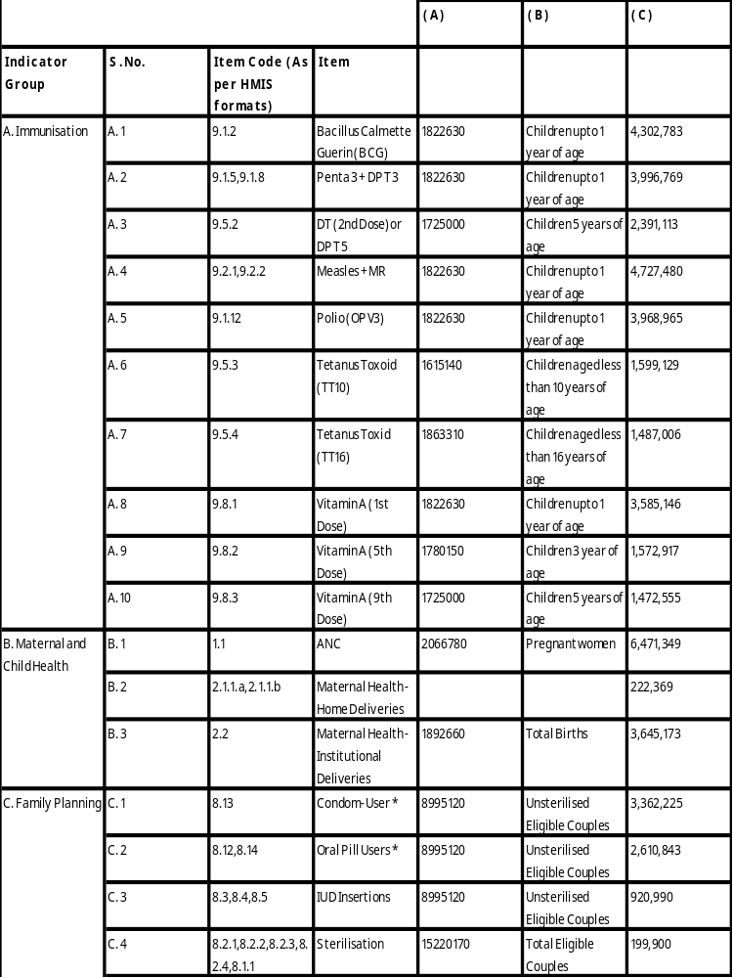

ANNEXURE -4-Table 3-Immunisation Items Rajasthan
1.Immunisation

BCG-BACILLUS CALMETTE GUERIN

PENTA 3+DPT 3

DT (2ND DOSE) OR DPT-5

MEASLES + MR

POLIO (OPV 3)

TETANUS TOXOID (TT10)

TETANUS TOXOID (TT16)

VITAMIN A (1ST DOSE)

VITAMIN A (5TH DOSE)

VITAMIN A (9TH DOSE)

ANNEXURE -5-Table 4 – Maternal Health and Family Planning Items - Rajasthan
2.Maternal health | 3.Family Planning
ANC | Condom user
Maternal health- home deliveries | Oral Pill user
Maternal health – institutional deliveries | IUD insertion
 | Sterilisation
 | Tubectomy
 | Vasectomy

ANNEXURE -6-Chart 1 –Immunisation coveragechart for comparison OF 2019-20 and 2020-21 for Rajasthan

ANNEXURE -7-Chart 2 – chart for comparison on need assessed and achievement 2019-20 and 2020-21 for Immunisation-Rajasthan

ANNEXURE -8-Chart 3– comparison on percent achievement 2019-20 and 2020-21 of need assessed during the period from April to June for immunisation 2020-21 and 2019-20

ANNEXURE -9-Chart 4- Maternal health coverage for 2019-20 and 2020-21 during the month of April to June (Rajasthan)

ANNEXURE -10-Chart 5 – chart for comparison on need assessed and achievement 2019-20 and 2020-21 for Maternal Health- Rajasthan

ANNEXURE -11-Chart 6 – chart for comparison on percent achievement 2019-20 and 2020-21 for Maternal Health- Rajasthan

ANNEXURE -12-Chart7- Family planning coverageComparison for 2019-20 and 2020-21, month of April to June -Rajasthan

ANNEXURE -13-Chart8- Comparison on need assessed for family planning coverage for 2019-20 and 2020-21-Rajasthan

ANNEXURE -14-Chart9- Comparison on percent achievement of need assessed for family planning coverage for 2019-20 and 2020-21

