Supplement

Comparative cost-effectiveness of SARS-CoV-2 vaccine dose fractionation in India: a modelling study

Zhanwei Du^{1,2}, Lin Wang³, Abhishek Pandey⁴, Wey Wen Lim¹, Matteo Chinazzi⁵, Ana Pastore y Piontti⁵, Eric H. Y. Lau^{1,2}, Peng Wu^{1,2}, Anup Malani⁶, Sarah Cobey⁷, Benjamin J. Cowling^{1,2*}
Affiliations:
¹ WHO Collaborating Centre for Infectious Disease Epidemiology and Control, School of Public Health, Li Ka Shing Faculty of Medicine, The University of Hong Kong, Hong Kong Special Administrative Region, China.
² Laboratory of Data Discovery for Health, Hong Kong Science and Technology Park, Hong Kong Special Administrative Region, China
³ Department of Genetics, University of Cambridge, Cambridge, CB2 3EH, UK
⁴ Center for Infectious Disease Modeling and Analysis, Yale School of Public Health, New Haven, CT 06510, USA
⁵ Laboratory for the Modeling of Biological and Socio-technical Systems, Northeastern University, Boston, MA, USA
⁶ Law School, University of Chicago, Chicago, Illinois, USA
⁷ Department of Ecology and Evolutionary Biology, University of Chicago, Chicago, Illinois, USA
Corresponding author: Benjamin J. Cowling
* Correspond to: bcowling@hku.hk

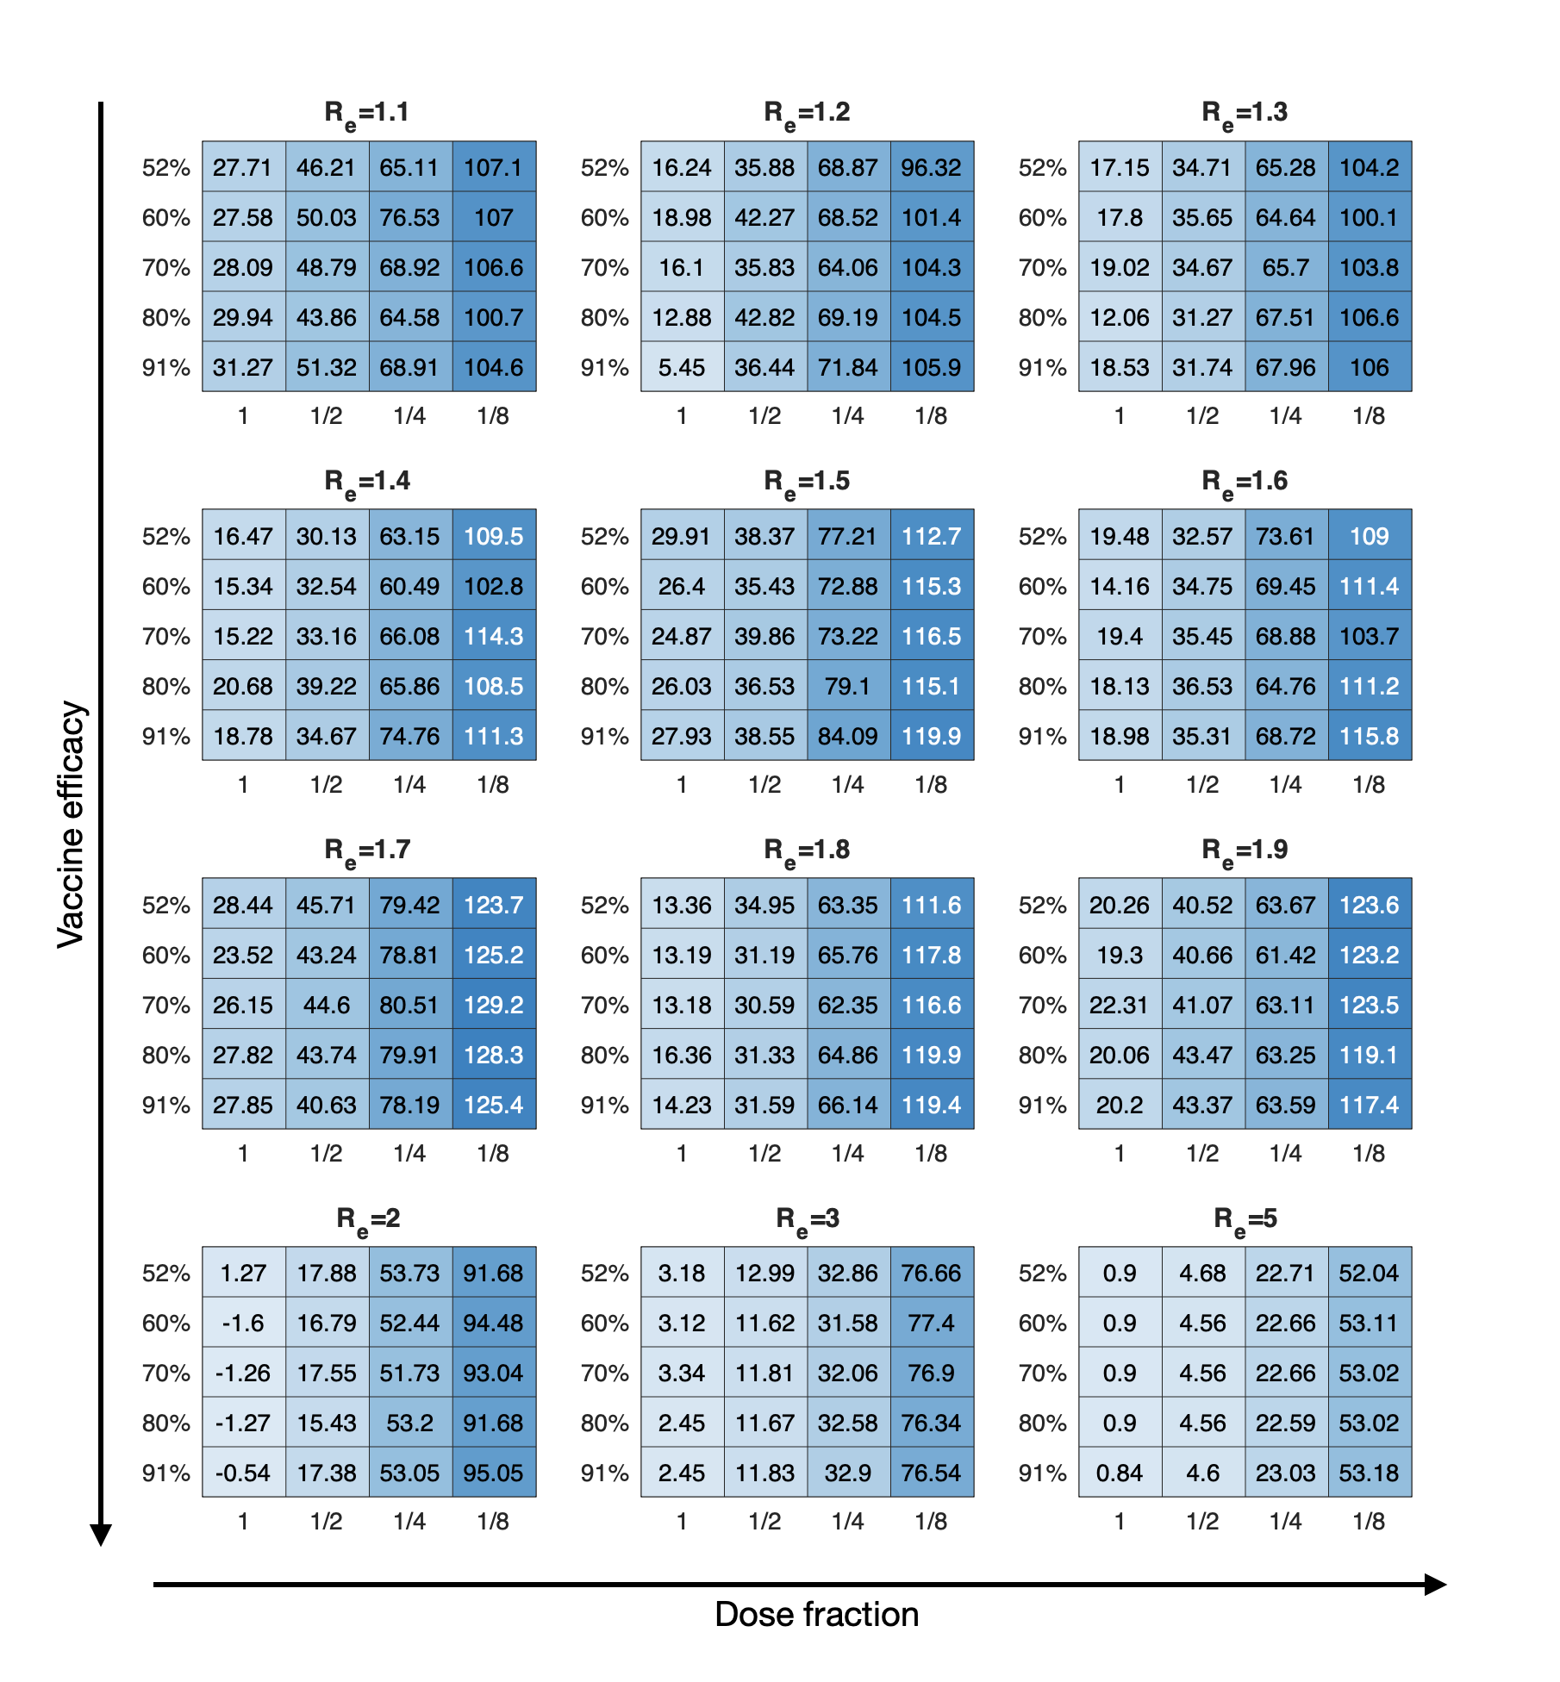
Figure S1. Projected net monetary benefit averted ($ billion) in the India individual network with proportions of vaccine efficacy and dose fractionation. Assuming a vaccine cost of US$12 and WTP per YLL averted of US$10,517, these projections are mean estimates of net monetary benefit (NMB) based on 100 stochastic simulations of COVID-19 transmission over vaccine efficacy of transmission from 52% to 91% over 12 synthetic scenarios of transmission, under parameters given in the appendix (Table S3). The optimal strategy under various transmission scenarios would always be doses of vaccines with more fractionations over vaccine efficacy of transmission.

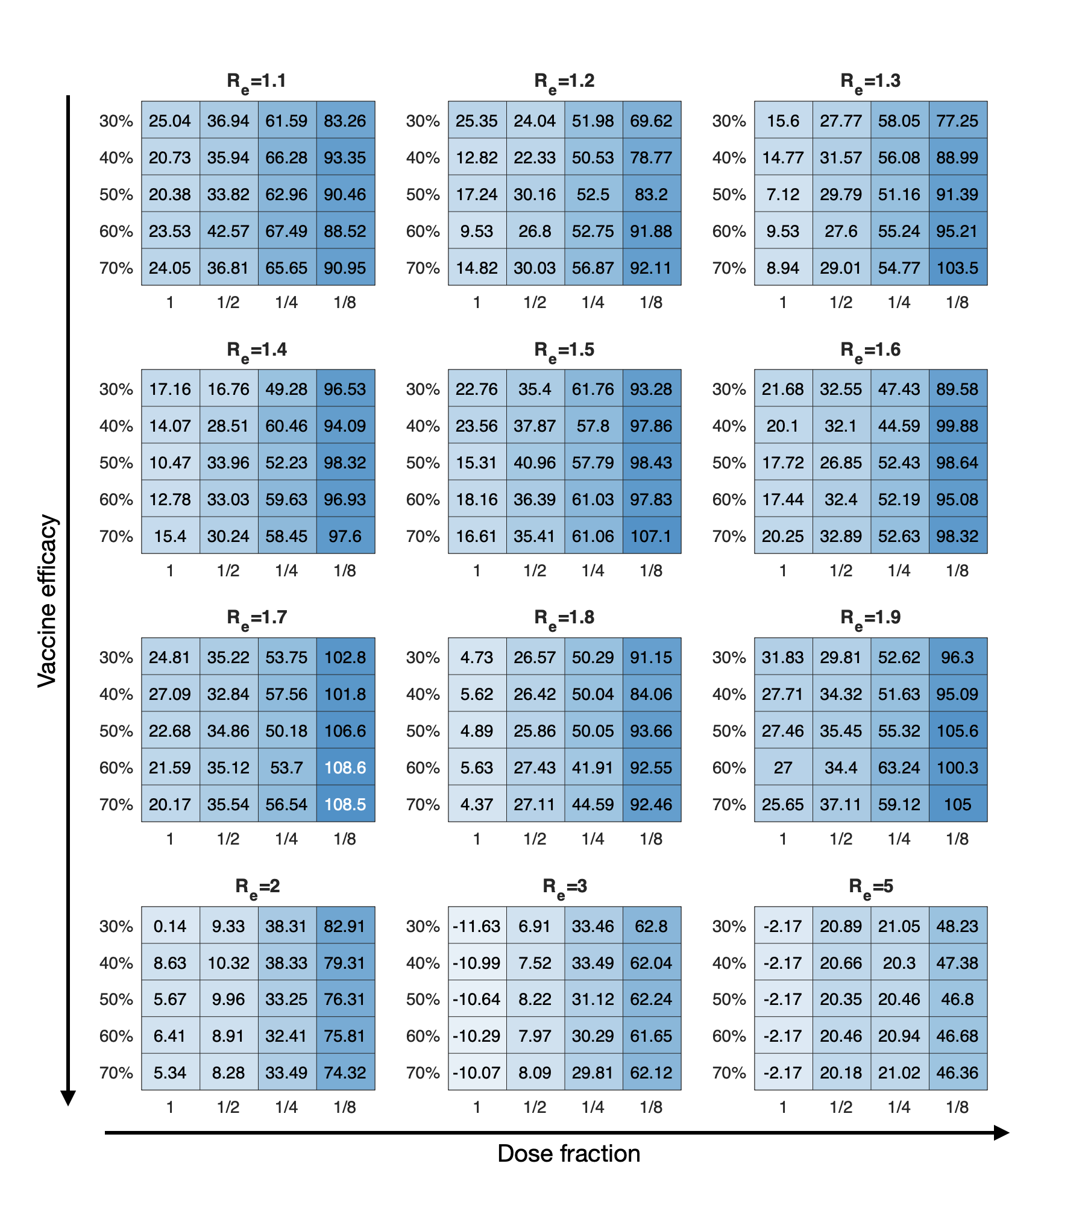
Figure S2. Projected net monetary benefit averted ($ billion) in the India individual network with reduced proportions of vaccine efficacy and dose fractionation. Assuming a vaccine cost of US$12 and WTP per YLL averted of US$10,517, these projections are mean estimates of net monetary benefit (NMB) based on 100 stochastic simulations of COVID-19 transmission over vaccine efficacy of transmission from 30% to 70% over 12 synthetic scenarios of transmission, under parameters given in the appendix (Table S4). The optimal strategy under various transmission scenarios would always be doses of vaccines with more fractionations over vaccine efficacy of transmission.
Table S1. The optimal choice is for 1/4 fractionated dose with 91% vaccine efficacy of transmission, across a range of SARS-CoV-2 transmission, assuming $12 per vaccine in India. We estimate the median (95% CrI) of incremental costs, YLL and net monetary benefits, in contrast with status quo, which are all reported and scaled to an India population of 1366 million.
R_{e} | Median incremental costs (95% CrI) in billion | Median incremental YLL averted (95% CrI) in million | Median incremental net monetary benefits (95% CrI) in billion
1.1 | 0.4 (95% CrI:-0.84, 1.48) | 10.54 (95% CrI:0.26, 19.06) | 106.61 (95% CrI:1.99, 193.18)
1.2 | 0.56 (95% CrI:-0.91, 1.83) | 10.32 (95% CrI:-3.8, 21.72) | 104.26 (95% CrI:-40.31, 219.77)
1.3 | 0.56 (95% CrI:-0.58, 1.62) | 10.27 (95% CrI:-1.39, 24.26) | 103.77 (95% CrI:-15.21, 246.86)
1.4 | 0.48 (95% CrI:-0.81, 1.71) | 11.3 (95% CrI:1.15, 22.72) | 114.34 (95% CrI:10.02, 230.52)
1.5 | 0.46 (95% CrI:-0.72, 1.6) | 11.51 (95% CrI:-3.61, 23.53) | 116.45 (95% CrI:-38.18, 239.04)
1.6 | 0.6 (95% CrI:-0.91, 2.12) | 10.27 (95% CrI:-2.78, 22.97) | 103.69 (95% CrI:-29.47, 233.58)
1.7 | 0.43 (95% CrI:-0.95, 1.76) | 12.76 (95% CrI:0.86, 24.07) | 129.21 (95% CrI:8.26, 244.36)
1.8 | 0.54 (95% CrI:-0.72, 1.71) | 11.54 (95% CrI:-0.32, 24.82) | 116.63 (95% CrI:-4.85, 251.89)
1.9 | 0.65 (95% CrI:-0.57, 1.97) | 12.22 (95% CrI:-2.22, 24.39) | 123.47 (95% CrI:-23.84, 246.91)
2 | 0.67 (95% CrI:-0.64, 1.93) | 9.23 (95% CrI:-4.93, 22.26) | 93.04 (95% CrI:-50.58, 225.69)
3 | 1.31 (95% CrI:-0.5, 2.99) | 7.7 (95% CrI:-7.19, 23.02) | 76.9 (95% CrI:-76.99, 233.54)
5 | 1.75 (95% CrI:0.53, 3.15) | 5.39 (95% CrI:-9.7, 22.08) | 53.02 (95% CrI:-101.06, 222.57)

Table S2. The optimal choice is for 1/4 fractionated dose with 91% vaccine efficacy of transmission, across a range of SARS-CoV-2 transmission, assuming $3 per vaccine in India ¹. We estimate the median (95% CrI) of incremental costs, YLL and net monetary benefits, in contrast with status quo, which are all reported and scaled to an India population of 1366 million.
R_{e} | Median incremental costs (95% CrI) in billion | Median incremental YLL averted (95% CrI) in million | Median incremental net monetary benefits (95% CrI) in billion
1.1 | -1.75 (95% CrI:-2.99, -0.67) | 10.54 (95% CrI:0.26, 19.06) | 108.76 (95% CrI:4.14, 195.33)
1.2 | -1.59 (95% CrI:-3.06, -0.32) | 10.32 (95% CrI:-3.8, 21.72) | 106.41 (95% CrI:-38.16, 221.93)
1.3 | -1.59 (95% CrI:-2.73, -0.53) | 10.27 (95% CrI:-1.39, 24.26) | 105.92 (95% CrI:-13.06, 249.01)
1.4 | -1.67 (95% CrI:-2.96, -0.44) | 11.3 (95% CrI:1.15, 22.72) | 116.49 (95% CrI:12.17, 232.67)
1.5 | -1.69 (95% CrI:-2.87, -0.55) | 11.51 (95% CrI:-3.61, 23.53) | 118.6 (95% CrI:-36.03, 241.2)
1.6 | -1.55 (95% CrI:-3.06, -0.03) | 10.27 (95% CrI:-2.78, 22.97) | 105.84 (95% CrI:-27.32, 235.73)
1.7 | -1.72 (95% CrI:-3.1, -0.39) | 12.76 (95% CrI:0.86, 24.07) | 131.37 (95% CrI:10.41, 246.51)
1.8 | -1.61 (95% CrI:-2.87, -0.44) | 11.54 (95% CrI:-0.32, 24.82) | 118.78 (95% CrI:-2.7, 254.05)
1.9 | -1.5 (95% CrI:-2.72, -0.18) | 12.22 (95% CrI:-2.22, 24.39) | 125.62 (95% CrI:-21.69, 249.07)
2 | -1.48 (95% CrI:-2.79, -0.22) | 9.23 (95% CrI:-4.93, 22.26) | 95.19 (95% CrI:-48.42, 227.84)
3 | -0.84 (95% CrI:-2.65, 0.84) | 7.7 (95% CrI:-7.19, 23.02) | 79.05 (95% CrI:-74.83, 235.69)
5 | -0.4 (95% CrI:-1.62, 0.99) | 5.39 (95% CrI:-9.7, 22.08) | 55.17 (95% CrI:-98.91, 224.73)

Table S3. Vaccine efficacy parameters for the individual-based SARS-CoV-2 infection dynamic model.
Parameters | Values
: infection-blocking vaccine efficacy (%) after the first dose to before the second dose | 52%
: infection-blocking vaccine efficacy (%) after the second dose | Assumed to be 52%, 60%, 70%, 80%, and 91% for different settings of dosing, respectively
: symptom-blocking vaccine efficacy (%) after the first dose to before the second dose | Assumed to be 88% with respect to the relationship between infection efficacy and symptom efficacy ²
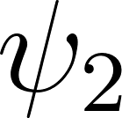: symptom-blocking vaccine efficacy (%) after the second dose | Assumed to be 88%, 92%, 95%, 97%, and 98% for different settings of dosing with respect to the relationship between infection efficacy and symptom efficacy ²

Table S4. Sensitivity analysis of vaccine efficacy parameters for the individual-based SARS-CoV-2 infection dynamic model.
Parameters | Values
: infection-blocking vaccine efficacy (%) after the first dose to before the second dose | 30%
: infection-blocking vaccine efficacy (%) after the second dose | Assumed to be 30%, 40%, 50%, 60%, and 70% for different settings of dosing, respectively
: symptom-blocking vaccine efficacy (%) after the first dose to before the second dose | Assumed to be 73% with respect to the relationship between infection efficacy and symptom efficacy ²
: symptom-blocking vaccine efficacy (%) after the second dose | Assumed to be 73%, 82%, 88%, 92%, and 95% for different settings of dosing with respect to the relationship between infection efficacy and symptom efficacy ²

Table S5. Epidemiological parameters for the individual-based SARS-CoV-2 infection dynamic model. We model multiple strategies for expanding vaccination combined with a fixed baseline level with no vaccination (i.e., status quo).
Parameters | Values
N: population of individuals | 47,568
: transmission rate | Calibrated to R_{e}
Initial number of infections (in exposed state) | 10
: transition rate out of exposed state | 1/3 ³
: recovery rate of symptomatic individuals | 1/4 ^{4,5}
: recovery rate of asymptomatic individuals | 1/9 ⁶
: transition rate from the pre-symptomatic to symptomatic stage | 1/2 ³
: relative infectiousness of pre-symptomatic cases | 1.57 ^{4,5}
: relative infectiousness of asymptomatic cases | 0.5 ⁷
: proportion of infections that are symptomatic | 75% ^{5,8}
$γ^{H}$: recovery rate in hospitalized compartment | 0.143 ⁹
: age-specific proportion of symptomatic cases that are hospitalized | [0%, 0.025%, 2.672%, 9.334%, 15.465%]  for [0-4y, 5-17y, 18-49y, 50-64y, >65y] ¹⁰
η: transition rate from symptomatic to hospitalized | 1/5.9 ¹¹
: age-specific mortality rate for hospitalized cases | [3.9%, 12.1%, 3.0%, 10.5%, 22.7%]  for [0-4y, 5-17y, 18-49y, 50-64y, >65y] ^{10,12}
: transition rate from hospitalized to deceased for cases that succumb | 0.128 ¹²
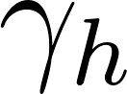: transition rate from hospitalized to recovered for cases discharged alive | 0.091 ¹²
: life expectancy (years) for age group , adjusted assuming a 3% yearly discount rate | [29.4, 28.1, 23.2, 16.3, 10.2]  for [0-4y, 5-17y, 18-49y, 50-64y, >65y] ¹³
Vaccination parameters
: daily available vaccination number assuming an India population of 1366 million and a daily vaccination rate of first dose starting from 0.01% on January 16, 2021 with the total of 12.5% population during the 150 days ¹⁴ | Assumed
: number of weeks for vaccination assignment | 20 ¹⁵
: days between first dose and second dose | 28 ¹⁶
: days acquiring immunity after the first or second dose | 14 ^{17,18}
: vaccine adherence rate | 0.7 ¹⁹
Status quo parameters
: daily available vaccination number assuming an India population of 1366 million and a daily vaccination rate of 0% | 0

Table S6. Cost parameters
Parameter | Value (USD)
Cost of administering two doses of vaccination () by taking Covishield vaccine manufactured by the Serum Institute of India as an example | $12 ²⁰
Median COVID-19 hospitalization cost by age group (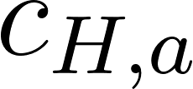) | $604 ²¹ for any age group

References.
1. Andersen, C., Andrews, K., Cain, J. & Tandona, A. South Asia Vaccinates against COVID-19: Health Financing and Health Systems Considerations. (2021).
2. Khoury, D. S. et al. Neutralizing antibody levels are highly predictive of immune protection from symptomatic SARS-CoV-2 infection. Nat. Med. (2021) doi:10.1038/s41591-021-01377-8.
3. Backer, J. A., Klinkenberg, D. & Wallinga, J. Incubation period of 2019 novel coronavirus (2019-nCoV) infections among travellers from Wuhan, China, 20-28 January 2020. Euro Surveill. 25, 2000062 (2020).
4. He, X. et al. Temporal dynamics in viral shedding and transmissibility of COVID-19. Nat. Med. 26, 672–675 (2020).
5. Aleta, A. et al. Modelling the impact of testing, contact tracing and household quarantine on second waves of COVID-19. Nat Hum Behav 4, 964–971 (2020).
6. Du, Z. et al. Comparative Cost-Effectiveness of SARS-CoV-2 Testing Strategies. papers.ssrn.com (2020) doi:10.2139/ssrn.3714642.
7. McEvoy, D. et al. Relative infectiousness of asymptomatic SARS-CoV-2 infected persons compared with symptomatic individuals: a rapid scoping review. BMJ Open 11, e042354 (2021).
8. Nishiura, H. et al. Estimation of the asymptomatic ratio of novel coronavirus infections (COVID-19). Int. J. Infect. Dis. 94, 154–155 (2020).
9. Lachmann, M. et al. Texas Trauma Service Area (TSA) COVID-19 transmission estimates and healthcare projections: Oct. 20 Update. (2020).
10. Verity, R. et al. Estimates of the severity of coronavirus disease 2019: a model-based analysis. Lancet Infect. Dis. 20, 669–677 (2020).
11. Tindale, L. et al. Transmission interval estimates suggest pre-symptomatic spread of COVID-19. Epidemiology (2020) doi:10.1101/2020.03.03.20029983.
12. Wang, X. et al. Impact of Social Distancing Measures on Coronavirus Disease Healthcare Demand, Central Texas, USA. Emerg. Infect. Dis. 26, 2361–2369 (2020).
13. Office of the Registrar General & Census Commissioner, India. SRS Based Abridged Life Tables 2013-17. https://censusindia.gov.in/Vital_Statistics/SRS_Life_Table/SRS%20based%20Abridged%20Life%20Tables%202013-17.pdf (2019).
14. Ritchie, H. et al. Coronavirus Pandemic (COVID-19). Our World in Data (2020).
15. Biggerstaff, M. Modeling Strategies for the Initial Allocation of SARS-CoV-2 Vaccines. https://stacks.cdc.gov/view/cdc/97351.
16. Jackson, L. A. et al. An mRNA Vaccine against SARS-CoV-2 — Preliminary Report. N. Engl. J. Med. 383, 1920–1931 (2020).
17. Vaccines and Related Biological Products Advisory Committee December 17, 2020 Meeting Briefing Document Addendum- Sponsor.
18. Wang, X. et al. Effects of COVID-19 Vaccination Timing and Risk Prioritization on Mortality Rates, United States. Emerging Infectious Disease journal 27, (2021).
19. U.S. Public Now Divided Over Whether To Get COVID-19 Vaccine. https://www.pewresearch.org/science/2020/09/17/u-s-public-now-divided-over-whether-to-get-covid-19-vaccine/ (2020).
20. Nagarajan, R. At Rs 700-Rs 1,500, price of Covid vaccine in India’s private sector among costliest. Times Of India https://timesofindia.indiatimes.com/india/at-rs700-rs1500-price-of-covid-vaccine-in-indias-private-sector-among-costliest/articleshow/82509814.cms (2021).
21. COVID-19 Treatment Cost in India & COVID Hospitalization Expenses. https://www.aegonlife.com/insurance-investment-knowledge/covid-19-treatment-cost-in-india/ (2020).

