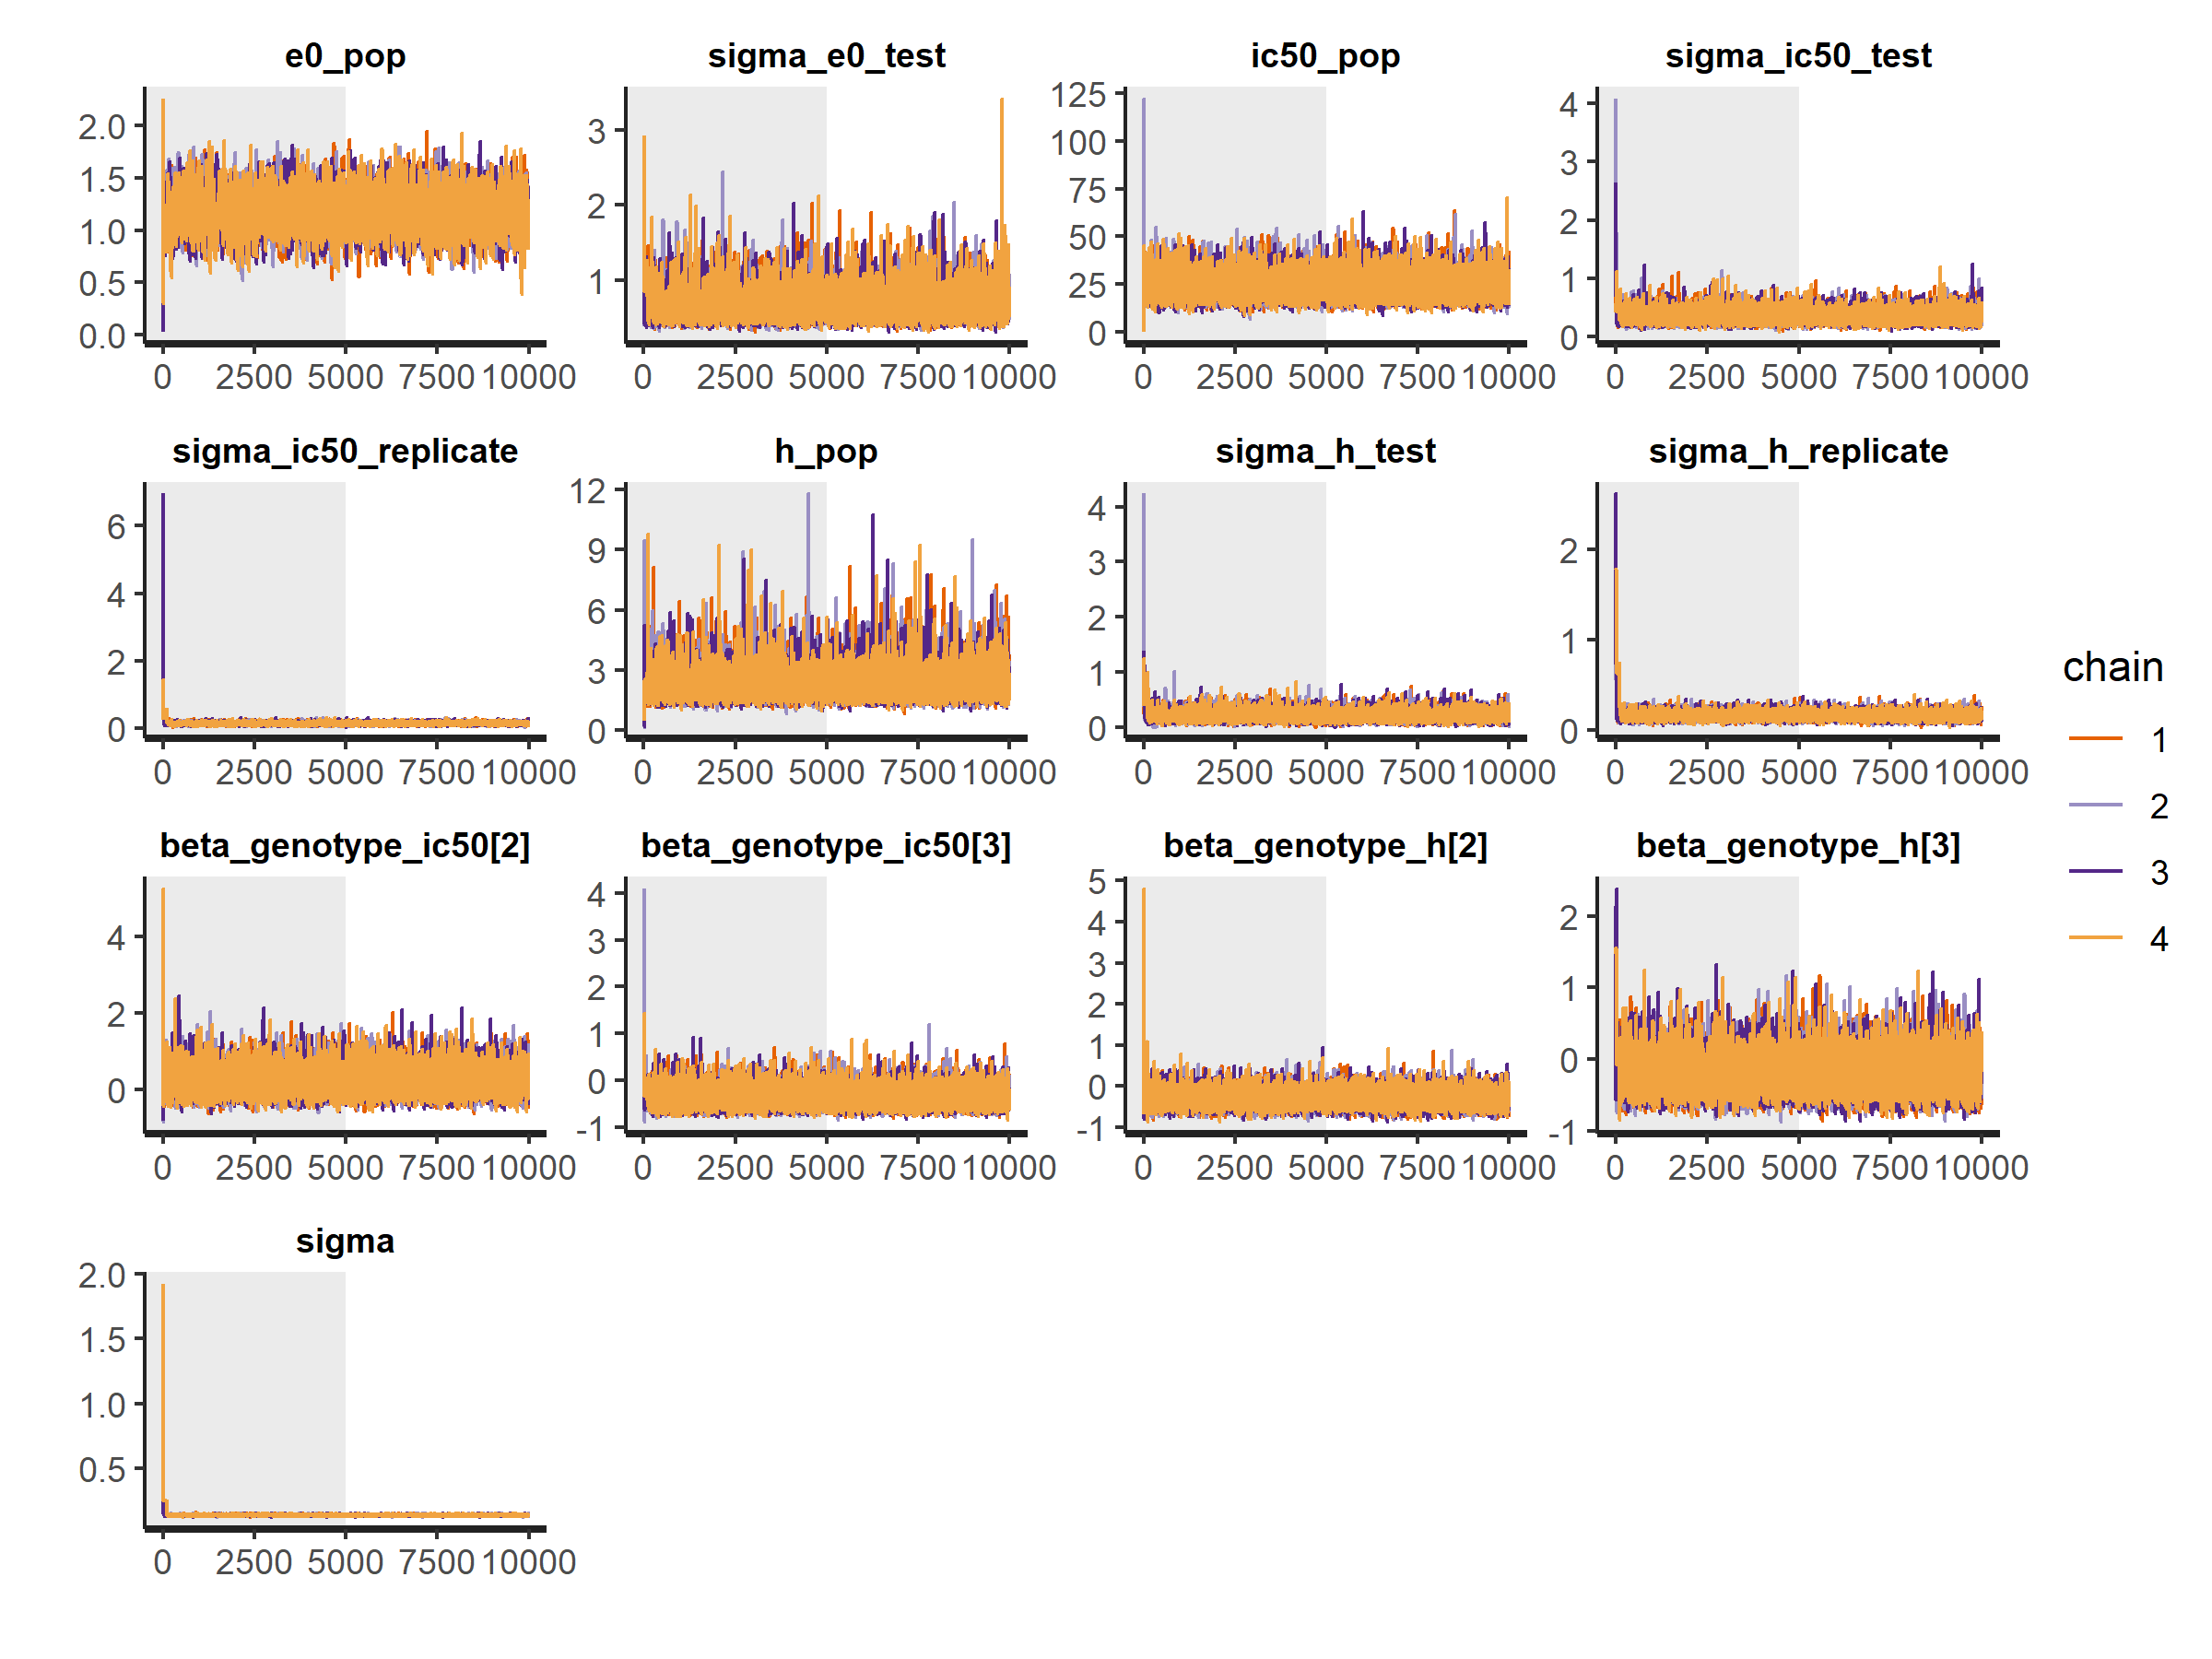
Figure S1. Traceplot of MCMC chains showing mixing and convergence for the Bayesian multilevel model fitted to clinical isolate data.

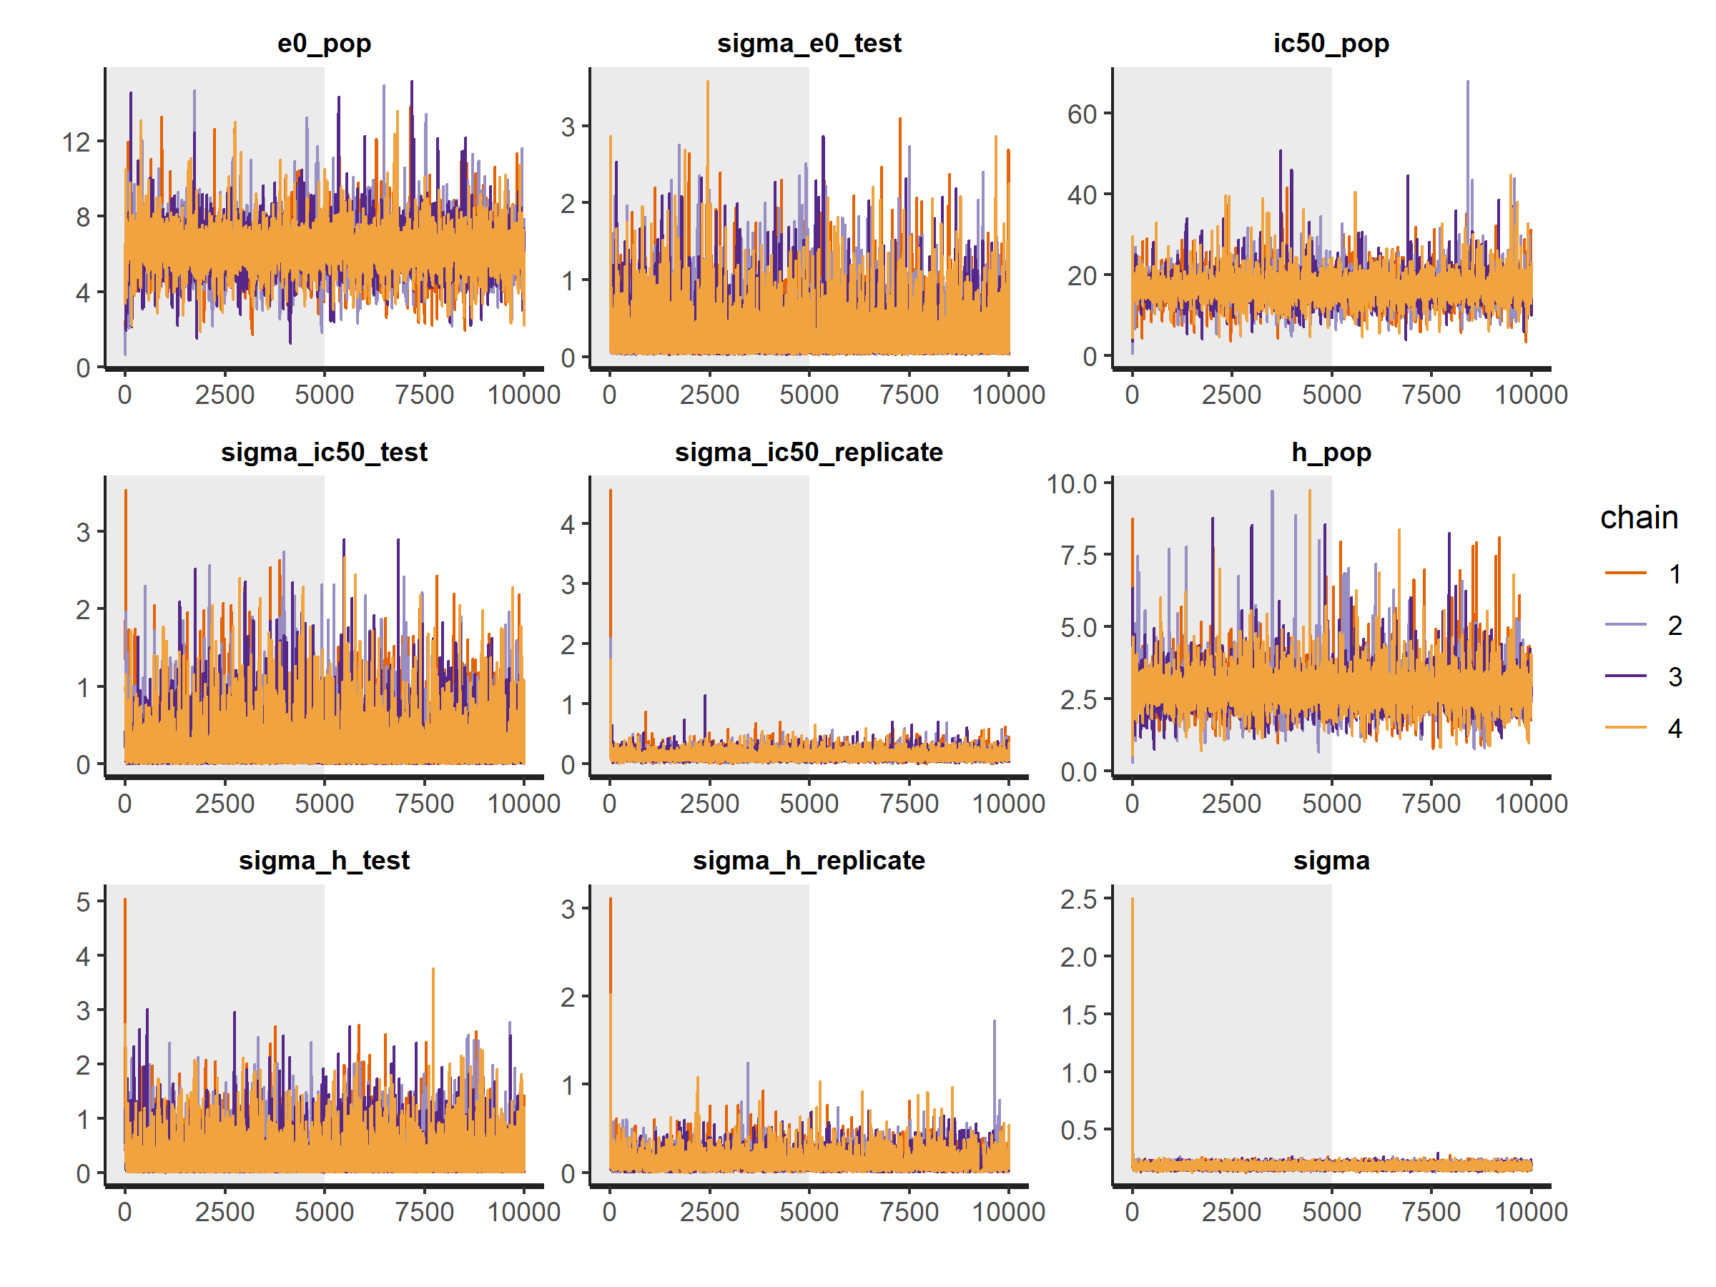
Figure S2. Traceplot of MCMC chains showing mixing and convergence for the Bayesian multilevel model fitted to NF54 data.
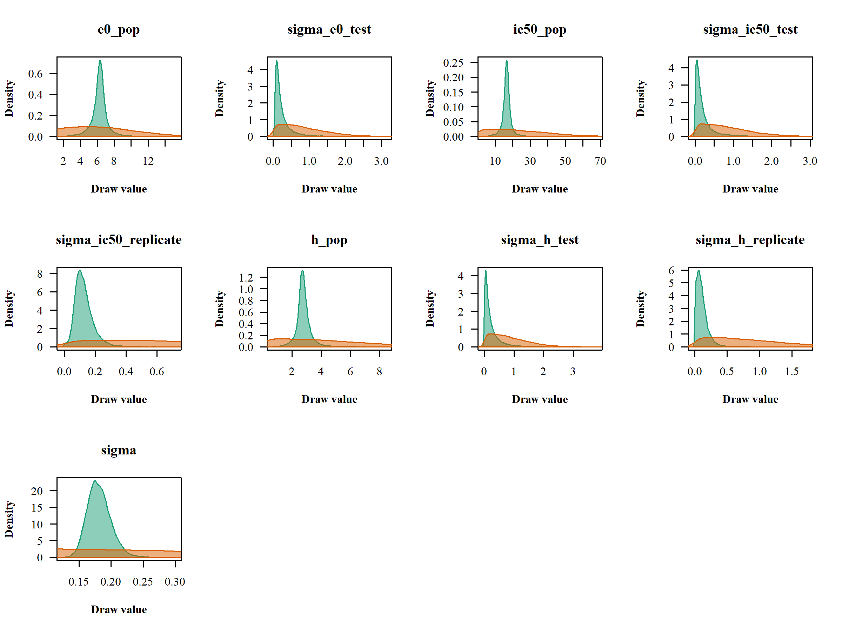
Figure S3. Comparison between prior distributions (orange) and posterior distributions (green) for the parameters of the Bayesian multilevel model fitted to NF54 data.

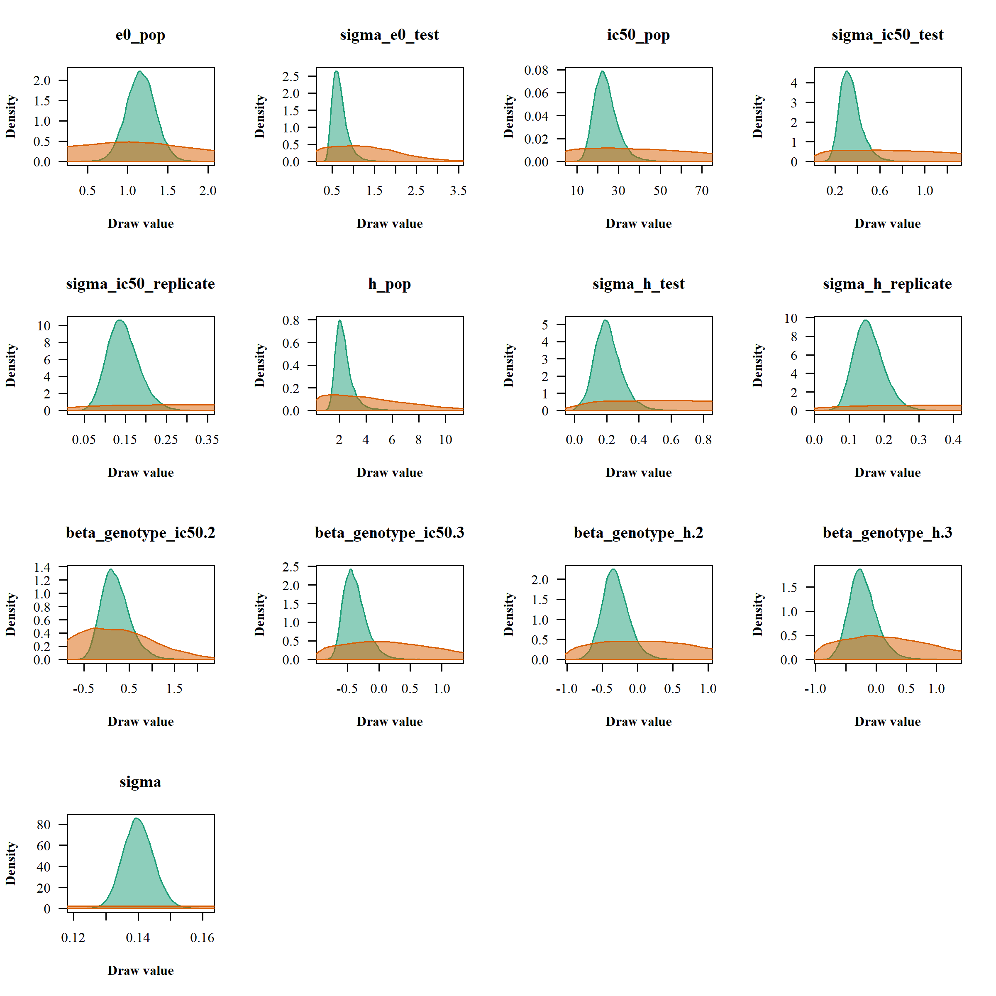
Figure S4. Comparison between prior distributions (orange) and posterior distributions (green) for the parameters of the Bayesian multilevel model fitted to clinical isolate data.

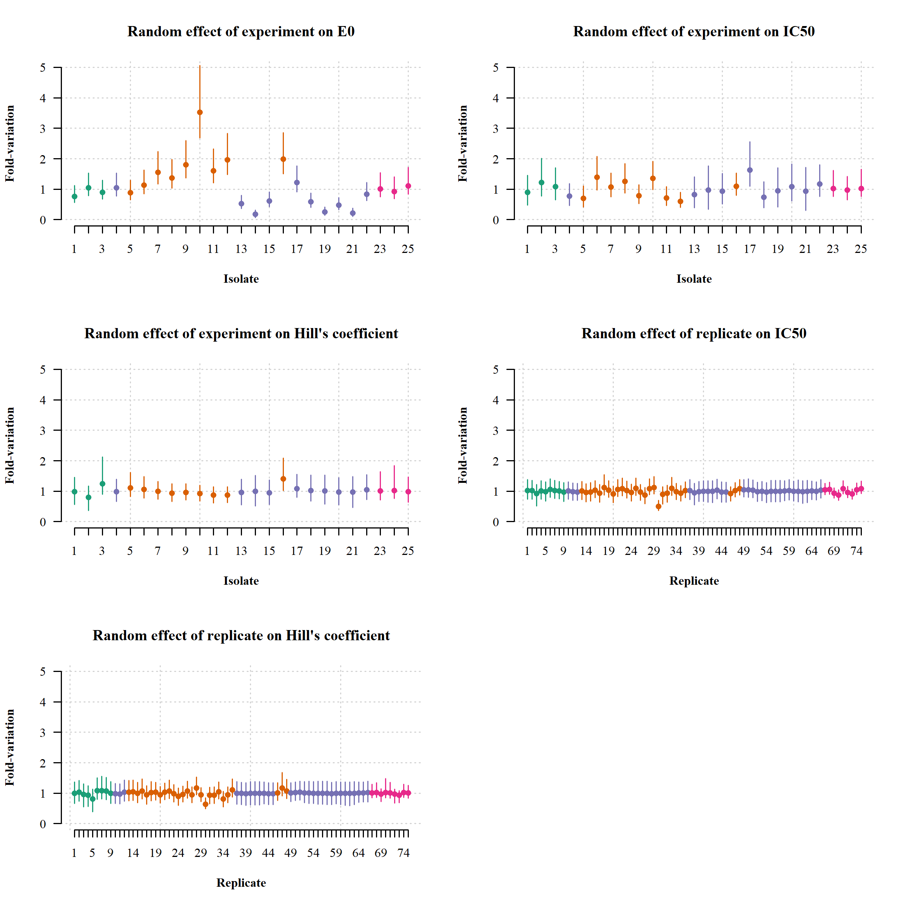
Figure S5. Random effects of experiment and replicate on E_{max} model parameters E₀, IC₅₀ and Hill’s coefficient. Green: wild-type, orange: R561H, purple: P441L and pink: NF54.
Table S1. Summary results of the ring survival assay experiments conducted in this study.
Test no. | Isolate/Strain | Kelch13 | Growth rate | Mean ring survival at 50 nM (SD) | IC₅₀ nM (95%CrI) | IC90 nM (95%CrI) | IC99 nM (95%CrI) | H (95%CrI)
1 | Isolate #1 | Wild type | 2.0 | 13 (3.6) | 20 (12 to 34) | 59 (28 to 122) | 183 (57 to 706) | 2.1 (1.3 to 4.07)
2 | Isolate #2 | Wild type | 1.8 | 37 (6.6) | 29 (19 to 45) | 109 (61 to 217) | 458 (151 to 1950) | 1.66 (1.06 to 3.01)
3 | Isolate #3 | Wild type | 1.6 | 10 (5.7) | 25 (18 to 35) | 55 (32 to 91) | 130 (55 to 320) | 2.79 (1.82 to 5.34)
4 | Isolate #4 | P441L | 3.5 | 4 (1.6) | 11 (7 to 15) | 40 (23 to 79) | 174 (66 to 607) | 1.64 (1.14 to 2.42)
5 | Isolate #5 | R561H | 1.1 | 11 (4.0) | 19 (12 to 29) | 72 (39 to 131) | 311 (116 to 867) | 1.64 (1.21 to 2.43)
6 | Isolate #6 | R561H | 1.7 | 46 (9.0) | 38 (27 to 53) | 155 (101 to 253) | 720 (321 to 1904) | 1.56 (1.16 to 2.22)
7 | Isolate #7 | R561H | 7.5 | 32 (5.1) | 29 (22 to 39) | 131 (87 to 206) | 664 (321 to 1638) | 1.47 (1.13 to 1.95)
8 | Isolate #8 | R561H | 4.1 | 42 (8.6) | 34 (25 to 47) | 169 (110 to 286) | 958 (431 to 2744) | 1.38 (1.04 to 1.84)
9 | Isolate #9 | R561H | 7.5 | 22 (8.8) | 21 (16 to 29) | 101 (65 to 164) | 549 (262 to 1346) | 1.42 (1.11 to 1.81)
10 | Isolate #10 | R561H | 3.4 | 46 (20.0) | 37 (28 to 47) | 187 (123 to 302) | 1086 (516 to 2822) | 1.36 (1.06 to 1.73)
11 | Isolate #11 | R561H | 6.9 | 24 (6.1) | 19 (14 to 28) | 109 (66 to 196) | 716 (299 to 2211) | 1.28 (0.97 to 1.67)
12 | Isolate #12 | R561H | 2.5 | 22 (8.7) | 16 (12 to 22) | 90 (55 to 156) | 580 (239 to 1637) | 1.29 (1 to 1.68)
13 | Isolate #13 | P441L | 3.8 | 13 (8.7) | 11 (6 to 20) | 45 (20 to 133) | 207 (57 to 1623) | 1.58 (0.92 to 2.56)
14 | Isolate #14 | P441L | 1.9 | 8 (4.1) | 13 (5 to 27) | 51 (16 to 208) | 212 (47 to 3507) | 1.66 (0.83 to 2.84)
15 | Isolate #15 | P441L | 3.1 | 15 (4.5) | 13 (8 to 22) | 53 (25 to 138) | 242 (70 to 1540) | 1.57 (0.96 to 2.48)
16 | Isolate #16 | R561H | 2.0 | 23 (6.3) | 30 (23 to 38) | 86 (62 to 129) | 270 (145 to 613) | 2.09 (1.51 to 2.99)
17 | Isolate #17 | P441L | 3.7 | 25 (3.8) | 23 (16 to 32) | 76 (48 to 121) | 281 (128 to 662) | 1.83 (1.35 to 2.65)
18 | Isolate #18 | P441L | 4.9 | 2 (0.9) | 10 (6 to 18) | 36 (18 to 90) | 147 (45 to 734) | 1.72 (1.09 to 2.76)
19 | Isolate #19 | P441L | 2.3 | 0 (0.7) | 13 (6 to 25) | 49 (19 to 157) | 202 (52 to 1850) | 1.68 (0.94 to 2.84)
20 | Isolate #20 | P441L | 2.4 | 18 (1.7) | 15 (8 to 27) | 61 (29 to 166) | 270 (79 to 2037) | 1.6 (0.93 to 2.63)
21 | Isolate #21 | P441L | 3.7 | 22 (13.0) | 13 (4 to 26) | 51 (15 to 249) | 221 (44 to 5238) | 1.61 (0.76 to 2.75)
22 | Isolate #22 | P441L | 3.0 | 10 (4.3) | 16 (11 to 24) | 58 (32 to 108) | 226 (83 to 718) | 1.75 (1.21 to 2.74)
23 | NF54 | Wild type | 5.4 | 4 (1.1) | 17 (15 to 20) | 38 (29 to 48) | 88 (57 to 128) | 2.81 (2.35 to 3.65)
24 | NF54 | Wild type | 6.3 | 5 (1.9) | 16 (13 to 19) | 34 (22 to 44) | 79 (40 to 120) | 2.85 (2.34 to 4.34)
25 | NF54 | Wild type | 6.7 | 6 (2.1) | 17 (15 to 20) | 39 (31 to 51) | 98 (65 to 146) | 2.65 (2.2 to 3.28)

Table S2. Pairwise differences in parameter estimates across kelch13 genotypes in the Bayesian multilevel E_{max} model fitted to isolate data.
 | Median | 95%CrI
IC₅₀ (nM)
R561H vs wild type | 4 | -11 to 15
P441L vs wild type | -9 | -24 to 1
R561H vs P441L | 13 | 4 to 23
H
R561H vs wild type | -0.7 | -2.6 to 0.1
P441L vs wild type | -0.5 | -2.4 to 0.5
R561H vs P441L | -0.2 | -0.9 to 0.4
ED90 (nM)
R561H vs wild type | 55 | -12 to 121
P441L vs wild type | -12 | -74 to 35
R561H vs P441L | 68 | 15 to 130
ED99 (nM)
R561H vs wild type | 402 | -79 to 1029
P441L vs wild type | 24 | -406 to 385
R561H vs P441L | 382 | -56 to 1008

