Supplementary Information

Trophic and Immunomodulatory Effects of Adipose Tissue-Derived Stem Cells in a Preclinical Murine Model of Endometriosis.

Toyofumi Hirakawa^{1,2,3}, Fusanori Yotsumoto¹, Naoto Shirasu², Chihiro Kiyoshima^{1,2,3}, Daichi Urushiyama¹, Kenichi Yoshikawa¹, Kohei Miyata¹, Masamitsu Kurakazu¹, Kaori Azuma Koga⁴, Mikiko Aoki⁴, Kazuki Nabeshima⁴, Kaori S Koga⁵, Yutaka Osuga⁵, Hiroaki Komatsu⁶, Fuminori Taniguchi⁶, Tasuku Harada⁶, Shin’ichiro Yasunaga², and Shingo Miyamoto¹*

¹Department of Obstetrics & Gynecology, Fukuoka University, 7-45-1 Nanakuma, Jonan-ku, Fukuoka 814-0180, Japan.
²Department of Biochemistry, Faculty of Medicine, Fukuoka University, 7-45-1 Nanakuma, Jonan-ku, Fukuoka 814-0180, Japan.
³Central Research Institute for Advanced Molecular Medicine, Fukuoka University, 7-45-1 Nanakuma, Jonan-ku, Fukuoka 814-0180, Japan.
⁴Department of Pathology, Fukuoka University, 7-45-1 Nanakuma, Jonan-ku, Fukuoka 814-0180, Japan.
⁵Department of Obstetrics and Gynecology, Faculty of Medicine, Tokyo University, 7-3-1 Hongo, Bunkyo-ku, Tokyo 113-8654, Japan.
⁶Department of Obstetrics and Gynecology, Faculty of Medicine, Tottori University, 36-1 Nishi-cho, Yonago 683-8504, Japan.

*Corresponding author: Shingo Miyamoto, MD, PhD
Director, Department of Obstetrics & Gynecology
Faculty of Medicine, Fukuoka University
7-45-1 Nanakuma, Jonan-ku, Fukuoka 814-0180, Japan.
Tel: +81-92-801-1011
Fax: +81-92-865-4114
E-mail: smiya@cis.fukuoka-u.ac.jp

Supplementary Figures
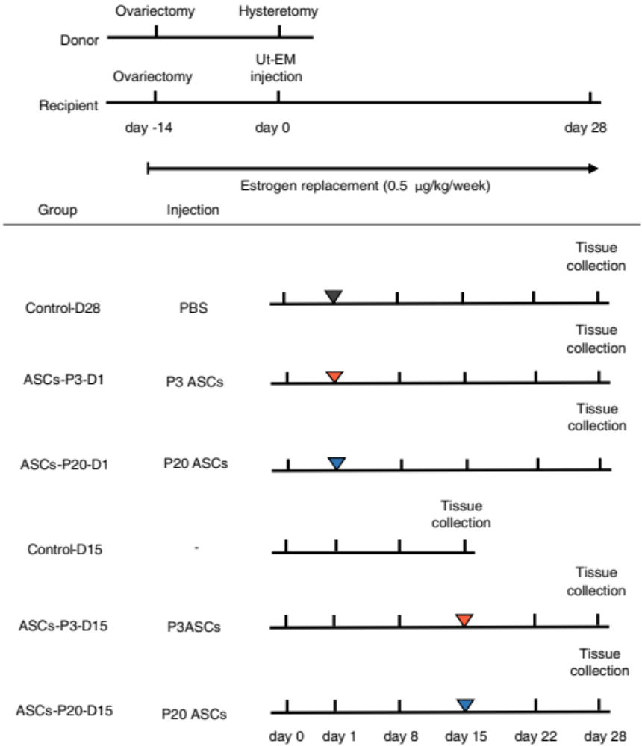
Fig.S1. Schematic diagram of the experimental study design and confirmation of fibrotic tissues. The schematic diagram is divided into upper and lower panels. The upper panel shows the time schedule for establishing the experimental murine model of endometriosis. In the lower panel, the time schedule, cell types, mediators, groups, and administration methods are presented.
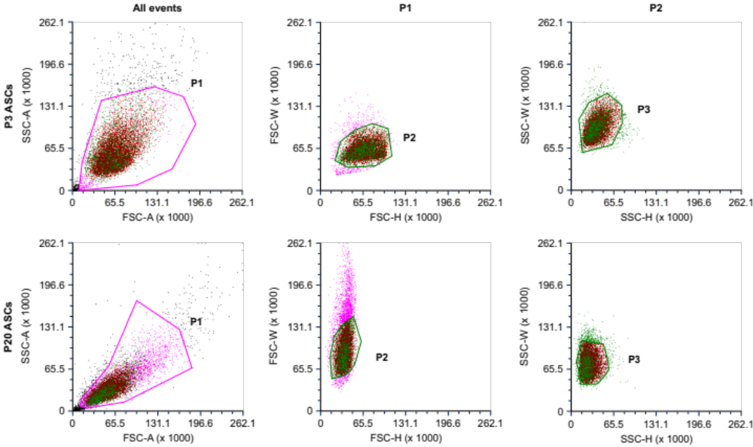
Fig.S2. Distribution patterns of third passage (P3 ASCs) and twentieth passage ASCs (P20 ASCs), plotted as FSC-A (cell size) versus SSC-A (granularity), in the flow cytometric analysis. The third (P3 ASCs) and twentieth (P20 ASCs) passages of adipose tissue-derived stem cells (ASCs) are identified as the cells in the P1 plot. Doublet exclusion was performed by plotting the heights or widths against the area for forward scatter (P2) or side scatter (P3) (FSC- and SSC-H/-W). The figure shows representative results. FSC-A: forward scatter area, SSC-A: side scatter area.

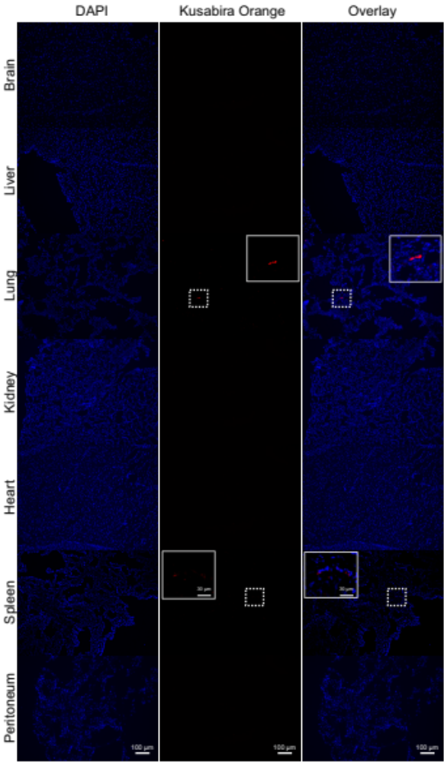
Fig.S3. Localization of KuO-ASCs in various organs after intravenous administration. Fluorescence micrographs showing localization of KuO-ASCs in the brain, liver, lungs, kidney, heart, spleen, and peritoneum after the intravenous administration of KuO-ASCs. Nuclei were counterstained with 4′,6-diamidino-2-phenylindole (DAPI). ASCs: adipose tissue-derived stem cells.

