Table 1: Date palm varieties utilized in the current research, their fruit descriptions, origins, and field study photos.
Variety | Codes | Origin | Description | Field photo
Ajwat Al Madinah | AJM | Kingdom of Saudi Arabia | Fruits are small and dark with longitudinal spot-lines. | 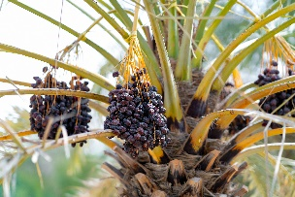
Makhtoumi | MAK | Kingdom of Saudi Arabia | The fruit has a reddish-blonde color and an oval to heart-shaped appearance. | 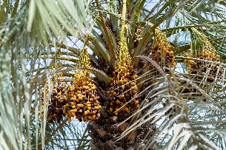
Rhothan | ROT | Kingdom of Saudi Arabia | The fruit is light yellow and has a thick oval shape. The rutab is light brown, while the tamer is brown. | 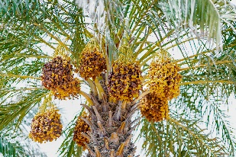
Sukkari | SUK | Kingdom of Saudi Arabia | The rutab is golden-brown; The fruit has patches of lighter color with a small-to-medium-sized cone shape. | 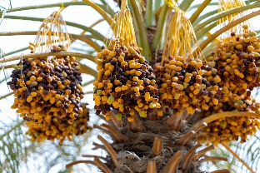
Naghal | NAG | United Arab Emirates | The fruit is an elongated oval shape with a slight curve and has a yellow-orange color. The rutab has a light brown hue, while the tamer is darker brown. | 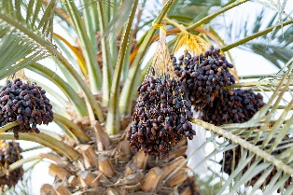
Khnizi | KHN | United Arab Emirates | The fruit is dark pink with an inverted oval shape. The rutab is dark brown, while the tamer is blackish brown. | 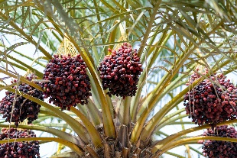
Abu Maan | ABUM | United Arab Emirates | The fruit is yellow, short, and heart-shaped. The fruit's rutab stage is amber, while the tamer is dark brown. | 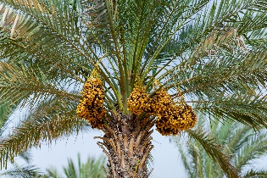
Barhi | BAR | United Arab Emirates | The fruit has a thick oval shape with a light-yellow color. The rutab has a light brown color, while the tamer has a waxy light brown color. | 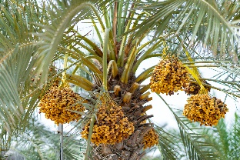
Farad | FAR | United Arab Emirates | The fruit is oval and elongated, pinkish-yellow, and dark brown at the tamer stage, and it is a dark brown color. | 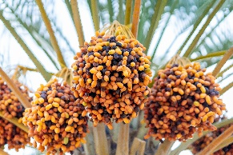
Khisab | KHI | United Arab Emirates | The color of the fruit is light red, and its shape is oval inverted. The fruit at rutab is reddish-brown, and it is dark brown at tamer. | 