Table S1. Age and sex specific metabolic syndrome scoring equations
Groups | Equations
Male
<60 | −2.9092 + 0.0262*WC + 0.3098*TG-0.944*HDL-C + 0.0097*MAP + 0.0745*FBG
≥60 | −2.3741 + 0.0264*WC + 0.4933*TG-0.999*HDL-C + 0.0054*MAP + 0.0821*FBG
Female
<60 | −2.4981 + 0.0199*WC + 0.5218*TG-0.8616*HDL-C + 0.0110*MAP + 0.1074*FBG
≥60 | −0.5682 + 0.0153*WC + 0.4587*TG-1.3567*HDL-C + 0.0036*MAP + 0.0688*FBG
Abbreviations: FBG, fasting blood glucose (mmol/L); HDL, high-density lipoprotein cholesterol (mmol/L); MAP, mean arterial pressure (mmHg); TG, triglycerides (mmol/L); WC, waist circumference (cm).

Table S2. The characteristics of all study participants according to cuMetSS quartile category (n=3,322).
Variables | Total (n = 3,322) | cuMetSS |  |  |  | P
Variables | Total (n = 3,322) | Q1 (n = 831) | Q2 (n = 830) | Q3 (n = 830) | Q4 (n = 831) | P
Age | 57.62 ± 8.48 | 59.26 ± 8.55 | 57.63 ± 8.64 | 57.41 ± 8.44 | 56.19 ± 8.01 | <0.001
Age group |  |  |  |  |  | <0.001
≥60 | 1265 (38.08) | 380 (45.73) | 321 (38.67) | 308 (37.11) | 256 (30.81)
<60 | 2057 (61.92) | 451 (54.27) | 509 (61.33) | 522 (62.89) | 575 (69.19)
Gender |  |  |  |  |  | <0.001
Male | 1544 (46.48) | 552 (66.43) | 436 (52.53) | 335 (40.36) | 221 (26.59)
Female | 1778 (53.52) | 279 (33.57) | 394 (47.47) | 495 (59.64) | 610 (73.41)
Residence |  |  |  |  |  | 0.037
Rural | 2884 (87.34) | 747 (89.89) | 716 (86.27) | 715 (86.14) | 706 (84.96)
Urban | 418 (12.66) | 82 (9.87) | 108 (13.01) | 109 (13.13) | 119 (14.32)
Education |  |  |  |  |  | 0.652
No formal education | 940 (28.30) | 227 (27.32) | 223 (26.87) | 240 (28.92) | 250 (30.08)
<High school | 2065 (62.16) | 530 (63.78) | 519 (62.53) | 514 (61.93) | 502 (60.41)
High school and above | 317 (9.54) | 74 (8.90) | 88 (10.60) | 76 (9.16) | 79 (9.51)
Marital |  |  |  |  |  | 0.061
Married/partnered | 3012 (90.67) | 745 (89.65) | 746 (89.88) | 748 (90.12) | 773 (93.02)
Never married/widowed/divorced/separated | 310 (9.33) | 86 (10.35) | 84 (10.12) | 82 (9.88) | 58 (6.98)
Alcohol |  |  |  |  |  | <0.001
Yes | 1291 (38.90) | 445 (53.55) | 323 (38.92) | 280 (33.73) | 243 (29.24)
No | 2028 (61.10) | 386 (46.45) | 506 (60.96) | 549 (66.14) | 587 (70.64)
Smoke |  |  |  |  |  | <0.001
Never | 2067 (62.39) | 391 (47.05) | 488 (58.80) | 557 (67.11) | 631 (75.93)
Former | 216 (6.52) | 66 (7.94) | 56 (6.75) | 60 (7.23) | 34 (4.09)
Current | 1030 (31.09) | 374 (45.01) | 282 (33.98) | 211 (25.42) | 163 (19.61)
Physical activity |  |  |  |  |  | <0.001
Vigorous | 600 (41.78) | 191 (22.98) | 153 (18.43) | 142 (17.11) | 114 (13.72)
Moderate | 430 (29.94) | 85 (10.23) | 97 (11.69) | 133 (16.02) | 115 (13.84)
Inactive | 406 (28.27) | 80 (9.63) | 92 (11.08) | 96 (11.57) | 138 (16.61)
FBG (mg/dL) | 99.52 ± 11.18 | 98.12 ± 10.91 | 98.58 ± 11.25 | 99.60 ± 10.79 | 101.76 ± 11.42 | <0.001
HbA1c (%) | 5.08 ± 0.38 | 5.09 ± 0.38 | 5.08 ± 0.38 | 5.07 ± 0.37 | 5.09 ± 0.39 | 0.726
TG (mg/dL) | 117.70 ± 73.99 | 70.52 ± 23.48 | 90.12 ± 32.09 | 118.11 ± 46.17 | 192.01 ± 98.37 | <0.001
TC (mg/dL) | 191.05 ± 36.58 | 188.18 ± 33.97 | 184.13 ± 34.76 | 191.41 ± 37.30 | 200.49 ± 38.17 | <0.001
HDL (mg/dL) | 52.59 ± 14.65 | 65.93 ± 14.62 | 53.54 ± 11.28 | 48.58 ± 10.47 | 42.32 ± 10.38 | <0.001
LDL (mg/dL) | 116.00 ± 32.98 | 110.45 ± 29.24 | 114.56 ± 30.32 | 120.62 ± 34.08 | 118.38 ± 36.87 | <0.001
BUN (mg/dL) | 15.68 ± 4.37 | 16.45 ± 4.58 | 15.85 ± 4.41 | 15.27 ± 4.16 | 15.13 ± 4.20 | <0.001
Cr (mg/dL) | 0.76 ± 0.18 | 0.78 ± 0.17 | 0.77 ± 0.19 | 0.76 ± 0.18 | 0.74 ± 0.17 | <0.001
UA (mg/dL) | 4.32 ± 1.18 | 4.34 ± 1.13 | 4.28 ± 1.15 | 4.26 ± 1.22 | 4.42 ± 1.22 | 0.025
Cystatin_C (mg/L) | 0.99 ± 0.24 | 1.03 ± 0.20 | 1.00 ± 0.23 | 1.00 ± 0.29 | 0.93 ± 0.21 | <0.001
CRP (mg/L) | 2.21 ± 6.81 | 2.14 ± 7.91 | 2.05 ± 6.01 | 2.24 ± 5.78 | 2.41 ± 7.33 | 0.740
WBC (1000 cells/uL) | 6.10 ± 1.80 | 5.92 ± 1.74 | 6.08 ± 1.74 | 6.13 ± 1.79 | 6.29 ± 1.91 | <0.001
Height (cm) | 1.58 ± 0.09 | 1.59 ± 0.09 | 1.59 ± 0.09 | 1.58 ± 0.08 | 1.57 ± 0.09 | <0.001
Weight (kg) | 57.84 ± 10.84 | 53.49 ± 9.25 | 56.86 ± 9.93 | 58.99 ± 10.85 | 62.03 ± 11.41 | <0.001
WC (cm) | 82.86 ± 11.98 | 77.05 ± 10.76 | 81.66 ± 10.73 | 84.18 ± 12.25 | 88.56 ± 11.13 | <0.001
BMI (kg/m²) | 23.26 ± 8.73 | 21.12 ± 2.88 | 22.52 ± 2.97 | 23.67 ± 3.56 | 25.73 ± 16.25 | <0.001
BMI category |  |  |  |  |  | <0.001
Underweight | 215 (6.52) | 108 (13.00) | 60 (7.23) | 36 (4.34) | 11 (1.32)
Normal weight | 1522 (46.12) | 549 (66.06) | 413 (49.76) | 331 (39.88) | 229 (27.56)
Overweight | 716 (21.70) | 116 (13.96) | 206 (24.82) | 205 (24.70) | 189 (22.74)
Obesity | 847 (25.67) | 51 (6.14) | 149 (17.95) | 253 (30.48) | 394 (47.41)
Abdominal obesity |  |  |  |  |  | <0.001
Yes | 1128 (33.96) | 79 (9.51) | 215 (25.90) | 333 (40.12) | 501 (60.29)
No | 2194 (66.04) | 752 (90.49) | 615 (74.10) | 497 (59.88) | 330 (39.71)
SBP (mm Hg) | 125.91 ± 19.76 | 122.09 ± 18.35 | 123.89 ± 18.65 | 128.20 ± 20.66 | 129.45 ± 20.37 | <0.001
DBP (mm Hg) | 74.00 ± 11.83 | 70.85 ± 10.80 | 72.96 ± 11.61 | 75.57 ± 12.05 | 76.62 ± 11.96 | <0.001
Hypertension |  |  |  |  |  | <0.001
Yes | 1031 (31.04) | 182 (21.90) | 213 (25.66) | 298 (35.90) | 338 (40.67)
No | 2291 (68.96) | 649 (78.10) | 617 (74.34) | 532 (64.10) | 493 (59.33)
Comorbidity |  |  |  |  |  | 0.267
Yes | 532 (16.03) | 145 (17.45) | 122 (14.70) | 142 (17.11) | 123 (14.80)
No | 2787 (83.97) | 686 (82.55) | 707 (85.18) | 687 (82.77) | 707 (85.08)
MetSS | 0.81 ± 2.53 | -1.56 ± 0.98 | -0.06 ± 0.76 | 1.12 ± 1.08 | 3.73 ± 2.81 | <0.001
MetSS (Wave 3) | 1.18 ± 2.57 | -1.18 ± 0.98 | 0.18 ± 0.78 | 1.40 ± 1.06 | 4.32 ± 2.70 | <0.001
cuMetSS | 2.98 ± 6.87 | -4.12 ± 2.23 | 0.17 ± 0.97 | 3.77 ± 1.18 | 12.07 ± 6.33 | <0.001
Incident heart disease |  |  |  |  |  | 0.026
Yes | 441 (13.96) | 98 (11.79) | 94 (11.33) | 129 (15.54) | 120 (14.44)
No | 2717 (86.04) | 694 (83.51) | 696 (83.86) | 660 (79.52) | 667 (80.26)
Incident stroke |  |  |  |  |  | 0.034
Yes | 233 (7.39) | 43 (5.17) | 54 (6.51) | 65 (7.83) | 71 (8.54)
No | 2922 (92.61) | 746 (89.77) | 739 (89.04) | 721 (86.87) | 716 (86.16)
Incident diabetes |  |  |  |  |  | <0.001
Yes | 230 (7.30) | 32 (3.85) | 56 (6.75) | 74 (8.92) | 68 (8.18)
No | 2919 (92.70) | 755 (90.85) | 733 (88.31) | 714 (86.02) | 717 (86.28)
FCMD |  |  |  |  |  | 0.001
Yes | 679 (20.44) | 136 (16.37) | 161 (19.40) | 193 (23.25) | 189 (22.74)
No | 2643 (79.56) | 695 (83.63) | 669 (80.60) | 637 (76.75) | 642 (77.26)
CMM |  |  |  |  |  | 0.018
Yes | 101 (3.04) | 16 (1.93) | 19 (2.29) | 34 (4.10) | 32 (3.85)
No | 3221 (96.96) | 815 (98.07) | 811 (97.71) | 796 (95.90) | 799 (96.15)
Abbreviations: MetSS, metabolic syndrome score; cuMetSS, cumulative metabolic syndrome score; FBG, fasting blood glucose; HbA1c, glycohemoglobin A1c; TG, triglycerides; TC, total cholesterol; HDL, high density lipoprotein cholesterol; LDL, low density lipoprotein cholesterol; BUN, blood urea nitrogen; Cr, creatinine; UA, uric acid; CRP, C-reactive protein; WBC, white blood cell; WC, waist circumference; BMI, body mass index; SBP, systolic blood pressure; DBP, diastolic blood pressure; FCMD, first cardiometabolic disease; CMM, cardiometabolic multimorbidity. Data are expressed as mean (standard deviation) for continuous variables or count (percent) for categorical variables. P value was calculated by the t-test, Kruskal-Wallis rank-sum test or the χ² test, where appropriate.

Table S3. The characteristics of all study participants according to baseline MetSS quartile category (n=3,322).
Variables | Total (n = 3,322) | MetSS |  |  |  | P
Variables | Total (n = 3,322) | Q1 (n = 831) | Q2 (n = 830) | Q3 (n = 830) | Q4 (n = 831) | P
Age | 57.62 ± 8.48 | 59.03 ± 8.63 | 57.50 ± 8.56 | 57.36 ± 8.40 | 56.59 ± 8.16 | <0.001
Age group |  |  |  |  |  | <0.001
≥60 | 1265 (38.08) | 380 (45.73) | 311 (37.47) | 298 (35.90) | 276 (33.21)
<60 | 2057 (61.92) | 451 (54.27) | 519 (62.53) | 532 (64.10) | 555 (66.79)
Gender |  |  |  |  |  | <0.001
Male | 1544 (46.48) | 495 (59.57) | 429 (51.69) | 351 (42.29) | 269 (32.37)
Female | 1778 (53.52) | 336 (40.43) | 401 (48.31) | 479 (57.71) | 562 (67.63)
Residence |  |  |  |  |  | 0.612
Rural | 2884 (87.34) | 730 (87.85) | 721 (86.87) | 722 (86.99) | 711 (85.56)
Urban | 418 (12.66) | 98 (11.79) | 104 (12.53) | 101 (12.17) | 115 (13.84)
Education |  |  |  |  |  | 0.476
No formal education | 940 (28.30) | 246 (29.60) | 213 (25.66) | 239 (28.80) | 242 (29.12)
<High school | 2065 (62.16) | 511 (61.49) | 527 (63.49) | 518 (62.41) | 509 (61.25)
High school and above | 317 (9.54) | 74 (8.90) | 90 (10.84) | 73 (8.80) | 80 (9.63)
Marital |  |  |  |  |  | 0.076
Married/partnered | 3012 (90.67) | 739 (88.93) | 748 (90.12) | 756 (91.08) | 769 (92.54)
Never married/widowed/divorced/separated | 310 (9.33) | 92 (11.07) | 82 (9.88) | 74 (8.92) | 62 (7.46)
Alcohol |  |  |  |  |  | <0.001
Yes | 1291 (38.90) | 415 (49.94) | 326 (39.28) | 284 (34.22) | 266 (32.01)
No | 2028 (61.10) | 416 (50.06) | 503 (60.60) | 546 (65.78) | 563 (67.75)
Smoke |  |  |  |  |  | <0.001
Never | 2067 (62.39) | 434 (52.23) | 495 (59.64) | 546 (65.78) | 592 (71.24)
Former | 216 (6.52) | 60 (7.22) | 56 (6.75) | 61 (7.35) | 39 (4.69)
Current | 1030 (31.09) | 337 (40.55) | 276 (33.25) | 221 (26.63) | 196 (23.59)
Physical activity |  |  |  |  |  | <0.001
Vigorous | 600 (41.78) | 188 (22.62) | 152 (18.31) | 146 (17.59) | 114 (13.72)
Moderate | 430 (29.94) | 90 (10.83) | 98 (11.81) | 126 (15.18) | 116 (13.96)
Inactive | 406 (28.27) | 82 (9.87) | 91 (10.96) | 107 (12.89) | 126 (15.16)
FBG (mg/dL) | 99.52 ± 11.18 | 97.91 ± 11.20 | 98.37 ± 10.94 | 99.00 ± 11.40 | 102.79 ± 10.49 | <0.001
HbA1c (%) | 5.08 ± 0.38 | 5.07 ± 0.38 | 5.09 ± 0.37 | 5.07 ± 0.39 | 5.10 ± 0.39 | 0.355
TG (mg/dL) | 117.70 ± 73.99 | 65.69 ± 19.48 | 85.83 ± 24.78 | 114.94 ± 31.12 | 204.29 ± 93.30 | <0.001
TC (mg/dL) | 191.05 ± 36.58 | 189.71 ± 34.25 | 187.23 ± 35.23 | 188.33 ± 37.03 | 198.95 ± 38.54 | <0.001
HDL (mg/dL) | 52.59 ± 14.65 | 67.73 ± 13.91 | 53.98 ± 10.03 | 47.84 ± 9.34 | 40.82 ± 9.24 | <0.001
LDL (mg/dL) | 116.00 ± 32.98 | 111.52 ± 29.18 | 118.33 ± 31.02 | 118.76 ± 33.50 | 115.40 ± 37.22 | <0.001
BUN (mg/dL) | 15.68 ± 4.37 | 16.51 ± 4.61 | 16.12 ± 4.56 | 15.09 ± 3.96 | 14.99 ± 4.14 | <0.001
Cr (mg/dL) | 0.76 ± 0.18 | 0.78 ± 0.16 | 0.77 ± 0.19 | 0.76 ± 0.18 | 0.75 ± 0.18 | 0.071
UA (mg/dL) | 4.32 ± 1.18 | 4.29 ± 1.09 | 4.27 ± 1.17 | 4.26 ± 1.21 | 4.48 ± 1.24 | <0.001
Cystatin_C (mg/L) | 0.99 ± 0.24 | 1.02 ± 0.20 | 1.01 ± 0.23 | 0.99 ± 0.29 | 0.94 ± 0.21 | <0.001
CRP (mg/L) | 2.21 ± 6.81 | 2.35 ± 8.79 | 1.96 ± 5.50 | 2.30 ± 5.22 | 2.22 ± 7.14 | 0.662
WBC (1000 cells/uL) | 6.10 ± 1.80 | 5.88 ± 1.72 | 6.01 ± 1.75 | 6.17 ± 1.82 | 6.35 ± 1.87 | <0.001
Height (cm) | 1.58 ± 0.09 | 1.58 ± 0.09 | 1.59 ± 0.09 | 1.58 ± 0.08 | 1.57 ± 0.09 | 0.012
Weight (kg) | 57.84 ± 10.84 | 53.69 ± 9.50 | 56.77 ± 9.89 | 58.98 ± 11.19 | 61.93 ± 11.00 | <0.001
WC (cm) | 82.86 ± 11.98 | 77.17 ± 11.64 | 81.09 ± 11.64 | 85.12 ± 9.70 | 88.08 ± 11.88 | <0.001
BMI (kg/m²) | 23.26 ± 8.73 | 21.38 ± 3.00 | 22.51 ± 3.20 | 23.62 ± 3.63 | 25.53 ± 16.23 | <0.001
BMI category |  |  |  |  |  | <0.001
Underweight | 215 (6.52) | 100 (12.03) | 65 (7.83) | 33 (3.98) | 17 (2.05)
Normal weight | 1522 (46.12) | 522 (62.82) | 423 (50.96) | 340 (40.96) | 237 (28.52)
Overweight | 716 (21.70) | 132 (15.88) | 186 (22.41) | 214 (25.78) | 184 (22.14)
Obesity | 847 (25.67) | 71 (8.54) | 151 (18.19) | 240 (28.92) | 385 (46.33)
Abdominal obesity |  |  |  |  |  | <0.001
Yes | 1128 (33.96) | 104 (12.52) | 209 (25.18) | 331 (39.88) | 484 (58.24)
No | 2194 (66.04) | 727 (87.48) | 621 (74.82) | 499 (60.12) | 347 (41.76)
SBP (mm Hg) | 125.91 ± 19.76 | 122.62 ± 18.62 | 123.43 ± 18.75 | 127.50 ± 20.29 | 130.07 ± 20.39 | <0.001
DBP (mm Hg) | 74.00 ± 11.83 | 71.42 ± 11.14 | 72.61 ± 11.25 | 75.33 ± 12.02 | 76.63 ± 12.15 | <0.001
Hypertension |  |  |  |  |  | <0.001
Yes | 1031 (31.04) | 197 (23.71) | 210 (25.30) | 279 (33.61) | 345 (41.52)
No | 2291 (68.96) | 634 (76.29) | 620 (74.70) | 551 (66.39) | 486 (58.48)
Comorbidity |  |  |  |  |  | 0.940
Yes | 532 (16.03) | 138 (16.61) | 131 (15.78) | 134 (16.14) | 129 (15.52)
No | 2787 (83.97) | 692 (83.27) | 699 (84.22) | 696 (83.86) | 700 (84.24)
MetSS | 0.81 ± 2.53 | -1.74 ± 0.82 | -0.19 ± 0.35 | 1.08 ± 0.43 | 4.06 ± 2.54 | <0.001
MetSS (Wave 3) | 1.18 ± 2.57 | -0.64 ± 1.60 | 0.56 ± 1.61 | 1.47 ± 2.05 | 3.32 ± 2.96 | <0.001
cuMetSS | 2.98 ± 6.87 | -3.56 ± 3.00 | 0.55 ± 2.56 | 3.83 ± 3.24 | 11.08 ± 6.93 | <0.001
Incident heart disease |  |  |  |  |  | 0.258
Yes | 441 (13.96) | 98 (11.79) | 107 (12.89) | 113 (13.61) | 123 (14.80)
No | 2717 (86.04) | 700 (84.24) | 685 (82.53) | 669 (80.60) | 663 (79.78)
Incident stroke |  |  |  |  |  | 0.002
Yes | 233 (7.39) | 44 (5.29) | 50 (6.02) | 80 (9.64) | 59 (7.10)
No | 2922 (92.61) | 751 (90.37) | 743 (89.52) | 706 (85.06) | 722 (86.88)
Incident diabetes |  |  |  |  |  | <0.001
Yes | 230 (7.30) | 36 (4.33) | 52 (6.27) | 68 (8.19) | 74 (8.90)
No | 2919 (92.70) | 756 (90.97) | 742 (89.40) | 712 (85.78) | 709 (85.32)
FCMD |  |  |  |  |  | 0.031
Yes | 679 (20.44) | 143 (17.21) | 166 (20.00) | 185 (22.29) | 185 (22.26)
No | 2643 (79.56) | 688 (82.79) | 664 (80.00) | 645 (77.71) | 646 (77.74)
CMM |  |  |  |  |  | 0.009
Yes | 101 (3.04) | 15 (1.81) | 19 (2.29) | 34 (4.10) | 33 (3.97)
No | 3221 (96.96) | 816 (98.19) | 811 (97.71) | 796 (95.90) | 798 (96.03)
Abbreviations: MetSS, metabolic syndrome score; cuMetSS, cumulative metabolic syndrome score; FBG, fasting blood glucose; HbA1c, glycohemoglobin A1c; TG, triglycerides; TC, total cholesterol; HDL, high density lipoprotein cholesterol; LDL, low density lipoprotein cholesterol; BUN, blood urea nitrogen; Cr, creatinine; UA, uric acid; CRP, C-reactive protein; WBC, white blood cell; WC, waist circumference; BMI, body mass index; SBP, systolic blood pressure; DBP, diastolic blood pressure; FCMD, first cardiometabolic disease; CMM, cardiometabolic multimorbidity. Data are expressed as mean (standard deviation) for continuous variables or count (percent) for categorical variables. P value was calculated by the t-test, Kruskal-Wallis rank-sum test or the χ² test, where appropriate.

Figure S1. To avoid the impact of extreme value, outliers (n=126) were removed by DBSCAN clustering (parameter: eps = 0.5, minPts = 5).
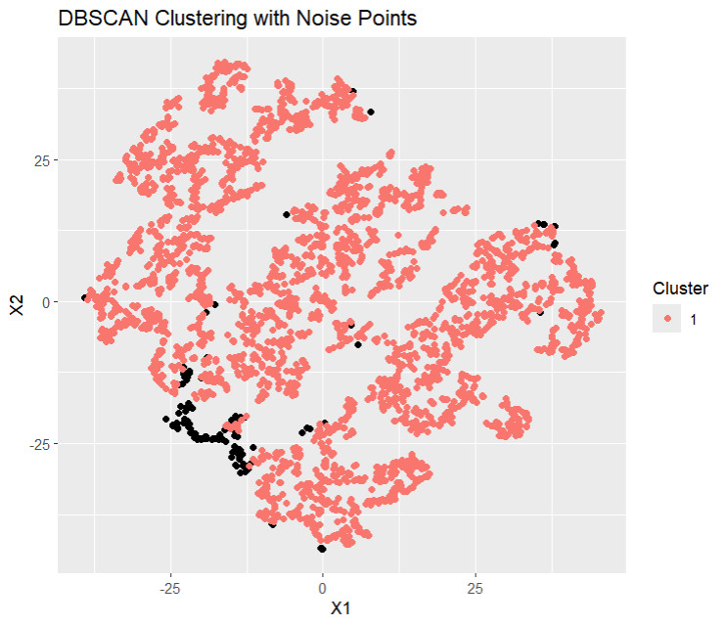
Abbreviations: DBSCAN, density-based spatial clustering of applications with noise.

Figure S2. Sensitivity analyses using three (K=3) or five (K=5) clusters.
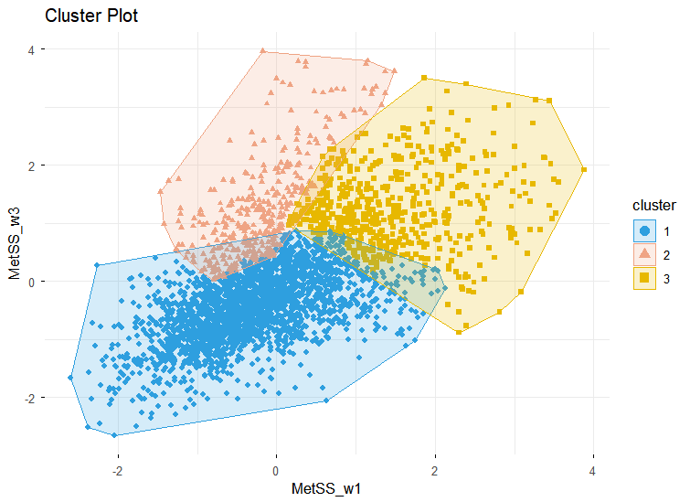A 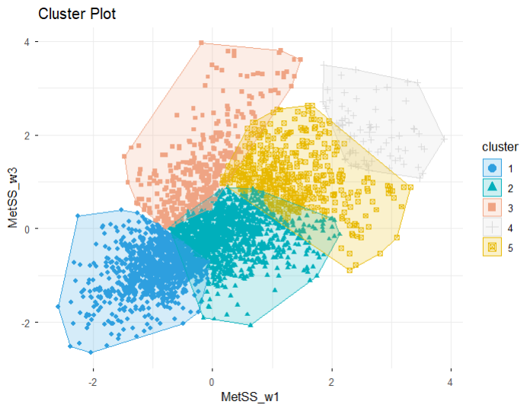B
Abbreviations: MetSS, metabolic syndrome score.

