Supplementary data

An Exploratory Study of Kinase Activation Profiles in Hypoxic Human Cardiomyocytes Treated with Protective Extracellular Vesicles
Andreas Czosseck¹, Barbara Szomolay^{2,3}, Ali Sajid Imani⁴, Robert E. McCullumsmith ^{4,5}, Patrick C.H. Hsieh⁶, Thierry Burnouf^{1,7}, David J. Lundy^{1,7,8,}*

Affiliations:
- Graduate Institute of Biomedical Materials & Tissue Engineering, Taipei Medical University, 301 Yuantong Road, Yonghe District, New Taipei City, Taiwan 235603
- Systems Immunity Research Institute, Cardiff University School of Medicine, Cardiff, United Kingdom
- Division of Infection and Immunity, Cardiff University School of Medicine, Cardiff, United Kingdom
- Department of Neuroscience and Psychiatry, College of Medicine and Life Sciences, University of Toledo, Toledo, Ohio 43614, USA
- Neuroscience Institute, Promedica, Toledo, Ohio, USA
- Institute of Biomedical Sciences, Academia Sinica, 128 Academia Road Section 2, Nangang, Taipei, Taiwan 115
- International PhD Program in Biomedical Engineering, Taipei Medical University, 301 Yuantong Road, Yonghe District, New Taipei City, Taiwan 235603
- Center for Cell Therapy, Taipei Medical University Hospital, 250 Wuxing Street, Xinyi District, Taipei, Taiwan 110

Gene | Description | Forward | Reverse
MYH6 | Myosin heavy chain 6 (aMHC) | GGAAGACAAGGTCAACAGCCTG | TCCAGTTTCCGCTTTGCTCGCT
MYH7 | Myosin heavy chain 7 (bMHC) | GGAGTTCACACGCCTCAAAGAG | TCCTCAGCATCTGCCAGGTTGT
NPPA | Atrial Natriuretic Peptide (ANP) | ACAATGCCGTGTCCAACGCAGA | CTTCATTCGGCTCACTGAGCAC
ATP2A2 | SERCA2 / ATPase Sarcoplasmic/Endoplasmic Reticulum Ca2+ Transporting 2 | GGACTTTGAAGGCGTGGATTGTG | CTCAGCAAGGACTGGTTTTCGG
PPARGC1A/  PERM1 | PGC-1a / PPARGC1 and ESSR induced regulator, Muscle 1 | CCAAAGGATGCGCTCTCGTTCA | CGGTGTCTGTAGTGGCTTGACT
PPARA | Peroxisome Proliferator Activated Receptor Alpha (PPAR alpha) | TCGGCGAGGATAGTTCTGGAAG | GACCACAGGATAAGTCACCGAG
LPL | Lipoprotein lipase | CTGCTGGCATTGCAGGAAGTCT | CATCAGGAGAAAGACGACTCGG
ACAT1 | Acetyl-CoA Acetyltransferase 1 | CCAGCCACTAAGCTTGGTTCCA | GTAGGAGCTTGTCCTTCACCTC
DGAT1 | Diacylglycerol O-acyltransferase 1 | GCTTCAGCAACTACCGTGGCAT | CCTTCAGGAACAGAGAAACCACC
SCD | Stearoyl-CoA desaturase (delta-9-desaturase) | CCTGGTTTCACTTGGAGCTGTG | TGTGGTGAAGTTGATGTGCCAGC
ALDOA | Aldolase | GACACTCTACCAGAAGGCGGAT | GGTGGTAGTCTCGCCATTTGTC
HK1 | Hexokinase 1 | CTGCTGGTGAAAATCCGTAGTGG | GTCCAAGAAGTCAGAGATGCAGG
HK2 | Hekokinase 2 | GAGTTTGACCTGGATGTGGTTGC | CCTCCATGTAGCAGGCATTGCT
PGK1 | Phosphoglycerate kinase 1 | CCGCTTTCATGTGGAGGAAGAAG | CTCTGTGAGCAGTGCCAAAAGC
GAPDH | Glycerinaldehyde-3-phosphat-Dehydrogenase | GTCTCCTCTGACTTCAACAGCG | ACCACCCTGTTGCTGTAGCCAA

Supplementary Table 1: List of primers used in the study

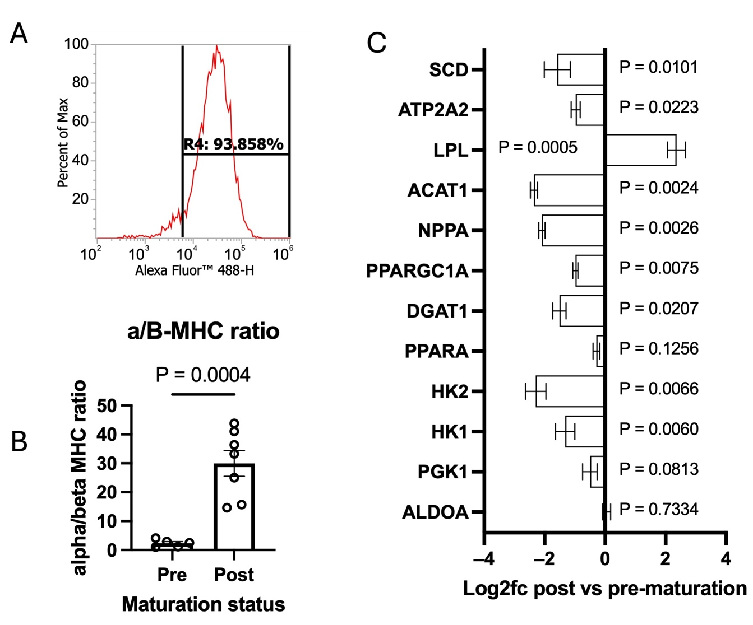

Supplemental Figure 1:
- Flow cytometry of the induced pluripotent stem cell-derived cardiomyocyte (iCM) population used in the study. Cells were stained for cardiac troponin I labelled with AF488. The gate threshold was set based on isotype control-stained cells.
- Gene expression level of alpha/beta myosin heavy chain (MHC) ratio, comparing pre vs. post maturation. N = 7 samples per group. Compared by unpaired t-test.
- Additional qPCR panel showed expression of glycolytic enzymes, fatty acid synthesis enzymes, fetal CM markers and maturation markers. X axis shows log2fc compared to pre-maturation iCMs. P values are based on one-sample t-tests compared to log2fc = 0.

Supplemental Figure 2
- Graph showing iCM viability over time during hypoxia from 4h to 36h. Each data point shows the mean of n = 4 independent samples. Error bars show SEM.
- Quantification of LDH release and cell viability under normoxic and 12h hypoxic conditions. The LDH increase % is based on a comparison to normoxic cell basal LDH release. Trypan blue is based on the % of positively stained cells.
- Total protein concentrations of each group following hypoxia exposure. All groups were compared by one-way ANOVA with Tukey’s post-test and the lowest three P values are shown. The comparisons not shown were P > 0.05.

Supplemental Figure 3
- Tables showing the layout of 24 total samples across 6 chips, carried out over two separate experimental runs. Sample labeling is indicated, with neg representing healthy normoxic cells, pos representing hypoxic cells with vehicle control, and T1-4 representing hypoxia combined with EV treatments.
- Coefficient of variation (CV) % values for each experimental group. Left; run 1, right; run 2.
- Violin plots of signal intensity distribution across groups for all replicates. Left; run 1, right: run 2.

Supplemental Figure 4
Violin plots for hypoxia + vehicle vs. each EV treatment group.

