Supplementary Materials

Supplementary Table S2 (continued). Short-form summary (full vs short).
Scale | Full items (vars) | Short-form items (vars) | Alpha (full) | Alpha (short) | Avg inter-item r (full) | Avg inter-item r (short) | Eigen1 (full) | Var% (full) | Loadings range (full) | Eigen1 (short) | Var% (short) | Loadings range (short) | Correlation (full vs short)
Perceived organisational support (Q22) | orgsup_1, orgsup_2, orgsup_3 | orgsup_1, orgsup_3 | 0.956 | 0.929 | 0.879 | 0.868 | 2.76 | 91.97 | 0.96-0.96 | 1.87 | 93.40 | 0.97-0.97 | 0.989
Job experience and role clarity (Q21+Q23) | jobfeel_1, jobfeel_2, jobfeel_3, jobfeel_4, jobfeel_5, role_1, role_2, role_3 | jobfeel_1, jobfeel_3, role_2, role_3 | 0.966 | 0.922 | 0.781 | 0.747 | 6.47 | 80.83 | 0.87-0.92 | 3.24 | 81.04 | 0.89-0.91 | 0.989
Emotional exhaustion / compassion fatigue (Q29) | emo_1, emo_2, emo_3, emo_4, emo_5 | emo_1, emo_5 | 0.976 | 0.913 | 0.890 | 0.846 | 4.56 | 91.25 | 0.93-0.96 | 1.85 | 92.29 | 0.96-0.96 | 0.987
Supplementary Table S2. Psychometric Redundancy Diagnostics for scales with Cronbach’s α > 0.95 (CITC and α-if-item-deleted).
Scale | Item (variable) | Corrected Item–Total Correlation (CITC) | Cronbach’s α if Item Deleted
Perceived organisational support (full) | orgsup_1 – Q22 Perceived organisational support: I can obtain timely feedback and guidance (1–5) | 0.902 | 0.940
Perceived organisational support (full) | orgsup_2 – Q22 Perceived organisational support: My suggestions are heard and used for improvement (1–5) | 0.916 | 0.929
Perceived organisational support (full) | orgsup_3 – Q22 Perceived organisational support: Excellent service receives formal recognition and commendation (1–5) | 0.905 | 0.937
Job experience and role clarity (full) | jobfeel_1 – Q21 Job experience: My responsibilities and tasks are clear (1–5) | 0.885 | 0.960
Job experience and role clarity (full) | jobfeel_2 – Q21 Job experience: My work feels valuable and meaningful (1–5) | 0.876 | 0.961
Job experience and role clarity (full) | jobfeel_3 – Q21 Job experience: I receive recognition from patients (1–5) | 0.847 | 0.962
Job experience and role clarity (full) | jobfeel_4 – Q21 Job experience: I collaborate smoothly with healthcare staff (1–5) | 0.894 | 0.960
Job experience and role clarity (full) | jobfeel_5 – Q21 Job experience: The workload/time commitment is acceptable (1–5) | 0.875 | 0.961
Job experience and role clarity (full) | role_1 – Q23 Role clarity and fit: Task priorities are clear (1–5) | 0.867 | 0.961
Job experience and role clarity (full) | role_2 – Q23 Role clarity and fit: When situations are unclear, the decision pathway is clear (1–5) | 0.851 | 0.962
Job experience and role clarity (full) | role_3 – Q23 Role clarity and fit: The role matches my capabilities (1–5) | 0.836 | 0.963
Emotional exhaustion (full) | emo_1 – Q29 Emotional exhaustion/compassion fatigue: I feel emotionally drained after volunteering (1–5) | 0.896 | 0.975
Emotional exhaustion (full) | emo_2 – Q29 Emotional exhaustion/compassion fatigue: I feel numb when facing patients’ needs or requests (1–5) | 0.932 | 0.969
Emotional exhaustion (full) | emo_3 – Q29 Emotional exhaustion/compassion fatigue: I need more time than usual to recover (1–5) | 0.944 | 0.967
Emotional exhaustion (full) | emo_4 – Q29 Emotional exhaustion/compassion fatigue: Recurrent thoughts or dreams related to service affect my rest (1–5) | 0.937 | 0.969
Emotional exhaustion (full) | emo_5 – Q29 Emotional exhaustion/compassion fatigue: I have become more irritable/short-tempered than before (1–5) | 0.940 | 0.968

Supplementary Table S3. Sensitivity analyses: Associations of POS full-item and short-form scores with top-box outcomes (unadjusted logistic models).
Outcome | Predictor | OR per 1-point | 95% CI | p | N
Top-box intention to continue (100% category) | POS mean score (3 items) | 2.77 | 2.04–3.77 | <0.001 | 562
Top-box intention to continue (100% category) | POS short-form mean (2 items) | 2.64 | 1.95–3.58 | <0.001 | 562
Top-box overall satisfaction (very satisfied) | POS mean score (3 items) | 4.26 | 3.07–5.91 | <0.001 | 562
Top-box overall satisfaction (very satisfied) | POS short-form mean (2 items) | 4.21 | 3.03–5.85 | <0.001 | 562

Supplementary Table S4. Full-item psychometrics for α > 0.95 scales (reported for transparency/comparability).
Scale | No. of items | Cronbach’s α | Eigenvalue of 1st factor | Variance explained by 1st factor (%) | Factor loadings on 1st factor (range) | Average inter-item correlation
Perceived organisational support (full) | 3 | 0.956 | 2.759 | 92.0 | 0.96-0.96 | 0.879
Job experience and role clarity (full) | 8 | 0.966 | 6.467 | 80.8 | 0.87-0.92 | 0.781
Emotional exhaustion (full) | 5 | 0.976 | 4.562 | 91.2 | 0.93-0.96 | 0.890

Figure S1. Participant flow
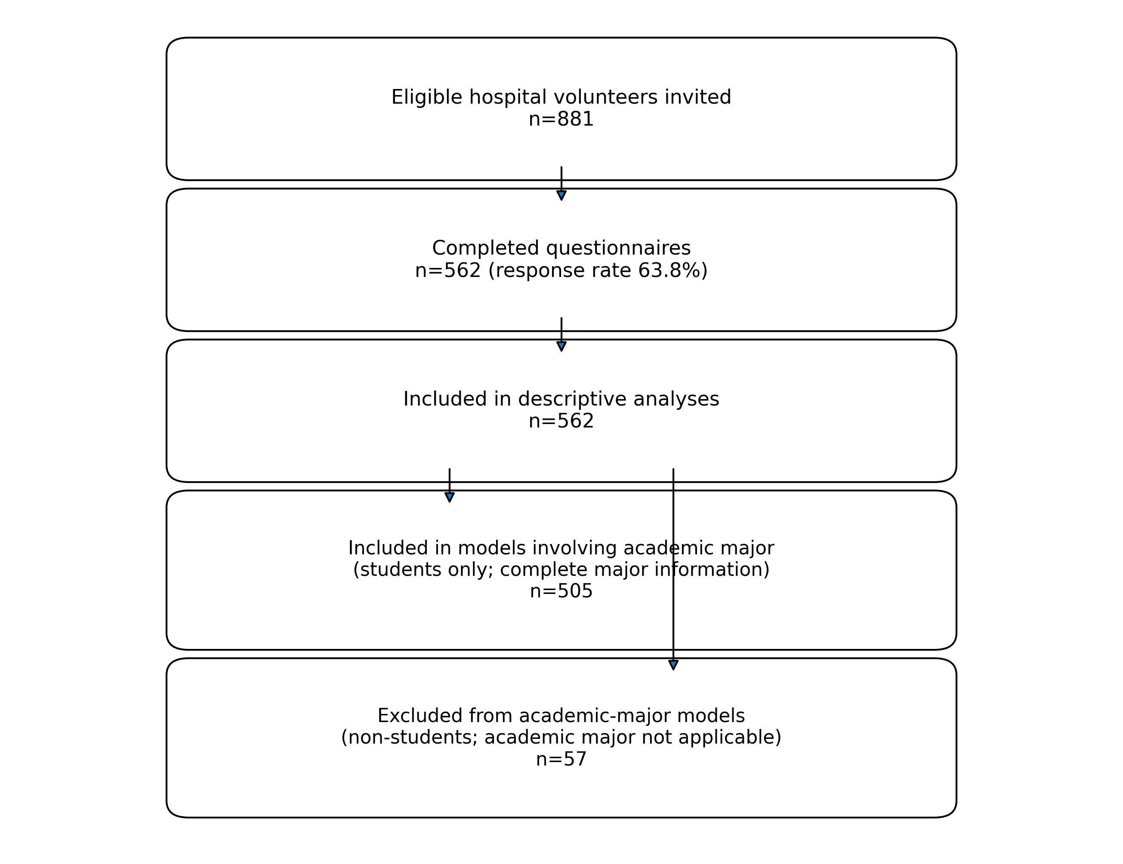
Eligible hospital volunteers invited: n=881. Completed questionnaires: n=562 (response rate 63.8%). Included in descriptive analyses: n=562. Included in models involving academic major (complete major information; students only): n=505. Excluded from academic-major models: n=57 (non-students; academic major not applicable).

File S1. Full questionnaire (English translation)
Volunteer Service Survey Questionnaire
The First Hospital of Hebei Medical University
This questionnaire aims to understand the current situation and needs of hospital volunteer services. Your responses will provide important evidence to inform service improvement. All information will be used for statistical analysis only, and your privacy will be strictly protected. If you have any questions about this survey, please contact: Mandi Guo (23034100629@stu.hebmu.edu.cn).
Part I. Basic Information
1. Gender * [Single choice]
- Male
- Female
2. Age * [Single choice]
- 14–18 years
- 19–25 years
- 26–30 years
- 31–35 years
- 36–40 years
- 41–45 years
- 46–50 years
- 51–55 years
- 56–60 years
- 61 years or older
3. Occupation * [Single choice]
- Student
- Healthcare worker
- Civil servant
- Employee in enterprise/institution
- Self-employed/Freelancer
- Unemployed
- Retired
- Other (please specify): ____________________
4. Highest education level * [Single choice]
- High school or below
- Associate/Bachelor’s degree (including current students)
- Master’s degree
- Doctoral degree or above
5. Academic discipline/major (multiple selections allowed) * [Multiple choice]
Note: Shown only if “Student” is selected in Question 3.
- I am a middle/high school student (no academic major)
- Philosophy (please specify): ____________________
- Economics (please specify): ____________________
- Law (please specify): ____________________
- Education (please specify): ____________________
- Literature (please specify): ____________________
- History (please specify): ____________________
- Science (please specify): ____________________
- Engineering (please specify): ____________________
- Agriculture (please specify): ____________________
- Medicine (please specify): ____________________
- Management (please specify): ____________________
- Arts (please specify): ____________________
- Other (please specify): ____________________
6. How did you learn about and register to become a volunteer? (multiple selections allowed) * [Multiple choice]
- Zhiyuanhui (volunteer platform/app)
- Patient Service Platform of The First Hospital of Hebei Medical University (hospital mini-program)
- Recommendation from acquaintances
- Other (please specify): ____________________
7. On average, how many hours per week do you participate in volunteer services? * [Single choice]
- Less than 2 hours
- 2–4 hours
- 4–6 hours
- 6–8 hours
- 8–16 hours
- More than 16 hours
8. Length of time participating in hospital volunteer services (from your first service to present) * [Single choice]
- Less than 3 months
- Less than 6 months
- Less than 1 year
- Less than 2 years
- Less than 3 years
- Less than 4 years
- Less than 5 years
- 5 years or more
9. How frequently have you participated in volunteer services in the past month? * [Single choice]
- Once per month
- 2–4 times per month
- 5–8 times per month
- 2–4 times per week
- 5–6 times per week
- Every day
- Irregular
10. Your cumulative volunteer service hours to date * [Single choice]
- <10 hours
- 10–20 hours
- 20–50 hours
- 50–100 hours
- 100–150 hours
- 150–200 hours
- 200–250 hours
- 250–300 hours
- 300–350 hours
- 350–400 hours
- 400–450 hours
- 450–500 hours
- >500 hours
11. When can you usually provide volunteer services? (multiple selections allowed) * [Multiple choice]
- Weekdays
- Weekends/holidays
- Winter/summer vacation
- Time is uncertain
12. Which types of volunteer services are you currently mainly involved in? (multiple selections allowed) * [Multiple choice]
- Self-service kiosk assistance
- Outpatient accompaniment
- Inpatient escort
- Wayfinding/triage guidance
- Examination assistance
- Ward companionship
- “Healing Through Music” program
- Sign language interpreting
- Foreign language interpreting
- Other (please specify): ____________________
13. Which types of volunteer services would you like to participate in? (multiple selections allowed) * [Multiple choice]
- Self-service kiosk assistance
- Outpatient accompaniment
- Inpatient escort
- Wayfinding/triage guidance
- Examination assistance
- Ward companionship
- “Healing Through Music” program
- Sign language interpreting
- Foreign language interpreting
- Other (please specify): ____________________
14. Are there any additional types of volunteer roles you would like to see offered? [Open-ended]
________________________________

Part II. Motivation and Concerns
15. Importance of motivations for becoming a volunteer * [Matrix]
Please rate each item from 1 (Not at all important) to 5 (Extremely important).
• Helping others and contributing to society 1 2 3 4 5
• Interest in the healthcare environment/clinical work 1 2 3 4 5
• Improving communication and adaptability skills 1 2 3 4 5
• Gaining experience and exploring new roles 1 2 3 4 5
• Giving back after receiving care/support from the hospital 1 2 3 4 5

16. Before formally joining, what was your greatest concern or potential barrier regarding hospital volunteer work? (multiple selections allowed) * [Multiple choice]
- Concerned that my professional knowledge is insufficient and I may not be competent
- Afraid of dealing with patients’ negative emotions or emergencies
- Worried that volunteering will take too much personal time and affect study/work
- Unfamiliar with the hospital’s management and support system, leading to uncertainty
- I had few/no concerns at the time
- Other (please specify): ____________________
17. What are your main purposes for participating in volunteer services? (multiple selections allowed) * [Multiple choice]
- I am willing to use my spare time to help others and contribute
- I need to accumulate volunteer service hours
- I have been helped before, so I want to help others
- I want to grow through volunteer activities
- I want to gain/demonstrate my personal value through volunteering
- Other (please specify): ____________________
Part III. Training and Role Experience
18. What is the greatest difficulty you encounter during service? (multiple selections allowed) * [Multiple choice]
- Insufficient professional knowledge or unfamiliarity with required skills
- Difficulty coordinating time
- Complex patient emotions or communication barriers
- I am introverted and not good at communication
- Other (please specify): ____________________
19. During service, which of the following are your main difficulties or barriers? (multiple selections allowed) * [Multiple choice]
- My service skills are insufficient; sometimes I do not know how to respond to patients’ requests for help
- Communication with some patients or family members is ineffective, and I may even be misunderstood
- Coordination with hospital staff is not smooth
- I feel my work has limited perceived value and is relatively trivial
- Volunteering conflicts with my study/work/life in terms of time/energy
- Lack of necessary logistical support (e.g., drinking water, rest area)
- I have encountered almost no difficulties
- Other (please specify): ____________________
20. Does the hospital’s volunteer training meet your needs? * [Single choice]
- Fully meets my needs
- Mostly meets my needs
- Partially meets my needs
- Does not meet my needs
21. Work experience in your role * [Matrix]
Please rate each statement from 1 (Strongly disagree) to 5 (Strongly agree).
• My responsibilities and tasks are clear 1 2 3 4 5
• My work feels valuable and meaningful 1 2 3 4 5
• I receive recognition from patients 1 2 3 4 5
• I collaborate smoothly with healthcare staff 1 2 3 4 5
• The workload/time commitment is acceptable 1 2 3 4 5

22. Perceived organisational support * [Matrix]
Please rate each statement from 1 (Strongly disagree) to 5 (Strongly agree).
• I can obtain timely feedback and guidance 1 2 3 4 5
• My suggestions are heard and used for improvement 1 2 3 4 5
• Excellent service receives formal recognition and commendation 1 2 3 4 5

23. Role clarity and fit * [Matrix]
Please rate each statement from 1 (Strongly disagree) to 5 (Strongly agree).
• Task priorities are clear 1 2 3 4 5
• When situations are unclear, the decision pathway is clear 1 2 3 4 5
• The role matches my capabilities 1 2 3 4 5

24. Autonomy and workload * [Matrix]
Please rate each statement from 1 (Strongly disagree) to 5 (Strongly agree).
• I can make necessary decisions within the scope of my responsibilities 1 2 3 4 5
• My current workload is within an acceptable range 1 2 3 4 5

Part IV. Perceptions and Personal Growth
25. Perceptions before volunteering * [Matrix]
Please rate each statement from 1 (Strongly disagree) to 5 (Strongly agree).
• The hospital provides humane care and warmth 1 2 3 4 5
• The management and processes are efficient and well-organised 1 2 3 4 5
• Volunteer services can substantially improve the patient experience 1 2 3 4 5

26. Perceptions after volunteering * [Matrix]
Please rate each statement from 1 (Strongly disagree) to 5 (Strongly agree).
• The hospital provides humane care and warmth 1 2 3 4 5
• The management and processes are efficient and well-organised 1 2 3 4 5
• Volunteer services can substantially improve the patient experience 1 2 3 4 5

27. What have been your greatest personal gains from volunteering? * [Ranking]
Please rank the three most important gains. Enter 1 for the most important, 2 for the second, and 3 for the third.
- [ ] A deeper understanding of and respect for life and health
- [ ] Improved interpersonal communication and teamwork skills
- [ ] Enhanced sense of social responsibility and altruism
- [ ] Acquired basic medical or first-aid knowledge
- [ ] Improved emotion regulation and stress tolerance
- [ ] Met many outstanding peers and healthcare professionals
- [ ] Other (please specify): __________

Part VI. Training and Skills Map
28. Training and skills map * [Matrix]
Please rate each statement from 1 (Strongly disagree) to 5 (Strongly agree).
• I can clearly explain common care-seeking processes in this hospital 1 2 3 4 5
• I can independently resolve common issues related to self-service kiosks/registration and payment 1 2 3 4 5
• I can recognise high-risk warning signs and promptly report them (e.g., sudden chest pain, seizure, dyspnoea) 1 2 3 4 5
• I have basic skills for emotional support and de-escalation of conflict 1 2 3 4 5

Part VII. Emotional Exhaustion and Compassion Fatigue
29. Emotional exhaustion and compassion fatigue (past two weeks) * [Matrix]
Please rate each statement using the following frequency scale: 1=Never, 2=Rarely, 3=Sometimes, 4=Often, 5=Always.
• I feel emotionally drained after volunteering 1 2 3 4 5
• I feel numb when facing patients’ needs or requests 1 2 3 4 5
• I need more time than usual to recover 1 2 3 4 5
• Recurrent thoughts or dreams related to service affect my rest 1 2 3 4 5
• I have become more irritable/short-tempered than before 1 2 3 4 5

Part VIII. Safety Events and Near Misses (Non-punitive; for improvement only)
30. In the past three months, have you witnessed or been involved in any of the following events? (Non-punitive; for data collection and improvement only) * [Multiple choice]
- Patient fall/wandering or getting lost
- Acute deterioration not reported in a timely manner
- Role mismatch/incorrect directions given
- Equipment/system failure
- Other (please specify): ____________________
- None
31. Total number of related events in the past three months * [Single choice]
Note: Shown only if any event is selected in Question 30 (excluding “None”).
- 0
- 1
- 2–3
- ≥4
32. For the most recent event, was it reported according to the protocol? * [Single choice]
Note: Shown only if any event is selected in Question 30 (excluding “None”).
- Yes
- No
33. If not reported, what was the main reason? * [Single choice]
Note: Shown only if “No” is selected in Question 32.
- The reporting process was unclear
- Concern about being blamed
- I did not think it was serious
- Other (please specify): ____________________
Part IX. Tasks and Peak Visit Times
34. Perceived peak visit periods on weekdays (multiple selections allowed) * [Multiple choice]
- 8:00–10:00
- 10:00–12:00
- 12:00–14:00
- 14:00–16:00
- Other time period (please specify): ____________________
Part X. Experience-focused Items
35. In your view, in which aspects does volunteer service provide the greatest help to patients? (multiple selections allowed) * [Multiple choice]
- Providing psychological support
- Improving visit efficiency
- Reducing the workload of healthcare staff
- Other (please specify): ____________________
36. Overall satisfaction with the hospital volunteer service system * [Single choice]
- Very satisfied
- Satisfied
- Neutral
- Dissatisfied
Part XI. Retention Intention and Suggestions
37. Overall, how likely are you to continue participating in this hospital’s volunteer services over the next year? * [Single choice]
- 100% (I will definitely continue)
- 75% (Very likely)
- 50% (Not sure)
- 25% (Unlikely)
- 0% (Definitely will not)
38. (Hypothetical) If you decide not to continue, what would be the most likely reason? [Open-ended]
Note: Shown only if 50%, 25%, or 0% is selected in Question 37.
________________________________

39. In your opinion, which aspects of volunteer support most need improvement? (multiple selections allowed) * [Multiple choice]
- Training content
- Establishing channels for volunteer feedback and suggestions
- Material/logistical support
- Other (please specify): ____________________
40. Do hospital managers (e.g., volunteer coordinators) communicate with you frequently and provide necessary support and encouragement? * [Single choice]
- Yes; communication is smooth and support is strong
- Sometimes, but not regularly
- Rarely; I feel largely unsupported and disconnected
- Never
41. How would you rate the hospital’s management and support for volunteers? * [Single choice]
- Very systematic: regular communication, timely feedback channels, strong logistical support, and effective incentives
- Fairly adequate: support is generally available, but communication and incentives are not routine
- Average: management occurs mainly when needed; routine contact is limited and support is modest
- Relatively loose/disorganised: it feels like “self-management,” and effective support is difficult to access when problems arise
42. How likely are you to recommend this volunteer program to friends/classmates? * [Numeric input]
Please enter a number from 0 (Not at all likely) to 10 (Extremely likely).
Answer: ________________________________

43. In your view, the social value of hospital volunteer services is mainly reflected in: * [Single choice]
- Sharing compassion and contributing to helping others
- Alleviating healthcare system pressure
- Promoting a more harmonious patient–clinician relationship
- Other (please specify): ____________________
44. In your service role, indicate the extent to which you agree with each statement * [Matrix]
Use 1 (Strongly disagree) to 5 (Strongly agree).
• My responsibilities and tasks are very clear 1 2 3 4 5
• I feel my work is valuable and meaningful 1 2 3 4 5
• I can feel that my work is recognised by patients 1 2 3 4 5
• I collaborate smoothly with healthcare staff 1 2 3 4 5
• The intensity and time commitment are within my acceptable range 1 2 3 4 5

45. Do you have any suggestions to improve hospital volunteer services? * [Open-ended]
________________________________

46. If your suggestions are meaningful or adopted for improvement, would you be willing to leave your name and contact information so that we can provide timely feedback? * [Single choice]
- Yes. My contact information is: ____________________
- No

