SUPPLEMENTARY MATERIAL
Risk of Bias and Methodological Quality (derived from extracted study characteristics)
Note: The main manuscript tables provide study-level design, sampling frame descriptors, and measurement labels but do not include a formal risk-of-bias (RoB) appraisal. The summaries below therefore provide a methodological risk profile derived from information reported in the extraction tables (e.g., design type, sampling frame descriptors, and whether outcome instruments were explicitly specified). A full RoB assessment for each quantitative study should be completed using an appropriate tool (e.g., JBI, NOS, or ROBINS-I) based on full-text review.
Table S1. Methodological quality / risk-of-bias profile summary (quantitative studies, n = 61).
Domain (proxy) | Low n (%) | Some concerns n (%) | High n (%) | Unclear n (%) | Information source (from extraction table)
Temporality/design | 1 (1.6%) | 60 (98.4%) | 0 (0.0%) | 0 (0.0%) | Study design label
Selection/representativeness | 3 (4.9%) | 42 (68.9%) | 16 (26.2%) | 0 (0.0%) | Population frame descriptor; survey identifiers (e.g., DHS/SANHANES/RODAM)
Outcome measurement | 10 (16.4%) | 21 (34.4%) | 0 (0.0%) | 30 (49.2%) | Outcome measure/instrument field
Reporting completeness | 47 (77.0%) | 14 (23.0%) | 0 (0.0%) | 0 (0.0%) | Mean age / age range / female proportion fields

Figure S1. Methodological quality / risk-of-bias profile (derived from extracted study characteristics).
Stacked proportions across quantitative studies (n = 61) for four proxy domains.
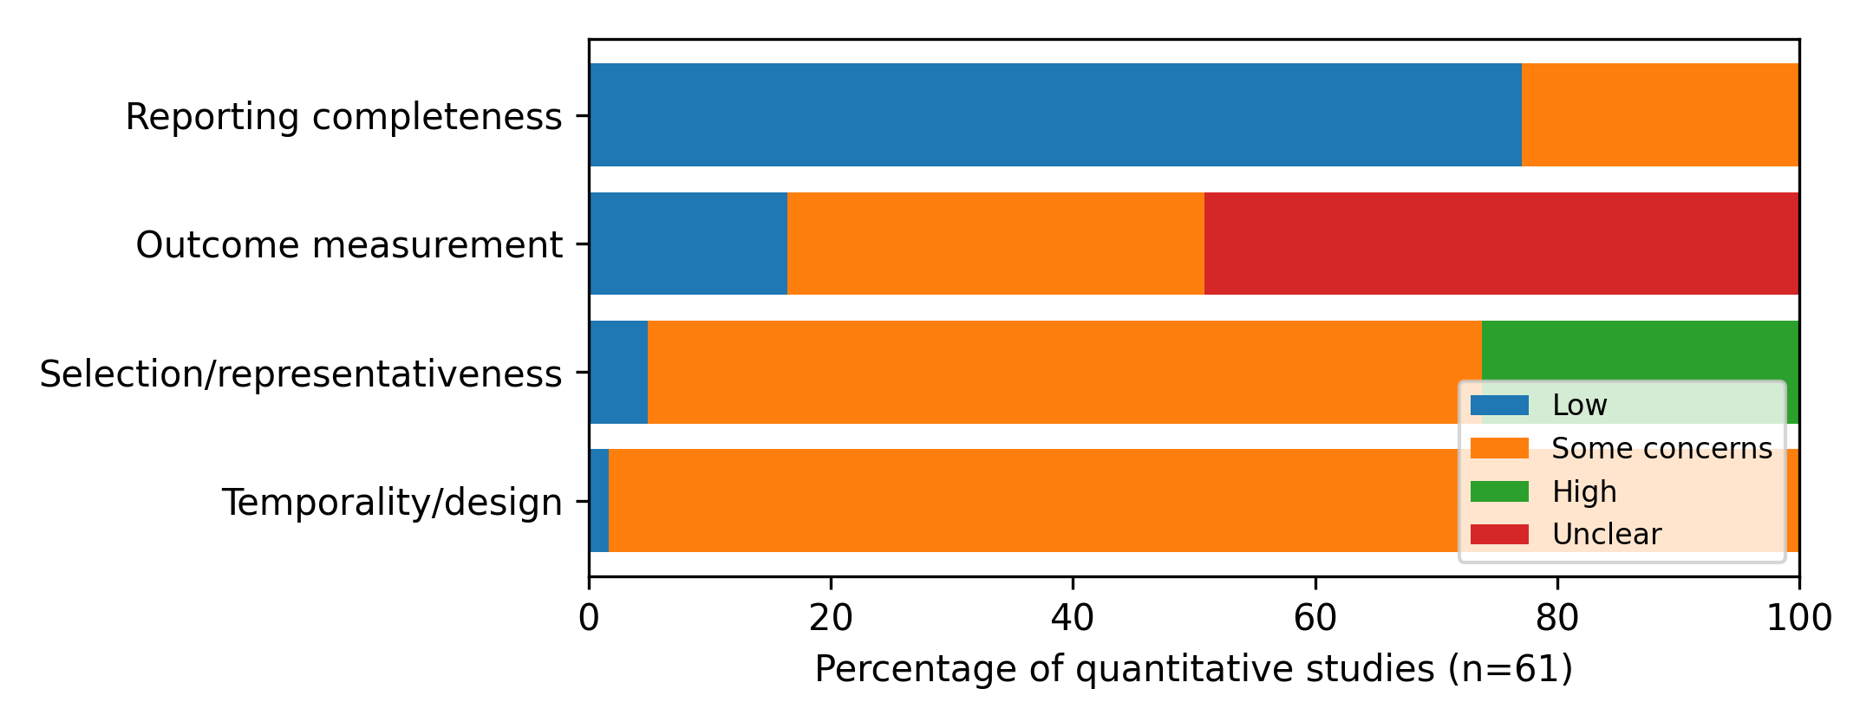

Table S2. Study-level methodological quality indicators and risk profile (quantitative studies, n = 61).
Ratings are proxies based on extracted table fields only; they are not a substitute for full-text RoB appraisal.
Study | Country | Design | Temporality / design | Selection / representativeness | Outcome measurement | Reporting completeness | Overall (proxy)
ASF Silva, 2007 (A. S. F. Silva, 2007) | South Africa | Cross-sectional | Some concerns | Some concerns | Low | Low | Some concerns
Abdo et al., 2023 (Abdo et al., 2023) | Ethiopia | Cross-sectional | Some concerns | High | Unclear | Low | High
Alwan et al., 2010 (Alwan et al., 2010) | Seychelles | Cross-sectional | Some concerns | Some concerns | Some concerns | Low | Some concerns
Amegbor et al., 2022 (Amegbor et al., 2022) | Uganda | Cross-sectional (DHS) | Some concerns | Low | Some concerns | Some concerns | Some concerns
Amenyah & Michels, 2016 (Amenyah & Michels, 2016) | Ghana | Cross-sectional | Some concerns | High | Unclear | Low | High
Awosan et al., 2017 (Awosan et al., 2017) | Nigeria | Cross-sectional | Some concerns | Some concerns | Unclear | Low | Some concerns
Balogun-Mwangi et al., 2023 (Balogun-Mwangi et al., 2023) | Kenya & Nigeria | Cross-sectional | Some concerns | Some concerns | Unclear | Low | Some concerns
Baratin et al., 2020 (Baratin et al., 2020) | Ghana (and Europe) | Cross-sectional (RODAM) | Some concerns | Low | Some concerns | Low | Some concerns
Benkeser et al., 2012 (Benkeser et al., 2012) | Ghana | Cross-sectional | Some concerns | Some concerns | Some concerns | Low | Some concerns
Case & Menendez, 2009 (Case & Menendez, 2009) | South Africa | Cross-sectional | Some concerns | Some concerns | Some concerns | Low | Some concerns
Chamik et al., 2018 (Chamik et al., 2018) | Seychelles | Cross-sectional | Some concerns | Some concerns | Some concerns | Some concerns | Some concerns
Choo-Kang et al., 2024 (Choo-Kang et al., 2024) | USA, Seychelles, Ghana | Cross-sectional | Some concerns | Some concerns | Unclear | Some concerns | Some concerns
Christian & Frempong, 2020 (Christian & Frempong, 2020) | Ghana | Cross-sectional | Some concerns | Some concerns | Unclear | Some concerns | Some concerns
Cilliers et al., 2006 (Cilliers et al., 2006) | South Africa | Cross-sectional | Some concerns | High | Low | Low | High
Cohen et al., 2015 (Cohen, Ndao, et al., 2015) | Cameroon & Senegal | Validation Study | Some concerns | Some concerns | Some concerns | Low | Some concerns
Cohen et al., 2017 (Cohen et al., 2017) | Cameroon / France | Cross-sectional | Some concerns | Some concerns | Unclear | Low | Some concerns
Cort et al., 2013 (Cort et al., 2013) | South Africa | Cross-sectional | Some concerns | Some concerns | Some concerns | Low | Some concerns
Draper et al., 2022 (Draper et al., 2022) | South Africa | Cross-sectional | Some concerns | Some concerns | Unclear | Low | Some concerns
Du et al., 2022 (Du et al., 2022) | Multi (Ghana subset) | Cross-sectional | Some concerns | High | Low | Low | High
Duboz et al., 2017 (Duboz et al., 2017) | Senegal | Cross-sectional | Some concerns | Some concerns | Some concerns | Low | Some concerns
Duda et al., 2006 (Duda et al., 2006) | Ghana | Cross-sectional | Some concerns | Some concerns | Unclear | Low | Some concerns
Edwards et al., 2003 (Edwards, 2003) | South Africa | Cross-sectional | Some concerns | High | Low | Some concerns | High
Ejike, 2013 (C. Ejike, 2013) | Nigeria | Cross-sectional | Some concerns | High | Some concerns | Low | High
Ejike, 2015 (C. E. C. C. Ejike, 2015) | Nigeria | Cross-sectional | Some concerns | High | Unclear | Low | High
Engda et al., 2021 (Engda et al., 2021) | Ethiopia | Comparative Cross-sectional | Some concerns | Some concerns | Low | Low | Some concerns
Engda et al., 2022 (Engda et al., 2022) | Ethiopia | Cross-sectional | Some concerns | Some concerns | Low | Low | Some concerns
Ettarh et al., 2013 (Ettarh et al., 2013) | Kenya | Cross-sectional | Some concerns | Some concerns | Some concerns | Some concerns | Some concerns
Faeh et al., 2007 (Faeh et al., 2007) | Seychelles | Cross-sectional | Some concerns | Some concerns | Unclear | Low | Some concerns
Holdsworth et al., 2004 (Holdsworth et al., 2004) | Senegal | Cross-sectional | Some concerns | Some concerns | Unclear | Some concerns | Some concerns
Hume et al., 2015 (Hume et al., 2015) | South Africa | Cross-sectional (EEG) | Some concerns | Some concerns | Some concerns | Low | Some concerns
Kibr, 2021 (Kibr, 2021) | Ethiopia | Cross-sectional | Some concerns | Some concerns | Unclear | Low | Some concerns
Le Grange et al., 2006 (le Grange et al., 2006) | South Africa | Cross-sectional | Some concerns | High | Unclear | Low | High
Lentoor & Myburgh, 2022 (Lentoor & Myburgh, 2022) | South Africa | Cross-sectional | Some concerns | Some concerns | Unclear | Low | Some concerns
Malete et al., 2013 (Malete et al., 2022) | Botswana | Cross-sectional | Some concerns | Some concerns | Unclear | Low | Some concerns
Manafe et al., 2021 (Manafe et al., 2021) | South Africa | Cross-sectional | Some concerns | Some concerns | Some concerns | Low | Some concerns
Maruf et al., 2013 (Maruf et al., 2014) | Nigeria | Cross-sectional | Some concerns | Some concerns | Unclear | Low | Some concerns
Mayega et al., 2012 (Mayega et al., 2012) | Uganda | Cross-sectional | Some concerns | Some concerns | Some concerns | Low | Some concerns
McHiza et al., 2019 (McHiza et al., 2019) | South Africa | Cross-sectional | Some concerns | Some concerns | Some concerns | Some concerns | Some concerns
McHiza et al., 2020 (McHiza et al., 2020) | South Africa | Cross-sectional | Some concerns | Some concerns | Unclear | Some concerns | Some concerns
Mchiza et al., 2010 (Mchiza et al., 2010) | South Africa | Cross-sectional | Some concerns | Some concerns | Unclear | Low | Some concerns
Mchiza et al., 2015 (Mchiza et al., 2015) | South Africa | Cross-sectional (SANHANES-1) | Some concerns | Low | Some concerns | Low | Some concerns
Mohamed & Idrees, 2023 (Mohamed & Idrees, 2023) | Sudan | Cross-sectional | Some concerns | High | Unclear | Some concerns | High
Musaiger et al., 2016 (Musaiger et al., 2017) | Sudan | Cross-sectional | Some concerns | High | Low | Some concerns | High
Okop et al., 2015 (Okop et al., 2015) | South Africa | Cross-sectional | Some concerns | Some concerns | Some concerns | Low | Some concerns
Okop et al., 2019 (Okop et al., 2019) | South Africa | Cross-sectional | Some concerns | Some concerns | Unclear | Low | Some concerns
Okoro et al., 2013 (Okoro et al., 2014) | Nigeria | Cross-sectional | Some concerns | Some concerns | Unclear | Low | Some concerns
Olatona et al., 2023 (Olatona et al., 2023) | Nigeria | Cross-sectional | Some concerns | High | Unclear | Low | High
Pedro et al., 2016 (Pedro et al., 2016) | South Africa | Cross-sectional | Some concerns | High | Some concerns | Low | High
Pengpid & Peltzer, 2017 (Pengpid & Peltzer, 2017) | Multi (African subset) | Cross-sectional | Some concerns | High | Unclear | Low | High
Prioreschi et al., 2017 (Prioreschi et al., 2017) | South Africa | Cross-sectional | Some concerns | Some concerns | Some concerns | Low | Some concerns
Robbeson et al., 2015 (Robbeson et al., 2015) | South Africa | Cross-sectional | Some concerns | Some concerns | Unclear | Low | Some concerns
Rosengren et al., 2015 (Rosengren et al., 2015) | Multi (Africa subset) | Cross-sectional | Some concerns | Some concerns | Some concerns | Low | Some concerns
Senekal et al., 2016 (Senekal et al., 2016) | South Africa | Cross-sectional | Some concerns | High | Low | Some concerns | High
Siervo et al., 2006 (Siervo et al., 2006) | Gambia | Cross-sectional | Some concerns | Some concerns | Unclear | Low | Some concerns
Tateyama et al., 2018 (Tateyama et al., 2018) | Zambia | Cross-sectional | Some concerns | Some concerns | Some concerns | Some concerns | Some concerns
Thomas & Kleyman, 2019 (Thomas & Kleyman, 2020) | Kenya/ USA | Experimental | Low | Some concerns | Unclear | Low | Some concerns
Tuffa et al., 2020 (Tuffa et al., 2020) | Ethiopia | Cross-sectional | Some concerns | Some concerns | Unclear | Low | Some concerns
Van Niekerk & Card, 2018 (van Niekerk & Card, 2018) | South Africa | Cross-sectional | Some concerns | Some concerns | Low | Low | Some concerns
Van Wijk, 2011 (Wijk, 2011) | South Africa | Cross-sectional | Some concerns | Some concerns | Unclear | Some concerns | Some concerns
WR da Silva et al., 2017 (W. R. da Silva et al., 2017) | Mozambique (subset) | Cross-sectional | Some concerns | High | Low | Low | High
Wilson et al., 2013 (Wilson et al., 2013) | Seychelles | Cross-sectional | Some concerns | High | Unclear | Low | High

Table S3. Key influential-case sensitivity analyses (most stabilizing deletion).
Model | Influential study (excluded) | Pooled OR after exclusion (95% CI) | τ² after exclusion | Pooled r after exclusion (95% CI)
Stream A (OR) | (Mohamed & Idrees, 2023) | 4.42 [2.59, 7.55] | 0.000 | –
Stream C (OR) | (Ettarh et al., 2013) | 2.22 [1.32, 3.74] | 0.346 | –
Stream D (OR) | (Pengpid & Peltzer, 2017) | 2.03 [0.98, 4.21] | 0.000 | –
Stream B (OR) | (Tuffa et al., 2020) | 2.60 [2.28, 2.97] | 0.000 | –
Stream C (r) | (Cort et al., 2013) | – | 0.000 | 0.28 [0.22, 0.33]
Stream D (r) | (Lentoor & Myburgh, 2022) | – | 0.000 | 0.14 [0.06, 0.22]

Table S4. Random-effects vs fixed-effect sensitivity analyses.
Model | RE pooled | FE pooled | I² (RE)
Stream A (OR) | 7.17 [1.51, 34.10] | 5.04 [3.53, 7.20] | 71.0
Stream B (OR) | 2.63 [1.06, 6.51] | 2.63 [2.30, 3.00] | 0.6
Stream C (OR) | 1.92 [1.06, 3.46] | 1.78 [1.58, 2.01] | 92.8
Stream D (OR) | 1.61 [0.60, 4.31] | 1.15 [1.07, 1.24] | 87.2
Stream C (r) | 0.21 [0.02, 0.39] | 0.17 [0.13, 0.21] | 86.7
Stream D (r) | 0.02 [-0.92, 0.92] | 0.05 [-0.01, 0.11] | 93.0

Table S5. Leave-one-out robustness summary.
Model | Leave-one-out pooled OR range | Null-crossing deletions (%) | Leave-one-out pooled r range
Stream A (OR) | 4.42–9.73 | 75% | –
Stream B (OR) | 2.60–4.09 | 0% | –
Stream C (OR) | 1.73–2.23 | 78% | –
Stream D (OR) | 1.45–2.03 | 100% | –
Stream C (r) | – | 0% | 0.19–0.28
Stream D (r) | – | 0% | -0.11–0.14

Figure S2 (a–f). Funnel plots assessing small-study effects and publication bias.
Funnel plots display the distribution of study effect sizes (x-axis; log Odds Ratios or Fisher’s z-transformed correlations) against their standard errors (y-axis) for the random-effects meta-analyses. Visual asymmetry may indicate potential publication bias or small-study effects. (a) Stream C (OR family): Determinants and anthropometric/metabolic outcomes. (b) Stream B (OR family): Determinants and eating/disordered eating outcomes. (c) Stream A (OR family): Determinants and body image/perception outcomes. (d) Stream C (Correlation family): Determinants and anthropometric/metabolic outcomes. (e) Stream D (OR family): Determinants and functioning/mental health outcomes. (f) Stream D (Correlation family): Anthropometric status and functioning/mental health outcomes.
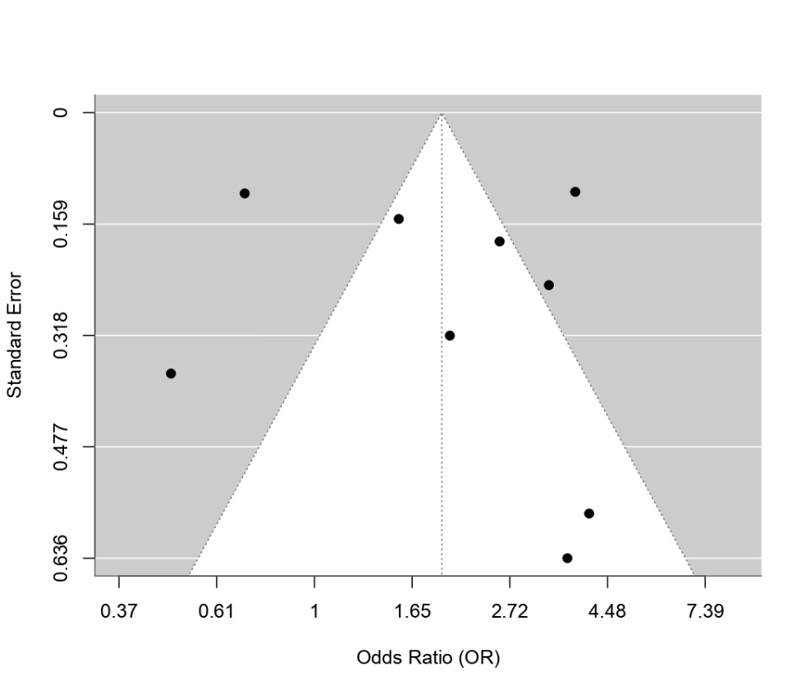
a. OR Anthrometabolic funnel plot

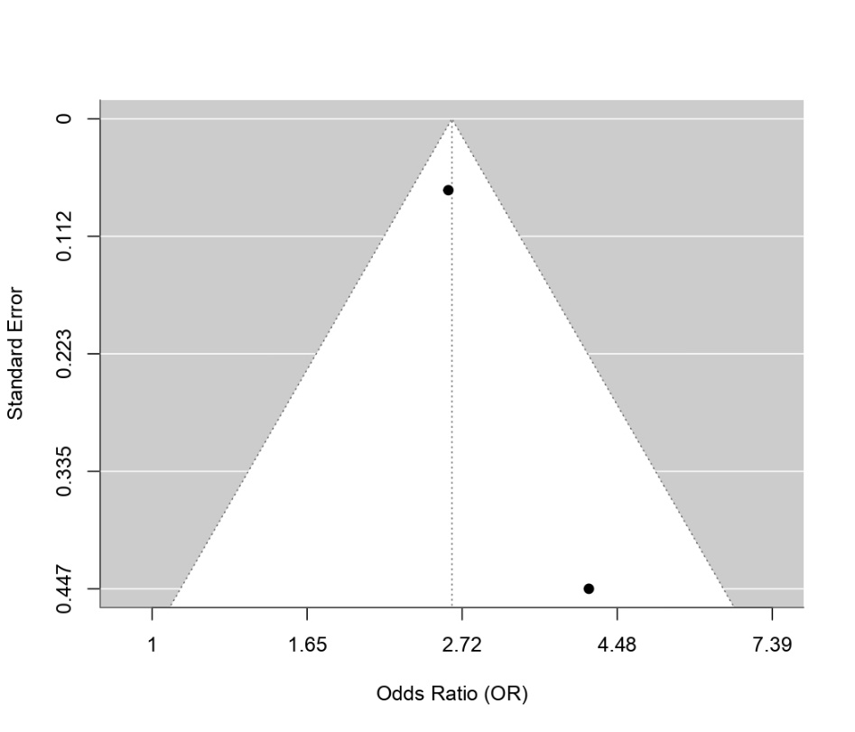
b. OR Eating funnel plot

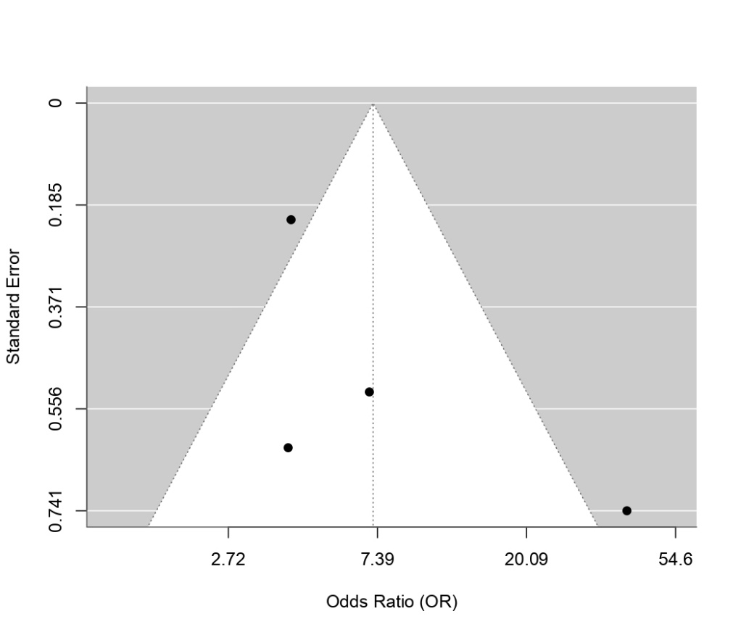
c. OR Body Image Funnel Plot

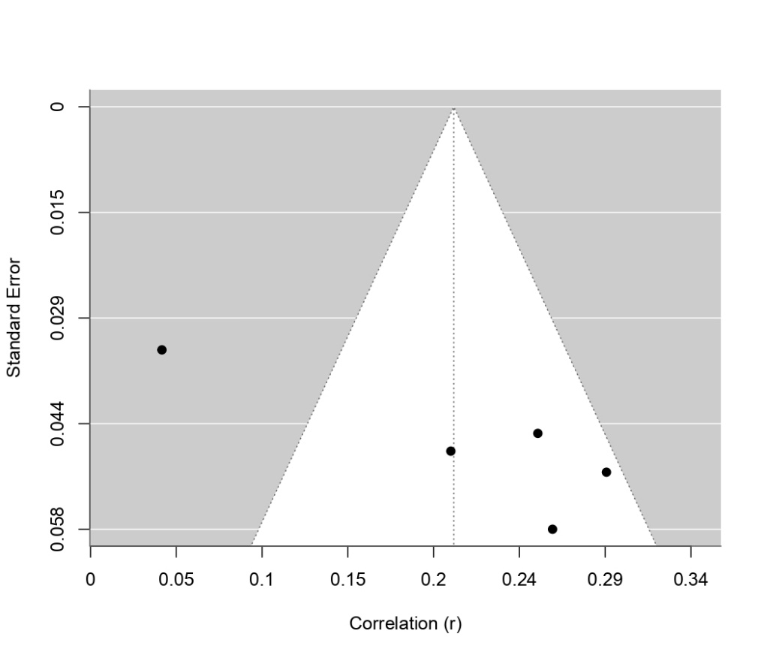
d. R Anthrometabolic funnel plot

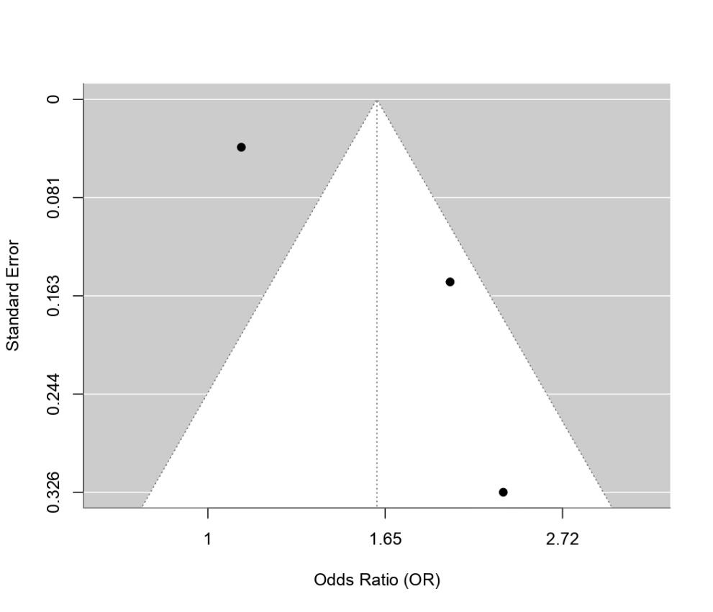
e. OR Mental health Funnel plot

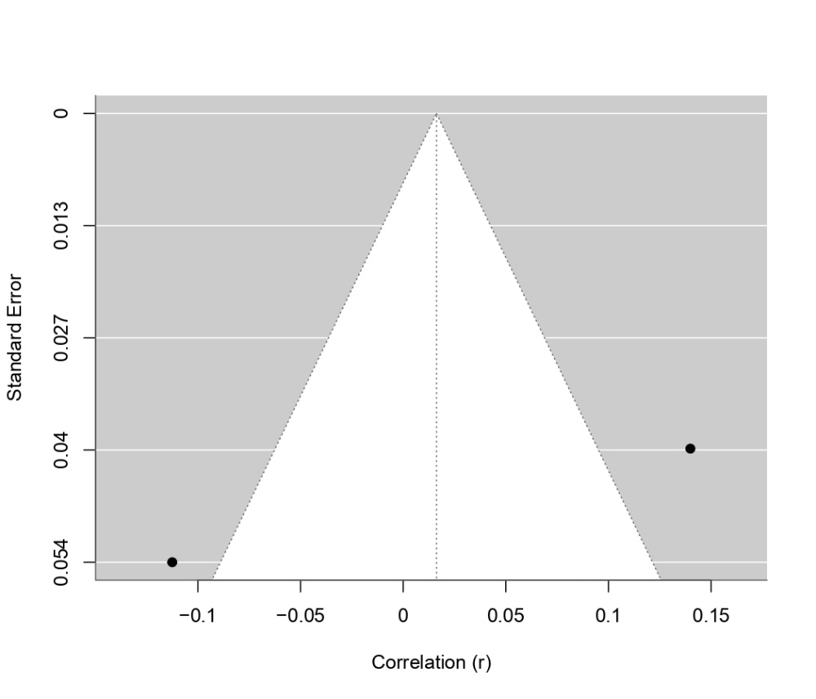
f. R mental health functional funnel plot

