Supplementary Figure 1. Performance comparison of feature selection algorithms. Violin plots show the distribution of the Area Under the Receiver Operating Characteristic (AUROC) curve for three feature selection methods: Minimum Redundancy Maximum Relevance (mRMR), Lasso logistic regression, and Elastic-Net logistic regression. Performance was evaluated within a 20-repetition bootstrapping framework on the training data. Panel (A) displays the results using the clinical dataset, and panel (B) shows the results using the spirometric dataset.

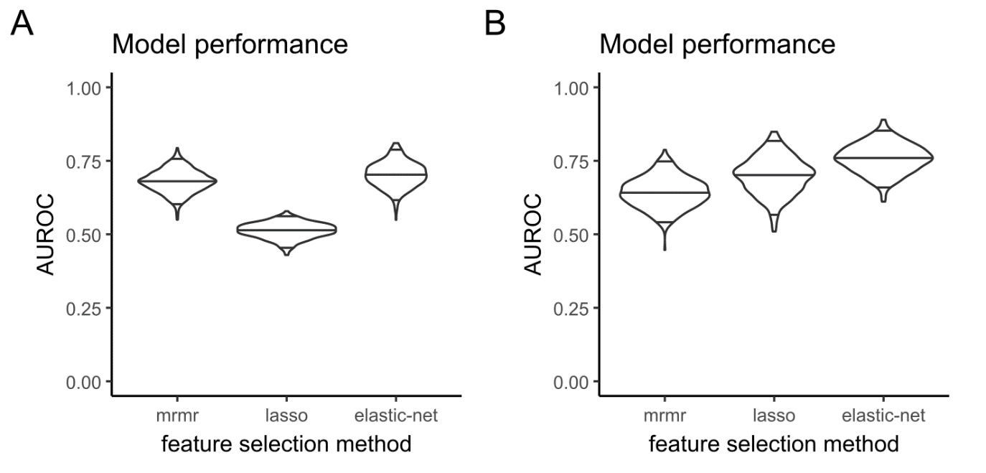
Supplementary Figure 2. Elastic-net feature importance ranking for clinical variables. The higher the number, the greater the relevance of the predictor for the algorithm.
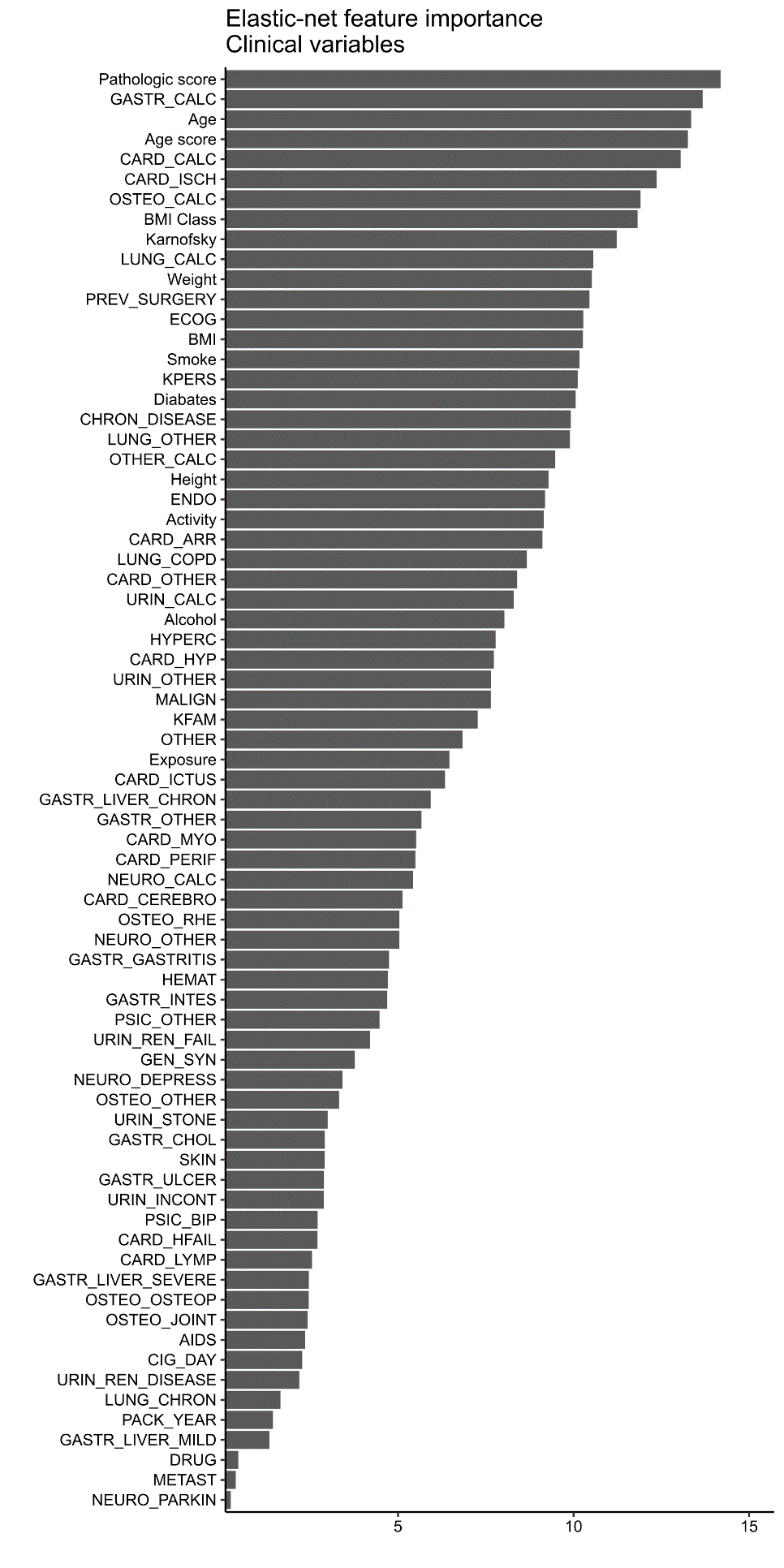
Supplementary Figure 3. Elastic-net feature importance ranking for spirometric variables. The higher the number, the greater the relevance of the predictor for the algorithm.
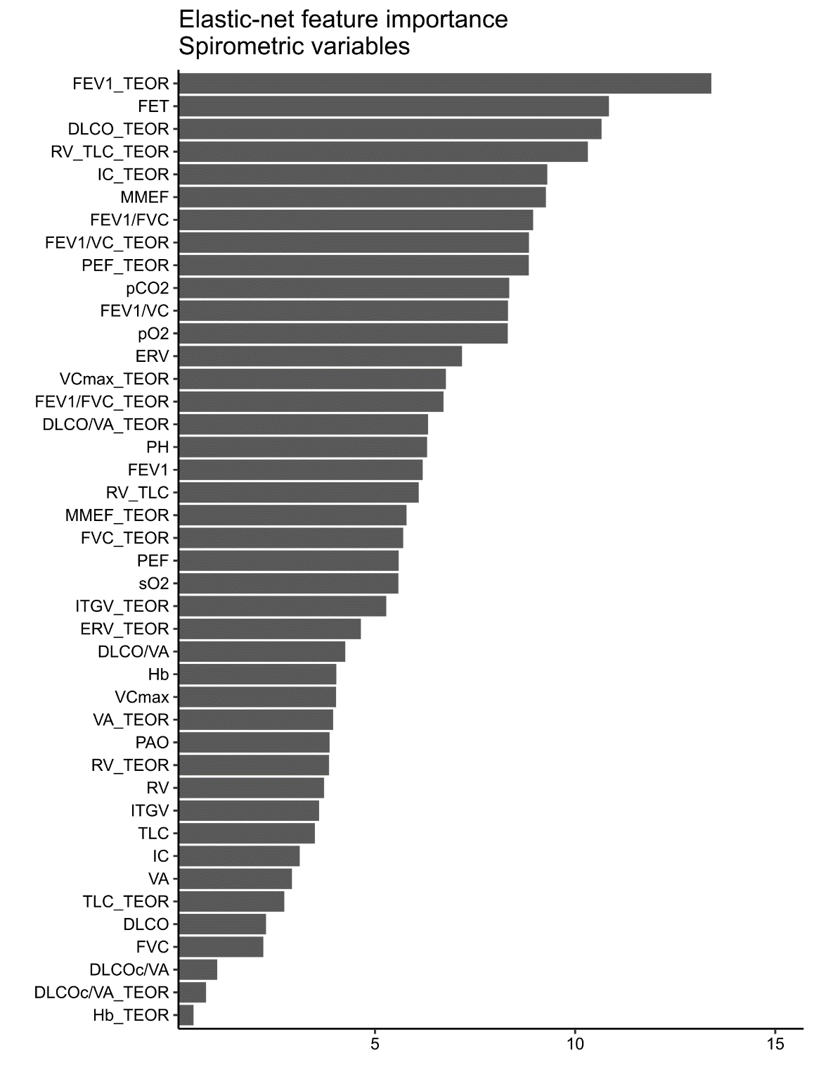

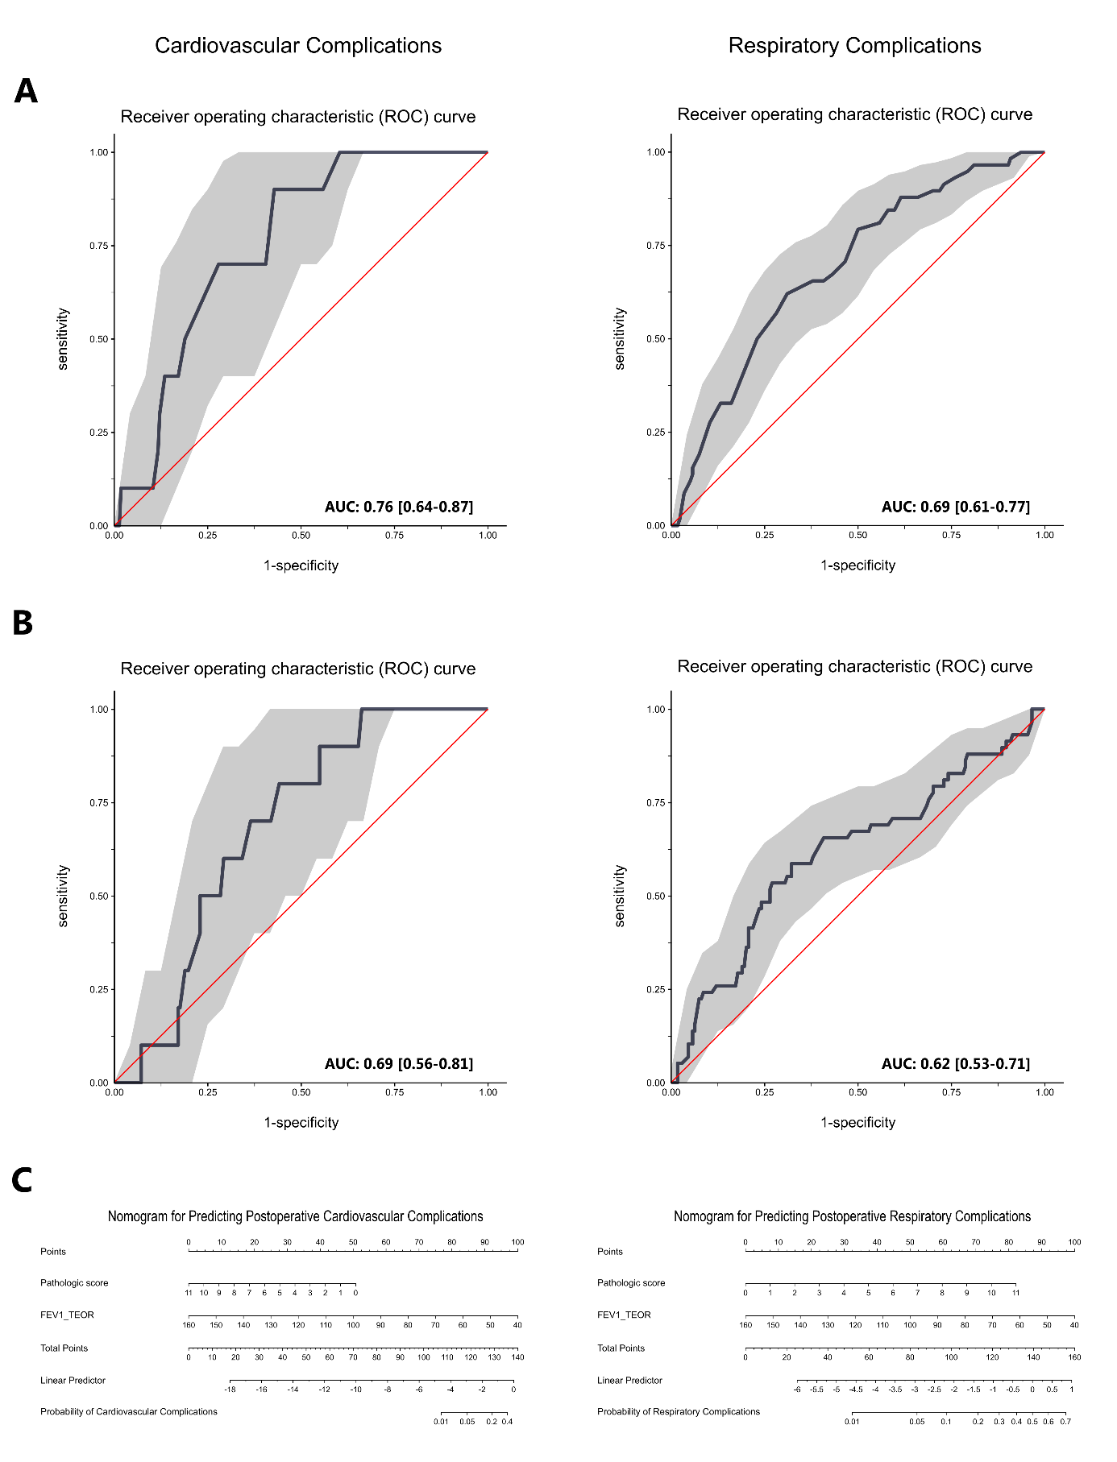
Supplementary Figure 4. Model performance in the external validation cohort, evaluated by Area Under the Receiver-Operator Characteristic (AUROC) curves. The panels show the performance of deployment models for two distinct outcomes: (A) cardiovascular complications and (B) respiratory complications. Within each panel, the curve on the left represents a model using FEV1_TEOR​ alone, while the curve on the right represents the combined model using both the Pathologic Score and FEV1_TEOR​. For all curves, the light grey shading represents the bootstrapped 95% confidence interval, and the red line indicates the performance of a random classifier (AUC = 0.50).

