Supplementary Material

Flow-Chart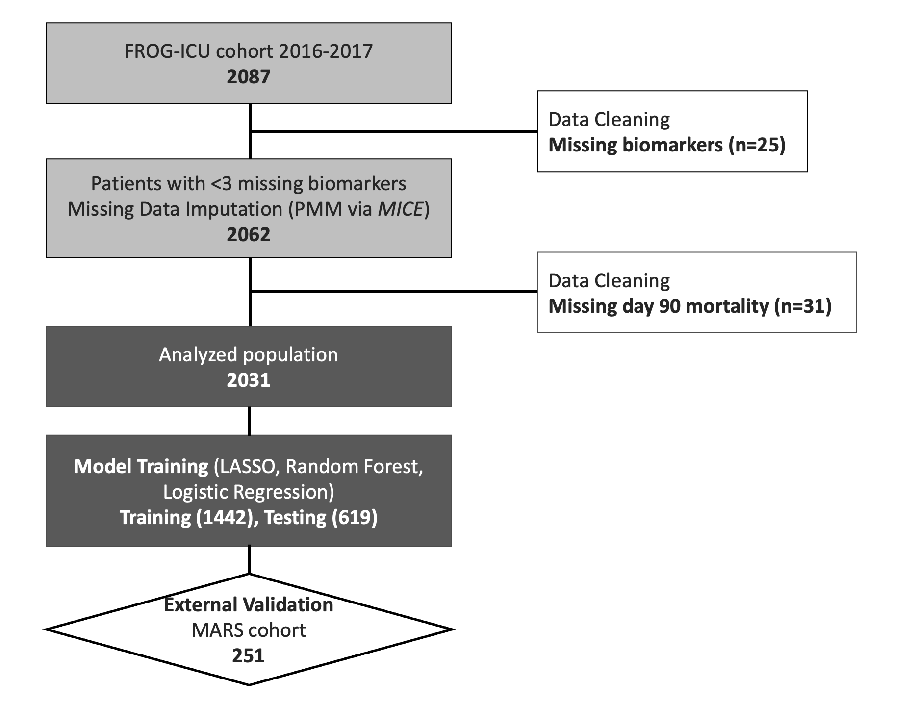

Supplementary Table 1. List and brief description of the 14 tested biomarkers
Biomarker | Full Name | Function
sFlt-1 | Soluble fms-like tyrosine kinase-1 | Inhibits VEGF signaling; marker of endothelial dysfunction and sepsis
PIVKA-II | Protein Induced by Vitamin K Absence-II | Reflects impaired vitamin K–dependent coagulation; marker of liver dysfunction
GDF-15 | Growth Differentiation Factor 15 | Stress-induced cytokine elevated in tissue injury and inflammation
Presepsin | Soluble CD14 subtype (PresepA & B) | Early marker of bacterial infection and sepsis severity
sTREM-1 | Soluble Triggering Receptor on Myeloid cells-1 | Released from myeloid cells during infection; correlates with sepsis severity
ESM-1 | Endocan | Indicates endothelial activation and vascular permeability
ANG-2 | Angiopoietin-2 | Mediator of vascular instability and inflammation; linked to shock and poor prognosis
IGFBP-7 | Insulin-like Growth Factor Binding Protein 7 | Marker of cellular stress; used in AKI risk prediction (especially with TIMP-2)
Tie-1 | Tyrosine kinase with immunoglobulin-like and EGF-like domains 1 | Regulates angiogenesis and vascular integrity; elevated in endothelial stress
Calprotectin | S100A8/A9 protein complex | Neutrophil-derived protein elevated in acute inflammation and infection
CRP | C-Reactive Protein | Classic acute-phase reactant produced by hepatocyte in response to IL-6
suPAR | Soluble Urokinase Plasminogen Activator Receptor | Reflects immune activation and is predictive of mortality in critical illness
IL-6 | Interleukin-6 | Central mediator in the acute-phase response and systemic inflammation
HBP | Heparin-Binding Protein | Neutrophil-derived protein. Increases vascular permeability, early predictor of sepsis severity and circulatory failure
IFN- γ | Interferon-gamma | Major pro-inflammatory cytokine critical in innate and adaptive immunity.

Supplementary Table 2. Table below shows the number of available measurements and the distribution of the 15 tested biomarkers expressed in pg/mL.
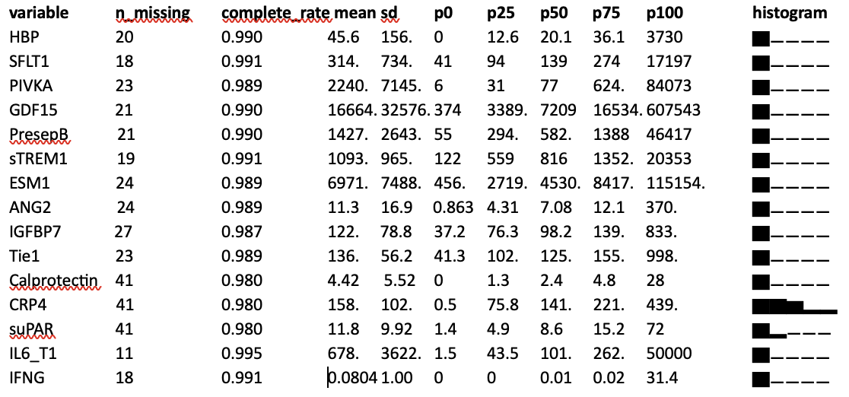

Supplementary Table 3. Table of sorted coefficient value in the LASSO model
 | 90-day mortality | MAKE in ICU
Variable | Absolute coefficient | Variable | Absolute coefficient
sTREM1 | 0.297966758 | sTREM1 | 0.89615935
IGFBP7 | 0.223179082 | PresepB | 0.33110732
suPAR | 0.183748521 | SAPS_II | 0.26198825
SFLT1 | 0.095770795 | IGFBP7 | 0.09128629
CRP4 | 0.040403968 | ESM1 | 0.06351148
IL6 | 0.027140985 | GDF15 | 0.01748228
SAPS II | 0.018510959 | - | -

Supplementary Figure 1. Correlation plot of the tested biomarkers. Red denotes positive correlation and blue denotes negative correlation. The darker the color, the greater the correlation c​o​e​f​f​i​c​i​e​n​t​. Spearman correlation.
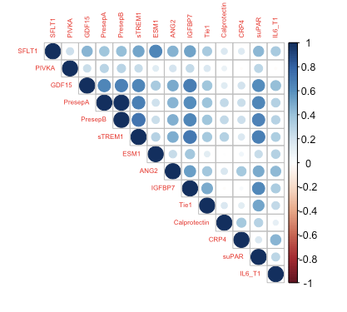

Supplementary Figure 2. Spearman correlation of sTREM1 on admission and severity score on admission (SAPS II) (left), spline curve of association between sTREM1 (log-transformed) and ICU-mortality (right)
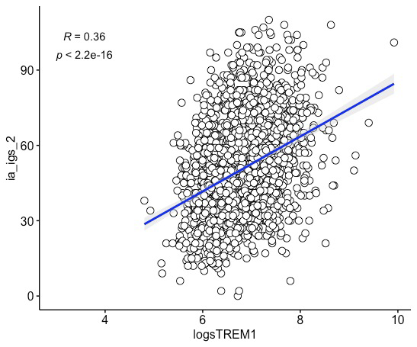

Supplementary Figure 3. Mean decrease in accuracy plot from the Random Forest model showing the relative importance of variables (top to bottom). This figure highlights the role of sTREM-1 in predicting MAKE in ICU patients.
