Table 1. Baseline characteristics and outcomes between survivors and non survivors in the FROG-ICU cohort and the MARS cohort stratified according to day 28 mortality
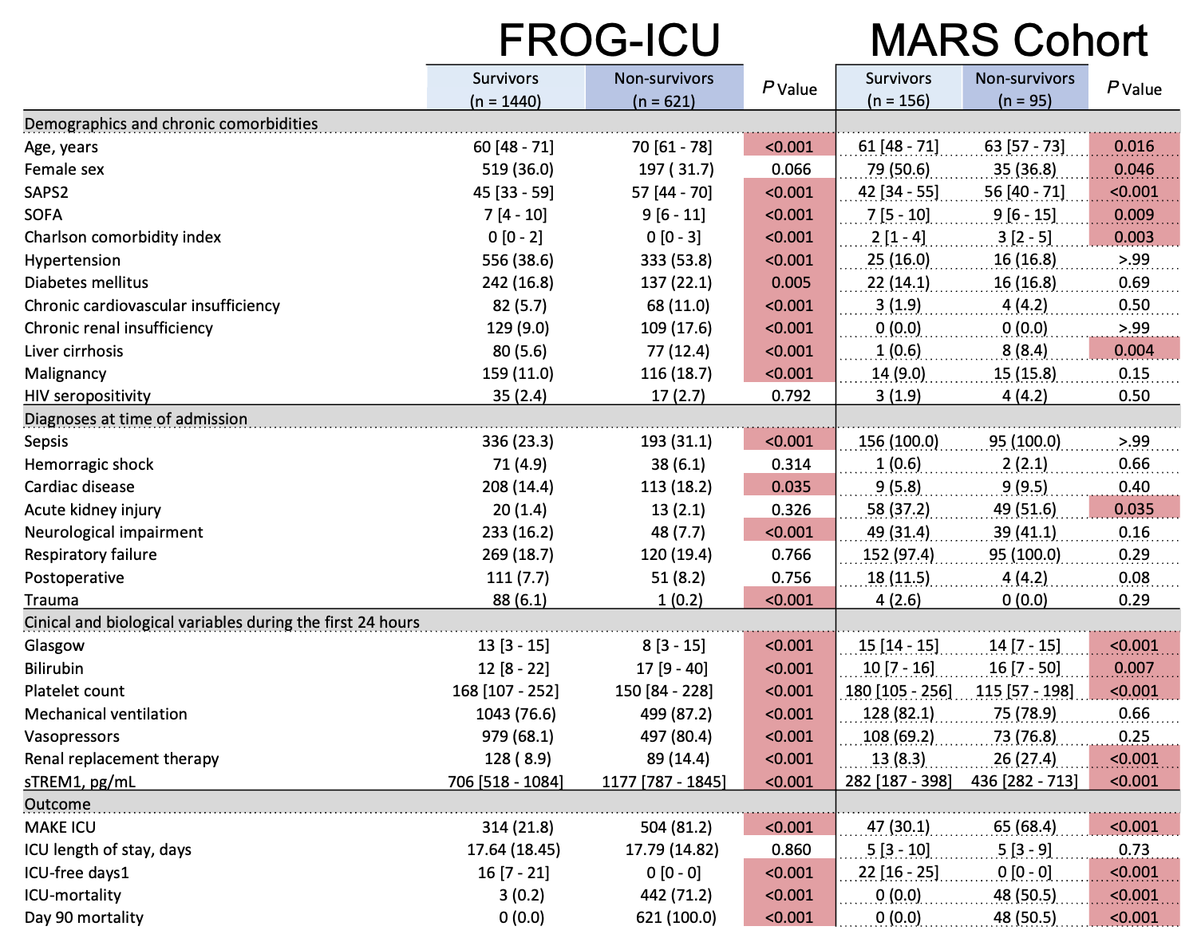
Data are presented as median [IQR] or n (%). Comparisons between survivors and non-survivors were performed using appropriate statistical tests, with significant p-values highlighted. ICU-free days at day 28: Number of days within the first 28 days after admission during which the patient is alive and not in the ICU. Patients who die before day 28 are assigned 0 ICU-free days. MAKE (Major Adverse Kidney Events): Composite endpoint including death, need for renal replacement therapy, or persistent renal dysfunction at follow-up (as defined in the original cohort criteria). ICU-mortality: Death occurring during the ICU stay. Day-90 mortality: All-cause mortality at 90

