Supplementary Materials
Supplementary Text
Sex chromosomes can be identified using an array of methods, including karyotyping, cytogenetics, NGS and bioinformatics to unveil coverage and heterozygosity differences, sex-specific SNPs and association tests, and sex-biased expression. Sponge karyotyping is notoriously difficult given the minute size of sponge cells and it has been performed only in a few species^{113–115}, and therefore we opted for a genomic approach in this study. To investigate the sex chromosome evolution across Porifera, we conducted a phylogeny-wide genome sampling of six sponge gonochoristic species, and two more gonochoristic sponges for which a chromosome-level genome was not available and transcriptomic data was used instead (Fig. S1; Tables S1–S2). But before processing the tissue samples for sequencing, we determined the sex of each individual sponge by surveying the tissue for gametes (Figs. S2–3), finding female and male gametes always in different individuals, pointing to different sex ratios in the populations surveyed, with female-skewed ratios in Chondrosia reniformis, Geodia hentscheli, Petrosia ficiformis and Halichondria panicea, and male-skewed ratios in the rest of species (Table S1).
Section 1. Sex chromosome identification and identity of the sex chromosome in C. reniformis:
We conducted FindZX for all species but only 2 showed a pattern consistent with sex-linked regions (Fig. 1; Fig. S4). In C. reniformis, we found a region within 2.6 to 3.8 Mb on chromosome 11 that showed significantly higher heterozygosity in females and higher coverage in males (Fig. 1A–B; Fig. S5; Tables S3–S6). This region coincides with an area of significant sequence divergence between males and females, where 12 out of the 25 loci with the highest (over 0.20) sex-specific F_{ST} values were located (Table S3). It also exhibits significantly higher SNP density in females (i.e. number of SNPs per unit of genome length; Table S7) and a significantly greater accumulation of sex-specific loci than in other chromosomes (χ² = 24.339, df = 13, p-value = 0.02815; Fig. 1C, Fig. S6; Table S8B-C), with three times more female- than male-specific loci. In addition, k-mer analysis identified female-specific k-mers that assembled into 2,178 contigs located within the SDR but extending slightly beyond its boundaries (Fig. 1D), while only 38 k-mers were significantly associated with males (Fig. S7A). Combined with the observation that coverage differences between sexes increase with mapping stringency, these results suggest a young ZW system where Z and W are divergent enough to show mapping coverage differences but still conserve homology to align and detect SNPs from W¹⁰.
In chromosome 2 we found higher male coverage, in the region within 3.6 to 4.7 Mb, but there was no heterozygosity bias (Fig. 1A–C; Fig. S5; Table S3–S6). This region contained only a few sex-specific loci (mostly male-specific; Fig. 1C; Fig. S6) and sex-specific k-mers (Fig. 1D; Supp.Fig. 7A-B), consistent with the genomic signature of an older, more differentiated Z chromosome¹⁰. Interestingly, within the alternate haplotype of the reference genome, we identified with FindZX a scaffold that displayed a female-biased coverage pattern and aligned (via BLAST) precisely with the SDR of chromosome 2 (Fig. S5C–D). In contrast, another scaffold from the alternate haplotype aligned with the SDR of chromosome 11 but exhibited the same coverage bias as the reference sequence (Fig. S5C–D). Likewise, the sex-specific k-mers blast found 2437 contigs in the scaffold aligned with chromosome 2 (Fig. S7C–D). This scaffold may represent the corresponding W chromosome homolog, consistent with a more advanced stage of differentiation, resulting from an inversion (Fig. 1E; Fig. S8A). Taken together, these findings suggest that the reference genome of C. reniformis corresponds to a ZW (female) individual, with chromosome 2 representing an older, more differentiated ZW pair and chromosome 11 representing a younger, less diverged zw pair, a pattern reminiscent of multi-sex-chromosome systems observed in several animals^{11–13,116–118}. In summary, our results indicate that the individual from which the reference genome was assembled was probably ZW/zw, suggesting that the system in Chondrosia reniformis might involve the combination of two pairs of sex chromosomes that segregate independently.
Section 2: Sex chromosome identification and identity of the sex chromosome in O. lobularis:
In Oscarella lobularis, FindZX detected significantly higher heterozygosity and coverage in males within the 2-3 Mb region of chromosome 5 (Fig. 1E–F), with an increase proportional to mapping stringency. This pattern is consistent with the presence of a differentiating sex chromosome (10). Analyses of RADseq data identified 634 putative male-specific loci and none in females, with a significant accumulation on chromosome 5 (X² = 101.69, df = 19, p-value = 2.641e-13; Fig. 1H; Fig. S6; Table S8B, S8D) and iDlG identified a clear pattern of divergence in chromosome 5 from positions 2–2.75 Mb (Fig. 1I). Since we also observed a higher coverage on males than females (Fig. 1G), this might be indicating that the reference genome was assembled for a male sponge with chromosome 5 acting as the Y chromosome. This hypothesis is also in line with the results obtained with iDIG, as females reached the “2” value, indicating that almost all polymorphisms found for them are homozygous for an allele different than that of the reference genome. However, coverage data analysed in FindZX appears to support a ZW system (Fig. 1F; Fig. S11). Additionally, we performed a k-mer analysis following the sexfindR pipeline (83) that recovered male-specific k-mers covering the SDR (Fig. 1J; Fig. S11).
Given that the sex of the reference genome is unknown, we further explored how our data could point to either a female or male identity for it. We assembled a draft female genome using only the reads of the females, and then mapped the male reads to it using bowtie. Then, we extracted unmapped male reads and re-mapped them to chromosome 5 from the reference chromosome genome. We observed a peak of reads that successfully mapped to the SDR of chromosome 5 from the reference, indicating that the reference chromosome level genome was done from a male individual (Fig. S12).
Notably, the SDR of chromosome 5 corresponds to one of the clearest transposable elements (TE) islands in the O. lobularis genome (Fig. S13), a feature typical of Y chromosomes¹¹⁹. The observed increase in coverage differences with mapping stringency in FindZX (Fig. S11) further supports the presence of sequence divergence between homologous regions. This suggests that while the X and Y chromosomes remain partially homologous, this similarity likely facilitated the assembly of the Y chromosome or X/Y co-assembly into the reference genome. Altogether, these results indicate that O. lobularis likely possesses an XY sex-determination system in an intermediate stage of differentiation, with chromosome 5 functioning as the X/Y chromosome.
None of the other four species with reference genomes showed significant biases in their heterozygosity, coverage or SNP density between females and males (Fig. S4; Tables S4–7) that could be indicative of a large sex-linked region. However, in A. damicornis, we detected a notable decrease in the male coverage in chromosome 12 (positions 10–12Mb), but it was not accompanied with an increase in heterozygosity or accumulation of RADsex markers (Fig. S4, Fig. S6; Tables S4–7). In addition, no accumulation of TEs accompanied by biases in other parameters, or accumulation of LINEs was detected for any of the genomes of these four species (Supp. Figs. 9–10).
Section 3. Sex-specific loci and sex-biased expression of sex determination markers:
3.1. Shared loci: RADSEX identified 7,657 sex-specific loci across the different species surveyed, pointing to different sexual systems based on the number of loci associated with each sex (Table S8). In Chondrosia reniformis and Oscarella lobularis, where previous analyses provided strong evidence for ZW and XY systems respectively, our RADSEX results were consistent with those findings. In the remaining species, where no sex chromosomes were detected, the distribution of sex-specific loci suggests the presence of polygenic XY– or ZW–like systems. Specifically, XY systems were inferred in Geodia hentscheli, Geodia barretti, Axinella damicornis, and Phakellia ventilabrum, and ZZ/ZW systems in Petrosia ficiformis, and Halichondria panicea (Fig. 2A; Table S8).
The sponge sex-specific loci mapped to 1,437 unique genes in the genomes of each species (Table S9A–B), 359 of which were previously described as involved in the process of sex determination in other animals (Fig. 2A) but with only 20 in total properly annotated within the GO term category sex determination (GO:0007530) (Fig. 2C; Table S9C-D). For each species, approximately one third of the genes where the sex-specific loci mapped were previously known to have a role in sex determination or gametogenesis (Fig. 2A–C; Table S9C-D). Of the 1,452 genes, approximately 22% were shared by 2 or more species (Fig. 2B). Of these shared genes, very few had known sex-related functions (Fig. 2B; Tables S9C-D, S10). From now on, only those that were present in all of one sex and none of the other will be discussed.
In our sponge species, sex determination pathways seem to converge on the same cohort of genetic regulators that maintain and repair DNA structure and determine gonad fate, as well as regulate the cell cycle, with minor contributions for those in metabolic and/or structural processes (Fig. 2B, E–G). Besides gametogenesis (or sexual reproduction), the annotations recovered for the sex-specific loci fell primarily into the categories of DNA repair and recombination, cell cycle, and translation regulation, suggesting that these genes govern the progression of meiosis and expression of targets through the genomes, similar to what has been found in mammalian Y chromosome genes²³ and those of other organisms². Interestingly, among the genes that were shared by 4 or more species, we found several transposable elements or transposon-related genes that were male-specific, including RTBS, suggested to be involved in promoting spermatogenesis and sperm motility of the snakeskin fish¹²⁰ , POL2, POL3 and POL5, that are transposable elements abundant in sex chromosomes and play a key role in sex chromosome evolution^{25,121}. One of the most interesting shared genes is YRD6, an uncharacterized protein described in C. elegans, that encodes a reverse transcriptase domain and that is shared by all sponge species in our study except for G. barretti and A. damicornis (Table S11D). YRD6 was found to be downregulated by hypoxia in testicles of the medaka fish Oryzias latipes²⁴, but no other link to sexual reproduction has ever been described to our knowledge. Other male-specific genes widely shared among sponges were the ATP-dependent helicase PIF1 and the RNA binding protein ZNFX1. DExD/H-box RNA helicases are classically associated with sexual development and sex determination, including PL10, vasa, and many other DDX helicases¹²². Here, DDX helicases were identified as sex-specific loci in several species, including female-specific in Halichondria panicea or male-specific in Chondrosia reniformis (Table S10). The role of DNA helicases in sex determination, in turn, has been much less studied. DNA helicases were originally recognized as enzymes that can unwind double-stranded DNA, and among them, the Pif1p helicase family, which belongs to the SF1 superfamily of helicases, is conserved from yeast to humans¹²³. In our study, PIF1, which has been previously found to be sex specific in the holothurian Apostichopus japonicus²⁶ and differentially expressed in testicular transcriptome from the fish Channa punctatus²⁷, was identified as male-specific and shared by 3 sponge species (Table S11D).
FEM1 genes, here represented by sex markers associated to males in both Chondrosia reniformis and Axinella damicornis (Table S9D, S10), have been identified as sex-determining genes in the hermaphrodite nematode Caenorhabditis elegans³¹. In C. elegans, Fem genes were inhibited by Tra-2 and could repress the Tra-1 through ubiquitination, which is a suppressor of Mab-3, and therefore, the expression of the Fem genes in males could induce Mab-3 expression and determine male development¹²⁴. Although FEM1 was consistently associated to male sex determination in our sponges, we have not identified a homologous sequence to MAB3, and therefore the downstream pathway most likely differs from the one acting in nematodes. Also, Structure-specific endonuclease subunit SLX1, whose deficiency produces defects in spermatid differentiation¹²⁵, was found shared by Chondrosia reniformis and Halichondria panicea. Finally, SPER or Egg peptide speract receptor, that facilitates fertilisation and promotes sperm motility in sea urchins^{126,127}, was found to be male-specific in O. lobularis and P. ficiformis (Table S9D, S10).
3.2. Unique Sex-specific genes in SDR regions: In Chondrosia reniformis, we identified 658 sex-specific loci, and approximately 7% of them have been previously found to be involved in sex determination processes in other animals (Table S9C, S10). Fifteen of the sex-specific loci were located in the candidate sex-determining regions of chromosomes 2 and 11 (Table S11A), and included POL, POL2, POL3, POL4, PO21, PIF1, YRD6 (in Chromosome 2) and CFDP2, PAR14, CENP-E, PTPRD, ADAS, LORF2, GARS, and CDK13 (in Chromosome 11). Several of those sex-specific loci have known sex-determining function, and had either male-specificity (PTPRD) or female-specificity (CDK13, CENP-E) in chromosome 11 (Table S11). Cell cycle and homeostatic regulators of the SDR in chromosome 11 showed moderate to high gene expression levels similar across sexes, while the transposable elements were low expressed but consistently more in females (Table S12). PTPRD, or receptor-type tyrosine-protein phosphatase delta, is a candidate trigger for temperature sex determination in reptilians, with male-specific upregulation of PTPRD that could act to stabilize commitment to male fate⁵¹. Cyclin-dependent kinases (CDKs), which regulate the cell cycle and ultimately normal proliferation of cells, and can be found in strata of sex chromosomes of vertebrates¹²⁸. In the absence of CDK in mutant mice, male and female infertility is produced by defective attachment of telomeres to the nuclear envelope, resulting in failed or incomplete synapsis of homologous chromosomes¹²⁹. Centromere-associated protein E (CENP-E) is a kinesin motor that mediates kinetochore-microtubule attachment and chromosome alignment during cell division¹³⁰, it is consistently more expressed in females with B chromosomes in the mouse Apodemus flavicollis¹³¹ and it has sex-specific alternative splicing in zebrafish gonads¹³². Interestingly, the centromere-associated protein E sequences in sponges appear in different clades, suggesting independent evolutionary trajectories (Fig. S16).
In Oscarella lobularis, RADsex identified 634 putative sex markers in males (Fig. 2A; Table S8) 6 of which blasted against genes located in the candidate sex-determining region of chromosome 5 (G2E3, PIF1, HMCN1, MRC1, DAPK1, RECQ), and were not found in the SDR of the main sex chromosome of Chondrosia reniformis. These sex-specific genes located in the SDR region (Table S11B) showed higher expression in females than in males, similarly to other genes located in the SDR that did not exhibit sex-specific behaviour (Fig. S19D–E). All these sex-specific genes of the SDR of chromosome 5 have known functions related to sex determination in other organisms: G2/M phase-specific E3 ubiquitin-protein ligase, or G2E3, is conserved across metazoans and is the ancestor of Phf7¹³³, which controls male sex determination in the Drosophila germline³³. G2E3 plays a crucial role in the gametogenesis of the flatfish Cynoglossus semilaevis¹³⁴ and is also located in the candidate sex-determining region of the holothurian Apostichopus japonicus being upregulated in males²⁶ . Like G2E3, PIF1 and RecQ were sex specific in Apostichopus japonicus²⁶, and RecQ is involved in DNA repair mechanisms during recombination, that are fundamental to inactivate sex chromosomes^{135,136}. HMCN1, which promotes cleavage furrow maturation during cytokinesis, plays an important role in gonad development in Schistosoma japonicum¹³⁷. Finally, DAPK1, which is a calcium/calmodulin-dependent serine/threonine kinase, is in the gene cluster of DMRT in humans¹³⁸ and fish¹³⁹ and a sex marker in ratite birds¹⁴⁰.
3.3. Lineage-specific sex-specific loci: The large number of genes with sex-specific loci involved in a wide array of genetic and cellular processes in sponges indicates a cumulative polygenic system for all species, regardless of the presence of sex chromosomes in O. lobularis and C. reniformis. Besides the conserved genetic regulators that were shared across several species, we identified species-specific genes involved in a panoply of biological processes, ranging from DNA repair and regulation of cell cycle, to regulation of signaling cascades (WNT, JNK and MAPK, among others) and embryonic morphogenesis (Fig. 2A; Fig. S18; Tables S10, S13). Only those with known sex determination or gametogenesis-related function are discussed below (Fig. 2A). A fundamental aspect of sexual reproduction is the capacity of recombination to exchange genetic material during meiosis. After synapsing and pairing, homologous autosomes faithfully separate into haploid gametes and then shuffle genetic material through meiotic recombination. While ancient sex chromosomes only pair at pseudoautosomal regions (PAR) and rarely form breaks outside PAR, young sex chromosomes of fish fully pair revealing that the degeneration and divergence of sex chromosomes is sometimes not sufficient to abrogate pairing³⁴. In this process, several genes have been reported to have a prominent role³⁵, including many that we found to be sex-specific across several sponge species, such as those recognizing meiotic double-strand breaks (DSBs) involved in their repair (Fig. 2B; Fig. S18), such as RAD52 in Phakellia ventilabrum and RAD51 in Halichondria panicea (Table S9D). These genes are central to the exchange of genetic information between non-sister homologs in eukaryotes as their homologs (RecA proteins) in bacteria, and are thought to be the primary sexual genetic machinery that arose to facilitate sexual cycles in eukaryotes³.
Signaling pathways have crucial roles for sex determination, especially in mammals³⁹. Consistently, the MAPK cascade was found to be enriched when analysing the male sex-specific loci of Chondrosia reniformis, Petrosia ficiformis, Phakellia ventilabrum, and Halichondria panicea, albeit with different genes (Fig. S18, Table S13). MAPK cascades are evolutionary conserved, intracellular signal transduction pathways that respond to various extracellular stimuli and control a large number of fundamental cellular processes including growth, proliferation, differentiation, motility, stress response, survival and apoptosis⁴⁴. Several of their downstream genes are growth-arrest specific gene 6 that controls gonadotropin release¹⁴¹, Tumor Necrosis receptors (TRAF genes), and growth factor receptors (EGFR and FGFR1–2), all identified as sex-specific in different species of our target sponges (Tables S9D, S13).
In O. lobularis we also identified male sex markers in other sex-related genes out of the candidate SDR (Tables S9–S10), that are associated to male sex differentiation and are part of the SRY cascade: including ATRX, and INSRR. Notably ATRX, a chromatin remodeler downstream of SRY in mammals⁴², is involved in testis development in marsupials¹⁴². Interestingly, although ATRX genes are present in all sponge species, except for P. ficiformis, this important sex-determining gene is sex-specific only in O. lobularis (Fig. S17; Table S13). Also, in the SRY pathway, insulin receptor kinase or INSRR¹⁴³ is critical for the upregulation of the pathway and testicular differentiation in mammals^{40,144} . Other genes with known sex-related functions that were male-specific in O. lobularis were BRCA2/FANCD1, which are involved in DNA repair¹³⁶, and whose mutations produces sex reversal in zebrafish¹⁴⁵, and WDR48 that could cause male DSD in humans and is involved in seminiferous tubules development¹⁴⁶.
In C. reniformis, the male sex marker SPT48, which locates in Chromosome 11 but out of the candidate SDR, is testis-specific in humans and mice and lack of expression produces azoospermia¹⁴⁷. Also, male-specific was the marker found in the gene UBXN in C. reniformis (Table S9D). UBXN genes positively regulate spermatogenesis in C. elegans via TRA-1A degradation¹⁴⁸. As for female sex-markers, we identified the Sterol O-acyltransferase 1 (SOAT1), which is upregulated in the female gonad of the frog Hoplobatrachus rugulosus during sex development¹⁴⁹.
In P. ficiformis, we identified a female sex-specific marker on an emblematic gene for mammal sex determination, WNT4, involved at several steps of mammalian female development^{41,43}. Also, female-specific sex markers were found in the genes H2AX that is necessary for chromatin remodeling and the inactivation of sex chromosomes during meiosis in male mice¹⁵⁰, TBX, which intriguingly is upregulated during testicular development in the rainbow trout¹⁵¹, and finally, UBE3A which regulates the expression of the sex-determining gene SOX9 in mice¹⁵².
In Geodia barretti, we identified a male sex-specific marker on the gene bromodomain-containing protein BRWD1 (Table S10), which is essential for both male and female fertility, but promotes haploid spermatid–specific transcription³⁶, and in G. hentscheli, male sex-specific markers were found in AGO2 (Table S10), which is an argonaute protein, and these regulate entry into meiosis and influence silencing of sex chromosomes in the male mouse germline¹⁵³, and CIRBP (Table S10), which has a role in sex determination in the snapping turtle, Chelydra serpentina¹⁵⁴. In P. ventilabrum, male-specific sex markers were associated to MEIG1, a Meiosis-expressed gene 1 protein specific to the male germline in mammals¹⁵⁵ and molluscs³⁷, by binding to meiotic chromosomes in spermatocytes prior to meiosis, and HAP2 (Table S10). HAP2/GCS1 proteins mediate membrane fusion between gametes in a broad range of eukaryotes, ranging from algae and higher plants to protozoans and cnidaria, which suggest they are derived from an ancestral gamete fusogen³⁸. In cnidarians, HAP2 localises in the testes, indicating a role regulating the male machinery for gamete production³⁸.
In A.damicornis, the gene containing a male-specific marker, PKRDC, is a DNA-dependent protein kinase catalytic subunit that plays an important role in testis function via meiotic regulation¹⁵⁶. In H. panicea, we identified a female-specific sex marker in the gene NOM1 (Table S10), which is a sex determining gene in the fish Acrossocheilus fasciatus together with WNT4 and DMRT3¹⁵⁷ and another in the gene MRCKA (Table S10), which causes severe male infertility in humans¹⁵⁸.
Section 4. Expression of genes with sex-specific loci and alternative splicing: In organisms without divergent sex chromosomes, and therefore largely identical genomes, intergenomic conflict may arise, which may be resolved by the evolution of sex-specific gene expression. One of the best characterized examples of AS in the pathway of somatic sex determination is that of the genus Drosophila⁴⁹. There, Sex-lethal (SXL), Transformer (TRA), and Transformer 2 (TRA2), operates in a multilevel splicing cascade that regulates sex-specific splicing of the downstream targets (male-specific lethal-2, fruitless, and doublesex), controlling sexually dimorphic cell differentiation and dosage compensation⁴⁹.
To understand gene expression patterns in genes with sex-specific loci, we first looked at differential gene expression using the matrix of transcripts produced by StringTie in the species with reference genomes. We found that in general, very few transcripts had differential expression, from 0.07% to 3.6% of the total transcripts (Table S14). Similarly, for the two Geodia spp., we found 0.2–0.4% of the transcriptome differentially expressed (Table S14). The species with more transcripts differentially expressed were P. ventilabrum, the C. reniformis and then P. ficiformis (Table S14). Among these transcripts differentially expressed we found that between 0.3 to 11.5% contained sex-specific loci, but none in O. lobularis or A. damicornis (Fig. 3A, Table S14). We also observed that for most genes with sex-specific genes, several transcripts were produced, with expression in both sexes (Fig. S18), although generally more in one of the 2 sexes, equalizing the overall gene expression for those loci (Fig. 18B–H; Fig. S19; Tables S14, S15).
Then, we used RNA-seq short read data to understand AS on the genomes of the six species with rMATs. We provide evidence that all sponges had AS, ranging from only 3.5% of their genes with AS events (838 events), as in P. ficiformis, to a 60.5% (10626 events) as in C. reniformis (Fig. 3A, Table S16A). Across sponges, we detected all five types of AS, skipped exons (SE), mutually exclusive exons (MX), alternative 5′ splice sites (A5), alternative 3′ splice sites (A3) and retained intron (RI), with SE being the most abundant in all species (Fig. 3A, Table S16A). In general a very low percentage of the genes with sex loci presented significant sex-biased AS, and SE was the most common AS type among them (Fig. 3A, Table S16A). In C. reniformis, the sponge with more AS, 142 genes showed significantly sex-biased AS, and from those only 11 were genes with sex-specific loci (Table S14A). Interestingly, in O. lobularis, there was no sex-biased AS event, either among the autosomal genes or those with sex-specific loci (Fig. 3A, Table S16A), while in H. panicea, there were 6 genes with significantly sex-biased events, but none of them were genes with sex-specific loci (Fig. 3A, Table S16A). In the rest of species, less than 6 genes with sex-specific loci contained AS significantly associated to sex (Fig. 3A, Table S14A). Our results indicate that sex-biased AS had only a minor role reducing conflict related to gene expression in sponges.
Only in Chondrosia reniformis, whose sexual system was identified as ZZ/ZW, expression of genes with sex-specific loci was significantly higher in females for those genes that produced several isoforms (Table S15). In the rest of species, the expression of genes with sex-specific loci was slightly higher in males (but not significantly), for both female and male sex loci and with and without isoforms (Fig. 3C–J; Fig. S18). Our results indicate that although sex-specific loci are determining the sex in all of our target species, the expression of these sex-specific loci is generally equalized across sexes because of the production of several isoforms expressed in both sexes, and only in a few cases we detect sex-biased AS (Fig. 3C–J; Fig. S18).
Some known genes involved in sex determination, such as FEM1, WNT4, ATRX, WRN, WDR48, and STAR that presented sex-specific loci produced a single transcript, in most cases with more expression in the sex that had the bias to, like ATRX in Oscarella lobularis more expressed in males (Fig. S18A) or WNT4 and STAR5 in Petrosia ficiformis more expressed in females (Fig. S18C). However, in other cases, the expression was biased towards the opposite sex in which we found the SNP fixed in RADSEX, like WRN in Chondrosia reniformis which is a gene with a male-specific locus that was more expressed in females (Fig. S18B) or WDR48 in Phakellia ventilabrum that is a gene with a female-specific locus with more expression in males (Fig. S18G). In the species where the gene for GATA contained sex-specific loci, Geodia barretti and Geodia hentscheli, we detected several sex-specific isoforms, where one was more expressed in females and the other in males (Fig. S18D–E).

Section 5. Conservation of synteny and evolutionary age of sex markers: Orthofinder generated 16953 orthogroups, with 91.5% of total proteins from all species being placed into an orthogroup. There were 4074 orthogroups containing proteins from all species, with 941 single copy orthogroups shared between all species, which is less than the 5% of the genomic content for the species. Using the set of single copy orthologs shared between the six sponge species, we investigated how macrosyntenic regions have been rearranged across sponge genomes (Fig. 4A). Our analysis shows well conserved synteny between the homoscleromorph O. lobularis and the five demosponges (Fig. 4A), which is indicative of good conservation of chromosome architecture across sponges and is not always the case in other animal phyla¹⁵⁹. Our analysis shows that all of the assembled chromosomes of the six sponge species have either a 1:1 equivalence or result from fusions and fissions of chromosomes across classes (Fig. 4A). Additionally, we find higher conservation of synteny between the homoscleromorph O. lobularis, and the demosponges C. reniformis and P. ficiformis, while there is a higher degree of rearrangement within P. ventilabrum, A. damicornis, and H. panicea, possibly influenced by the presence of a great number of chromosome fission events between A. damicornis and H. panicea¹⁵⁹.
Our results indicate only slight conservation of synteny among genes with sex-specific loci, since among the 2895 sex loci detected across all species, only 65 were found in synteny: 18 of C. reniformis, 10 of O. lobularis, 36 of P. ficiformis, and 1 of H. panicea (Fig. 4B; Table S17), which represents 8% of the syntenic orthologs. Most of the sex-loci of C. reniformis that showed synteny were located in chromosome 11, whereas for the rest of the species they were distributed across many chromosomes (Fig. 4B). Only 3 of the sex-loci that showed synteny were identified as sex-specific in more than 1 species: for instance, OXSR1, that was identified as sex specific in C. reniformis and located in chromosome 11 was also sex-specific in O. lobularis and showed synteny to its chromosome 13 (Fig. 4B; Table S17). Similarly, two sex-loci identified in P. ficiformis (ENOF1 and ERBB3) were also sex-specific for C. reniformis, but while the first one is located in chromosome 11 of C. reniformis and Chromosome 15 in P. ficiformis, the second one is in chromosome 1 of C. reniformis and Chromosome 11 of P. ficiformis (Fig. 4B; Table S17). Perhaps the most striking result is the conservation of synteny detected for the sex loci of C. reniformis that fell on the sex chromosome (chromosome 11). While these genes were approximately 80% of the genomic make–up of the syntenic ALG in dark green, they represented only half of chromosome 11 of C. reniformis, given that this chromosome appears to be the result of a fusion between 2 ancestral autosomal chromosomes (Fig. 4A–B). The genomic instability of this fusion could have prompted the appearance of an inversion, leading to the restriction of recombination in this pair of chromosomes and thereby the emergence of the sex chromosomes in C. reniformis.
When analysing the 2 species with sex chromosomes, the macrosyntenic pattern is stronger, with 4,582 single-copy orthologs in synteny in 10 ALGs (Fig. S20A). The sex-chromosomes of both species were largely syntenic but resulted from fusions of other chromosomes (Fig. S20A–B). We analysed the GO enrichments of the ALGs where we detected the 115 syntenic genes with sex-loci and those in the sex chromosomes, and recovered regulation of mitotic cell cycle, chromosome organisation, or cell cycle DNA replication (Fig. S20C–E).
Our results support the notion that sex chromosomes evolve independently from autosomes¹⁶⁰, with a great turnover because sponge sex chromosomes are still largely undifferentiated, which makes them more prone to reversion to autosomes. In contrast, fully differentiated sex chromosomes are more stable¹⁶¹, like the X chromosome of insects that is conserved along the entire class¹⁶², the Z chromosome of birds¹⁶³, or the Y chromosome of eutherian mammals¹⁶⁴. Such degree of conservation may also be linked to the evolutionary scale analysed, because while the avian W chromosome arose approximately 140 million years ago¹⁶⁵, the divergence of the demosponge and homoscleromorph clades analysed here occurred at least 580 million years ago¹⁶⁶, placing the putative origin of common sex chromosome (if any) much earlier.
Section 6. Evolutionary age of sex markers: We investigated the evolutionary age of protein-coding genes in six sponge species (5 demosponges and 1 homoscleromorph) using GenEra, assigning each gene to its most probable taxonomic origin based on their homology. The results are summarized in the supplementary table (Table S18A–B). A total of 102,213 genes were analyzed across the species, with individual species contributing between 15,210 loci (Oscarella lobularis) and 21,424 loci (Petrosia ficiformis). A total of 11,354 genes (11.1%) were classified as species-specific, with Phakellia ventilabrum and Chondrosia reniformis showing the highest numbers (2,532 and 2,540 genes, respectively). The number of genes assigned to the different taxonomic levels varied by species and clade. However, the majority of genes in each species were assigned to ancestral nodes such as Metazoa (9,805 genes in total), Eukaryota (12,656), and Cellular Organism (54,793), reflecting their conserved nature across animals and deeper eukaryotic lineages. Notably, a substantial proportion (5,544 genes) were inferred to have originated at the Heteroscleromorpha level, consistent with shared innovations within this major demosponge clade (Fig. 4C). This burst in genomic innovation in haplosclerid sponges is similar to what was found in other studies looking at genomic content across animals^{54,56}.
To investigate the evolutionary history of genes involved in sexual processes, we collected the sex-specific genes (n = 2,705) from the full GenEra annotation dataset and analyzed them based on their inferred evolutionary origin (Table 18C). The majority of sexual-function genes were assigned to deep evolutionary nodes, with cellular organisms accounting for 1,725 loci (63.8%), followed by Eukaryota (297 loci, 11%), Metazoa (233 loci, 8.6%), and Opisthokonta (98 loci, 3.6%). This suggests a conserved core of sex-related genes that predate the emergence of metazoans (Fig. 4C). Only a minority of sex loci were assigned to sponge-specific or lineage-specific levels: species-specific genes represented just 6.3% (170 loci) of the total, and assignments to sponge clades such as Heteroscleromorpha (134 loci), Demospongiae (43 loci), and more derived sponge lineages (e.g., Axinellida + Suberitida, Chondrillida, etc.) were relatively infrequent. Notably, species such as Petrosia ficiformis and Phakellia ventilabrum showed a broader distribution of gene origins across taxonomic levels, including genes assigned to Haplosclerida, Porifera, and Demospongiae, whereas Halichondria panicea and Oscarella lobularis displayed a restricted set of origins with few or no lineage-specific assignments. These patterns suggest that while the majority of sex-related genes are highly conserved, there may be some degree of lineage-specific recruitment or innovation of reproductive genes in particular demosponge clades. However, the generally low proportion of such lineage-specific sex loci implies that the molecular toolkit for sexual reproduction in sponges is largely ancient and evolutionarily stable.
We further characterized the distribution of sex-related genes by mapping them to orthogroups (OGs) and summarizing their presence across phylogenetic strata (Table S18C). Overall, we identified 1,764 OGs containing sex-related genes, comprising a total of 2,639 genes. Notably, there was a close correspondence between the number of OGs and the number of genes at each stratum, suggesting that most sex-related OGs contain only one or a few genes per species.
The deepest nodes in the tree harbored the highest number of sexual OGs: Cellular organisms (1,064 OGs / 1,709 genes), Eukaryota (218 OGs / 253 genes) and Metazoa (180 OGs / 233 genes). The high overlap between the number of sex-related OGs and the number of sexual genes at each level suggests that redundancy within orthogroups is limited, and that sex-related genes tend to be evolutionarily conserved and non-duplicated. This could reflect strong functional constraints on core components of the sexual machinery, which may limit gene duplication or diversification. Moreover, the predominance of these OGs in ancient strata supports the idea that the genetic toolkit for sexual reproduction was already well established in early eukaryotic and metazoan ancestors. The modest contribution of more recent, lineage-specific OGs might correspond to functional fine-tuning or clade-specific adaptations, rather than de novo innovation of entirely new sexual pathways.
To explore the putative functions of sex-related genes conserved in ancient evolutionary strata, we performed GO enrichment analyses for each species and focused on genes assigned to deep taxonomic levels (e.g., Cellular Organisms, Eukaryota, Metazoa, Table S18E). Enriched GO terms were subsequently grouped into functional categories based on their semantic similarity and supported associations with sexual functions in animals, as described in the literature (Table S18D). Specifically, enriched terms were classified into seven biologically relevant categories: DNA Repair & Recombination, linked to meiosis¹⁶⁷, Cell-Cycle Control, associated with gametogenesis¹⁶⁸, Membrane Fusion & Adhesion, involved in fertilization processes¹⁶⁹, Transcriptional Regulation, related to sex determination¹⁷⁰, Cytoskeleton Dynamics, underpinning gamete motility¹⁷¹, Stress Response, connected to mate recognition mechanisms¹⁷², and Apoptosis, implicated in germline quality control¹⁷³. This categorization allowed us to functionally characterize the ancient core of sex-related genes in sponges and assess potential evolutionary conservation or lineage-specific specialization across the species analyzed (Fig. 4D). The GO enrichment analysis of sex loci revealed distinct functional categories associated with specific phylogenetic depths. Genes assigned to deep evolutionary strata, particularly Cellular Organisms and Eukaryota, were predominantly enriched in terms related to DNA repair and recombination, cell-cycle regulation, cytoskeleton organization, membrane fusion and adhesion, stress response, and apoptosis. These categories correspond to key cellular processes known to underlie meiotic regulation, gamete motility, fertilization, and germline quality control in metazoans, indicating that the molecular basis of sexual function is largely rooted in ancient cellular mechanisms. The high enrichment of DNA repair and recombination among the functions in which our sex loci were involved are then in line with the hypothesis that sex emerged as an adaptation for DNA repair, in fact, as a mechanism facilitating a repair process known as homologous recombinational repair, known to carry out double-strand damages³.
Genes assigned to the Metazoa stratum were more frequently associated with transcriptional regulation and reproductive process terms, consistent with the emergence of more specialized, multicellular reproductive systems and sex determination pathways within animals³. For instance, there is now evidence of a high degree of conservation of sex chromosomes for more than 300 million years in vertebrates⁵⁷, and our results point to an even higher conservation of the sex complements across animals, probably dating before the Cambrian. Notably, a subset of syntenic genes shared among all six sponge species (highlighted in dark grey in the circular plot) were predominantly associated with non-metazoan strata such as cellular organisms and Eukaryota. These conserved blocks suggest that the ancient core of sex-related genes not only retains functional signatures of ancestral cellular processes but also exhibits conserved genomic organization across diverse demosponge lineages. This pattern reinforces the idea that while regulatory complexity may have expanded in the metazoan ancestor, the foundational components of sexual function were established much earlier and maintained through strong selective constraints, as supported by data showing presence of meiotic sex and its machinery in the Last Common Ancestor of Eukaryota⁵⁸. In fact, recent evolutionary theories suggest that meiotic sex could be a reaction to endosymbiont entry, and more precisely in reaction to reactive oxygen species (ROS) stress⁵⁸. We also found enrichments of stress responses and cell fusion processes in genes with sex-specific loci shared across sponges, supporting the idea that the stress and DNA damage, likely created by the incorporation of endosymbionts, could be a driver of meiotic sex appearance, as a mechanism facilitating a repair process known as homologous recombinational repair^{3,58}.
Section 7. Patterns of Evolution of sex determination systems in animals: A major stumbling block to understanding the evolution of sexual systems across Metazoa is understanding their current distribution among organisms. To this end, here we built two composite trees for Porifera and Metazoa from previously published studies^{174–176} and overlapped the presence of sex chromosomes, sexual mode (gonochorism/hermaphroditism), and sexual strategy (XY and ZW) on each of the clades (Fig. 5). For Porifera, we included 44 families from the four classes (Fig. 5A), and for metazoans we provide information for all the 32 phyla currently known (Fig. 5B). Our final data set of sponges includes 21 gonochoristic, 21 hermaphroditic and one uncharacterized family (no information about its sexual mode has been published) (Fig. 5A), showing that the last common ancestor of all poriferans was hermaphroditic (8). Although the transition to separate sexes was very common through sponge evolution, this seems to be uncoupled from the sexual strategy that evolved within those lineages (Fig. 5A). Such diversity in molecular tools to produce dioecy is also pervasive along the entire Tree of Animals (Fig. 5B). While in many clades of metazoans the presence of sex chromosomes appears to have coevolved with a ZW strategy (such as in nematodes, planarians, or echinoderms), in many others these two traits are unlinked (in insects, molluscs, and vertebrates), and there is remarkable diversity in the sex chromosome system exhibited at the phylum, class and even order level (Fig. 5B)^{2,177}. But even more, dramatic sex chromosome turnover is observed at the family level in some groups of animals, like carpodatylid geckos, where the evolution of ZW sex determination systems occurs several times independently, with evolution of XY and even environmental sex determination systems⁵⁹.
Although the sexual mode is known for all phyla, excepting for Micrognatozoa (Fig. 5B), there are only a handful of studies dealing with the existence of sexual chromosomes and the system they presented, most of them focused in vertebrates^{178,179} or some in other closely-related invertebrates, such as echinoderms¹⁷⁷ or the well-known cephalochordate Amphioxus¹⁸⁰. Among the rest of invertebrates, it is not surprising that the bits of information about sex chromosomes are focused in some well-established bilaterian model species, especially within arthropods¹⁸¹, nematodes¹⁸² or platyhelminthes¹⁸³, and few in molluscs¹⁸⁴ and annelids¹⁸⁵. More recently, the interest to investigate sex determination across other non-bilaterian groups has peaked^{6,186}, especially since the resources, tools and algorithms have advanced significantly. But, given the mechanisms that determine sex can vary widely among all known animal taxa, the research in a broader diversity of species and phyla, and specially within the most ancestral ones, is essential in order to understand how sex is determined and how it evolves across metazoans. In this sense, our study is considerably expanding the knowledge on the evolution of sexual strategies across Porifera, since we provide for the first time the sexual system of seven of these families, with four of them presenting a XY-like system, while three are ZW-like (Fig. 5A). And even more importantly, we provide evidence of a conserved set of loci that are prone to sex-specification mechanisms since the dawn of the animal lineage, but an independent emergence of sex chromosomes in Porifera, most likely caused by the instability of structural inversions that occurred during chromosomal fusions.
Supplementary Figures
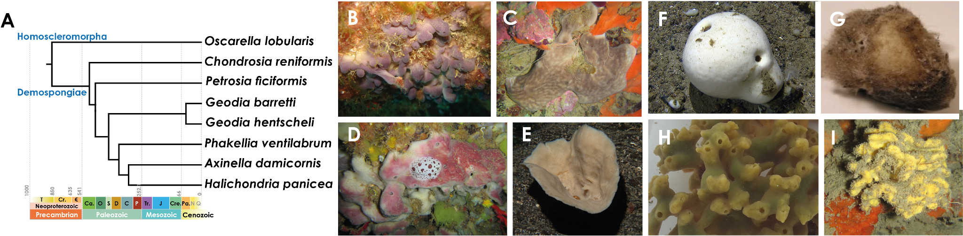
Figure S1. Sponge species in the study. A. Phylogenetic framework for the selected sponge species. B. Oscarella lobularis (picture by Ana Riesgo). C. Chondrosia reniformis (picture by Marta Turon). D. Petrosia ficiformis. E. Phakellia ventilabrum (picture by Bernard Picton). F. Geodia barretti. G. Geodia hentscheli (picture by Paco Cárdenas). H. Halichondria panicea (picture by Lars Kumala). I. Axinella damicornis (picture by Marta Turon).

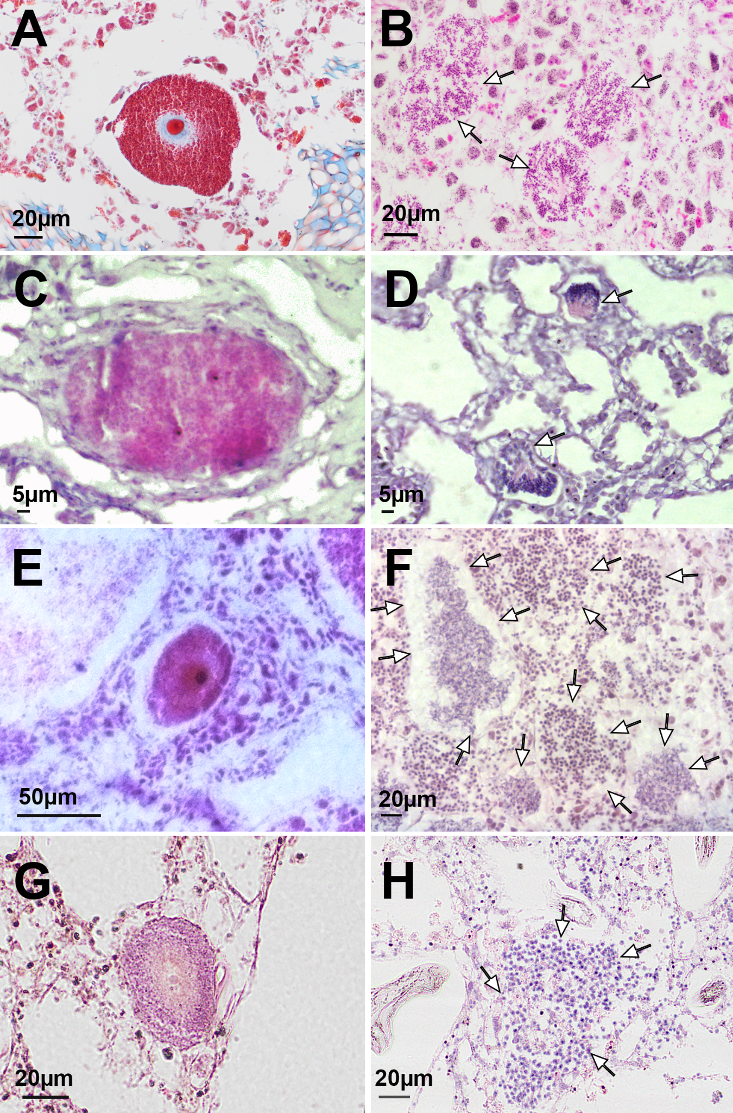
Figure S2. Histological sections of gametes within the tissues of sponges. A–B. Oocytes and spermatic cysts (arrows) of Petrosia ficiformis. C–D. Oocytes and spermatic cysts (arrows) of Oscarella lobularis. E–F. Oocytes and spermatic cysts (arrows) of Halichondria panicea. G–H. Oocytes and spermatic cysts (arrows) of Axinella damicornis.

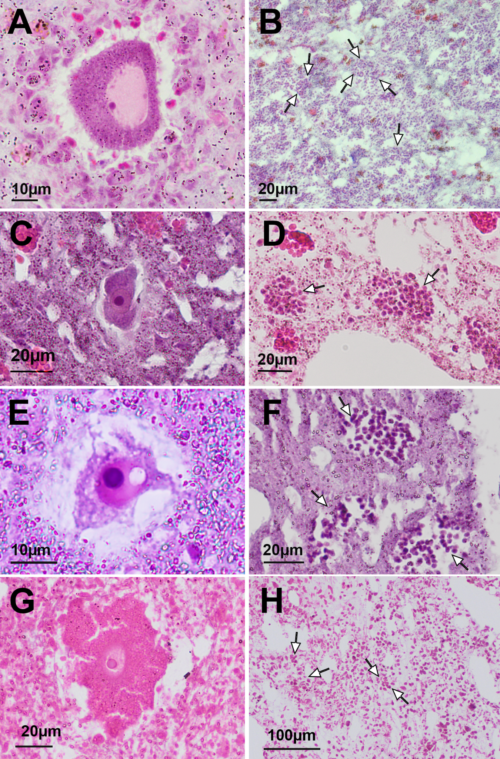
Figure S3. Histological sections of gametes within the tissues of sponges. A–B. Oocytes and spermatic cysts (arrows) of Chondrosia reniformis. C–D. Oocytes and spermatic cysts (arrows) of Geodia barretti. E–F. Oocytes and spermatic cysts (arrows) of Geodia hentscheli. G–H. Oocytes and spermatic cysts (arrows) of Phakellia ventilabrum.
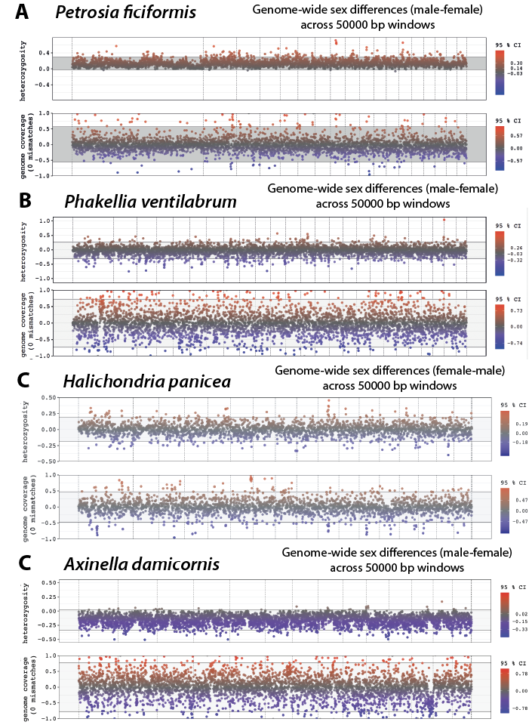
Figure S4. Data from FindZX pipeline (Sigeman et al. 2022) for species for which we failed to identify sex chromosomes. Sex differences (female–male) in heterozygosity and genome coverage (50,000 bp windows). The grey background marks the 95% confidence interval (CI), calculated with bootstrapping from the genome-wide mean value for each metric expected under no sex differences, and the colour scale indicates significant bias to females (red) and to males (blue). Genome coverage was calculated with 0 mismatches when mapping. A. Petrosia ficiformis. B. Phakellia ventilabrum. C. Halichondria panicea. D. Axinella damicornis.
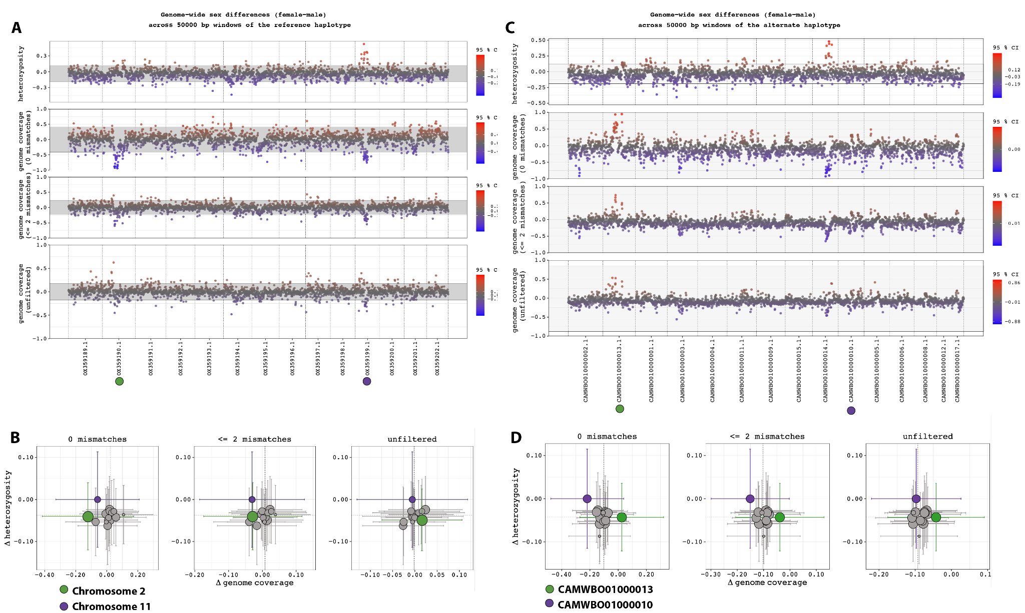
Figure S5. Data from FindZX pipeline (Sigeman et al. 2022) for the reference haplotype (A–B) and the alternate haplotype (C–D) in Chondrosia reniformis. Sex differences (female–male) in heterozygosity and genome coverage on 50,000 bp windows calculated with 0, 2 and unfiltered (A–C) mismatches when mapping. The grey background marks the 95% confidence interval (CI), calculated with bootstrapping from the genome-wide mean value for each metric expected under no sex differences, and the colour scale indicates significant bias to females (red) and to males (blue). (B–D). Mean sex differences (female–male) per chromosome on 50,000 bp windows.

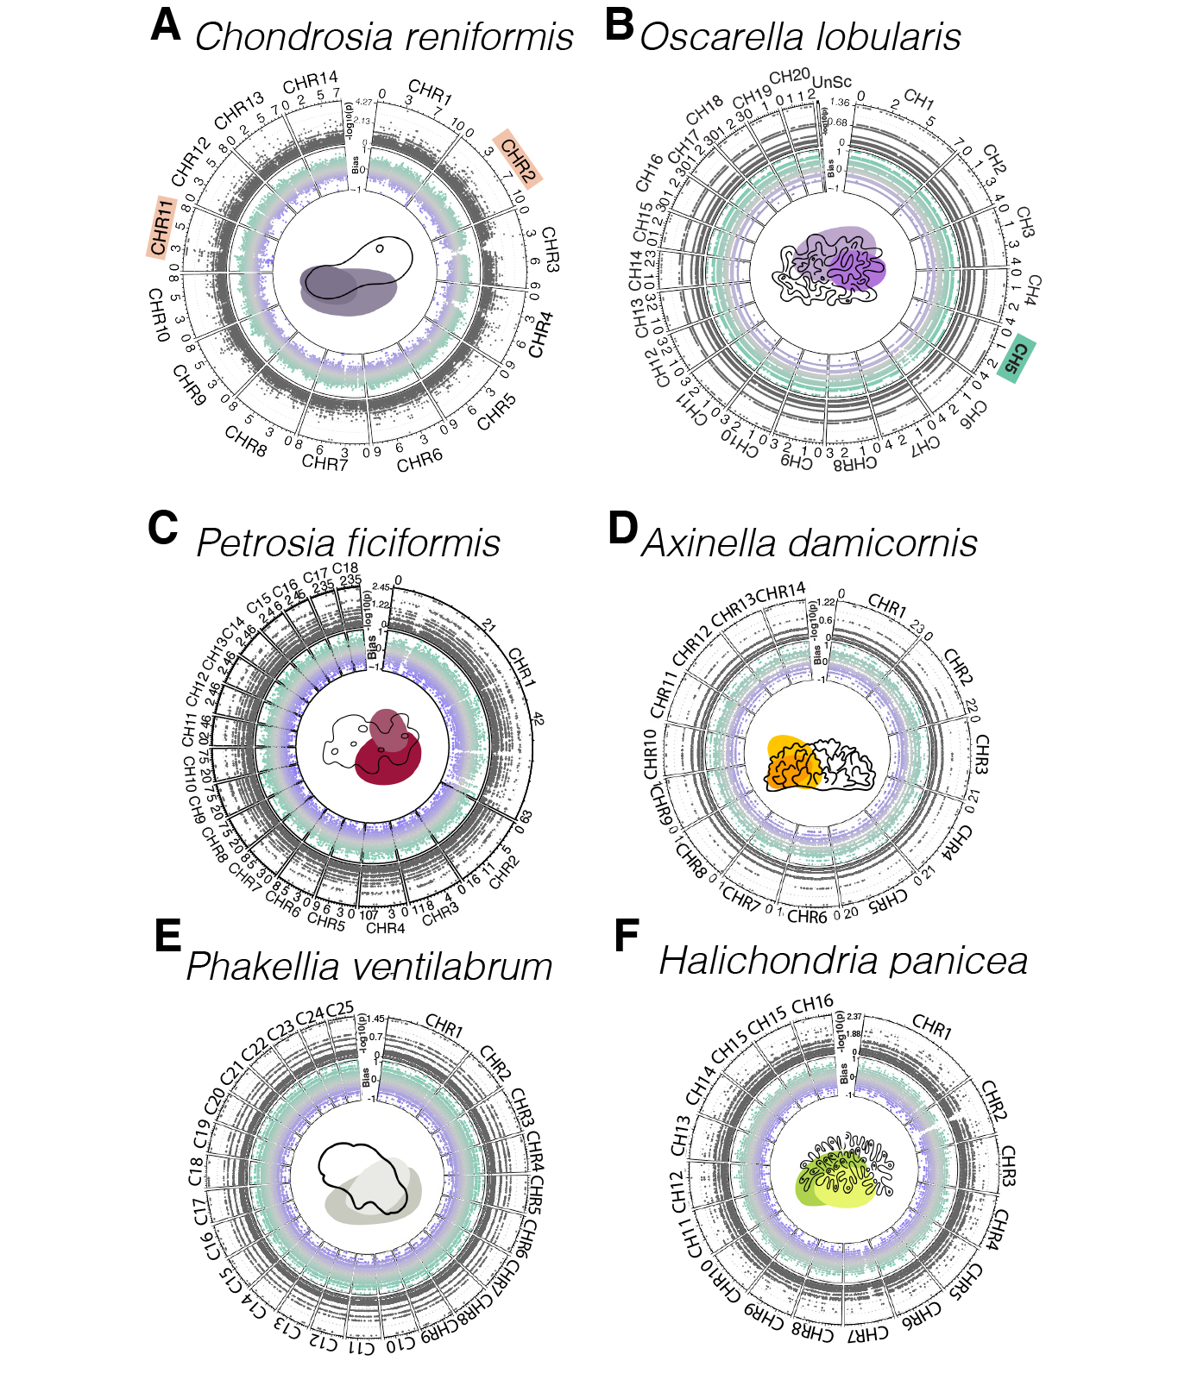
Figure S6. Circos plots showing separated chromosomes (and not unplaced scaffolds) showing in the top track the sex-bias of markers obtained with RADSEX, with a value of 1 if the marker is present in all males (green) and no females, and -1 if the marker is present in all females (purple) and no males. The bottom track shows the probability of association with sex (chi-squared test, using Bonferroni correction).

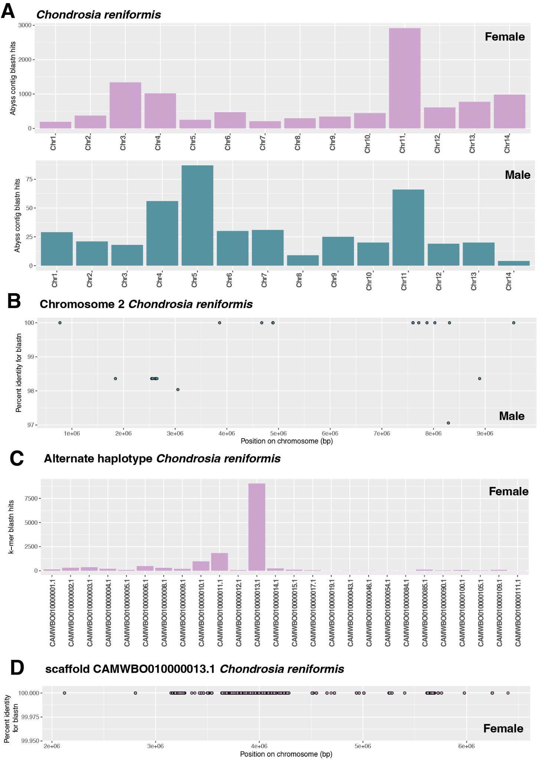
Figure S7. Sex-specific k-mer distribution on Chondrosia reniformis. A. Number of sex−specific k−mers from kmerGWAS in Chondrosia reniformis assembled in contigs with abyss and linked to the reference genome with blastn. B. Distribution of male−specific k−mers from kmerGWAS across Chondrosia reniformis chromosome 2 from blastn. C. Number of female−specific k−mers from kmerGWAS in Chondrosia reniformis assembled in contigs with abyss and linked to the alternate haplotype genome with blastn. D. Distribution of female−specific k−mers from kmerGWAS across Chondrosia reniformis chromosome scaffold CAMWBBO010000013.1, homologous to the reference chromosome 2 from blastn.

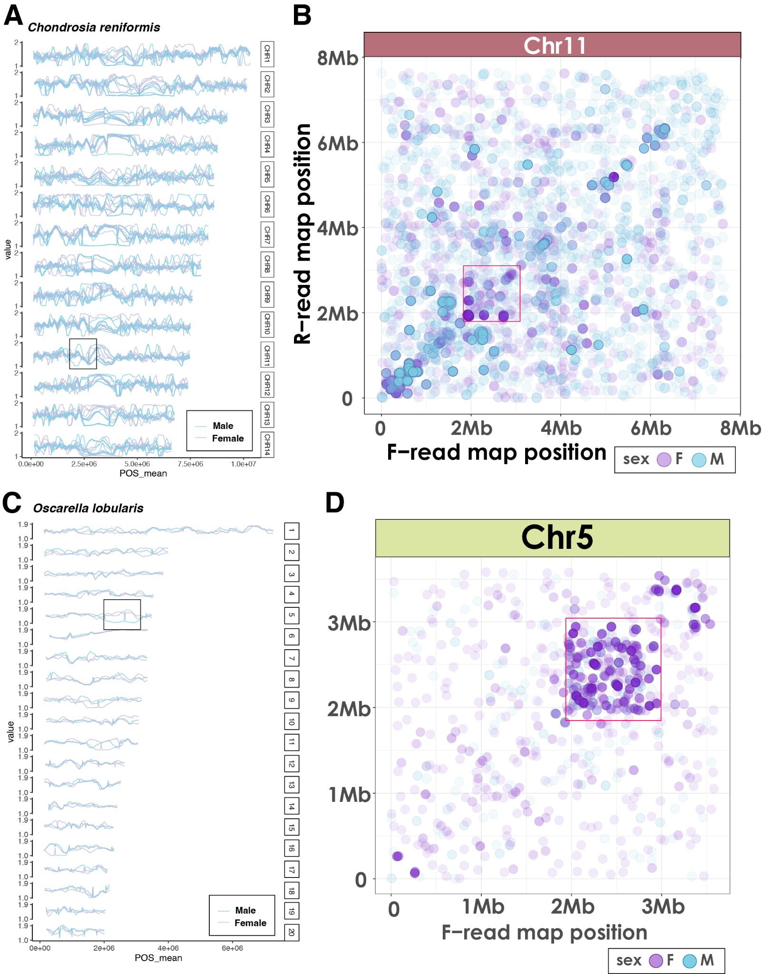
Figure S8. Average genotype for each specimen (5,000 bp windows). Values are as follows: 0 = fixation of reference SNPs, 1 = non-fixation, 2 = fixation of alternative SNPs in Chondrosia reniformis chromosomes (A) and Oscarella lobularis chromosomes (C). POS_mean= mean position in Mb. (B, D). Position of paired-end reads mapping collinearly (F-F / R-R) in chromosome 11 of Chondrosia reniformis (B) and Chromosome 5 in Oscarella lobularis (D).

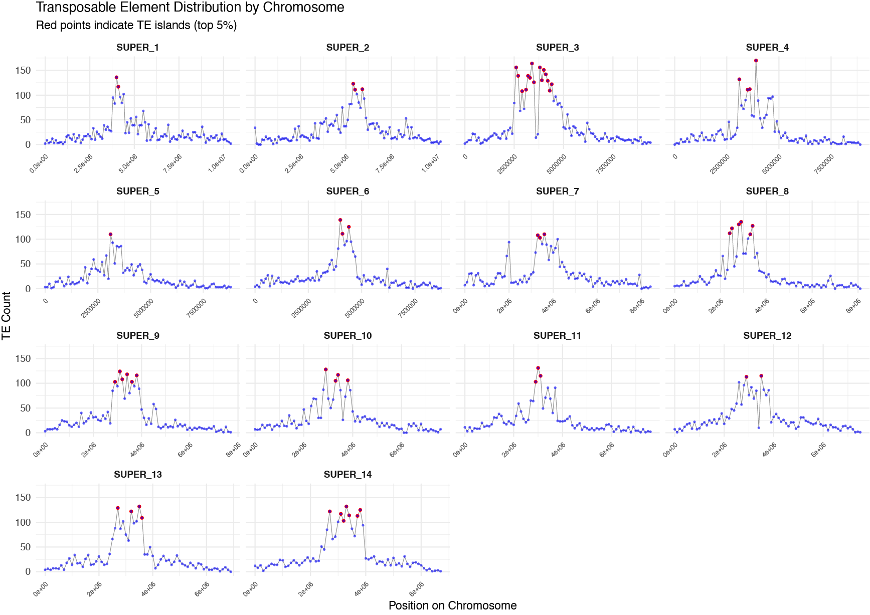
Figure S9. Number of counts of transposable elements (TEs) per Mb in the different chromosomes of Chondrosia reniformis. Red dots indicate TE islands (top 5%).

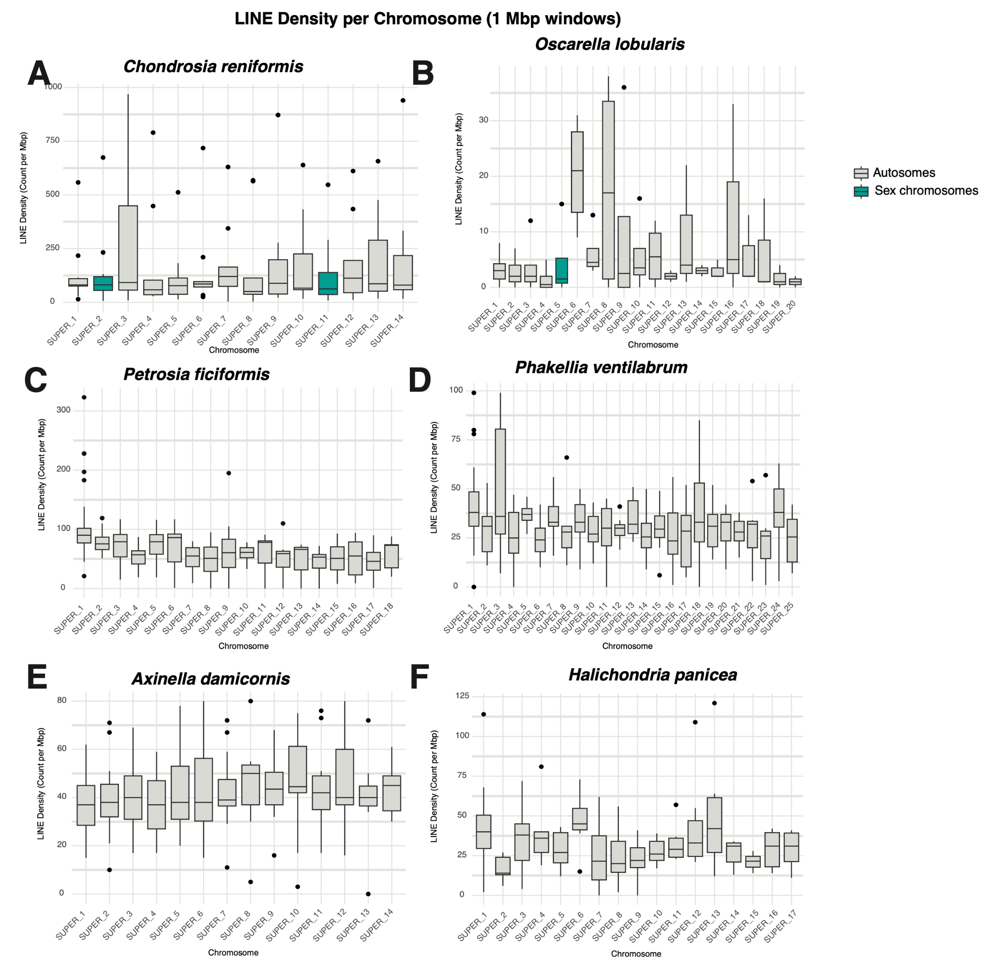
Figure S10. Average (and standard deviation) of counts of LINEs per Mb in the different chromosomes of the sponges.

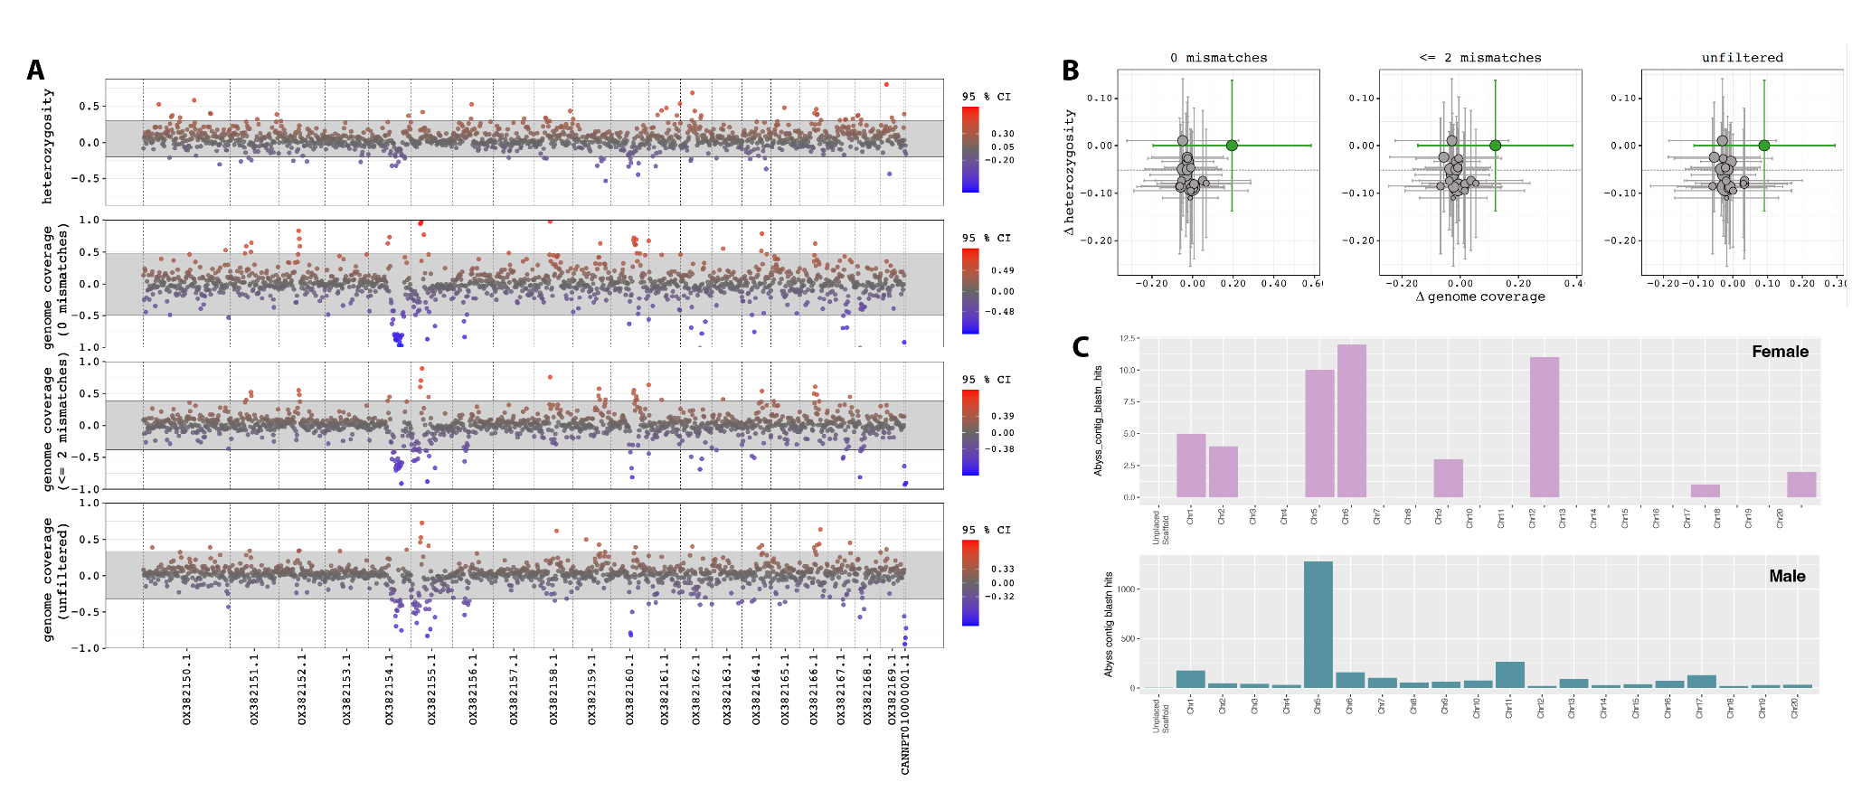Figure S11. Data from FindZX pipeline (Sigeman et al. 2022) for the reference haplotype (A–B) in Oscarella lobularis. Sex differences (female–male) in heterozygosity and genome coverage on 50,000 bp windows calculated with 0, 2 and unfiltered (A) mismatches when mapping. The grey background marks the 95% confidence interval (CI), calculated with bootstrapping from the genome-wide mean value for each metric expected under no sex differences, and the colour scale indicates significant bias to females (red) and to males (blue). (B). Mean sex differences (female–male) per chromosome on 50,000 bp windows. (C). Sex-specific k-mer distribution on Oscarella lobularis. Number of sex−specific k−mers from kmerGWAS in Oscarella lobularis assembled in contigs with abyss and linked to the reference genome with blastn.

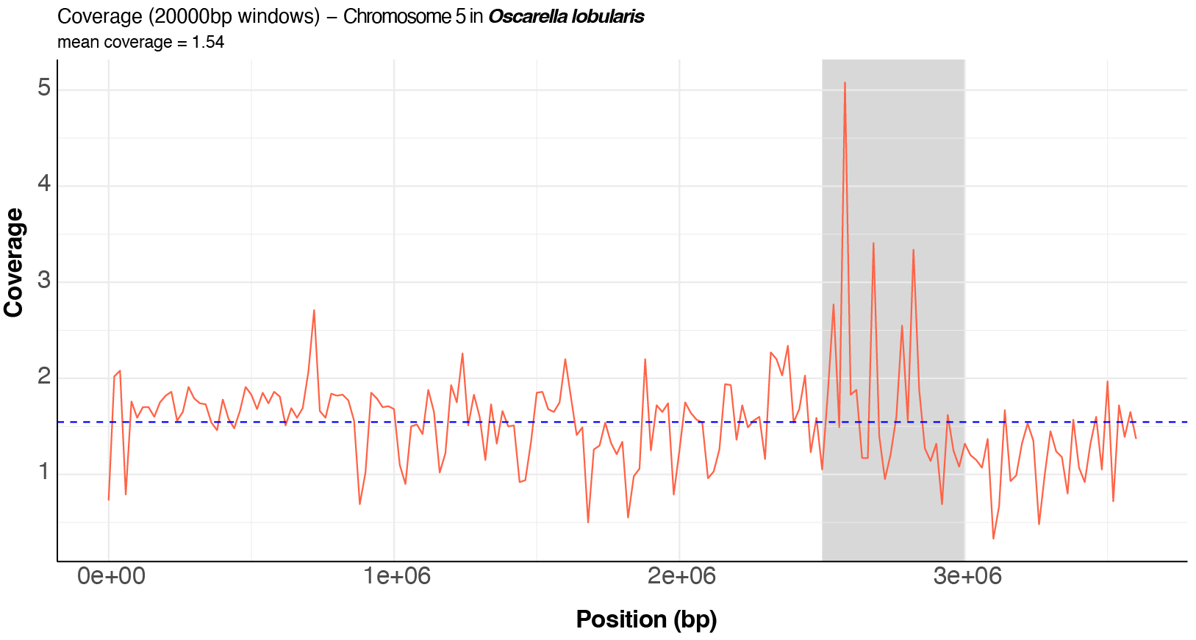
Figure S12. Coverage of male reads on sex chromosome 5 of Oscarella lobularis. The reads used for the mapping were those from male individual Olob13 that did not map to the draft female genome assembly done with only reads from female individuals (Supplementary Text Section 2). Note the higher coverage around the sex-determining region identified by FindZX.

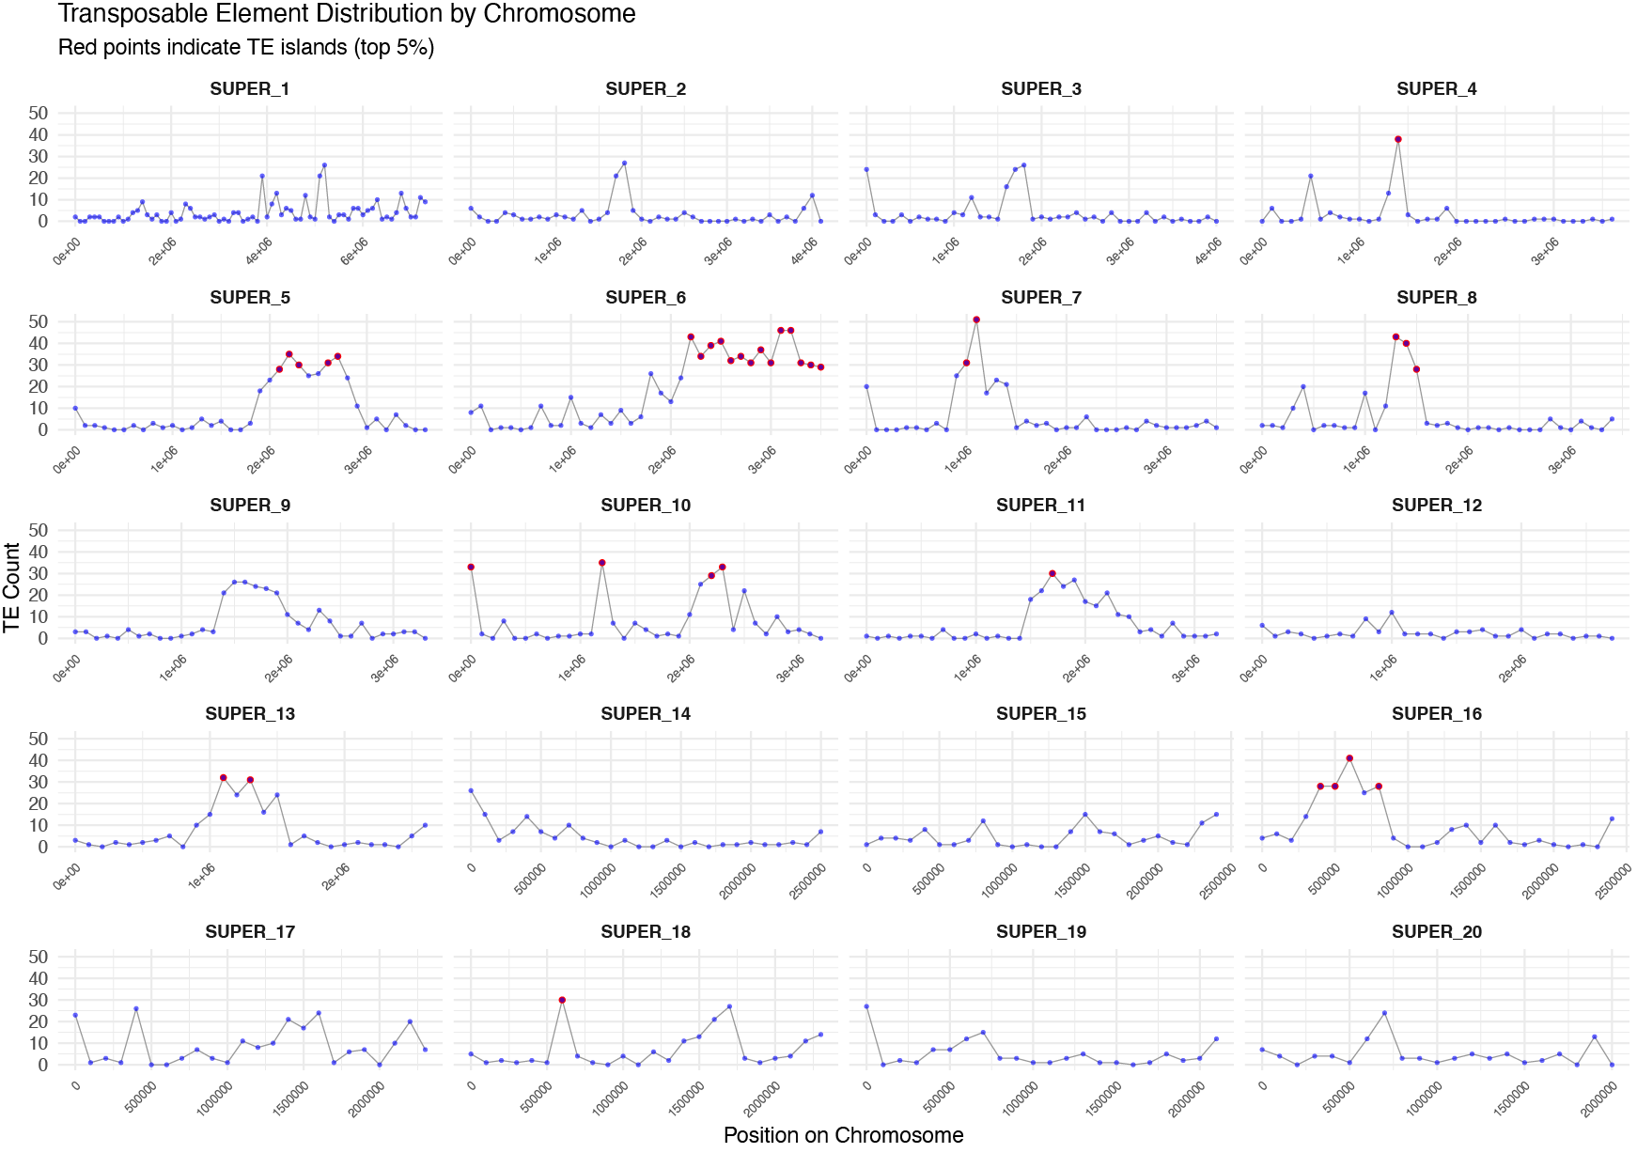
Figure S13. Number of counts of transposable elements (TEs) per Mb in the different chromosomes of Oscarella lobularis. Red dots indicate TE islands (top 5%).

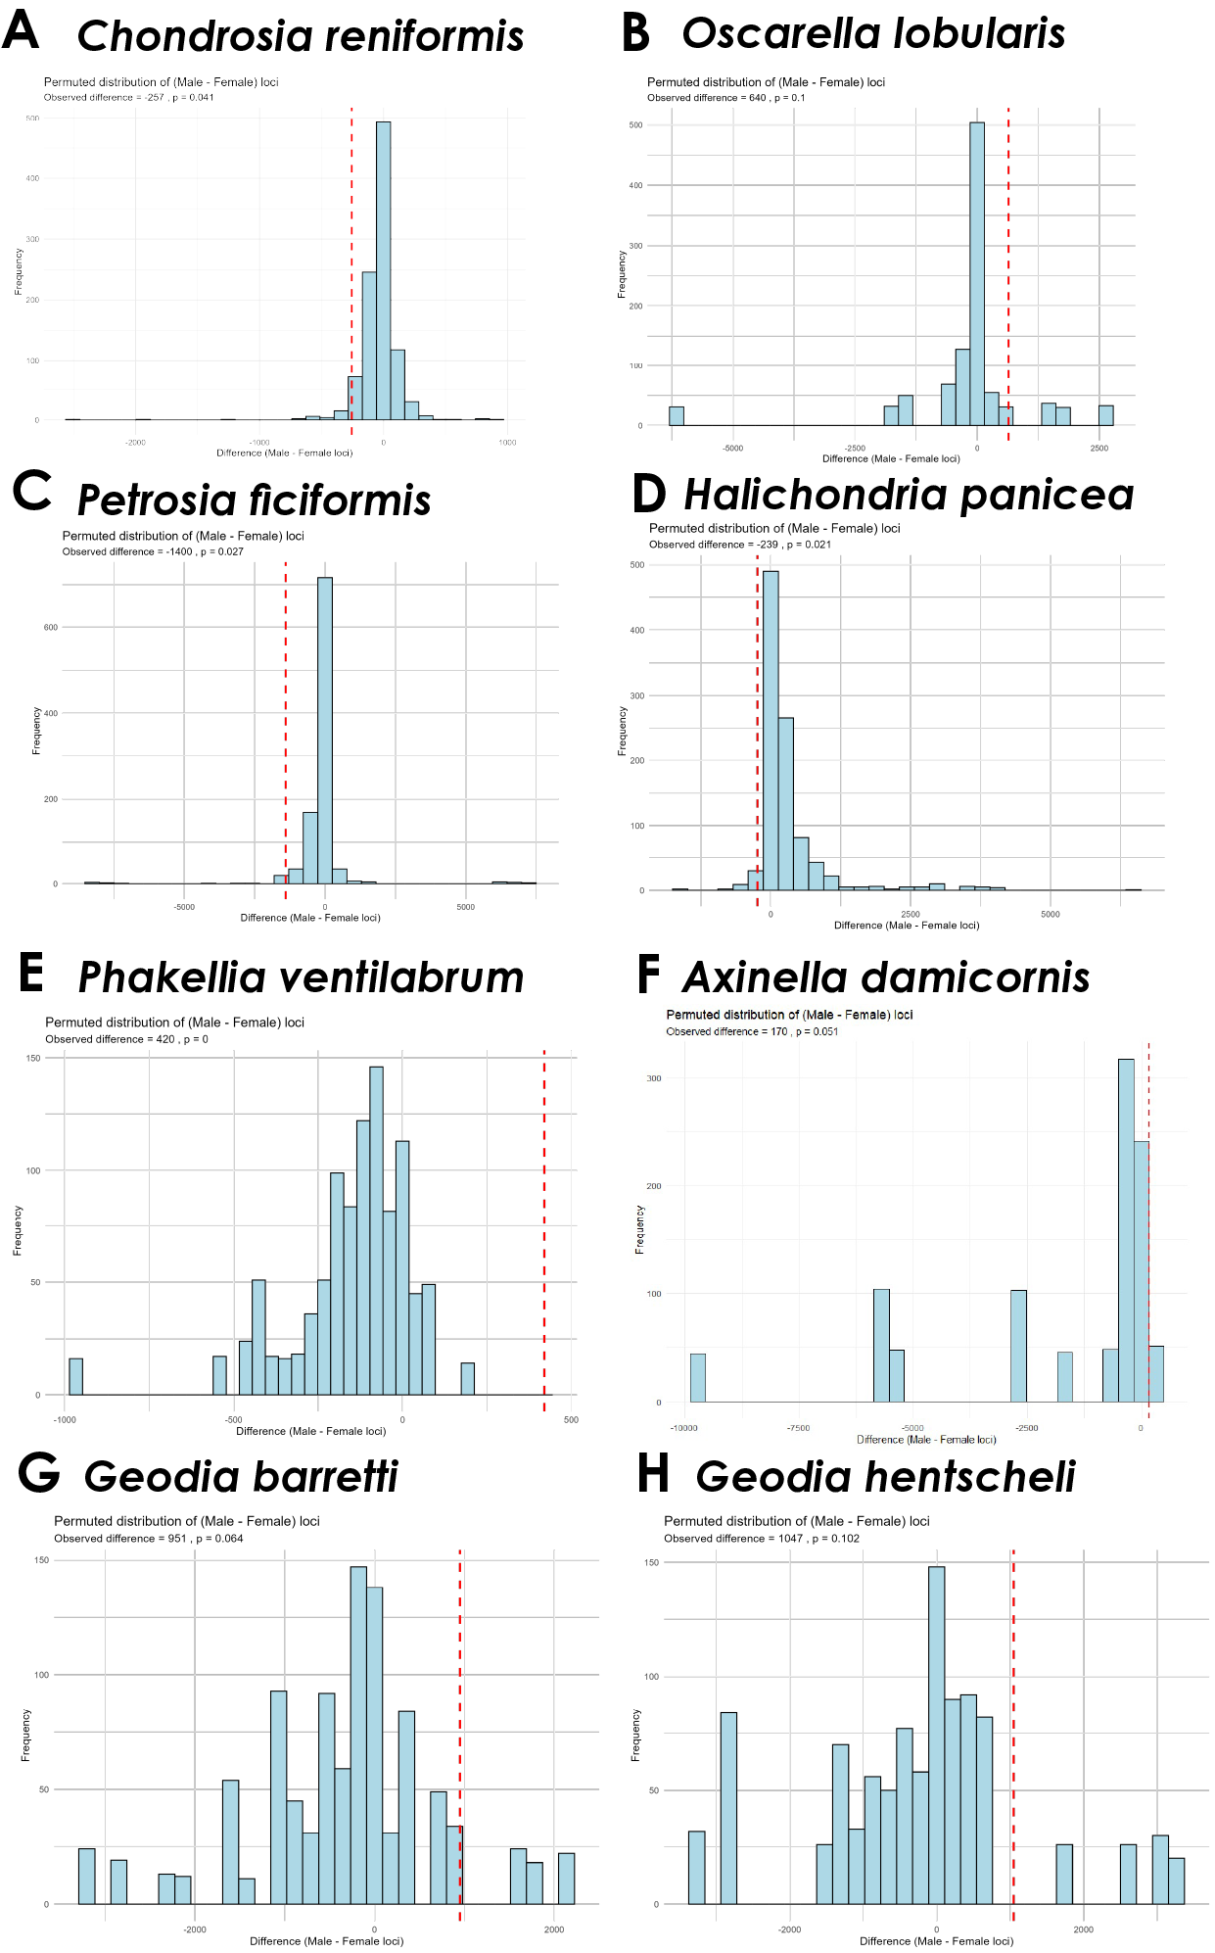
Figure S14. Histogram showing the bias towards female or male loci when randomising the sex assigned to the samples to run RADSEX using 100 permutations. p-values obtained performing a chi-square test comparing the observed result against the permutation-based expected frequencies. The red line points to the observed result, obtained when samples were assigned sex based on the presence of female or male gametes.

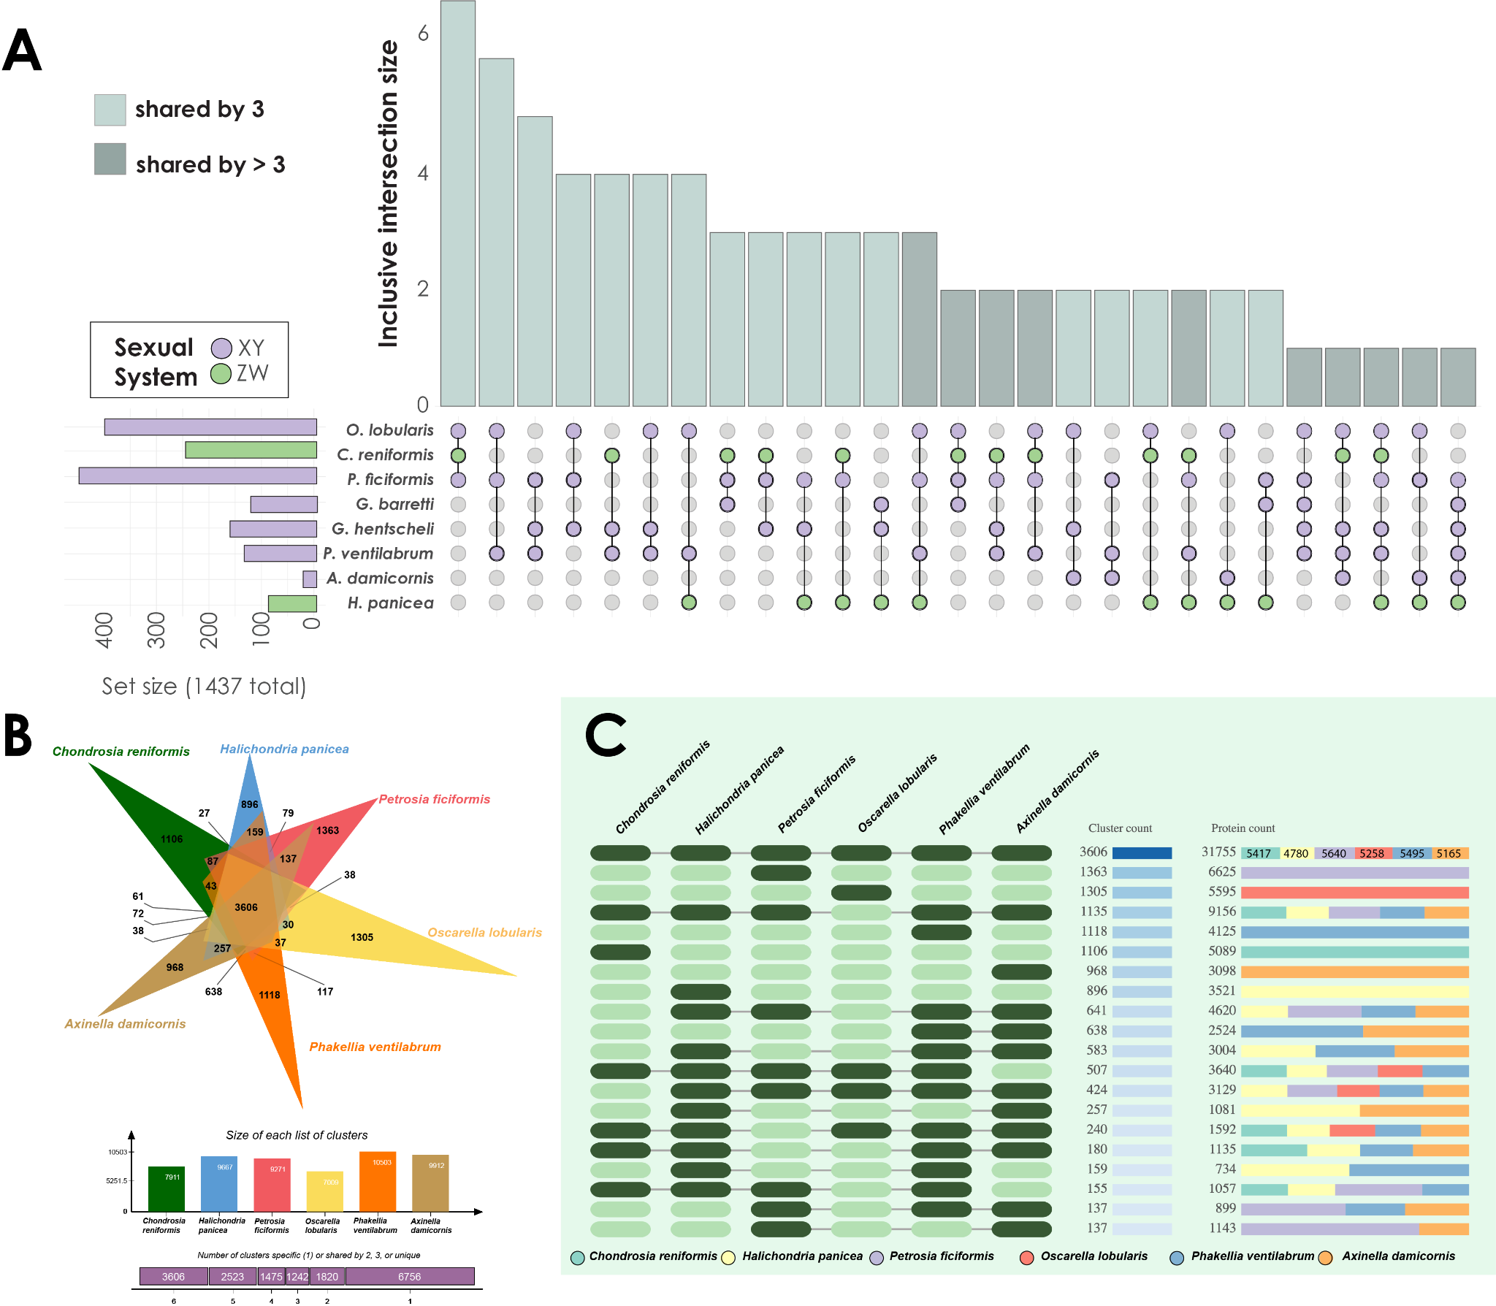
Figure S15. A. Upset plot showing the number of shared genes with sex-specific loci among the different species (only showing those shared by at least 3 species). B. Venn diagram from Orthovenn3 showing the number of orthogroups (clusters of proteins) shared among the 6 genomes, and C. Diagram of the number of protein clusters (and proteins within) shared among the different genomes.

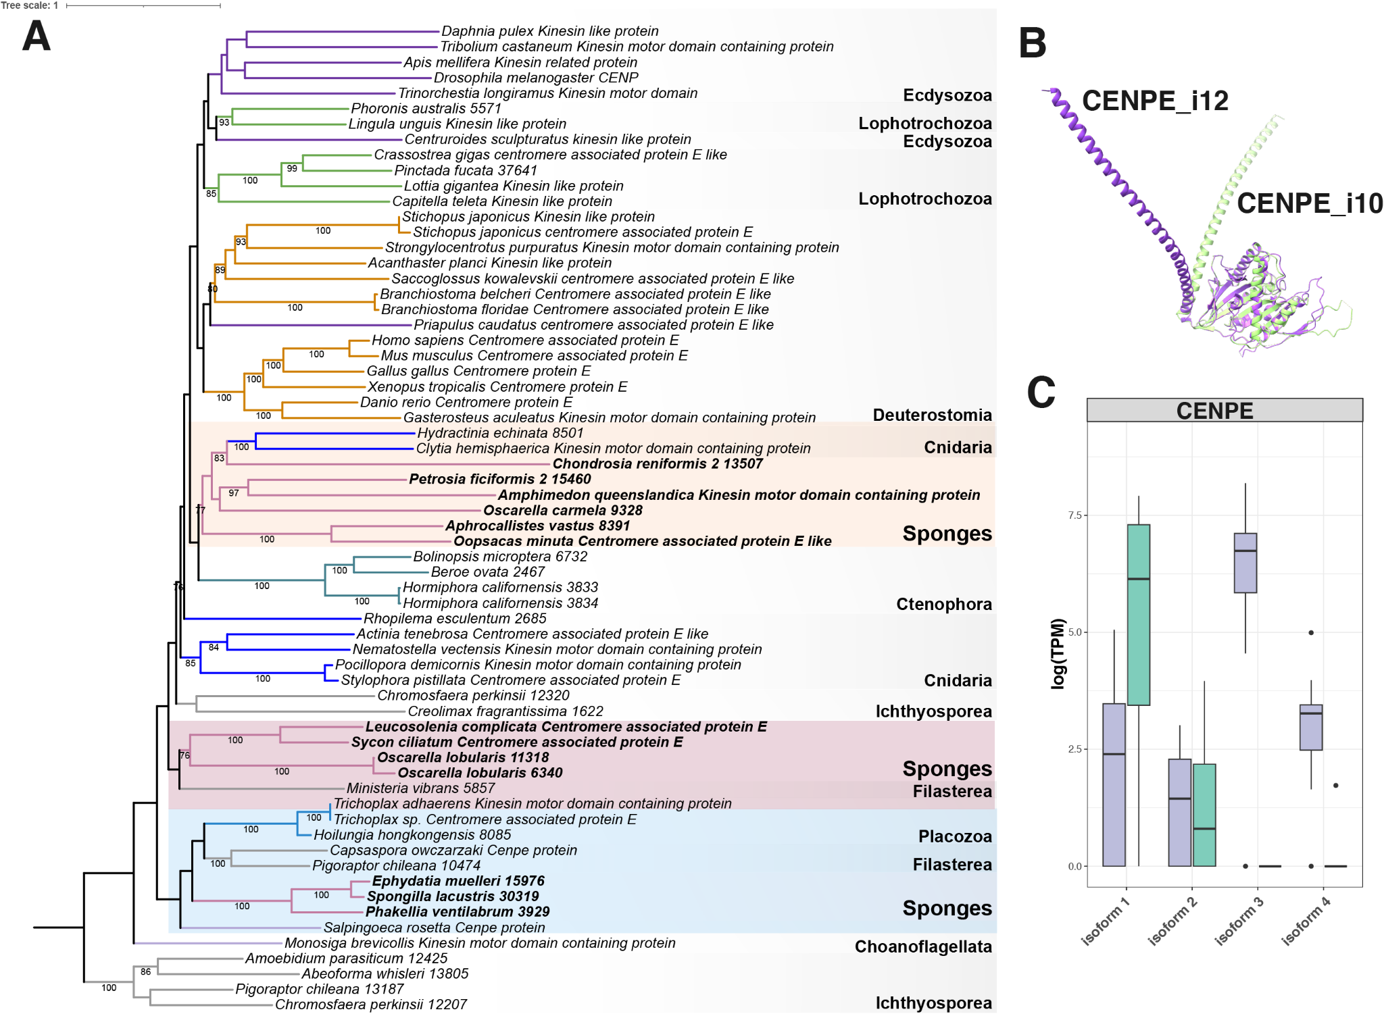
Figure S16. Phylogenetic hypothesis for the evolution of CENP-E proteins across metazoans obtained with IQ-TREE. Bootstrap values are shown below the nodes. B. Alphafold structural prediction for CENP-E isoforms that are more expressed in one sex (CENPE_i10, males) or the other (CENPE_i12, females) in Chondrosia reniformis. C. Expression levels in TPMs for the CENP-E isoforms in Chondrosia reniformis. In B and C, green denotes males and purple denotes females.

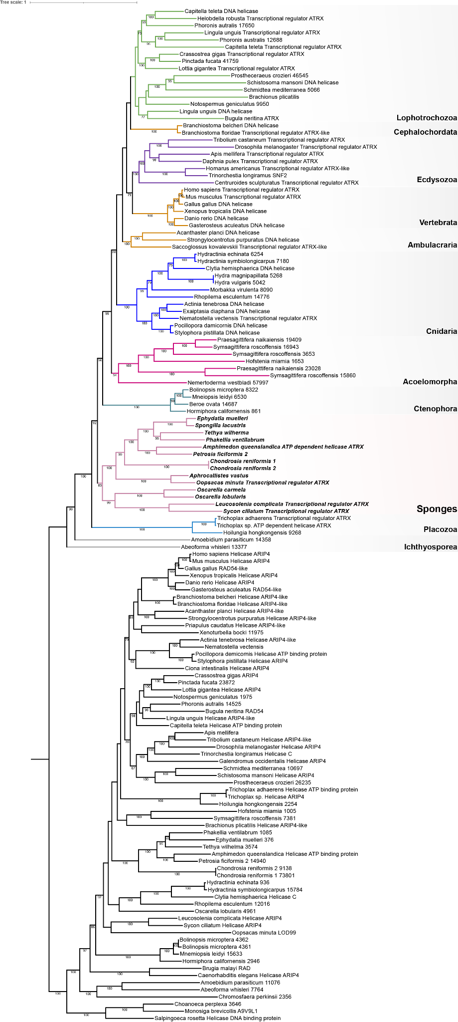
Figure S17. Phylogenetic hypothesis for the evolution of ATRX across metazoans obtained with IQ-TREE. Bootstrap values are shown below the nodes.

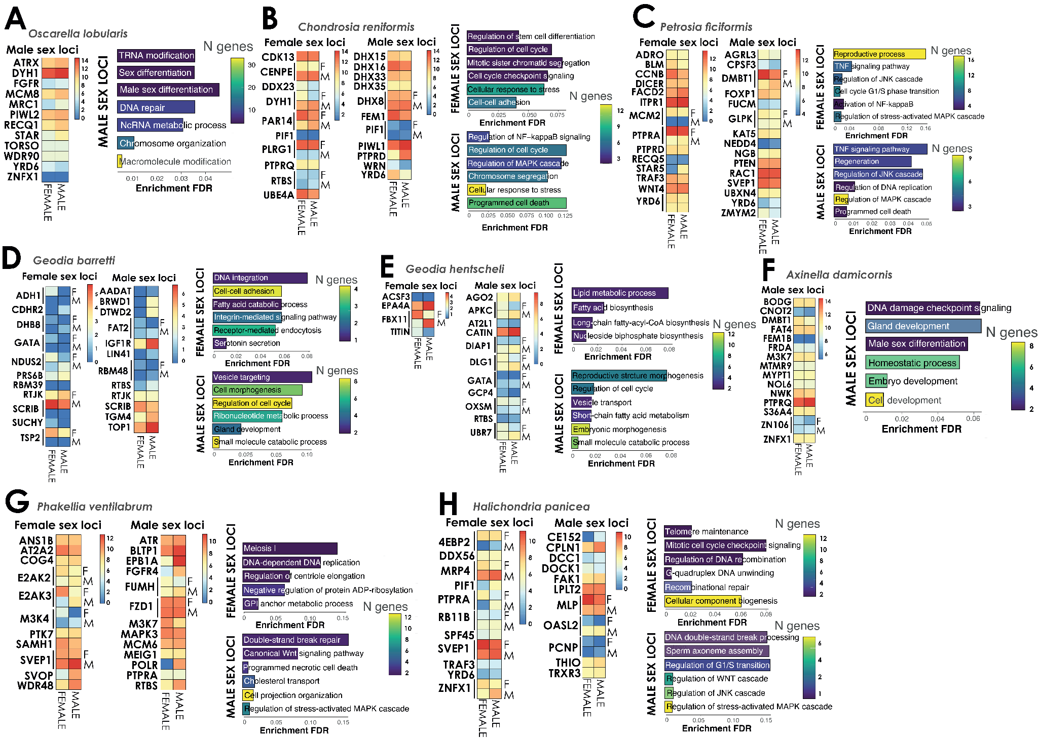
Figure S18. A–H. Relative expression of selected genes with male and female-specific loci in male and female specimens, along with the GO enrichment of both genes with male and female-specific loci in all species. Note that genes with isoforms that are more expressed in one sex than the other are indicated with F and M at the right side of the heatmaps.

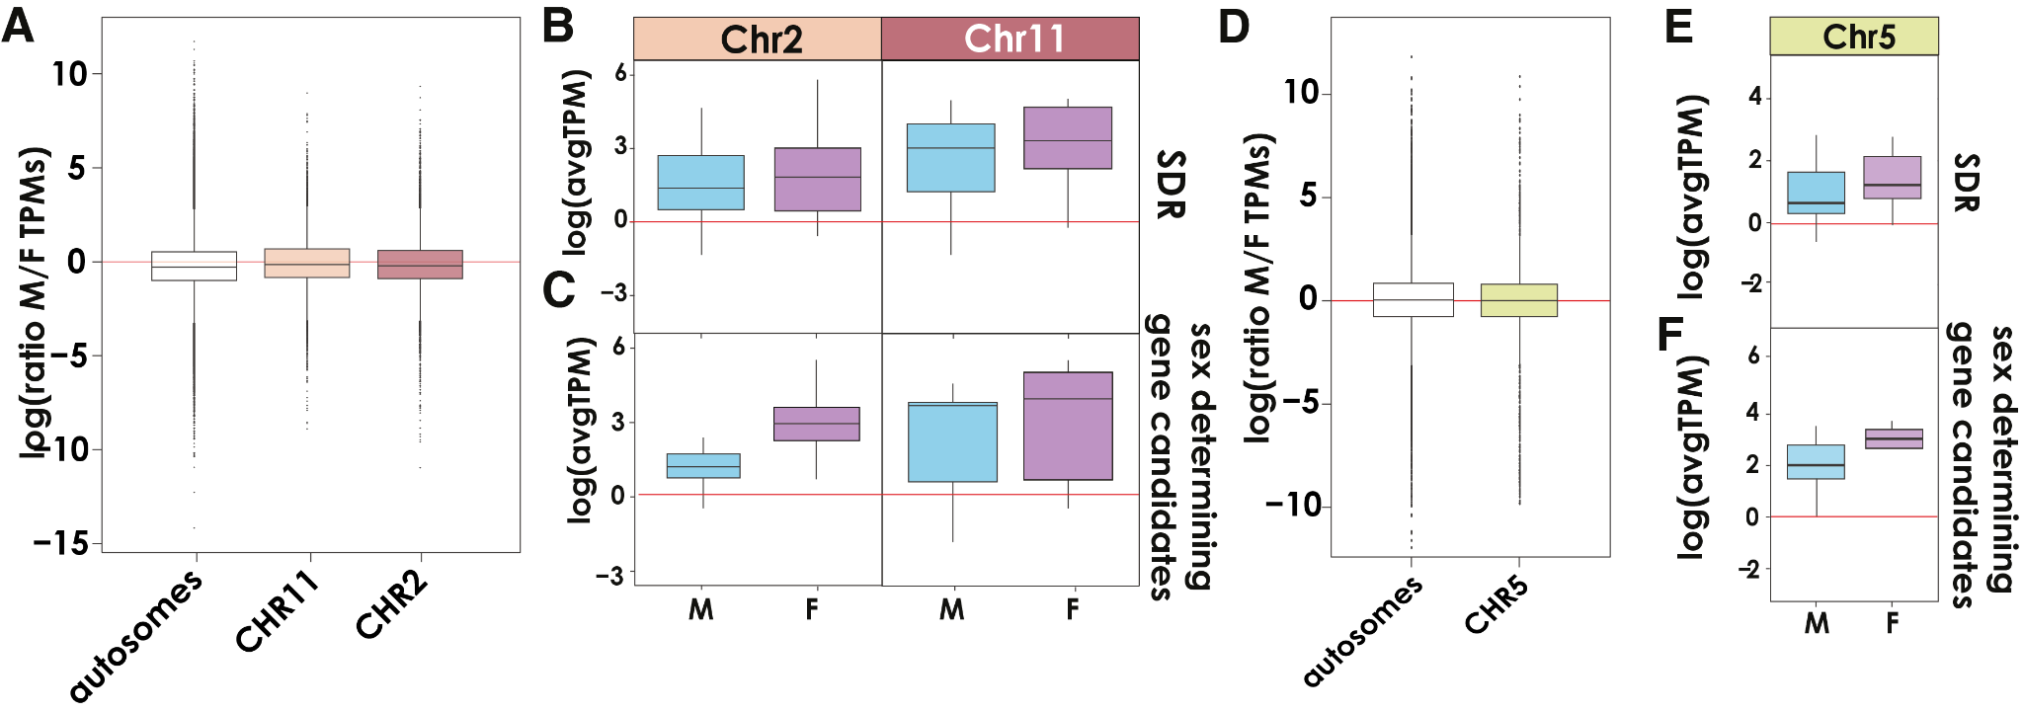
Figure S19. A. Average ratio of male/female expression along the autosomes and sex-linked chromosomes (2 and 11). B–C. Average gene expression (TPMs) in females and males in the SDRs and the genes with known sex determination function of the SDRs. D. Average ratio of male/female expression (TPMs) along the autosomes and the sex-linked chromosome 5. E–F. Average gene expression (TPMs) in females and males in the SDR and the genes with known sex determination function of the SDR.
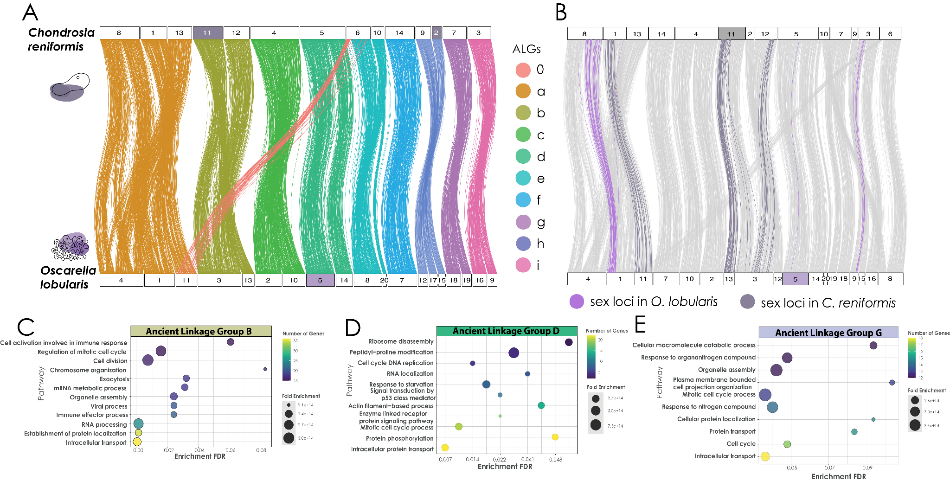
Figure S20. A. Conserved synteny across the species with sex chromosomes: Chondrosia reniformis and Oscarella lobularis. Colored vertical lines connect orthologous genes (n=4,582) across the two species with significantly enriched conservation of synteny. Each color represents a distinct ALG. Two or more colors converging on a chromosome indicate fusion events. B. Conserved synteny of genes with sex-specific loci (n=115) between Chondrosia reniformis and Oscarella lobularis. Colored vertical lines indicate genes with sex-specific loci, and grey vertical lines are all ALGs shown in Figure S14A. C–E. Gene Ontology enrichments of ALGs on sex chromosomes (ALGB in sex chromosome 11 of C. reniformis, ALGD in sex chromosome 5 of O. lobularis and ALGG in potential sex chromosome 2 of C. reniformis).

Table captions
Table S1. Sampling details for all species considered in the study and basic reproductive measurements.
Table S2. Genomic and transcriptomic resources of each species. References for the genomes: Pita et al. 2025¹⁸⁷; Riesgo et al. 2025¹⁸⁸; Steindler et al. 2025¹⁸⁹).
Table S3. Haplotype-level measures of FST from the Stacks populations program (Catchen et al., 2013) for Chondrosia reniformis and Oscarella lobularis.
Table S4. Normalised coverage .bed files of Chondrosia reniformis, Oscarella lobularis, Axinella damicornis, Petrosia ficiformis, and Phakellia ventilabrum from mosdepth (Pedersen and Quinlan, 2018)
Table S5. Coverage with 0 mismatches allowed in 50kb windows of Chondrosia reniformis, Oscarella lobularis, Axinella damicornis, Petrosia ficiformis, and Phakellia ventilabrum calculated by findZX (Sigeman et al., 2022).
Table S6. Heterozygosity in 50kb windows of Chondrosia reniformis, Oscarella lobularis, Axinella damicornis, Petrosia ficiformis, and Phakellia ventilabrum calculated by findZX (Sigeman et al., 2022).
Table S7. SNP density in 100000kb windows of Chondrosia reniformis, Oscarella lobularis, Axinella damicornis, Petrosia ficiformis, and Phakellia ventilabrum. SNPs relative to the reference genome detected by bcftools [v1.12] (Li, 2011) and calls filtered with vcftools [v0.1.16] (Danecek et al., 2011). P-value of the differences between male and female calculated after a 1000 permutations test from SNPdensity_permutations.R from the SexFindR pipeline (83).
Table S8. A. Summary of RADSex markers identified as sex-specific loci (p>0.05) in each of the species that were present in all or most individuals of one sex and none of the other. Cells in green are male-specific loci, and cells in purple are female-specific loci. B. Results for the chi-square tests of the RADSex markers accumulation. Chi-square test (with Monte Carlo simulation because of low counts) was used to test whether marker frequencies differed from a uniform distribution across chromosomes. C–I. RADsex loci information and annotation on the genome and transcriptomes. C. Chondrosia reniformis. D. Oscarella lobularis. E. Petrosia ficiformis. F. Phakellia ventilabrum. G. Halichondria panicea. H. Axinella damicornis. I. Geodia barretti. J. Geodia hentscheli.
Table S9. Genes with sex-specific loci. A. Mapping correspondence of sex-specific loci to the reference genomes of Chondrosia reniformis, Oscarella lobularis, Petrosia ficiformis, Phakellia ventilabrum, Axinella damicornis and Halichondria panicea. B. Abbreviations for the genes with sex-specific loci in all species surveyed, which were annotated through blast against SwissProt proteins. C. Genes with sex-specific loci annotated with GO category sex determination in the different species. D. Genes with sex-specific loci shared among the different species and unique to each of them.
Table S10. Functional annotations for the genes with sex-specific loci in all species surveyed, obtained with RADSEX and then annotated through blast against SwissProt proteins. A. Chondrosia reniformis. B. Oscarella lobularis. C. Petrosia ficiformis. D. Geodia barretti. E. Geodia hentscheli. F. Phakellia ventilabrum. G. Axinella damicornis. H. Halichondria panicea.
Table S11. Functional annotations for the genes with sex-specific loci located in the SDRs of sex chromosomes of Chondrosia reniformis (A) and Oscarella lobularis (B), obtained by blast hits against swissprot proteins. Their function related to sexual reproduction or sex determination is indicated with a reference to the scientific article where it is described.
Table S12. Gene expression levels (TPMs) for the genes with sex-specific loci located in the SDRs of sex chromosomes of Chondrosia reniformis (A, B) and Oscarella lobularis (C), obtained with StringTie.
Table S13. Gene ontology enrichments for the genes with sex-specific loci in all species surveyed, obtained with ShinyGO. A. Chondrosia reniformis. B. Oscarella lobularis. C. Petrosia ficiformis. D. Geodia barretti. E. Geodia hentscheli. F. Phakellia ventilabrum. G. Axinella damicornis. H. Halichondria panicea.
Table S14. Differential gene expression (at transcript level) for all species, performed with Hisat2/StringTie/edgeR in those with a reference genome and trinity/RSEM/edgeR in those without. A. Summary statistics for the analysis in all species. Abbreviations: N transcripts=number of transcripts, N DEG=number of differentially expressed genes/transcripts, N DEG sexloci=number of differentially expressed genes/transcripts with a sex-specific loci, Up in M=upregulated in males, Up in F=upregulated in females, %DEG=proportion of transcripts differentially expressed, N genes w/sex loci=number of genes with a sex-specific loci, %DEG sexloci=proportion of transcripts with a sex-specific loci that are differentially expressed. B. Chondrosia reniformis. C. Oscarella lobularis. D. Petrosia ficiformis. E. Axinella damicornis. F. Phakellia ventilabrum. G. Halichondria panicea. H. Geodia barretti. I. Geodia hentscheli.
Table S15. Transcript-level expression for genes with sex-specific loci in all species surveyed. A. Oscarella lobularis. B. Chondrosia reniformis. C. Petrosia ficiformis. D. Axinella damicornis. E. Phakellia ventilabrum. F. Halichondria panicea. G. Geodia barretti. H. Geodia hentscheli.
Table S16. Alternative splicing events (AS) and association with sex. A. Summary of overall AS in the different species and AS in genes with sex-specific loci. Abbreviations: skipped exons (SE), mutually exclusive exons (MX), alternative 5′ splice sites (A5), alternative 3′ splice sites (A3) and retained intron (RI). B. Chondrosia reniformis. C. Oscarella lobularis. D. Petrosia ficiformis. E. Phakellia ventilabrum. F. Axinella damicornis. G. Halichondria panicea.
Table S17. Table of orthologs in all six species: Sp1=Oscarella lobularis, Sp2=Chondrosia reniformis, Sp3=Petrosia ficiformis, Sp4=Phakellia ventilabrum, Sp5=Axinella damicornis, Sp6=Halichondria panicea. Labels: sex_gene_sp$=indicates genes with sex-specific loci in the given species, Sex_all=indicates genes with sex-specific loci in a certain species.
Table S18. Phylostratigraphic distribution of protein-coding and sex-related genes in six sponge species. The table summarizes results from GenEra analyses across the six species (Chondrosia reniformis, Halichondria panicea, Petrosia ficiformis, Phakellia ventilabrum, Amphimedon queenslandica, Oscarella lobularis), including (A–B) the assignment of 102,213 protein-coding genes to evolutionary strata, (C) the subset of 2,705 sex-related genes and their orthogroup distribution, (D) functional GO enrichment categories inferred for sex loci, and (E) enrichment profiles of sex-related genes across species.

