The following Supplementary Materials belong to the paper:
“The Impact of Overconfidence and Environmental Conditions on Hazard Perception and Risk Assessment: An Experimental Study Using Video-Based Traffic Scenarios”

By authors:
Elena Lupia
Alessandro Bortolotti
Riccardo Palumbo

Section A - Categorical and temporal annotation of Video-based Hazard Perception Task stimuli.
The Hazard Perception Task consisted of 80 videos (selected from Song et al., 2024). Table A1 reports the categorical and temporal annotation of the stimuli, with a legend provided below.

Table’s Legenda:
Annotation Name | Description
Hazard / Safe | Whether a hazard is present in the video
day / night | Time of day the video is taken
MovieFile_name | Name of the file
Duration (s) | Duration of the video
Hazard onset (s) | Time in seconds of hazard onset from the start of video, i.e. the initial indication that the situation is hazardous, not the first moment the eventual hazardous object becomes visible.
Type of hazard | Category of hazard: vehicle, pedestrian, cyclist, animal
Hazard side | The location of the hazard relative to video midline
Hazard Frame | Screenshot representing the hazard
Brief description | Brief description of how the hazard develops
Driver response time | Time in seconds of first driver response from start of video
Onset_response | Time in seconds between hazard onset and video driver response

Table A1. Categorical and temporal annotation of Video-based Hazard Perception Task stimuli.
Trial | Hazard / Safe | Day / Night | MovieFile_name | Duration (s) | Hazard onset (s) | Type of Hazard | Hazard side | Brief description | Driver response time | Onset_response | Video Frame
1 | Hazard | day | noaudio_c_002_critical_pedestrian | 8.16 | 4.7 | vehicle | left | Car's door opens along the adjacent lane | 5.23 | 0.53 | 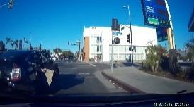
2 | Hazard | day | noaudio_c_008_critical_driver_hits_sign | 8.0 | 3.5 | vehicle | right | Dynamic obstacles caused by a vehicle going off the road | 7.9 | 4.4 | 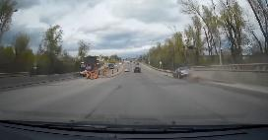
3 | Hazard | day | noaudio_c_008_critical_traffic_cone | 8.14 | 2.45 | obstacle | right | Dynamic obstacles (a traffic cone) crossing the roadway | 3.42 | 0.95 | 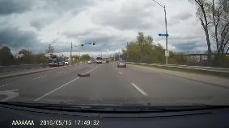
4 | Hazard | day | noaudio_c_010_critical_unsignaled_turn | 8.0 | 5.05 | vehicle | left | Unsignaled turn by oncoming vehicle in lane | 5.4 | 0.35 | 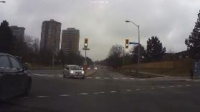
5 | Hazard | day | noaudio_c_012_critical_cut_across | 8.04 | 3.93 | vehicle | right | Vehicle pop out that performs a turnaround | 5.7 | 1.77 | 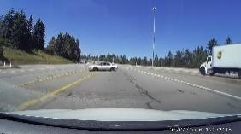
6 | Hazard | day | noaudio_c_013_critical_u_turn | 8.03 | 3.7 | vehicle | right | Oncoming vehicle in lane that performs a turnaround | 4.33 | 0.63 | 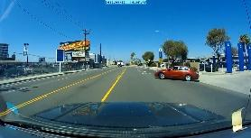
7 | Hazard | day | noaudio_c_016_critical_loose_tires | 8.0 | 0.91 | obstacles | left | Dynamic obstacles (two tires) crossing the roadway in the car's direction in snowy conditions | 2.46 | 1.56 | 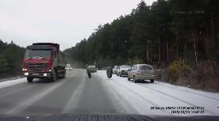
8 | Hazard | day | noaudio_c_018_critical_swerve | 8.03 | 3.75 | vehicle | left | Critical swerve by a vehicle that is not visible because it is immediately behind another. | 5.45 | 1.7 | 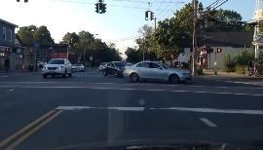
9 | Hazard | day | noaudio_c_019_critical_swerve | 8.08 | 2.52 | vehicle | right | Critical entry of a vehicle into our lane in rainy conditions | 3.3 | 0.78 | 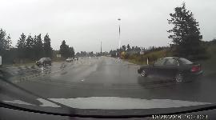
10 | Hazard | day | noaudio_c_020_critical_deer | 8.0 | 5.55 | animal | left | A deer suddenly crosses the roadway in rain conditions | 5.76 | 0.22 | 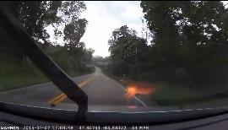
11 | Hazard | day | noaudio_c_022_critical_truck_crashes | 8.06 | 3.14 | vehicle | right | Critical truck crash | 6.7 | 3.56 | 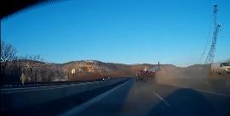
12 | Hazard | day | noaudio_c_023_critical_truck_crashes | 8.03 | 2.83 | vehicle | right | Critical incident in which a truck overturns | 4.4 | 1.57 | 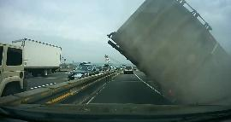
13 | Hazard | day | noaudio_c_024_critical_stopped_car_in_road | 8.0 | 2.03 | vehicle | left | A stopped car occupies the lane of traffic | 2.3 | 0.27 | 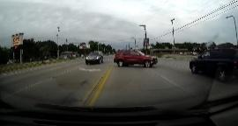
14 | Hazard | day | noaudio_c_026_critical_run_light | 7.97 | 5.33 | vehicle | right | A vehicle suddenly arriving from the right cutting us off | 5.5 | 0.17 | 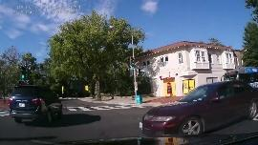
15 | Hazard | day | noaudio_c_029_critical_swerve | 8.04 | 4.25 | vehicle | right | Critical swerve of a vehicle for lane change | 6.0 | 1.75 | 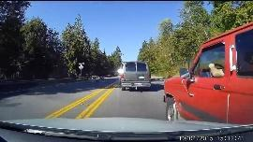
16 | Hazard | day | noaudio_c_035_critical_crash_in_lane | 8.0 | 3.3 | vehicle | left | Critical lane crash, involved three vehicles | 4.97 | 1.66 | 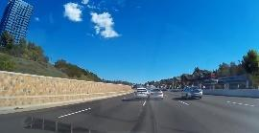
17 | Hazard | day | noaudio_c_045_critical_tire | 8.07 | 1.4 | obstacle | left | Dynamic obstacles (a tire) crossing the roadway in the car's direction | 3.7 | 2.3 | 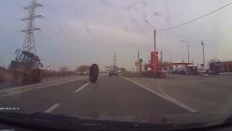
18 | Hazard | day | noaudio_c_046_critical_pedestrian | 8.0 | 4.7 | pedestrian | right | Pedestrian crossing right of way | 6.5 | 1.8 | 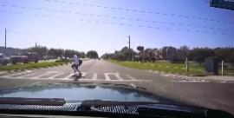
19 | Hazard | day | noaudio_c_critical_001 | 8.0 | 4.0 | vehicle | left | Critical lane crash, involved two vehicles | 4.73 | 0.73 | 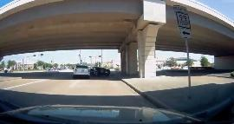
20 | Hazard | day | noaudio_c_critical_055 | 8.03 | 6.0 | animal | left | An animal suddenly crosses the roadway in snowy conditions | 7.25 | 1.25 | 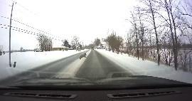
21 | Hazard | night | noaudio_c_critical_070 | 8.0 | 5.0 | vehicle | right | Critical entry of a vehicle into our lane | 6.0 | 1.0 | 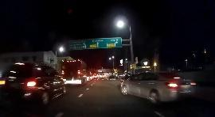
22 | Hazard | night | noaudio_c_critical_072 | 8.06 | 4.57 | animal | right | An animal suddenly crosses the roadway in snowy conditions | 5.15 | 0.58 | 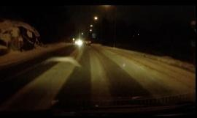
23 | Hazard | night | noaudio_c_critical_162 | 8.03 | 4.7 | vehicle | right | Crash collision of a vehicle against the  guardrails | 5.65 | 0.95 | 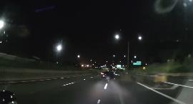
24 | Hazard | night | noaudio_c_critical_163 | 8.04 | 1.37 | vehicle | left | Crash crash of a vehicle against the security wall | 2.84 | 1.48 | 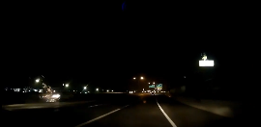
25 | Hazard | night | noaudio_c_critical_186 | 8.0 | 4.0 | obstacles | / | Dynamic obstacles crossing the roadway in the car's direction | 4.6 | 0.6 | 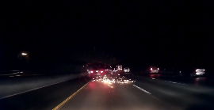
26 | Hazard | night | noaudio_c_critical_200 | 8.0 | 3.0 | vehicle | left | Oncoming vehicle in lane | 3.5 | 0.5 | 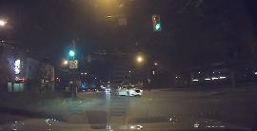
27 | Hazard | night | noaudio_c_critical_209 | 8.06 | 2.6 | vehicle | right | Critical swerve of a vehicle for lane change | 3.17 | 0.57 | 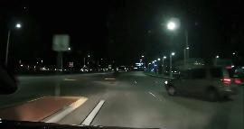
28 | Hazard | night | noaudio_c_critical_232 | 8.03 | 6.0 | vehicle | left | Vehicle breaks into the lane of traffic, cutting us off | 6.85 | 0.75 | 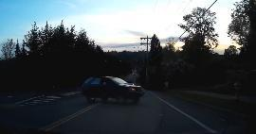
29 | Hazard | night | noaudio_c_critical_266 | 8.04 | 1.0 | pedestrian | right | Pedestrian crossing right of way | 3.3 | 2.3 | 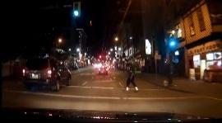
30 | Hazard | night | noaudio_c_critical_276 | 8.04 | 5.8 | animal | right | An animal suddenly crosses the roadway in snowy conditions | 6.55 | 0.75 | 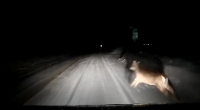
31 | Hazard | night | noaudio_c_critical_307 | 8.3 | 4.5 | vehicle | left | Vehicle breaks into the lane of traffic, cutting us off | 5.98 | 1.48 | 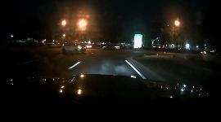
32 | Hazard | night | noaudio_c_critical_315 | 8.0 | 4.61 | vehicle | right | Critical swerve of a vehicle for lane change | 5.03 | 0.42 | 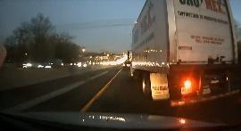
33 | Hazard | night | noaudio_c_critical_319 | 8.0 | 3.22 | obstacle | left | Dynamic obstacles (a tire) crossing the roadway in the car's direction | 3.72 | 0.5 | 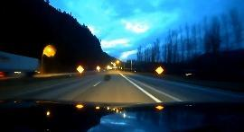
34 | Hazard | night | noaudio_c_critical_352 | 8.0 | 2.35 | vehicle | right | Critical swerve of a vehicle for lane change | 3.08 | 0.73 | 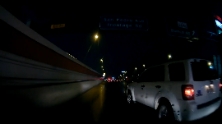
35 | Hazard | night | noaudio_c_critical_359 | 8.0 | 2.5 | animal | right | An animal stopped on the roadway | 4.03 | 1.53 | 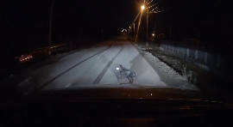
36 | Hazard | night | noaudio_c_critical_369 | 8.0 | 3.56 | animal | right | An animal suddenly crosses the roadway | 4.25 | 0.69 | 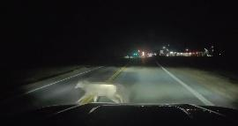
37 | Hazard | night | noaudio_c_critical_395 | 7.96 | 1.0 | vehicle | right | Loss of control of a vehicle in the adjacent lane in snowy conditions | 2.28 | 1.28 | 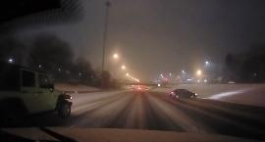
38 | Hazard | night | noaudio_c_critical_405 | 7.96 | 1.52 | vehicle | right | Vehicle breaks into the lane of traffic, cutting us off in snowy conditions | 2.34 | 0.82 | 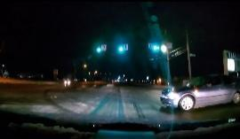
39 | Hazard | night | noaudio_c_critical_417 | 8.0 | 3.6 | vehicle | right | Crash crash of a vehicle against the security wall | 4.2 | 0.61 | 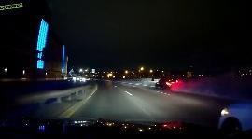
40 | Hazard | night | noaudio_c_critical_435 | 8.04 | 5.7 | pedestrian | left | Pedestrian crossing right of way | 6.55 | 0.85 | 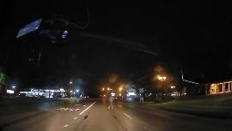
41 | Safe | day | noaudio_c_005_no_event | 10.07
42 | Safe | day | noaudio_c_006_no_event_2 | 8.0
43 | Safe | day | noaudio_c_012_no_event_1 | 8.01
44 | Safe | day | noaudio_c_013_no_event_1 | 8.03
45 | Safe | day | noaudio_c_016_no_event_1 | 8.01
46 | Safe | day | noaudio_c_018_no_event_1 | 8.0
47 | Safe | day | noaudio_c_019_no_event_1 | 8.08
48 | Safe | day | noaudio_c_024_no_event_1 | 8.03
49 | Safe | day | noaudio_c_033_no_event_1 | 6.0
50 | Safe | day | noaudio_c_036_no_event_2 | 8.03
51 | Safe | day | noaudio_c_039_no_event_2 | 10.27
52 | Safe | day | noaudio_c_041_no_event_1 | 8.0
53 | Safe | day | noaudio_c_041_no_event_3 | 8.07
54 | Safe | day | noaudio_c_044_no_event_1 | 8.08
55 | Safe | day | noaudio_c_046_no_event_1 | 8.08
56 | Safe | day | noaudio_c_047_no_event_1 | 8.0
57 | Safe | day | noaudio_c_049_no_event_2 | 8.03
58 | Safe | day | noaudio_c_049_no_event_3 | 8.0
59 | Safe | day | noaudio_c_050_no_event_3 | 8.0
60 | Safe | day | noaudio_c_054_no_event_2 | 8.04
61 | Safe | night | noaudio_c_no_event_011 | 8.1
62 | Safe | night | noaudio_c_no_event_070 | 8.14
63 | Safe | night | noaudio_c_no_event_072 | 8.0
64 | Safe | night | noaudio_c_no_event_084 | 8.0
65 | Safe | night | noaudio_c_no_event_090 | 8.02
66 | Safe | night | noaudio_c_no_event_098 | 8.07
67 | Safe | night | noaudio_c_no_event_125 | 8.03
68 | Safe | night | noaudio_c_no_event_125b | 8.0
69 | Safe | night | noaudio_c_no_event_163 | 8.01
70 | Safe | night | noaudio_c_no_event_186 | 8.01
71 | Safe | night | noaudio_c_no_event_200 | 8.03
72 | Safe | night | noaudio_c_no_event_209 | 8.1
73 | Safe | night | noaudio_c_no_event_291 | 2.51
74 | Safe | night | noaudio_c_no_event_291b | 4.93
75 | Safe | night | noaudio_c_no_event_317 | 4.23
76 | Safe | night | noaudio_c_no_event_323 | 1.75
77 | Safe | night | noaudio_c_no_event_334b | 10.6
78 | Safe | night | noaudio_c_no_event_359 | 5.8
79 | Safe | night | noaudio_c_no_event_362 | 5.0
80 | Safe | night | noaudio_c_no_event_376 | 7.11
Reference:
Song, J., Kosovicheva, A. & Wolfe, B. Road Hazard Stimuli: Annotated naturalistic road videos for studying hazard detection and scene perception. Behav Res 56, 4188–4204 (2024). https://doi.org/10.3758/s13428-023-02299-
Section B - Full Model Estimates
Table B1: GLMM fixed-effects estimates for Response Accuracy
 | Estimate | SE | t-score | p-value
(Intercept) | 2.69 | 0.07 | 36.28 | <.001 | ***
Confidence bias | -0.04 | 0.01 | -4.42 | <.001 | ***
Hazard | 0.21 | 0.06 | 3.43 | <.001 | ***
Nighttime | -0.29 | 0.06 | -4.82 | <.001 | ***
Confidence bias x Hazard | 0.005 | 0.009 | 0.55 | .581
Confidence bias x Daytime | -0.003 | 0.009 | -0.35 | .729
Hazard x Daytime | -0.41 | 0.06 | -6.79 | <.001 | ***

Table B2: LMM fixed-effects estimates for Reaction Times (RTs)
 | Estimate | SE | df | t-score | p-value
(Intercept) | 826.12 | 46.00 | 62.96 | 17.96 | <.001 | ***
Confidence bias | -4.46 | 5.88 | 63.01 | -0.76 | .451
Nighttime | -98.83 | 17.41 | 2387.29 | -5.68 | <.001 | ***
Table B3: LMM fixed-effects estimates for Subjective Risk Estimation
 | Estimate | SE | df | t-score | p-value
(Intercept) | 3.79 | 0.08 | 63.00 | 50.52 | <.001 | ***
Confidence bias | -0.004 | 0.01 | 63.02 | -0.41 | .683
Hazard | 1.77 | 0.02 | 5103.03 | 93.87 | <.001 | ***
Nighttime | 0.17 | 0.02 | 5103.03 | 8.78 | <.001 | ***
Confidence bias x Hazard | 0.01 | 0.002 | 5103.03 | 5.50 | <.001 | ***
Confidence bias x Daytime | -0.0004 | 0.002 | 5103.03 | -0.18 | .860
Hazard x Daytime | 0.15 | 0.02 | 5103.03 | 8.25 | <.001 | ***
Significance: *: p < .05; **: p < .01; ***: p < .001.

