Supplemental Table 1: Characteristics of participating hospitals
Centre | VINCat Group (by number of beds) | Complexity Level | Hospital stays (2022) | Hospital admissions (2022)
Hospital Universitari Mútua de Terrassa | Group 1  (>500 beds) | Reference hospital | 85.860 | 12.623
Hospital Germans Trias i Pujol | Group 1  (>500 beds) | High technology hospital | 176.980 | 24.778
Hospital de Sant Pau | Group 1  (>500 beds) | High technology hospital | 158.318 | 23.151
Hospital de Bellvitge | Group 1  (>500 beds) | High technology hospital | 238.464 | 38.430
Hospital de Barcelona | Group 2  (200-500 beds) | High technology hospital | 67.371 | 11.444
Hospital Josep Trueta de Girona | Group 1  (>500 beds) | Reference hospital | 108.722 | 19.837
Hospital Parc Taulí | Group 1  (>500 beds) | Reference hospital | 175.474 | 27.118
Hospital de Terrassa | Group 2  (200-500 beds) | Community hospital | 91.021 | 22.851

Supplemental Figure 1. Recommendations included in the catheter insertion and maintenance bundles.
Supplemental Figure 1 Legend: The bundles comprised appropriate catheter and insertion site selection, hand hygiene, skin antisepsis with 2% alcoholic chlorhexidine, the use of appropriate materials, and the removal of unnecessary or suspicious catheters.

Supplemental Figure 2. Multilevel Poisson regression model including center as a random effect. Observed versus predicted incidence rates of catheter-related bacteremia (CRB) per 1,000 hospital stays (2011-2022).
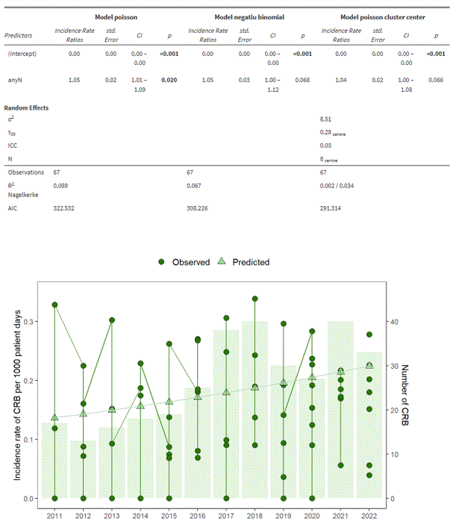

Supplemental Figure 3. Funnel Plot: Incidence Rates of Catheter-Related Bacteremia (CRB) per 1,000 Hospital Stays During the Intervention Period by Hospital and Trimester.

Supplemental Figure 3 Legend: Each dot represents the CRB incidence rate for a participating hospital during a specific trimester of the intervention period. The solid horizontal line represents the overall mean incidence rate across all hospital-trimester observations. The curved dashed lines represent the 95% confidence limits around the mean incidence rate, forming the funnel shape. Points falling outside the funnel boundaries would indicate hospitals with statistically significant deviations from the overall mean incidence rate.

Supplemental Figure 4. Funnel Plot: Incidence Rates of Catheter-Related Bacteremia (CRB) per 1,000 Hospital Stays During the Post-Intervention Period by Hospital and Trimester.
Supplemental Figure 4 Legend: Each dot represents the CRB incidence rate for a participating hospital during a specific trimester of the post-intervention period. The solid horizontal line represents the overall mean incidence rate across all hospital-trimester observations. The curved dashed lines represent the 95% confidence limits (95% CI) around the mean incidence rate. Points falling outside the funnel boundaries would indicate statistically significant variation from the overall mean.

