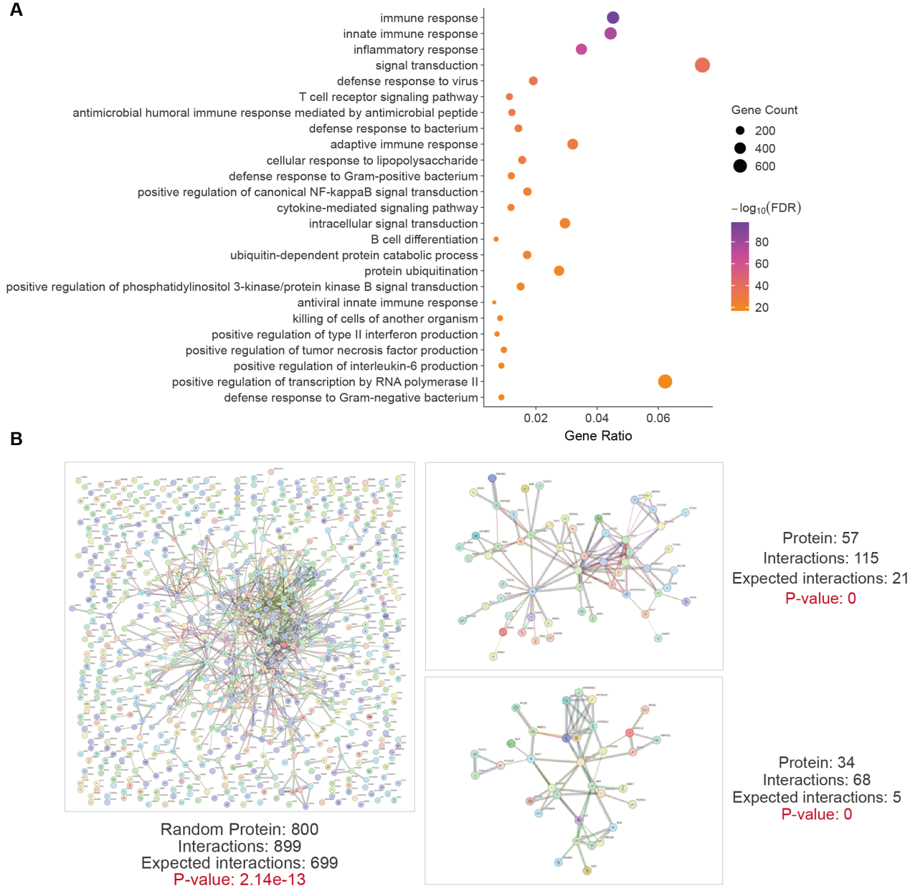
Supplementary Figure S1. Characteristics of curated immune-related genes. (A) GO enrichment analysis of the curated immune-related genes, highlighting significantly over-represented biological processes and pathways associated with immune regulation. X-axis indicates gene ratio, Y-axis indicates enriched biological functions, color of circles indicates P-value, and size of circles indicates number of genes. (B) The protein-protein interaction network of a random subset of 800 immune-related genes, as well as the interaction networks of two representative clusters derived from this subset, illustrating the highly interconnected and complex interaction patterns among immune genes. Related to Figure 1.

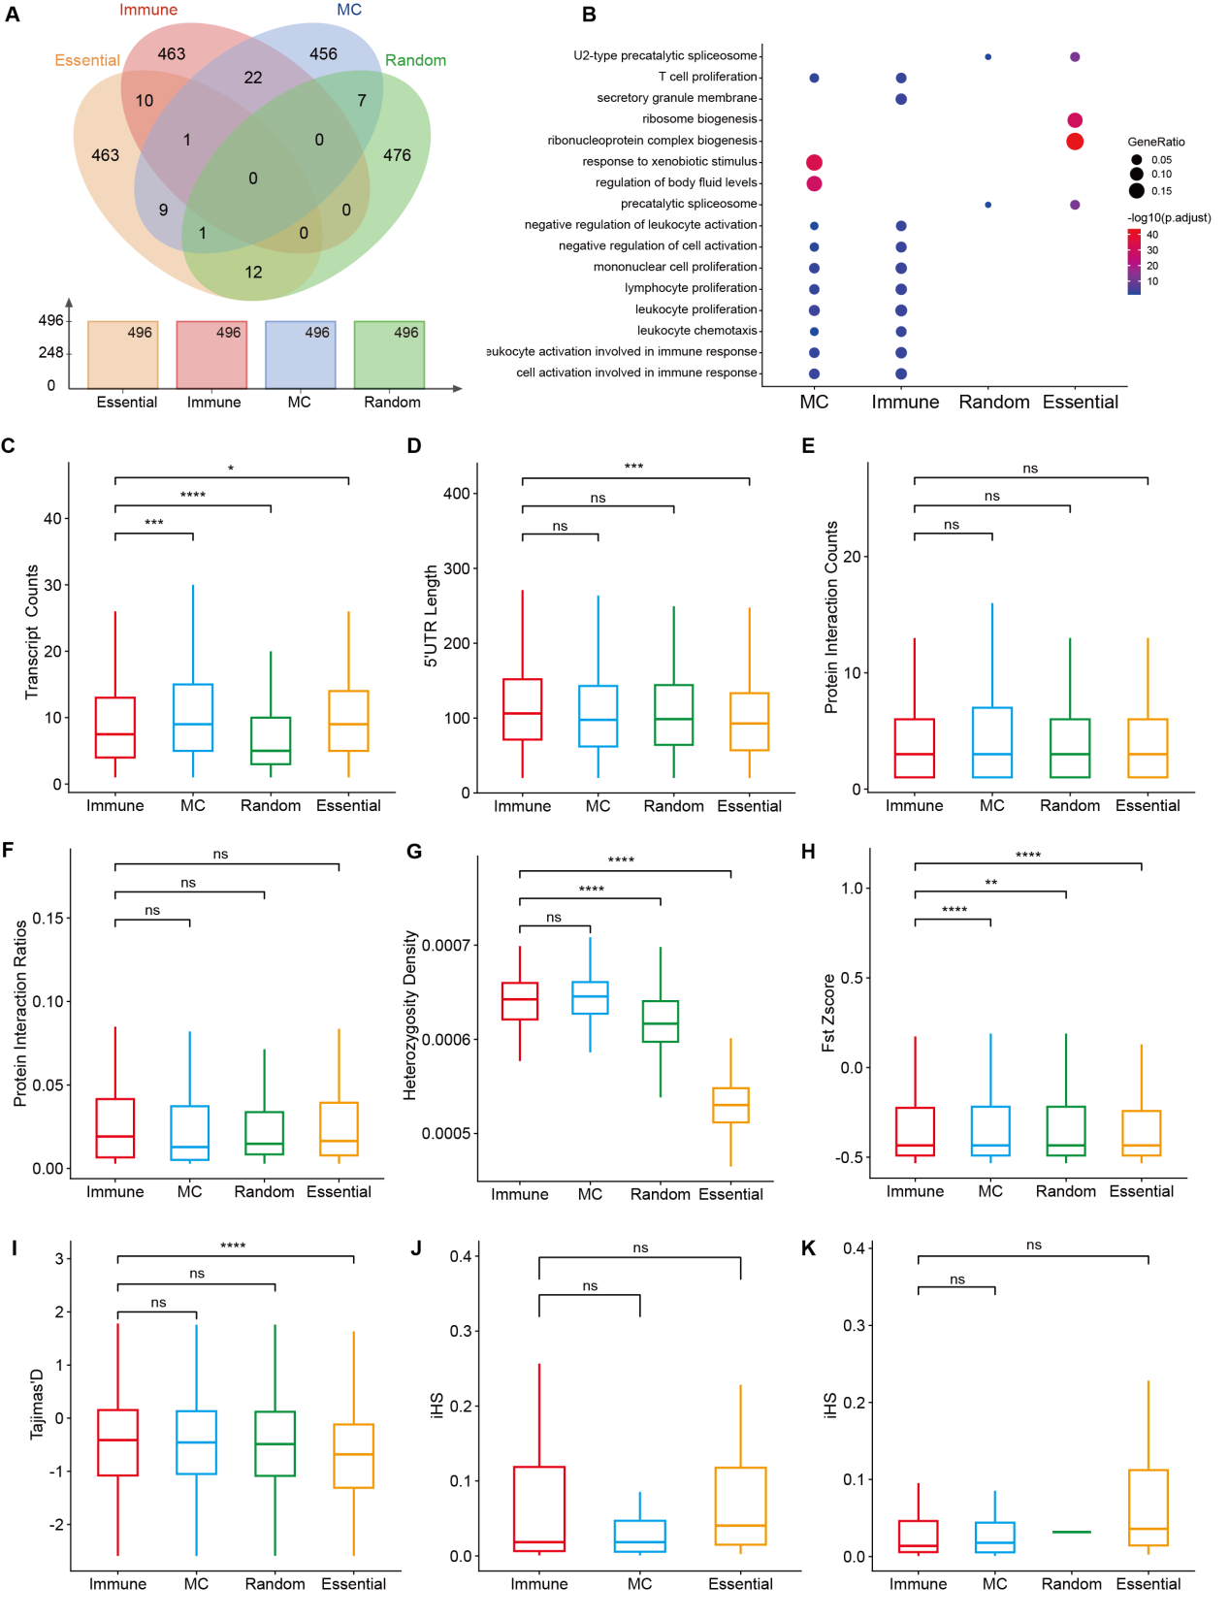
Supplementary Figure S2. Comparative functional and evolutionary characteristics of four immune-related gene categories. (A) Venn diagram showing the overlap among four immune-related gene categories. (B) GO enrichment analysis illustrating significantly enriched biological processes within each gene category. (C) Comparison of transcript counts among the four gene categories. (D) Comparison of 5’-UTR results across the four gene categories. (E) Comparison of protein interaction counts among the four gene categories. (F) Comparison of protein interaction ratios across the four gene categories. (G) Comparison of heterozygosity density across four gene categories in the CHB population. (H) Comparison of F_{ST} results represented as Z scores across the four gene categories. (I) Comparison of Tajima’s D results across four gene categories. (J) Comparison of iHS results among the three non-random gene categories. The random gene category was excluded due to having only two valid iHS values. (K) Comparison of iHS results among the four gene categories. "****" stands for P < 0.0001, "***" stands for P < 0.001, "**" stands for P < 0.01, "*" represents P < 0.05, "ns" means not significant, and all P values were calculated using the Mann–Whitney U test. Related to Figure 1.

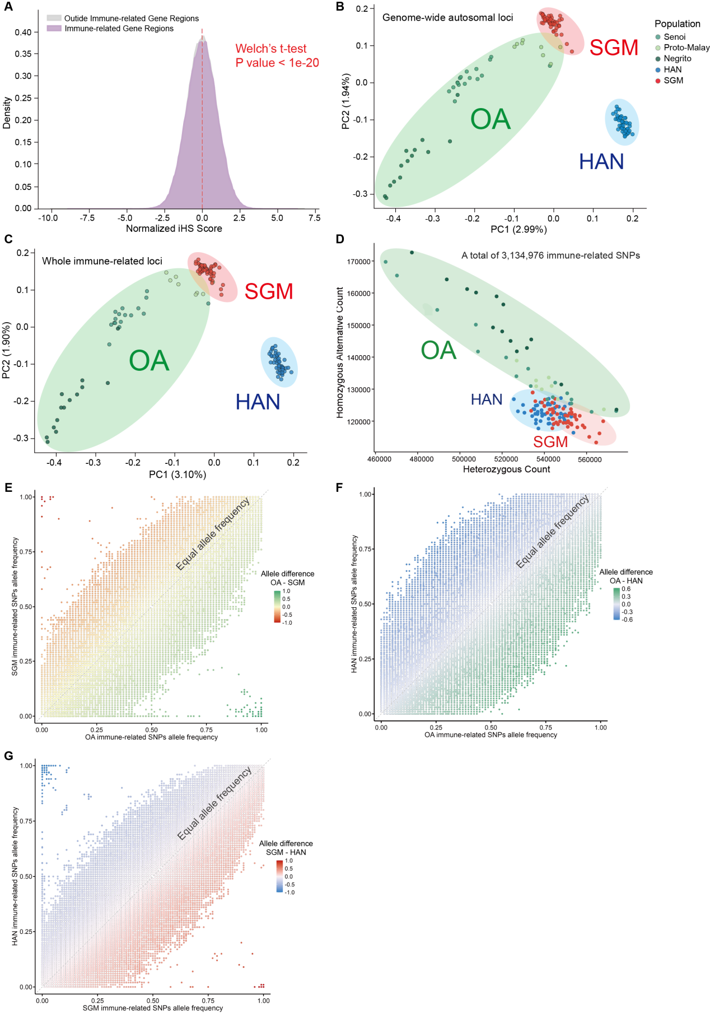
Supplementary Figure S3. Population differentiation of immune-related genetic variation among OA, SGM, and HAN populations. (A) Distribution of iHS values for immune and non-immune loci in the OA populations, with statistical comparison by Welch’s t-test. (B) Genome-wide PCA based on 9.57 million SNPs, with the first two principal components explaining 2.99% (PC1) and 1.94% (PC2) of the variance. (C) PCA restricted to 9,856 curated immune genes. PC1 (3.10%) and PC2 (1.90%) reveal enhanced differentiation between OA and reference populations (SGM/HAN). (D) The distribution of heterozygous and homozygous non-reference genotypes for immune-related SNPs across populations. A total of 3,134,976 immune-related SNPs were included in the analysis. (E) Differences in allele frequency distributions of immune-related SNPs between OA and SGM populations. (F) Differences in allele frequency distributions of immune-related SNPs between OA and HAN populations. (G) Differences in allele frequency distributions of immune-related SNPs between SGM and HAN populations. Colors indicate OA (green), SGM (red), and HAN (blue). Related to Figure 1.

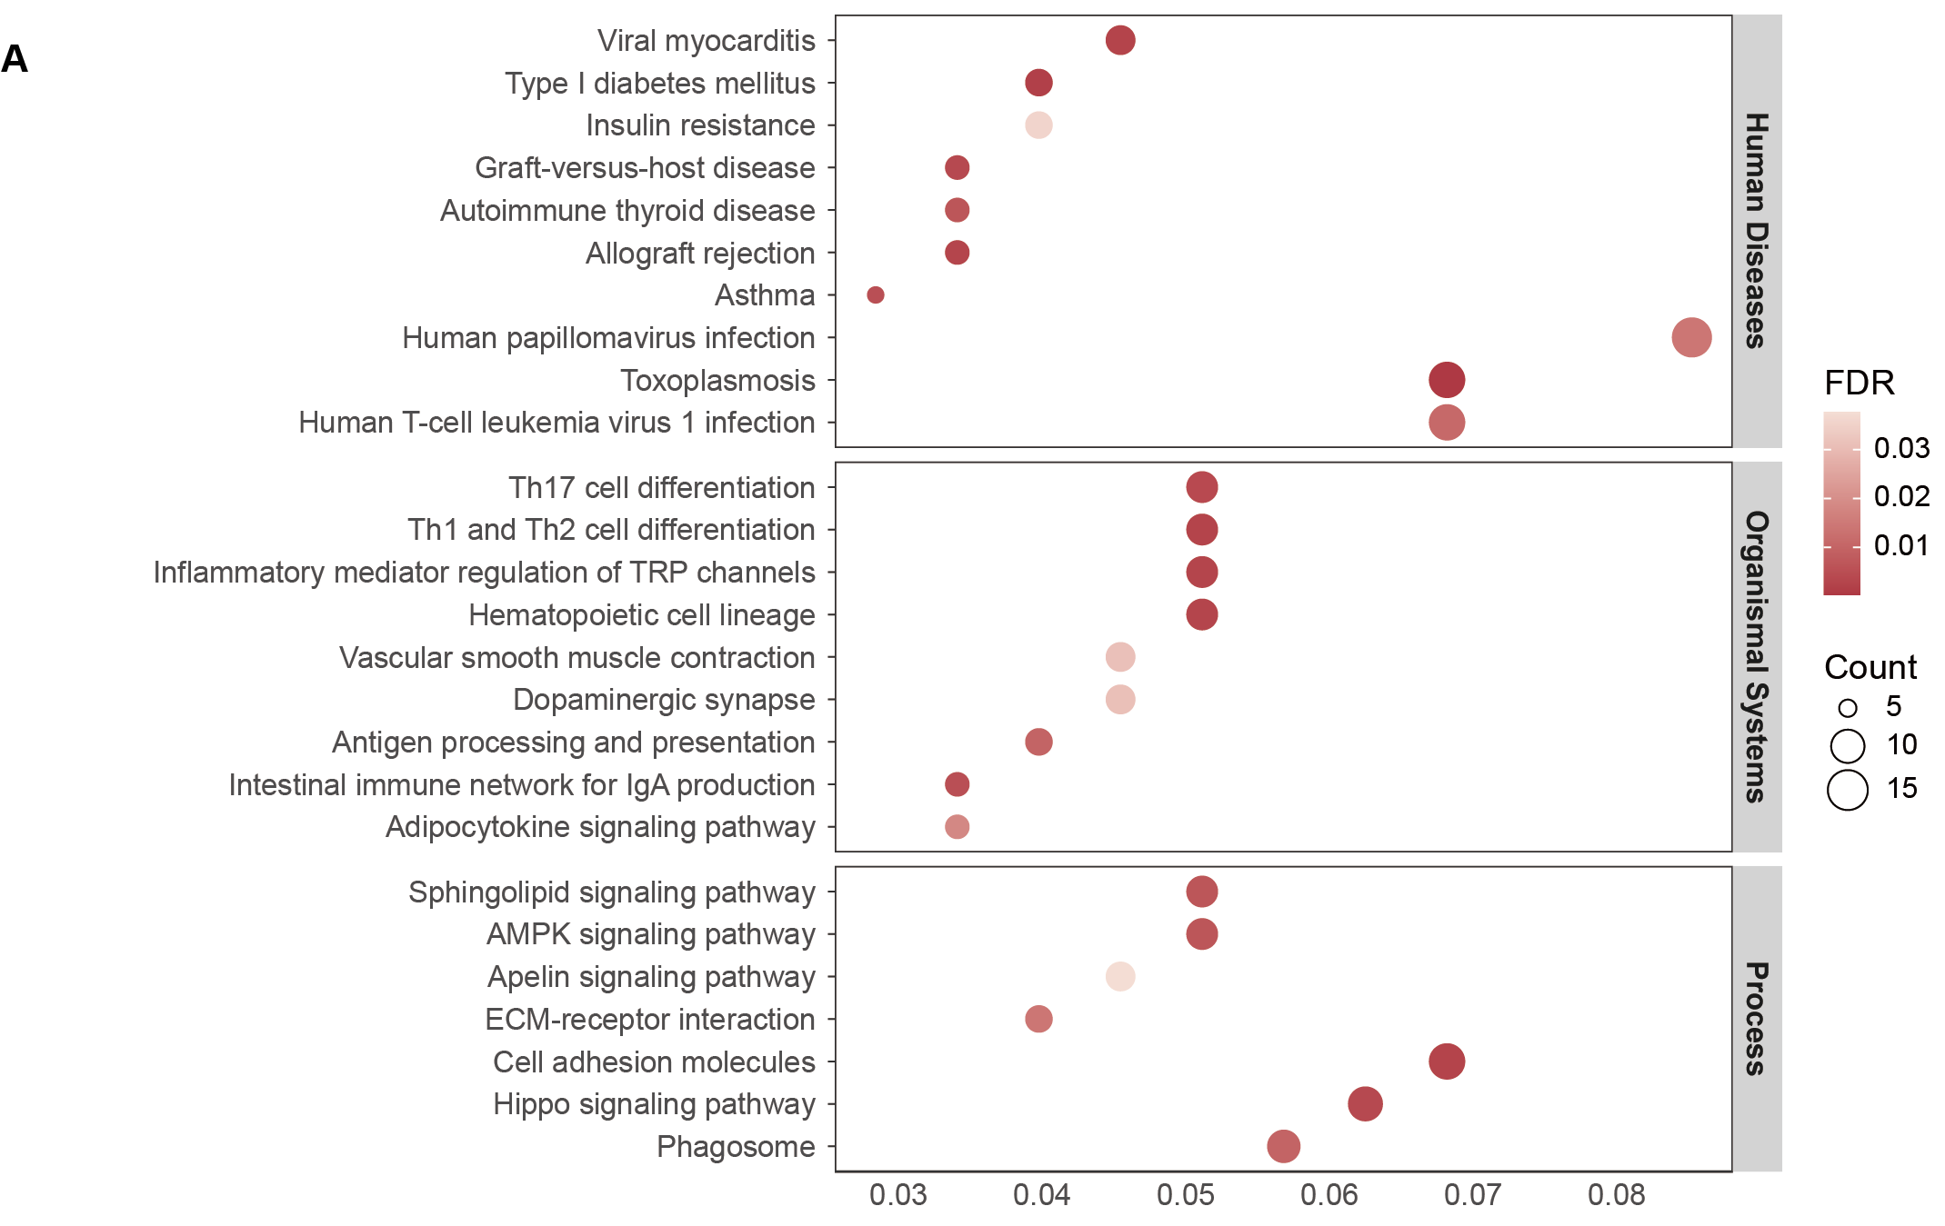
Supplementary Figure S4. KEGG enrichment analysis of immune genes under selection in OA populations. (A) The KEGG enrichment results characterize three major functional categories: Human Diseases, Organismal Systems, and Biological Processes. The color gradient of the heatmap represents the FDR for pathway enrichment, while the circle size indicates the gene count in each significantly enriched pathway. Related to Figure 2.

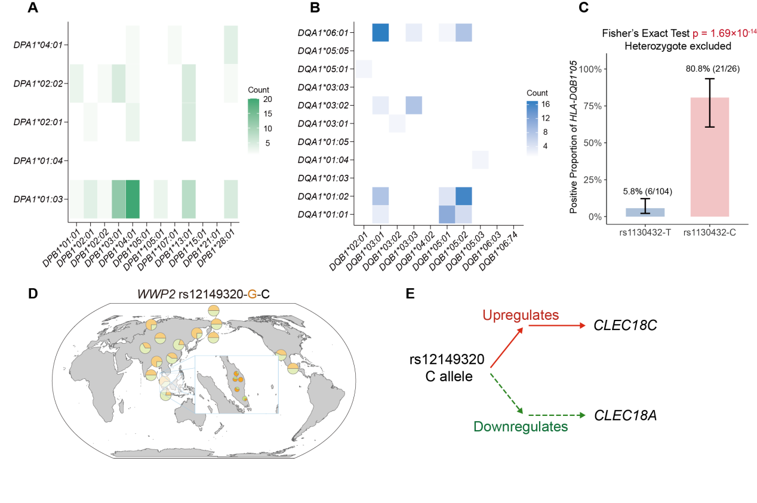
Supplementary Figure S5. Selection signals of the immune-related genes HLA-DPA1, HLA-DQB1 and WWP2 in OA populations. (A) The heatmap shows the frequency with which specific HLA-DPA1 and HLA-DPB1 alleles co-occur within individuals in the OA populations, representing their potential haplotype combinations. (B) The heatmap shows the frequency with which specific HLA-DQA1 and HLA-DQB1 alleles co-occur within individuals in OA populations, representing their potential haplotype combinations. Color intensity indicates the co-occurrence count, with higher values corresponding to more frequent joint occurrence of the allele pair. (C) Association analysis between the rs1130432 allele and the HLA-DQB1*05 allele, restricted to individuals homozygous for rs1130432. (D) Indigenous populations showing convergent allele frequencies of the WWP2 rs12149320 C allele with OA populations. (E) Regulatory trend of the rs12149320 C allele on CLEC18A and CLEC18C expression levels. Related to Figure 3.

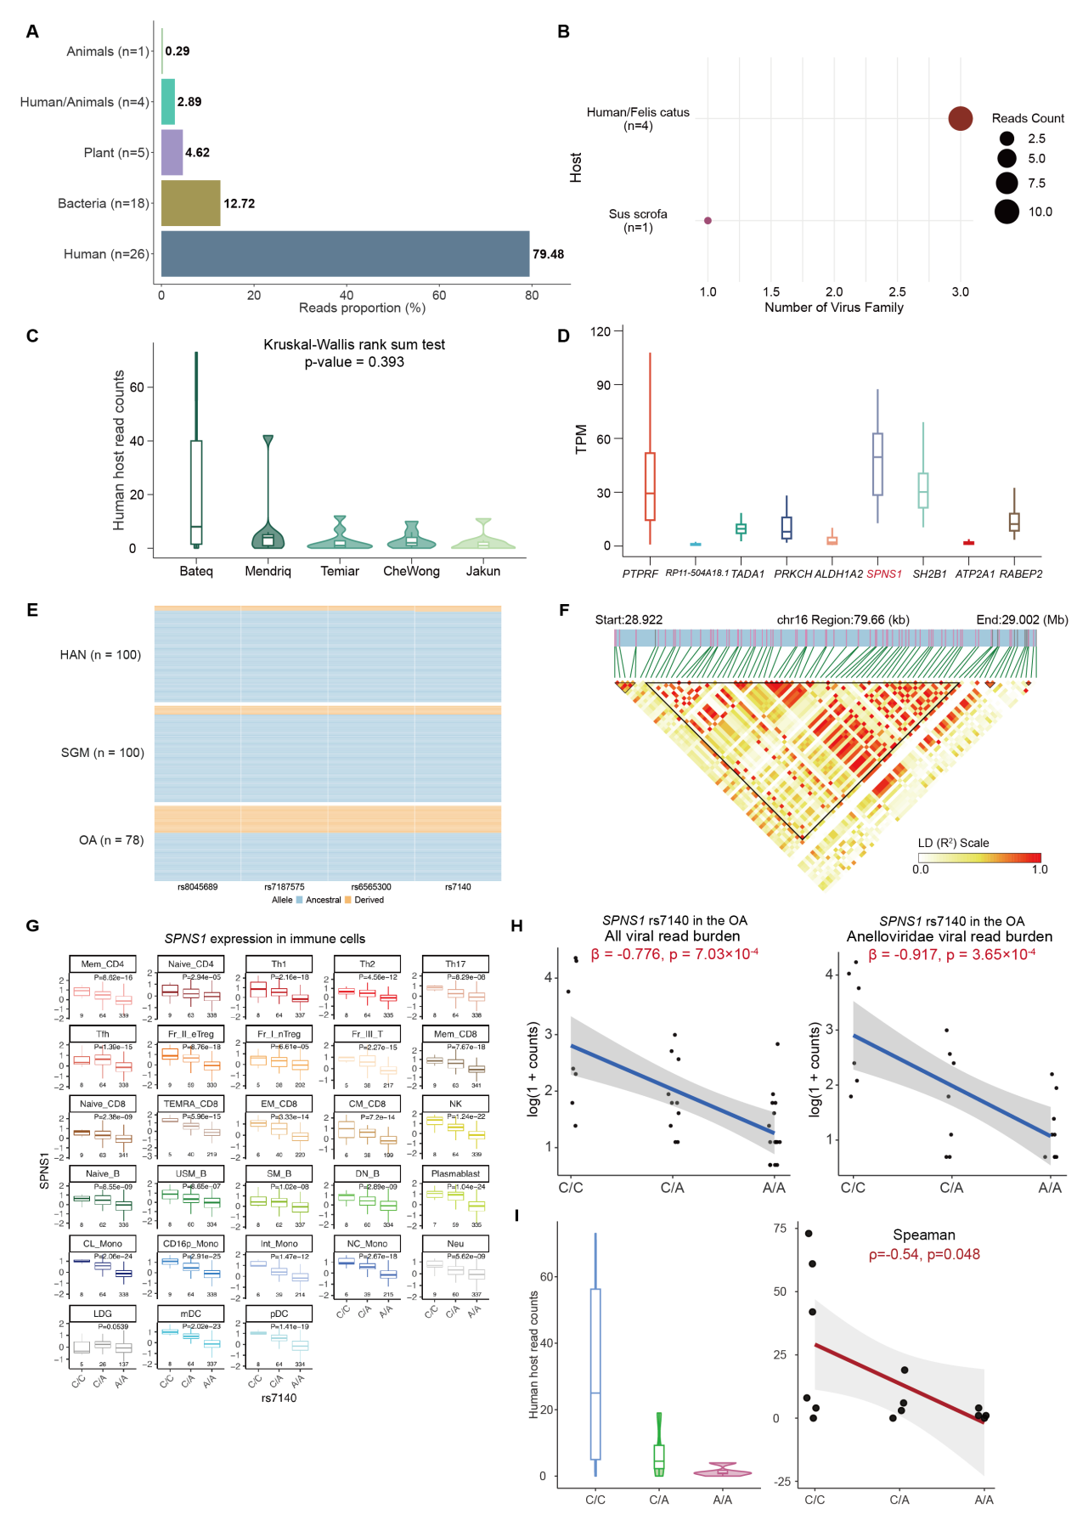
Supplementary Figure S6. Composition of the OA blood virome and functional association of the selected immune gene SPNS1. (A) Host category distribution of viral reads identified in the blood virome of OA individuals. (B) Host species composition of viral reads detected in OA blood viromes. (C) Distribution of individual-level human-host viral read counts among five OA sub-populations (Bateq, CheWong, Jakun, Mendriq, and Temiar). Although the number of human-host viral reads varied across populations, no significant differences were observed (Kruskal–Wallis test, P = 0.393). (D) Expression (TPM) of genotype–virome association signal genes in GTEx Whole Blood. FYB2 was not included in the whole Whole Blood dataset and is therefore not shown. (E) Haplotype structure of selected SNPs in SPNS1. OA individuals exhibit a distinct haplotype configuration enriched for the selected variants. (F) Linkage disequilibrium (LD) block structure of the SPNS1 locus. A 62.92 kb LD block encompasses the four selective SNPs within SPNS1 in OA populations. (G) Regulatory effect of rs7140 on SPNS1 expression based on ImmuNexUT data. The A allele of rs7140 significantly downregulates SPNS1 expression across 27/28 (96.4%) immune cell types. (H) Association of rs7140 genotype with viral read counts in OA populations. Left: individuals carrying the A allele show reduced levels of total viral reads in blood. Right: the same allele is associated with lower Anelloviridae-specific viral read counts. (I) Individuals carrying the A allele of rs7140 exhibit significantly reduced levels of human-host viral reads in blood of Negrito, consistent with the overall OA trend. Related to Figure 4.

