Supplementary tables
Table S1. Nonlinear dose–response model parameters for in vitro antibacterial activity assay
Parameter | Estimate | Standard error | 95% LCL | 95% UCL
A1 (minimum response) | –63.315 | 58.204 | -182.954 | 56.324
A2 (maximum response) | 954.774 | 51.034 | 849.873 | 1059.675
LOGx₀ (log EC₅₀) | 0.99556 | 0.03507 | 0.92348 | 1.06765
Hill slope (p) | -3.089 | 0.69599 | -4.520 | -1.659
Span | 1018.089 | 85.183 | 842.993 | 1193.186

Table S2. Effective concentrations (EC-values) for in vitro antibacterial activity assay
EC-value | Estimate (µg/mL) | Standard error | 95% LCL | 95% UCL
EC₁₀ | 20.158 | 3.518 | 12.926 | 27.390
EC₂₀ | 15.504 | 1.939 | 11.517 | 19.491
EC₅₀ | 9.898 | 0.799 | 8.255 | 11.541
EC₈₀ | 6.320 | 0.844 | 4.585 | 8.054
EC₉₀ | 4.861 | 0.895 | 3.020 | 6.701

Table S3. Model fit statistics for in vitro antibacterial activity assay
Statistic | Value
Number of data points | 30
Degrees of freedom | 26
R² | 0.924
Adjusted R² | 0.915
Reduced Chi-square | 14,133.21
Root MSE | 118.883
ANOVA F-value | 163.087
ANOVA P-value | 5.20 × 10⁻¹⁸

Table S4. Pairwise Log-rank (Mantel–Cox) comparisons among dietary caffeic acid treatments in toxicity test
Treatment | 0 mg/kg | 50 mg/kg | 100 mg/kg | 1000 mg/kg | 2000 mg/kg
0 mg/kg
50 mg/kg | 1.098 (0.295)
100 mg/kg | 2.001 (0.157) | 0.157 (0.692)
1000 mg/kg | 3.004 (0.083) | 0.545 (0.460) | 0.116 (0.734)
2000 mg/kg | 4.105 (0.043) | 1.173 (0.279) | 0.493 (0.482) | 0.139 (0.709)
Values are presented as χ² (p-value). Bold value indicates the significance between treatments of the log-rank test

Table S5. Pairwise Log-rank (Mantel–Cox) comparisons among dietary caffeic acid treatments in challenge test with Streptococcus agalactiae
Treatment | Control (-) | Control (+) | 25 mg/kg | 50 mg/kg | 100 mg/kg
Control (-)
Control (+) | 59.037 (0.000)
25 mg/kg | 35.960 (0.000) | 5.023 (0.025)
50 mg/kg | 25.725 (0.000) | 9.428 (0.002) | 0.905 (0.341)
100 mg/kg | 47.685 (0.000) | 2.267 (0.132) | 0.689 (0.406) | 3.271 (0.070)
Values are presented as χ² (p-value). Bold value indicates the significance between treatments of the log-rank test

Supplementary figures
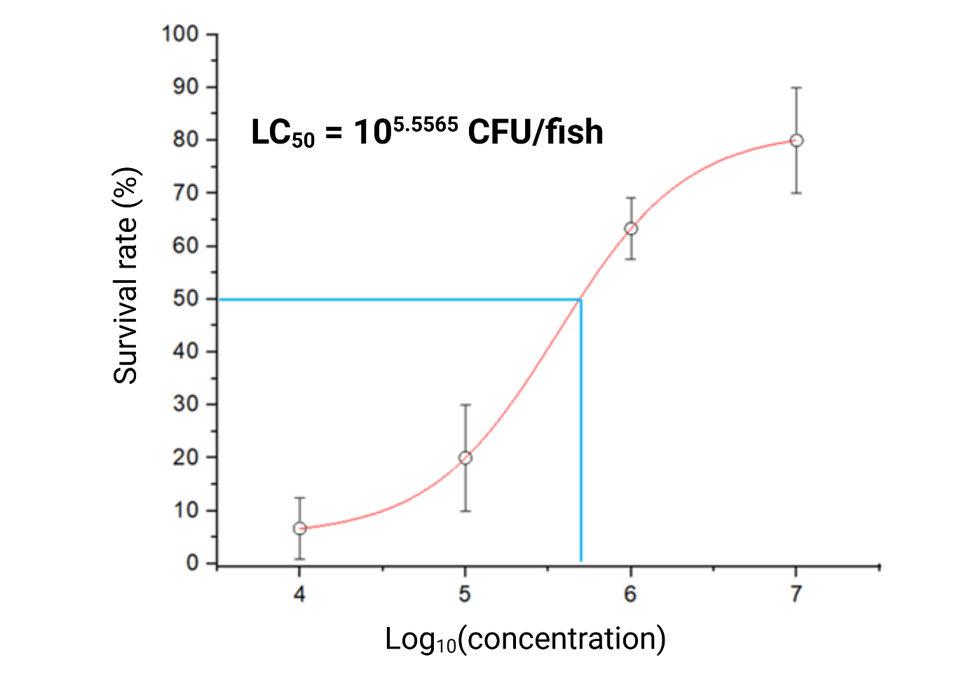
Figure S1. Dose–response curves for Streptococcus agalactiae in Asian seabass after 7 days. Survival rates (%) are plotted against the logarithm of bacterial concentration (CFU/mL). Blue lines denote the 50 % survival threshold.

