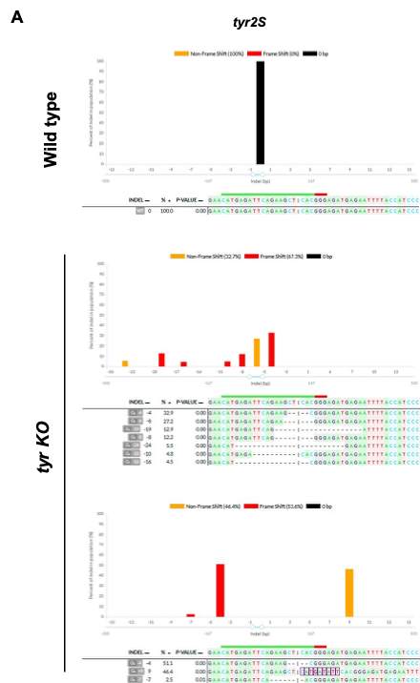

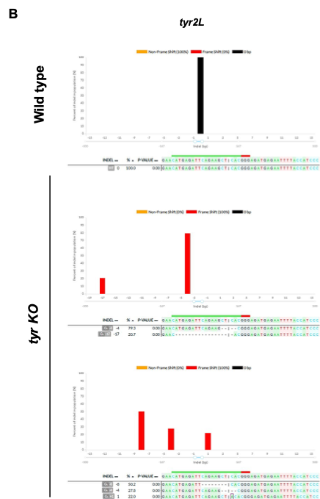

Supplementary Figure 1. Genomic analysis of mutations in tyr KO tadpoles. (A,B) TIDE (Tracking of Indels by DEcomposition) analysis showing CRISPR-induced mutations in the tyr 2S (A) and tyr 2L (B) loci in tyr KO tadpoles. Wild-type controls display only unmodified sequences (black), whereas representative tyr KO tadpoles show complete loss of the wild-type allele and the presence of 2 to 7 distinct indel mutations (orange and red).

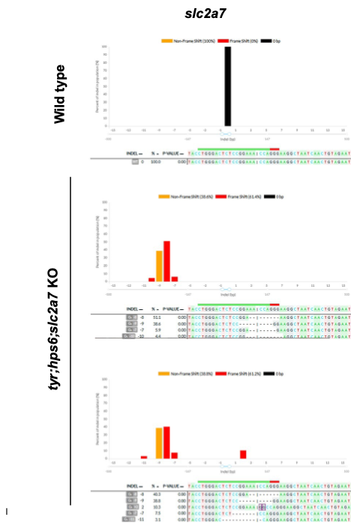

Supplementary Figure 2. Genomic analysis of slc2a7 mutations in tyr;hps6;slc2a7 KO tadpoles. TIDE analysis showing CRISPR-induced mutations in the slc2a7 locus in tyr;hps6;slc2a7 KO tadpoles. Wild-type controls display only unmodified sequences (black), whereas two representative KO tadpoles show complete loss of the wild-type allele and the presence of four and five distinct indel mutations (orange and red), respectively.

Supplementary Table 1

Gene | Forward Primer (5′→3′) | Reverse Primer (5′→3′) | Amplicon size (bp)
tyrosinase 2L | ATGGCTCCTCTTGTGGTCAG | GCATTGTGGCTTTCACCTCATA | 741
tyrosinase 2S | GCAGTTTGGTGCCTGTTGTC | GAGTGTCTTACCTGCCACGA | 821
slc2a7 | AATGAGGGTCGTCGTGTGTTT | TTTGGACTTTTAGGGGGCAGT | 636

