Supplementary Information
High-Speed Non-Volatile Barium Titanate Field Programmable Photonic Gate Array

Cristina Catalá-Lahoz^{1*}, Jose Roberto Rausell-Campo¹, Daniel Pérez-López², Lucas Güniat³, Clarissa Convertino³, Felix Eltes³, Jean Fompeyrine³, Charis Mesaritakis⁴, Adonis Bogris⁴, Quentin Wilmart⁵, Jonathan Faugier-Tovar⁵, Benoit Charbonnier⁵ and José Capmany^{1,2*}
¹Photonics Research Labs, iTEAM Research Institute, Universitat Politècnica de València, Camí de Vera s/n, Valencia, 46022, Valencia, Spain.
²iPronics Programmable Photonics S.L., Valencia, Spain
³Lumiphase AG, Laubisrütistrasse 44, 8712 Stäfa, Switzerland
⁴University of West Attica, Athens, Greece
⁵CEA-Leti, Grenoble, France

*Corresponding author(s). Email: ccatala@iteam.upv.es, jcampany@iteam.upv.es

Contents
Supplementary Note 1. Electrical driving schemes for non-volatile operation. 2
Supplementary Note 2. Setup and automated graph-based characterization of the mesh. 3
Supplementary Note 3. Extended experimental results: matrices and spectral responses. 4
Supplementary Note 4. Thermal sensitivity of the barium titanate phase shifters. 5
Supplementary Note 5. Fabrication metrology and layer thickness verification. 6

Supplementary Note 1. Electrical driving schemes for non-volatile operation.

Optical Characterization Setup
The characterization of the Non-Volatile Programmable Unit Cell (NV-PUC) was conducted using dedicated test structures fabricated on the same chip as the hexagonal mesh. The optical measurement setup utilized a tunable Continuous Wave (CW) laser (EXFO T100S-HP) acting as the light source. To ensure optimal coupling efficiency, the polarization of the input light was adjusted using a manual polarization controller prior to coupling.
Light coupling into and out of the PUC’s grating couplers was achieved using two cleaved fibers mounted on 8º tilted wedges equipped with Tapered V-Groove Fiber Holders. The optical power transmitted through the device was detected and analyzed using a programmable power meter (EXFO FTBx-1750).
Electrical Control
Electrical actuation of the PUC was performed using Radio Frequency (RF) probes with a 250 µm pitch. These probes delivered control signals generated by a dual-channel arbitrary waveform generator (Teledyne T3AFG120). The signal routing was designed to switch sequentially between an "Erase" signal and a "Write/Set" signal without manual intervention:
- Channel 1 (Erase Line): Connected to an electrical amplifier to achieve the necessary voltage compliance for domain reorganization.
- Channel 2 (Pulse Train/Write Line): Connected directly to the output switch.
Both channels were routed into a coaxial switch (Radiall R570412000LP), allowing for the precise sequential application of the erasure and setting waveforms to the PUC. Figure S1 shows a schematic of the complete setup.

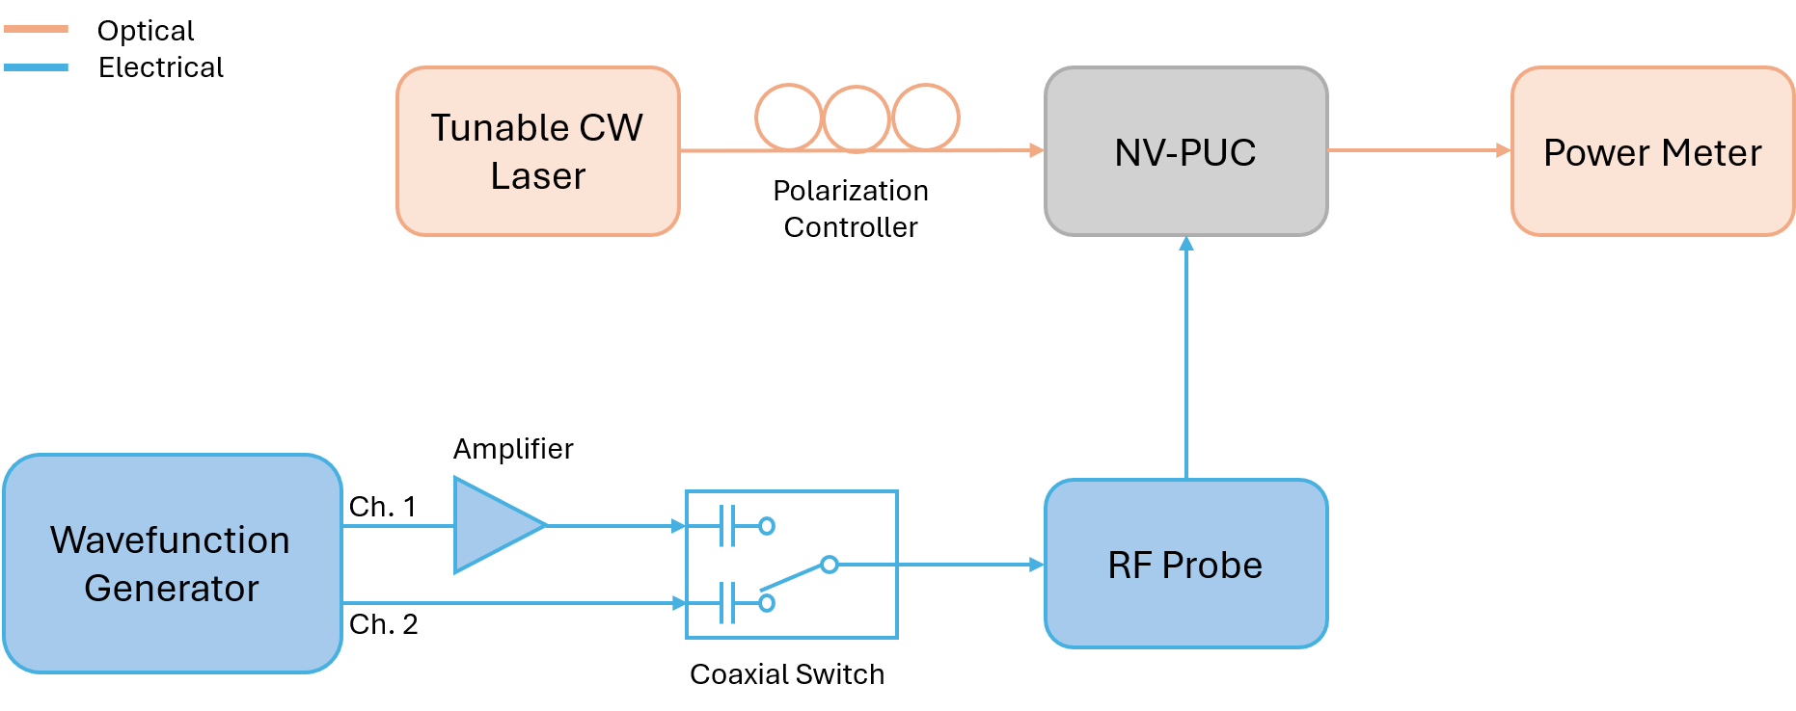
Fig. S1. Schematic of the NV-PUC Characterization Setup. The optical path consists of a tunable CW laser, a polarization controller, and a power meter. The electrical actuation is managed by a dual-channel wavefunction generator; Channel 1 (Erase) is amplified, while Channel 2 (Write) is connected directly. A coaxial switch routes the appropriate signal to the RF probe for domain erasure or state setting.
Experimental Procedure
To accurately characterize the ferroelectric switching dynamics, a four-step protocol was defined¹:
Step I: Domain Erasure (Reset). To eliminate hysteresis and history effects from previous measurements, the ferroelectric domain state was first erased. A sine wave with a frequency of 1.3 MHz was applied for a duration of 2 seconds. This signal was amplitude-modulated with a down-ramp waveform (33.33 Hz) to gradually reduce the field strength, reorganizing the domains into an arbitrary, randomized distribution.
Step II: Saturation (poling). Subsequently, two specific ferroelectric domain states (State 0 and State 1) were defined by applying a sequence of 10⁴ pulses.
- Pulse Duration: 300 ns.
- Amplitude: +5 V for State 0, -5 V for State 1.
This pulse combination results in a saturated state for both poling directions.
Step III: Set a state. After setting the initial saturated state (0 or 1), we apply a train of N pulses, each with a duration of 300 ns (with 300 ns separation as well). These pulses alternated between specific high level ($V_{HL}$) and low level ($V_{LL}$) amplitudes to induce partial switching.
Step IV: Measure. Immediately following the pulse train, the voltage source is turned off. The optical transmission is then measured to quantify the non-volatile change in the PUC state.
The temporal evolution of the applied voltage signals throughout the four phases is depicted in Fig. S2.
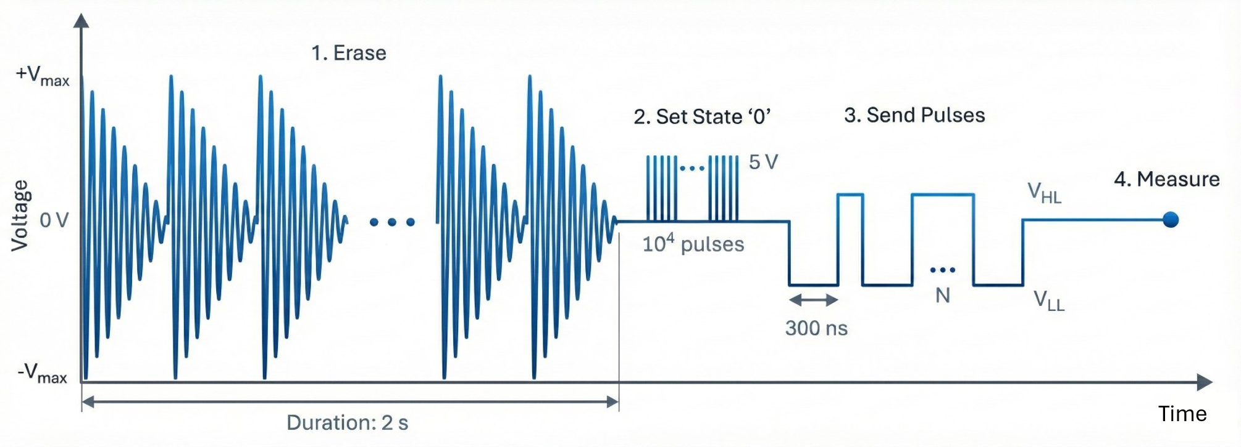
Fig. S2. Electrical actuation and measurement protocol. The characterization sequence consists of four steps. (1) Erase: A sinusoidal signal (1.3 MHz) amplitude-modulated with a down-ramp waveform (33.33 Hz) is applied for 2 s to randomize the ferroelectric domains and eliminate history effects. (2) Initialization: The device is poled into a saturated state (State ‘0’) using a sequence of 10⁴ pulses (5 V). (3) Actuation: A train of N pulses (30 ns duration, 300 ns separation) with alternating high and low amplitudes is sent to induce partial switching. (4) Measurement: The voltage is set to 0 V (zero bias) to measure the non-volatile optical transmission.
Time

Supplementary Note 2. Setup and automated graph-based characterization of the mesh.

Experimental Setup
For the mesh measurements, the device was automatically characterized using a custom-built setup. A bank of power meters (EXFO LTB-12 mainframe with FTBx-1750 modules) was employed to monitor the optical power at the mesh output ports. The active components were driven by multi-channel voltage sources (Qontrol Ltd.).
Automated Control Algorithm
The characterization routine relies on a directed graph abstraction of the mesh topology $G(V, E)$, where nodes represent the Mach-Zehnder Interferometers (MZIs) ports and edges represent the waveguide links². The characterization process consists of three main steps (see Algorithm 1):
- Pathfinding: For a given (Source, Target) pair of optical ports, the algorithm computes the shortest path using Dijkstra’s algorithm. A geometric constraint is applied to avoid physical bends exceeding a maximum angle ($θ_{max}=120$º), ensuring no return by the same MZI (although other methods such as directed graphs can be used).
- Path Optimization: Once the path is defined, the voltages of the MZIs along the path are optimized simultaneously using Particle Swarm Optimization (PSO) to maximize the optical power at the target port.
- Crosstalk Suppression: To minimize crosstalk, the algorithm identifies the "adjacent" MZIs (nodes sharing a coupler with the active path but not part of it). The main path is temporarily detuned to induce leakage, and the adjacent MZIs are then optimized via PSO to minimize the detected power at the output, effectively blocking alternative paths.
- Individual Component Characterization: With the routing configuration fully established, the system performs a sequential sweep of components. Each MZI along the path is individually swept across the voltage range 0-12 V, while keeping the rest of the path and adjacent MZIs at the optimized state. The resulting transmission curves are stored in a dataset, and the specific MZI is returned to its optimal voltage before proceeding to the next component.
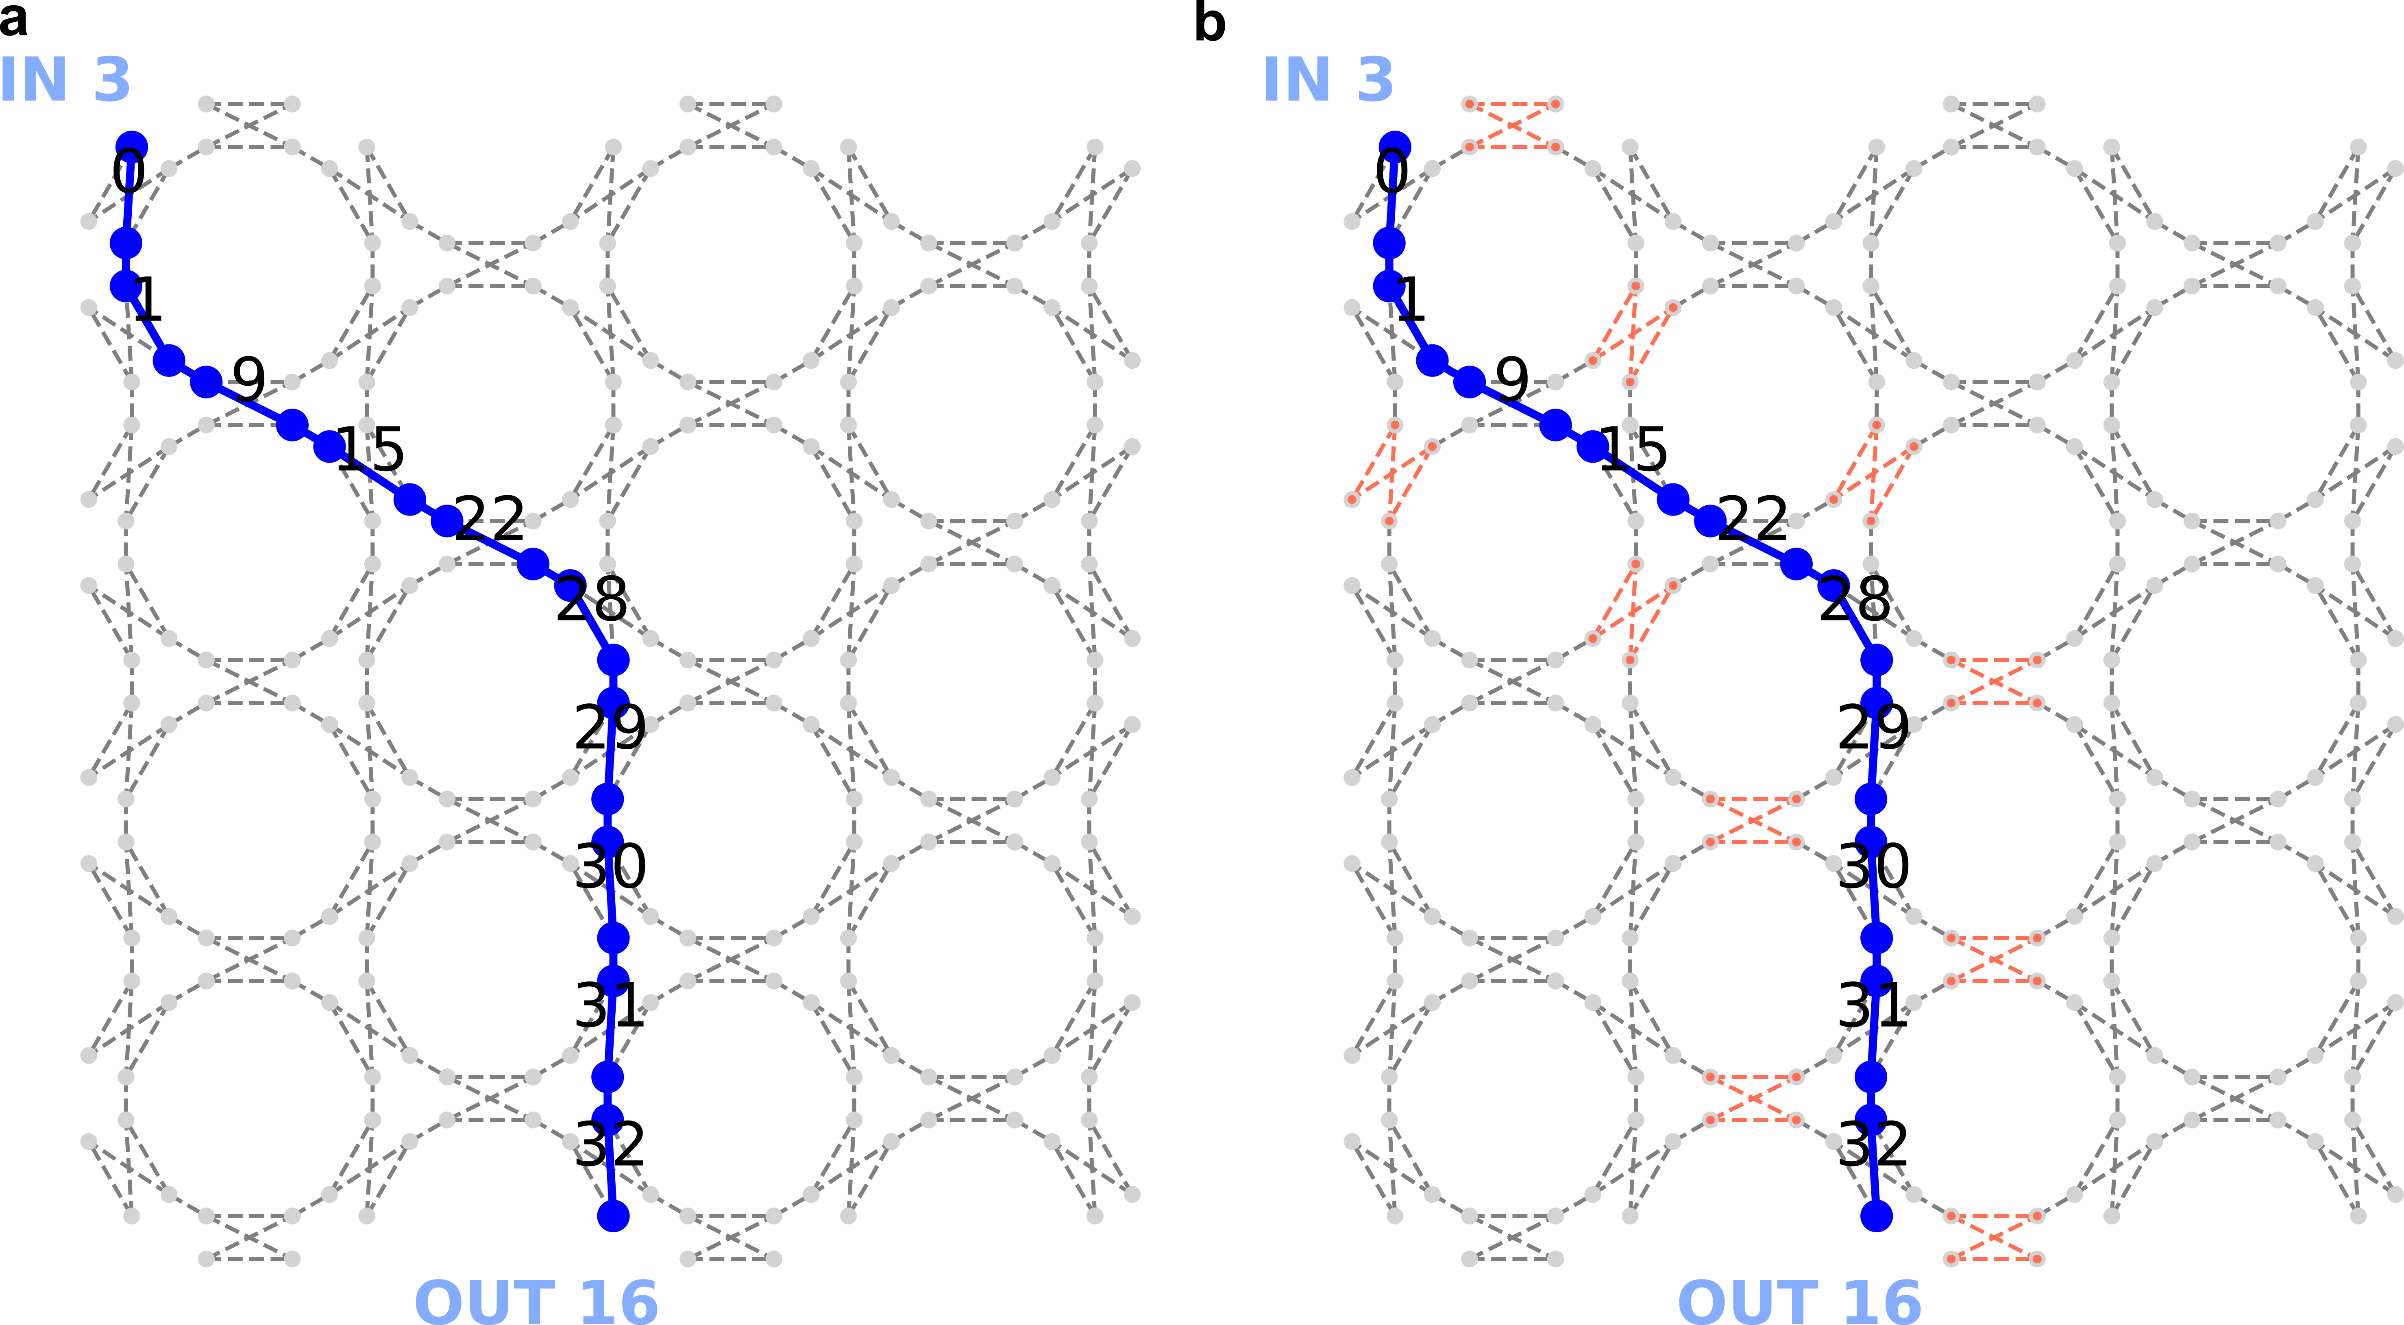
Fig. S3. Graph-based routing and crosstalk suppression strategy. a, Graph representation of the mesh topology showing the calculated shortest path (solid blue line) connecting Input 3 to Output 16. The labelled nodes correspond to the active MZIs (e.g., 0, 1, 9, 15...) whose voltages are optimized using PSO to maximize transmission. b, Visualization of the leakage suppression stage. The red dashed links indicate the adjacent MZIs and ports identified by the algorithm. These specific nodes are actively nulled to isolate the main path, minimizing optical crosstalk.
Input: Graph G, InputPort S, OutputPort T, MaxAngle θ_max
Output: Characterized Dataset for path S → T

1: // PHASE 1: Topology Analysis & Pathfinding
2: Initialize instruments (Laser, PowerMeter, VoltageSources)
3: // Find shortest valid path using Dijkstra with angle constraint
4: Path, MZIs_Active ← Pathfinder(G, S, T, θ_max)
5: If Path is empty then Return Error

6: // PHASE 2: Main Path Optimization
7: Define Objective_Max(v):
8: Apply voltages v to MZIs_Active
9: Return -ReadPower(T) // Negative for minimization solver
10: v_path ← PSO_Optimize(Objective_Max, bounds=[0, V_π], iterations=60)
11: ApplyVoltage(MZIs_Active, v_path)

12: // PHASE 3: Leakage (Null Adjacent Nodes)
13: // Temporarily detune main path to force light into adjacent nodes
14: v_detuned ← v_path ± δ_leak
15: ApplyVoltage(MZIs_Active, v_detuned)
16: MZIs_Adj ← FindAdjacentNodes(G, Path)
17: Define Objective_Min(v):
18: Apply voltages v to MZIs_Adj
19: Return ReadPower(T) // Minimize leakage power
20: v_adj ← PSO_Optimize(Objective_Min, bounds=[0, V_π], iterations=60)
21: ApplyVoltage(MZIs_Adj, v_adj)
22: ApplyVoltage(MZIs_Active, v_path) // Restore optimal path

23: // PHASE 4: Sequential Sweep and Data Collection
24: Initialize Dataset D
25: For each mzi in MZIs_Active do:
26: // Sweep current MZI from 0 to 12V
27: SweepVoltage(mzi, range=[0, 12.0])
28: Curve_Data ← RecordPower(T)
29: Store Curve_Data in D
30: // Restore optimal voltage for this MZI
31: ApplyVoltage(mzi, v_path[mzi])
32: End For
33: Return D

Algorithm 1. Pseudo-code for the automated mesh characterization algorithm.

Supplementary Note 3. Extended experimental results: reconfigurable filtering.

Complementing the representative filter demonstrations discussed in the main text, this section presents the complete measurements of the synthesized optical filters, extending the analysis to configurations with longer cavity lengths and higher delays.
Optical Ring Resonators (IIR Filters)
In addition to the cavities discussed in the main text ($L_{r} = 6L_{PUC}$ and $10L_{PUC}$), we implemented a larger ring topology. Figure S4 summarizes the three synthesized topologies. The extended configuration (Ring 3) utilizes a cavity length of $14L_{PUC}$, achieving a reduced Free Spectral Range (FSR) of 44.5 pm.
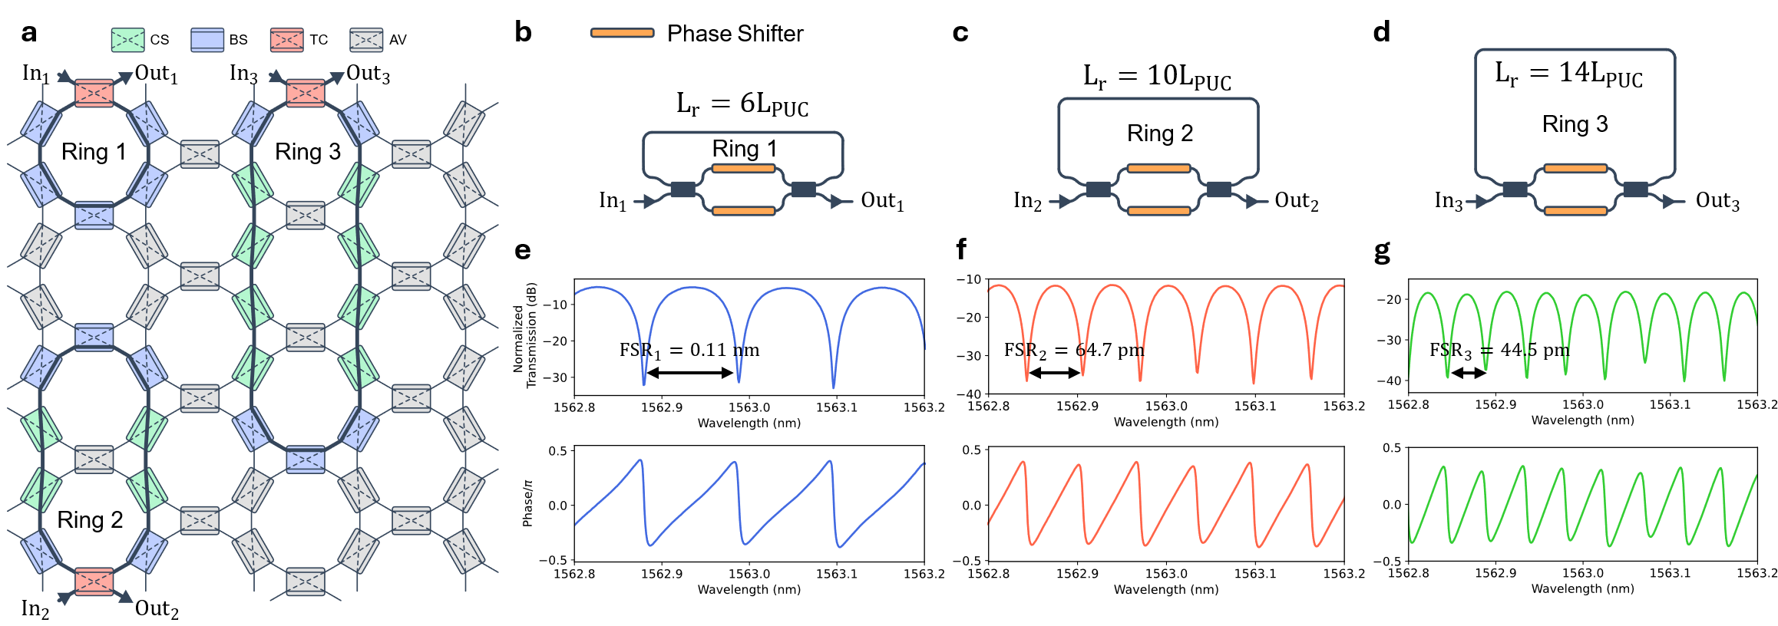
Fig. S4. Extended characterization of Optical Ring Resonators (ORRs). a, Schematic representation of the photonic mesh configured to support three distinct ring topologies. b–d, Block diagrams of the synthesized cavities. e–g, Measured normalized transmission spectra (top) and phase response (bottom).
Unbalanced Mach-Zehnder Interferometers (FIR Filters)
Similarly, the main text introduced finite impulse response filters with path differences of $ΔL = 2L_{PUC}$ and $4L_{PUC}$. Here, we extend these measurements to a high-order delay line configuration with $ΔL = 8L_{PUC}$ (Fig. S5). This configuration (UMZI 3) yields the finest spectral resolution among the FIR filters tested, with a measured FSR of 78.1 pm.
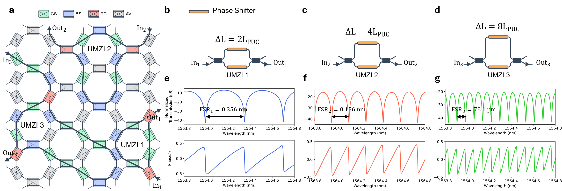
Fig. S5. Extended characterization of Unbalanced Mach-Zehnder Interferometers (UMZIs). a, Mesh topology showing the routing for three UMZIs with increasing delay lines. b–d, Diagrams illustrating the path length differences. e–g, Experimental spectral characterization. The plots display the transmission (top) and phase (bottom).

Supplementary Note 4. Thermal sensitivity of the barium titanate phase shifters.

To ensure the stability of the electro-optic reconfiguration, we characterized the thermal sensitivity of the Barium Titanate (BTO) phase shifters. A representative MZI within the mesh was isolated and characterized under varying thermal conditions using a Thermo-Electric Cooler (TEC) to precisely control the chip temperature. We performed voltage sweeps from 0 to 12 V at three distinct temperature setpoints: 20ºC, 25ºC, and 30ºC. As shown in Fig. S6, deviations in the operating temperature induce a shift in the phase response, altering the bias voltage required to achieve destructive interference. The voltage deviation between 25º and 20ºC is 0.45 V and between 25º and 30ºC is 0.24 V. That is why it is necessary to maintain the same temperature during characterization and measurements. Notably, the measurement at 25ºC (orange curve) exhibited the deepest resonance dip, achieving 42 dB of rejection. Conversely, deviations to 25ºC and 30ºC resulted in a degradation of the ER and a spectral shift. Consequently, a constant temperature of 25ºC was selected and actively maintained via the TEC for all the experiments presented in this work.
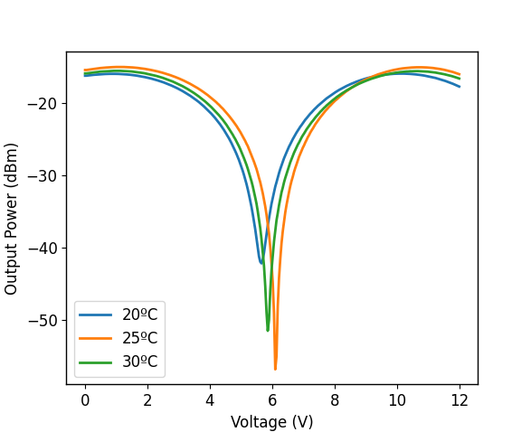
Fig. S6. Thermal dependence of a MZI with BTO phase shifters.

Supplementary Note 5. Fabricated silicon waveguide.

The photonic circuitry was processed on 200 mm base wafers fabricated at CEA-Leti using a silicon-on-insulator (SOI) platform featuring a 3 µm thick buried oxide (BOX) layer. While the platform is nominally based on a 220 nm silicon layer, characterization of the actual fabricated structures was verified.
To prepare a surface suitable for the heterogeneous integration of BTO, a planarized top cladding was required. The targeted top oxide thickness was 350 nm, which was achieved through a sequence of oxide deposition followed by a planarization step using Chemical-Mechanical Polishing (CMP).
Final validation was performed using Scanning Electron Microscopy (SEM) on a cross-section (Fig. S7). The imaging confirmed a robust rectangular waveguide profile with a core width of approximately 512.6 nm and a height of 242.5 nm. Furthermore, the critical top oxide thickness was measured at 365.7 nm. This value slightly exceeds the nominal target but ensures a sufficient planarization margin for the subsequent direct wafer bonding of the BTO film.

Fig. S7. Cross-sectional SEM analysis of the fabricated silicon waveguide.

References

1. Geler-Kremer, J. et al. A ferroelectric multilevel non-volatile photonic phase shifter. Nat. Photon. 16, 491–497 (2022).
2. Lopez-Hernandez, A., Gutierrez-Zubillaga, M. & Perez-Lopez, D. Automatic Self-calibration of Programmable Photonic Processors. in 2022 IEEE Photonics Conference (IPC) 1–2 (Institute of Electrical and Electronics Engineers Inc., Vancouver, 2022). doi:10.1109/IPC53466.2022.9975587.

