Supplementary information for
Scalable additive manufacturing via integral image formation

Seok Kim^{1,2}, Jordan Jerome Handler³, Young Tae Cho², George Barbastathis^{1,4},
and Nicholas Xuanlai Fang¹*

¹Department of Mechanical Engineering, Massachusetts Institute of Technology, Cambridge, MA 02139, USA.
²Department of Mechanical Engineering, Changwon National University, Changwon, South Korea.
³Sloan School of Management, Massachusetts Institute of Technology, Cambridge, MA 02142 USA.
⁴Singapore-MIT Alliance for Research and Technology (SMART) Centre, 1 Create Way, Singapore 138602.
*e-mail: nicfang@mit.edu

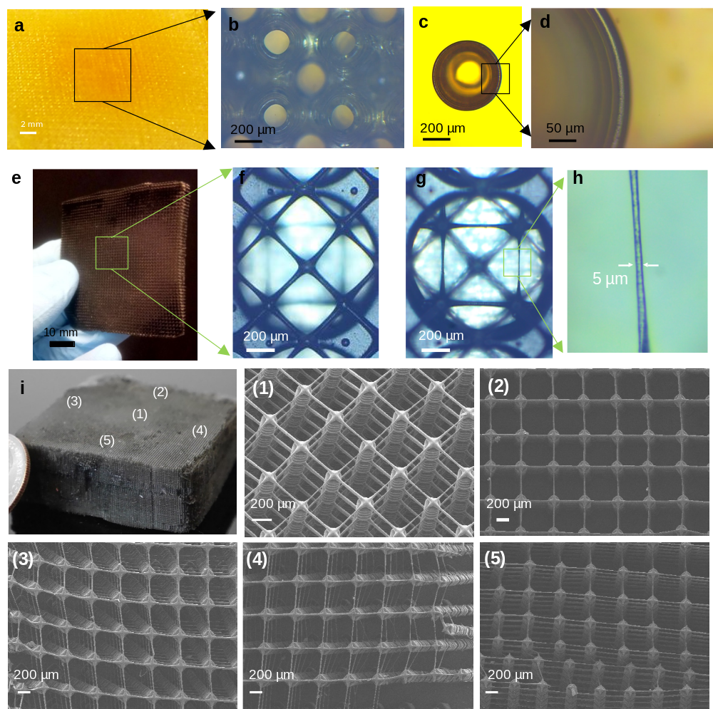

Figure S1. Optical microscope images of 3D-printed microstructures of Fig. 1 in the main text: (A-B) Triply periodic bicontinuous microstructures (total layers with slicing thickness of 50 µm: 60). (C-D) Trapezoidal shell-type microstructures with reentrant geometry (total layers with slicing thickness of 20 µm: 20). (E-H) An architecture of free-standing microfiber arrays with diameters 5 - 20 µm and an overall size of ~ 50 × 50 mm². (I) Scanning electron micrograph (SEM) of cubic-truss microlattices in Fig. 1B for validating a uniformity in the printed sample.

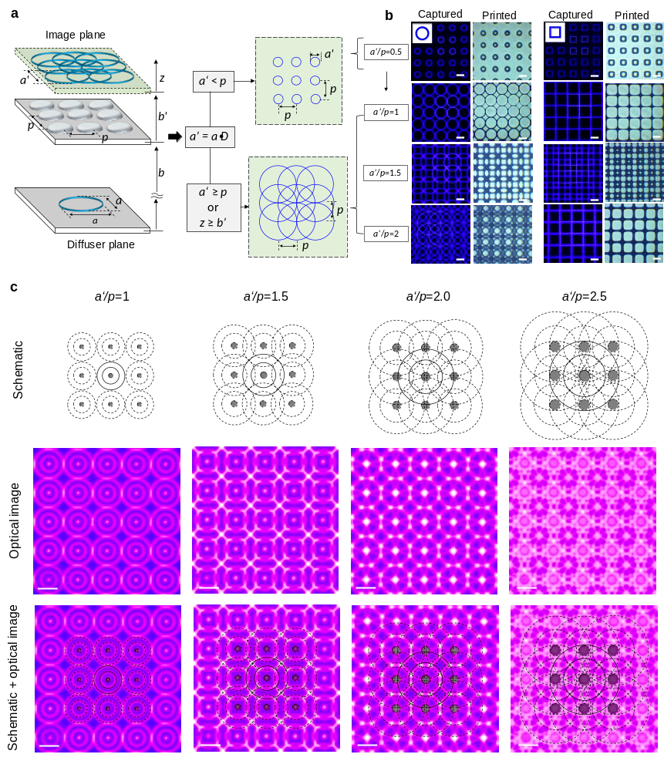
Figure S2. (A) The geometric relationship between the lens array and an input object. (B) The captured optical microscope and printed structures via photopolymerization. Parallel replication of a single object image by the lens array, which captures an object image and generates an array of repetitive patterns (a'/p < 1). Kaleidoscopic interwoven patterns form through the overlap and superposition of multiple replicated images based on the interaction between the lens array and a single object image (a'/p ≥ 1). (C) Kaleidoscopic patterns of a concentric circular grating with varying a'/p. Illustrative schematics and optical image are provided on the top and middle, respectively. All scale bars are 100 μm.
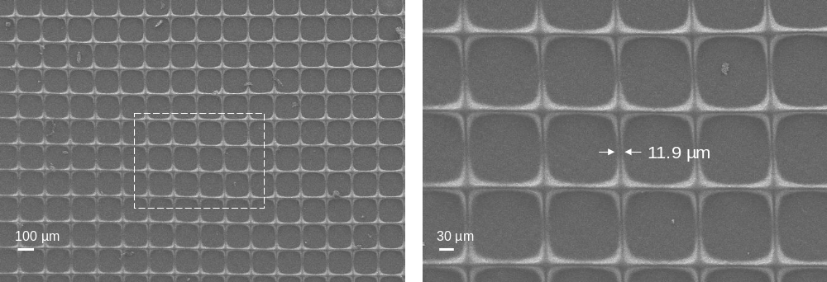
Figure S3. SEM of square kaleidoscopic interwoven patterns (a'/p = 1) with the minimum feature size of 11.9 µm in Fig, S2B. These structures were produced with Lens 2, defined within the caption of Fig. 4 and in the Methods section).

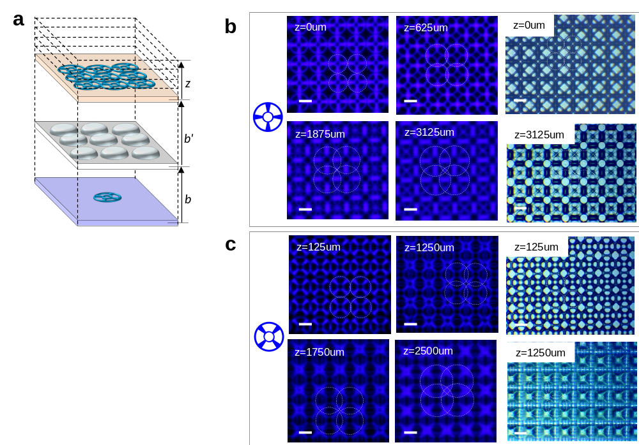
Figure S4. Out-of-plane image-based kaleidoscopic patterns with periodic optical distribution at different propagation distance along z (z ≥ b’). (A) Replicated patterns with an array-lens, including distance definitions. (B-C) Various kaleidoscopic images and printed structures. Object image is provided on the left. All scale bars are 100 μm.

Dynamic image-based kaleidoscopic patterns

Unlike the illumination-based approach in prior work [1], the kaleidoscopic approach in this work stems from the superposition of multiple output images and enables more controllable and predictable patterns through combinations of the dynamic input image and lens array imaging. Figures S2-4 shows representative output patterns and printings created by modulating the geometry, and size of the input images, and propagation distance (z) via the lens array. Kaleidoscopic interwoven lattices were printed with Lens 2 with a minimum feature size of ~ 12 µm over an exposure area up to 100 mm² (Figs. S3). First, the kaleidoscopic images in Fig. S2-3 were produced by adjusting the projection image shapes and sizes from 0.92 to 3.66 mm with a D of 0.082. Here, the focal plane of the digital microscope camera coincided with the imaging plane of the lens array (z = b’). Second, the vertical set position of the digital microscope camera was changed until the lens array produced out-of-plane kaleidoscopic patterns. Then, the distance between the focal plane of the microscope and the imaging plane of lens array was gradually increased. The images in Fig. S4 were captured as the distance varied (z ≥ b’).

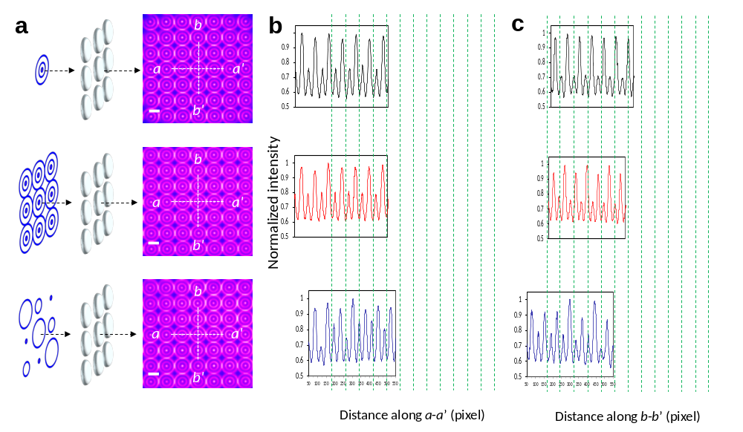
Figure S5. Intensity profiles of integral imaging patterns with compressive multi-projection. (A) Different imaging configurations and optical microscope images. Plot of normalized gray value versus distance along (B) line a-a’ and (C) line b-b’ in (A). A close analysis of captured images and their corresponding intensity profiles reveals that the synthetic pattern with three-decomposed EIs generates slightly asymmetric profiles as compared to that of synthetic patterns with identical EIs. This is presumably due to the small discrepancy of reconstructed images generated by the overlap of spatially non-uniform images from slightly different perspectives. All scale bars are 100 μm.

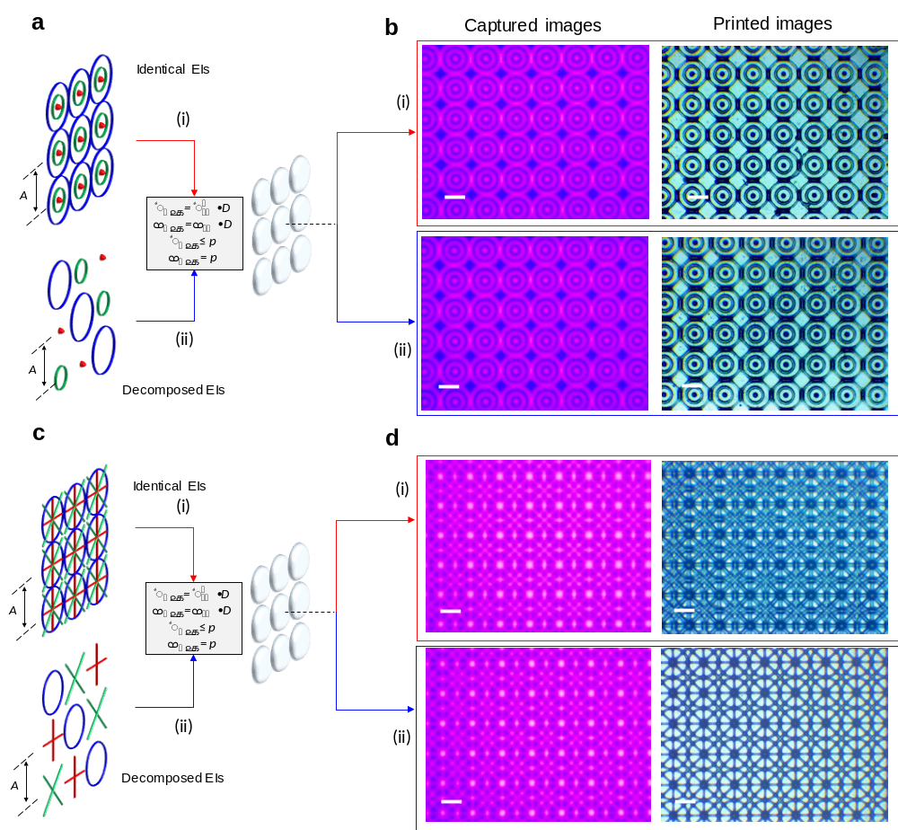
Figure S6. (A, C) Integral imaging mechanism by image replication and multiple EIs capture through the lens array. (B, D) Optical microscope-captured images and corresponding polymerized microstructures. All scale bars are 100 μm.

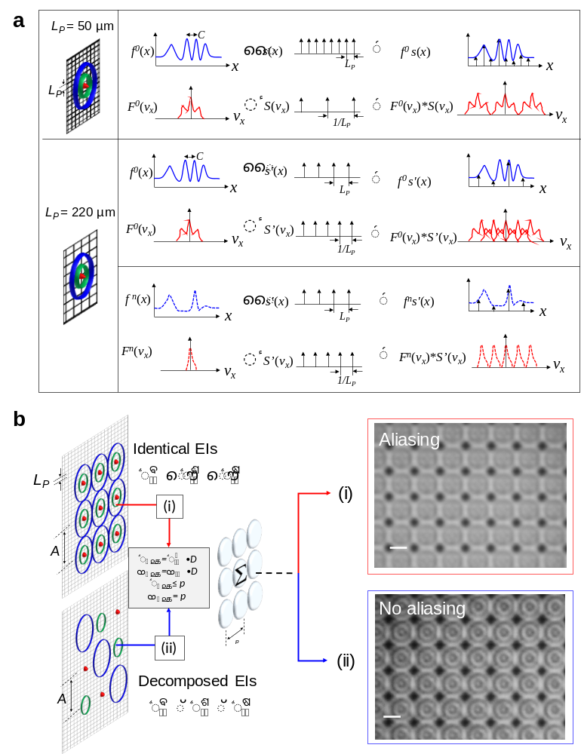
Figure S7. (A) Frequency analysis of the image reconstruction for large (1280 × 800 with L_{P} of 50 µm) and low display bandwidth (1024 × 600 with L_{P} of 220 µm). Here, f(x) and L_{P} represent the target object and the projected pixel size of constituent digital microdisplay, respectively. s(x) and v_{x} denote the sampling function of comb(x/L_{P}) caused by the effect of the pixel sampling and the spatial frequency (= 1/C) of the target image, respectively. (B) Output imaging patterns created by a microdisplay with an L_{P} of 220 μm. (i) Integral imaging with identical EIs of a concentric circular grating. (ii) Integral imaging with the three decomposed EIs for synthesis into the concentric circular grating on the imaging plane through the lens array. All scale bars are 100 μm.

Integral imaging patterns with compressive multi-projection
According to a simple one-dimensional model assumption in Fig. S7, the pixel values of the display image $a_{in}^{n}(x)$ can be represented by $f^{n}\left(x\right)comb\left(x/L_{P}\right)*rect\left(x/L_{P}\right)$, where $f^{n}\left(x\right)$ and L_{P} represent the target object and the projected pixel size of the constituent digital display, respectively. The Fourier transform of $a_{in}^{n}(x)$ is represented by $A_{in}^{n}\left(v_{x}\right)=\left|{L_{P}}^{2}\right|F^{n}\left(v_{x}\right)*comb\left(v_{x}L_{P}\right)sinc(v_{x}L_{P})$, where v_{x} is the spatial frequency (= 1/C) of the target image. Considering the Nyquist sampling criteria (v_{N} = 1/2L_{P}), a digital micromirror device (DMD)-based display unit (L_{P} of ~ 50 μm) can provide enough spatial resolution (|v_{x}| < v_{N}) to prevent the aliasing (i.e., spectral overlap) in integral imaging with both identical and decomposed EIs, thereby enables comparable reconstruction performance, as shown in Fig. 2C. However, a microdisplay with L_{P} of ~ 220 μm results in the aliasing from the integral imaging of identical EIs (Fig. S7B-i) due to insufficient spatial resolution (|v_{x}| > v_{N}). Herein, the compressive integral projection used to decompose the high-frequency spatial component of the initial target image (i.e., |v_{x}| < v_{N}) can provide a solution that can restore the desired target image. As shown in Figure S6B-ii, the integration of micro-optical elements into relatively cheap display devices can resolve high frequency components without aliasing effects, and is expected to facilitate low-cost mass-production. Here, we arranged EIs of 9 × 9 with distance A of 1.83 mm showing identical or decomposed images of the concentric circular grating. The input images in the case of Fig. S7B were generated via an LCD-based 3D printing system (Photocentric 3D Liquid Crystal LC10) with an L_{D} of ~ 220 µm, M of 1, and A_{S} of 2 × 10⁴ mm². In the relationship [$a_{out}]=\left[H\right][a_{in}^{n}]$ as depicted in Fig. 2B, the transfer matrix H was determined by its elements h_{m,n}, which represented the impulse response function of the unit-lens in the lens array, where m and n represent the numbers of the unit-lens within the lens array in the horizontal and vertical directions, respectively. Considering the demagnification (D) of the object image by the unit-lens, the h_{m,n} of the lens array can be defined as $rect(xD/p)*comb(x/p)$, where rect(xD/p) and comb(x/p) are the window function of the unit-lens and the modulation of the entire lens array composed of many identical unit-lenses, respectively. In this study, all h_{m,n} were assumed to be identical in this study. The transfer function can be described as $sinc(v_{x}p/D)comb(v_{x}p)$ through a Fourier transform of the impulse response, where v_{x} is the spatial frequency of the displayed images. Thus, the lens array imaging can increase the amount of the transferable spatial information by a factor of D.

Deterministic aperiodic lattices
Our deterministic aperiodic lattices created with higher complexity are inspired by moiré patterns and can be categorized as quasilattices, superlattices, and incommensurate lattices. The aperiodic lattices would be classified as high symmetry quasilattices when a number of identical lattices of equal pitch are superimposed with equiangular offsets. Because of the equiangular offset superposition of equal pitch lattices, the resultant reciprocal lattice has reciprocal vectors of equal magnitude and with an equal angle between them. An example of quasilattices is shown in Fig. 2D (i), where two square lattices with circular gratings are superimposed at equiangular offsets of 45° to create 8-fold symmetric quasilattices. Here, the equiangular offsets of square lattices are 45°, 90°, 180°, and 360°. Superlattices are created when multiple lattices of the same pitch but non-equiangular offsets are overlapped. Examples of superlattices are shown in Fig. 2D (ii-iii), where multiple square lattices with identical structures are superimposed at non-equiangular offsets of ± 30° and 3° to create 12-fold and higher-order superlattices. Rotational overlapping of hetero-multilayer in Fig. 2D (iv) can also create more sophisticated patterns with no quasiperiodicity or superperiodicity, which can be classified as incommensurate moiré lattices.

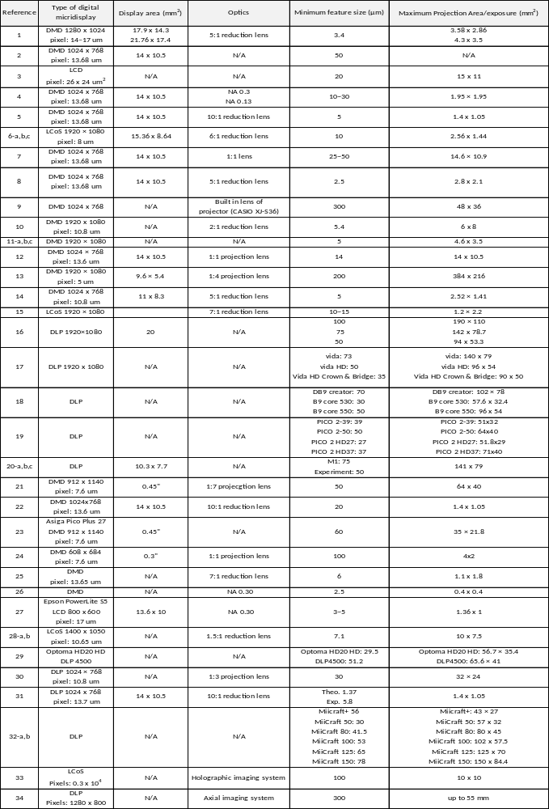
Table 1. Exposure area and minimum feature size of reported projection-based SLA printers. Commercial system performance is based on the manufacturer’s specifications.
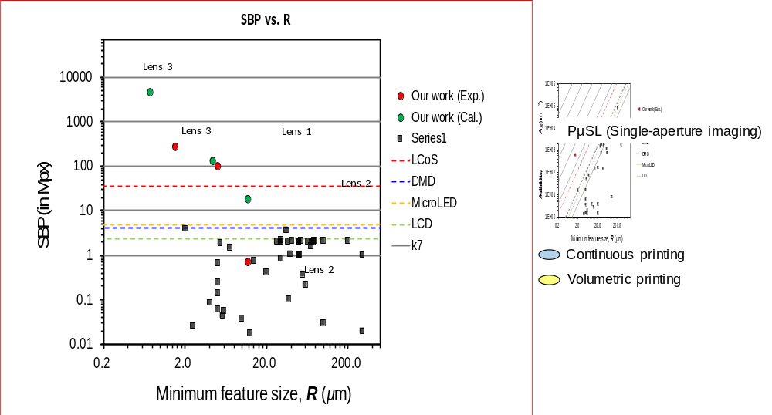
Figure S8. SBP-resolution summary. Plotted data points show the specific published results of the current PµSL systems. The dashed line represents analytical scaling equations grouped by digital microdisplay devices of LCoS, DMD, MicroLED, or LCD. The red and green circles represent experimental results as well as the authors’ calculations for ideal results considering the potential of integral lithographic system, respectively.

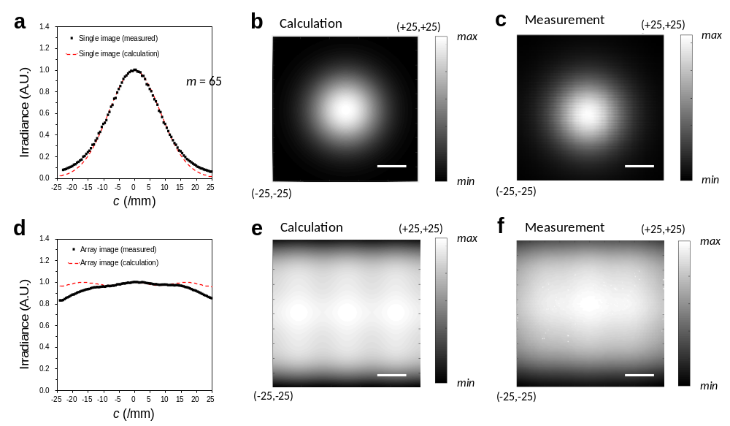
Figure S9. (A) The irradiance distribution (normalized to its maximum value) along the horizontal direction C_{x} direction at the center of vertical direction C_{y} for a = 9 mm and b = 68.75 mm. The dotted and dashed curves show the measured and calculated irradiance patterns of a single image source, respectively. (B-C) Calculated and measured 2D irradiance distributions for a single image source, respectively. (D) The corresponding irradiance distribution for a square array of 5 × 3 circular sources with a = 9 mm and A = 10 mm. (E-F) Calculated and measured 2D irradiance distributions for a rectangular array of image sources, respectively. We note that the irradiance was measured at the imaging distance b = 68.75 mm without the array-lens. All scale bars are 10 mm.

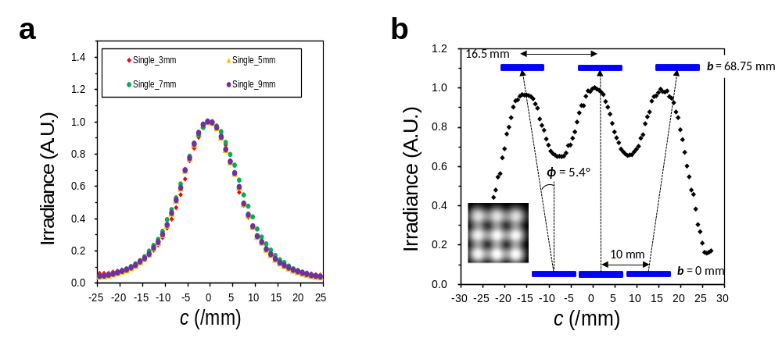
Figure S10. (A) The normalized illumination distribution according to the size variation of a. (B) The measured divergence angle φ in our system. The irradiance distribution (normalized to its maximum value) was measured at the imaging distance b = 68.75 mm without the diffuser and the lens array.

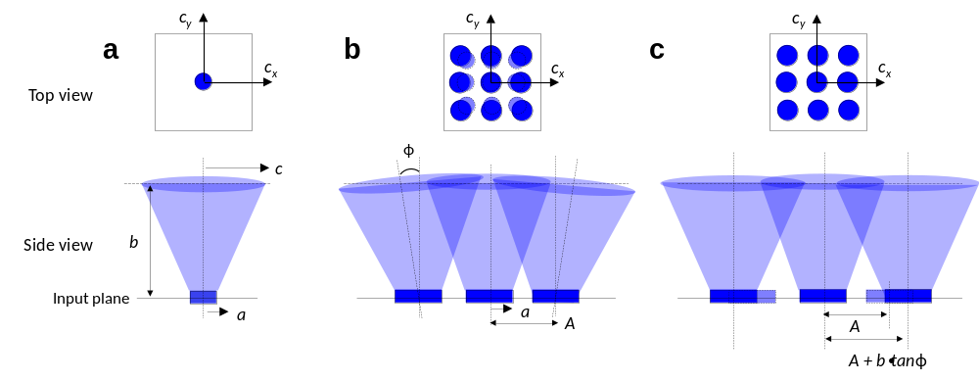
Figure S11. Conceptual schematics for analyzing the illumination distribution between a single image source and array image sources. (A) Illumination distribution of the single image source. (B) Actual illumination distribution and propagation of array image sources in our system. (C) The paraxial approximation for simplicity in this study.

Illumination distribution
To describe a simple analytical equation for the illumination distribution in our system, we assume that the input image produces an incoherent illuminating source and a nonperfect Lambertian distribution defined as a cosine-power function of $P\left(r, θ\right) ∝ P_{0}\left(r\right)\cos^{m}θ$ where θ is the radiating angle, m is the directionality, P₀(r) = P₀/r² is the radiant power on the axis at distance r from the image source when θ = 0 °, and P₀ is proportional to a². In Fig. S9A-C, the radiant power distribution projected at lateral position (c_{x}, c_{y}) over the illuminating plane at imaging distance b from a single image source is described by radiometric theory with Cartesian coordinates [2-4]. Accordingly, the practical approximation for the radiant power distribution of a single image source right below the array-lens can be described as
$P\left(a,b,c\right) ∝ \frac{a^{2}b^{m}}{{\left[\left(b^{2}+c_{x}^{2}+c_{y}^{2}\right)\right]}^{\frac{m+2}{2}}} .$ (S1)
We measured the illumination distribution over the c_{x}-c_{y} plane with variations of size a when b = 68.75 mm, and further fitted the measured irradiance distribution to determine the constant m. Based on the measurements of the radiant power distribution for a single image source along the c_{x} axis at c_{y} = 0 for a selected value of a = 9 mm, we extracted the fitting constant m = 65 in our system (Fig. S9A and 10A). Also, we noticed that the constant m significantly depends on the radiating characteristic of the diffusing optics and the divergence of the delivering optics, rendering it effectively independent of the size a (Fig. S10A). Consequently, we assume that all input images have equal values of m in this study. From the illumination distribution analysis with a single object source, we derive the approximated equation of irradiance superposition to estimate the illumination distribution from an array object source. After considering the measured divergence angle φ caused by the delivery optics of the initial printing system used in this study (Fig. S10B), the illumination distribution from the array object source is approximated by the summation of the irradiances of a matrix of N × M (where N and M are odd numbers) images,
$P\left(a,b,c\right) ∝ a^{2}b^{m}∙\sum_{j=1}^{M}{\sum_{i=1}^{N}{{\left\{b^{2}+{\left[c_{x}-\left(N+1-2i\right)\left(\frac{A+b∙tanφ}{2}\right)\right]}^{2}+{\left[c_{y}-\left(M+1-2i\right)\left(\frac{A+b∙tanφ}{2}\right)\right]}^{2}\right\}}^{-\frac{m+2}{2}}}}.$(S2)
For the simple analytic approach, we used a paraxial approximation that the divergence angle shifts only the distance between array image sources and thereby model the illumination propagation to the array-lens without divergence (Fig. S11). In a simple circle array object source with N × M = 5 × 3, the calculated and measured illumination distributions for a rectangular arrangement of image sources is shown in Fig. S8E and F when a = 9 mm, A = 10 mm, and φ = 5.4 °. We believe that the discrepancy of the calculation and measurement at the edges may originate from the small divergence angle φ caused by the delivering optics in our initial printing system.

The spatial resolution and photopolymerization depth study
Because the current system is based on the projection microstereolithography (PµSL) technique, in-plane resolution (lateral direction) is limited by the performance of the projection system (e.g., an optical wavelength of the illuminating light, the pixel size of a digital microdisplay, and the effective NA of a lens) and the photopolymerization kinetics [5-6]. The details about the in-plane resolution in the current system are described in the main text. On the other hand, vertical resolution can be determined by two main parameters such as the resolution of the vertical translational stage and the photopolymerization depth in vertical direction. The current system can faithfully achieve a vertical translational stage resolution of 5 μm. Also, the PµSL techniques utilize photochemical effect to convert liquid monomer into solid polymer in which a photopolymerization process involves chemical factors such as concentration of photoinitiator and photoabsorber, diffusivity of photoinitiator, and quantum yield. When UV radiation enters the photopolymer resin, it is absorbed by the resin. The absorbed energy distribution inside the resin surface can be determined by means of the Lambert-Beer absorption law [5-6]. The vertical resolution is determined by light penetration depth (D_{p}) (defined as the depth within the resin where irradiation drops to 1/e of the intensity on the surface) and the photopolymerization depth (C_{d}). The detailed theoretical model for the photopolymerization process has been described in Refs 5-6. Here, we investigated the experimental study for C_{d} to obtain the process condition for the printing of the desired structure. The experimental result of the photopolymerization depth study provides empirical working curves to be used to determine the appropriate light intensity and exposure time in the current system. The relationship between the cure depth C_{d} and the applied exposure dose E is expressed by
$C_{d}=D_{p}ln⁡(\frac{E}{E_{c}})$, (S3)
where E_{c} is the critical exposure dose. Equation S3 defines the working curve that is used to control the polymerization thickness. Note that the horizontal axis is logarithmic scale of exposure and exposure is obtained by multiplying light intensity and exposure time (E = I × t). Figure S12 has measurements for the cure depth C_{d} as a function of exposure dose E, plotted according to Equation S3 so that the D_{p} parameter can be measured from the slope and the E_{c} parameter can be obtained from the energy dose intercept. These measurements were taken for UV absorber (Sudan 1) containing 0.05 - 0.7% (w/w) in hexanedioldiacrylate (HDDA).

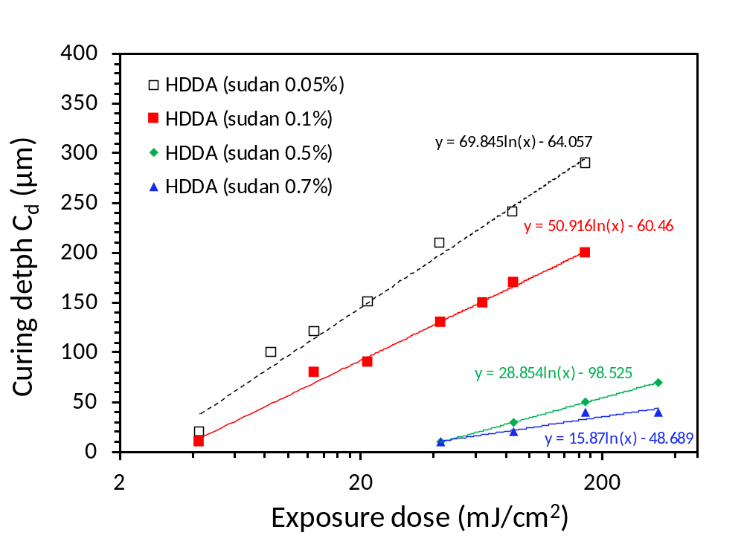
Figure S12. Cure depth versus energy for UV absorber (Sudan 1) containing 0.05 - 0.7% (w/w) in hexanedioldiacrylate (HDDA).

References
1. Zhang, H. et al. Kaleidoscopic imaging patterns of complex structures fabricated by laser-induced deformation. Nature Communications 7, 13743 (2016).
2. Sun, C. et al. Calculating model of light transmission efficiency of diffusers attached to a lighting cavity. Opt. Express 18, 6137-6148 (2010).
3. Moreno, I., Avendaño-Alejo, M., & Tzonchev, R. I. Designing light-emitting diode arrays for uniform near-field irradiance. Appl. Opt. 45, 2265-2272 (2006).
4. Chen, H., Liou, C., & Siao, S. Illumination distribution and signal transmission for indoor visible light communication with different light-emitting diode arrays and pre-equality circuits. Optical Engineering 54, 115106 (2015).
5. Sun, C., Fang, N., Wu, D. M., & Zhang, X. Projection micro-stereolithography using digital micro-mirror dynamic mask. Sensors and Actuators A 121, 113-120 (2005).
6. Behroodi, E., Latifi, H. & Najafi, F. A compact LED-based projection microstereolithography for producing 3D microstructures. Sci Rep 9, 19692 (2019).
References list of Table 1
1. C. Sun, N. Fang, D.M. Wu, and X. Zhang, Projection micro-stereolithography using digital micro-mirror dynamic mask. Sensors and Actuators A 121, 113-120 (2005).
2. L. Han, G. Mapili, S. Chen and K. Roy, Projection Microfabrication of Three-Dimensional Scaffolds for Tissue Engineering. J. Manuf. Sci. Eng. 130, 021005 (2008).
3. C. Xia and N. X. Fang, 3D micro fabricated bioreactor with capillaries. Biomed. Microdevices, 11, 1309-1315 (2009).
4. J. Choi, R. Wicker, S. Lee, K. Choi, C. Ha, and Ildoo Chung, Fabrication of 3D biocompatible/biodegradable micro-scaffolds using dynamic mask projection microstereolithography. Journal of Materials Processing Technology 209, 5494-5503 (2009).
5. J. Choi, R. B. Wicker, S. Cho, C. Ha and S. Lee, Cure depth control for complex 3D microstructure fabrication in dynamic mask projection microstereolithography. Rapid Prototyping Journal 15, 59-70 (2009).
6-a. X. Zheng, J. Deotte, M. P. Alonso, G. R. Farquar, T. H. Weisgraber, S. Gemberling, H. Lee, N. Fang, and C. M. Spadaccini, Design and optimization of a light-emitting diode projection micro-stereolithography three-dimensional manufacturing system. Review of Scientific Instruments 83, 125001 (2012).
6-b. X. Zheng, H. Lee, T. H. Weisgraber, M. Shusteff, J. DeOtte, E. B. Duoss, J. D. Kuntz, M. M. Biener, Q. Ge, J. A. Jackson, S. O. Kucheyev, N. X. Fang, and C. M. Spadaccini, Ultralight, Ultrastiff Mechanical Metamaterials. Science 344, 1373-1377 (2014).
6-c. X. Zheng, W. Smith, J. Jackson, B. Moran, H. Cui, D. Chen, J. Ye, N. Fang, N. Rodriguez, T. Weisgraber, and C. M. Spadaccini, Multiscale metallic metamaterials. Nature Materials 15, 1100-1106 (2016).
7. H. Kang, J. H. Park, and D. Cho A pixel based solidification model for projection based stereolithography technology. Sensors and Actuators A 178, 223- 229 (2012).
8. A. Waldbaur, B. Waterkotte, K. Schmitz, and B. E. Rapp, Maskless Projection Lithography for the Fast and Flexible Generation of Grayscale Protein Patterns. Small 8, 1570-1578 (2012).
9. C. Zhou, Y. Chen, Z. Yang, and B. Khoshnevis, Digital material fabrication using mask-image-projection-based stereolithography. Rapid Prototyping Journal 19, 153-165 (2013).
10. A. R. Schultz, P. M. Lambert, N. A. Chartrain, D. M. Ruohoniemi, Z. Zhang, C. Jangu, M. Zhang, C. B. Williams, and T. E. Long, 3D Printing Phosphonium Ionic Liquid Networks with Mask Projection Microstereolithography. ACS Macro Lett. 3, 1205-1209 (2014).
11-a. K. Kim, W. Zhu, X. Qu, C. Aaronson, W. R. McCall, S. Chen, and D. J. Sirbuly, 3D Optical Printing of Piezoelectric Nanoparticle Polymer Composite Materials. ACS Nano 8, 9799-9806 (2014).
11-b. A. P. Zhang, X. Qu, P. Soman, K. C. Hribar, J. W. Lee, S. Chen, and S. He, Rapid Fabrication of Complex 3D Extracellular Microenvironments by Dynamic Optical Projection Stereolithography. Adv. Mater. 24, 4266-4270 (2012).
11-c. P. Soman, B. T. D. Tobe, J. W. Lee, A. M. Winquist, I. Singec, K. S. Vecchio, E. Y. Snyder, and S. Chen, Three-dimensional scaffolding to investigate neuronal derivatives of human embryonic stem cells, Biomed. Microdevices 14, 829-838 (2012).
12. Y. L. Jeyachandran, N. Meyerbröker, A. Terfort, and M. Zharnikov, Maskless Ultraviolet Projection Lithography with a Biorepelling Monomolecular Resist. J. Phys. Chem. C 119, 494-501 (2015).
13. M. M. Emami, F. Barazandeha, and F. Yaghmaie Scanning-projection based stereolithography: Method and structure. Sensors and Actuators A 218, 116-124 (2014).
14. Lawrence Livermore National Laboratory, Large-Area Projection Micro-Stereolithography (LAPμSL), LLNL-MI-670797 (2015).
15. M. Shusteff, Projection Microstereolithography for Architected Materials. Technical Report, Lawrence Livermore National Laboratory (LLNL), Livermore, CA (2015).
16. Kudo3D Titan, https://www.kudo3d.com/titan2-and-titan2-hr/
17. Envision Perfactory, https://envisiontec.com/3d-printers/desktop-3d-printers/"
18. DB9 Creator https://www.b9c.com/
19. Asiga Freeform Pico 2, https://www.asiga.com/products/printers/pico2/"
20-a. Carbon M1 Printer, https://www.carbon3d.com/
20-b. J. R. Tumbleston, D. Shirvanyants, N. Ermoshkin, R. Janusziewicz, A. R. Johnson, D. Kelly, K. Chen, R. Pinschmidt, J. P. Rolland, A. Ermoshkin, E. T. Samulski, and J. M. DeSimone, Continuous liquid interface production of 3D objects. Science 347, 1349-1352 (2015).
20-c. R. Janusziewicz, J. R. Tumbleston, A. L. Quintanilla, S. J. Mecham, and J. M. DeSimone, Layerless fabrication with continuous liquid interface production. PNAS 113, 11703-11708 (2016).
21. Autodesk Ember, https://ember.autodesk.com/overview#tech_specs
22. W. Yang, H. Yu , W. Liang, Y. Wang, and L. Liu, Rapid Fabrication of Hydrogel Microstructures Using UV-Induced Projection Printing. Micromachines 6, 1903-1913 (2015).
23. H. Gong, M. Beauchamp, S. Perry, A. T. Woolleyb, and G. P. Nordin, Optical approach to resin formulation for 3D printed microfluidics. RSC Adv. 5, 106621 (2015).
24. M. P. Lee, G. J. T. Cooper, T. Hinkley, G. M. Gibson, M. J. Padgett, and L. Cronin Development of a 3D printer using scanning projection stereolithography, Sci. Rep. 5, 9875 (2015).
25. A.S. Limaye and D.W. Rosen, Process planning method for mask projection micro-stereolithography. Rapid Prototyping Journal 13, 76-84 (2007).
26. Y. Jung, H. Lee, T. Park, S. Kim, and S. Kwon, Programmable gradational micropatterning of functional materials using maskless lithography controlling absorption. Sci. Rep. 5, 15629 (2015).
27. R. Raman, B. Bhaduri, M. Mir, A. Shkumatov, M. K. Lee, G. Popescu, H. Kong, R. Bashir, High-Resolution Projection Microstereolithography for Patterning of Neovasculature. Adv. Healthcare Mater. 5, 610–619 (2016).
28-a. F. Zhou, W. Cao, B. Dong, T. Reissman, W. Zhang, C. Sun, Additive Manufacturing of a 3D Terahertz Gradient-Refractive Index Lens. Adv. Optical Mater. 4, 1034-1040 (2016).
28-b. F. Zhou, Y. Bao, W. Cao, C. T. Stuart, J. Gu, W. Zhang, and C. Sun, Hiding a realistic object using a broadband terahertz invisibility cloak. Sci. Rep. 1, 78 (2011).
29. A. Urrios, C. Parra-Cabrera, N. Bhattacharjee, A. M. Gonzalez-Suarez, L. G. Rigat-Brugarolas, U. Nallapatti, J. Samitier, C. A. DeForest, F. Posas, J. L. Garcia-Corderob, and A. Folch, 3D-printing of transparent bio-microfluidic devices in PEG-DA, Lab Chip 16, 2287 (2016).
30. Q. Ge, A. H. Sakhaei, H. Lee, C. K. Dunn, N. X. Fang, and M. L. Dunn. Multimaterial 4D Printing with Tailorable Shape Memory Polymers. Sci. Rep. 6, 31110 (2016).
31. J. Na, N. P. Bende, J. Bae, C. D. Santangelob, and R. C. Hayward, Grayscale gel lithography for programmed buckling of non-Euclidean hydrogel plates, Soft Matter 12, 4985 (2016).
32-a. N. P. Macdonald, J. M. Cabot, P. Smejkal, R. M. Guijt, B. Paull, and M. C. Breadmore, Comparing Microfluidic Performance of Three-Dimensional (3D) Printing Platforms, Anal. Chem. 89, 3858-3866 (2017).
32-b. http://www.miicraft.com/product/
33. Shusteff, M. et al. One-step volumetric additive manufacturing of complex polymer structures. Sci. Adv. 3, eaao5496 (2017).
34. Kelly, B., et al. Volumetric additive manufacturing via tomographic reconstruction. Science 363, 1075–1079 (2019).

