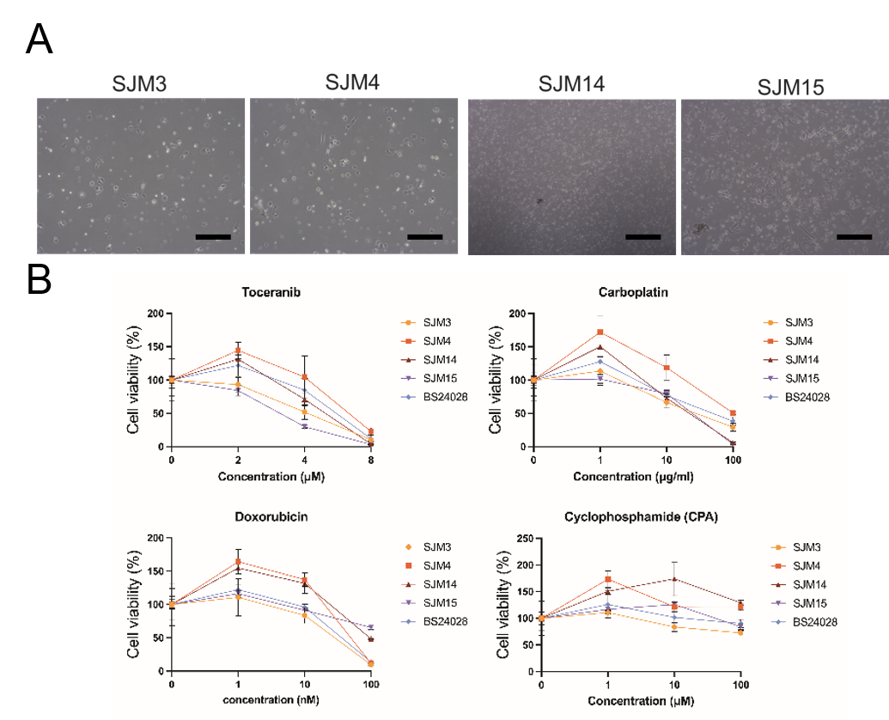
Fig. S1. Bright-field images and drug sensitivity testing of orthotopic xenograft-derived hemangiosarcoma (HSA) 2.5D organoids.
(A) Bright-field images of HSA 2.5D organoids generated directly from orthotopic xenograft tumor tissues. Scale bar = 500 µm. (B) Orthotopic xenograft-derived HSA 2.5D organoids treated with carboplatin, doxorubicin, toceranib, or cyclophosphamide. Cell viability was evaluated via the PrestoBlue™ cell viability assay. Results are expressed as mean ± S.E.M..

Fig. S2. Bright field images of HSA 3D organoids.
Bright-field images of HSA 3D organoids generated directly from orthotopic xenograft tumor tissues and floating 2.5D orthotopic xenograft organoids. Scale bar = 500 µm.

