Cytotoxic metabolites from the endophytic fungus Penicillium sp. ArD1 derived from Corchorus olitorius seeds
Arwa Mortada Ahmedª, Islam M.Abdel-Rahman^{b}, Jiabao Zhang^{c}, Jianye Zhang^{c}, Jun Wu^{d}, Usama Ramadan Abdelmohsen^{a,e*}, Mostafa A. Fouad^{e,f}, Basma Khalaf Mahmoud^{e,f}*
ªDepartment of Pharmacognosy, Faculty of Pharmacy, Deraya University, 61111 New-Minia City, Egypt
^{b}Department of Pharmaceutical Chemistry, Faculty of Pharmacy, Deraya University, 61111 New-Minia, Egypt
^{c}Guangzhou Municipal and Guangdong Provincial Key Laboratory of Molecular Target & Clinical Pharmacology, the NMPA and State Key Laboratory of Respiratory Disease, School of Pharmaceutical Sciences and the Fifth Affiliated Hospital, Guangzhou Medical University, Guangzhou 511436, China.
^{d}Guangdong Key Laboratory for Research and Development of Natural Drugs, College of Pharmacy, Guangdong Medical University, Dongguan, 523808, China.
^{e} Department of Pharmacognosy, Faculty of Pharmacy, Minia University, Minia, 61519, Egypt.
^{f} Department of Pharmacognosy, Faculty of Pharmacy, Minia National University (MNU), New- Minia, Egypt.

* correspondence .Usama Ramadan Abdelmohsen, E-mail: usama.ramadan@mu.edu.eg

Basma Khalaf Mahmoud, E-mail:basmaakh88@yahoo.com
ABSTRACT
Corchorus olitorius L. seeds are a rich source of endophytic fungi, which afford many cytotoxic secondary metabolites. The fungus was taxonomically identified via sequencing as Penicillium sp. ArD1 (closely related to P. oxalicum). The fungal extract was subjected to chromatographic separation, leading to the isolation and structural elucidation of four compounds: two naphtho-pyrones ((1) and (2)), the cyclic pentapeptide malformin A1 (3), and the fatty acid Tridecanoic acid (4). Structures were confirmed using extensive 1D and 2D NMR as well as mass spectrometry. The isolated metabolites were evaluated for cytotoxicity against human lung carcinoma cell lines A549 and H1299. malformin A1 (3) demonstrated the highest and most potent activity, yielding IC₅₀ values of 0.75±0.02 and 0.85±0.14 µM, respectively. In addition, malformin A1 revealed different hydrogen bonding and hydrophobic interactions within the enzyme’s active site of matrix metalloproteinase-9 (MMP-9) in the molecular docking study. These findings highlight malformin A1 from endophytic Penicillium sp. as a promising and highly potent lead compound for the development of anti-lung cancer therapeutics.
KEYWORDS: Penicillium; cytotoxic activity; endophytic fungus; secondary metabolites; naphtho-γ-pyrones; malformin A1.
NMR spectra for compounds 1-3

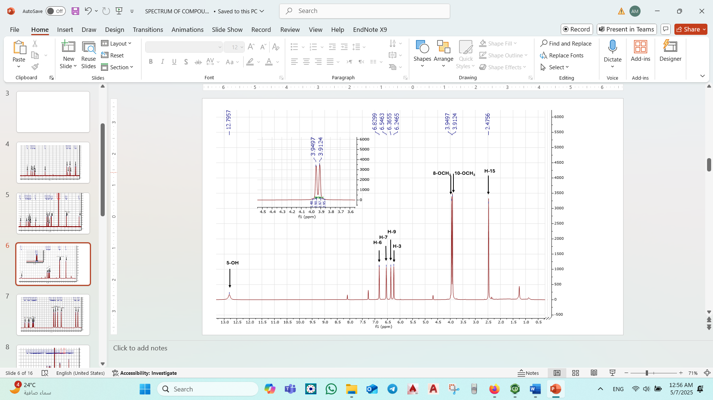
Figure S1. ¹H NMR spectrum of Flavasperone (1) (400 MHz, CDCl₃)

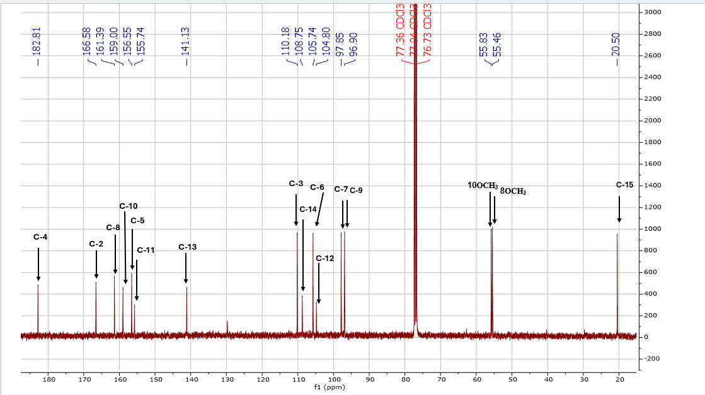

Figure S2. ¹³C NMR spectrum of Flavasperone (1) (100 MHz, CDCl₃)



Figure S3.HR-ESI-MS spectrum of Flavasperone (1).

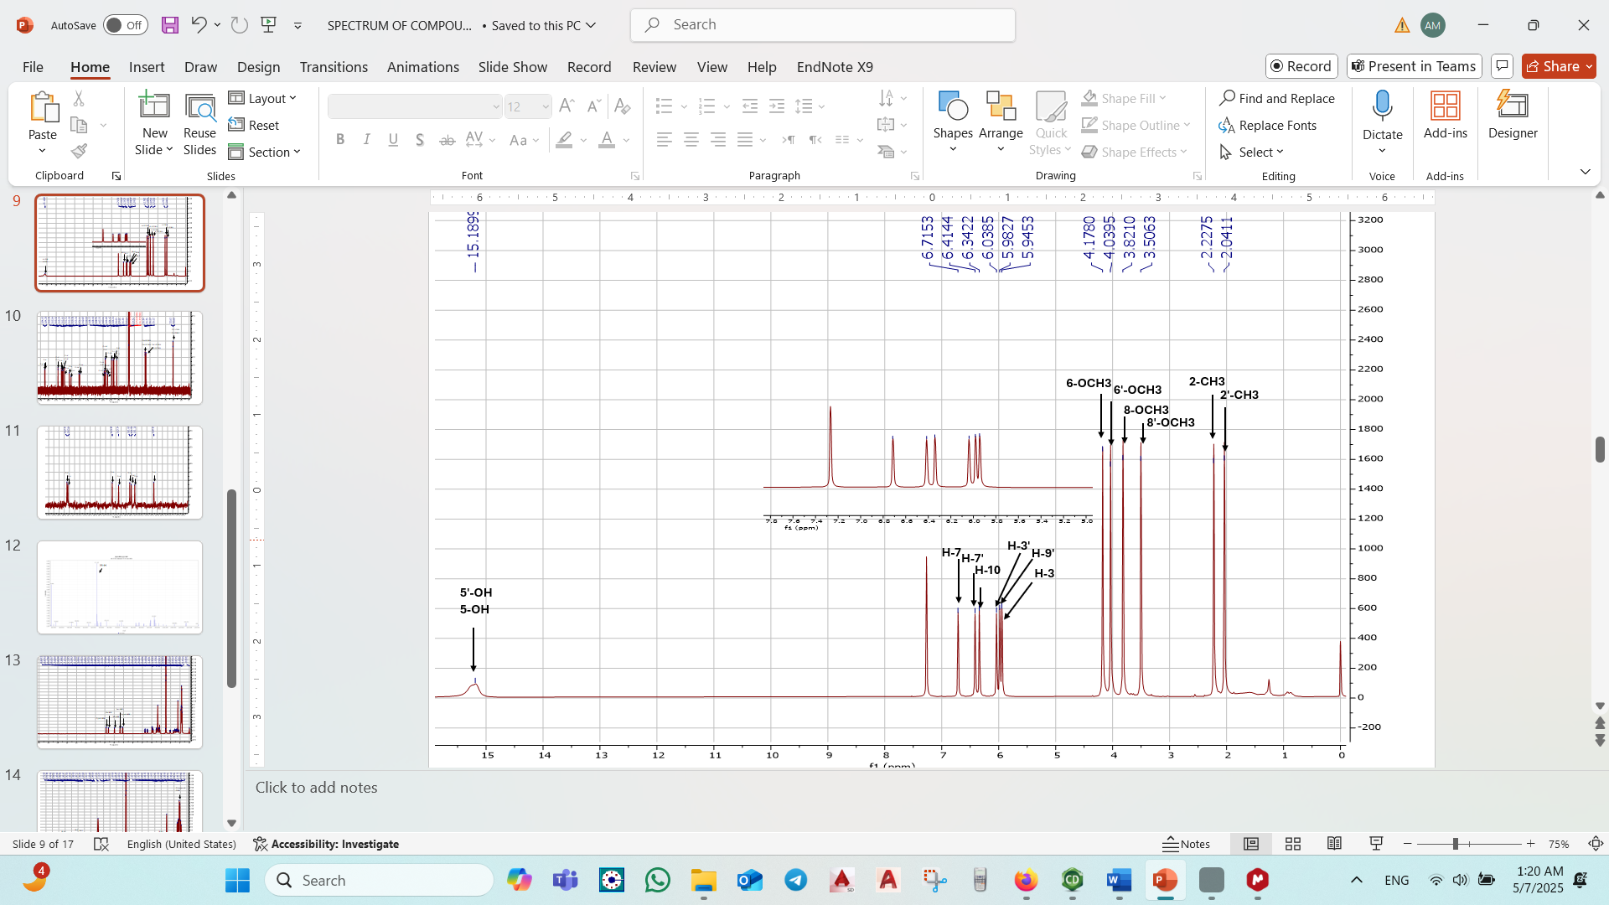
Figure S4. ¹H NMR spectrum of Rubasperone B (2) (400 MHz, CDCl₃)

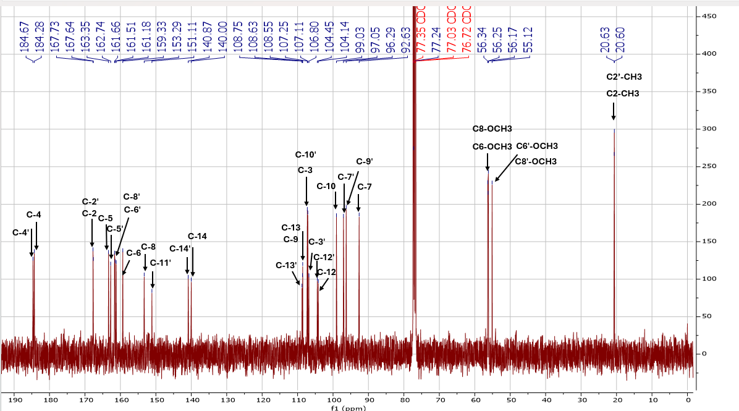

Figure S5. ¹³C NMR spectrum of Rubasperone B (2) (100 MHz, CDCl₃)

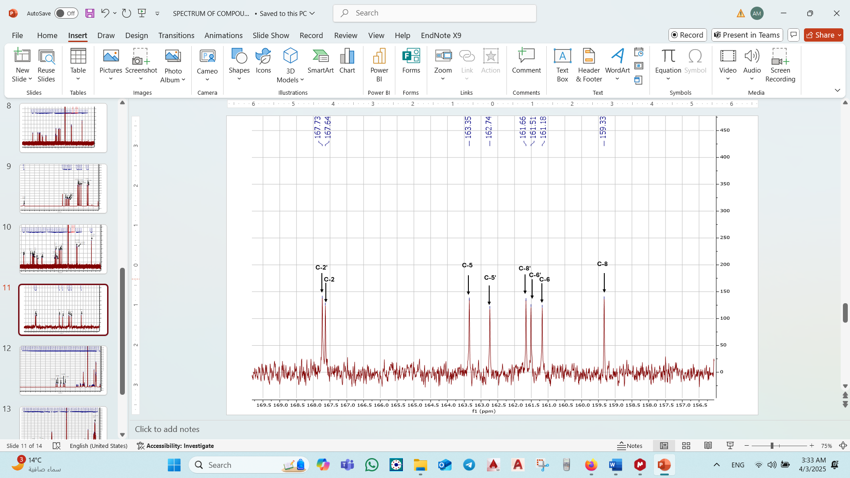
Figure S6. Expanded 1³ C-NMR spectrum of Rubasperone B (2) (100 MHz, CDCl3).
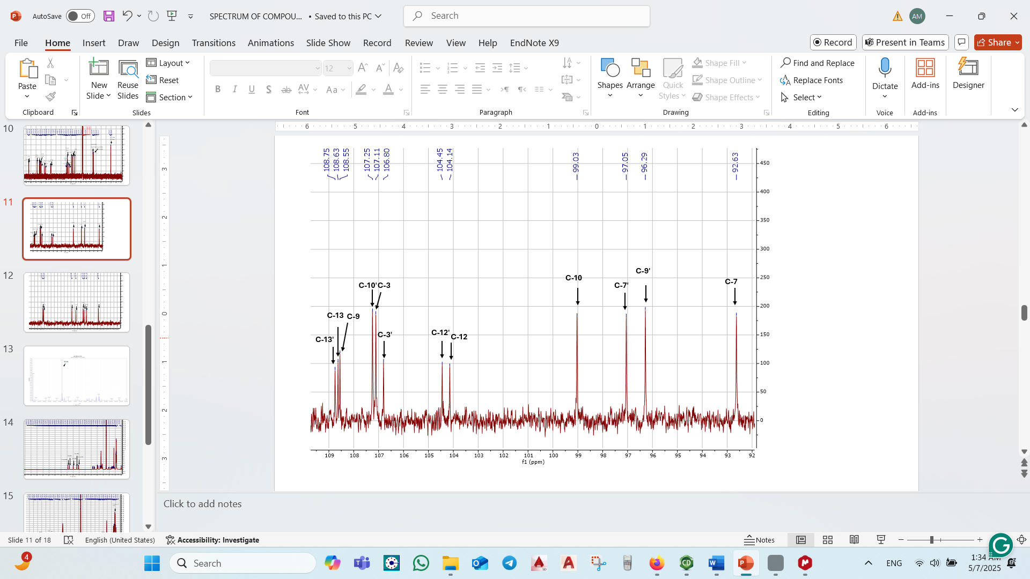
Figure S7. Expanded 1³ C-NMR spectrum of Rubasperone B (2) (100 MHz, CDCl3).
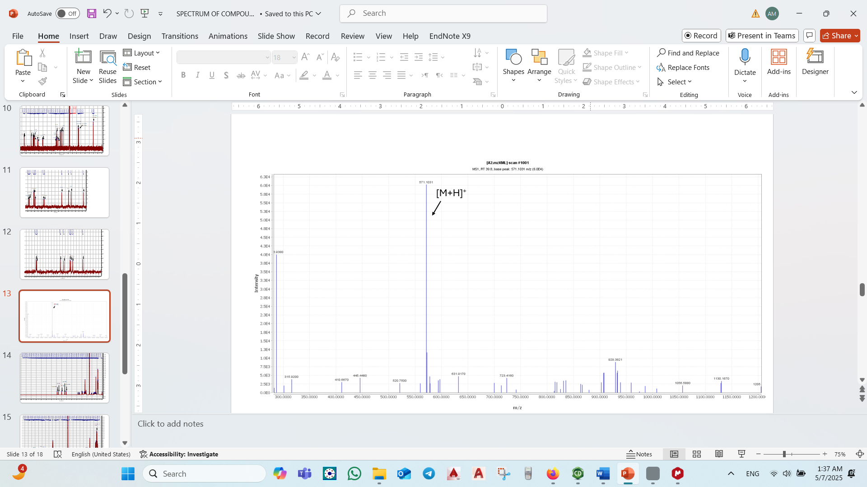
Fig S8. HR-ESI-MS spectrum of spectrum of Rubasperone B (2).
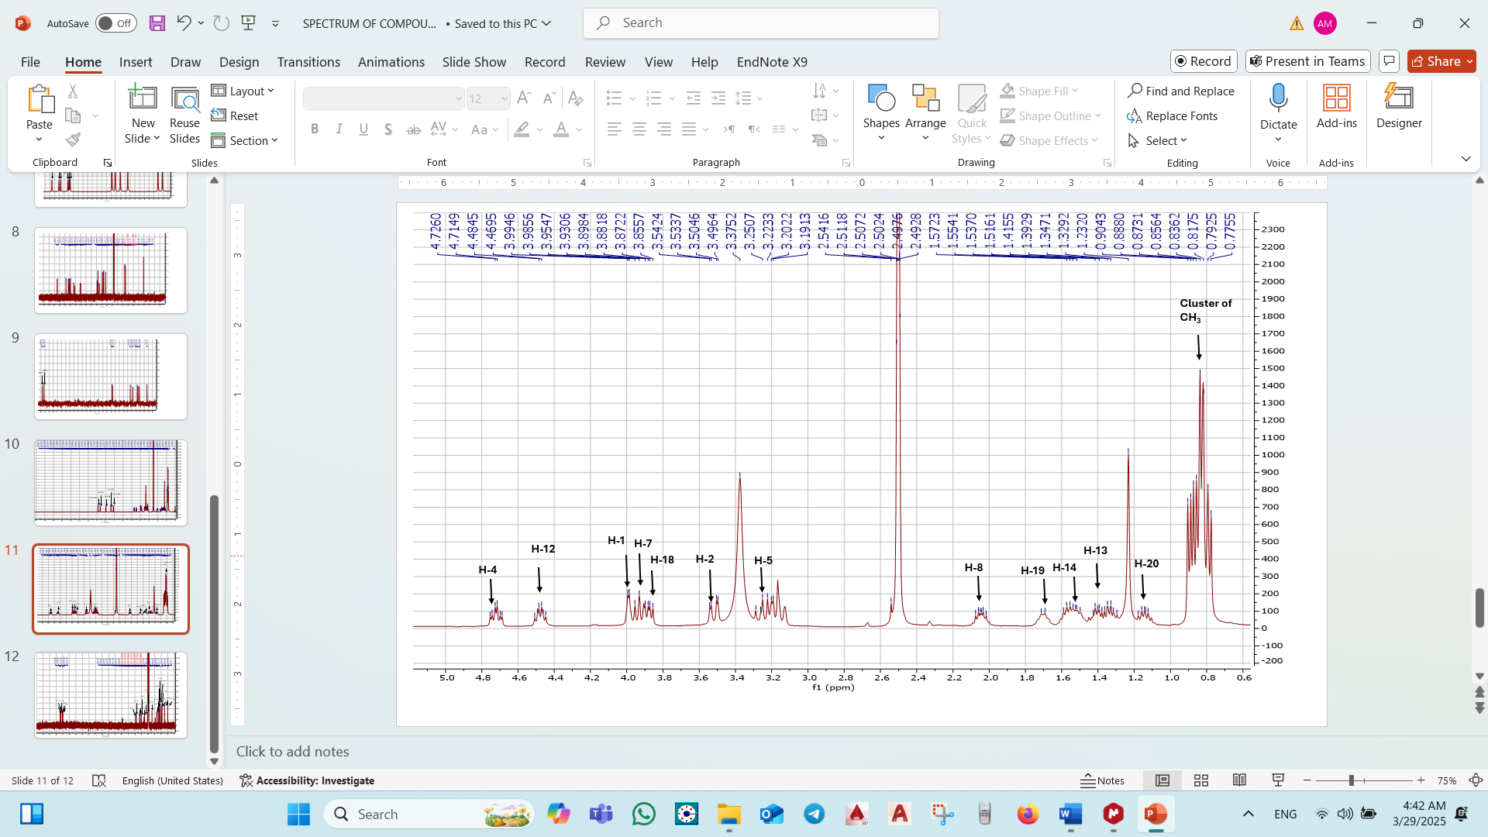
Figure S9. ¹H-NMR spectrum of Malformin A1 (3) (400 MHz, DMSO-d6).

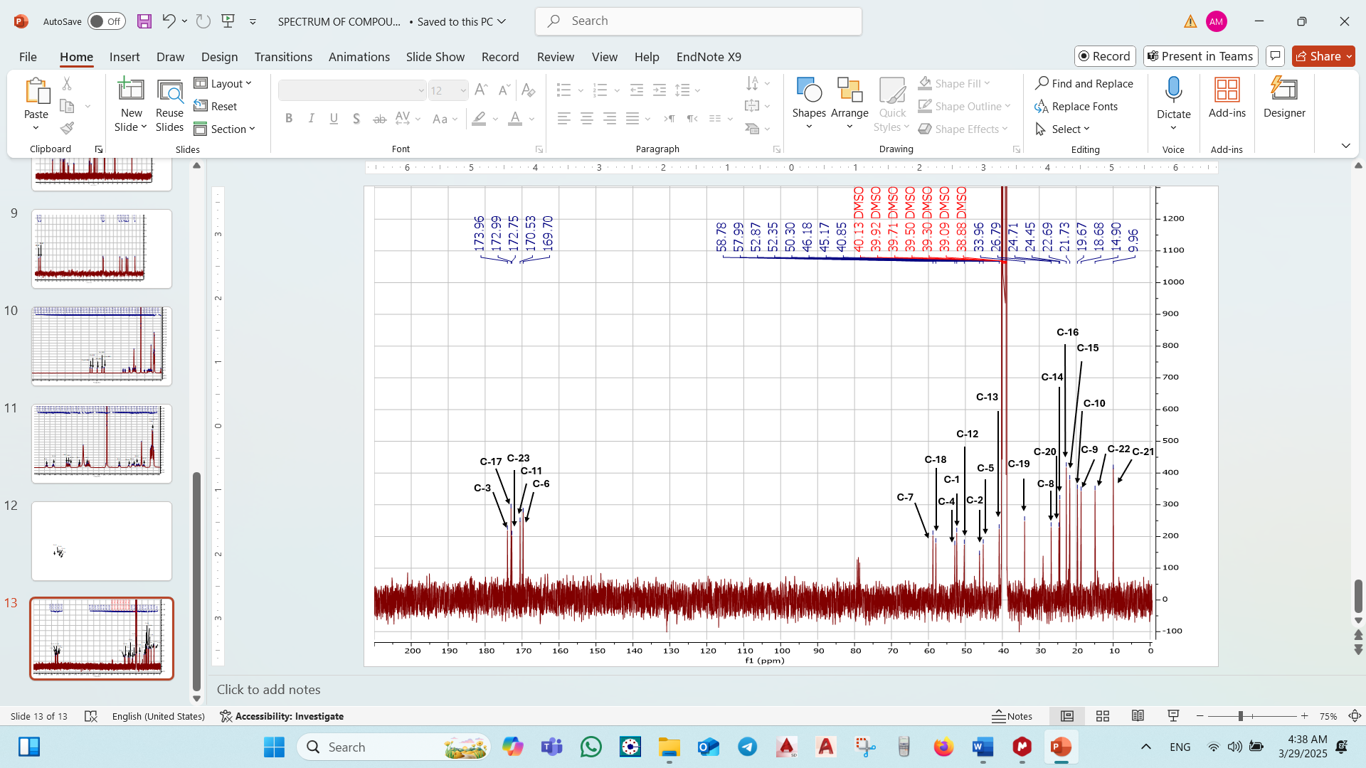

Figure S10. ¹³C-NMR spectrum of Malformin A1 (3) (100 MHz, DMSO-d6)

Figure S11. HMBC spectrum of Malformin A1 (3) (DMSO-d6)

Figure S12. ¹H-¹H COSY spectrum of Malformin A1 (3) (DMSO-d6).

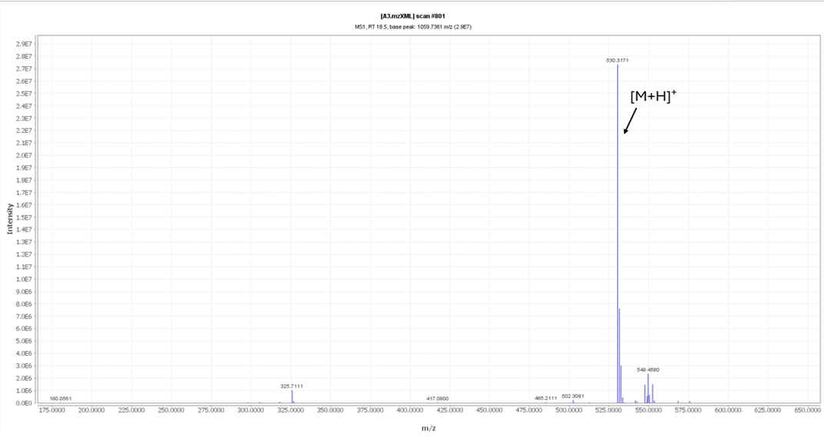
Figure S13. HR-ESI-MS spectrum of Malformin A1 (3).

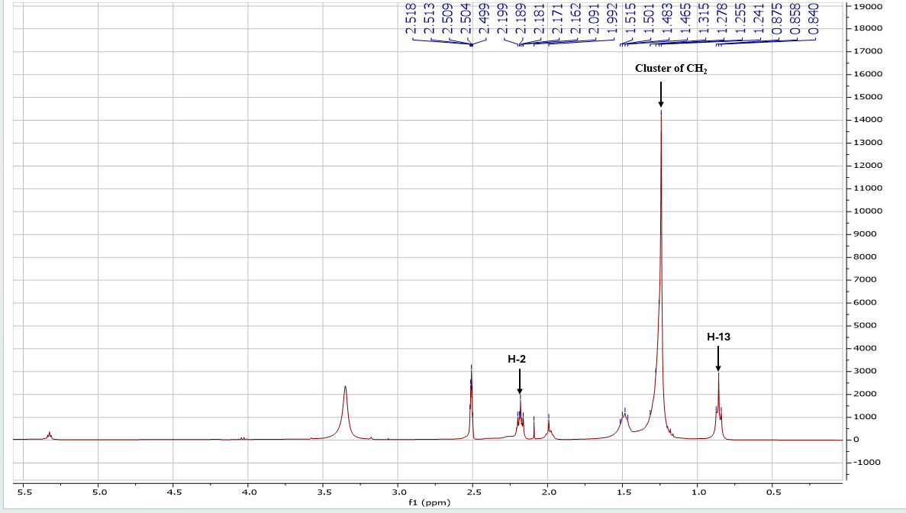
Figure S14. ¹H-NMR spectrum of Tridecanoic acid (4) (400 MHz, CDCl₃).

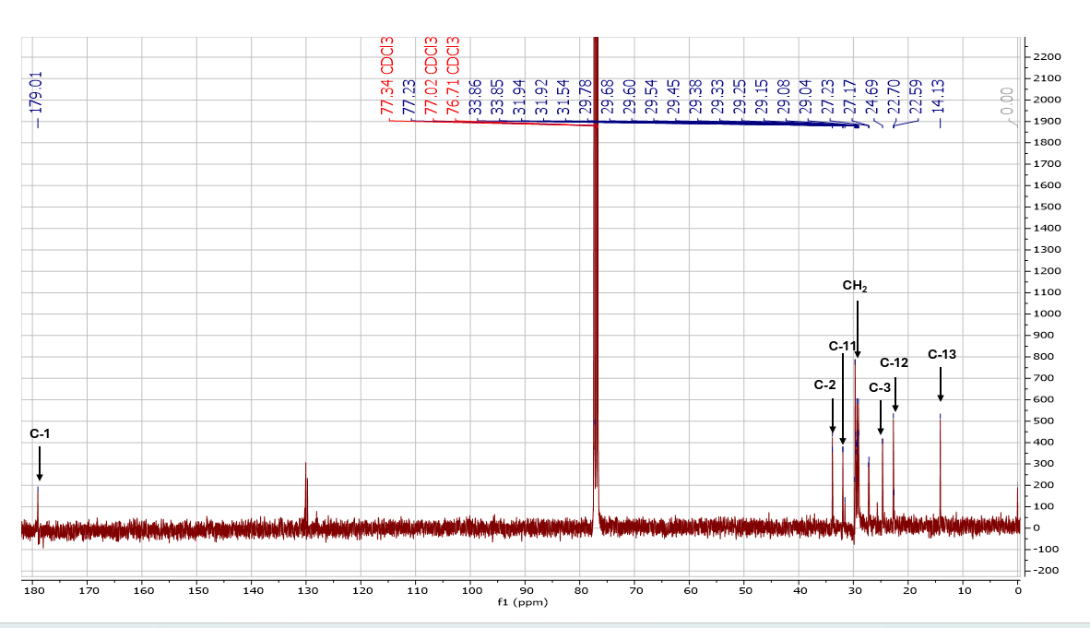

Figure S15. ¹³C-NMR spectrum of Tridecanoic acid (4) (100 MHz, CDCl₃).

Figure S16. EI-MS spectrum of Tridecanoic acid (4).
